Sairam Soundararajan

SDEV300: Building Secure Python Applications

University of Maryland Global Campus

Professor Howards

|  |  |  |  |  |
| --- | --- | --- | --- | --- |
| Test Case | Input | Expected Output | Actual Output | Pass? |
| 1 | This program does not contain user input within the code since this is an HTML program. | * Serving Flask app "website_program" (lazy loading)  * Environment: production  WARNING: This is a development server. Do not use it in a production deployment.  Use a production WSGI server instead.  * Debug mode: off  * Running on http://127.0.0.1:5000/ (Press CTRL+C to quit) | * Serving Flask app "website_program" (lazy loading)  * Environment: production  WARNING: This is a development server. Do not use it in a production deployment.  Use a production WSGI server instead.  * Debug mode: off  * Running on http://127.0.0.1:5000/ (Press CTRL+C to quit) |  |

Snapshots of Test Run:

The website will only operate during test run. Once the test run is over, the website will be inaccessible until the program is run again.





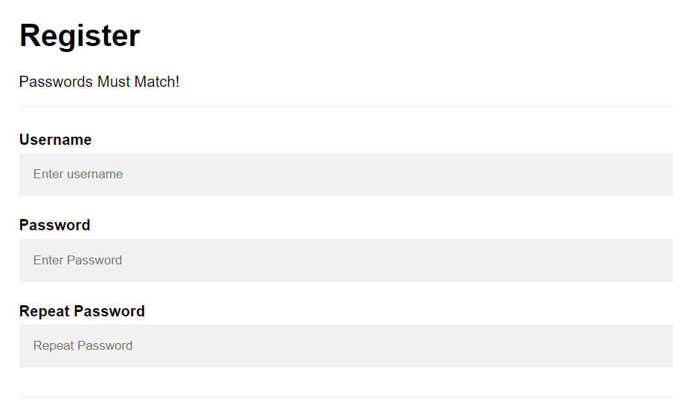

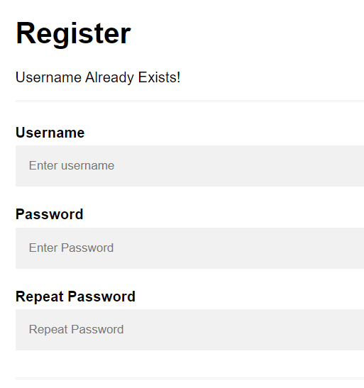 

Pylint Discussion and Snapshots:

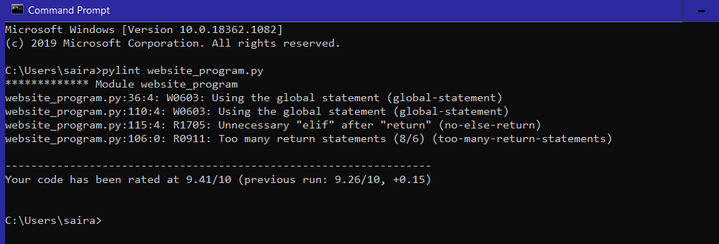

I understand the goal is to get 10.00/10. Unfortunately, I was not able to achieve that score. The warnings displayed above are what keep the program running successfully. If I had altered these variables and statements mentioned, I would have had errors in the program that would have prevented it from running successfully.