Homework 1: Setting Up AWS and Cloud9

Sairam Soundararajan

SDEV320

Prof. Donoho

University of Maryland Global Campus

The first step I did was set up my AWS Academy student account through the course invitation I received in my university email. After setting up my account, I went to my dashboard to navigate AWS Learner Lab. On the Modules tab, I accessed the Learner Lab link. Then on the Learner Lab, I clicked on Start Lab. A red dot next to AWS changes from red to yellow to indicate loading. When the lab is ready, the dot changes to green. From there, I clicked on the AWS next to the green dot to get to the AWS Management Console. Next to the services button is a search bar where I type in “Cloud9”. After pulling up Cloud9, I clicked on Create Environment, where I typed the name and description, created a new instance for environment, chose t2.micro as the Instance Type, chose 1 hour for the cost savings setting, and selected amazon lunix2 as the platform, After configuring settings, I clicked on Create Environment. Finally, Cloud9 loads the environment and the welcome screen shows up. The IDE is ready for use

To test Cloud9, I went to File, New from Template, and was able to choose any programming file such as Java Console Application, C++ File, and Python File. From there, I tested the code with import statements, timestamp, and print statements such as hello world, introduction of myself, and cool things about me (like what I am doing in my life). When clicking Run, the program of each language successfully displayed the following:

Hello World from AWS Cloud9!

My name is Sairam Soundararajan and I am graduating from UMGC this May

My hobbies are singing, playing piano, composing (many genres), rapping (a little), playing sports, poetry, reading, and biking

The local date and time is: Tue Mar 21 22:25:26 2023

**AWS Cloud9 Screenshots**

C++: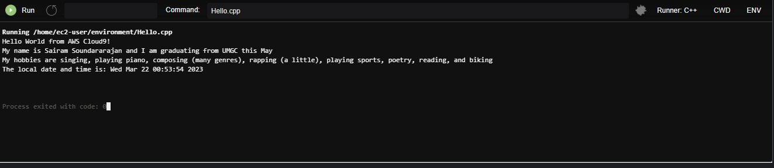

Java Console Application:

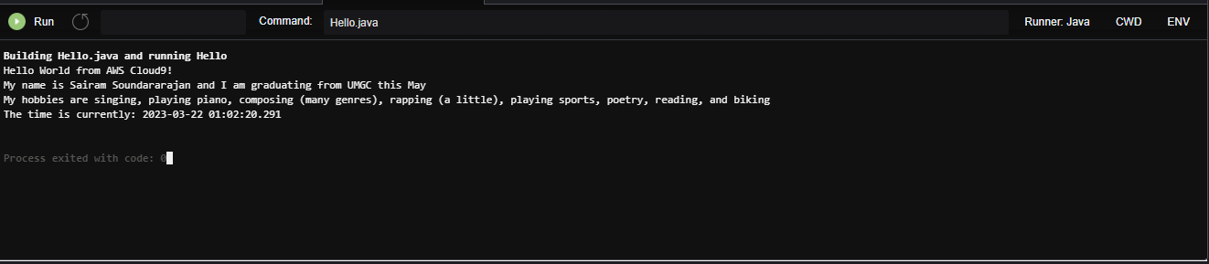

Python:

