Deployment guide
  - prep-test-naturalisation — Proxmox · Cloudflare · Nginx Proxy Manager

Two complete guides in one document: Part 1 walks through the prep-test-naturalisation deployment step by step; Part 2 is the reusable generic playbook for every future application on the same stack.
15 October 2026
Contents
Right-click and choose Update Field to fill this in.

Part 1 — prep-test-naturalisation deployment

Complete deployment guide
prep-test-naturalisation — from a Windows machine to https://test-fr.abdoudiallo.fr, on a Proxmox / Cloudflare / Nginx Proxy Manager stack.
This guide compiles every step, in the order needed, with the exact values of the infrastructure and the failures already met (and fixed) along the way. DEPLOY.md remains the shorter day-to-day reference; this is the full story.

0. TL;DR
Situation | Command
Nothing exists yet | follow §1 → §5, once
Daily deploy after a code change | sh auto_deploy.sh --tag <new-tag>
Just check docker + SSH reachability | sh auto_deploy.sh --check
Deploy the same tag again | sh auto_deploy.sh
Redeploy quickly, image already inside the LXC | §7, "Fast redeploy"
Something is wrong | §8 Troubleshooting

Current state: the application is deployed and healthy in LXC 109, published on port 4200. The only remaining step is the Nginx Proxy Manager Proxy Host (§5), after which the site is publicly live.

1. Infrastructure (reference)
Layer | Value | Notes
Proxmox host | dialloPavillion — 192.168.1.55 | SSH on port 2222 (not 22)
Application LXC | 109, hostname test-fr | nesting=1,keyctl=1, Docker installed
App directory | /opt/test-fr | on the host and inside the LXC (pct push)
Docker image | prep-test-naturalisation:<tag> | built on Windows, shipped as a .tar
Published port | 4200 → container 8080 | the convention: 10.10.10.<LXC_ID>:4200
Reverse proxy | Nginx Proxy Manager on 10.10.10.7 | proxy on :80, admin UI on :81
Cloudflare tunnel | Proxmox-Server | every route points to http://10.10.10.7:80
Public hostname | test-fr.abdoudiallo.fr | DNS CNAME created by Cloudflare automatically
Windows tooling | Docker Desktop, OpenSSH (ssh/scp), cmder | sh comes from Git for Windows; the deploy prefers Git's OpenSSH

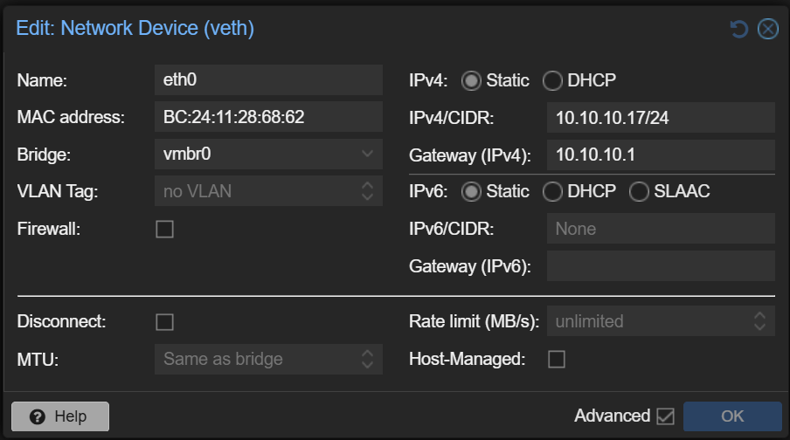
The network device of the application container: bridge vmbr0, static address 10.10.10.109/24, gateway 10.10.10.1. The convention is that the last octet is the LXC id, which is what makes every Proxy Host readable as 10.10.10.<LXC_ID>:4200.
Existing routes on the same tunnel, for reference: lasignare, boycott-list, ugop-formation — all → http://10.10.10.7:80, each with a Proxy Host in NPM forwarding to 10.10.10.<LXC_ID>:4200.
Note: The cmder tab is cmd.exe. The POSIX form VAR=value command does not exist there ('SSH_PORT' is not recognized…). Use the script's options — they work identically under cmd.exe, PowerShell and Git Bash — or set VAR=value && sh ….

2. Prerequisites (one-time check)
# Windows: Docker Desktop must be running
docker info --format '{{.ServerVersion}}'

# Proxmox host: LXC running, Docker + compose inside it, IP
ssh -p 2222 root@192.168.1.55
pct status 109 # status: running
pct exec 109 -- docker version --format '{{.Server.Version}}'
pct exec 109 -- docker compose version
pct exec 109 -- hostname -I # expect 10.10.10.109
If Docker-in-LXC fails later with permission denied on /var/lib/docker, check /etc/pve/lxc/109.conf contains features: nesting=1,keyctl=1 and add it if missing, then pct reboot 109.
To stop typing passwords: ssh-keygen -t ed25519 then ssh-copy-id -p 2222 root@192.168.1.55
Or in one step: sh auto_deploy.sh --setup-key (installs the public key on the host).

3. Build and deploy (one command)
From the project root, in cmder/cmd.exe:
sh auto_deploy.sh # tag 1.0.0, port 4200, LXC 109, ssh 2222
sh auto_deploy.sh --check # docker + SSH only, then stops
sh auto_deploy.sh --tag 1.0.1 # new version
sh auto_deploy.sh --port 8095 # if 4200 is already taken in the LXC
sh auto_deploy.sh --help # all options
What happens, in order:
Step | What it does | Typical time
1/6 | checks docker, scp, ssh and probes the SSH port without a password — a failure stops here, before any build | < 1 s
2/6 | docker build: validates the question bank and regenerates the bundle inside the build | ~30 s cold, ~3 s cached
3/6 | local test: starts the built container on 127.0.0.1:18080, checks /healthz and the served question bank size, removes it | ~3 s
4/6 | docker save → dist/prep-test-naturalisation-<tag>.tar (≈ 21 MB) | ~10 s
5/6 | scp archive + compose + the two scripts to root@192.168.1.55:/opt/test-fr | ~20 s
6/6 | ssh → pct push into LXC 109, docker load, compose down, compose up -d, wait for healthy | ~30 s

Three Proxmox passwords are requested (remote directory, file copy, remote execution) — none at all after sh auto_deploy.sh --setup-key.
Because step 2 validates the bank and regenerates the bundle, an image can never ship inconsistent data or a stale data/questions.data.js, and step 3 proves the container actually serves before it travels.

Expected output on success
=== 1/6 Checks
docker OK · target root@192.168.1.55:2222 (LXC 109, /opt/test-fr) · tag 1.0.1 · port 4200
SSH reachable on port 2222
...
=== 6/6 pct push into LXC 109, docker load and restart
==> Container prep-test-naturalisation Started
==> Waiting for the health probe
container health: healthy

OK — application deployed (tag 1.0.1, port 4200)

4. Cloudflare route (one-time)
Zero Trust → Networks → Tunnels → Proxmox-Server → Add route → Published application:
Field | Value
Subdomain | test-fr
Domain | abdoudiallo.fr
Service URL | http://10.10.10.7:80 — identical to the other routes

A simple subdomain needs no advanced certificate. Cloudflare creates the DNS CNAME itself — never add an A record by hand for that hostname.
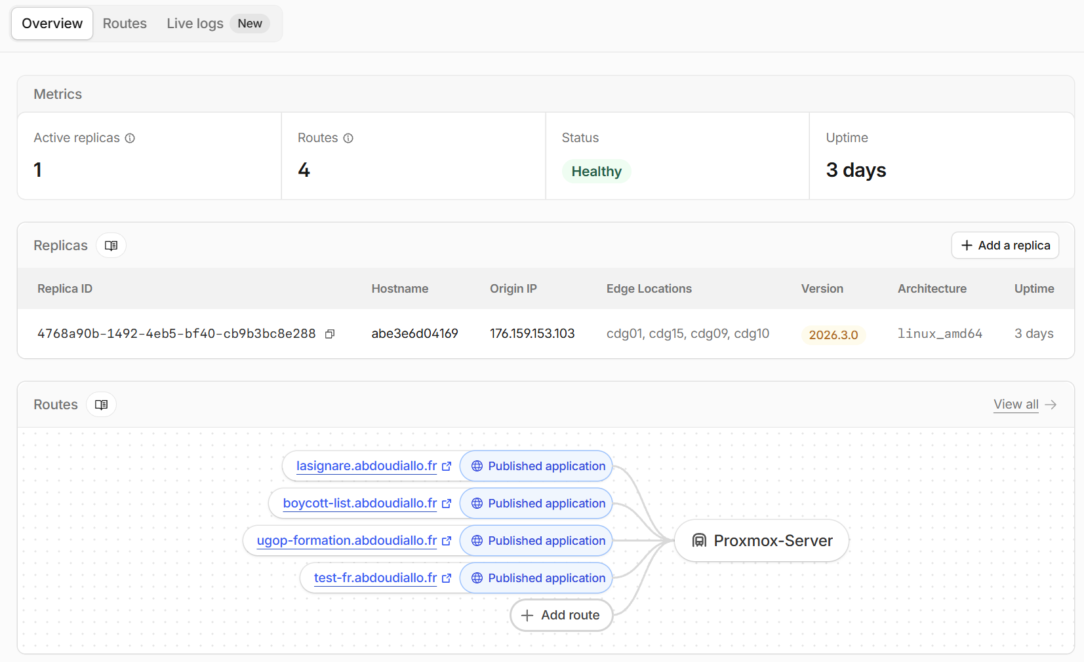
Every application of the tunnel appears as one published application, all pointing at the same reverse proxy.
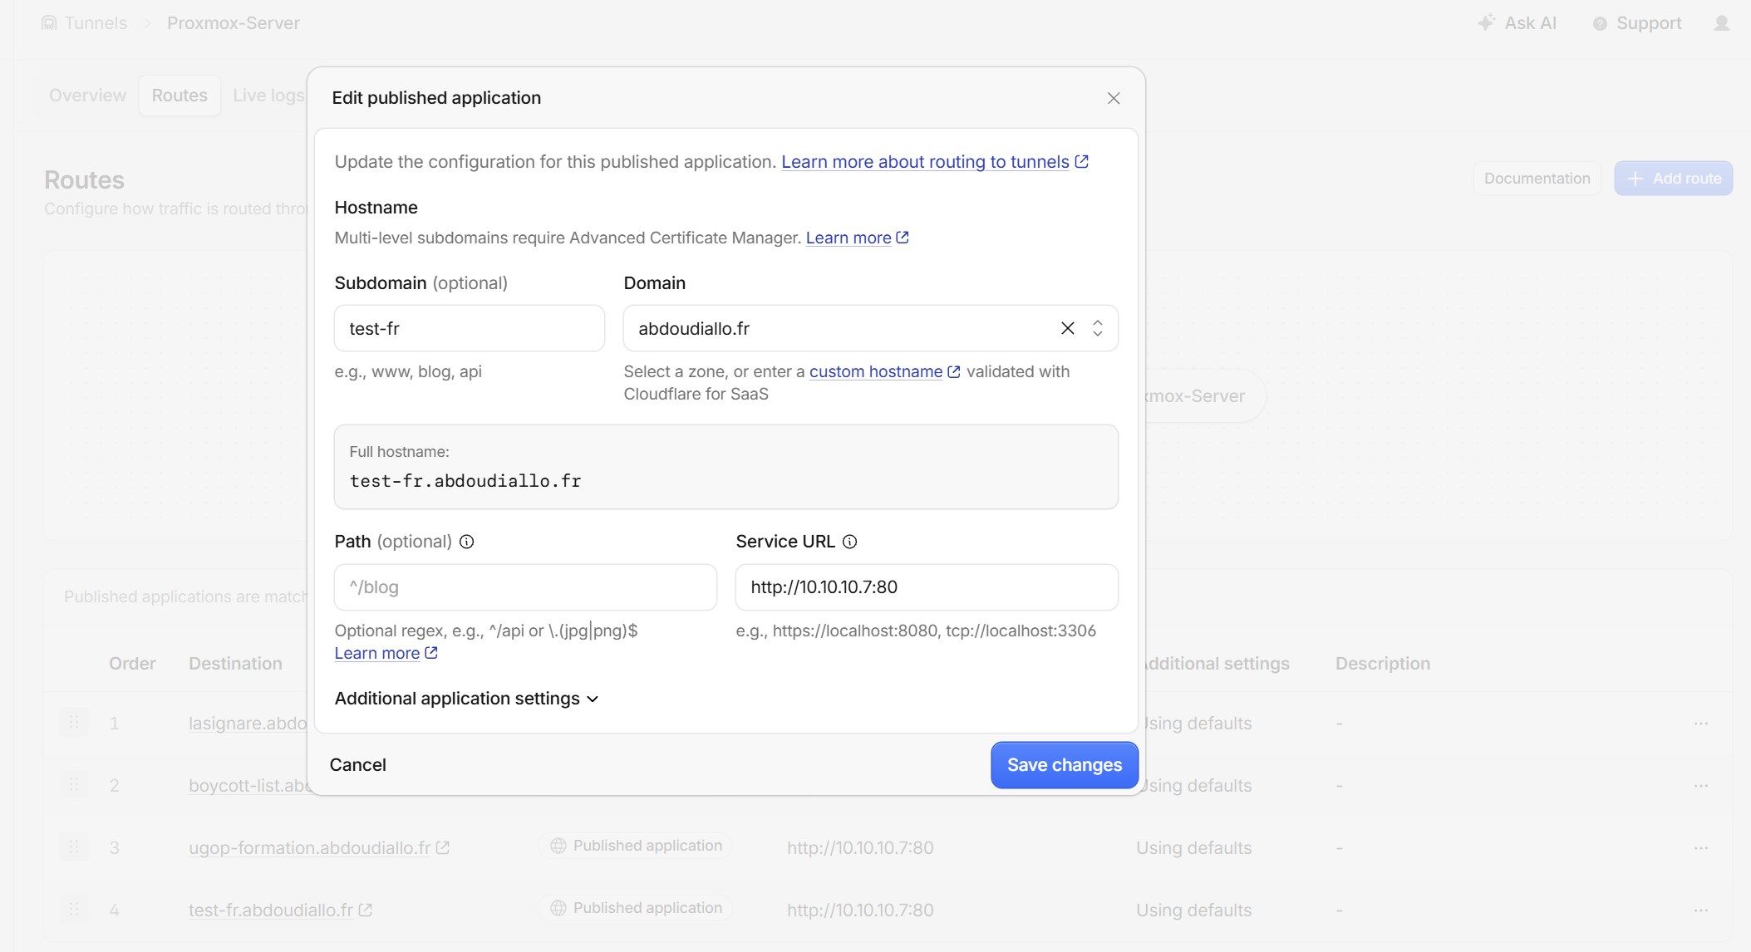
The route of this deployment: the public hostname in front of http://10.10.10.7:80.

5. Nginx Proxy Manager Proxy Host (one-time, the last step)
The reverse proxy is NPM. One Proxy Host per application — the same gesture as for lasignare, boycott-list and ugop-formation.
# admin UI on 10.10.10.7:81, through an SSH tunnel (note the port!)
ssh -p 2222 -L 81:10.10.10.7:81 root@192.168.1.55
# then browse http://localhost:81 and log in
Hosts → Proxy Hosts → Add Proxy Host, Details tab:
Field | Value
Domain Names | test-fr.abdoudiallo.fr
Scheme | http
Forward Hostname / IP | 10.10.10.109 (the convention: 10.10.10.<LXC_ID>)
Forward Port | 4200
Block Common Exploits | on
Websockets Support | off (static site)

Then the SSL tab: Request a new SSL certificate (Let's Encrypt — HTTP-01 passes through Cloudflare), Force SSL, HTTP/2, accept the terms, Save. Cloudflare stays on Full (strict): an NPM/Let's Encrypt certificate satisfies it.
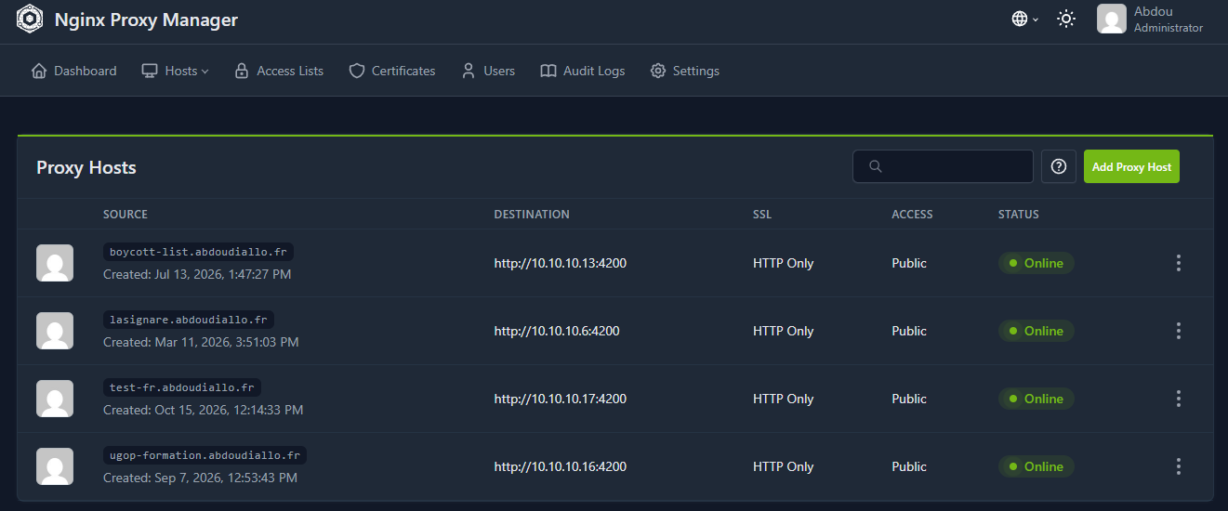
One Proxy Host per application — the same list that already carries lasignare, boycott-list and ugop-formation.
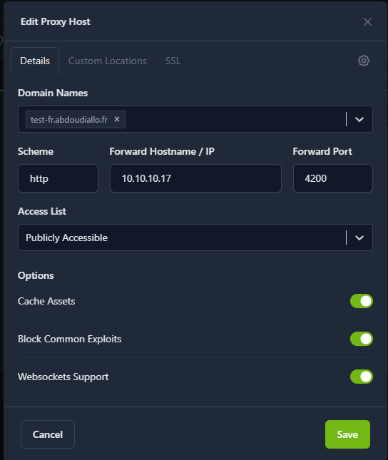
The Proxy Host of this deployment: scheme http, forward host 10.10.10.109, port 4200.
Note: If https://test-fr.abdoudiallo.fr shows NPM's "Congratulations!" page, the tunnel and DNS are correct — the Proxy Host is simply still missing. That is exactly where this deployment stood before this step.

6. Verification ladder
Check each layer instead of jumping straight to the browser:
# 1. inside the container (LXC 109)
pct enter 109
docker ps # healthy, 0.0.0.0:4200->8080
curl -I http://127.0.0.1:4200/healthz # HTTP/1.1 200 OK
docker inspect --format '{{index .Config.Labels "org.opencontainers.image.version"}}' prep-test-naturalisation:1.0.1

# 2. from the PC, over the LAN (bypasses proxy and Cloudflare)
curl -I http://10.10.10.109:4200/healthz
start http://10.10.10.109:4200

# 3. through the proxy, from the host (tests the NPM routing by Host header)
curl -I http://10.10.10.7/healthz -H 'Host: test-fr.abdoudiallo.fr'

# 4. through Cloudflare
curl -I https://test-fr.abdoudiallo.fr/healthz
# 5. what the server actually sends must be the new code. This is the check that
# catches an image that was never rebuilt, or a client-side cache. Filenames never
# change, so grep for a string just added or removed (here: the disclaimer
# block that was deleted) — 0 is the expected answer.
docker exec prep-test-naturalisation sh -c "wget -qO- http://127.0.0.1:8080/assets/js/views.js | grep -c non-officiel"
curl -s https://test-fr.abdoudiallo.fr/assets/js/views.js | grep -c non-officiel
# 6. is a CDN in front holding a stale copy? A brand-new browser never reaches the
# origin, so this is the layer that fools "it is still there in incognito".
curl -sI https://test-fr.abdoudiallo.fr/assets/js/views.js | grep -iE "cf-cache-status|^age:|cache-control"
# a cache-busting query is a NEW key for the CDN: it must fetch from the origin
curl -s "https://test-fr.abdoudiallo.fr/assets/js/views.js?bust=1" | grep -c non-officiel
Then in the browser on https://test-fr.abdoudiallo.fr:
- an Examen blanc starts (40 questions, 45:00 countdown);
- the console shows no CSP errors;
- the exports work — "Exporter ce bilan" (Markdown) and the JSON export in Statistiques (they use blob: URLs: the first thing to check if the CSP is tightened);
- reloading mid-session resumes the session (this also proves localStorage works on the new hostname).

7. Day-2 operations
New version
sh auto_deploy.sh --tag 1.0.2
Redeploys are safe by design: the port guard excludes this application's own container — it still publishes 4200 until it is recreated — and only aborts if a different container holds that port. (Verified: own container → proceeds, foreign container → aborts.)
Fast redeploy, without re-transferring the 21 MB archive — handy while iterating on the helper scripts, when the image is already inside the LXC:
scp -P 2222 deploy/deploy-inside-lxc.sh root@192.168.1.55:/opt/test-fr/
ssh -p 2222 root@192.168.1.55 "pct push 109 /opt/test-fr/deploy-inside-lxc.sh /opt/test-fr/deploy-inside-lxc.sh"
ssh -p 2222 root@192.168.1.55 "pct exec 109 -- env TAG=1.0.0 APP_PORT=4200 LXC_ID=109 REMOTE_DIR=/opt/test-fr sh /opt/test-fr/deploy-inside-lxc.sh"
Logs / restart / stop (inside the LXC)
pct enter 109
cd /opt/test-fr
docker compose -f docker-compose-prod.yml logs -f web
docker compose -f docker-compose-prod.yml restart
docker compose -f docker-compose-prod.yml down # stop and remove the container
docker compose -f docker-compose-prod.yml up -d # start it again
Rollback — the previous image stays loaded locally as long as it is not pruned:
cd /opt/test-fr
docker load -i prep-test-naturalisation-1.0.1.tar
TAG=1.0.1 docker compose -f docker-compose-prod.yml up -d
What to back up: nothing on the server. The application is stateless — users' progress lives in their browser's localStorage. Keep the repo (and, if they are used, the Cloudflare tunnel token and NPM configuration) elsewhere.
Files on the server
Proxmox host /opt/test-fr/ ← scp target
LXC 109 /opt/test-fr/ ← pct push target: archive + compose + scripts
prep-test-naturalisation-1.0.1.tar
docker-compose-prod.yml
deploy-lxc.sh deploy-inside-lxc.sh
Container /usr/share/nginx/html/ ← index.html, assets/, data/, robots.txt

8. Troubleshooting (the failures actually met)
Symptom | Cause | Fix
At step 5/6 nothing happens until ENTER is pressed | Windows' own ssh.exe (System32\OpenSSH) hides its password prompt when called from cmd.exe/cmder | the script already prefers Git's OpenSSH (/usr/bin/ssh); if it persists set SSH_BIN, or remove prompts for good with sh auto_deploy.sh --setup-key
'SSH_PORT' is not recognized as an internal or external command | VAR=value command typed in cmd.exe | use the script options (--ssh-port 2222), or set VAR=value && sh …
ssh: connect to host 192.168.1.55 port 22: Connection refused | sshd listens on 2222 (Port 2222 in sshd_config) | default is now 2222; otherwise sh auto_deploy.sh --ssh-port <port>
COPY index.html … ENOENT /app/index.html in the build | a test reads index.html, which was not copied into the build stage | already fixed (COPY index.html robots.txt ./); rerun the deploy
NPM's "Congratulations!" page | no Proxy Host for that hostname yet | §5
502 returned by NPM | Proxy Host exists but the upstream is not answering | docker ps in LXC 109; check port 4200 and the Forward Host 10.10.10.109
Port 4200 is already published in this LXC (LXC_ID=…) by another container | a different container holds the port, or the deploy targets the wrong LXC | sh auto_deploy.sh --lxc <id> if the LXC is wrong, else --port 8095
The same message names prep-test-naturalisation (this application's own container) and the deploy aborts | the deploy-inside-lxc.sh sitting in the LXC predates the guard fix | rerun sh auto_deploy.sh — the fixed script is re-pushed before it runs
container unhealthy | nginx did not start | docker logs prep-test-naturalisation
read-only file system | the compose read_only / tmpfs were modified | restore them from the repo
docker load: no such file | archive not transferred | rerun the deploy, check ls -lh /opt/test-fr
stale questions displayed | bundle not regenerated | rerun sh auto_deploy.sh (the build regenerates it)
A JS/CSS change does not show up after a deploy | the browser still holds the old file | code is now served with expires -1: a plain refresh is enough. If the tab was already open, Ctrl+F5 once
The deployed file is not the new code | a stale Docker build cache served an old layer — nothing errors | step 3/6 now compares the SHA of assets/js/views.js with the local file; rerun with --no-cache
The change is missing even in a fresh browser | Cloudflare's edge cache holds the old file — a new browser never reaches the origin | check cf-cache-status: HIT, then purge that URL in Cloudflare (Caching → Configuration → Purge Cache) and set Browser Cache TTL → Respect Existing Headers
CSP errors in the console | Cloudflare Rocket Loader rewriting <script> | disable it (Speed → Optimization)
Statistics not persisted | private browsing, or localStorage refused | expected: the app works without persistence

No SSH at all? Two fallbacks are documented in DEPLOY.md §11: scp straight to the LXC's own sshd, or serve the archive over HTTP from the PC (node tools/serve.mjs 8000) and pull it with curl from the Proxmox console.

9. Recipe for the next application
The pattern is reusable as-is (note: "for future webapps just add a proxy host"):
- Give the app a static container image that serves on port 8080 and exposes a /healthz endpoint. Validating the data and regenerating derived files inside docker build (as here) guarantees that an inconsistent artefact is never shipped.
- Create a dedicated LXC named after the subdomain (pct create … --hostname <subdomain> --features nesting=1,keyctl=1), install Docker.
- In the compose file, publish 4200:8080 — the port convention of all the applications — with restart: unless-stopped and a healthcheck.
- Add a Cloudflare route <subdomain> → http://10.10.10.7:80.
- Add an NPM Proxy Host: <subdomain>.abdoudiallo.fr → http://10.10.10.<LXC_ID>:4200, SSL tab with Let's Encrypt + Force SSL.

10. Reference

Command options and environment variables
Option | Env var | Default | Meaning
--check | CHECK_ONLY | no | checks docker + SSH, then stops
--tag <t> | TAG | 1.0.0 | image tag (archive name too)
--port <p> | APP_PORT | 4200 | port published in the LXC
--ssh-port <p> | SSH_PORT | 2222 | Proxmox SSH port
--lxc <id> | LXC_ID | 109 | target LXC
--host <u@h> | PROXMOX_HOST | root@192.168.1.55 | Proxmox host
--remote-dir <p> | REMOTE_DIR | /opt/test-fr | remote directory
--no-local-test | LOCAL_TEST | yes | skip the local container test
--setup-key | SETUP_KEY | no | installs the public key on the host, then stops
--no-cache | NO_CACHE | no | ignores the Docker build cache (fixes a stale layer)
--help | — | — | usage

The image
Item | Value
Base | nginxinc/nginx-unprivileged:1.27.5-alpine — uid 101, non-root
Internal port | 8080, published on 4200
Content | index.html, assets/, data/questions.data.js, robots.txt
Probe | GET /healthz → 200 ok
Headers | strict CSP, X-Content-Type-Options, X-Frame-Options, Referrer-Policy, Permissions-Policy
Caching | index.html + JS/CSS revalidate on every load (expires -1); images and fonts 30 days; question bank 1 hour
Hardening | read_only, cap_drop: ALL, no-new-privileges, tmpfs for /tmp, /var/cache/nginx, /var/run
Delivery | docker save → ≈ 21 MB .tar, docker load on the server
Build gate | bank validation + bundle regeneration, plus a /healthz smoke test of the built container

The application
- 204 multiple-choice questions written from the official Ministry of the Interior fiches and question lists (40 principes · 42 institutions · 40 droits · 42 histoire · 40 société).
- Official exam format implemented as-is: 40 questions, 28 knowledge + 12 situational, 45 minutes, pass at 32/40.
- Modes: mock exam, customised practice, review of mistakes, situational drill, express test. Per-theme statistics, resumable sessions, exports.
- 100 % static, no backend, no cookies, no tracking — user data stays in the browser's localStorage.
- Licence: code MIT; question content derived from formation-civique.interieur.gouv.fr under Etalab 2.0. Unofficial tool, not affiliated with the Ministry.

Repository map
prep-test-naturalisation/
├── auto_deploy.sh one-command deploy (options listed above)
├── DEPLOY.md shorter reference + no-SSH fallbacks
├── GUIDE.md this document
├── Dockerfile 2 stages: validate+build+test, then nginx non-root
├── docker-compose.yml local build & run (http://localhost:8080)
├── deploy/
│ ├── docker-compose-prod.yml the single production file (4200:8080)
│ ├── deploy-lxc.sh runs on the Proxmox host: pct push
│ ├── deploy-inside-lxc.sh runs inside the LXC: load + compose up + health gate
│ └── nginx/default.conf the container's own nginx config
├── assets/, data/, index.html the application
├── research/ provenance (official lists, sources, QA record)
└── tools/ validate, build bundle, local server

Part 2 — Generic playbook for future applications

Generic deployment guide — Proxmox / Cloudflare / Nginx Proxy Manager stack
A reusable playbook for deploying any containerised web application to dedicated infrastructure: build on Windows, ship a Docker image, run it in a dedicated LXC, and publish it on <subdomain>.abdoudiallo.fr.
Use it as a template: replace <app>, <subdomain>, <LXC_ID> and <tag> with the target values. Concrete defaults from the reference setup are given throughout — these are the values already deployed for boycott-list, lasignare, ugop-formation and test-fr.
Note: Reference implementation: the prep-test-naturalisation project. Its auto_deploy.sh, Dockerfile, deploy/ folder and GUIDE.md are a working example of everything below — copy them as the starting point for a new app.

1. What the playbook delivers
Goal | How
No registry, no CI, no Kubernetes | the image is built on Windows, docker saved to a .tar, copied by scp
One command to deploy | sh auto_deploy.sh (~2 min, cached build ~40 s)
Never ship a broken artefact | the data/asset validation runs inside docker build; the built container is smoke-tested before it travels
Nothing open on the router | Cloudflare Tunnel (the existing Proxmox-Server tunnel)
One reverse proxy for everything | Nginx Proxy Manager on 10.10.10.7, one Proxy Host per app
Boring, repeatable operations | image tags, docker load, compose down/up, a health gate, a documented rollback

2. The pipeline
Windows (cmdr) Proxmox host 192.168.1.55 (ssh :2222) LXC <LXC_ID>
────────────── ────────────────────────────────── ────────────
auto_deploy.sh
1 docker build (tests inside)
2 docker run + /healthz (local smoke test)
3 docker save → dist/<app>-<tag>.tar
4 scp ───────────────────────────► /opt/<app>/
5 ssh ────────────────────────────► deploy-lxc.sh
└─ pct push ─────────────────────────► /opt/<app>/
docker load
compose up -d
◄──── health = healthy ───────────────────── /healthz
Cloudflare (tunnel Proxmox-Server) ──► http://10.10.10.7:80 (Nginx Proxy Manager)
└─ Proxy Host <subdomain> → 10.10.10.<LXC_ID>:4200
Two network paths reach the app: public (Cloudflare → NPM → 10.10.10.<LXC_ID>:4200) and local (http://10.10.10.<LXC_ID>:4200 from any machine on the LAN).

3. Conventions (defaults of the infrastructure)
Item | Value | Why
Proxmox host | root@192.168.1.55, SSH port 2222 | the sshd listens on 2222, not on 22; use -p 2222 everywhere
LXC naming | one LXC per app, --hostname <subdomain> | matches NPM's routing and reads well in the Proxmox tree
LXC requirements | features: nesting=1,keyctl=1 | Docker inside an LXC
App directory | /opt/<app> | on the host and inside the LXC (same path)
Container port | 8080 internal, published as 4200 | 4200 is the convention for every app
LXC IP convention | 10.10.10.<LXC_ID> | e.g. LXC 109 → 10.10.10.109; older containers may not follow this convention, new ones will — always check with hostname -I; the past apps dont match the LXC_ID to the id in the ip adress but the first apps will
Reverse proxy | Nginx Proxy Manager on 10.10.10.7 | proxy :80, admin UI :81
Tunnel | Cloudflare Proxmox-Server | every route → http://10.10.10.7:80
Windows shell | cmder, default tab = cmd.exe | VAR=value command does not work there — use script options, or set VAR=value && …
Delivery | docker save → scp → pct push → docker load | no registry credentials, works offline

4. The four artefacts every project needs

4.1 Dockerfile — static site, two stages
# syntax=docker/dockerfile:1.7

# Stage 1: run the checks INSIDE the image build. A failing test or an invalid
# data file aborts the build, so a broken artefact can never be shipped.
FROM node:22-alpine AS build
WORKDIR /app
COPY package.json ./
COPY data data
COPY assets assets
COPY tools tools
COPY index.html robots.txt ./
RUN node tools/validate-questions.mjs \
&& node tools/build-data.mjs

# Stage 2: non-root nginx serving the result on 8080
FROM nginxinc/nginx-unprivileged:1.27.5-alpine AS runtime
ARG VERSION=1.0.0
LABEL org.opencontainers.image.version="${VERSION}"
COPY deploy/nginx/default.conf /etc/nginx/conf.d/default.conf
COPY index.html /usr/share/nginx/html/index.html
COPY assets /usr/share/nginx/html/assets
COPY --from=build /app/data/questions.data.js /usr/share/nginx/html/data/questions.data.js
EXPOSE 8080
HEALTHCHECK --interval=30s --timeout=3s --start-period=5s --retries=3 \
CMD wget -qO- http://127.0.0.1:8080/healthz >/dev/null 2>&1 || exit 1
CMD ["nginx", "-g", "daemon off;"]
Rules that matter: pin the base image; expose only /healthz; serve on 8080 as a non-root user; copy exactly what is served (nothing else); run the checks in stage 1 — for a static site, validating the source data and rebuilding the derived bundle is usually enough. Keep tests fast if any are added: they run on every build.

4.2 deploy/docker-compose-prod.yml — the single production file
name: <app>

services:
web:
image: <app>:${TAG:-1.0.0}
container_name: <app>
restart: unless-stopped
ports:
- "${APP_PORT:-4200}:8080"
read_only: true
tmpfs:
- /tmp:size=16m,mode=1777
- /var/cache/nginx:size=16m
- /var/run:size=1m
cap_drop: [ALL]
security_opt: ["no-new-privileges:true"]
healthcheck:
test: ["CMD", "wget", "-qO-", "http://127.0.0.1:8080/healthz"]
interval: 30s
timeout: 3s
start_period: 5s
retries: 3
logging:
driver: json-file
options: { max-size: "10m", max-file: "3" }
No build:, no volumes, no env_file unless the app really needs one. read_only plus cap_drop: ALL is free hardening for a static site — keep the tmpfs list, nginx needs to write there.

4.3 auto_deploy.sh — the one command
Requirements, in this order:
- Options, not env prefixes (cmd.exe cannot do VAR=value command): --check, --tag, --port, --ssh-port, --lxc, --host, --remote-dir, --no-local-test, --help. Keep env-var fallbacks for Git Bash/PowerShell. Add --setup-key (installs the public key once, then no prompts) and use an explicit SSH/SCP binary: prefer Git's MSYS OpenSSH to Windows' own System32\OpenSSH\ssh.exe, which can hide its password prompt until ENTER is pressed when the script runs under cmd.exe/cmder.
- Pre-flight probe of the SSH port, without a password — fail in one second rather than after a two-minute build:
PROBE=$(ssh -p "$SSH_PORT" -o ConnectTimeout=8 -o BatchMode=yes \
-o PreferredAuthentications=none "$PROXMOX_HOST" true 2>&1 || true)
case "$PROBE" in
*"Permission denied"*) echo "SSH reachable on port $SSH_PORT" ;;
*) echo "SSH unreachable — see --ssh-port/--host" >&2; exit 1 ;;
esac
- docker build with the tag.
- Local smoke test: docker run -d --rm -p 127.0.0.1:18080:8080 <image>, poll /healthz, check the served payload size, then docker rm -f.
- Verify that the built image really contains the current source — while it is up, and compare the SHA of a served file with the local one. A stale build cache serves an old file with no error at all, so this check is what makes it visible. Offer a --no-cache option for when it fires.
- docker save -o dist/<app>-<tag>.tar <image>.
- ssh … "mkdir -p '<dir>'" then a single scp of the archive + compose + scripts.
- ssh … "LXC_ID=… TAG=… APP_PORT=… sh <dir>/deploy-lxc.sh".
- Print a summary: image, archive, LXC, port, public URL, log/stop commands.

4.4 deploy/deploy-lxc.sh + deploy/deploy-inside-lxc.sh
Split the remote work in two, so each part is small and re-runnable:
- deploy-lxc.sh runs on the Proxmox host: verify pct status <LXC_ID> is running (start it if not), pct exec … mkdir -p <dir>, pct push the archive + compose + the inner script, then pct exec <LXC_ID> -- env TAG=… APP_PORT=… REMOTE_DIR=… sh <dir>/deploy-inside-lxc.sh.
- deploy-inside-lxc.sh runs inside the LXC: detect docker compose vs docker-compose; refuse if APP_PORT is already published by another container — exclude the container itself by name, otherwise every redeploy aborts on the port it publishes itself; message naming both fixes (wrong LXC vs port taken); compose down; the docker load; compose up -d; poll docker inspect --format '{{.State.Health.Status}}' up to 30×2 s; on failure print the last 60 log lines and exit 1; finally docker image prune -f.

4.5 Repository layout to copy
<app>/
├── auto_deploy.sh one-command deploy
├── Dockerfile
├── docker-compose.yml local build (http://localhost:8080)
├── GUIDE.md / DEPLOY.md docs
├── deploy/
│ ├── docker-compose-prod.yml deployed as-is
│ ├── deploy-lxc.sh on the Proxmox host
│ ├── deploy-inside-lxc.sh inside the LXC
│ └── nginx/default.conf the container's nginx (8080, headers, /healthz)
│ serve JS/CSS with `expires -1`: filenames never change,
│ so a long cache keeps visitors on a stale file
└── <app sources>

5. One-time setup for a new app
The starting point is the Template LXC: a container whose only content is setup_dev_env.sh — the provisioning script that installs the shared toolchain (Git, Python, build tools, Java + Maven, Node LTS + Angular CLI, Docker Engine with the compose plugin, MongoDB). A new application is a clone of that template with its own hostname, resources and address; nothing is created from scratch.
1. Clone the template and give the clone its identity
# via the Proxmox UI: right-click the Template container → Clone → Full clone
# or on the host:
pct clone <template-id> <LXC_ID> --hostname <subdomain> --full --storage local-lvm
pct set <LXC_ID> --cores 2 --memory 2048 # per app: what it actually needs
pct set <LXC_ID> --net0 name=eth0,bridge=vmbr0,ip=10.10.10.<LXC_ID>/24,gw=10.10.10.1
pct set <LXC_ID> --onboot 1
pct start <LXC_ID>
The network device of a clone: bridge vmbr0, static address 10.10.10.<LXC_ID>/24, gateway 10.10.10.1. That convention is what lets a Proxy Host address any application as 10.10.10.<LXC_ID>:4200 without further bookkeeping.
2. Provision it (only when the template has not been provisioned yet)
pct exec <LXC_ID> -- bash -c "cd /root && chmod +x setup_dev_env.sh && ./setup_dev_env.sh"
pct exec <LXC_ID> -- docker version --format '{{.Server.Version}}'
pct exec <LXC_ID> -- hostname -I # expect 10.10.10.<LXC_ID>
The script is reproduced in full in Appendix B; extend its package list when an application needs something it does not install.
3. Cloudflare route — Zero Trust → Networks → Tunnels → Proxmox-Server → Add route → Published application: subdomain <subdomain>, domain abdoudiallo.fr, service URL http://10.10.10.7:80 (identical to every other route). Cloudflare creates the DNS CNAME itself — never add an A record for that hostname.
Cloudflare: the published-application routes of the Proxmox-Server tunnel
Cloudflare: the route of one application, pointing at the reverse proxy
4. Nginx Proxy Manager — admin UI on 10.10.10.7:81, reached through a tunnel (ssh -p 2222 -L 81:10.10.10.7:81 root@<proxmox-host>) → Hosts → Proxy Hosts → Add Proxy Host:
Field | Value
Domain Names | <subdomain>.abdoudiallo.fr
Scheme | http
Forward Hostname / IP | 10.10.10.<LXC_ID>
Forward Port | 4200
Block Common Exploits | on
Websockets Support | off unless the app needs it

SSL tab: Request a new SSL certificate (Let's Encrypt; HTTP-01 passes through Cloudflare), Force SSL, HTTP/2, accept the terms, Save. Cloudflare stays on Full (strict) — an NPM/Let's Encrypt certificate satisfies it.
COMMANDS ::
# COMMANDS TO CHECK THE SSH PORT
ss -tlnp | grep sshd
grep -iE '^Port' /etc/ssh/sshd_config /etc/ssh/sshd_config.d/* 2>/dev/null
systemctl status ssh --no-pager
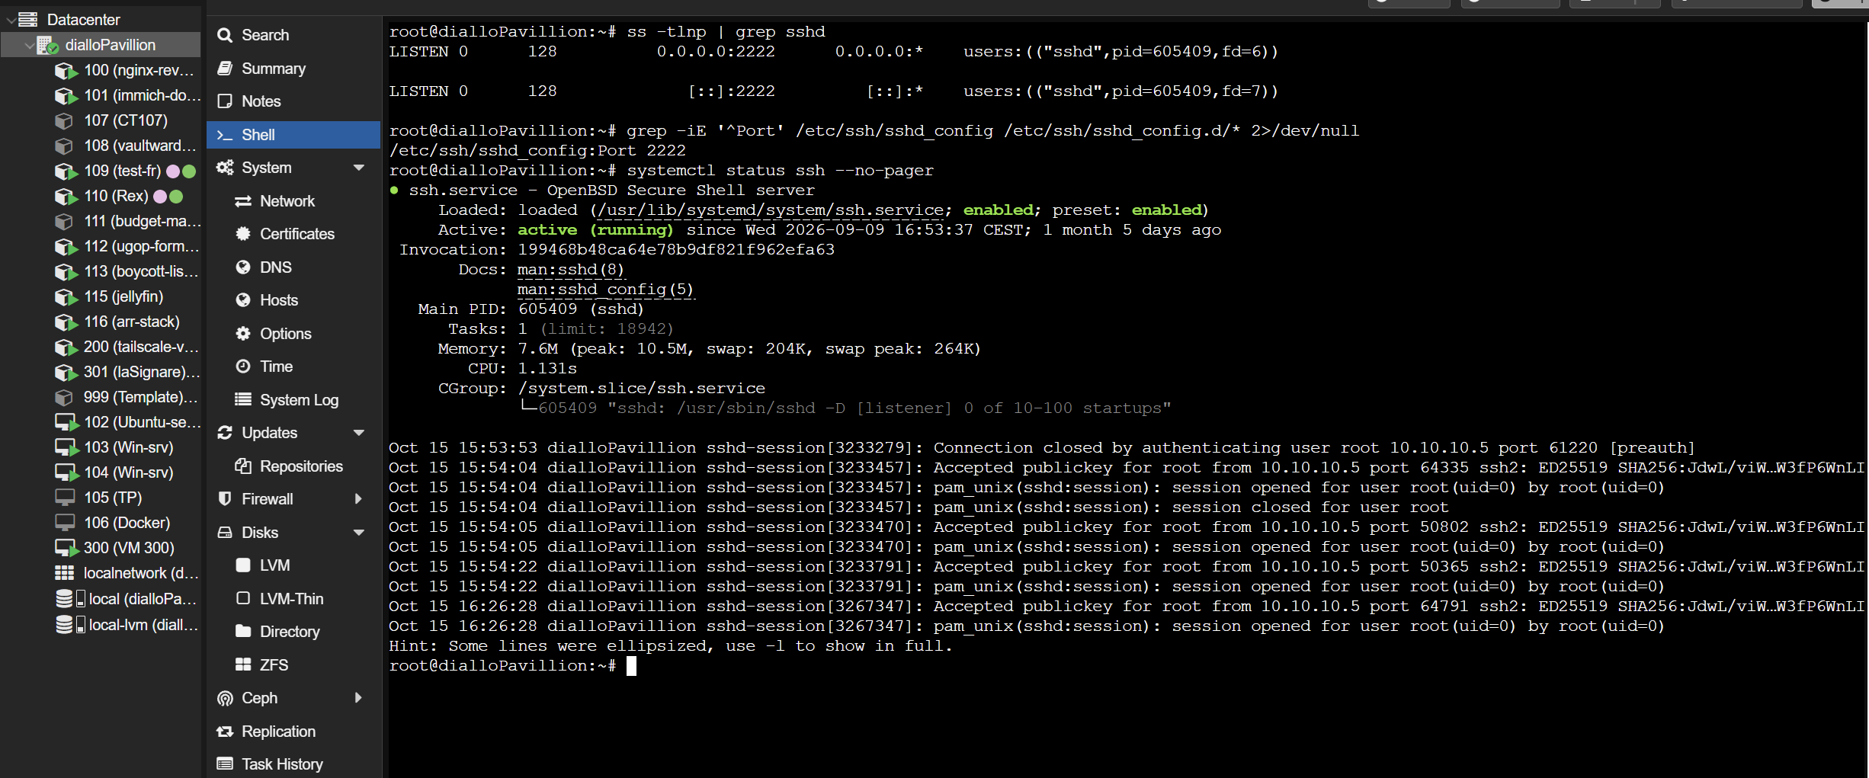
Proxmox: locating the SSH port of the host — the value that the deploy scripts need as --ssh-port / -p, since this infrastructure listens on 2222 rather than 22.
Nginx Proxy Manager: the host list, one Proxy Host per application
Nginx Proxy Manager: the Proxy Host of a single application
5. Optional hygiene — Cloudflare Speed → Optimization: disable Rocket Loader for the hostname (it rewrites <script> tags and breaks strict CSP setups).

6. Deploy, update, rollback
# deploy / update (from the project root, cmder)
sh auto_deploy.sh # current tag
sh auto_deploy.sh --tag 1.1.0 # first deployment of a new version
sh auto_deploy.sh --check # docker + SSH only, no build
sh auto_deploy.sh --port 8095 # if 4200 is already used in that LXC
sh auto_deploy.sh --lxc 120 --tag 1.1.0 # another app/LXC

# logs, restart, stop (inside the LXC)
pct enter <LXC_ID>
cd /opt/<app>
docker compose -f docker-compose-prod.yml logs -f web
docker compose -f docker-compose-prod.yml restart
docker compose -f docker-compose-prod.yml down
docker compose -f docker-compose-prod.yml up -d

# rollback: the previous image is still loaded locally
docker load -i <app>-<previous-tag>.tar
TAG=<previous-tag> docker compose -f docker-compose-prod.yml up -d
Redeploys are safe by design: the in-LXC script excludes the container itself from the port check — it still publishes the port until it is recreated — and aborts only when a different container holds it.
Fast redeploy, without re-transferring the archive (the image is already in the LXC):
scp -P 2222 deploy/deploy-inside-lxc.sh root@192.168.1.55:/opt/<app>/
ssh -p 2222 root@192.168.1.55 "pct push <LXC_ID> /opt/<app>/deploy-inside-lxc.sh /opt/<app>/deploy-inside-lxc.sh"
ssh -p 2222 root@192.168.1.55 "pct exec <LXC_ID> -- env TAG=<tag> APP_PORT=4200 LXC_ID=<LXC_ID> REMOTE_DIR=/opt/<app> sh /opt/<app>/deploy-inside-lxc.sh"
If no keys are set up yet: ssh-keygen -t ed25519 then ssh-copy-id -p 2222 root@192.168.1.55 — after that the deploy is password-free, or use sh auto_deploy.sh --setup-key once.

7. Verification ladder
Always climb it in order; the layer that fails indicates where the problem is.
# 1. container (inside the LXC)
docker ps # healthy, 0.0.0.0:4200->8080
curl -I http://127.0.0.1:4200/healthz # 200 OK
docker inspect --format '{{index .Config.Labels "org.opencontainers.image.version"}}' <app>:<tag>

# 2. LAN, from a workstation (bypasses proxy and Cloudflare)
curl -I http://10.10.10.<LXC_ID>:4200/healthz
start http://10.10.10.<LXC_ID>:4200

# 3. through the reverse proxy, from the Proxmox host (tests NPM routing)
curl -I http://10.10.10.7/healthz -H 'Host: <subdomain>.abdoudiallo.fr'

# 4. public
curl -I https://<subdomain>.abdoudiallo.fr/healthz
# 5. what the server actually sends must be the new code. Filenames never change
# between releases, so this is the check that catches an image that was not
# rebuilt, or a client-side cache. Grep for a string just added or removed.
docker exec <app> sh -c "wget -qO- http://127.0.0.1:8080/assets/js/app.js | grep -c '<string>'"
curl -s https://<subdomain>.abdoudiallo.fr/assets/js/app.js | grep -c '<string>'
# 6. is a CDN (Cloudflare) in front holding a stale copy? A brand-new browser never
# reaches the origin, so this is the layer that fools "it is still there in a
# fresh browser". A cache-busting query is a new key, forcing an origin fetch.
curl -sI https://<subdomain>.abdoudiallo.fr/assets/js/app.js | grep -iE "cf-cache-status|^age:|cache-control"
curl -s "https://<subdomain>.abdoudiallo.fr/assets/js/app.js?bust=1" | grep -c '<string>'
Application-level checks in the browser: the main screen loads, a full workflow runs, the developer console shows no CSP errors, and (if the app stores data locally) reloading keeps state — that also proves localStorage works on the new hostname.

8. Troubleshooting
Symptom | Cause | Fix
The deploy stalls at the transfer step until ENTER is pressed | Windows' own ssh.exe hides its password prompt under cmd.exe/cmder | prefer Git's OpenSSH (/usr/bin/ssh), set SSH_BIN, or add --setup-key so there is no prompt at all
'VAR' is not recognized as an internal or external command | VAR=value command was typed in cmd.exe | use the script options, or set VAR=value && sh …
ssh: connect to host … port 22: Connection refused | sshd listens on 2222 | --ssh-port 2222 (default in the template); check with ss -tlnp | grep sshd on the host
Permission denied (publickey,password) in --check | normal: the probe tests the port, not authentication | nothing to fix; the real deploy will ask for the password
COPY … ENOENT during the build | a test reads a file the build stage never copied | add it to the COPY list in stage 1
container unhealthy | the server inside did not start | docker logs <app>
read-only file system | read_only/tmpfs were modified | restore them from the repo
Port 4200 is already published in this LXC **by another container** | a different container holds the port, or the wrong LXC is targeted | --lxc <id>, or --port 8095 (and match it in the Proxy Host)
On a redeploy, that message names the container itself | the helper script inside the LXC predates the guard fix | redeploy: the script is re-pushed before it runs
NPM's "Congratulations!" page | no Proxy Host for that hostname | add one (§5)
502 from NPM | Proxy Host exists, upstream down | docker ps in the LXC; check port 4200 and the Forward Host
CSP errors after deploying | Cloudflare Rocket Loader rewriting <script> | disable it
stale content served | the image was not rebuilt | redeploy (the build regenerates the assets)
A JS/CSS change does not show up after a deploy | the browser holds the old file: filenames never change, so a long cache on code is a trap | serve code with expires -1 (revalidate); a plain refresh then suffices
The served file is not the one just changed, and the deploy reported success | a stale Docker build cache reused an old layer — no error anywhere | compare the SHA of a served file with the local one during the smoke test, and rebuild with --no-cache
The change is missing even in a fresh browser | a CDN in front (Cloudflare) holds the old file at its edge — a new browser never reaches the origin | look for cf-cache-status: HIT, purge that URL on abdoudiallo.fr Cache -> Configuration -> Purge Cache -> Custom Purge -> URL -> input the url // and set the zone's Browser Cache TTL to Respect Existing Headers
Knowing what a built image really contains | Docker is the only obvious way to look inside | unpack the saved archive instead: docker save produces an OCI tar whose layers can be read with any tar reader (see the project's inspect-image.py)
docker load: no such file | archive not transferred | rerun the deploy, check ls -lh /opt/<app>
Docker-in-LXC permission denied on /var/lib/docker | missing nesting=1,keyctl=1 | add to /etc/pve/lxc/<id>.conf, pct reboot <id>

No SSH available? Two fallbacks: scp straight to the LXC's own sshd (docker load
- compose up from there), or serve the archive over HTTP from a local machine (node tools/serve.mjs 8000) and pull it with curl from the Proxmox web console.

9. Daily cheat sheet (previous habits → the new ones)
Old habit (boycott-list) | Now
chmod +x auto_deploy.sh && ./auto_deploy.sh | same, or sh auto_deploy.sh
docker build + docker save frontend.tar + scp | steps 1, 3, 4 of auto_deploy.sh
one pct push per file | deploy-lxc.sh pushes them all
docker load -i frontend.tar | step 6/6
docker compose -f docker-compose-prod.yml up -d frontend | automated, plus a health gate
docker ps / docker logs frontend_boycott_list | docker ps / docker logs <app>
--force-recreate after a broken state | rerun the deploy (it does down then up -d)
editing .env on the Proxmox web console | not needed: auto_deploy.sh passes TAG/APP_PORT as environment variables

10. Why these choices (so they can be changed knowingly)
- One LXC per app — isolation, independent restarts, and each app gets a stable 10.10.10.<id> address that the proxy targets. Cost: one container's overhead.
- Port 4200 everywhere — a single convention means the NPM Proxy Host is always 10.10.10.<LXC_ID> + 4200; no per-app port bookkeeping. Change one app only if the port is already taken in that LXC.
- No registry — docker save/load needs no credentials, works on an isolated LAN, and the archive is a few tens of MB. A registry becomes worthwhile when a second host or a CI runner appears.
- Tests inside docker build — the image is the release artefact; if it builds, the checks passed. That is what makes a one-command deploy safe without CI.
- Non-root, read-only, no capabilities — a static site needs none of them, and it removes whole classes of container escape.
- Cloudflare Tunnel — no ports open on the router, no certificate on the origin, and the public IP stays private. NPM still provides per-host certificates for the internal path.

11. New app checklist (20 minutes)
- [ ] pct create <ID> … --hostname <subdomain> --features nesting=1,keyctl=1, start it, install Docker
- [ ] Copy Dockerfile, deploy/, auto_deploy.sh from the reference project; rename <app> / ports
- [ ] sh auto_deploy.sh --lxc <ID> --check → SSH reachable
- [ ] sh auto_deploy.sh --lxc <ID> --tag 1.0.0 → container healthy
- [ ] Verify layer 2 (http://10.10.10.<ID>:4200/healthz)
- [ ] Cloudflare: add the route → http://10.10.10.7:80
- [ ] NPM: add the Proxy Host → 10.10.10.<ID>:4200, SSL tab with Let's Encrypt + Force SSL
- [ ] Verify layers 3 and 4, then the app in the browser (console clean, no CSP errors)
- [ ] Redeploy once with a new tag (sh auto_deploy.sh --tag 1.0.1) to prove the update path
- [ ] Write the app's own GUIDE.md from this template, with its specifics

12. Full-stack variant: Angular + Spring Boot/Quarkus + PostgreSQL
The static-site pattern of the preceding sections is the simple case. A full-stack application adds a database and a second container, and the reverse proxy only ever talks to the frontend — the API and the database stay on an internal network.

12.1 Angular (SSR) image
FROM node:22-alpine AS build
WORKDIR /app

# Increase memory for the Angular build
ENV NODE_OPTIONS="--max-old-space-size=8192"

COPY package*.json ./
RUN npm ci
COPY . .
RUN npm run build

# Stage 2: Run the Angular SSR server
FROM node:22-alpine
WORKDIR /app
COPY --from=build /app/dist ./dist

ENV HOST=0.0.0.0
ENV PORT=4200
ENV NODE_OPTIONS="--max-old-space-size=4096"

EXPOSE 4200

ENTRYPOINT ["node", "--max-old-space-size=4096", "dist/frontend/server/server.mjs"]
Three decisions carry the whole file: npm ci (not install) reproduces the build from package-lock.json; the build stage is given 8 GB of heap so a large Angular compilation does not run out of memory; the runtime keeps the SSR server on 4200, the port the Proxy Host of §5 expects.

12.2 Spring Boot image
# Stage 1: Build with Maven + JDK 25
FROM maven:3.9-eclipse-temurin-25 AS build
WORKDIR /app

# Maven is already installed – do NOT install it again

COPY pom.xml .
RUN mvn dependency:go-offline -B

COPY src ./src
RUN mvn clean package -DskipTests

# Stage 2: Run with JDK (instead of JRE, to use local image)
FROM eclipse-temurin:25-jdk
WORKDIR /app
COPY --from=build /app/target/backend-0.0.1-SNAPSHOT.jar app.jar

EXPOSE 8080
ENTRYPOINT ["java", "-Djava.security.egd=file:/dev/./urandom", "-jar", "app.jar"]
pom.xml is copied before src/ on purpose: dependency:go-offline then sits in its own layer, so the Maven repository is downloaded once and only a source change triggers a real rebuild. Tests are skipped in the image because a release pipeline or the developer machine already ran them — drop -DskipTests if the image itself must be the release gate.

12.3 Quarkus variant
# Stage 1: build the Quarkus application
FROM maven:3.9-eclipse-temurin-25 AS build
WORKDIR /app

COPY pom.xml .
RUN mvn -B dependency:go-offline

COPY src ./src
RUN mvn -B clean package -DskipTests -Dquarkus.package.jar.type=fast-jar

# Stage 2: run the fast-jar layout
FROM eclipse-temurin:25-jdk
WORKDIR /app
COPY --from=build /app/target/quarkus-app /app/quarkus-app

EXPOSE 8080
ENTRYPOINT ["java", "-jar", "/app/quarkus-app/quarkus-run.jar"]
A Quarkus fast-jar is a directory (quarkus-run.jar plus lib/, app/ and quarkus/), so the whole quarkus-app tree is copied rather than a single jar. For a native binary, build with -Dnative on a quay.io/quarkus/ubi-quarkus-native-image stage and copy the resulting executable — the port convention and the Proxy Host rules do not change.

12.4 docker-compose-prod.yml for the stack
services:
postgres:
image: postgres:18-alpine
restart: unless-stopped
env_file:
- .env
environment:
POSTGRES_DB: ${DB_NAME}
POSTGRES_USER: ${DB_USERNAME}
POSTGRES_PASSWORD: ${DB_PASSWORD}
volumes:
- pg-data:/var/lib/postgresql
healthcheck:
test: ["CMD-SHELL", "pg_isready -U ${DB_USERNAME} -d ${DB_NAME}"]
interval: 5s
timeout: 5s
retries: 5
networks:
- internal-app-network

backend:
image: boycott-list-backend:latest
restart: unless-stopped
container_name: backend_boycott_list
ports:
- "8080:8080"
volumes:
- ./backups:/backups
depends_on:
postgres:
condition: service_healthy
env_file:
- .env
environment:
- SPRING_PROFILES_ACTIVE=dev
- SPRING_DATASOURCE_URL=jdbc:postgresql://postgres:5432/${DB_NAME}
- SPRING_DATASOURCE_USERNAME=${DB_USERNAME}
- SPRING_DATASOURCE_PASSWORD=${DB_PASSWORD}
- SPRING_JPA_HIBERNATE_DDL_AUTO=update
- SPRING_JPA_DATABASE_PLATFORM=org.hibernate.dialect.PostgreSQLDialect
# Notification vars
- DISCORD_WEBHOOK_URL=${DISCORD_WEBHOOK_URL}
- NOTIFICATION_EMAIL_TO=${NOTIFICATION_EMAIL_TO}
- NOTIFICATION_EMAIL_ENABLED=true
- SPRING_MAIL_HOST=${SPRING_MAIL_HOST}
- SPRING_MAIL_PORT=${SPRING_MAIL_PORT}
- SPRING_MAIL_USERNAME=${SPRING_MAIL_USERNAME}
- SPRING_MAIL_PASSWORD=${SPRING_MAIL_PASSWORD}
- SPRING_MAIL_PROPERTIES_MAIL_SMTP_AUTH=${SPRING_MAIL_PROPERTIES_MAIL_SMTP_AUTH}
- SPRING_MAIL_PROPERTIES_MAIL_SMTP_STARTTLS_ENABLE=${SPRING_MAIL_PROPERTIES_MAIL_SMTP_STARTTLS_ENABLE}
networks:
- internal-app-network
- proxy-network

frontend:
image: boycott-list-frontend:latest
restart: unless-stopped
container_name: frontend_boycott_list
ports:
- "4200:4200"
networks:
- proxy-network
- internal-app-network

networks:
proxy-network:
external: true
internal-app-network:
driver: bridge

volumes:
pg-data:
What each decision buys:
Element | Effect
proxy-network declared external | compose attaches to the network the reverse proxy already uses instead of creating its own
only frontend joins proxy-network | one published entry point; the API and the database are reachable only inside internal-app-network
backend publishes 8080 | convenient for LAN debugging; the ports: block can be removed when the API must stay private
depends_on: condition: service_healthy | the API starts only after pg_isready succeeds, which removes the usual boot-time connection errors
env_file: .env and ${…} interpolation | credentials and mail settings stay out of the compose file; .env must never be committed
named volume pg-data | the database survives compose down and recreation, unlike an anonymous volume
bind-mounted ./backups | a predictable place on the LXC for dumps
restart: unless-stopped on all three services | the stack returns by itself after a reboot of the container or the host

12.5 Shipping a multi-image stack
auto_deploy.sh (Appendix A) saves a single image. A stack needs every image in one archive, and the health gate must watch the container that serves traffic:
docker build -t <app>-backend:${TAG} -t <app>-backend:latest ./backend
docker build -t <app>-frontend:${TAG} -t <app>-frontend:latest ./frontend
docker save -o dist/<app>-${TAG}.tar <app>-backend:${TAG} <app>-frontend:${TAG}
Inside the LXC, one docker load -i dist/<app>-${TAG}.tar imports both images, then TAG=${TAG} docker compose -f docker-compose-prod.yml up -d starts the three services. Poll the frontend for the health gate and, when the API exposes one, its health endpoint too: a stack whose database or API is unhealthy must fail the deployment rather than be reported as successful.
The Proxy Host is unchanged from §5 — <subdomain>.abdoudiallo.fr → 10.10.10.<LXC_ID>:4200 — because the SSR server is the only component the reverse proxy needs to reach.

12.6 The full-stack deploy script in use
A real example, for a two-image stack (boycott-list, deployed to LXC 113): two images, one compose file, three services. It is the multi-image counterpart of Appendix A.
#!/bin/bash
set -e # stop on any error

# ------------------------------------------------------------------
# CONFIGURATION
# ------------------------------------------------------------------
PROXMOX_HOST="root@192.168.1.55"
LXC_ID="113"
REMOTE_DIR="/opt/boycott-list"

# ------------------------------------------------------------------
# Step 1: Build & transfer frontend image
# ------------------------------------------------------------------
echo "🛠 Building frontend image..."
cd frontend
docker build -t boycott-list-frontend:latest .
docker save boycott-list-frontend:latest -o frontend.tar
echo "📤 Uploading frontend.tar to Proxmox host..."
scp frontend.tar ${PROXMOX_HOST}:${REMOTE_DIR}/
cd ..

# ------------------------------------------------------------------
# Step 2: Build & transfer backend image
# ------------------------------------------------------------------
echo "🛠 Building backend image..."
cd backend
docker build -t boycott-list-backend:latest .
docker save boycott-list-backend:latest -o backend.tar
echo "📤 Uploading backend.tar to Proxmox host..."
scp backend.tar ${PROXMOX_HOST}:${REMOTE_DIR}/
cd ..

# ------------------------------------------------------------------
# Step 3: Copy Docker Compose files
# ------------------------------------------------------------------
echo "📄 Copying docker-compose files..."
scp docker-compose-prod.yml ${PROXMOX_HOST}:${REMOTE_DIR}/

# ------------------------------------------------------------------
# Step 4: Push files from Proxmox host to LXC container
# ------------------------------------------------------------------
echo "🚚 Pushing files into LXC ${LXC_ID}..."
ssh ${PROXMOX_HOST} <<EOF
pct push ${LXC_ID} ${REMOTE_DIR}/backend.tar ${REMOTE_DIR}/backend.tar
pct push ${LXC_ID} ${REMOTE_DIR}/frontend.tar ${REMOTE_DIR}/frontend.tar
pct push ${LXC_ID} ${REMOTE_DIR}/docker-compose.yml ${REMOTE_DIR}/docker-compose.yml
pct push ${LXC_ID} ${REMOTE_DIR}/docker-compose-prod.yml ${REMOTE_DIR}/docker-compose-prod.yml
EOF

# ------------------------------------------------------------------
# Step 5: Deploy inside LXC
# ------------------------------------------------------------------
echo "🚀 Deploying new images inside LXC ${LXC_ID}..."
ssh ${PROXMOX_HOST} "pct exec ${LXC_ID} -- bash -c '
cd ${REMOTE_DIR}
docker-compose -f docker-compose-prod.yml down
docker load -i frontend.tar
docker-compose -f docker-compose-prod.yml up -d frontend
docker load -i backend.tar
docker-compose -f docker-compose-prod.yml up -d backend
'"

echo "✅ Redeployment complete!"
What is worth changing before reusing it for another stack:
Point | Reason
scp and ssh are called without a port | this infrastructure listens on 2222, not 22, so both need -P 2222 / -p 2222; Appendix A derives the port from an option
docker-compose (v1) | the containers ship the compose v2 plugin: docker compose is what the compose files assume and what is maintained
the docker-compose.yml line in step 4 | that file exists in few projects — only docker-compose-prod.yml is deployed; with set -e, a failed pct push aborts the whole run
no health gate | the script ends when up -d returns, so a container that starts and immediately crashes is reported as success; Appendix A polls the health status and prints the logs on failure
hardcoded PROXMOX_HOST, LXC_ID, REMOTE_DIR | turning them into options/environment variables (Appendix A) makes one script serve every application
up -d frontend then up -d backend | per-service startup works, but up -d on the whole file also applies depends_on and starts the database in the right order
emoji in the status lines | harmless interactively; plain ASCII is safer when output is captured by CI or a non-UTF-8 locale

Note: The two scripts are complementary rather than competing: Appendix A is the single-image, option-driven, health-gated version used by the static application described in this playbook; the script above is the straightforward two-image version that shipped boycott-list.

Appendix A — the complete auto_deploy.sh
This is the generic form of the script that deploys this project. Copy it next to the Dockerfile, replace every <placeholder>, and the whole chain — build, local test, docker save, transfer, pct push, docker load, health gate — runs from one command. §4.3 explains why each step exists; §4.4 covers the two helpers it calls on the remote side.
Placeholders: <app>, <subdomain>, <domain>, <proxmox-host>, <ssh-port>, <LXC_ID>, <app-port>. The smoke test compares the SHA of assets/js/app.js with the copy the built container serves — point that at a file the application actually serves.
#!/usr/bin/env sh
# =============================================================================
# <app> — one-command deployment
#
# sh auto_deploy.sh deploys (LXC 109, port <app-port>, ssh <ssh-port>)
# sh auto_deploy.sh --check checks docker + SSH, then stops
# sh auto_deploy.sh --tag 1.1.0 new image tag
# sh auto_deploy.sh --port 8095 if <app-port> is already taken in the LXC
# sh auto_deploy.sh --ssh-port 22 another ssh port
# sh auto_deploy.sh --lxc 120 another container
# sh auto_deploy.sh --help all the options
#
# The same path as boycott-list:
# 1. checks (including an SSH probe, without a password)
# 2. docker build (the checks run inside the image)
# 3. local test container on 127.0.0.1:18080, /healthz probe + SHA check
# 4. docker save → dist/<app>-<tag>.tar
# 5. scp + pct push → /opt/<app> inside the LXC
# 6. docker load + compose up -d in the LXC, waiting for the probe
#
# Three Proxmox passwords are requested (remote directory, copy, execution).
# To stop typing them: ssh-keygen -t ed25519 then
# ssh-copy-id -p <ssh-port> root@<proxmox-host>
# — or simply: sh auto_deploy.sh --setup-key
#
# NOTE cmd.exe / cmder: the form "VARIABLE=value command" does not exist under
# cmd.exe, hence the options above. cmd equivalent if preferred:
# set SSH_PORT=<ssh-port> && sh auto_deploy.sh --check
# =============================================================================
set -e

PROXMOX_HOST="${PROXMOX_HOST:-root@<proxmox-host>}"
SSH_PORT="${SSH_PORT:-<ssh-port>}"
LXC_ID="${LXC_ID:-<LXC_ID>}"
REMOTE_DIR="${REMOTE_DIR:-/opt/<app>}"
TAG="${TAG:-1.0.0}"
APP_PORT="${APP_PORT:-<app-port>}"
CHECK_ONLY="${CHECK_ONLY:-no}"
LOCAL_TEST="${LOCAL_TEST:-yes}"
TEST_PORT="${TEST_PORT:-18080}"
SETUP_KEY="${SETUP_KEY:-no}"
NO_CACHE="${NO_CACHE:-no}"

# OpenSSH binaries. Git for Windows' bundled ssh/scp (MSYS) show their password
# prompt immediately; Windows' own C:\Windows\System32\OpenSSH\ssh.exe may wait for a
# stray ENTER before displaying it when the script runs under cmd.exe/cmder.
# The MSYS build is preferred; override with SSH_BIN / SCP_BIN.
if [ -z "${SSH_BIN:-}" ]; then
if [ -x /usr/bin/ssh ]; then SSH_BIN=/usr/bin/ssh; else SSH_BIN=ssh; fi
fi
if [ -z "${SCP_BIN:-}" ]; then
if [ -x /usr/bin/scp ]; then SCP_BIN=/usr/bin/scp; else SCP_BIN=scp; fi
fi

usage() {
cat <<'AIDE'
<app> — build, transfer and deploy to the LXC

sh auto_deploy.sh [options]

Options:
--check checks docker + SSH then stops (no build)
--setup-key installs the public key on the Proxmox host (no more passwords)
--no-cache ignores the Docker build cache (fixes a stale layer)
--tag <tag> image tag (default 1.0.0)
--port <port> port published in the LXC (default <app-port>)
--ssh-port <port> ssh port of the Proxmox host (default <ssh-port>)
--lxc <id> target LXC container (default <LXC_ID>)
--host <user@host> Proxmox host (default root@<proxmox-host>)
--remote-dir <path> remote directory (default /opt/<app>)
--no-local-test skips the local container test
-h, --help shows this help

Examples:
sh auto_deploy.sh
sh auto_deploy.sh --check
sh auto_deploy.sh --tag 1.1.0
sh auto_deploy.sh --port 8095 --lxc 120
sh auto_deploy.sh --setup-key

The same settings exist as environment variables (PROXMOX_HOST,
SSH_PORT, LXC_ID, REMOTE_DIR, TAG, APP_PORT, LOCAL_TEST, NO_CACHE, SSH_BIN, SCP_BIN) — but
use the options or "set VAR=value && sh auto_deploy.sh".
AIDE
}

POSITIONALS=0
while [ "$#" -gt 0 ]; do
case "$1" in
--check) CHECK_ONLY="yes" ;;
--setup-key) SETUP_KEY="yes" ;;
--no-cache) NO_CACHE="yes" ;;
--tag) shift; TAG="${1:?--tag expects a value}" ;;
--port|--app-port) shift; APP_PORT="${1:?--port expects a value}" ;;
--ssh-port) shift; SSH_PORT="${1:?--ssh-port expects a value}" ;;
--lxc) shift; LXC_ID="${1:?--lxc expects a value}" ;;
--host) shift; PROXMOX_HOST="${1:?--host expects a value}" ;;
--remote-dir) shift; REMOTE_DIR="${1:?--remote-dir expects a value}" ;;
--no-local-test) LOCAL_TEST="no" ;;
-h|--help) usage; exit 0 ;;
-*) echo "Unknown option: $1" >&2; usage >&2; exit 1 ;;
*) if [ "$POSITIONALS" -eq 0 ]; then TAG="$1"; POSITIONALS=1
elif [ "$POSITIONALS" -eq 1 ]; then APP_PORT="$1"; POSITIONALS=2
else echo "Too many arguments: $1" >&2; exit 1; fi ;;
esac
shift
done

if [ "$SETUP_KEY" = "yes" ]; then
echo "Copying the public key to $PROXMOX_HOST (port $SSH_PORT) — after this, no more passwords."
if command -v ssh-copy-id >/dev/null 2>&1; then
ssh-copy-id -p "$SSH_PORT" "$PROXMOX_HOST"
else
PUB=$(ls "$HOME"/.ssh/*.pub 2>/dev/null | head -n 1)
[ -n "$PUB" ] || { echo "No public key found. Generate one first: ssh-keygen -t ed25519" >&2; exit 1; }
"$SSH_BIN" -p "$SSH_PORT" "$PROXMOX_HOST" "mkdir -p ~/.ssh && chmod 700 ~/.ssh && cat >> ~/.ssh/authorized_keys && chmod 600 ~/.ssh/authorized_keys && echo 'key installed'" < "$PUB" || exit 1
fi
exit 0
fi

ROOT_DIR=$(cd "$(dirname "$0")" && pwd)
cd "$ROOT_DIR"

IMAGE="<app>:$TAG"
ARCHIVE="<app>-$TAG.tar"

banner() {
printf '\n=== %s\n' "$1"
}

banner "1/6 Checks"
command -v docker >/dev/null 2>&1 || { echo "docker was not found in the PATH." >&2; exit 1; }
command -v "$SCP_BIN" >/dev/null 2>&1 || { echo "scp was not found (OpenSSH). Install Git for Windows, or set SCP_BIN." >&2; exit 1; }
command -v "$SSH_BIN" >/dev/null 2>&1 || { echo "ssh was not found (OpenSSH). Install Git for Windows, or set SSH_BIN." >&2; exit 1; }
docker info >/dev/null 2>&1 || { echo "The Docker daemon is not responding: start Docker Desktop." >&2; exit 1; }
echo " docker OK · target $PROXMOX_HOST:$SSH_PORT (LXC $LXC_ID, $REMOTE_DIR) · tag $TAG · port $APP_PORT"

# SSH probe: the PORT is tested without attempting authentication (therefore
# without a password). A reachable server answers "Permission denied"; a closed
# port or an unreachable host answers something else — the script stops BEFORE building
# the image.
PROBE=$("$SSH_BIN" -p "$SSH_PORT" -o ConnectTimeout=8 -o BatchMode=yes -o PreferredAuthentications=none "$PROXMOX_HOST" true 2>&1 || true)
case "$PROBE" in
*"Permission denied"*)
echo " SSH reachable on port $SSH_PORT"
;;
*)
echo " ! SSH unreachable at $PROXMOX_HOST (port $SSH_PORT)" >&2
echo " response: $(printf '%s' "$PROBE" | head -n 1)" >&2
echo " · sshd may be listening on another port:" >&2
echo " sh auto_deploy.sh --ssh-port 22" >&2
echo " · or the host has changed:" >&2
echo " sh auto_deploy.sh --host root@10.0.0.5" >&2
echo " · first connection to this host:" >&2
echo " ssh -p $SSH_PORT $PROXMOX_HOST (to accept the key)" >&2
echo " · diagnostics:" >&2
echo " from this machine: ssh -v -p $SSH_PORT $PROXMOX_HOST" >&2
echo " on the host : ss -tlnp | grep sshd" >&2
exit 1
;;
esac

if [ "$CHECK_ONLY" = "yes" ]; then
echo " --check: checks completed, stopping before the build."
exit 0
fi

banner "2/6 Building the image $IMAGE"
echo " (the checks run inside the build)"
OPTIONS_BUILD=""
[ "$NO_CACHE" = "yes" ] && OPTIONS_BUILD="--no-cache"
# shellcheck disable=SC2086
docker build $OPTIONS_BUILD --build-arg "VERSION=$TAG" -t "$IMAGE" -t "<app>:latest" .

banner "3/6 Local container test"
if [ "$LOCAL_TEST" = "no" ]; then
echo " skipped (--no-local-test)"
elif ! command -v curl >/dev/null 2>&1; then
echo " skipped: curl is missing from this shell"
else
CID=$(docker run -d --rm -p "127.0.0.1:$TEST_PORT:8080" "$IMAGE")
HEALTHY="no"
i=0
while [ "$i" -lt 20 ]; do
if curl -fsS "http://127.0.0.1:$TEST_PORT/healthz" >/dev/null 2>&1; then
HEALTHY="yes"
break
fi
i=$((i + 1))
sleep 1
done

# The image must contain the CURRENT code: a stale build cache serves an old file
# without any visible error. Compare a served asset with the local one, while the
# container is still up.
HASH_OK="no"
if [ "$HEALTHY" = "yes" ] && command -v sha256sum >/dev/null 2>&1; then
HASH_LOCAL=$(sha256sum assets/js/app.js | cut -c1-12)
HASH_SERVED=$(curl -fsS "http://127.0.0.1:$TEST_PORT/assets/js/app.js" | sha256sum | cut -c1-12)
if [ "$HASH_LOCAL" != "$HASH_SERVED" ]; then
echo " FAILURE: the image does not serve the current assets/js/app.js" >&2
echo " local : $HASH_LOCAL" >&2
echo " served : $HASH_SERVED" >&2
echo " Cause: a stale build cache. Rerun with --no-cache." >&2
docker rm -f "$CID" >/dev/null 2>&1 || true
exit 1
fi
HASH_OK="yes"
fi

docker rm -f "$CID" >/dev/null 2>&1 || true
if [ "$HEALTHY" != "yes" ]; then
echo " FAILURE: the /healthz probe does not answer on port $TEST_PORT" >&2
exit 1
fi
echo " /healthz 200 · the served code matches the local file"
if [ "$HASH_OK" = "yes" ]; then
echo " assets/js/app.js byte-identical to the local file"
fi

fi

banner "4/6 Exporting the image"
mkdir -p dist
docker save "$IMAGE" -o "dist/$ARCHIVE"
ls -lh "dist/$ARCHIVE" | sed 's/^/ /'

banner "5/6 Sending to $PROXMOX_HOST:$REMOTE_DIR"
"$SSH_BIN" -p "$SSH_PORT" "$PROXMOX_HOST" "mkdir -p '$REMOTE_DIR'"

FILES="dist/$ARCHIVE deploy/docker-compose-prod.yml deploy/deploy-lxc.sh deploy/deploy-inside-lxc.sh"
# shellcheck disable=SC2086
"$SCP_BIN" -P "$SSH_PORT" $FILES "$PROXMOX_HOST:$REMOTE_DIR/"

banner "6/6 pct push into LXC $LXC_ID, docker load and restart"
"$SSH_BIN" -p "$SSH_PORT" "$PROXMOX_HOST" "LXC_ID='$LXC_ID' REMOTE_DIR='$REMOTE_DIR' TAG='$TAG' APP_PORT='$APP_PORT' sh '$REMOTE_DIR/deploy-lxc.sh'"

cat <<FIN

image : $IMAGE
archive : dist/$ARCHIVE
LXC container : $LXC_ID (directory $REMOTE_DIR)
published port: $APP_PORT → 8080 in the LXC
public URL : https://<subdomain>.<domain>

TO CHECK (only once):

1. Cloudflare · Zero Trust → Networks → Tunnels → Proxmox-Server
→ Add route → Published application
Subdomain : <subdomain>
Domain : <domain>
Service : http://10.10.10.7:80 (like the other routes)

2. Nginx Proxy Manager (10.10.10.7:81) → Hosts → Proxy Hosts → Add Proxy Host
Domain Names : <subdomain>.<domain>
Scheme : http
Forward Hostname / IP : 10.10.10.$LXC_ID
Forward Port : $APP_PORT
SSL tab: Request a new certificate, Force SSL, HTTP/2, Save.
Admin UI via tunnel: ssh -p $SSH_PORT -L 81:10.10.10.7:81 $PROXMOX_HOST

logs / stop:
pct enter $LXC_ID
cd $REMOTE_DIR
docker compose -f docker-compose-prod.yml logs -f web
docker compose -f docker-compose-prod.yml down
FIN
Note: Nothing here is magic: --setup-key removes the passwords, --check stops after the pre-flight, and --no-cache ignores the Docker build cache when a stale layer is suspected.

Appendix B — setup_dev_env.sh, the template container's provisioning script
The Template LXC contains this single file. It installs the shared toolchain — Git, Python 3 with pip and venv, the C/C++ build tools, OpenJDK 25 + Maven, Node.js LTS + Angular CLI, tmux, Docker Engine with the Buildx and Compose plugins, and MongoDB 7 — then prints every installed version. Run it once per container:
chmod +x setup_dev_env.sh
sudo ./setup_dev_env.sh
#!/bin/bash

# >/dev/null 2>&1 hides installation outputs
# can add the needed dependencies to list

GREEN="\e[32m"
YELLOW="\e[33m"
RED="\e[31m"
RESET="\e[0m"

log() {
echo -e "${GREEN}[INFO]${RESET} $1"
}

warn() {
echo -e "${YELLOW}[WARN]${RESET} $1"
}

fail() {
echo -e "${RED}[ERROR]${RESET} $1"
exit 1
}

error_handler() {
fail "Command failed: '$BASH_COMMAND' (line $1)"
}

trap 'error_handler $LINENO' ERR

set -e # stop script if a command fails

log "Updating system packages..."
apt update -y >/dev/null 2>&1
apt upgrade -y >/dev/null 2>&1

log "Installing Git..."
apt install -y git >/dev/null 2>&1

log "Installing Python 3 and pip..."
apt install -y python3 python3-pip python3-venv >/dev/null 2>&1

log "Installing C/C++ compiler and build tools (gcc, make)..."
apt install -y build-essential >/dev/null 2>&1

log "Installing Java (OpenJDK 25) and Maven..."
apt install -y openjdk-25-jdk maven >/dev/null 2>&1

log "Installing curl and ca-certificates..."
apt install -y curl ca-certificates >/dev/null 2>&1

log "Installing Node.js (LTS) and npm..."
curl -fsSL https://deb.nodesource.com/setup_lts.x | bash - >/dev/null 2>&1
apt install -y nodejs >/dev/null 2>&1

log "Installing Angular CLI..."
npm install -g @angular/cli >/dev/null 2>&1

log "Installing tmux..."
apt install -y tmux >/dev/null 2>&1

# --- DOCKER INSTALLATION ---
log "Adding Docker GPG key..."
install -m 0755 -d /etc/apt/keyrings
curl -fsSL https://download.docker.com/linux/ubuntu/gpg | gpg --dearmor -o /etc/apt/keyrings/docker.gpg >/dev/null 2>&1
chmod a+r /etc/apt/keyrings/docker.gpg

log "Adding Docker repository..."
echo \
"deb [arch="$(dpkg --print-architecture)" signed-by=/etc/apt/keyrings/docker.gpg] https://download.docker.com/linux/ubuntu \
"$(. /etc/os-release && echo "$VERSION_CODENAME")" stable" | \
tee /etc/apt/sources.list.d/docker.list >/dev/null

log "Installing Docker Engine & Docker Compose..."
apt update -y >/dev/null 2>&1
apt install -y docker-ce docker-ce-cli containerd.io docker-buildx-plugin docker-compose-plugin >/dev/null 2>&1

log "Starting and enabling Docker..."
systemctl start docker >/dev/null 2>&1
systemctl enable docker >/dev/null 2>&1
# ---------------------------

log "Installing prerequisites for MongoDB..."
apt install -y gnupg >/dev/null 2>&1

log "Adding MongoDB repository..."
curl -fsSL https://www.mongodb.org/static/pgp/server-7.0.asc | \
gpg --dearmor -o /usr/share/keyrings/mongodb-server-7.0.gpg >/dev/null 2>&1

echo "deb [ arch=amd64,arm64 signed-by=/usr/share/keyrings/mongodb-server-7.0.gpg ] https://repo.mongodb.org/apt/ubuntu jammy/mongodb-org/7.0 multiverse" \
| tee /etc/apt/sources.list.d/mongodb-org-7.0.list >/dev/null

log "Installing MongoDB..."
apt update -y >/dev/null 2>&1
apt install -y mongodb-org >/dev/null 2>&1

log "Starting MongoDB..."
systemctl start mongod >/dev/null 2>&1
systemctl enable mongod >/dev/null 2>&1

echo ""
log "MongoDB status: active (running) means its all good"
systemctl status mongod --no-pager
# --no-pager prevents systemctl status from opening the pager (q exit screen)

echo ""
log "Installed versions:"
java -version
echo ""
mvn -version
echo ""
python3 --version
pip3 --version
echo ""
gcc --version | head -n 1
echo ""
node -v
npm -v
echo ""
ng version
echo ""
docker -v
docker compose version

echo ""
log "Setup completed."

echo ""
warn "To run this script:"
echo -e "${YELLOW}chmod +x setup_dev_env.sh${RESET}"
echo -e "${YELLOW}sudo ./setup_dev_env.sh${RESET}"
Note: set -e combined with the ERR trap means the first failing command aborts the script and reports the line it failed on, so a half-provisioned container cannot be mistaken for a ready one. Installation output is silenced to keep the log readable; remove the >/dev/null 2>&1 redirections when a package refuses to install and its message is needed.

