BUILDING A PHOTO MONTAGE
(Filling a Photo with Smaller Photos)

This assignment involves manipulating three separate photos so that two of them create a subtle filling for the third. Along the way, we will cover some very useful Photoshop tools. We will all work with the same three photos to learn how to this process works, and then you will locate and use three photos of your choice to complete the extension exercise.

For this lesson, I will be filling this image…
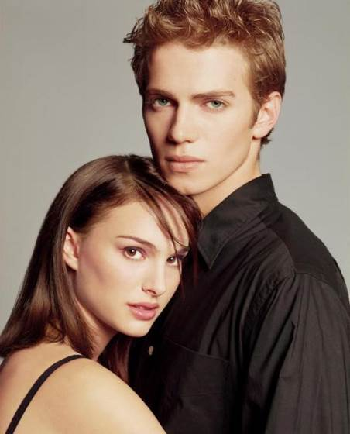
With these two images…
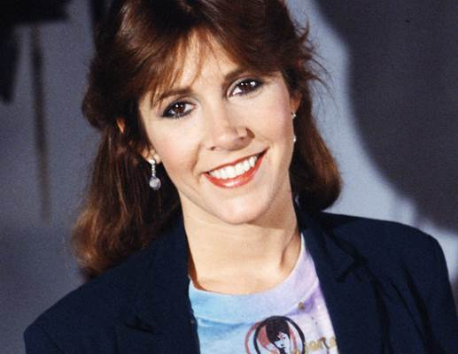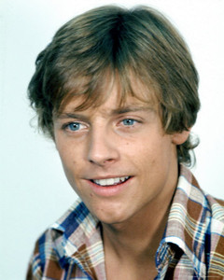

The top photo is a publicity still of Hayden Christensen and Natalie Portman. The bottom images are Carrie Fisher and Mark Hamill. The four actors are related through characters they played in movies…characters we can't see or mention because that would be a violation of copyright and get us in trouble…but, you get it right? Carrie and Mark were the kids of…um…ahhh, you get it.

Let's get started making our montage.

- Open Photoshop
- Surf to the folder where you opened these directions and open the image named Main.jpg

The image contains a bunch of extra space that we don’t really need, so let's crop the image so that we are left with the most important part – their faces.

- Click the Rectangular Marquee Tool…
- Click off the upper left corner of the image…
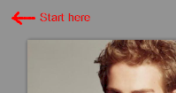
Note that if you can't see the empty space to the upper left or your image you can decrease the zoom by typing 50% in the Zoom box at the bottom of the image…
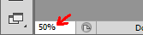
and pressing Enter
- Drag towards the lower right corner of the image until you have a selection box that is 550 pixels wide and 650 pixels high – Photoshop will display a small black box…
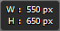
that lets you know the width and height of your selection
- Release the mouse button

We need our selection box to be a specific width and height so that when we insert Carrie and Mark's heads later an exact number of heads will fit with no pieces of their heads cut off.

- You should now have a selection similar to this…
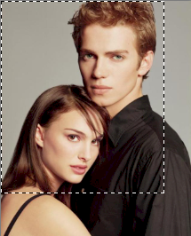
- To remove the unwanted area, click Image then click Crop…
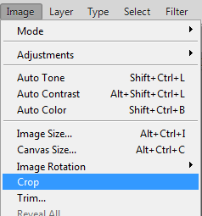
which will leave you with only your selection…
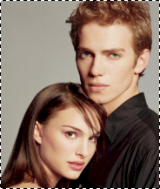
- Press Ctrl+D on the keyboard to deselect your image

Now let's work with the other two images to get them to be the correct size.

- Surf to the same folder where you opened these directions and open Carrie.jpg and then Mark.jpg in Photoshop
- Click Window on the menu bar and look at the very bottom, notice that you should see all three images that you currently have open…
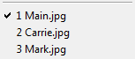
Click on 3 Mark.jpg to bring up the image of Mark Hamill…

- We will be using the crop tool this time, so click the Crop Tool…
Notice that Photoshop places crop handles around our image…
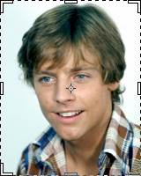
- Set the Zoom to 100%...
- Set the Crop Tool options bar (this is located directly under the Menu bar) to match the image below…
- Change the View option by clicking where you see Rule of Thirds in the above image and selecting Auto Show Overlay…
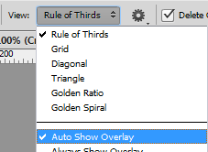
this prevents Photoshop from placing a grid over our image, which can get annoying (if Auto Show Overlay is already selected, simply click off of the menu to deselect it)

We are going to ignore the crop handles and instead use the crop tool to create an exact sized image. Just so you know, it is possible to click and drag on the crop handles to achieve the same result as what we are about to do (but then we wouldn't learn how to create an exact sized image). We want to use just Mark's face, so a good step at this point would be to take a measurement of his face so we know what size to crop our image to. Luckily for you I have already measured his face – it is approximately 180 pixels tall. When we transfer his face onto the Main image, we need him to be square, so let's create a 180x180 box on Mark.

- Click near Mark's shoulder and drag up and to the right to create a 180 pixel by 180 pixel box…
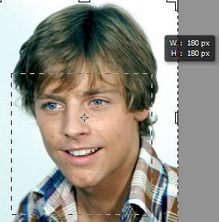
When you release the mouse button, Photoshop will create a crop box for you…
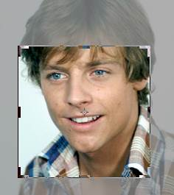

His face it obviously not centered in the box, so let's fix that.

- Click INSIDE the crop box (if you try to click outside the crop box you will actually be rotating Mark – not what we want) and drag Mark until his head sits in the box (try to place his chin on the bottom center crop handle…
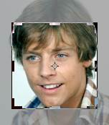
Notice when you click and drag that Mark (the background) moves and not the crop box – this is what is supposed to happen
- In the very upper-right corner of the Photoshop window, just below the Close X, click the Commit current crop operation button…

which leaves only his face…
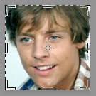

So far so good, but 180x180 is too large an image and thus not useful for what we want to do, so let's adjust the size of his head so that it is 50x50 pixels.

- Click Image on the menu bar and then click Image size…
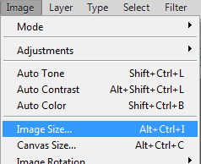
The Image Size window opens…
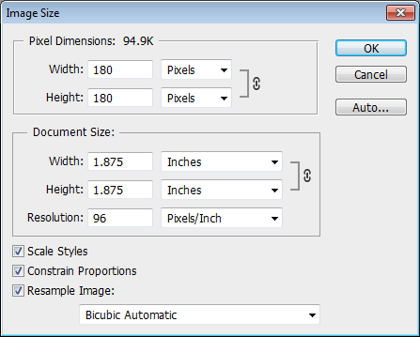
- Make sure Constrain Proportions is checked – this will cause Photoshop to change the Height automatically to match the Width we are about to put in
- Change the Width setting to 50…
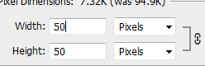
Note that Photoshop changes the Height setting automatically to match
- Click OK
- Click the Move Tool…
to remove the crop handles so you can get a good look at your new resized head

Now let's get Carrie Fisher's head to be the correct size.

- Switch over to Carrie.jpg
- Use the Crop Tool to draw a 250x250 box
- Reposition Carrie's head inside the box…
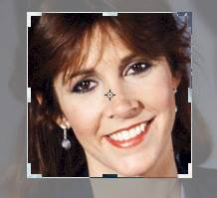
- Commit the current crop operation
- Resize the image to 50 pixels by 50 pixels


Now we need to start a new file so that we can bring the two tiny heads together to create the image that will overlay our hugging parents.....I mean actors who just happen to be in the same photograph together and who are in no way Disney©®™ related characters.

- Click File then click New
- We want a new file that is twice as wide as our two small images (which are each 50 pixels wide), so we need to set both Width and Height for this image to 100…
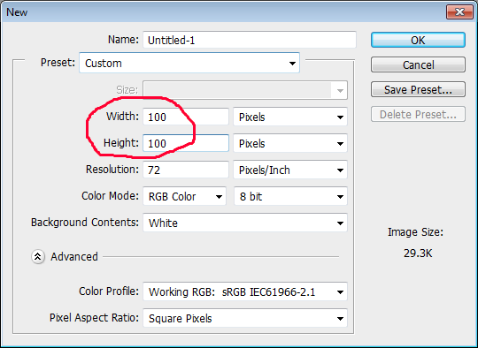
make sure you are measuring in Pixels and NOT inches – a 100 inch square image is an image that is 8 feet tall and 8 feet wide which will probably crash Photoshop
- Click OK
- Return to your Mark image and press Ctrl+A – this is the keyboard shortcut to select everything – then press Ctrl+C to copy the image to your computer's clipboard
- Return to your new, blank image – which in the file list is at the bottom of the Window menu option and should be listed as 4 Untitled-1 – and press Ctrl+V to paste…

- Click the Move Tool
- Click on Mark's head and drag it to the upper-left hand corner of the document…

Notice that his head will snap to the corner automatically when you move it close to the corner
- Press Ctrl+V to paste another version of his head

Photoshop should paste this new version in the center as it did the original head, however it might place it directly on top of the one you just put in the corner. If you press Ctrl+V and it looks like nothing has happened, don't panic – it is actually there. You can reassure yourself of this by having a look at the Layers panel, which should look like this:
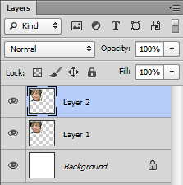
Notice that there are in fact two layers with Mark's head on them. If you pasted his head multiple times because you went crazy with Ctrl+V before reading this part of the directions, simply right-click each layer above Layer 2 and click Delete Layer to remove it.

- Move the second head to the lower-right corner…

- Repeat the above process to insert two Carrie heads and place one in the bottom-left and one in the upper-right corner…


You should now have four different layers with small pictures on them…
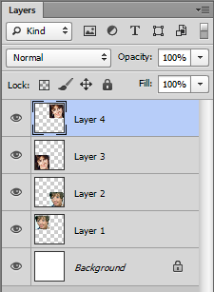
Don't worry if you do not have a Background layer. It is not necessary for what we are doing and the next step will destroy it anyway.

- Let's get all of our tiny heads onto one layer by clicking the layer menu button…
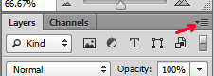
and then clicking Flatten Image…
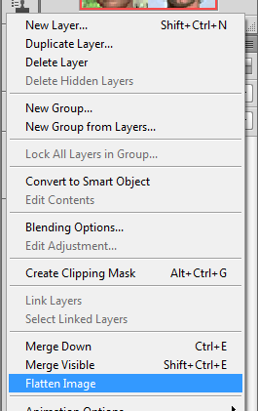
you should now have only one layer…
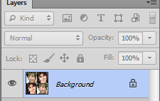

We now have the tiled image that will serve as our overlay to our Main image. We need to lower the color saturation of our tiny heads so that they will not interfere with the color of the background (the huggers).

- Click Image then point at Adjustments and click Desaturate…
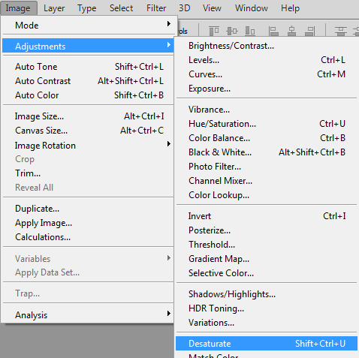
this will remove the color from your image…


Now that our tiny heads are how we want them, let's do one more thing to them before we apply them to our Main image.

- Click Image then click Image Size and change the Height and Width values to 50 pixels
- Click OK

Yes, we now have even tinier heads. You may be wondering why we didn't just make our heads 50 pixels instead of 100 pixels back in direction 30. The answer is simple: the greater change you make in size the more distortion you introduce into the image. Keeping the size at 100 on direction 30 allowed us to keep most of the detail of the images, and thus our new 50x50 image is much clearer than it would have been.

We now need to turn our tiny heads into a pattern that will automatically repeat across our hugging parents…I mean completely unrelated actors.

- Click Edit then click Define Patten…
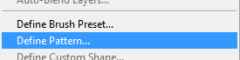
- For Name: type smallpics…
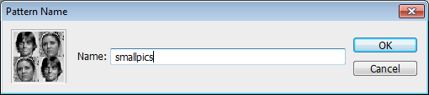
- Click OK

While it looks like nothing has happened, our images are now defined as a Photoshop pattern that can be used to fill a selection. Keep working and exactly what this means will become clear.

- Close all of the images you currently have open except Main.jpg – when asked if you wish to save Untitled-1 click Yes and save it to your student folder (you do not have to change the name) – when asked if you want to save the Carrie and Mark files click No
- In the Main file, click the New Layer icon at the bottom of the Layers panel…
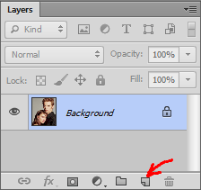
Photoshop automatically inserts a new layer named Layer 1 at the top of the layer stack…
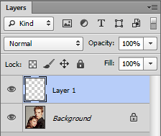
- Make sure Layer 1 is selected (the layer should be highlighted in blue as in the image above) and click Edit then click Fill…
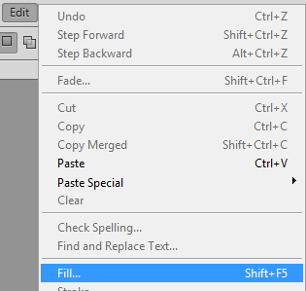
to open the Fill window…
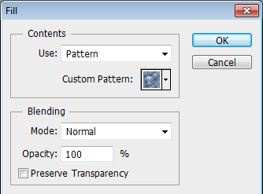
- Make sure the Use option is set to Pattern, Blending Mode is set to Normal, and Opacity is set to 100%
- Click the Custom Pattern drop-down arrow and select the smallpics pattern – is will be the last thumbnail in the list…
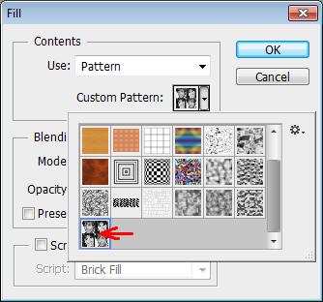
- Click OK – Photoshop will fill the layer with your pattern…
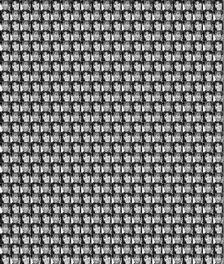
- To get our pattern to blend into the original image, click the layer blending mode drop-down arrow…
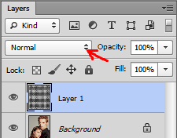
and select Soft Light…
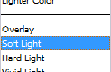
your image should now look like this…
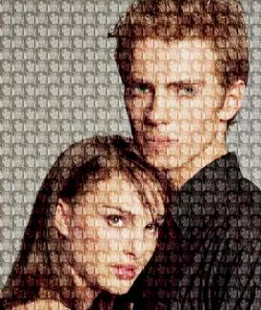

Almost there! Our tiny heads are a little too bold and are actually distracting from our overall image at this point. We can soften things up a bit by adjusting the Opacity of our tiny head layer.

- Use the Opacity slider…
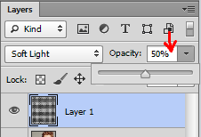
on the Layers panel to reduce the opacity of Layer 1 to 50%, which will give you the image below…
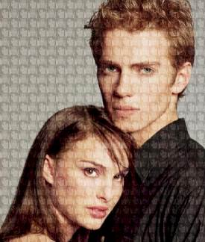
- Save your image in your student folder as Montage_yourname (but, you know, use your actual name in place of 'yourname')

Extension Exercise

Now that you've worked through our montage of four completely unrelated actors, your task is to go online and find three separate images – one to serve as the background and two to create the Fill Pattern – to create your own custom montage. Keep the following in mind:
- Make sure the overlay images fit the background image without cutting off parts of the overlay images
- You can make the overlay images larger (but not too large as that will be a distraction) than the ones we used in these directions, but do not use anything smaller as these will be too small to tell what they are
- The images need to relate to each other in some way – you do not have to use human heads, just make sure all of the images have something to do with each other
- Take this assignment a step farther and use more than two images in your overlay, just make sure to keep the first bullet above in mind and that your overlay pattern is rectangular
- Keep the subject matter of your images school appropriate!
- Save your completed image to your Student folder as Custom_yourname

