CREATING A WORKING LIGHTSABER
This lesson will allow us to have a little fun. We are going to take a scene where someone is holding an ordinary toy lightsaber and give it the glow seen in the movies. At the end of this tutorial, we will add in a little extra surprise to really take our scene to the next level.
Keep in mind while doing this that it is not necessary to have a toy lightsaber. This process will work no matter what you are holding, even something as simple as a stick. For that matter, we can place a lightsaber in the hands of someone not actually holding one (see the images at the end).
Let’s get started by finding an image we want to use. For these directions, I will be working with the following two images…
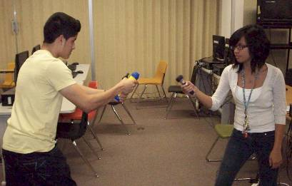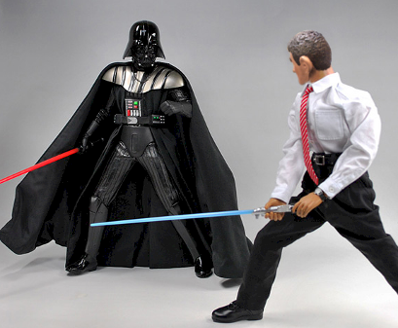
Notice that in the first image, the student’s lightsabers do not have blades (in fact, each one is holding a simple flashlight…and Martin is holding his flashlight upside down). The second image is a couple of toys fighting it out, but in this one there are blades.
As you work through these directions, you will be working with both kinds of images: one where you have a blade and one where you do not (we will take two different pictures, one of you holding a toy lightsaber with no blade and one with the blade extended). We will learn different tools as we work with each image. Remember that if you want to repeat this process on your own later that it is not necessary to have a toy lightsaber – anything shaped like a lightsaber handle (such as a flashlight) or any long blade-like object (such as a stick or cardboard tube) will work.
PART ONE
Let’s jump into Photoshop and get to work…
- Open Photoshop
- Click File then Open
- Surf to your folder and double-click the image of you with NO BLADE on your lightsaber
- Press the D key to make the foreground color black and the background color white…
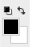
- Press the X key to switch the two colors (we need white to be the foreground color)…
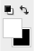
Let’s make a new layer to begin building the blade so that we are not messing with the original image…
- On the Layers palette, click the Create a new layer button (red arrow below)…
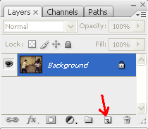
if you do not see the Layers palette, simple click Window on the Menu Bar and click Layers
- Notice that Photoshop has created a new layer for us named Layer 1…
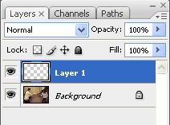
- Let’s rename this layer by double-clicking on the words Layer 1, notice that the layer name changes so you can type in a new name…
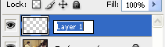
if you had the Layer Style window pop up when you double-clicked, just click Cancel and try again
- Rename this layer Blade and press Enter to apply the name change
We now need to create our blade. Since there is a huge variety of possible lightsaber hilts (that is what you call the handle of a sword) that you could be using, we need to take a second and adjust the size of our brush to be the correct size for your hilt. To do this, we need to zoom in on the top of our hilt…
- Click the Zoom Tool…
- In the Zoom Tool options bar, make sure the Zoom In button is selected…
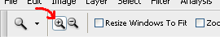
- Click and drag to create a box around the top of your lightsaber hilt…
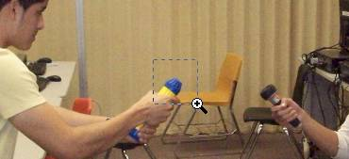
- Release the mouse to zoom in on that area...
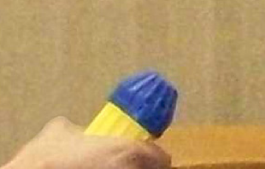
- Select the Brush Tool…
- We need to have a good, solid edge brush to start with, so click the drop-down arrow on the Brush preset picker on the Brush options bar…
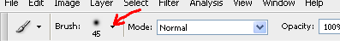
- Click the Hard Round 19 pixels brush…
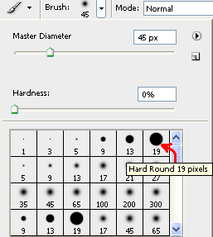
- Place the circle of your brush over the end of your lightsaber hilt…
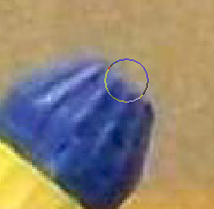
- Press the ] key on the keyboard to increase the size of your brush until it is the same width as the end of your lightsaber hilt (note that pressing ] will increase your brush size while pressing [ will decrease it)…
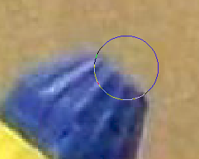
if you can’t get the brush width to match the width of your hilt using ], you can return to the Brush present picker and type in a width for Master Diameter by hand…
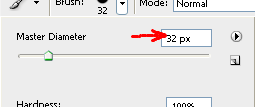
for our example image, I had to manually change the size to 32 px
Make sure your brush size is the same size as the end of your hilt and is not larger than it. We will be adding lines with glows on them and if the line is too large our blade will look fake.
To create the blade, we are going to use a path and let Photoshop draw the line in for us so that we can be certain that it is perfectly straight.
- Click the Zoom Tool
- Press and hold the Alt key (notice that the zoom cursor changes from a to a ) and click repeatedly on your image until you can see the entire image
- Click the Pen Tool…
- In the Pen Tool Options bar, make sure Paths and Pen Tool are selected…
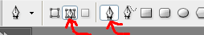
- Click at the base of your lightsaber hilt to drop a point…
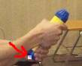
DO NOT click and drag – just click
- Determine how long you want your lightsaber to be (don’t go crazy and make it too long) and click where the end of your blade will be to drop a second point – notice that Photoshop creates a straight line connecting your two points…
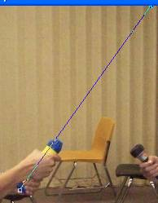
this line is called a path, and is a temporary line that Photoshop will use in the following steps to create the line that will become our amazing lightsaber blade
Notice two things about my blade at this point:
- It appears to be going off the top of my image – this is not a problem as it really does not matter for what we are doing if you can see the top of your lightsaber or not
- The path is crooked – notice that is does not go through the center of the top of my hilt; this is not a problem and is actually what we want at this point as it allows us to use another tool to fix this issue
The next thing we have to do is straighten our line out…
- Click the Direct Selection Tool…
- Click on the point at the top of your path and drag it so that the path passes through the middle of the top of your hilt…
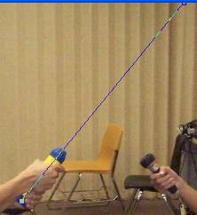
if your bottom point is out of place, take the time now to move it to the correct spot
- Let’s have Photoshop add in our line for us by right-clicking our image – this will cause a window to pop up…
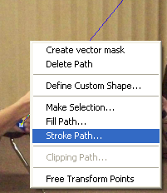
- Click Stroke Path – the Stroke Path window will display…
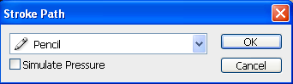
- Click the drop-down arrow and choose Brush…
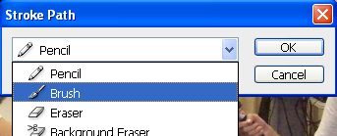
- Click OK – notice that Photoshop creates a line along our path using the color we had selected (white) and the Brush we had selected…
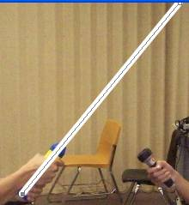
- Right-click on your image and choose Delete Path
- We need to remove the portion of the blade that is over our hilt, so select the Eraser Tool…
- Zoom in on your hilt and remove all of the white on it…
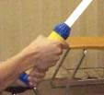
Now that we have our blade, we need to make a copy of our Blade layer so that we can add in the glow around our blade.
- Right-click the Blade layer and click Duplicate Layer…
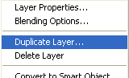
- The Duplicate Layer window opens…
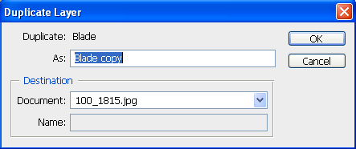
- Rename the layer Glow and click OK – notice that Photoshop places the new layer at the top of the layer stack…
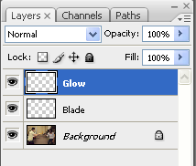
- Our layers are out of order – we need the Blade layer to be at the top of the layer stack – so let’s move the Blade layer up by clicking the Blade layer to select it and then dragging it up until the black line pointed at with the red arrow below is at the top of the layer stack…
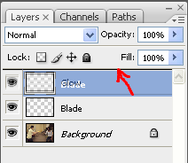
- Your layer stack should now look like this…
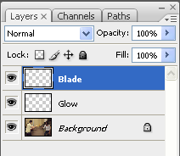
- We are going to leave the Blade layer alone and add glow to the Glow layer, so make Glow the active layer (it should be highlighted in blue)…
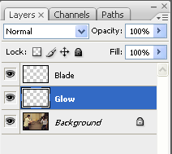
- Click Filter then point at Blur and click Gaussian Blur…
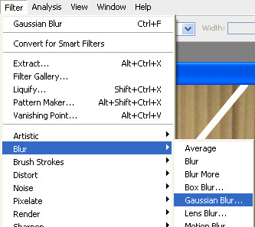
- In the Gaussian Blur window, set the Radius to 20 pixels…
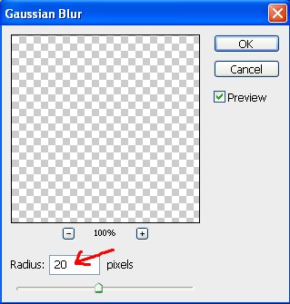
- Your blade should now have a very soft blur to it…
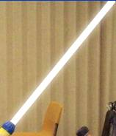
The 20 pixels setting mentioned above is not set in stone – we just need to give our blade a soft glow. The pictures we took in class are rather large, so a 20 pixel blur works well for the Glow layer. If you do this in the future, you will need to adjust the width of your blur settings to match the size of your image.
Now that we have our blade built, we need to add in some color…
- Click on the Blade layer to select it
- Double-click on the layer icon – make sure you are not double-clicking on the layer name (look at the image below and double-click where you see the red X)…
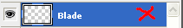
- The Layer Style window opens…
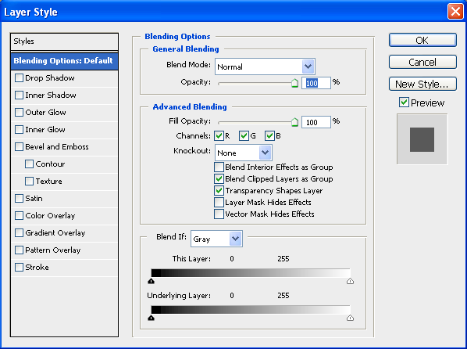
- We first need to apply an Outer Glow, so click on the words Outer Glow to select it…
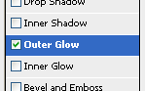
notice that when you click Outer Glow that the checkbox activates (be careful, if you just click on the checkbox Photoshop will actually turn on the Outer Glow but not select it – be sure you can see the options discussed in the following directions)
- In the Structure section, set Opacity to 100%...
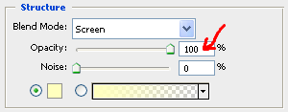
- Click the Set color of glow box…
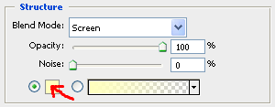
- The Color Picker window opens…
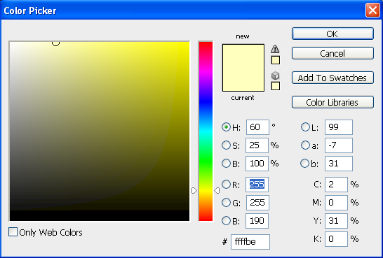
In Star Wars, the evil characters usually have red lightsabers, so I’m going to make Martin evil by giving him a red blade. You can give your character any color blade you want, just be sure to make a note of what color you use as you will need to use that same color again in just a moment.
- If you want to use red like me, simply type ff0000 into the Hexadecimal color value box…
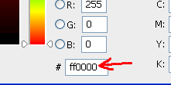
ff0000 is the hexadecimal code for red, but if you don’t want to use red then feel free to change the options in the color picker until you get a color you do like and then write down the hexadecimal code for that color as you will need it for the directions that follow
- When you have a color you are happy with, click OK
- For the rest of the settings in Structure: Blending Mode should be set to Screen and Noise should be set to 0%
- In the Elements section, change the Size setting to 100 px…
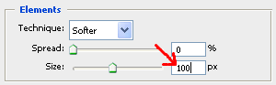
remember that this amount will not work for all images – it works for us because all of our images are the same size – if you do this in the future you will need to adjust the Size setting to whatever works best for the image size you are using
- For the rest of the setting under Elements: Technique should be set to Softer and Spread should be set to 0%
- In the Quality section, click the drop-down arrow to open the Contour picker…
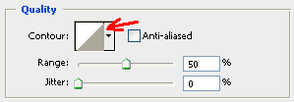
- Double-click the Half Round contour…
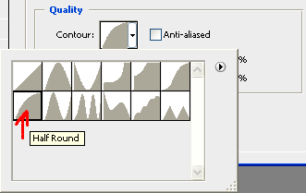
this will cause our glow to be slightly more spread out than the default setting
- For the rest of the settings under Quality: Anti-aliased should be unchecked, Range should be set to 50%, and Jitter should be set to 0%
- The core of our blade tends to be too white at this point, so let’s give it a slight color tint by clicking Color Overlay to turn it on…
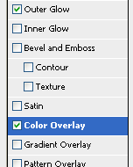
- Set the Opacity to 10%...
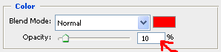
- Click the Set color of overlay box (that little red box just above the Opacity number setting) and set it to the same color you used to create the Outer Glow
- Click OK to exit the Layer Style window
- You should now have an awesome lightsaber similar to this…
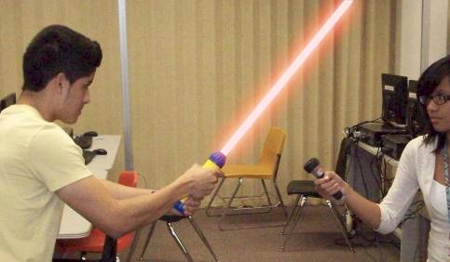
You may be wondering at this point what impact the Glow layer is having on our blade. If we turn off the visibility of our Glow layer we can see what’s going on.
- Click the layer visibility icon (the little eyeball) next to the Glow layer to turn the visibility of the Glow layer off…
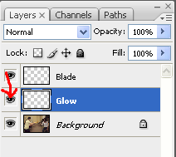
please note that the Glow layer is still there, you just can’t see it right now – you can see it again if you turn the little eyeball back on
- If you repeatedly turn the visibility of the Glow layer on and off the difference will become obvious…
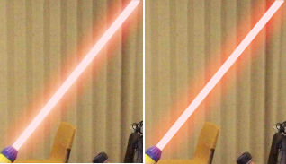
the above left image has the Glow layer turned on, while it is turned off in the above right image – note that the Glow layer simply gives the blade more of an intense glow, and keeps the line between the blade’s white core and the colored glow from being too pronounced (that means obvious)
We are done with our lightsaber! If you have additional people with lightsabers in your image, take the time now to add in blades for each. Be sure you use a different color for each blade in your image. Once you have blades for all the lightsabers in your image, you should have something like this…
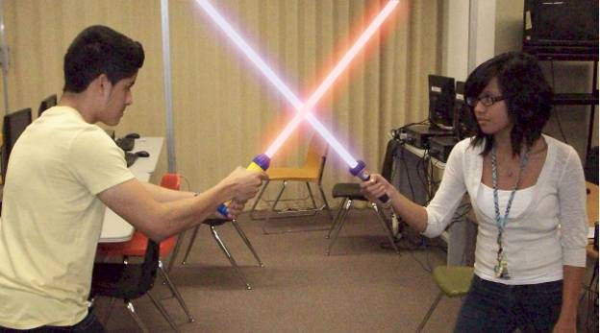
If you have blades that cross like in my image, it does not really matter which blade is on top – I have Martin’s blade in front of Cindy’s blade in the image above, but there is no reason why I couldn’t switch them. It is up to you how you want them to be.
PART TWO
For this part, we will use the image of you holding a lightsaber with the blade extended. I will be using this image…
Much of the process that follows is the same as above, but in this part we will work on making selections. There are multiple tools we can use to get something as simple as a lightsaber blade selected (such as Quick Mask mode, Magic Wand Tool, Magnetic Lasso Tool, etc.), so we are going to choose one of the most commonly used: the Magnetic Lasso Tool. We will then use the Lasso Tool to fine tune our selection.
Let’s get started…
- Open Photoshop
- Click File then Open
- Surf to your folder and double-click the image of you with a blade on your lightsaber
- Press the D key to make the foreground color black and the background color white
- Press the X key to switch the two colors (we need white to be the foreground color)
- On the Layers palette, click the Create a new layer button
- Rename the new layer Blade
- Click the Magnetic Lasso Tool…
if you do not see the Magnetic Lasso Tool it is likely because you currently have a different lasso tool selected – find the Lasso Tool and right-click it…
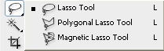
now click the Magnetic Lasso Tool to select it
- Zoom in on your lightsaber blade
- Starting at the end of your lightsaber, click once on the very tip to drop a point…
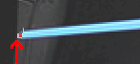
- Slowly drag your mouse around the outside of your blade until you return to the point you just dropped…
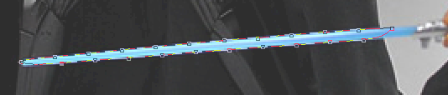
do not worry about getting the selection to be perfect at this point – notice that most of my blade is selected but the area near the hilt is messed up (the Magnetic Lasso Tool works by detecting the contrast between two colors, in this case the light colored blade and the dark colored background, but in the area where there is a light colored blade and a light colored background, Photoshop had difficulty deciding where to place the line), this is not a problem – we will clean it up in the directions that follow
- Click back on your original point to have Photoshop turn the line into a selection…
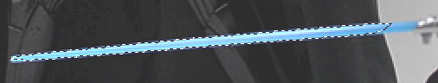
- Let’s clean up our selection so that we have the entire blade (and only the blade) selected by turning on the Lasso Tool…
- Zoom in on the very tip of your blade…
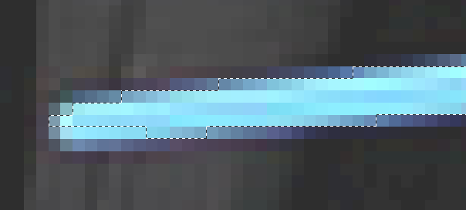
notice that the Magnetic Lasso was not perfect in its selection
- Use the Lasso Tool to adjust the selection – to add to the selection, press and hold the Shift key as you drag a circle around the pixels you wish to add (when you release the mouse you should see those pixels added to your selection; to remove pixels from the selection, press and hold the Alt key as you drag a circle around the pixels you wish to remove – there may be times where it difficult to tell if a pixel belongs to the blade or not – don’t be too worried about these instances because when you add the glow most of these small problems will disappear)
- Slowly work your way down your blade adjusting your selection until you have only the blade itself selected…
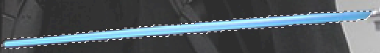
- Make sure the Blade layer is still the active layer, and click Edit then click Fill…
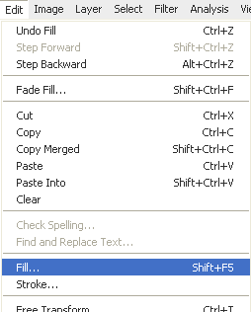
- The Fill window opens…
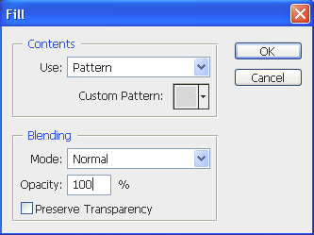
- Click the drop-down arrow next to Use and choose Color…
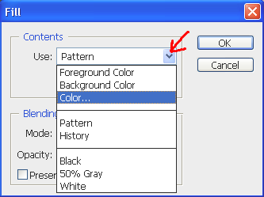
- In the Choose a color window, type ffffff in the hexadecimal number box…
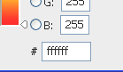
- Click OK
- Click OK again
- Notice that your blade is now filled with white…
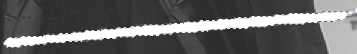
- Press Ctrl+D to deselect your blade
- This process tends to leave the edge of our blade very sharp and crisp, a little too sharp in fact, so let’s soften the edge up just a bit by clicking Filter then pointing at Blur and clicking Blur More…
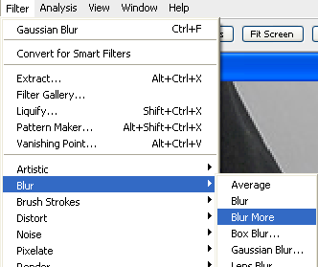
- Your image is larger than the one I am using, so the impact of Blur More will be greater on my picture, but you should see a slight blurring of the edge of your blade…
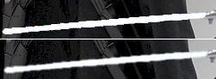
the top image above is before the blur, the bottom image is after
From this point on, the process to create the completed blade is the same as it was for Part One. Repeat directions 34 – 64 in Part One to complete your blade. When finished, you should have something similar to the image below…
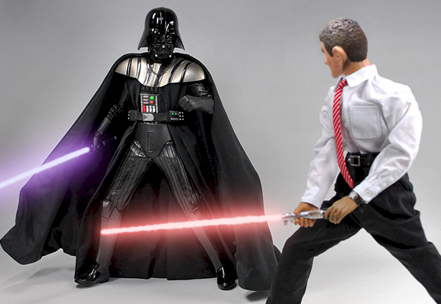
Notice that in the original picture, Darth Vader’s blade was red and the other guy’s was blue, but when I created the blades I made Vader’s purple and other one red. Feel free to make your blades any color you like. Also, for the blades above, I lowered the Opacity on the Outer Glow to 75% (because the image lacks very bold colors so 100% opacity looks too bright) and set the Size to 25 px (because my image is much smaller than the ones we took in class). Just remember that if you are doing this process in the future, that you will have to adjust the various settings to match the size and quality of your image.
When you are finished, save your file in your class folder as lightsaber.psd.
THE EXTRA SURPRISE
To really make a battle between two students stand out above the rest, we can add lightning coming from one person’s hand while the other person blocks the lightning with their blade. These directions only cover working with lightsabers, so to find out how to add lightning you will need to go to the Add Rain and Lightning tutorial and follow the directions on adding lightning. The difference is that instead of having the lightning coming out of a cloud, you will have the lightning coming out of your hand and ending on the blade of a lightsaber. Then it is just a matter of giving the lightning a nice glow and adding in a little color for highlight to complete the effect. Take a look at the image below…
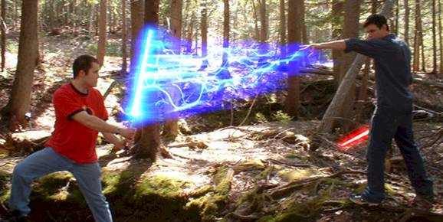
GO HAVE FUN WITH THIS
To wrap up this tutorial, I want to remind you that you are not limited to working with images of yourself. There are plenty of pictures out on the Internet that you can edit and create some great images. Here are some examples of completed images taken from across the Internet, many of which involve adding in lightsabers where none existed…
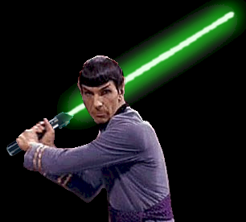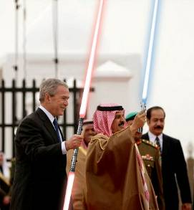
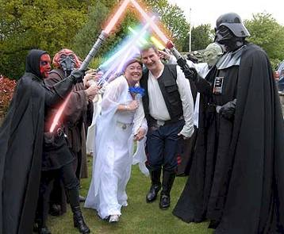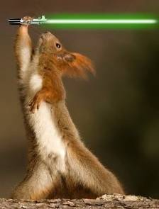
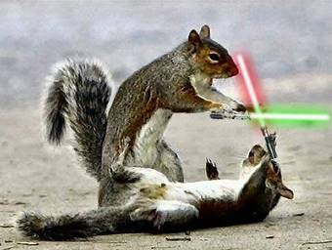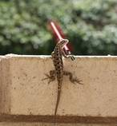
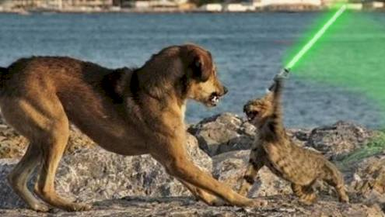
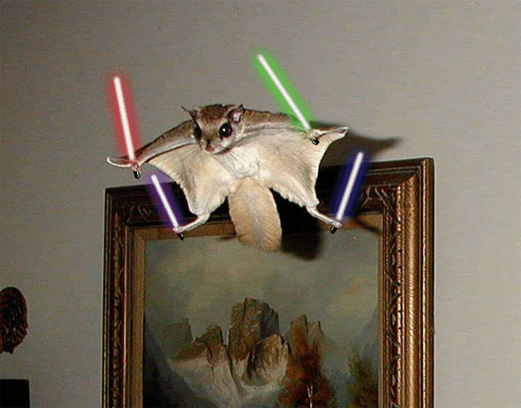
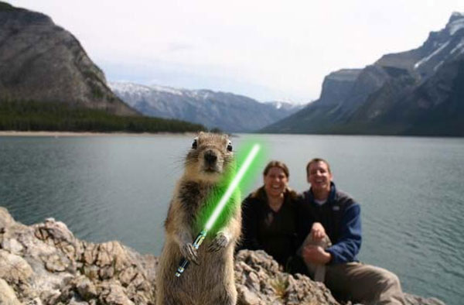
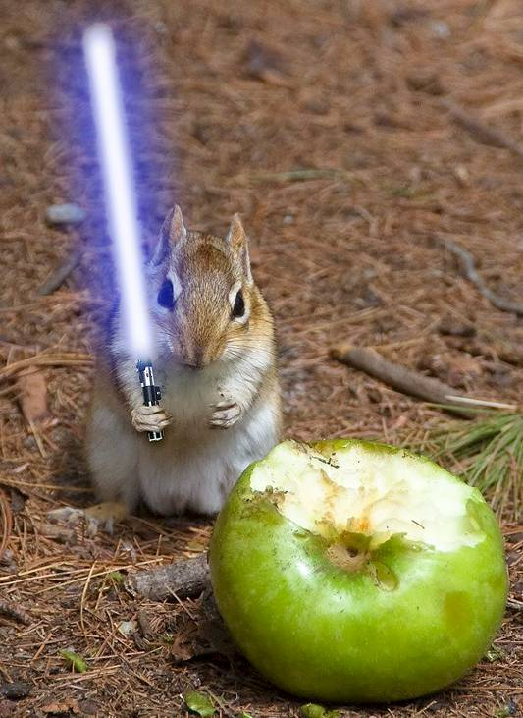
Just look at those evil eyes…touch his apple and he’ll cut you…
(animals using lightsabers are always funny).

