**Creating a** [**3D moon**](http://www.panosfx.com/photoshop-tutorials/3d-moon)

This tutorial will cover how to add a 3D moon to your space scene. Keep in mind that this is an actual 3D object that can be manipulated in 3D space and not simply a flat image of the moon. This can be slightly complicated, so don’t start it unless you are certain that you have time to finish it.

1. Open Photoshop

We need to start with a panoramic image that is called a 'planetary map', which is basically a flat image that represents the surface of a planet that can be wrapped around a 3D sphere. I have linked the Moon’s planetary map in Step 21 for you.

1. Use the link in Step 21 to save the Moon’s planetary map to your Photoshop folder
2. Open the Moon’s planetary map in Photoshop

At this point, it is a very large image, so let’s resize it to something a little easier to work with.

1. Click Image and then click Image Size (or press Ctrl-Alt-I)…  
   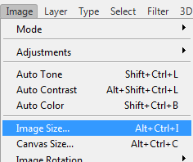
2. In the Image Size window, enter 3000 in the width field…  
   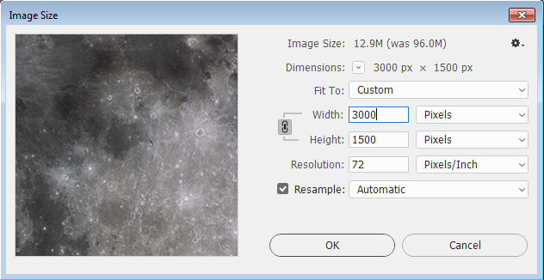  
   Notice as you do that the Height field should change to 1500 automatically

If Height does not change to 1500 automatically, you will need to manually enter the amount.

1. Click OK
2. Double-click the Hand Tool to set the zoom so that the moon image stretches the entire width of your canvas

Since this is an actual photograph of the Moon (which is far away) some of the surface detail has been lost. Let’s sharpen the image a bit to emphasize those details.

1. Click Filter and then click Sharpen and then click Smart Sharpen…  
   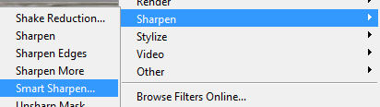
2. In the Smart Sharpen window, adjust the settings to match the image below…  
   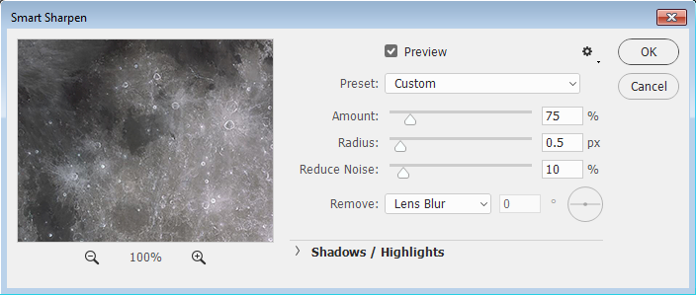
3. Click OK
4. On the Background layer, click the Lock to convert the layer into a regular layer…  
   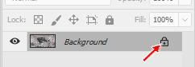
5. Rename the layer to Moon Map
6. Insert a new layer at the top of the layer stack and name it Space
7. Fill the Space layer with black
8. Move the Space layer below the Moon Map layer…  
   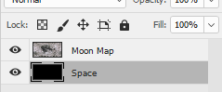
9. Make Moon Map the active layer

Now we will convert the flat Moon planetary map in a complete 3D model.

1. Click 3D on the menu bar and then click New Mesh from Layer and then point at Mesh Preset and then click Sphere…  
   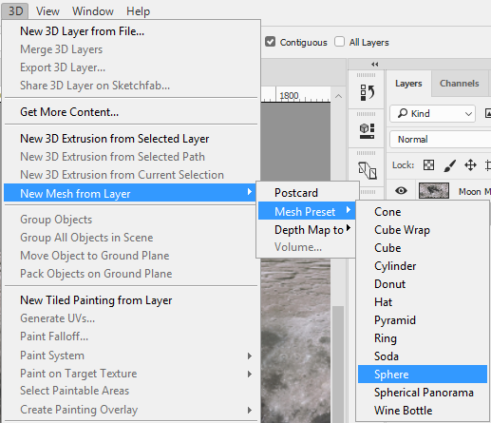
2. Photoshop will think for a second and then display the following message…  
   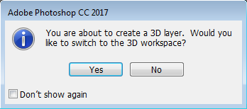
3. Click Yes

Our Moon planetary map is now wrapped around a sphere creating a fully 3D digital moon…

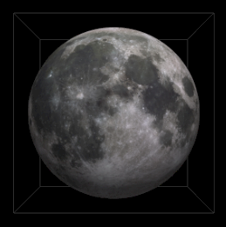

The bounding box you see above appears when you mouse over the moon. The view of the moon we have now is what we normally see from earth, so let’s take a second to rotate the moon so that what we see is not so common and will look a little more like the moon of an alien world

1. Press V to select the Move tool
2. Click the 3D panel to make it active…  
   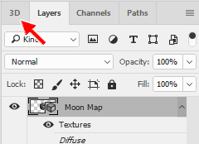
3. In the 3D panel, click on Sphere…  
   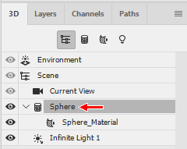  
   Notice that you now have control handles on your moon…  
   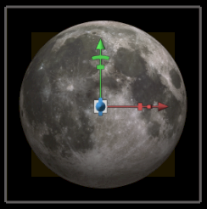
4. Hover your mouse on the Y axis rotation handle (red arrow below) – a pop-up window indicating that you are rotating around the Y axis should come up…  
   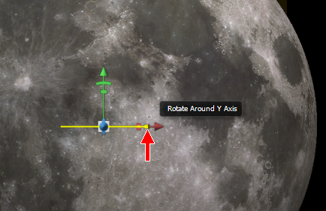
5. Drag your mouse to the left until you see a different, unfamiliar part of your moon…  
   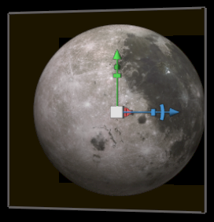

Let’s change the lighting so that it shines from the upper right side (known as a Waxing Gibbous moon).

1. In the 3D panel, click on the Filter By: Lights icon…  
   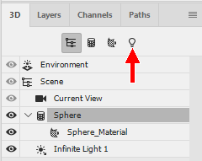  
   To switch to the Infinite Light 1 option…  
   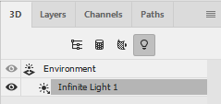  
   Note that your moon should have a light indicator showing that the light is coming from the top…  
   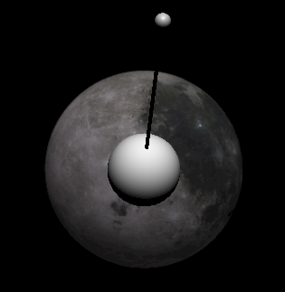
2. Click on the small sphere at the end of the black arm and drag the mouse to the right to move the light direction until the moon is illuminated from the upper right side…  
   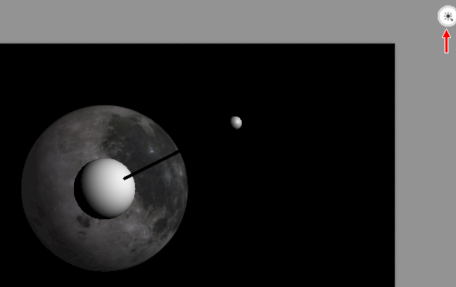

You should notice two things as you alter the light direction:

* You can drag the small sphere closer to or farther away from the moon to change the depth of the shadow being cast
* An artificial light source (red arrow above) is provided for you and moves around your moon as you drag to let you know where the source of the light is

Note that these directions set up the light source to be in the upper-right hand corner of your image, but if your sun is located in another area of your scene (and if it is that is fine – you can put your sun wherever you want) you will need to adjust the light source so that it matches the location of your sun.

When you look at the moon through a telescope, you do not see a flat terrain but a rough surface full of craters and mountain ranges. Your moon currently looks flat because you are using a simple photograph. Let's give your moon some texture.

1. Return to the Layers panel and double click the Moon Map texture…  
   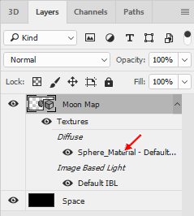  
   This will open a NEW DOCUMENT with the Moon’s planetary map loaded…  
   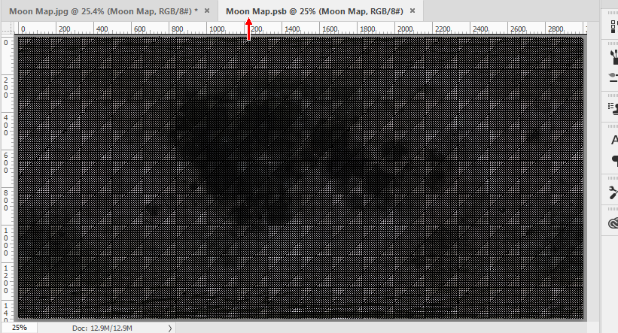
2. Press Ctrl+A and then Ctrl+C to copy the layer content into the clipboard

We will use this image to create a texture for the 3D object.

1. Close the newly created Moon Map document (close only the new document and NOT the document with our 3D moon and NOT Photoshop)
2. Return to the 3D panel and click the Filter By: Whole Scene icon (red arrow below)…  
   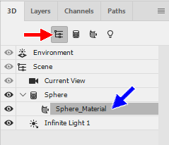
3. Click on Sphere Material (blue arrow above)
4. Locate the Properties panel (it should be directly above the 3D and Layers panel)…  
   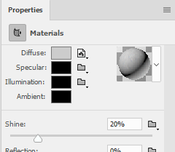
5. Click the folder icon to the right of Bump…  
   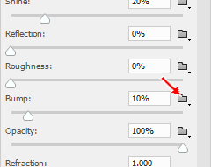
6. Select New Texture…  
   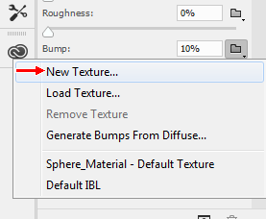
7. A New document window will open – Click OK…  
   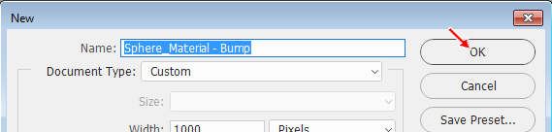
8. Press Ctrl+V to paste the moon map

If you look closely, you will notice that you are actually looking at only the upper-left corner of the moon map. We need to resize our map so that it fills the entire canvas.

1. Press Ctrl+T to enter Free Transform mode
2. Resize the map so that it fills the entire canvas…  
   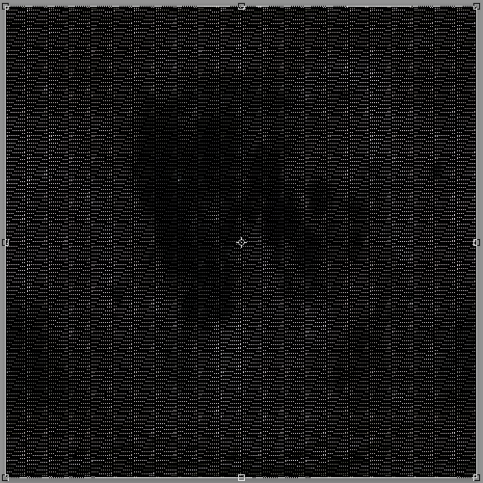  
   Yes, you are placing a rectangle image in a square canvas
3. Press Enter to apply the resize

Remember that the map is huge, so you will need to zoom out to see the entire image.

1. Save the Sphere Material file in your student folder

Returning to your 3D moon image, you should notice that the moon’s mountain ranges and crater rims stand out…

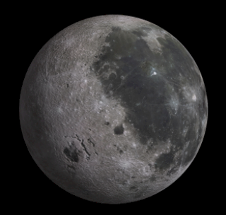

Now we need to get our moon into our space scene.

1. Position your 3D moon file so that you can see it and your space scene
2. Click on the Moon Map layer and drag it onto your space scene…  
   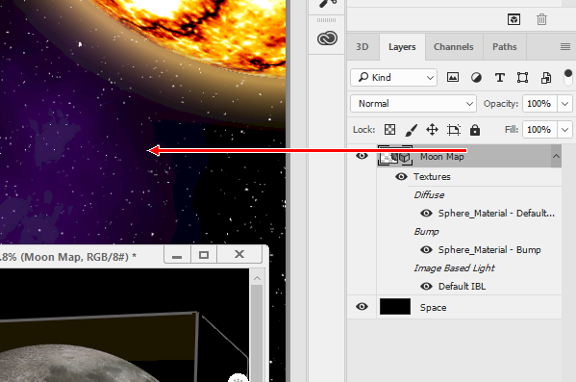  
   Photoshop should insert your 3D moon into your space scene and place it on its own layer

You may notice that your 3D moon is considerably larger than your space scene…

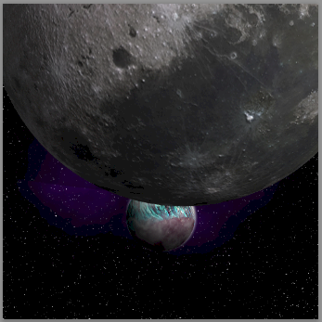

We need to resize our moon and orient it so that it is in a good spot in relation to our planet.

1. Make sure the Moon Map layer is active and click on your moon so that you can see the control handles…  
   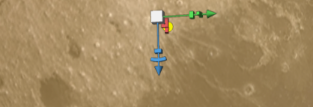
2. Resize the moon by using the Scale Uniformly control at the center of the control handles…  
   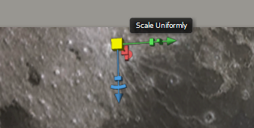  
   Click and drag down to decrease the size of the moon (dragging up increases the moon’s size)

To move and rotate your moon, simply point at various areas around the bounding box. For instance, clicking on one set of edges…

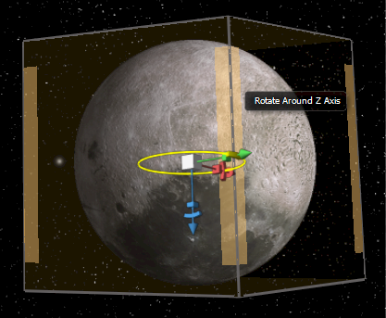

will allow you rotate the moon around the Z axis (rotate left-and-right) while clicking on the other set…

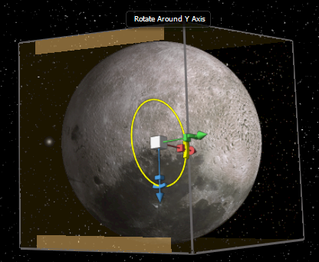

will allow you to rotate the moon around the Y axis (rotate up-and-down). Pointing at and clicking various areas of the bounding box will allow you to manipulate your moon in a large variety of ways.

1. Resize and orient your moon so that it sits in orbit around one of your planets…  
   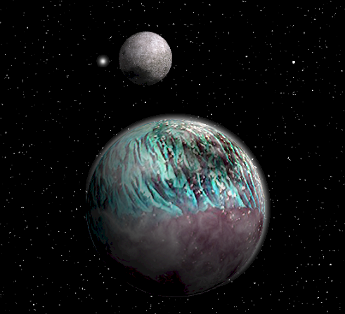

It may not be obvious to you, but your moon is actually casting a shadow which is covering up the stars around it. This happens by default and is intended to give a sense of realism to our 3D scenes, but for what we are doing the shadow is not necessary so let’s turn this shadow off.

1. Click on your moon to select it
2. In the Properties panel, uncheck the Cast Shadows checkbox…  
   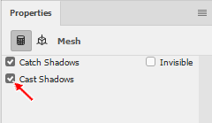

And that’s it! Our 3D moon is now in our scene and ready to amaze people.

1. Save your Space scene
2. Close Photoshop