Creating a [3D moon](http://www.panosfx.com/photoshop-tutorials/3d-moon)

1. **Open Photoshop.**
2. We need to start with a panoramic image which is called a 'planetary map'. The planetary map can be downloaded by using the link in Step 21.
3. Load the image in Photoshop. At this point it is very large, so let’s resize it to something a little easier to work with. Go to Image🡪Image Size (or press Ctrl-Alt-I). In the box that pops up, enter 3000 (pixels) in the width field and hit OK:

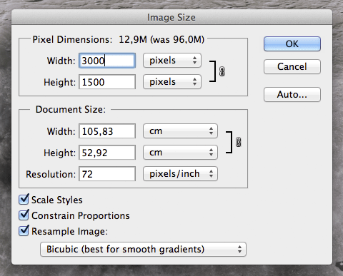

1. Click on the zoom tool on the tool bar and then right-click your moon image and click Fit on Screen so your moon image stretches the entire width of your work area.
2. Since this is an actual photograph of the moon (which is far away) some of the surface detail has been lost. Let’s sharpen the image to emphasize those details. Go to Filter🡪Sharpen🡪Smart Sharpen. Use the Smart Sharpen filter with the following settings:

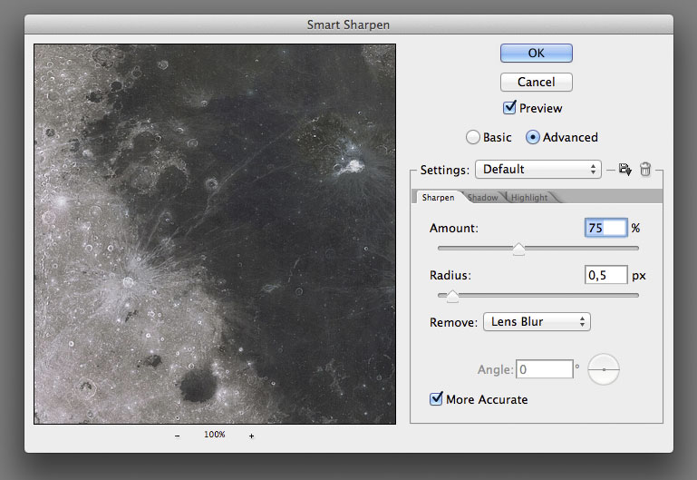

1. Double click the Background layer name and rename it to "Moon map".
2. Insert a new blank layer, name it "Space", and fill with black.
3. Move the Space layer below the Moon Map layer.

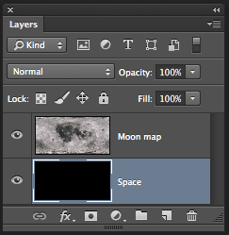

1. Click on the "Moon map" layer. From the main menu select 3D🡪New Mesh from Layer🡪Mesh Preset🡪Sphere. If Photoshop asks if you want to switch to the 3D Workspace click Continue. This will map the "Moon map" image layer inside a 3D sphere. We have just created a digital full moon on the screen:

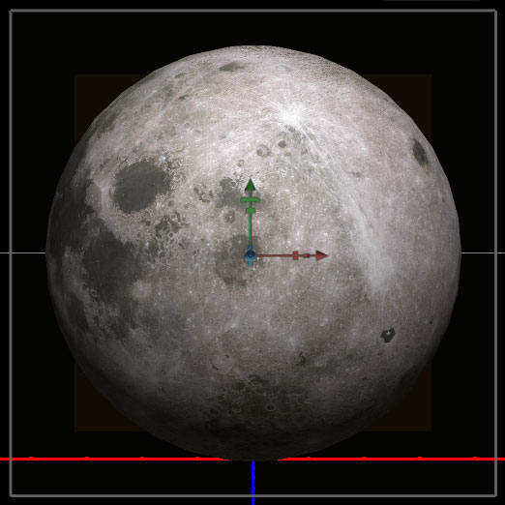

What we are looking at now is not the view of the moon we are used to seeing from earth (Photoshop used a different area of the moon map than what normally faces the earth), so let’s fix this little problem.

1. Make sure you are in the 3D workspace (if you are not select Window🡪Workspace🡪3D).
2. Press V to select the Move tool.
3. In the 3D panel click on Sphere:

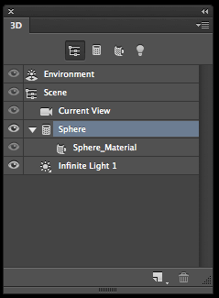

1. Hover your mouse on the Y axis rotation handle (yellow arrow below). A tiny pop-up window saying “Rotate Around Y Axis” should come up:

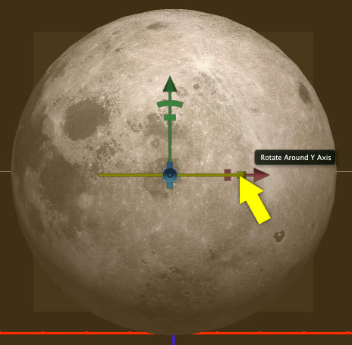

1. Drag your mouse to the left until you see the familiar image of the ‘man in the moon’:

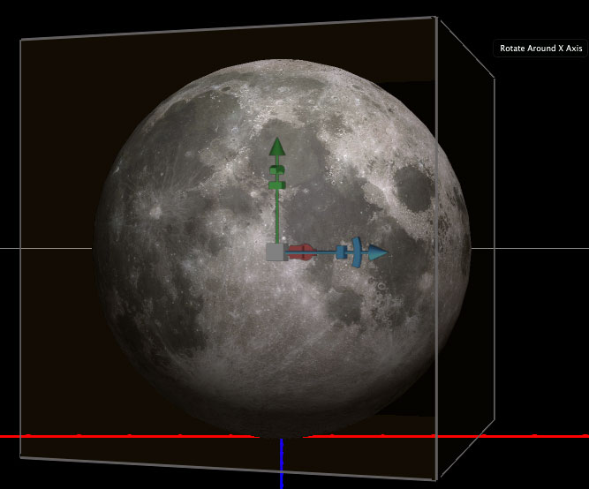

1. Now let’s change the lighting on the moon to the right side (known as a Waxing Gibbous). In the 3D panel click on the ‘Filter by Lights’ icon (yellow arrow):

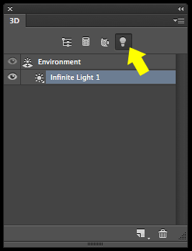

1. Drag the mouse to move the light direction until the moon is illuminated from the right side:

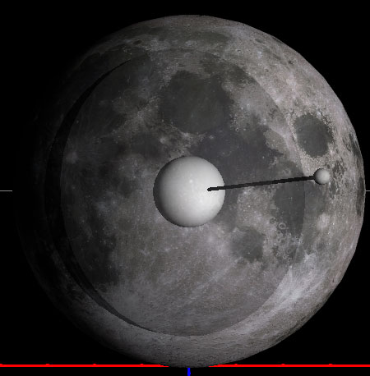

1. You can also change the Intensity for this light from 1 to 1.5.
2. When you look at the moon through a telescope, you do not see a flat terrain but a rough surface full of craters and mountain ranges. Your moon currently looks flat because you are using a simple photograph. Let's give our moon some texture by going to the Layers panel and double clicking the "Moon map" texture:

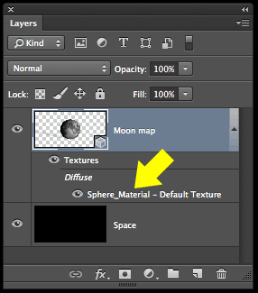

1. This will open a **NEW DOCUMENT** with the original moon map. Press Ctrl-A and then Ctrl-C to copy the layer content into the clipboard. We will use this image to create a texture for the 3D object. Close the **new document**. Close the **new document** (close ONLY the **new document,** NOT **Photoshop**!).
2. Go to the 3D panel. Click the "Filter by Whole Scene" icon (arrow 1). Click on "Sphere Material" (arrow 2).

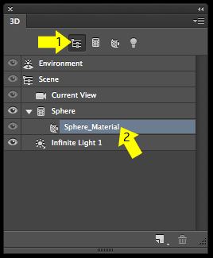

1. Go to the Properties panel (Window🡪Properties) and click the little folder icon to the right of "Bump" and select "New Texture":

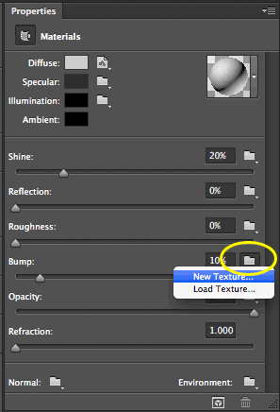

1. A New document window will open – Click OK:

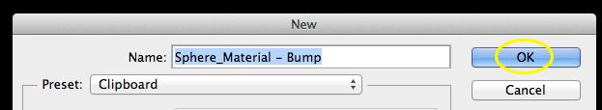

1. Click again on the icon to the right of "Bump" and select "Open texture":

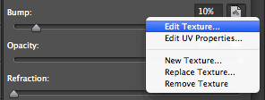

1. This will open a new document. Press Ctrl-V to paste the moon map. Flatten the image. Press Ctrl-S to save the changes and close the document.
2. And BOOM! – you can now see the Moon's mountain ranges and crater rims standing out. Depending on the size of the original image map, you may need to amend the bump value which is 10% by default.
3. We are ready to render the 3D object. Click 3D🡪Render. The scene will be rendered in a few minutes. Flatten the image. You can now adjust the levels to your personal preference and even sharpen the image slightly if you wish. Your moon is now complete:

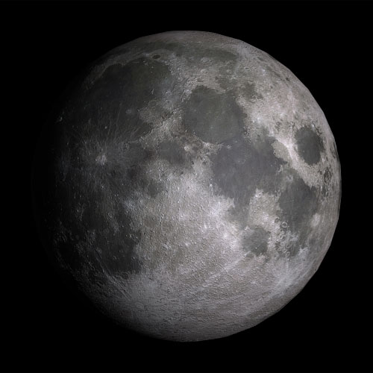

1. Copy your moon to your Space scene.
2. Resize your moon so that it matches the scale of your scene.
3. Place your moon in orbit around one of your planets.
4. Save your Space scene.