CONVOLUTION CONTROL IP

REVISION 0.0 2019.08

JUNSUNGLEE
doking123@naver.com
010-4016-8568

Table of Contents
1. SPECIFICATION 3
1.1. DESIGN SPECIFICATION(PARAMETERS) 3
1.2. MEMORY MAP 4
2. FINITE STATE MACHINE 5
3. PSEUDO CODE (CNNIP CONTROL) 6
4. WAVEFORM 7
4. TOP DESIGN 8

SPECIFICATION

DESIGN SPECIFICATION(PARAMETER)

- Stride : 1 or 2
- Padding : 0
- Filter size : 5 or 3
- Input size : 32x32
- Feature size : 28x28

※ Feature size is depend on #1~#3 specs. For example, the Stride ‘1’, Padding ‘ON’, Filter size ‘3’ the Feature size is going to be ‘30’. The feature size formula like Figure 2.1.

Figure 1.1. Feature size formula

MEMORY MAP

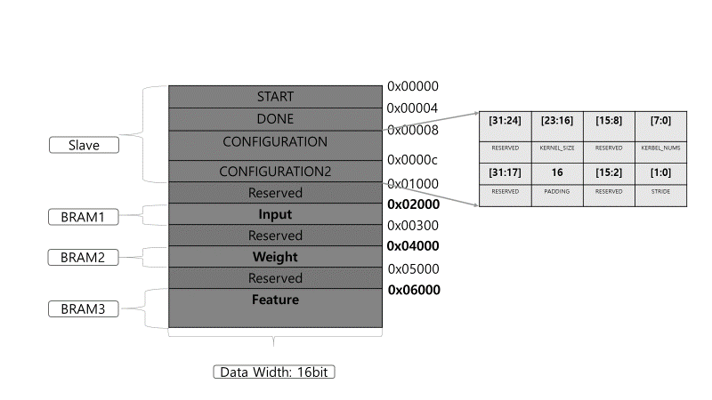
Figure 1.2. Memory map and required memory
On this Figure 1.2, There is the memory allocation information. This project uses 16bit fixed point, therefore the data width is ’16bit’.

The details like in below.
- Slave registers: parameter setting value. Consist of 4 registers.
- BRAM1 : INPUT data value, enough data capacitance (32x32=1024)
- BRAM2 : WEIGHT data value.
- BRAM3 : FEATURE data value.

FINITE STATE MACHINE

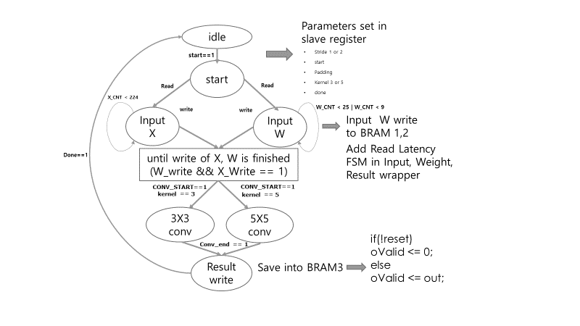
Figure 2.1. Finite State Machine of CNN_CTRL module

- IDLE state: when START data in Figure 1.2. is ‘1’, the next state will be START.
- START state: this state is for initiating transition of CNN control FSM. When current state is transit into START parameters such as Stride, Padding value from Figure 2.2. is set into the slave registers.
- Input X, W state: After parameters is set, input X, and input W is being read and saved into BRAM 1,2. While input signals are processing, W_cnt and X_cnt signals are going to be counted until is finished. When counting signals are done, convolution calculation state begins.
- CONV(3 or 5) state : This state is for convolution with ‘W’ values from Input W and ‘X’ values from Input X, when satisfied the condition of stride. Also, I add modified Ovalid calculation in order to extract values what designer desires.
- Result Write state: After convolution and Ovalid calculations, this state saves result data into BRAM3.

PSEUDO CODE (CNNIP CONTROL)

enum { IDLE, START, INX, INW, CONV, RESULT_WRITE } state_aq, state_next;

reg [7:0] cnt_inx;
reg [4:0] cnt_inw;
reg [16:0] cnt_aq; // for done state

// input x register
always @(posedge clk_a, negedge arstz_aq)
if (!arstz_aq) cnt_inx <= 8'b0;
else if (state_aq == INX) cnt_inx <= cnt_inx + 8'b1;
else cnt_inx <= 8'b0;

// input w register
always @(posedge clk_a, negedge arstz_aq)
if (!arstz_aq) cnt_inw <= 5'b0;
else if (state_aq == INW) cnt_inw <= cnt_inw + 5'b1;
else cnt_inw <= 5'b0;

// use wires as shortcuts
wire inx_done = (cnt_inx == 8'd255);
wire inw_done = (cnt_inw == 5'd25);
wire wait_done = (cnt_aq == 16'b1000_1111_0000_0000);

// state transition
always @(posedge clk_a, negedge arstz_aq)
if (!arstz_aq) state_aq <= IDLE;
else state_aq <= state_next;

// state transition condition
always @(*)
begin
state_next = state_aq;
case (state_aq)
IDLE:
if (CMD_START) state_next = START;

START:
if(X_read) state_next = INX;

START:
if(W_read) state_next = INW;

INX & INW:
if (W_write && X_write==1) state_next = CONV;

CONV:
if(CONV_end) state_next = RESULT_WRITE;

RESULT_WRITE:
state_next = IDLE;
endcase
end

WAVEFORM

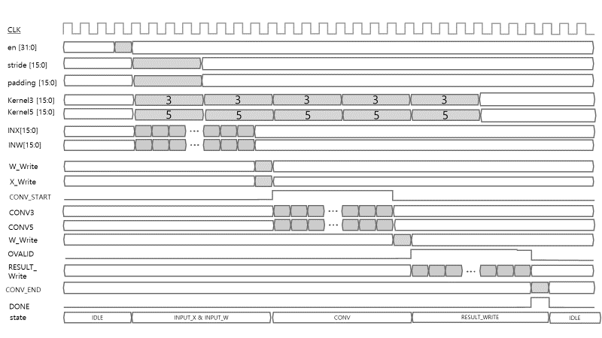
Figure 4.1 waveform of Convolution IP

TOP DESIGN

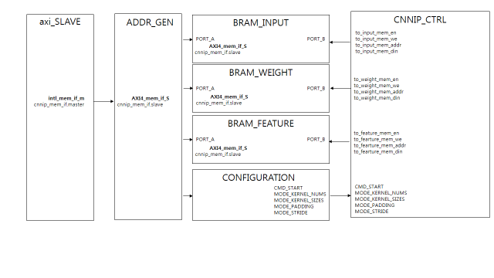
Figure 5.1 Top architecture of Convolution IP

