LSTM Hand-Trajectory Prediction for Latency Compensation in Vision-Based Robot Teleoperation
This report explains the problem this project solves, how the solution is implemented, and how to run it step by step.

1. About the Project
The problem. The teleoperation pipeline tracks the operator's hand with a webcam (MediaPipe Hands) and servos a 6-DOF arm toward it in real time (MoveIt Servo pose tracking). The raw hand position estimated from camera images is noisy, so the original pipeline smoothed it with an exponential moving average (EMA). Smoothing removes jitter but introduces lag (~75 ms): the robot is always commanded toward where the hand was, not where it is.
The fix. We replace the EMA with a small LSTM (~4,700 parameters) that predicts the hand's displacement ~100 ms ahead from the last 15 frames, compensating the camera–inference–control latency and turning lag into lead. The model is trained on 22,420 self-recorded hand positions — no manual labels are needed, since the future position in the same recording serves as the training target. Predicting displacement (rather than absolute coordinates) makes the model translation-invariant; an earlier absolute-coordinate version failed badly due to distribution shift between workspace regions.
Results. At a 98 ms prediction horizon the LSTM reaches 2.32 mm MAE — 47% better than copying the last frame (persistence) and 68% better than the deployed EMA. The trained model is exported to TorchScript and runs inside the live ROS 2 node at 0.1–0.2 ms per frame, with a runtime LSTM/EMA toggle and automatic EMA fallback.

2. System Requirements
- Ubuntu 22.04 with ROS 2 Humble
- MoveIt 2
- Python dependencies — listed in nxp_omniman_ws/project/requirement.txt; install them with:
pip install -r requirement.txt

3. Build and Run — Step by Step

Step 1 — Create the workspace
mkdir -p ~/workspaces/nxp_omniman_ws/src
cd ~/workspaces/nxp_omniman_ws/src

Step 2 — Clone the repository (skip if you downloaded the ZIP)
git clone git@github.com:dokterkepin/nxp_omniman_ws.git .

Step 3 — Install ROS dependencies via rosdep
cd ~/workspaces/nxp_omniman_ws
rosdep install --from-paths src --ignore-src -r -y

Step 4 — Build the workspace
colcon build --symlink-install

Step 5 — Set the camera port
You can check which port the camera is attached to in Ubuntu with: v4l2-ctl --list-devices
Set the camera port in src/project/mediapipe_pose_tracking/launch/omniman_hand_teleop_demo_launch.py:
DeclareLaunchArgument("camera_device", default_value="0") — at line 167 the default is camera port 0; change it to the port your camera is attached to.
Also make sure the port is updated in src/project/mediapipe_pose_tracking/scripts/hand_pose_publisher_node.py:
DeclareLaunchArgument("camera_device", default_value="0") — see line 67; the default is port 0.

Step 6 — Run the demo
ros2 launch mediapipe_pose_tracking omniman_hand_teleop_demo.launch.py

4. How It Works
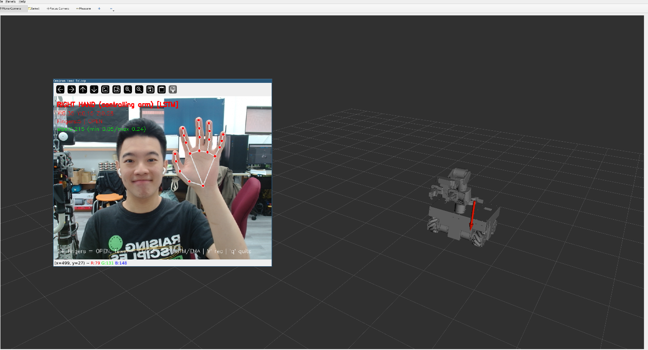
The implementation is based on MoveIt Servo real-time pose tracking: MediaPipe hand tracking generates a target pose, and a proportional controller servos the arm toward it in real time. This project adds an LSTM trajectory predictor in front of that controller — instead of commanding the EMA-smoothed (lagging) hand position, the node commands the position the LSTM predicts ~100 ms ahead. The prediction is clamped to the workspace box, and the node automatically falls back to the EMA while the 15-frame buffer fills or whenever hand tracking is lost.
Move your right hand to control the target position. Raise your left hand to reset the arm to the ready pose — useful when you run into a singularity. Press m at runtime to toggle between LSTM and EMA modes (the active mode is shown in the camera overlay).

5. Repository Map (ML Components)
The machine-learning components live in the mediapipe_pose_tracking package (branch final_project):
- scripts/hand_pose_publisher_node.py — teleoperation node with the recording mode (r key), the deployed LSTM predictor, and the LSTM/EMA toggle (m key)
- dataset/hand_traj_*.csv — the recorded sessions (22,420 frames)
- report/train_lstm_trajectory.ipynb — the full training pipeline: loading, splitting, training, evaluation, figures, and model export
- models/lstm_hand_traj.{pth, torchscript.pt, json} — the trained model (PyTorch state dict + TorchScript) and its normalization constants

6. Retraining the Model
- Run the teleoperation node (the robot is optional — only the webcam is needed), press r, and move your hand to record a new CSV session.
- Run all cells in report/train_lstm_trajectory.ipynb to retrain and re-export the model.
- Restart the node to deploy the new model.
Hyperparameters: window L = 15 frames, horizon H = 3 frames (~98 ms), hidden size 32, single LSTM layer, Adam (learning rate 10⁻³), batch size 256, 60 epochs, best-validation checkpoint, seed 42.

7. Results Summary
Test-set error at the 98 ms prediction horizon (lower is better):
Method | MAE [mm] | RMSE [mm]
LSTM (ours) | 2.32 | 5.68
Persistence (copy last frame) | 4.36 | 10.27
EMA (deployed pipeline) | 7.20 | 16.75
Under 5-fold blocked cross-validation the LSTM scores 2.28 ± 0.45 mm MAE and 4.75 ± 1.67 mm RMSE, beating both baselines in all five folds on both metrics. Inference takes 0.1–0.2 ms per frame on CPU — negligible against the 33 ms frame budget.
Honest caveat: on the real robot, switching between LSTM and EMA produces no perceptible difference in teleoperation feel. The arm's proportional controller and velocity/acceleration limits dominate the end-to-end latency — the system is actuator-limited, not perception-limited. The predictor measurably improves the reference signal the robot is asked to track; exploiting it fully would require a faster arm or higher control bandwidth.

