Operia
Quick Guide (rough, very)

Tech Stack
:

Backend
Supabase (Postgres + RLS, Auth with Entra ID/MFA, Edge Functions (Deno), Storage, pg_cron) + Email sender: Resend (https://resend.com) – for sending logon + asset reminders.
Email receiver: Postmark (https://postmarkapp.com/) - for detecting asset bounce emails (invalid emails).
SMS: GatewayAPI (https://gatewayapi.com) – for sending asset reminders.
Domain control: one.com
:

Frontend
Vite/React/TypeScript SPA + Tailwind/shadcn + TanStack Query/Router + i18next.
Icons: https://lucide.dev/icons; Animated icons here: https://animate-ui.com/docs/icons + https://lucide-animated.com/

Android:
Kotlin + Jetpack Compose + supabase-kt

Integrations
OpenRouteService (https://openrouteservice.org/) - for maps.
Google Maps – for maps.

General Elements
The Operia Table is a common feature used throughout the application.

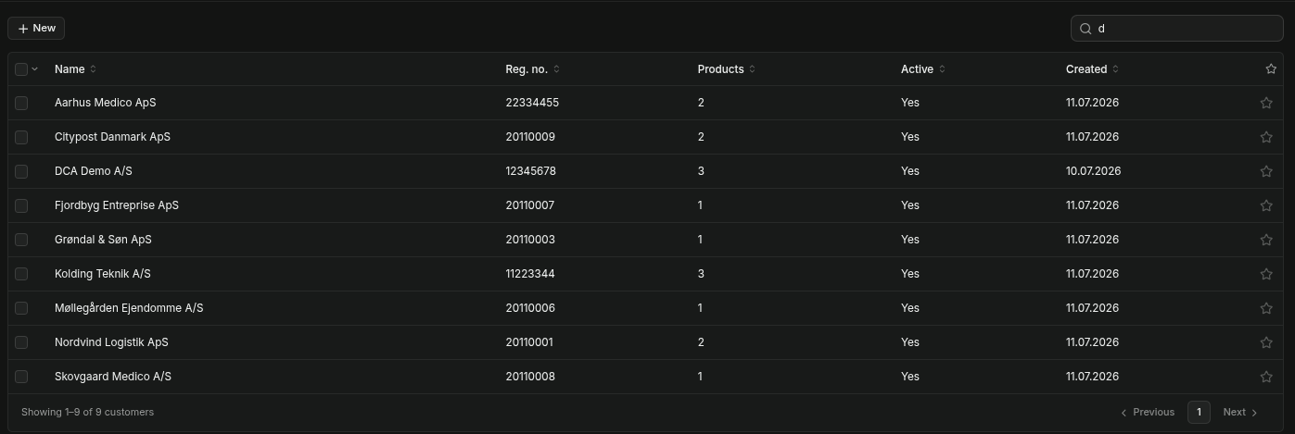
Top/Right: search/filter; all columns are sortable; leftmost column has checkboxes which can be selected/unselected by clicking on the checkbox, rightmost column has stars which can be starred/unstarred by clicking on the star / or by right-clicking on a row. Checkbox column header has a drop down menu, which at a minimum has these two items: Select All; Starred + more depending on which table it is. When one or more rows have been selected, a selected row will be displayed under the table: this has at a minimum these two icons (right-aligned): Show only selected; Delete Selected.

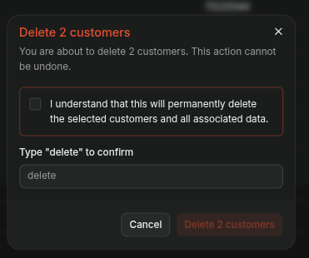

Delete selected will popup a warning/confirmation dialog, where the user has to click on checkbox to confirm + type in “delete” (or “slet” in Danish) in their selected language. Under the table/to the right is the pagination. The table shows max 10 rows per pagination page.

Clicking on a table row displays a detail pane (or most tables) with two or more tabs. The leftmost tab is always “Details”, and the rightmost tab is always “Actions.” To the right of Actions, is always two icons: Maximize/Normalize (maximize/normalize the detail pane), and a “X” to remove the detail pane.

The Details tab typically has:
ID of the selected id (in a non-editable field + copy-to-clipboard icon). The ID is Operia’s internal ID, and used for issue tracking if a customer calls in with a problem.

Name, Description, Notes – where available.

Any changes will always display the Cancel/Save Changes bar at the bottom of the screen. Such that you always know precisely where it is.

The Action tab typically has a delete function. With the same popup warning dialog.

Menus

Icon toolbar (top/right screen)
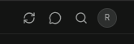

1) Refresh. Load data from database, in case there have been an update (from another user working on the same customer) Refresh also happens at a regular interval (30 seconds), the interval time can be configured in Operia Configuration → General → Refresh Interval

2) Feedback. Allows the user to come with bug reports or ideas for improvements. Entries can be read in Operia Configuration → Feedback

3) Search. Not yet implemented.

4) Account Menu
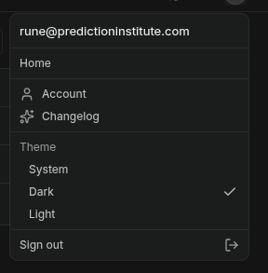

1) Account. Takes you to the account page.

Account Page
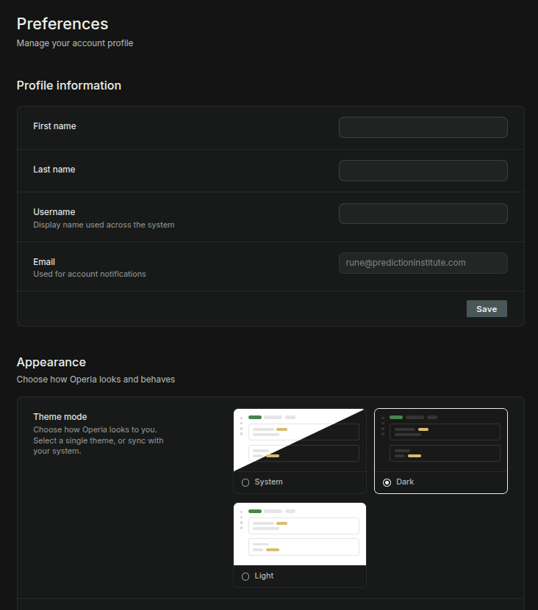

The user can change his Name, Username, Email. Username is used for display on the web; First, Last name are used for email, SMS, handheld greeting, etc.

Appearance. Choose same theme as computer (only supported on some OS), dark or light mode.
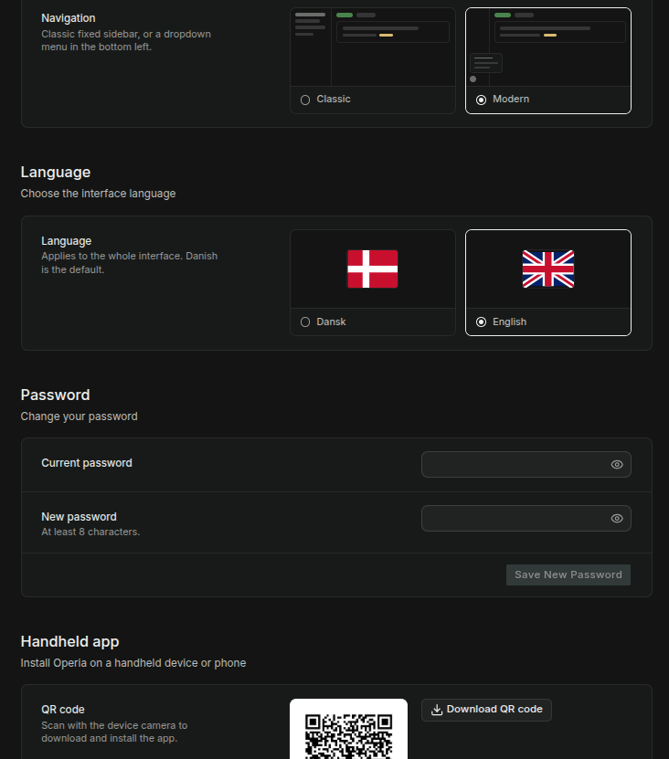

Navigation. Classic: all menu-items are available on the sidebar. Modern: Only the package flow menu-items are visible (should also be Asset flow I think), and displayed as buttons instead of menu-texts. All the remaining functionality is available, from the pull-up start menu (bottom/left).

Language. Select language. Only Danish/English for now. Others can easily be added.

QR. Take picture with your Android or download for Mobile Android app install. The QR code is just an url pointing to the Supabase Amazon S3 bucket containing the APK.

Home
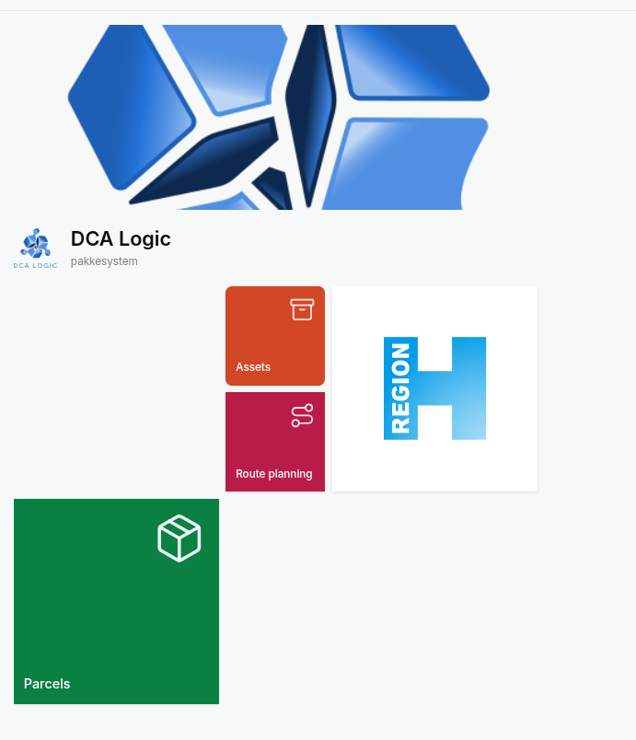

The home/landing page displays all the products the user has access to. Clicking on a product redirects to the product page. The Home page can be returned to by clicking Home in the side-menu/start-menu, where it is always the top menu-item.
The Home page can be configured under Configuration → Home Design (& Operia Configuration → Home Design)

Configuration
There are two configuration levels: Operia Configuration and Customer Configuration.

Operia Configuration is application-wise configuration options. They either apply to all customers, or determine the functionality which is available application-wise (for all customers, both on the web and the handheld), or functions as a template for configurations of new customers – depending on which Operia Configuration is chosen. Only Super-users can see the Operia Configuration.

Customer Configuration are configuration settings for a single customer. Will override the Operia Configuration, where the Operia Configuration is a template for Customer Configurations. Only Managers (& Super-users) can see the Operia Configuration.

The two configurations can be found at 1) the bottom of the side-menu (classic navigation layout), or bottom of drop-down menu (modern navigation layout)
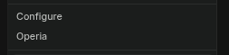

Operia Configuration
The configuration options are available:

1) Customers
2) Users
3) Feedback
4) General
5) Products & Features
6) Home Design
7) Handheld Design
8) Carriers
9) Shipping & Billing
10) Assets
11) Maps & Routes
12) Data Transfer
13) API Keys
14) Integrations
15) Templates
16) Localization
17) Notifications
18) Billing
19) Logs
20) Log Drains

---

1) Customers.
This configurations shows all customers created in Operia.

Clicking on a row displays a detail pane (or most tables) with two or more tabs. The leftmost tab is always “Details”, and the rightmost tab is always “Actions.” To the right of Actions, is always two icons: Maximize/Normalize (maximize/normalize the detail pane), and a “X” to remove the detail pane.

Details tab:
ID
Company Name
Reg No.

Action tab
Deactivate customer (can be re-activated)
Delete customer

Other tabs:
2) Products
3) Billing
4) Shipping & Billing
5) Logo
6) Localization
7) Appearance
8) Data Transfer
9) Log Drains

Products
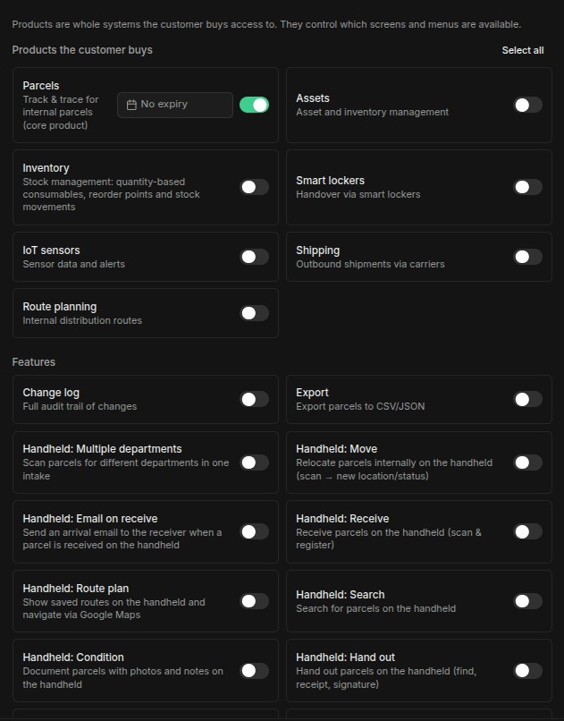

Here the Customer can be given access to products & Features. Features belong to Products, and only the Features of the activated Products are shown. Products and Features can also be given an expiry date. Customer managers can see his own enabled Products & Features (Configuration → Products & Features), but only in read-only mode.

Billing
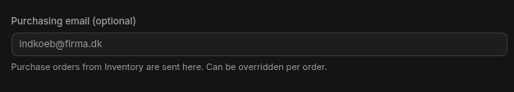
Only has this one configuration: purchasing email. Moved. This configuration option should be moved under Details.

Shipping & Billing
Mainly a scaffold page for now, the functionality has not been developed or integrated further in the system.

Select Margin or BYOC
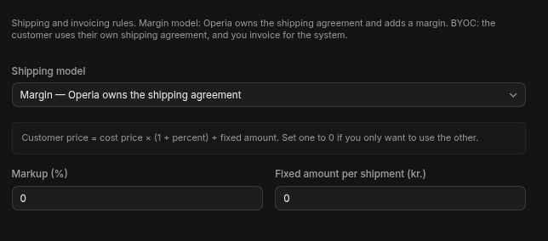

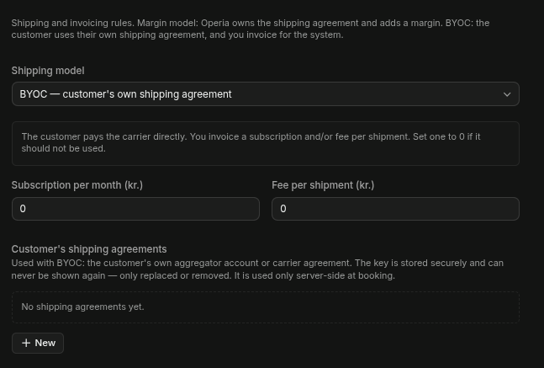

Logo
Upload a customer logo. I think the menu is deprecated, as the functionality has been moved under Home Design.

Localization
Select language (templates, etc.), currency (used in Shipping & Billing), and timezone.

Appearance
Change colours, texts of individual products. This features has not been implemented throughout, not sure if it is still required.

Data Transfer
Enable / disable SFTP and/or Email data updates for this customer.
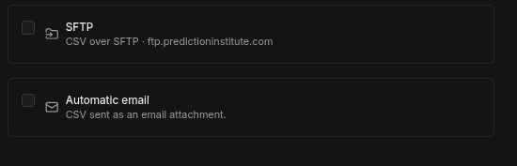

If either of those are disabled, they’ll be disabled (no displayed at all) for all customers.

Log Drains
Automatically send log messages to a third party system. Either HML/NDJSON (generic) or Grafana Loki. Can strengthen the NIS2 position.

This is an advanced feature which is usually only available for pro-packages.
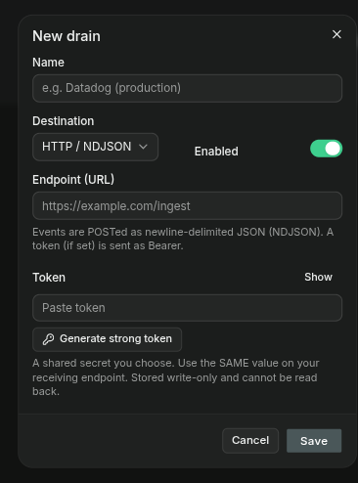

2) Users
This configurations shows all users created in Operia. Users are actually created in Supabase (Supabase → Dashboard → Project → Authentication) and only copied to Operia. For increased security and things like 2FA. The user name is an Operia add-on which is not stored in Supabase.

- Details tab: the name and email can be changed.
- Access tab: give individual roles to the user. Currently these roles are defined:

1) Managers: access to everything (that is accessible on the customer. Customer managers, still do not have access to Operia configurations, or other customers, etc. - same as the current users)

- all pages the other roles can access, including customer configuration

2) Data Managers
- can access the pages under Master Data; Employees, Departments, Lockers, Import/Export.

3) Package handlers

- can access the Parcel pages: Receive parcel, Hand out parcel.

4) Package managers

- in addition the pages of the Package handlers, can also access the parcel pages: Parcel Dashboard, Parcels, Parcel Reports, Parcel Statistics.

5) Handheld package handler

- Can register and hand out parcels on the handheld.

6) Asset handlers

- not yet defined.

7) Asset managers

- can access all pages under Assets.

8) Handheld asset handler

- not yet defined.

9) Inventory handlers

- not yet defined.

10) Inventory managers

- can access all pages under inventory.

11) Handheld inventory handler

- not yet defined.

12) Route Planner handlers

- not yet defined.

13) Route Planner managers

- can access all pages under Route Planner.

14) Handheld Route Planner

- can use the route planner on the handheld
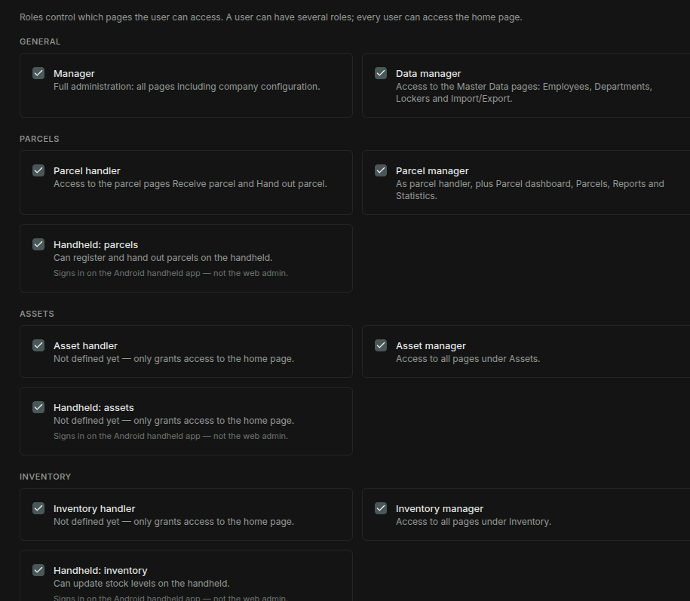

- Action tab, has delete user (will also be deleted in Supabase) and change password
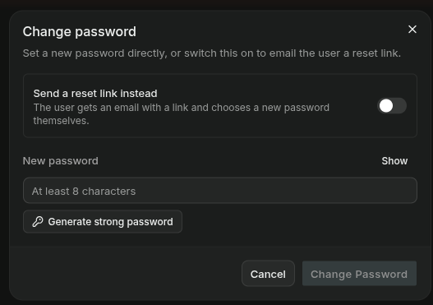

New password can be explicitly written in (or automatically generated), or a link can be sent to the user, where he can change it himself.

3) Feedback
List what feedback has been received (through the icon toolbar – top/right). To types of feedback: Idea, Issue!

4) General
Some general settings. There is only this one for now: Refresh Interval. This determines how often the application will poll the backend for data updates. Default 30 seconds.

5) Products & Features
Lists the Products and Features which are available in the application. Turning off a Product or Feature removes the Product/Feature from all customers (they’ll not be displayed)

6) Home Design
Design the look and functionality of the home/landing page. There are two tabs: Details, Tiles.

Details
Write in (optional) a Welcome Title / Subtitle (note. these are not language localized – will be the same for whatever language is selected. This can be changed if necessary)
Upload (optional) a logo (transparent PNG, landscape, about 480×120 px, max 4:1 ratio. Shown at full height without cropping). I think perhaps this should be changed; logos should be square?
Upload (optional) a hero (JPG about 1600×600 px. Cropped to fill, so keep the key content centred). Ought to be changed, so it accepts other file formats (PNG)
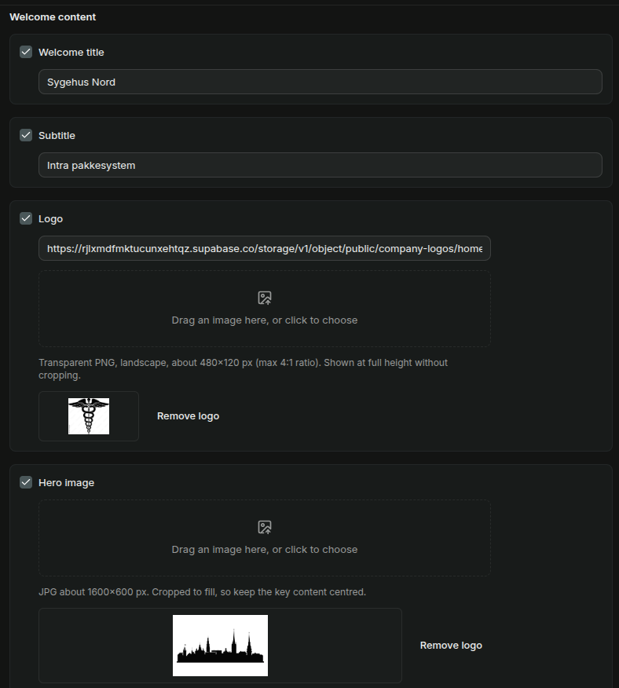

Tiles
Order, rearrage, resize and design the titles displayed on the home page.

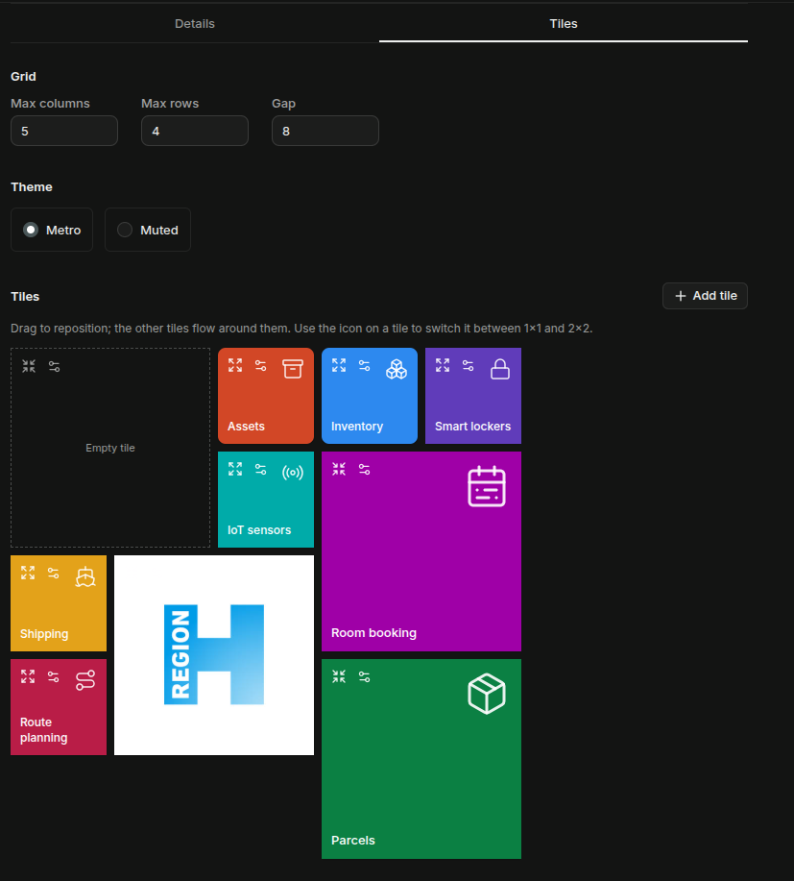

- Max columns / Rows: determines how wide/high he tile space is.
- Gap: space between tiles.
- There: Metro, muted. Added six other themes, incl. handheld. (theme should be removed I think, now that individual tiles can be given individual colours. Or else, the themes should have more difference, than just a muted alternative – the latter solution is best I think.)
- Tile Area: Drag tiles around to reorder. Click on maximize / normalize icon (top/left on all tiles) to set size to either 1x1 or 2x2 (it should be possible to set other sizes, 1x2. 1x3. Etc.)
- Tile Configuration: click on the configuration icon to open the tile configuration dialog.
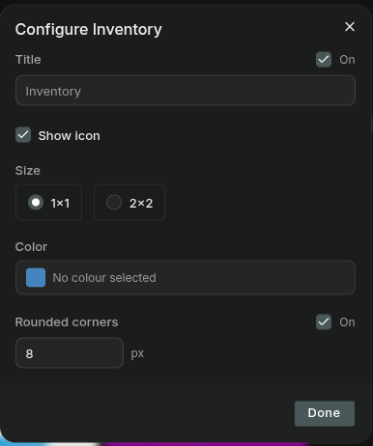

  - Title: Name on tile. Unclick the checkbox, to remove title entirely.
  - Show Icon. Display icon on title.
  - Size: 1x1 or 2x2. Added more sizes (it should be possible to set other sizes, 1x2. 1x3. Etc.)
  - Color. Pick or set the background color of the tile.
  - Rounded Corners. Set corner rounding.
  - Remove tile. Remove tile.

7) Handheld Design
Design the Android handheld (changing the design does not necessitate a new APK file) The page has three tabs: Details, Tiles, Actions.
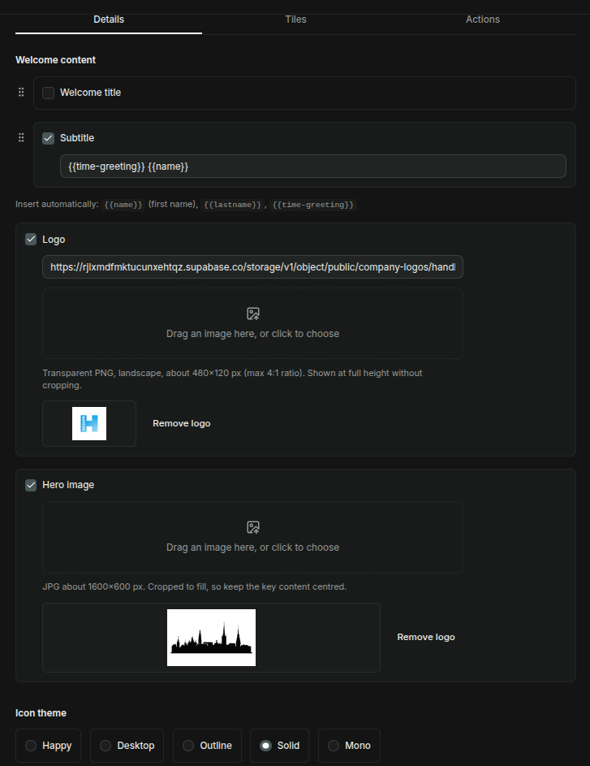

Details
Welcome title & Subtitle: What is displayed at the top of the handheld. Welcome title has a larger font, than Subtitle. Drag either up/down to determine which is on top. Use the special tags {{name}} = first name; {{lastname}} = last name; {{time-greeting}} = greeting depending on the time of the day, Good Morning, Good Evening, Good Night.
Logo & Hero. Add/Remove logo and hero to handheld.
Icon Theme. Happy = colorful icons; desktop = same icons as those used on the web; Outline, Solid, Mono = native Android icon sets.

Tiles
The mockup shows how the handheld will look.
Drag tiles to reposition. Click on (rightmost) X-icon to remove tile.
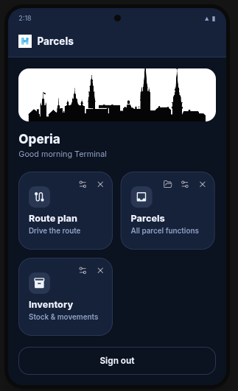

Click on configure icon, to open the configuration dialog:
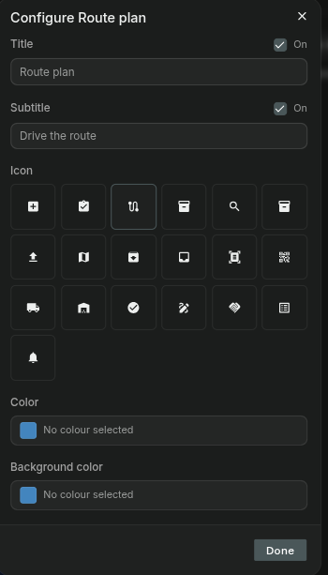

In the tile configuration dialog, the tile title + subtitle can be set, the icons, and foreground/background colors.
The Parcels title is a special tile with sub-titles under it (like a file folder). Click on the folder icon, to open the folder configuration dialog. Drag titles around in the folder, or click on an individual tile configuration icon, to configure the tile.

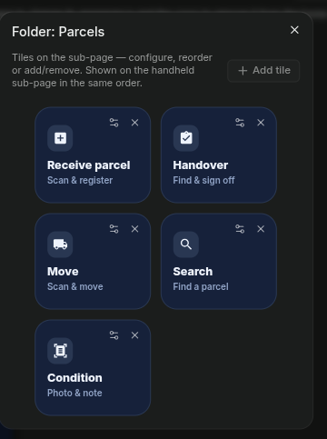

Click on the “+ Add title” to add new tiles to the handheld.
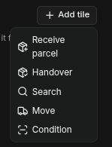

Actions
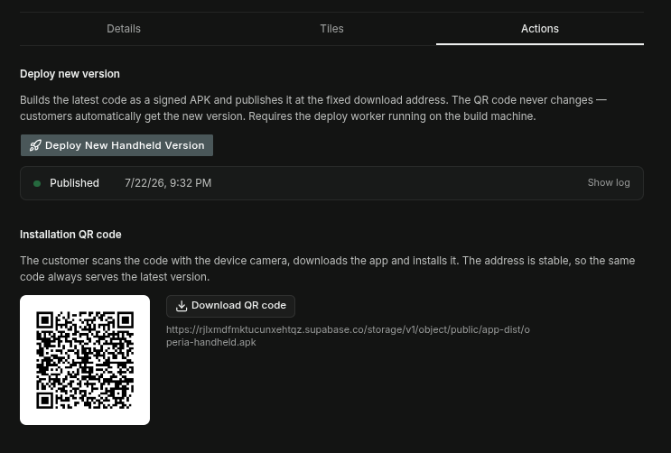

Deploy: Only superuser developers.
QR Code: scan with handheld camera or download code to install application on the phone.

8) Carriers
Note Carrier Agreements is a stub, the functionality has not been fully implemented or integrated with the rest of the application.
Table of existing carrier agreements. Click on row in table to edit an existing agreement, or click on the “+ New” button to create a new carrier agreement. Carrier Agreements can be of either type: Aggregator Account or Carrier Agreement (direct). The type cannot be changed after having been made. The API key, after having been pasted in, cannot be edited or displayed again. If changes need to be made to this, a new API key will have to be inserted.

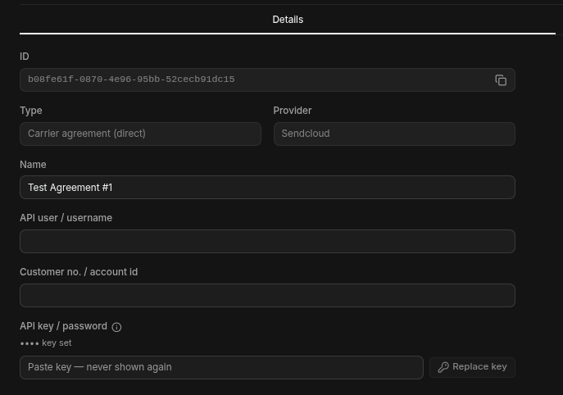

9) Shipping & Billing
Mainly a scaffold page for now, the functionality has not been developed or integrated further in the system.

Select Margin or BYOC

10) Assets
Configuration options for the Asset product.
- Default Expiry.
- Default Categories. Categories which will be given by default to new customers (they can edit or delete them if they want)
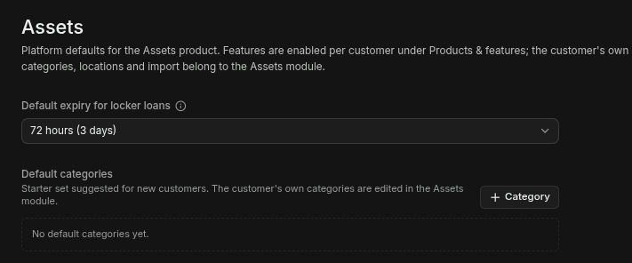

11) Maps & Routes
Determine which route manager is used by Operia: OpenRouteService (https://openrouteservice.org/) mostly free, as good as Google Maps – except for live congestion reporting; or Google Maps. Each map service requires an API key.
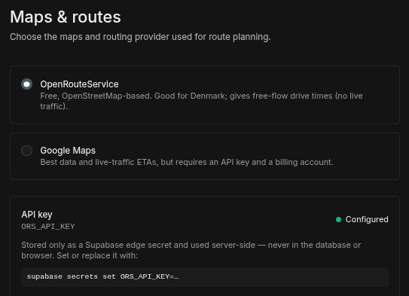

12) Data Transfer
Activate / deactivate and configure SFTP and/or Automatic Email for data uploads.
Both of these features have been implemented and test. The SFTP only on local server. Both will require an extra iteration of test before taking to production with a customer.
The SFTP requires an external server (Supabase cannot do active listening).
Here are some examples of costs:
* Hetzner : $3.20/md (www.hetzner.com)
* fly.io : $1.94/md (https://fly.io/docs/about/pricing/) + storage cost?
* Railway : (https://railway.com/pricing)
* Hostinger : $2.99 / md - for 48 months up front. (https://www.hostinger.com/pricing) $3.79/md includes daily backup.
Email includes some comprehensive added security checks, but I’m not sure they’re 100% effective. Will reequire some additional consideration before just opening for automatic processing.
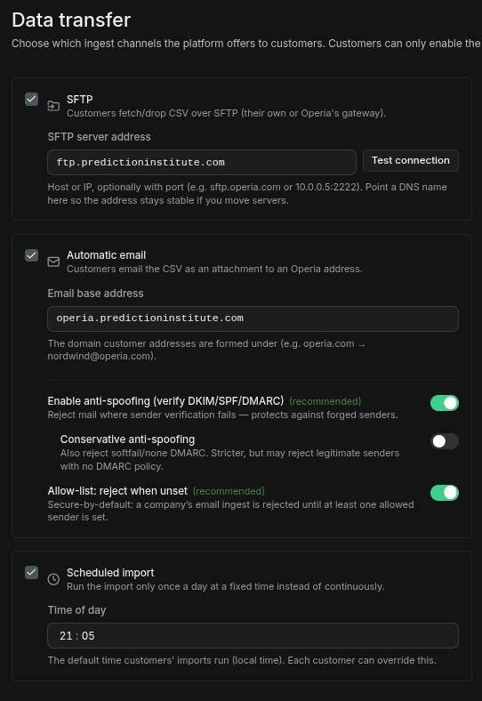

13) API Keys
Removed Nothing here. Should probably deleted.

14) Integrations
Integrations with third party software and services. Only one such is present at the current time: Microsoft Active Directory.
Microsoft Active Directory. This is an advanced feature which is usually only available for pro-packages.
This is for automatic update of the employees in the system. That is; parcel handlers.
- Enable. Checkbox; enable/disable MS AD. Sitewse.
- Anonymize retired employees. If enabled (recommended for NIS2), retired employees are anonymized in Operia. They will not be anonymized until all their outstanding parcels are sorted out.
- Sync interval. Hourly; 4hrs; 12hrs; Daily; Weekly
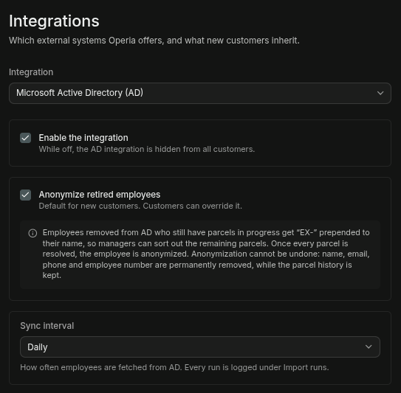

15) Templates
Message and barcode/QR code templates.
Currently there are 15 templates defined in the system. Each can be given using all defined languages (currently only Danish & English)
Messages can have some special codes insert, which will be substituted when delivering the message: {{company name}} {{receipient name}} {{reference}} {{barcode}} {{carrier}} {{date}}. We can add more to this list, as required.
Perhaps we should integrate the web and SMS in a single template page, to cut down on the number, the same way language is already integrated.
- Asset Expiry
- Asset Expiry (SMS)
- Asset Manual Reminder
- Asset Manual Reminder (SMS)
- Asset Reminder 1
- Asset Reminder 1 (SMS)
- Asset Reminder 2
- Asset Reminder 2 (SMS)
- New Customer Invite
- Package Arrival
- Package Arrival (SMS)
- Package Reminder 1
- Package Reminder 1 (SMS)
- Package Reminder 2
- Package Reminder 2 (SMS)
- Package Label
The Package Label template has some special configuration options:
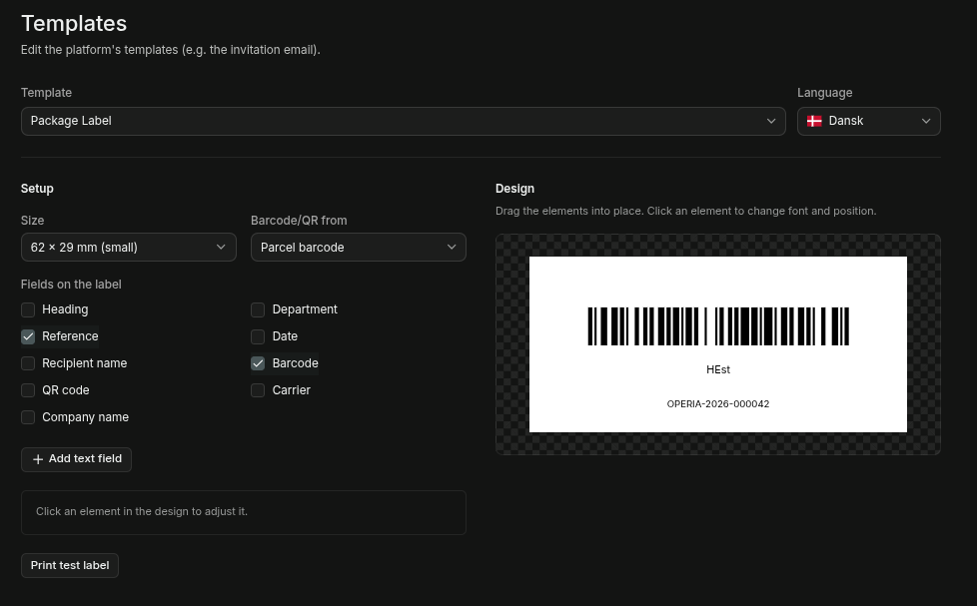

- Size: 62 x 29 mm (small); 62 x 100 mm (large); 100 x 150 mm (shipping); custom.
- Barcode/QR from: Reference (Operia); Parcel Barcode (should not parcel QR be here?)
- Fields: Can insert a number of fields, incl. Barcode & QR code.
- On the preview pane, the individual elements can be dragged around to reposition them as wanted. All fields can also be configured with regard to size, font, etc.

16) Localization
Set default values for language, and currency; as well as which languages and currencies are available for the customer. Only languages & currencies which are enabled here are available for customer managers to select.

17) Notifications
Configure site-wise notification protocols. Some overall configurations:
- Activation: send parcel notifications; send asset reminders.
- Channels: Email, SMS
Quit Hours: during which nothing will be sent. This needs more testing.
And some configuration that pertains to the type of thing being notified on.
Parcel Flow & Asset flow notifications (they’re the same):
- Reminder 1. Send reminder after X number of days.
- Reminder 2. Send 2nd reminder after X number of days.
- Maximum number of reminders per parcel/asset. Keep sending 2nd reminder for only this number of times.
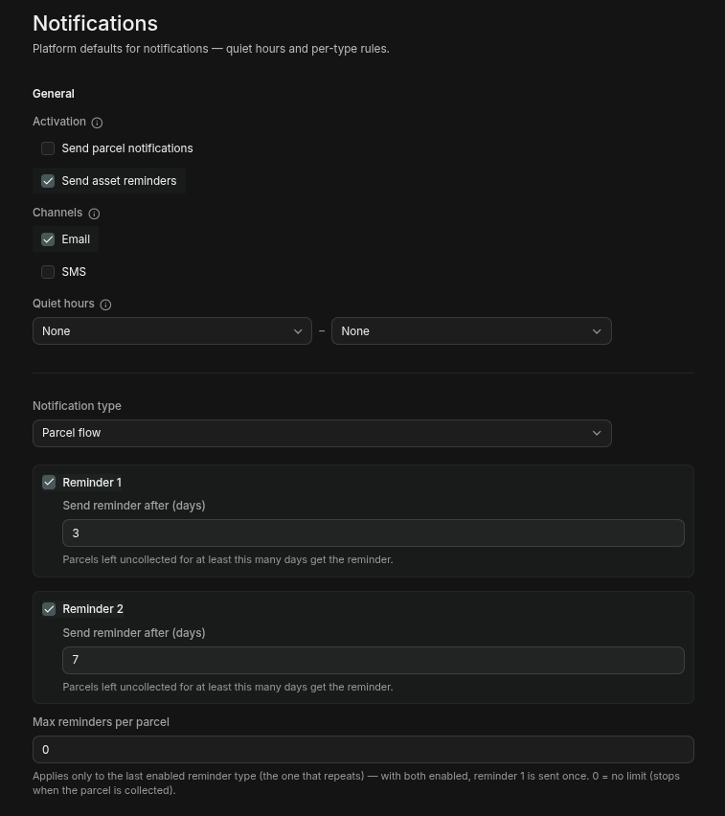

18) Billing
Nothing implemented here. Should be removed?

19) Logs
The logging is quite extensive. Which is a selling point for NIS2, and in general good for examining what is going on if users report some issue.
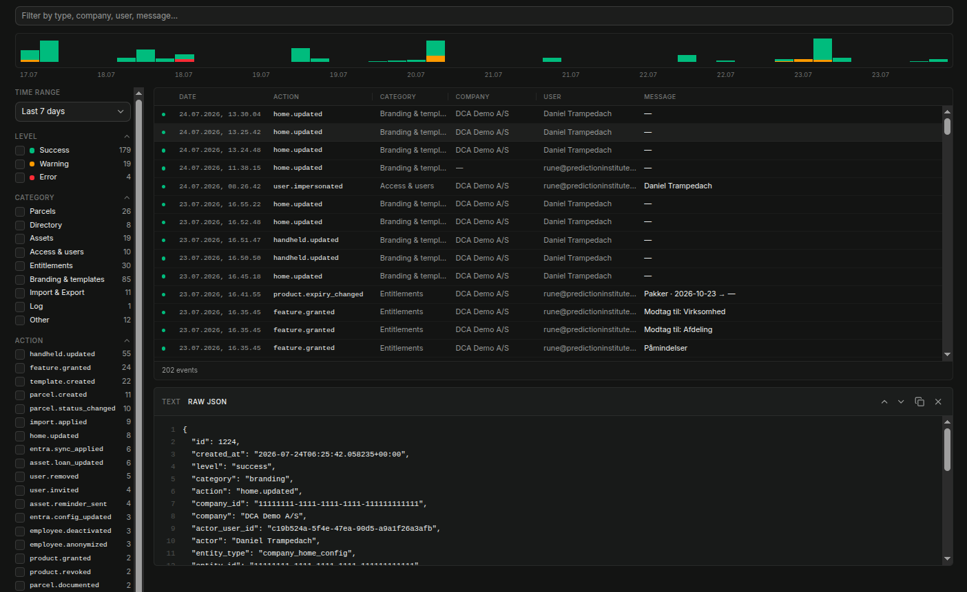

- Top/Left is a search/filter input, for isolating a particular log.
- Below the filter input, is the daily log activity bars.
- Clicking on a log row, will open up a detail pane below. Where the log message can be downloaded in text or JSON format.
- Hovering over the date, or a column which has been truncated will display a fuller message in a tooltip.
- On the left of the log table you can filter down the displayed log messages to the log levels, categories, actions you are interested in.
- Too/right is a icon toolbar. You can toggle which columns you want displayed, download the whole log, presse live to make log messages appear as they happen.

20) Log Drains
Automatically send log messages to a third party system. Either HML/NDJSON (generic) or Grafana Loki. Can strengthen the NIS2 position.

This is an advanced feature which is usually only available for pro-packages.

List of existing log drains. Click on the button new to create a new drain.

Customer Configuration
The customer configuration has a subset of the options on the Operia configuration, with a few variations. These configuration menus are available:
- Users
- Products & Features
- Templates
- Localization
- Notifications
- Billing
- Shipping & Billing
- Logo
- Appearance
- Home Design
- Handheld Design
- Data Transfer
- Integrations
- Log Drains

Users
Same as Operia Configuration → Users, except only displays users for the customer (and no superusers).

Products & Features
Displays the Products and Features turned on for the customer. Read only, so the user cannot change. Only Products and Features which have been enabled are displayed. BUG: I think only products and features that are included should be displayed.

Templates
Same as on Operia Configuration → Templates

Localization
Same as on Operia Configuration → Localization, except only those languages and currencies which have been turned on on Operia are included here.

Notifications
Same as on Operia Configuration → Notifications

Billing
Nothing here. Delete?

Shipping & Billing
Same as on Operia Configuration → Shipping. Mostly a stub page.

Logo
Same as on Operia Configuration → Logo. Page has been deprecated?

Appearance
Same as on Operia Configuration → Appearance. Page has been deprecated?

Home Design
Same as on Operia Configuration → Home Design

Handheld Design
Same as on Operia Configuration → Handheld Design

Data Transfer
Same as on Operia Configuration → Data Transfer.

Integrations
A few options are the same as on Operia Configuration → Integrations, but here the user also has options to set up the actual AD connection.
- Entra Tenent ID
- Entra Client ID
- Entra Secret
- Button: Test Connection
- Group Filter
- Initials Source
Operia is using the initial (to search employees in package intake), but AD does not have a dedicated initials field. An AD source can be given here, if none is given the initials are inferred from the First, Last names.
- Button: Dry Run
Make a test sync to see if everything looks sane. Nothing will actually be updated.
- Button: Sync now
Manually run an update.

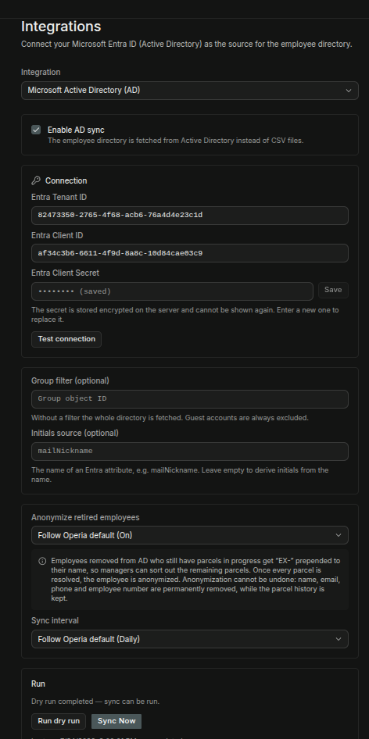

Log Drains
Same as on Operia Configuration → Log Drains.
Automatically send log messages to a third party system. Either HML/NDJSON (generic) or Grafana Loki. Can strengthen the NIS2 position.

This is an advanced feature which is usually only available for pro-packages.

Parcel Handling

Parcel Overview
A quick overview of active parcels (unassigned, registered, in storage, in transit, in locker – as well as those that have been delivered, rejected, returned over the last 24hrs)
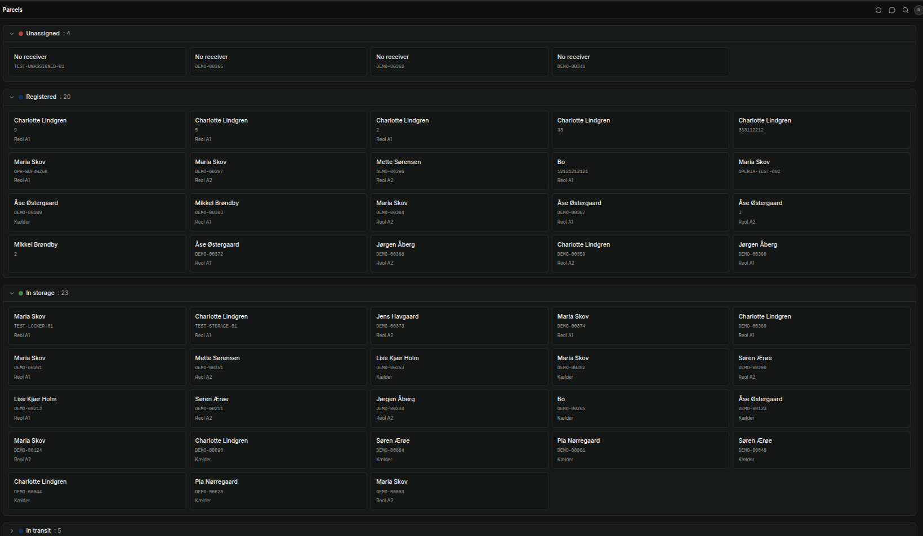
Clicking on a parcel displays a popup dialog, where the user can chose to go to handout, move, or set condition of the parcel.
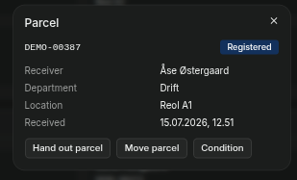

Dashboard
This page is only reachable in the Classic navigation theme. Added Add to start menu in Modern theme?
A quick overview of parcel statistics. A stub page for further development.

Parcels
This page is only reachable in the Classic navigation theme. Added Add to start menu in Modern theme?
A table with all parcels in the system. This page is meant for administrators.

Receive Parcel
The parcel intake.
- Barcode
Scan (using the pistol scanner) or manually type in a barcode number. The scanner can scan both barcodes and QR codes. (should be called Bar/QR-code?) Barcodes can also be typed manually (is this only for test?)
- Receiver
Type in the receiver. A drop down will show employees with the the letters typed in-
- Department. Drop Down.
- Carrier. Drop Down.
- Handling. Drop Down.
- Location. Drop Down.
- Condition Photo
Attach image from the computer or use webcam to take a photo.
- Note

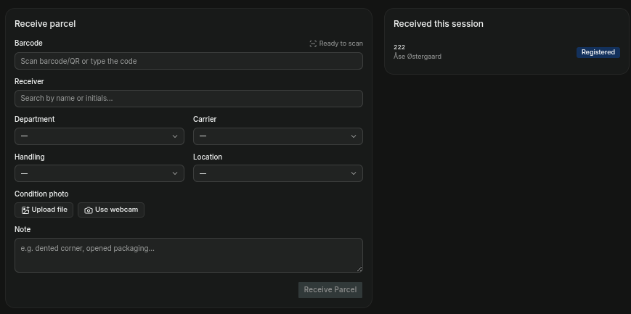

Hand Out Parcel
Use the pistol scanner to scan the barcode/QR code, or type in the barcode manually and press search. (is the manual type only for test?)

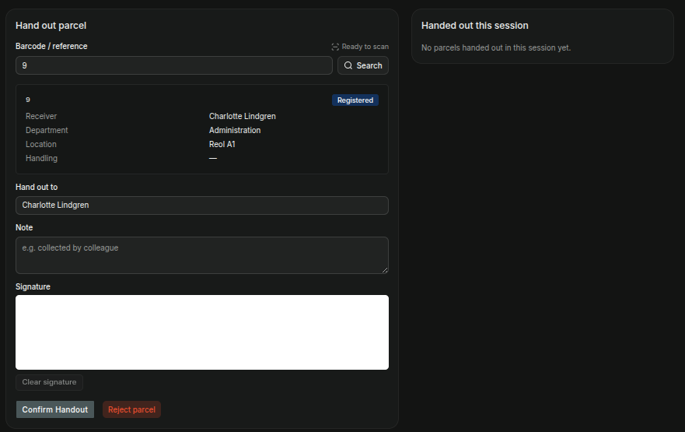

The signature can be drawn using the mouse or by a dedicated signature pad.
Click on Confirm Handout or Reject Parcel.

Move Parcel
Use the pistol scanner to scan the barcode/QR code, or type in the barcode manually and press search. (is the manual type only for test?)
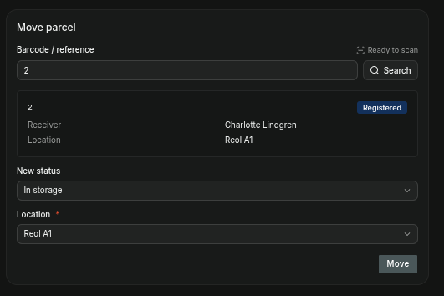

Select Status and Location and click on the button Move.

Condition
If a package is damaged or has some other issue, this can be documented here. Both with pictures and notes.
Use the pistol scanner to scan the barcode/QR code, or type in the barcode manually and press search. (is the manual type only for test?)
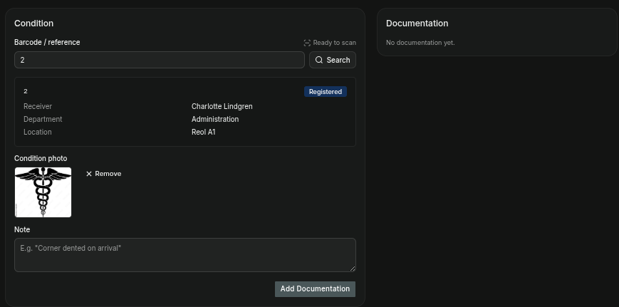

Attach image from the computer or use webcam to take a photo.

Search Parcel
Search package up in order to process it.
Use the pistol scanner to scan the barcode/QR code, or type in the barcode manually and press search. (is the manual type only for test?)
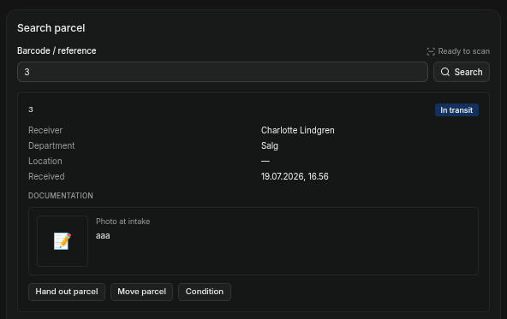

Click on buttons to go to handout, move, or set condition of the parcel.

Reports
This page is only reachable in the Classic navigation theme. Added Add to start menu in Modern theme?
Choose one of the report types. Download as PDF, CSV, Word.
Report types:
- Operations Report
- Exceptions Report
- Department Report
- Parcel History
The reports are suggestions/stubs. Review for desired KPIs etc.
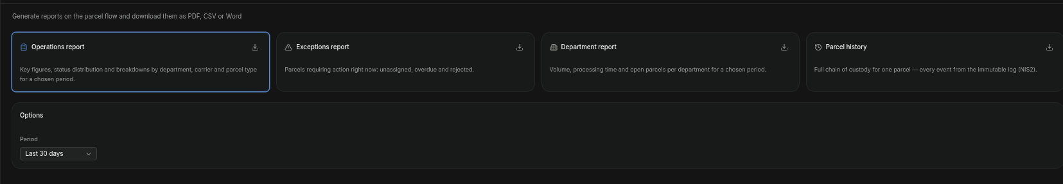

Statistics

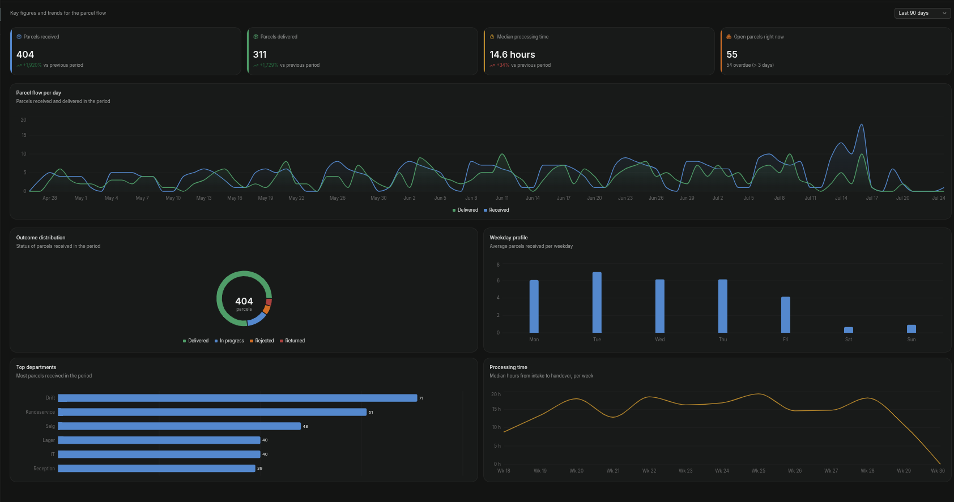

This page is only reachable in the Classic navigation theme. Added Add to start menu in Modern theme?
These are the current statistics:

- Pakkeflow pr. dag / Parcel flow per day
- Resultatfordeling / Outcome distribution
- Ugedagsprofil / Weekday profile
- Top-afdelinger / Top departments
- Ekspeditionstid / Processing time

Here are some other parametres which could be used:
- Modtager (Navn)
- Afsender
- Fragtfirma (PostNord, DHL, ..)
- Placering
- Type (brev)
- Status (unassigned, regustered, in storage, in transit, in locker, delivered, rejected, returned)

Master Data
The Master Data menus contain data which are shared across multiple products (Parcels + Assets).

Employees

Departments

Lockers

Input/Export

