Icon toolbar (top/right screen)


1) Refresh. Load data from database, in case there have been an update (from another user working on the same customer) Refresh also happens at a regular interval (30 seconds), the interval time can be configured in Operia Configuration → General → Refresh Interval

2) Feedback. Allows the user to come with bug reports or ideas for improvements. Entries can be read in Operia Configuration → Feedback

3) Search. Not yet implemented.

4) Account Menu
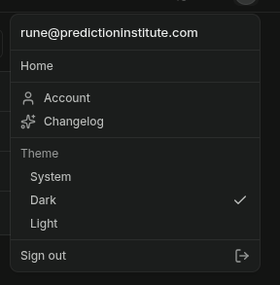

1) Account. Takes you to the account page.

Account Page
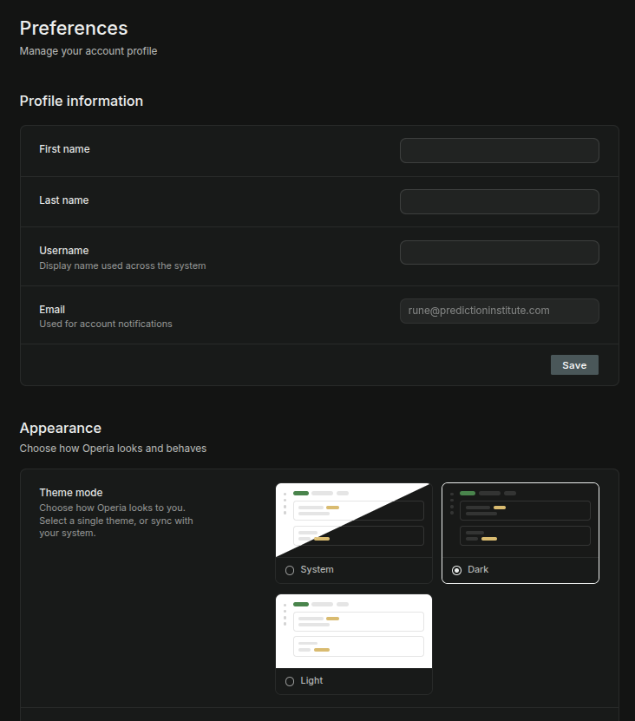

The user can change his Name, Username, Email. Username is used for display on the web; First, Last name are used for email, SMS, etc.

Appearance. Choose same theme as computer (only supported on some OS), dark or light mode.
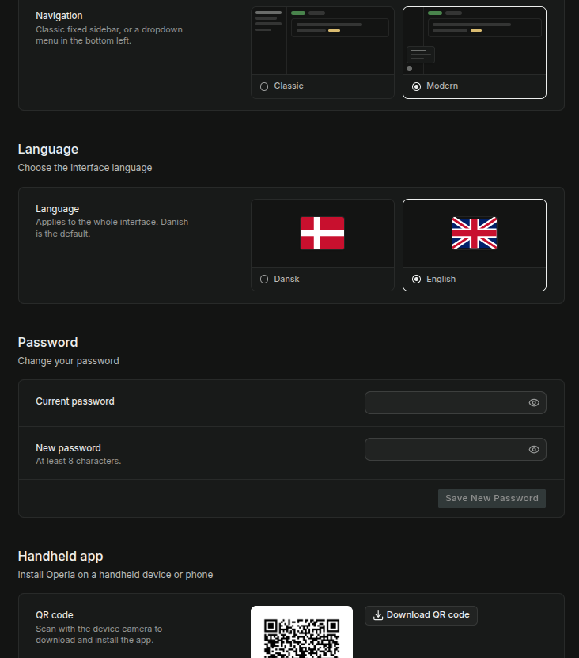

Navigation. Classic: all menu-items are available on the sidebar. Modern: Only the package flow menu-items are visible (should also be Asset flow I think), and displayed as buttons instead of menu-texts. All the remaining functionality is available from the start menu (bottom/left).

Language. Select language. Only Danish/English for now. Others can easily be added.

QR. Take picture or download for Mobile Android app install. The QR code is just an url pointing to the Supabase Amazon S3 bucket containing the APK.

Configuration

There are two configuration levels: Operia Configuration and Customer Configuration.
Operia Configuration is site-wise configuration options. They’re either system wise configurations (applicable for all customers), or determine the functionality which is available application-wise (for all customers), or functions as a template for configurations of new customers – depending on which Operia Configuration is chosen. Only Super-users can see the Operia Configuration.
Customer Configuration are configuration settings for a single customer. Will override the Operia Configuration, when the Operia Configuration is a template for Customer Configurations. Only Managers (& Super-users) can see the Operia Configuration.

The two configurations can be found at 1) the bottom of the side-menu (classic navigation layout), or bottom of drop-down menu (modern navigation layout)
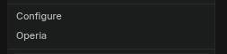

Operia Configuration has these items:

1) Customers
2) Users
3) Feedback
4) General
5) Products & Features
6) Home Design
7) Handheld Design
8) Carriers
9) Shipping & Billing
10) Assets
11) Maps & Routes
12) Data Transfer
13) API Keys
14) Integrations
15) Templates
16) Localization
17) Notifications
18) Billing
19) Logs
20) Log Drains

---

1) Customers.
This configurations shows all customers created in Operia. The table is a common feature used throughout the application. Top/Right: search/filter; all columns are sortable; leftmost column has checkboxes which can be selected/unselected by clicking on the checkbox, rightmost column has stars which can be starred/unstarred by clicking on the star / or by right-clicking on a row. Checkbox column header has a drop down menu, which at a minimum has these two items: Select All; Starred + more depending on which table it is. When one or more rows have been selected, a selected row will be displayed under the table: this has at a minimum these two icons (right-aligned): Show only selected; Delete Selected. Delete selected will popup a warning/confirmation dialog, where the user has to click on checkbox to confirm + type in “delete” (or “slet” in Danish) in their selected language.

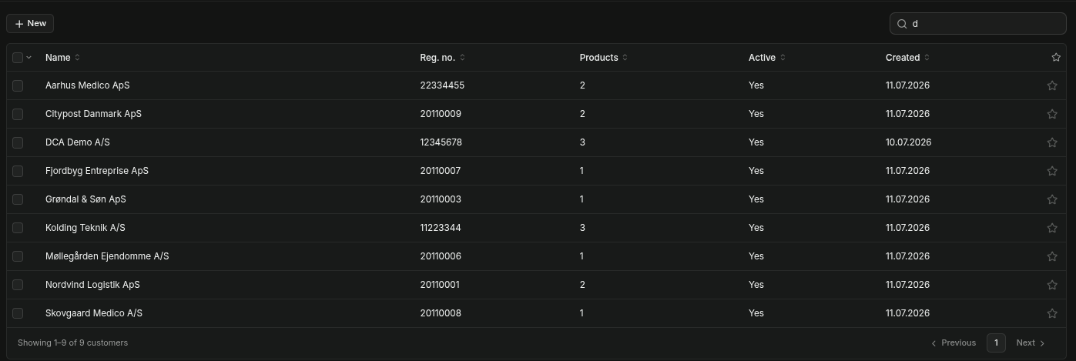
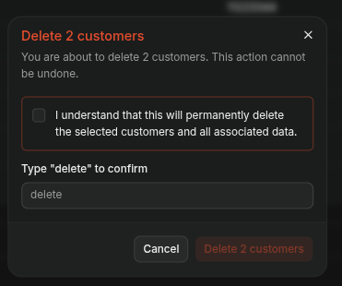

‘

Clicking on a row displays a detail pane (or most tables) with two or more tabs. The leftmost tab is always “Details”, and the rightmost tab is always “Actions.” To the right of Actions, is always two icons: Maximize/Normalize (maximize/normalize the detail pane), and a “X” to remove the detail pane.

The Details tab typically has:
ID of the selected id (in a non-editable field + copy-to-clipboard icon). The ID is Operia’s internal ID, and used for issue tracking if a customer calls in with a problem.

Name, Description, Notes – where available. And on Customers also: “Reg no.”

Any changes will always display the Cancel/Save Changes bar at the bottom of the screen. Such that you always know precisely where it is.

The Action tab typically has a delete function. With the same popup warning dialog.
And on Customers also a button to deactivate a customer (can be re-activated)

On Customers, the other tabs are:
1) Products
2) Billing
3) Shipping & Billing
4) Logo
5) Localization
6) Appearance
7) Data Transfer
8) Log Drains

Products.
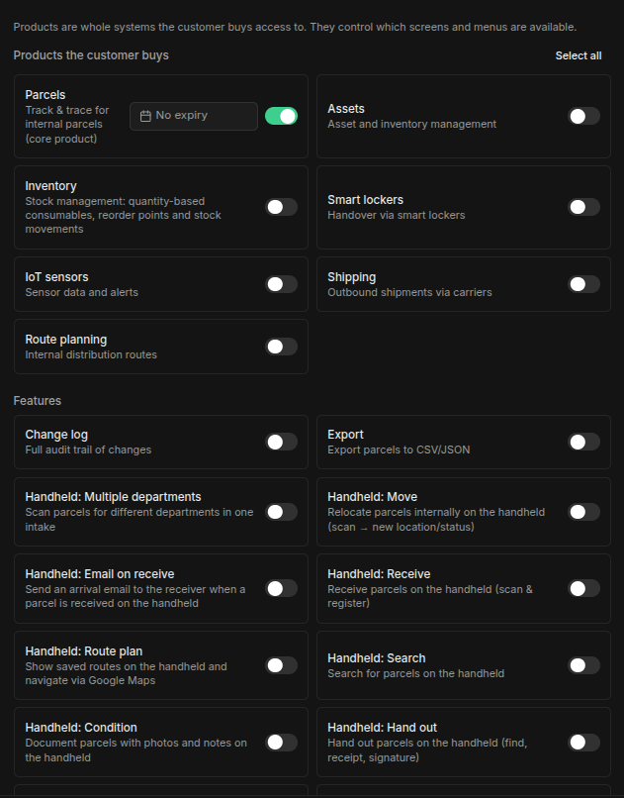

Here the Customer can be given access to products & Features. Features belong to Products, and only the Features of the activates Products are shown. Products and Features can also be given an expiry date.

Billing
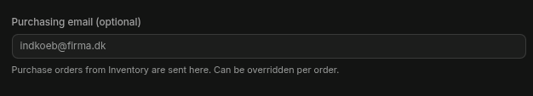
Only has this one configuration: purchasing email. This configuration option should be moved under Details.

Shipping & Billing
Select Margin or BYOC
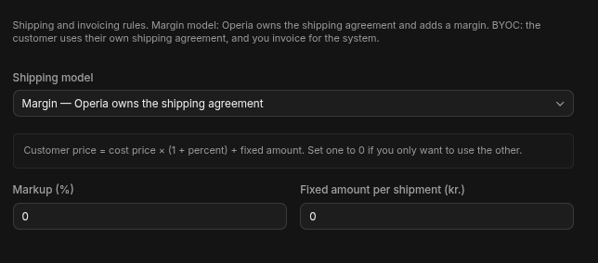

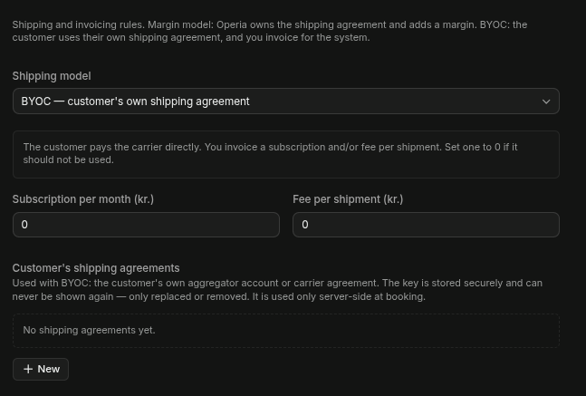

Logo
Upload a customer logo. I think the menu is deprecated, as the functionality has been moved under Home Design.

Localization
Select language (templates, etc.), currency (used in Shipping & Billing), and timezone.

Appearance
Change colours, texts of individual products. This features has not been implemented throughout, not sure if it is still required.

Data Transfer
Enable / disable SFTP and/or Email data updates for this customer.
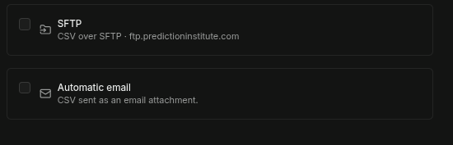

Log Drains
Automatically send log messages to a third party system. Either HML/NDJSON (generic) or Grafana Loki.
This is an advanced feature which is usually only available for pro-packages.
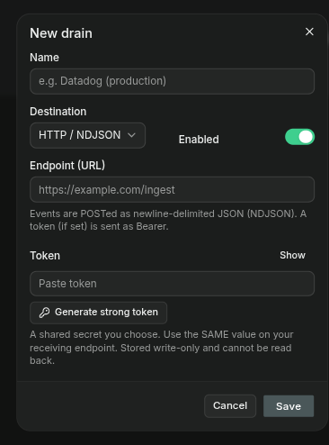

1) Users
This configurations shows all userscreated in Operia. Users are actually created in Supabase (Supabase → Dashboard → Project → Authentication) and only copied to Operia. For increased security and things like 2FA.

On the Details tab, the name and email can be changed.
Access tab: give individual roles to the user. Currently these roles are defined:

1) Managers: access to everything (that is accessible on the customer. Customer managers, still do not have access to Operia configurations, or other customers, etc. - same as the current users)

- all pages the other roles can access, including customer configuration

2) Data Managers
- can access the pages under Master Data; Employees, Departments, Lockers, Import/Export.

3) Package handlers

- can access the Parcel pages: Receive parcel, Hand out parcel.

4) Package managers

- in addition the pages of the Package handlers, can also access the parcel pages: Parcel Dashboard, Parcels, Parcel Reports, Parcel Statistics.

5) Handheld package handler

- Can register and hand out parcels on the handheld.

6) Asset handlers

- not yet defined.

7) Asset managers

- can access all pages under Assets.

8) Handheld asset handler

- not yet defined.

9) Inventory handlers

- not yet defined.

10) Inventory managers

- can access all pages under inventory.

11) Handheld inventory handler

- not yet defined.

12) Route Planner handlers

- not yet defined.

13) Route Planner managers

- can access all pages under Route Planner.

14) Handheld Route Planner

- can use the route planner on the handheld
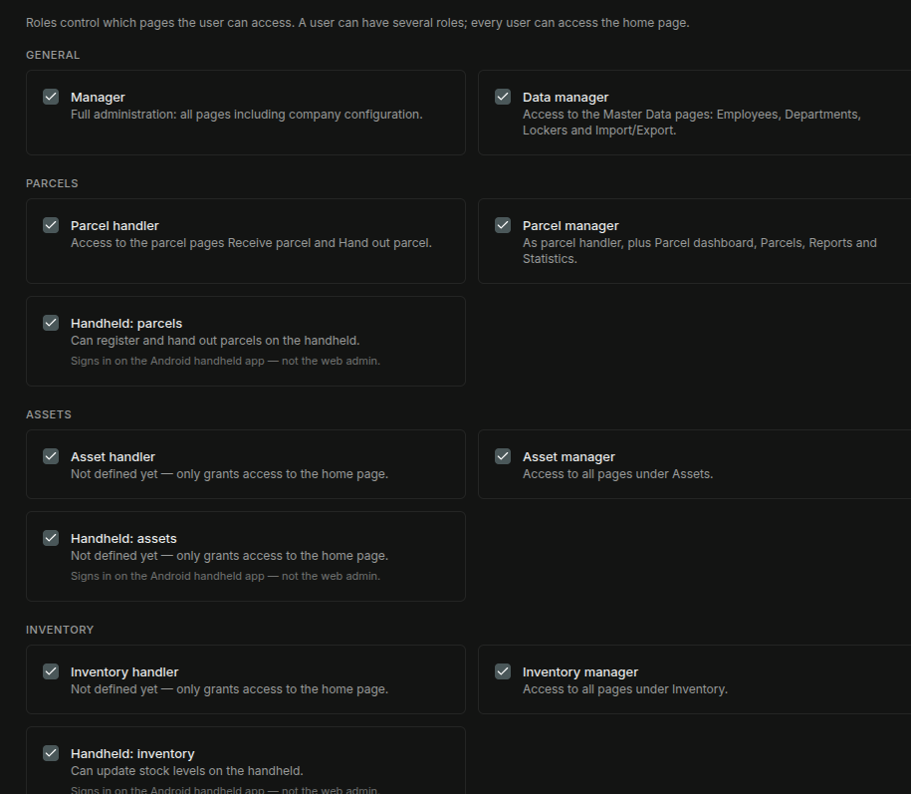

Action tab, has delete user (will also be deleted in Supabase) and change password
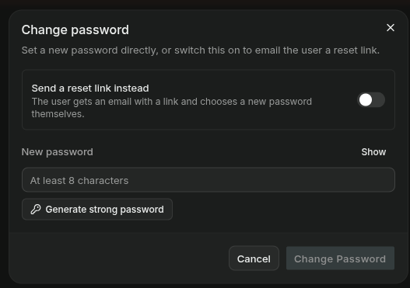

New password can be explicitly written in (or automatically generated), or a link can be sent to the user, where he can change it himself.

