I wanted to approach the given problem of classficiation of unlabeled data without modifying the dataset manually in any manner so I was not going to go with semi-supervised learning that involves labelling a small part of training data by hand and then allowing the network to learn labels based on this small part of training data.
Two of the most promising methods of learning labels based on completely unlabeled data I ran into are a 3 step method of self-supervised learning – clustering – selflabeling based on paper “Learning To Classify Images Without Labels” by Wout Van Gansbeke et al. and a less complex self-supervised learning method involving intra (similarity) and inter (difference) reasoning between measured objects, based on paper “Self-Supervised Relational Reasoning for Representation Learning” by Massimiliano Patacchiola et al.

I have chosen the latter because while it already has an implementation that makes life easy and allows to readjust and recycle the given code to needed use case, it is not bascially a complete library like “Learning To Classify Images Without Labels” implementation is – which in turn would make showcasing any of my abilities hard because of how complete it is.

I have tried a custom model used in the implementation, a deeper and a shallower version of this custom model to compare in what direction the complexity should go, as well as two library models: ResNet18 and MobileNet v3.

The overall summary of this exercise is that it is a good proof of concept of a working approach. The available train dataset seems small so data augmentation that goes on within the pipeline is necessary to create more, very needed repetitions for the networks.
The networks performance differs substantially on each run which suggests a data shortage and perhaps not enough runtime/epochs but in terms of train accuracy according to the binary cross-entropy loss function, there is still room to imporve and usually the networks do not plateau on the 100 epoch runs I made. Deeper networks seem to perform worse in a few runs but tend to get better over time, shallow networks seem to learn faster but their apex seems lower.
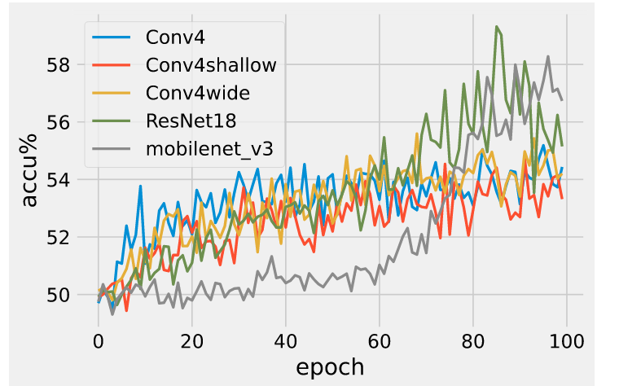

The test runs usually keep the balanced dataset at around 50% which is obviously still close to random as we are classifying binary. The unbalanced dataset performance can differ depending on the stochastic factor of the run, usually it performs worse than the balanced dataset.
