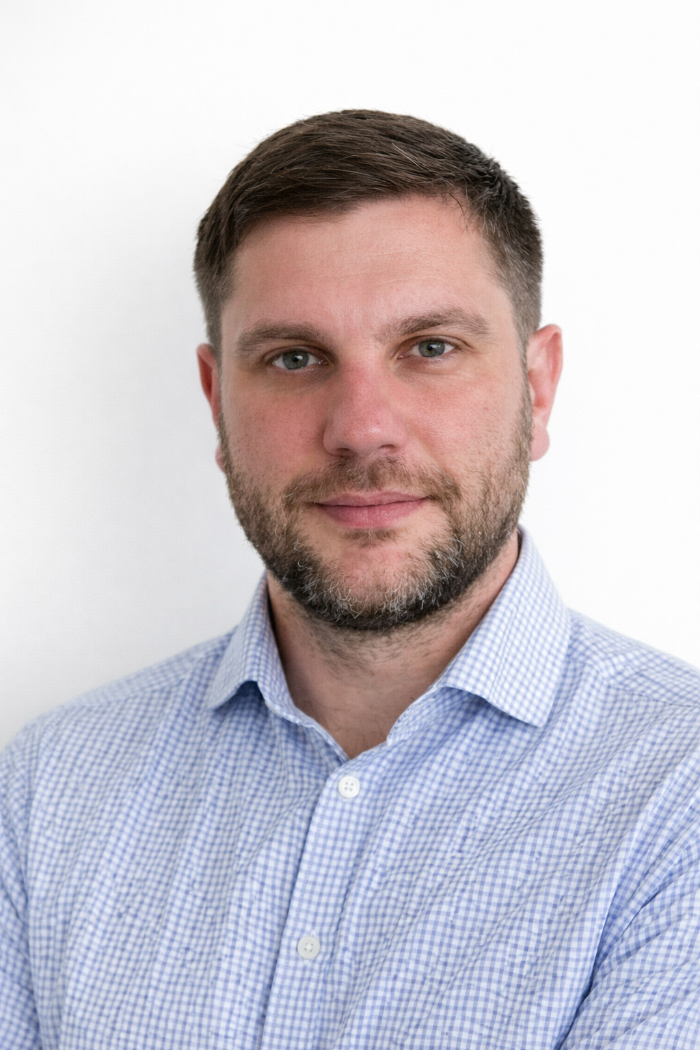
Mariusz Horodecki
Zer Chirchu 20, 3933 Staldenried
+41 77 952 24 37
horodecki.mariusz@gmail.com

Work experience
2020-01 - 2025-10 Director, GL Solutions Sp. Z o.o., Zielona Góra, Poland
Led planning and execution of road construction and infrastructure projects delivering 30–40k
EUR jobs, improving on-time delivery and contract compliance.
Coordinated site compliance to reduce rework and delays via schedules, improving daily operations with machines / tools reducing labor work.
Managed operational delivery of public and private contracts, maintaining regulatory
documentation and requirements
2018-11 - 2020-01 Head of Quality & Product Service, Expondo Polska Sp. z o.o., Zielona Góra, Poland
Led three departments (35 staff) to standardize procedures and KPI dashboards, improving
quality oversight and team performance.
Reduced customer claims by 70% through targeted product fixes and process controls, restoring
OEM acceptance and supplier reliability.
Optimized warehouse workflows to halve pick/put steps by reorganizing locations, cutting handling
time and stock discrepancies.
2016-08 - 2018-11 Quality Manager, SE Bordnetze SRL, Greenfield project Orhei, Moldova
Established Greenfield plant quality systems and processes, achieving IATF certification at first
attempt and passing multiple customer audits.
Implemented VDA, Formel-Q and IATF standards across five sections (80 employees) to raise
production quality and OEM readiness.
Served as primary contact for OEM customers and certification bodies, reducing audit
nonconformities and improving supplier transparency.
2011-03 - 2016-07 Global Process Improvement Specialist, Sumitomo Electric Bordnetze SE, Wolfsburg,
Germany
Optimized workstations and processes, conducted time studies
Reduced costs through efficient production solutions
Lead auditor (PK) – coordinated global audits, benchmarking, and alignment with customer
requirements

IT & AI Skills
Excel (PivotTables, formulas, conditional formatting, data validation, charts, reporting)
PowerPoint (stakeholder presentations, reporting decks)
Word (SOPs, work instructions, process documentation)
Outlook/Calendar (planning, coordination)
Prompt engineering (structured prompts, structured output, reusable templates, guardrails)
Data summarization and insight extraction for KPI reviews and problem-solving
AI-assisted workflow automation (multi-step task flows, tool-supported assistants, structured reporting outputs)
Responsible use & data privacy (compliance-aware)

Technical & Operational Skills
Project Management (CAPEX/OPEX)
Process Engineering
Quality Management (IATF, VDA, Formel-Q)
Functional specifications and requirements
KPI dashboards and reporting
Standardization & Kaizen implementation
Root cause analysis (FMEA, 5 Why, PDCA)
Construction/site management
Education
2012-2015 Poznań University of Technology,
Master of Science in Electrical Engineering
specialization: Industrial and automotive systems
2008-2012 Poznań University of Technology,
Bachelor of Engineering in Electrical Engineering
specialization: Microprocessor control systems
Language Skills
Polish (native)
English (fluent)
German (intermediate)
Russian and Romanian (basic knowledge)
Interests
Systems thinking & workflow optimization, process automation & planning architectures, long-distance cycling, outdoor
activities, hiking, fiction (e.g., fantasy/sci-fi) and non-fiction (decision psychology, NLP)
References
Will be announced on request.

