**Lab 1 – Bank Account Simulator Program**

By: Laura Pereda

**First Test Case** – Initial Balance is Negative

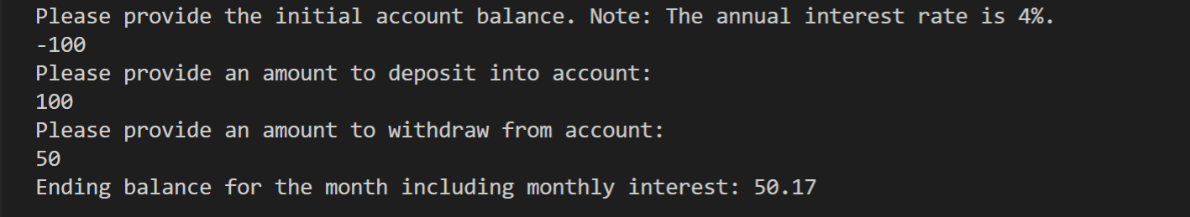

* The initial balance became 0 (due to negative)
* Depositing $100 and withdrew $50 => Balance = $50
* Final balance with monthly interest = $50.17

**Second Test Case** – Withdrawal that results in balance less than $50

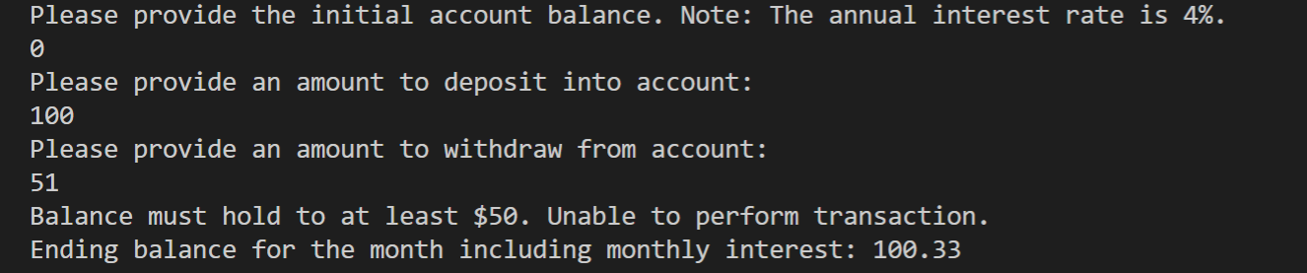

* Depositing $100 & withdrawing $51 results in a balance of $49, which does not uphold the policy of having at least $50 in account.
* Thus, final balance with monthly interest is based on the withdrawal transaction never occurring.

**Final Test Case** – Normal Case

