DOKUZ EYLÜL UNIVERSITY
ENGINEERING FACULTY
DEPARTMENT OF COMPUTER ENGINEERING

CME 2210
Object Oriented Analysis and Design

LIBRARY MANAGEMENT SYSTEM

by
Nuri Çilengir 2016510111
Hasan Berk Kocabaş 2016510046
Mustafa Deniz 2016510018

CHAPTER ONE
INTRODUCTION

1.1 Subject

The subject of the project is library management. Library management system will designed to digitize and simplfy the library management.

1.2 Purpose

The purpose of that document is to present a description of the Library Management System. This document explain the all details this software project that database design, operations, interfaces and use of the application.

1.3 Scope

Library Management System is a desktop base application for students, teachers and managers. The system will allow universities to manage their libraries easily with user friendly interfaces and system tools.

More specifically, the LibraryManagementSystem will also allow students to search for books and request them. Teachers also can search books, request them and add publication to system. Managers can edit all informations about users, books and respond to book requests.

1.4 References

[1] IEEE Software Engineering Standards Committee, “IEEE Std 830-1998, IEEE Recommended Practice for Software Requirements Specifications”, October 20, 1998

CHAPTER TWO
REQUIREMENTS

2.1 External Interfaces

Registiration Screen: That page is for the user registiration.
Login Screen: That page is allow to user and manager login.
Profile Page: That page is allow the show user informations and edit them. In this page also show user activity history.
Collection Page: In this page books are listed. User can search and request for available book.
Manager Page: Manager can manage all users, books and request in this page.
Report page: In this page all reports are listed. For example: book requests and logs.
Aplly Page: For the users allow the book request. Users can see available date interval to the take book. (In the modal)

2.2 Functions

Crud Operations: Users and books can be deleted, updated, created and readed.
Search Operations: Collections, authors, publishers, users can be searched.
Filter Operations: Category, author, publisher, publication date filter can be applied.
Request Operation: User can request for a book.
Calculation Operations: Total user, total book, total request, success – unsuccess requests can be calculated.
Book isAvailable function: This function show to users that book is available or not.

2.3 Performance Requirements

We will use hibernate ecosystem for ORM operations. The software should be capable of storing all the data so arraylist, stack and queue structures will be used.

2.4 Logical Database Requirements

All data that user accounts, collections, etc. will be saved in the database. Program requires a fast and simple design to reliability and maintainability. Hibernate ecosystem and mysql will be used.

2.5 Design Constraints

User Interfaces will be written in Java Swing. N-Tier architecture will be used for reusable and systematical application.

2.6 Software System Quality Attributes

The program must be reliable, support new versions, maintainable for necessary updates and security is the other important thing for Library Management System. Spring security ecosystem will be used for authentication. Test driven development will be used with Junit.

2.7 Analysis Class Model

Class Author: name
Class Book: title, authors, category_ıd, publısher_ıd, type, isbn, edition, publication_year, description
Class Barrow: book_ıd, user_ıd, status, request_date, return_date, return_status
Class BookDetails: book_ıd, return_date, availability
Class BookImages: book_ıd, image
Class Category: name
Class Publisher: name
Class User: name, email, password, city_id, phone, address, zipcode, sex, bdate, isadmin
Class city: name

CHAPTER Three
UML DIAGRAMS
3.1 Use Case Diagram
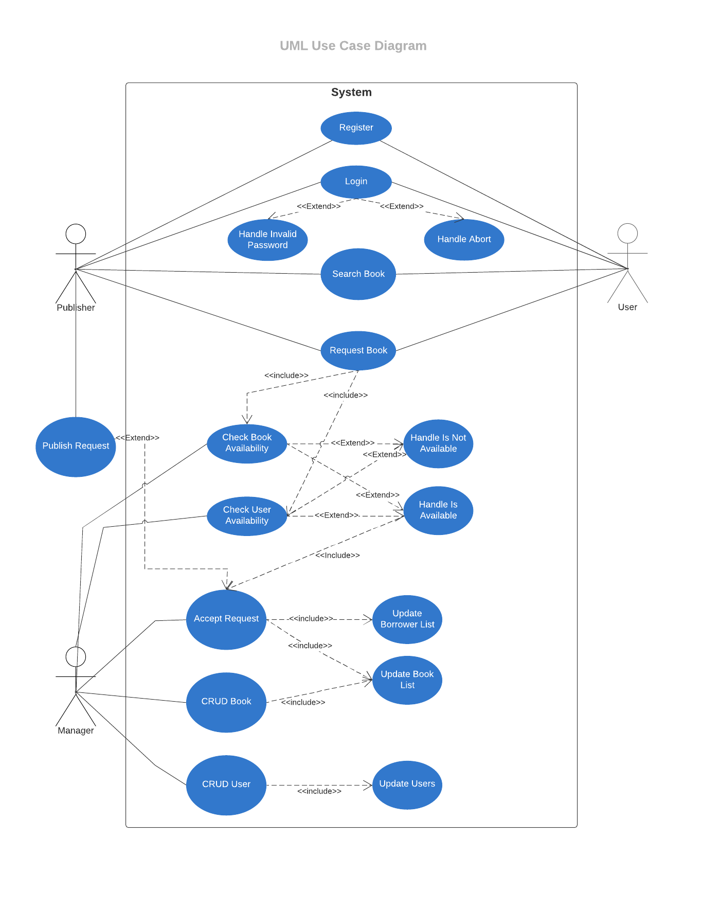
This diagram shows the abilities of the actors in the program in general.The program has 3 actors which are Manager, Standart User(Generally Students) and Publisher. Standart User has ability for registering, searching and requesting books. Publishers, in addition to Standart User they can publish publishment. Managers can access all managerials functions such as deleting, creating, updating and reading all data. Other manager task is the control requrests and accept or decline them. Managers perform this task based on book and user status.

3.2 Class Diagram
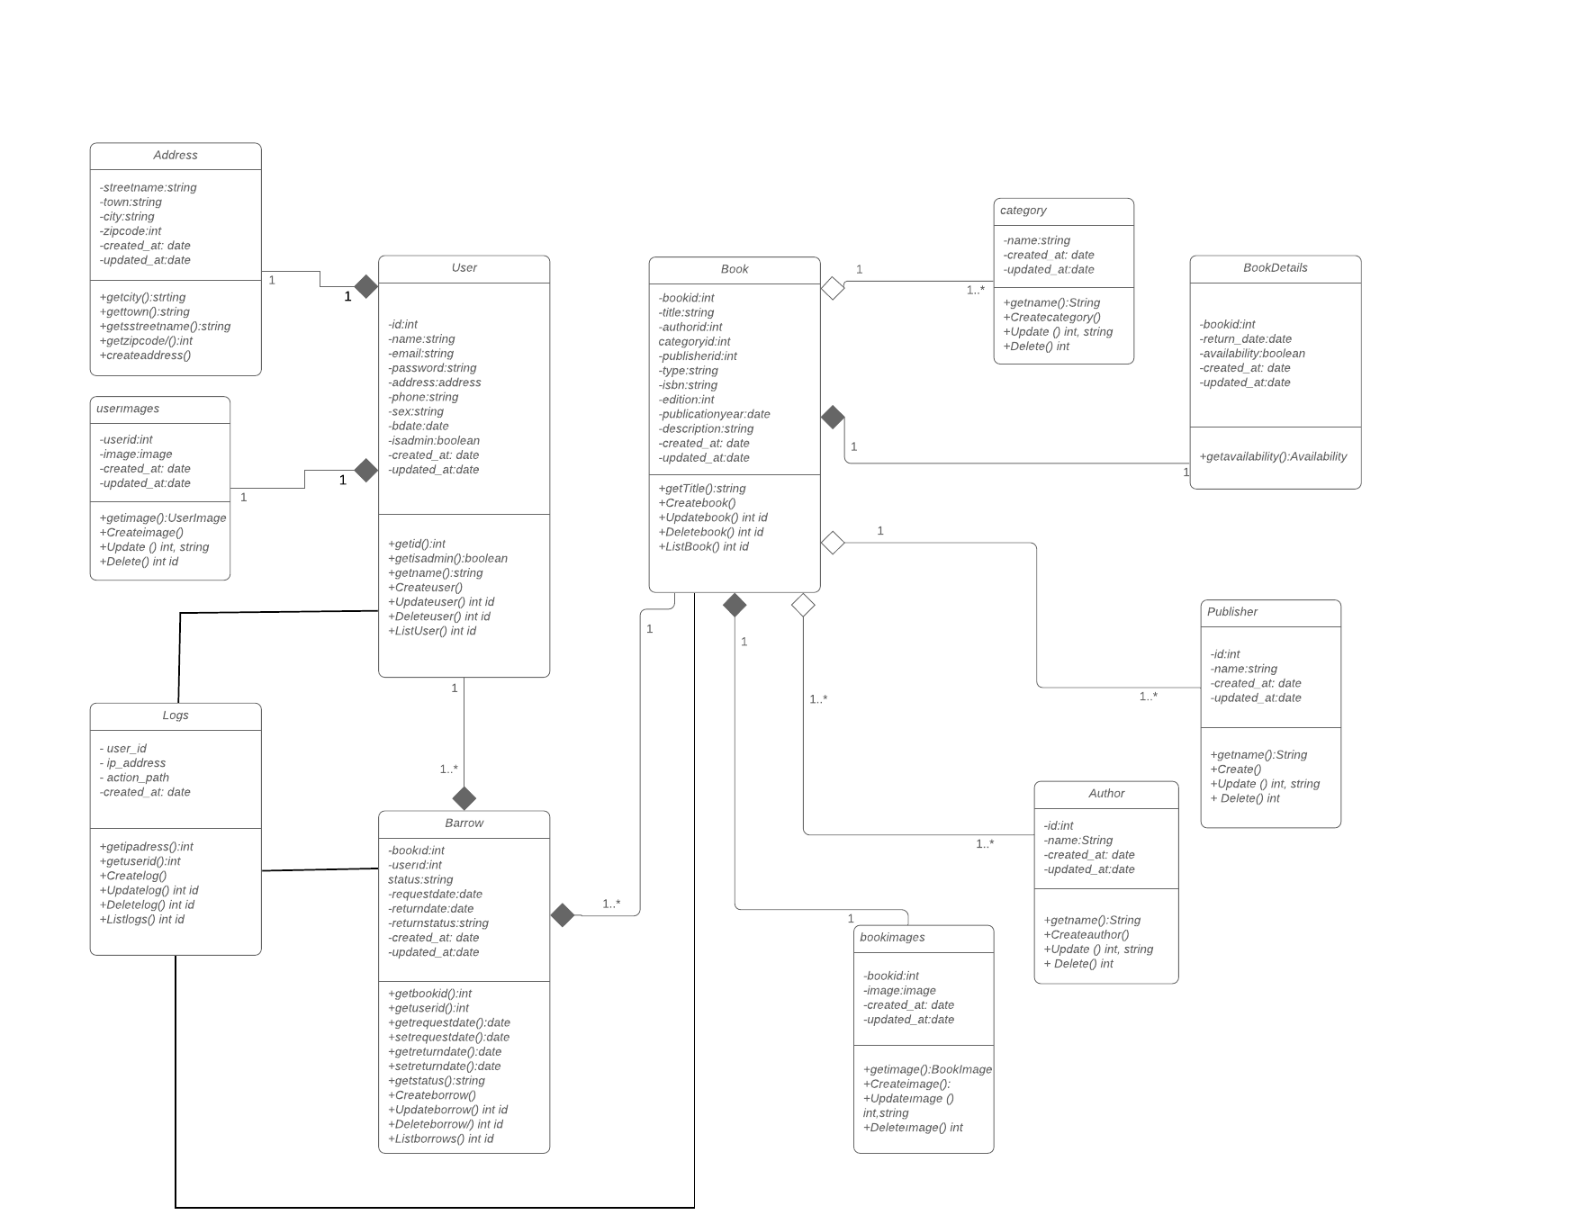

Class diagram is listed above. We have user and book class like a main class. Barrow class connected user and book classes. All user types having address, ımage class and some attributes. Books also have category, details, publisher, author and images classes. Barrow class connected user and book classes. Logs class keeping records belong to user and book operations.
3.3 Activity Diagram
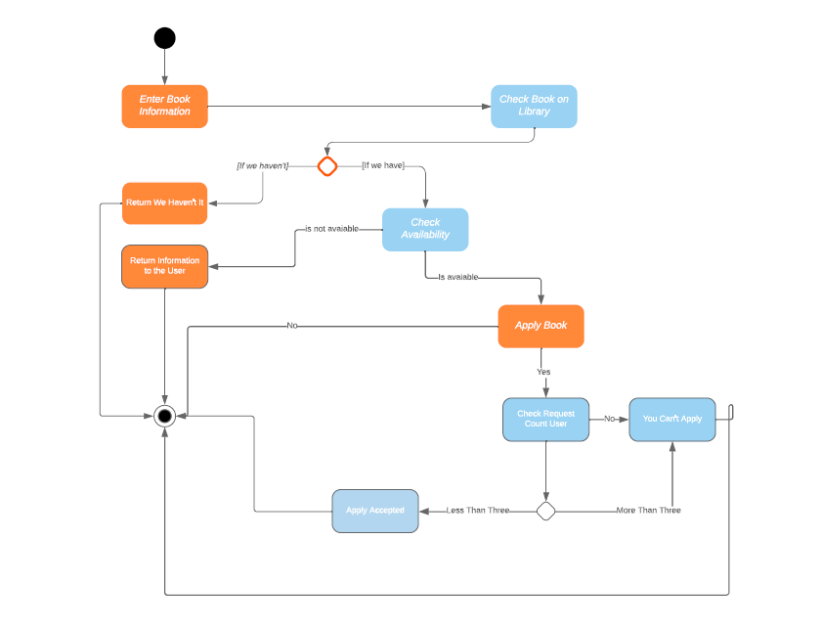
This diagram show us the path of books when hire. First time user enter a book then Book checked on the system if it can be borrow user can apply it but if it can’t available system return the book isn’t available. When user apply for book system checks request count of user. If it more than three user can’t apply for borrow a book if less than three he can apply and borrow the book.

3.4 State Diagram
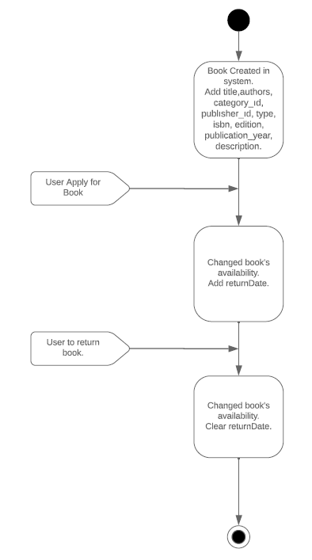
In this state diagram we tell book status. First time book created in system we add some information about book. Then when user apply for book book’s availability status is change and system add a returnDate. When user to return the book system made book status available and clear the returnDate.

3.5 Sequence Diagram
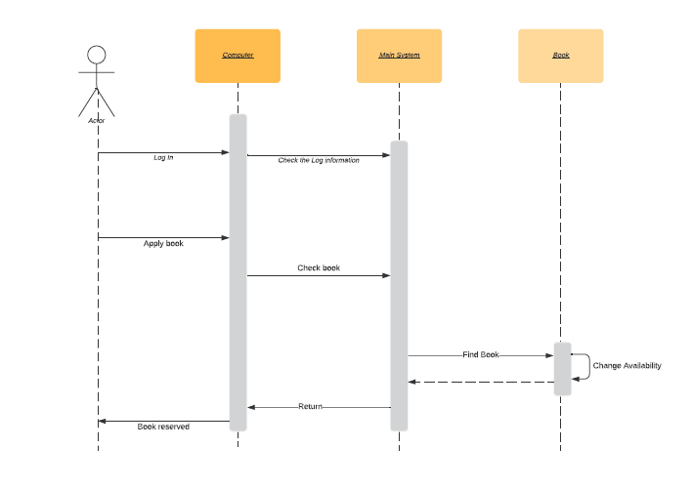
In this diagram our objects ae computer main system and book. First action is logged in system by user then system check the information about the user ıf the information true user can apply for books. Second action is applying book. In this diagram we calculate best case scenario so user applied book and system confirm book in the system and return book can borrow. So computer return this information to user. The object book just change its availability.

