

May 27, 2020

ONLINE FOOD SERVICE SYSTEM

CME 2210 OBJECT ORIENTED ANALYSIS AND DESIGN

İREM OKUR - MELİSA BEYSÜMENGÜ - İREM ÇALMAZ

DEPARTMENT OF COMPUTER ENGINEERING

DOKUZ EYLÜL UNIVERSTY

# Table Of Contents



*1.*

Table Of Contents 1

Introduction 3

1.1 What the Problem is? 3

1.2 Goals for the Project 3

1.3 Stakeholders 4

1.4 Motivation for the Project 5

1.5 Process Flow Preview 5

2. Analysis and Design 6

2.1 Plan for Requirements Engineering 6

2.2 Functional Requirements 8

2.3 Non Functional Requirements 10

2.4 Use Cases 15

2.5 Models 19

2.5.1 Class Diagram 19

2.5.2 Use Case Diagram 20

2.5.3 Activity Diagrams 21

2.5.4 State Diagrams 23

2.5.5 Sequence Diagram 24

Project Plan 25

3.1 Task Descriptions 25

3.2 Task Assignment 26

3.3 Deliverables and Milestones 27

3.4 Project Schedule 28

Testing 29

4.1 Features tested 29

4.2 Test Cases 29

4.3 Testing Schedule 30

Conclusion 31

5.1 The Problem and Solution 31

5.2 The Team and the SE Process 31

5.3 Engagement of Umbrella Activities 32

5.4 The Stakeholders that Benefited 32

5.5 The Team’s Benefits 32

User Manual 34

6.1 Software Description 34

6.2 How to Use the Software 34

6.3 Troubleshooting Common Problems 36

# Introduction



*1.*

### 1.1 What the Problem is?

The System is going to provide a safe, fast and easy online ordering system interface for customers. Every costumer has their own profiles and they can access to the system with given password. Costumers can choose a restaurant according to their budget . Payments will be done at the doorstep.

Furthermore, the system contains admin section. This section allows restaurant owners to add new food or remove an existing food on the current menu and admins can see the total orders. Moreover, admin can shut down the system to service because of the unexpected circumstances for instance occurness of over ordering.

### 1.2 Goals for the Project

Online food service system is created to help customers who wants to order food and the system keeps the name of the restaurants which has a package delivery option. In the past years, when a customer wanted to order a food, they would go to the restaurant or they would call the restaurant directly but this online food service system saves the customers’s time and assists them to choose the best food option according to their budget.

### 1.3 Stakeholders

Two types of stakeholders can be noted in our software. These are : admin who enter the system and manage the system, and customers which is the main users of the system. System provides friendly approach for both stakeholders.

Admins can manage the system according to what they want. Online Food Service System allows admins who are the restaurant owners, to add new food or remove an existing food on the current menu and see the all customers. Moreover, admin can shut down the system to service because of the unexpected circumstances for instance occurness of over ordering.

Customers can choose a restaurant according to their budget and selected food type. With the Online Food Service System customers can save their time by using this..

### 1.4 Motivation for the Project

To develop the Online Food Service System that would increase our ability of the team work also coding skills. Since whole system has lots of details.

Our team members strive to give the online food service everything that stakeholders will desired. Our team is good as problem solving, coding and being a team. We have good comminication with each other. All three members of the team works perfectly. Three of us working on the programming abilities helps in ensuring no errors are implemented and every single detail is put into place. All of these properties lead us to the Online Food Service System.

### 1.5 Process Flow Preview

For our process flow, we plan on working together will be more easier. All three of us will sit together and think about the development process. However the unexpected circumstances occured. So our team has to work separately. For the modeling process ( flowchart ) we did not think all of the process start to end. There will be times that we may have to go back to analize because of the errors.

# 2. Analysis and Design



## 2.1 Plan for Requirements Engineering

**Inception Task:**

Beginning of this Project was to create a certain management system .We decided to design a system that can help users to order food easily and quickly on their desktops.Also the system that can help the owners of the restaurants to manage their business.

To help the process of this Project we asked ourselves some important questions.Here some questions that we asked :

* Which type of users we are targeting with this system ?
* Which types of scenerios may occur during this process?
* What are the basic functions? **(**What attributes will be used ?)
* Which type of GUI will be used for this Project ?

**Elicitation Task:**

Our purpose at this stage is to identify the problem, propose solutions, and talk with each other

and exchange our ideas according to estimated scenerios. Meetings are scheduled with the team on Skype for understanding the overall of the project . The plan is to get a idea of what should be accomplished.

Final decisions that we made were :

* Final scenerios were discussed for different user types(Customer or Admin) and list of requriments were listed at this time.

**Elaboration Task:**

Information elaborated from the inception and elicitation tasks are refined during this part. Scenarios were created to describe and for understanding how admin or customer will be interacting with this food service system. Any attributes are to be defined as well as how each function interacts with each other.Furthermore we designed the UML diagrams of the Project.

**Specification Task:**

During this task, we create a software requirements specification template. In this template we will note down the overall purpose of this project .Descriptions of user classes, design will be included. Also attributes, and what interfaces are to be used with this software will be included When this task is finished ,samples are created .

**Validation Task:**

During this task ,any requirements stated are to be provide that they are clearly defined. Any miss-interpretation that exists should be resolved. All the requirements should be clear for all the team members and stakeholders. Any phrases that are implicit ,should be rewritten as an explicit form.

**Requirements Management:**

In requirements Management ,Changes can be occur in any stage of this Project andAny potential changes in any potantial circumstances would be discussed and if it is wrong ,changes will be rediscussed.

## 2.2 Functional Requirements

**Hardware Requirements:**

The software should be ran on any sort of desktop or laptop enviroment that has certain IDE.Essential input/output devices are Mouse,keyboards.Nothing else is required.

**System Interface - Primary Tasks:**

* View all available restaurants with foods.
* Search for desired food,budget
* Select their desired restaurant
* Allow for registration
* Sign up display form.
* Allow the customer to log in
* Log in display form .
* Allow customers to set their information

**System Interface – Secondary Tasks:**

* Allow Customer to see all the food that he/she ordered in the past.
* Allow user to change and set their information on the system.
* Admins can shut down their restaurant.
* Store user’s information in the text files.
* When registering the system ,the user provides their information in the form.
* This information sends and stores in the text file.
* Authenticate any user loggin in.
* Communicates with the text files and to verify the inputted phone and password is correct.
* Calculate the food list that will display on the screen according to Customer’s budget.

**Restaurant - side Software - Primary Tasks:**

* Track Customer queue in the system .
* Displays the present customer queue on the screen .
* Add Food on the menu.
* Display a screen and admin enters food name,price,ingredians of the desired food that he/she wants to add on the menu.
* Remove a food on the system.
* Admin selects a food on the menu and warning shows up and admin pushes the button to confirm.

**Restaurant-side Software - Secondary Tasks:**

* Keep and display foods on the restaurant’s menu.
* Sets the Restaurant and Admin’s information on the system.
* Allow Admin to change the restaurants availability.
* Admin will log in through the log in display form such as customers would, but would have a different looking interface to allow for them to remove, add, shutdown the restaurant.
* Remove the customer from the queue.
* Admin selects the customer on the panel and clicks on the button to approve.

## 2.3 Non Functional Requirements

**Performance Requirements:**

* Being logged in should allow customers to give orders quickly without entering their information everytime and allows Admin to manage the restaurant easily.
* Ability to maintain the certain amount of customers on the system.
* Speedy performance

**Security Requirements:**

* Prevent false Phone/password inputs being used when registering.
* Keep the information that User’s have on the system.

**Quality Attributes:**

* Easy to see and use.
* Maintain an user friendly environment on the system.
* Maintain the readablity

Screenshot Mockups: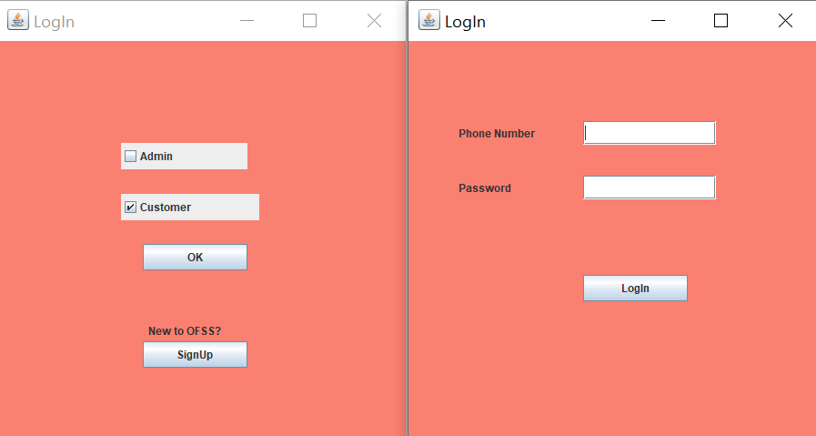

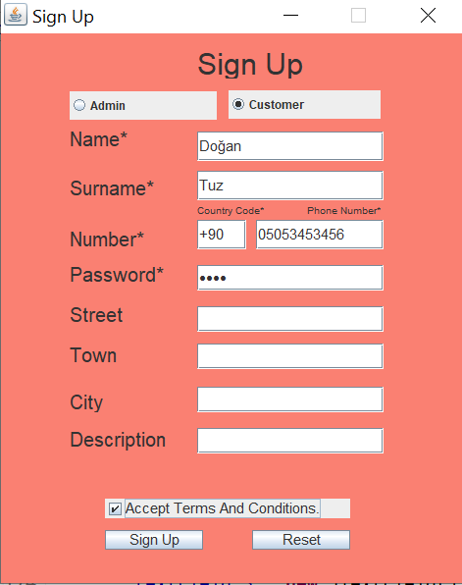

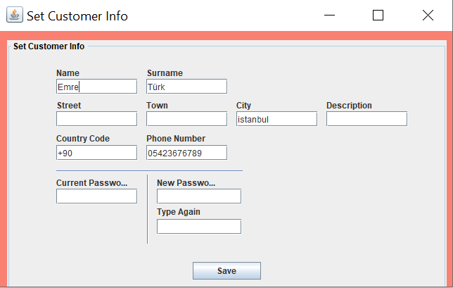

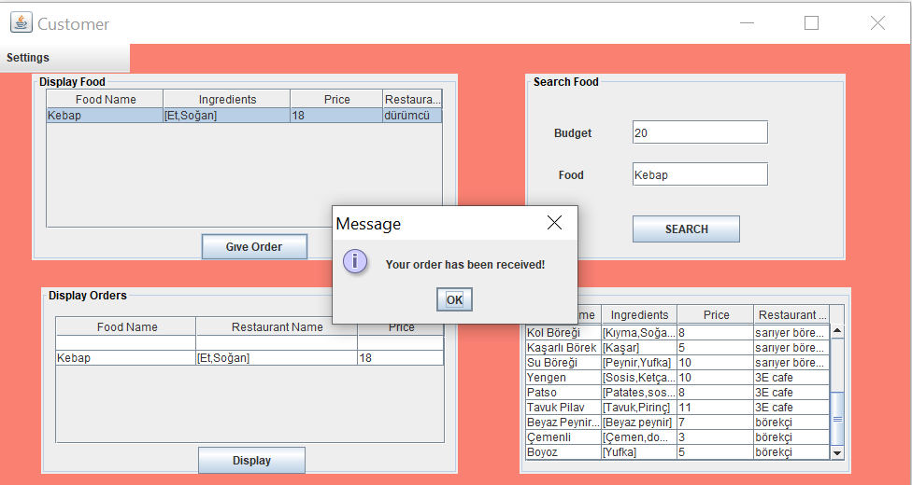

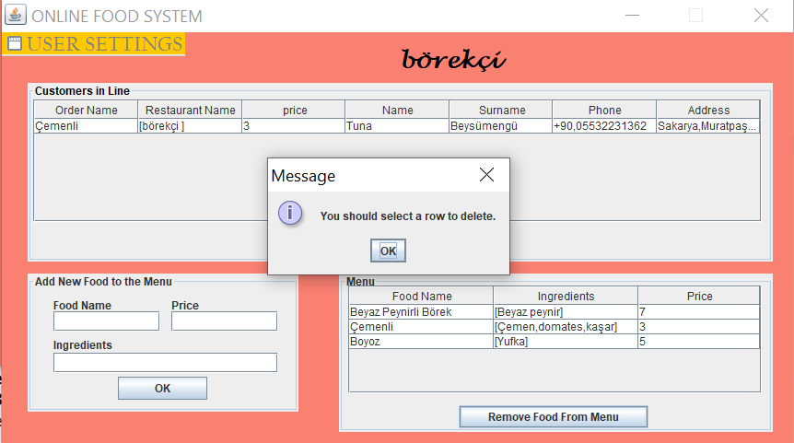

The system gives that error to user when user did not choose the desired food to remove from the menu.

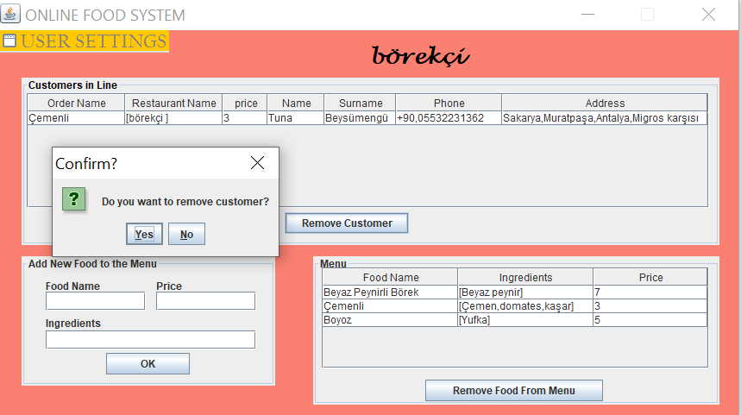

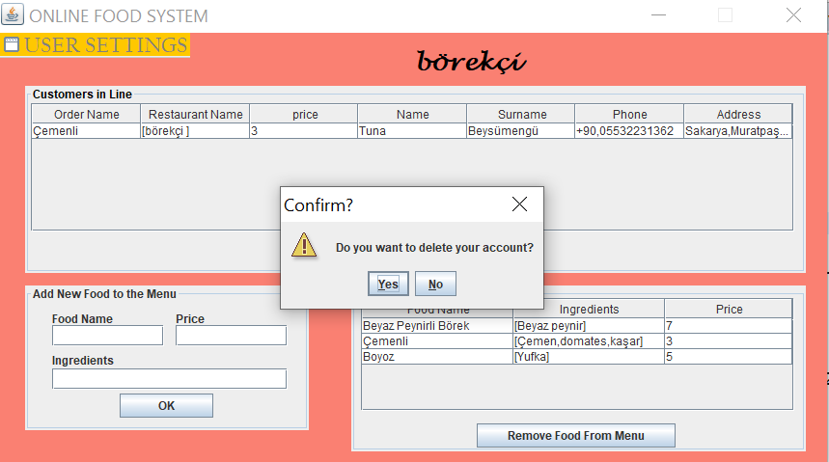

## 2.4 Use Cases

**Use Case #1: *Give Order***

**Primary Actor:** Customer

**Goal in Context**: Give an order and add the customer to queue of the restaurant

**Preconditions:** Customer is logged in the system

**Trigger:** Customer enters the budget and enters the food that he/she wants.

**Scenario**:

1. Customer: User logs onto to online food system as Customer (enters Phone/Password).
2. Customer: Enters her/his budget and enters the food that she/he wants to have.
3. Customer: Selects the desired restaurant from the screen and give order.

**Exceptions**:

1. Customer Phone/Password incorrect: System gives an warning and customer is expected to enter Phone/Password again.
2. Entering wrong food syntax : Customer is expected to give an appropriate food name.

**Priority:** Optional

**When available:**  Customer decides to logged in

**Frequency of use:** Optional /Anytime

**Channel to actor:** Food service system

**Secondary Actors:** Admin( Restaurant Owner)

**Channels to Secondary Actors:** Food service System

**Open Issues:**

1. Is there a limit for entering the budget on the system when Customer is ready to give an order?
2. Should the customer have an option to change what food he/she wants after confirming what order they decided on?

**Use Case #2: *Remove Food***

**Primary Actor:** Admin (Restaurant owner)

**Goal in Context:** Removing the certain food on the menu

**Preconditions:** Admin is logged in the system and displays the menu on the screen.

**Trigger:** Admin selects the desired food that he/she wants to remove on the menu

**Scenario**:

1. Admin: User logs onto to online food system as Admin (enters Phone/Password).
2. Selects the certain food on the menu to remove and push the button.

**Exceptions**:

1. Admin Phone/Password incorrect: System gives an warning and Admin is expected to enter Phone/Password again.
2. Admin is not signed on the system : If the user is not signed up on the system ,user is expected to push the sign up button.

**Priority:** Optional

**When available**: When Admin is logged in the system.

**Frequency of use:** Optional /Anytime

**Channel to actor:** Food service system

**Secondary Actors:**  Customers

**Channels to Secondary Actors:** Food service system

**Open Issues:**

1. Should the Admin have an option to get back the removed food on the menu ?

## 2.5 Models

### 2.5.1 Class Diagram

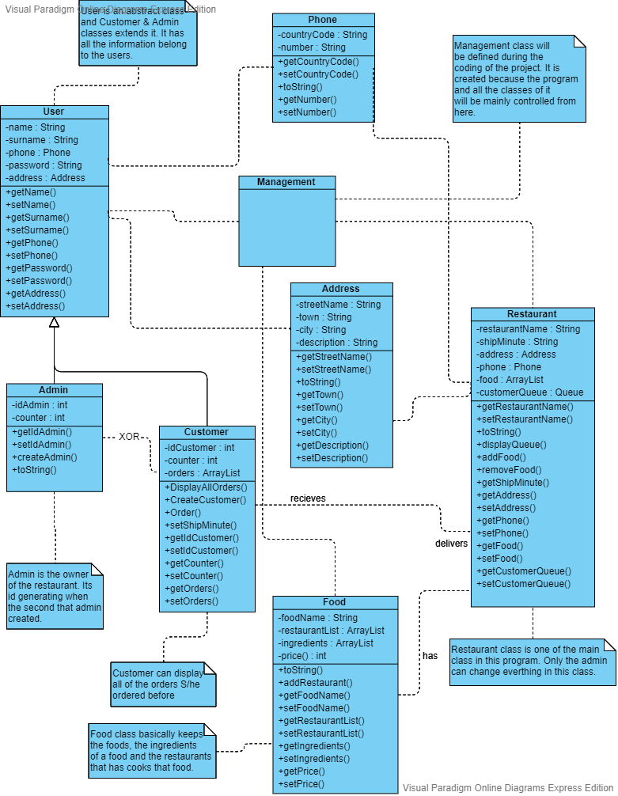

### 2.5.2 Use Case Diagram

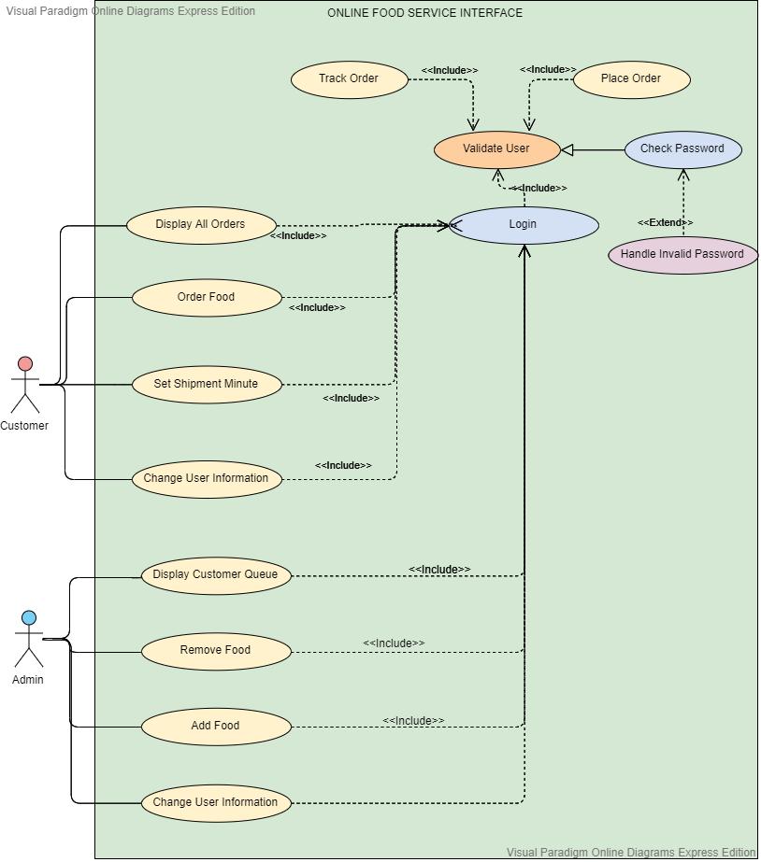

2.5.3 Activity Diagrams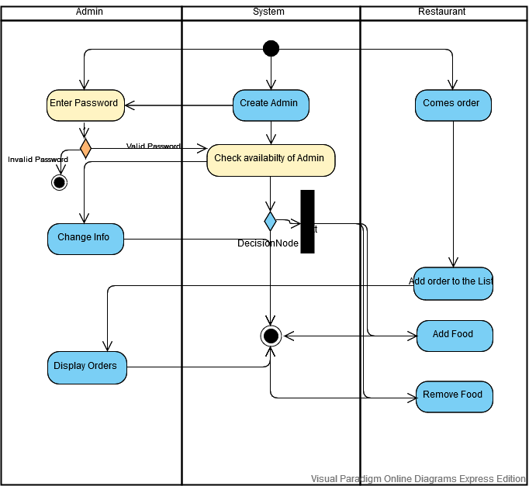

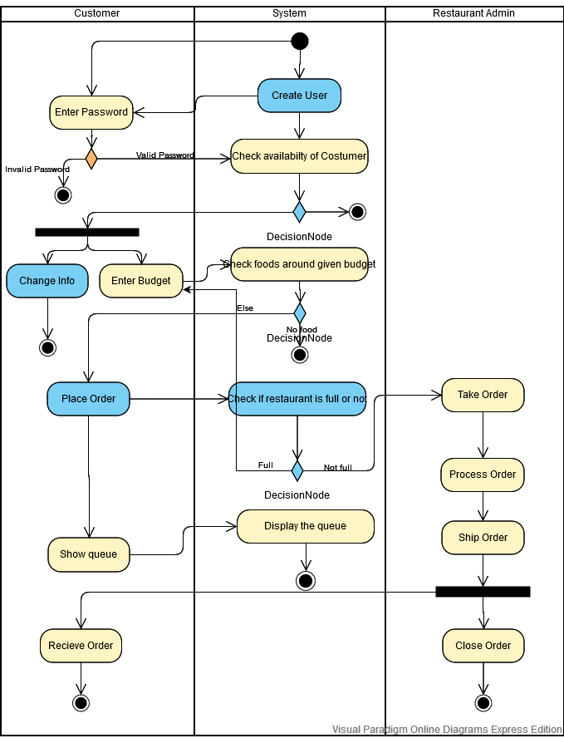

2.5.4 State Diagrams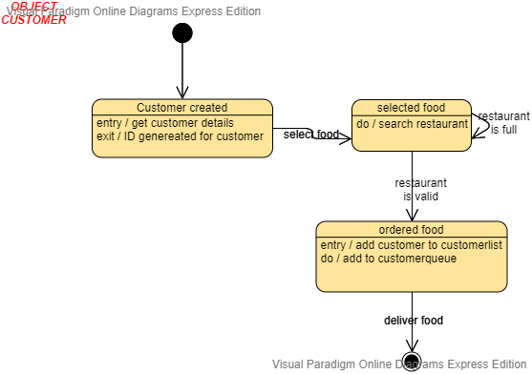

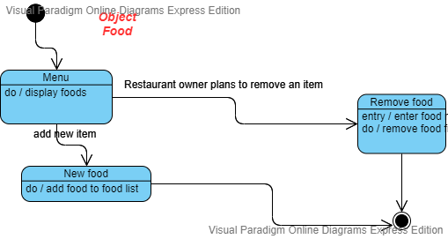

### 2.5.5 Sequence Diagram

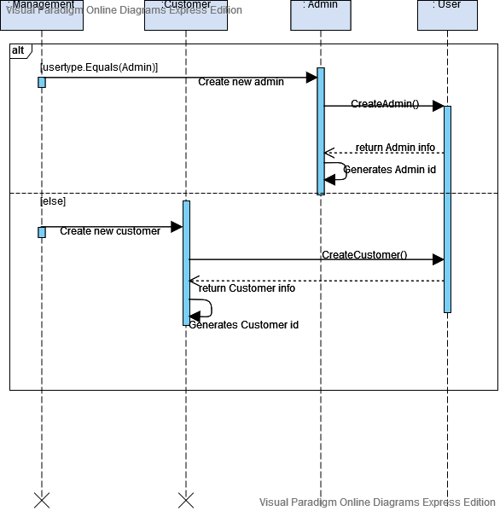**e**

# Project Plan



*3.*

## 3.1 Task Descriptions

**Design Models and Mockups**

Designing the models and mockups facilitate to confirm clarity in sight of the project still as however it works. We as a team thought together and designed.

**Storage Creation**

The Online Food Service System provides storage for customer information, admin information, orders, restaurant information, and foods as txt files. To keep the informations is the vital part of the Online Food Service System. Because most of the system abilities have to update these informations.

**GUI (GRAPHICAL USER INTERFACE) Creation**

The Front - Endwill be designed using Java Swing (GUI) ,using the mockups, requirements, and models that we designed earlier. GUIshould allow for users ( admin and customer ) to immediately see what they want. ( give order, display menu, remove cutomer etc. ) If they select “LogOut” button system will directly lead them to the begining page. Also they can change their information.

**Testing**

Testing will be implemented as a proper sample txt. Test cases may be used to

lead and understand the basic actions of both customers and admins. Any bugs or errors

that occur will be seen and helps to solved quickly.

**Finalization and Reports**

Online Food Service System is completely ready for users. All testing and function processes are finished. Reports will be created to ensure all information and functionality is clear. In order stakeholders can understand correctly.

## 3.2 Task Assignment

All test assignments were distributed equal to the group. All three of us worked together in the project planning. Because of the extraordinary circumstances, we reached each other by using Skype. Most of the system done by all of us. We sit down in Skype for like more than 5 hours a day. However we could not do the whole system together so we decided to divide some parts of the project according to the working intensity.

İrem Okur, created the LogIn and SıgnUp frames by using Java Swing (GUI).

Melisa Beysümengü, created the Admin frames by using also Java Swing (GUI).

İrem Çalmaz, created the Customer frames by using also Java Swing (GUI).

Reports were created throughout the process by all three group members and gathered to

clear and efficient final report.

## 3.3 Deliverables and Milestones

We had five major Milestones in this project:

1. Decision making of the system.

2. Completion of Diagrams Design and Skeleton code.

3. Completion of Whole code.

4. Completion of GUI.

5. Completion of report

These milestones were all completed on schedule and yielded a Deliverable at the end of each.

## 3.4 Project Schedule

The first period of the project which start date on 26th of February. Finish date was 26th of May.We as a team thought that Online Food Service System’s project planner not divide by team member, it should divide by milestones of the project so that Online Food Service System’s project planner as following.

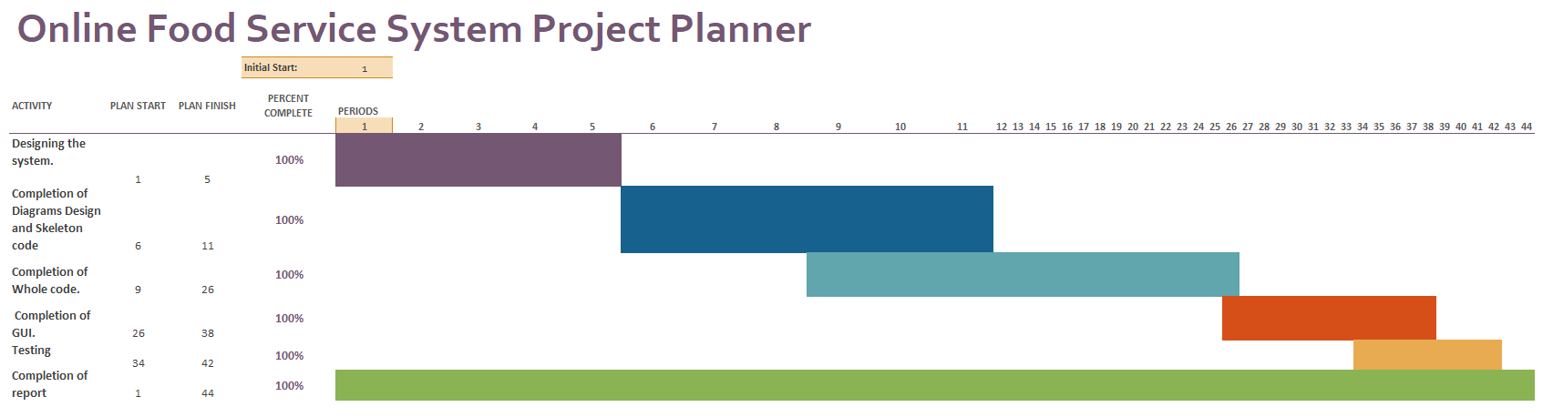

Our team use Online Food Service System project planner as a milestone chart.

|  |  |  |
| --- | --- | --- |
| Period color | Start Date | End Date |
|  | 26.02.2020 | 09.03.2020 |
|  | 09.03.2020 | 02.04.2020 |
|  | 30.03.2020 | 10.05.2020 |
|  | 07.05.2020 | 23.05.2020 |
|  | 20.05.2020 | 26.05.2020 |
|  | 26.02.2020 | 26.05.2020 |

# Testing



*4.*

## 4.1 Features tested

We start by using some testing strategies.

The features we tested were as follows:

● To ensure that the application itself ran (Dynamic)

● LogIn and SignUp worked efficiently and properly (Dynamic)

● Checking Admin’s management abilities.

● Checking Customer’s order.

## 4.2 Test Cases

Following ups are test cases that we implemented to check.

* Showing confirm dialog when user tries to do something important to the system.
* Showing information box when user add or remove something from the system.
* Check all tables when anytime a user enters the sytem.

## 4.3 Testing Schedule

The testing began right after the project itself finished.

# Conclusion



*5.*

## 5.1 The Problem and Solution

We designed the system that can provide a safe, fast and easy online ordering system for customers.

The solution was to provide Online Food Service System that would allow for customers

and admins to access the system easily. The Online Food Service System ensure the users

change their informations, add or remove objects which they want. The System stores any

information that user may input when making a decision. This software provides an easy-to-use

interface (user-friendly).

## 5.2 The Team and the SE Process

The Software Engineering process we used was the waterfall method. In this methodeach phase depends on the deliverables of the previous one and corresponds to a specialisation of tasks. So all of the deliverables connects eachothers.

## 5.3 Engagement of Umbrella Activities

Five of the main Umbrella activities we used were as follows:

1. Software project tracking and control: This activity was used for progress against the plan and take actions to maintain the schedule.
2. Risk management: This activity was used for risks that may affect the outcome and quality.
3. Technical reviews: This activity was used for work products to uncover and remove errors before going to the next activity.
4. Software configuration management: Which was used to lead the project to manage the effects of change throughout the software process.
5. Reusability management: This activity was define the criteria for work product reuse and establishes mechanism to achieve reusable components.

## 5.4 The Stakeholders that Benefited

After finishing the project all of our stakeholders which are admin and customer, benefited from the software

## 5.5 The Team’s Benefits

Our Team benefitted good way from the Online Food Service System. Our programming skills improved during the process of the project. Furthermore, our team has three members, so we learned how to work together as a team. Begining of the process a unexpected health circumstances was occured. However these bad sitiuation did not effect the process in a bad way and we manage to communicate with each other more.

## 

# User Manual



*6.*

## 6.1 Software Description

The Online Food Service System has two sides. User can enter as an admin or as an customer.

If user enteres as an costumer, everyone has their own profiles, they can change their profiles. They can see all the foods from all of the restaurants. Also can choose a restaurant according to their budget then they can give an order.

If user enteres as an admin, who is the restaurant owners,they can add new food or remove an existing food on the current menu and can see the total orders. Also they can remove the customer. Moreover, admin can shut down the system to service that means delete their account.

## 6.2 How to Use the Software

The system is a desktop application so the user must run the code first. After running the code, three options occurs to the user which are admin, customer and signup. If user enteres the first time user should choose the signup option and enter their informations. After the signup user should choose which type of user that he/she is then choosen type of user should enter the system by using their phone number and passwords.

If user chooses the admin option, the system shows multiple options to the admin. If admin wants to add a new food to the system, should fill the empty spaces on the “add new food to the Menu” panel and click the “Ok” button. If admin wants to remove the existing food from the system, should select a row from the “Menu” panel then click the “Remove Food From The Menu” button. If admin wants to remove the customer from the system, click the “Remove Customer” button. And lastly the system ensures setting menu bar to the admin which has 4 options. (Set user information, Set restaurant information, LogOut, Shut down the restaurant) If admin wants to change her/his information, he/she must enter their password, even if they did not change it.

If user chooses the customer option, the system displays four panels and one menubar. On the “All Foods” panel user can see the all food from all of the restaurants. Customer can search food by entering budget and food name to the “Search Food” panel then search result will be shown in the “Display Food” panel. Customer can order food from that panel by selecting and click the “Give Order” button. Customer also can display all of the orders that they ordered. On the “Settings” menubar has 2 options. (Set user information, LogOut) In the set user information part, also the customer has to enter their password, even if they did not change it.

## 6.3 Troubleshooting Common Problems

Problem: Invalid Login (which gaves “wrong password or phone number” error.)

* Make sure you have entered the password and the phone number correctly.
* Or you might close the restaurant and delete your account. To solve this you must open a new account.

Problem: Accept terms and Conditions

* Make sure you have filled all of the “*” ones on SignUp panel. Also you should click on the “Accept terms and Conditions” button.

Problem: Choose

* Make sure you click the type of the user when the program first occured.

Problem: Add Food

* Make sure you fill all of the blank spaces in the “Add new Food” panel.

Problem: Remove Food

* Make sure you select a row you wanted to remove from the “Menu” panel.

Problem: Password

* When you want to set information, make sure you entered your current password to finish the setting.