**Bookstore Application:**

A simple web-based bookstore application built using Spring 5.2 and Hibernate 5.4. The application allows users to view, add, edit, and delete books from the catalog.

**Features:**

1. View all books in the store

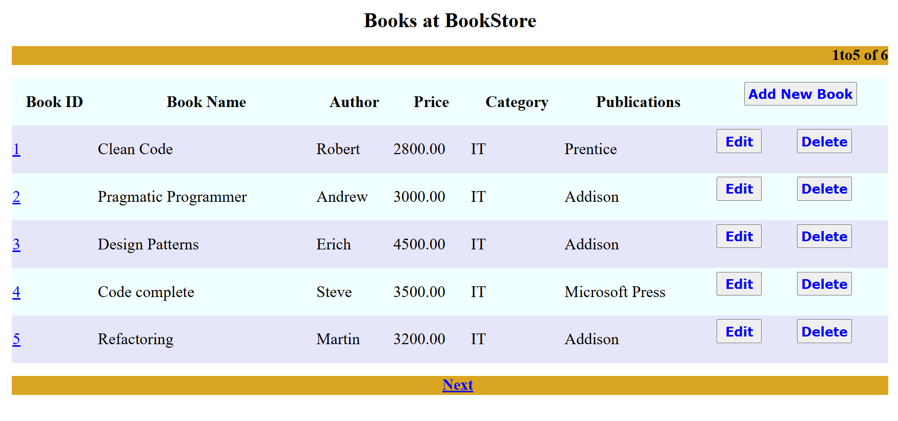

1. Add new books

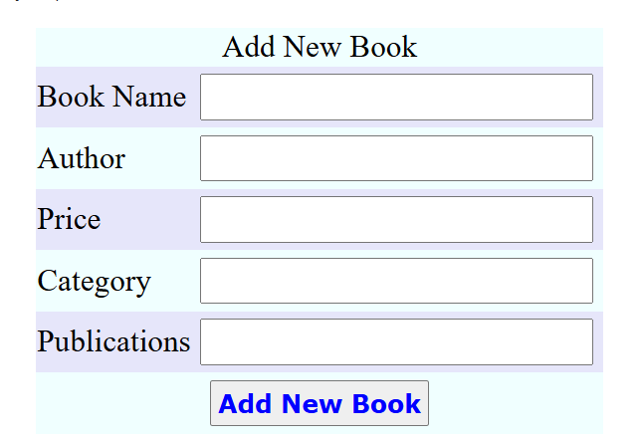

1. Edit existing books

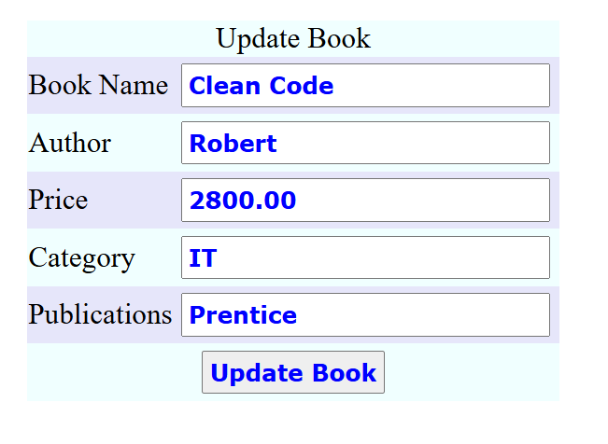

1. Delete books

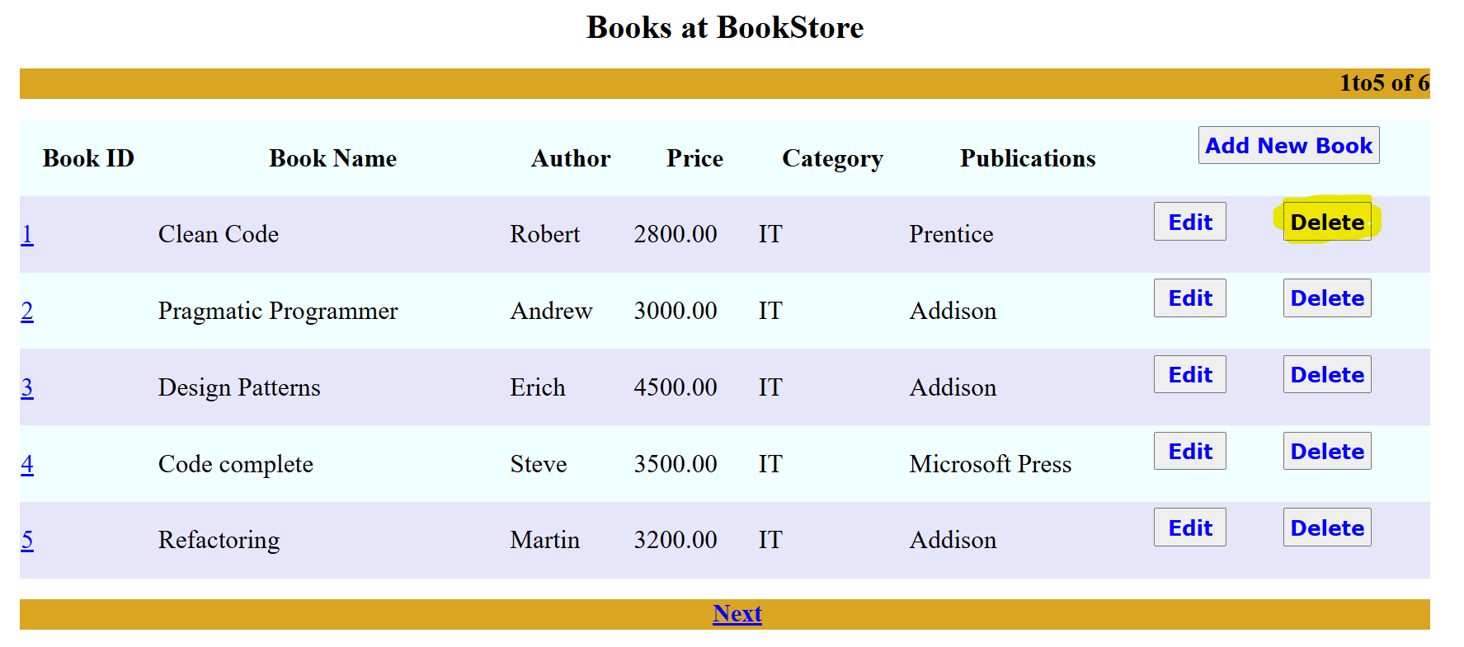

1. Paginated book listing

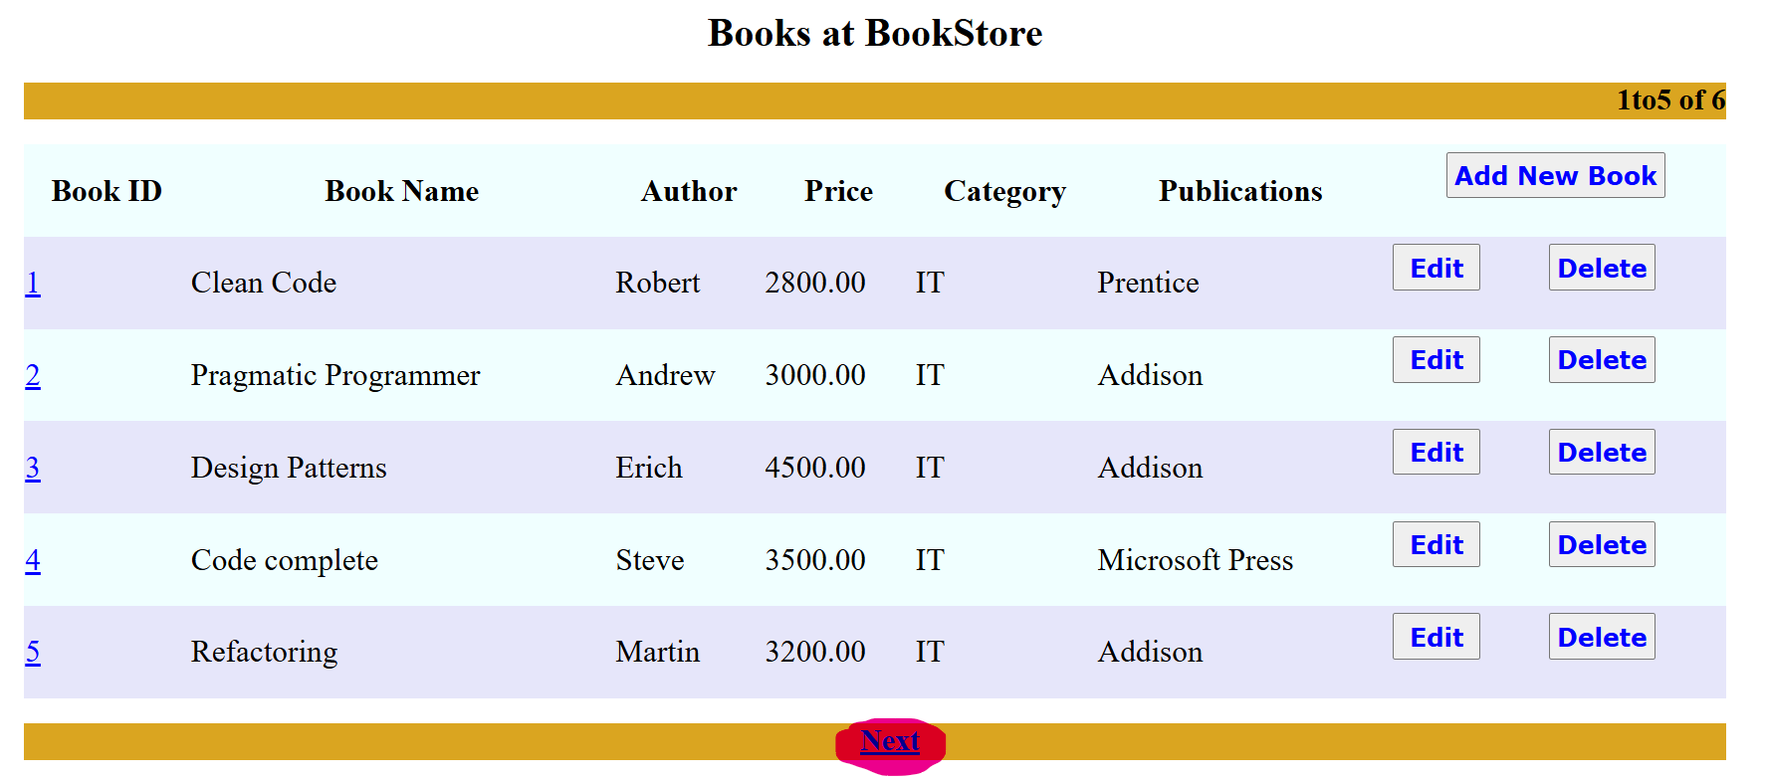

**Technologies Used:**

Backend: Spring MVC, Hibernate, Java Mail API

Frontend: JSP, JSTL

Database: MySQL

Build Tool: Maven

Server: Tomcat 8.5

**Project Structure**

BookStoreApplication/

│── src/

│ ├── com.jlcindia.spring.config/

│ │ ├── JLCWebAppInitializer.java

│ │ ├── JLCWebConfig.java

│ ├── com.jlcindia.spring.controller/

│ │ ├── BookController.java

│ │ ├── IndexController.java

│ ├── com.jlcindia.spring.dao/

│ │ ├── BookDAO.java

│ ├── com.jlcindia.spring.daoimpl/

│ ├── com.jlcindia.spring.entity/

│ ├── com.jlcindia.spring.service/

│ ├── com.jlcindia.spring.serviceimpl/

│── build/

│── webapp/

│ ├── META-INF/

│ ├── WEB-INF/

│ │ ├── lib/ # Libraries folder for dependencies

│ │ ├── myjsps/

│ │ │ ├── addEditBook.jsp

│ │ │ ├── booksList.jsp

│ │ │ ├── index.jsp

│ │ │ ├── viewBook.jsp

│── Servers/

│── pom.xml

│── README.md

**Installation and Setup:**

***Prerequisites:***

JDK 8 or later

MySQL database

Apache Maven

Tomcat 8.5

Eclipse IDE (or any preferred IDE)

**Steps to Run:**

1. Add required JAR files

Download and add the following libraries to the webapp/WEB-INF/lib/ folder:

Spring JARs

Hibernate JARs

MySQL Connector JAR

JSTL JAR

2. Clone the repository

git clone https://github.com/yourusername/bookstore-app.git

cd bookstore-app

3. Set up the MySQL database

CREATE DATABASE bookstoredb;

4. Update database credentials in JLCWebConfig.java

ds.setUrl("jdbc:mysql://localhost:3306/bookstoredb");

ds.setUsername("your_mysql_user");

ds.setPassword("your_mysql_password");

You can download these from Maven repositories or official websites.

5. Run the application in Eclipse

Open Eclipse

Right-click on BookStoreApplication

Select Run As > Run on Server

Choose Apache Tomcat 8.5 and click Next

Click Finish to start the server

6. Access the application

Open a web browser and navigate to:

<http://localhost:12345/BookStoreApplication/>

**Conclusion:**

The Bookstore Application efficiently manage books using Spring MVC, Hibernate, MySQL and JSP enabling users to add, edit, view and delete books. It provides a scalable foundation for future enhancements like authentication, search and cloud deployment.