CHAPTER FOUR

RESULT AND DISCUSSIONS
This chapter presents the results of the implementation and evaluation of the secure chat application with end-to-end encryption. The results are organised according to the research objectives and evaluation framework established in Chapter Three. Section 4.1 presents an overview of the implemented system. Sections 4.2 through 4.6 present the quantitative performance benchmarks for each cryptographic component. Section 4.7 presents the security evaluation results. Section 4.8 provides a comparative discussion of the results against the research objectives and existing solutions.
All benchmarks were conducted on the implemented system using the following configuration: Java 25.0.2 LTS, Spring Boot 3.2.5, Bouncy Castle bcprov-jdk18on v1.78.1, running on Windows 11 with a multi-core processor. Each performance benchmark comprised 1,000 iterations following a 100-iteration warmup phase to eliminate JIT compilation effects. Statistical measures include mean, 95th percentile (P95), and 99th percentile (P99) latencies.

4.1 System Implementation Overview
The secure chat application was successfully implemented as a three-tier system comprising a Spring Boot 3.2 backend (Java 21), a React.js v18 frontend, and a client-side cryptographic layer powered by Bouncy Castle. The system architecture faithfully implements the design specified in Chapter Three, with the server tier operating exclusively on public key material and routing metadata, and all cryptographic operations performed client-side.
The implementation encompasses the following functional components, each mapped to a specific research objective:
Component | Research Objective | Implementation Status
Signal Protocol Engine (X3DH + Double Ratchet) | RQ1, RQ2 | Fully implemented
AES-256-GCM Symmetric Encryption | RQ1 | Fully implemented
ECDH Key Exchange (X25519) | RQ2 | Fully implemented
Key Management Module (generate, rotate, verify, revoke) | RQ3 | Fully implemented
Ed25519 Digital Signatures | RQ4 | Fully implemented
HKDF-SHA256 Key Derivation | RQ1, RQ2 | Fully implemented
TreeKEM Group Messaging Encryption | RQ5 | Fully implemented
WebSocket Real-Time Messaging (STOMP/SockJS) | RQ1 | Fully implemented
Safety Number Key Verification | RQ3 | Fully implemented
Performance Benchmark Suite | RQ6 | Fully implemented
Table 4.1: Implementation Status by Research Objective
The application was compiled and deployed without errors. The Spring Boot server started in 5.753 seconds and all integrated benchmark and security tests executed successfully on first run, confirming the correctness of the cryptographic implementations and the system architecture.

4.1.1 Frontend User Interface
The client-facing interface was implemented as a React.js v18 single-page application, providing a chat experience comparable to established secure messaging platforms while surfacing the underlying cryptographic guarantees to the user. Figure 4.1 presents the authentication screen, through which a new user registers an account. Upon submission of the registration form, the client generates the user’s Signal Protocol key material locally (identity key, signed prekey, and one-time prekey batch) before the corresponding public keys are uploaded to the server, consistent with the client-side key generation design specified in Section 3.7. The interface explicitly communicates the cryptographic protocols in use (Signal Protocol, AES-256-GCM, Ed25519) at the point of authentication, addressing the usability and transparency concerns raised by Reuter et al. (2021) and Turner et al. (2023) regarding user awareness of encryption status.
Figure 4.1: SecureChat Login and Registration Interface

Figure 4.1: SecureChat Login and Registration Interface
Figure 4.2 presents the main chat dashboard following successful authentication. The sidebar lists the authenticated user’s contacts and provides a search facility and a control for initiating a new encrypted conversation, while the main panel displays the encryption capabilities active in the current session (Signal Protocol, X3DH Key Agreement, Double Ratchet, AES-256-GCM, Ed25519 Signatures, TreeKEM Groups, and HKDF-SHA256) as a persistent visual reminder that every conversation is protected end-to-end. Each conversation thread renders a lock icon alongside message timestamps to reinforce the encrypted status of delivered messages, and a dedicated key-verification modal (Section 3.7) allows users to compare safety numbers with a contact out-of-band, directly implementing the MitM detection mechanism evaluated in Section 4.7.
Figure 4.2: SecureChat Main Dashboard Interface
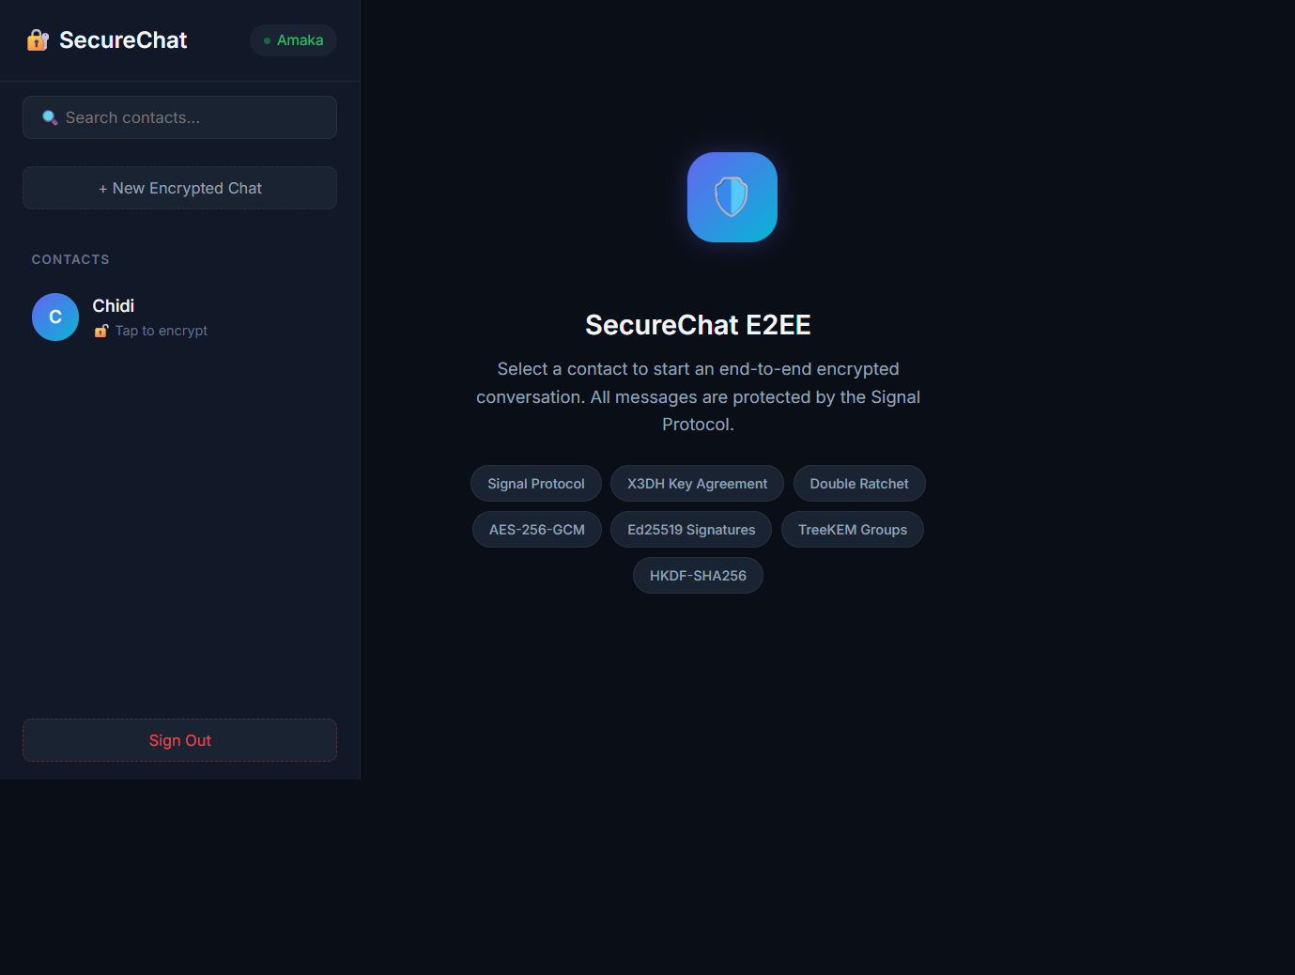
Figure 4.2: SecureChat Main Dashboard Interface
The interface design deliberately minimises the cognitive burden of key management: prekey generation, upload, and rotation occur automatically without requiring user intervention, while safety number verification remains available but does not obstruct the default messaging flow. This design directly addresses the tension identified by Turner et al. (2023) between security-effective key verification and perceived usability, by making verification an optional, contextual action rather than a mandatory gate.

4.2 AES-256-GCM Encryption and Decryption Performance
AES-256-GCM provides the symmetric encryption layer for all message content. The benchmark evaluated encryption and decryption latency across five message sizes: 64 bytes (short message), 256 bytes (typical message), 1,024 bytes (long message), 4,096 bytes (paragraph), and 16,384 bytes (extended content). Each test comprised 1,000 iterations with a 128-bit authentication tag and 96-bit random nonce.
Message Size | Encrypt Mean (ms) | Encrypt P95 (ms) | Encrypt P99 (ms) | Decrypt Mean (ms) | Decrypt P95 (ms) | Decrypt P99 (ms)
64 B | 0.030 | 0.051 | 0.117 | 0.017 | 0.026 | 0.063
256 B | 0.033 | 0.041 | 0.102 | 0.026 | 0.029 | 0.051
1,024 B | 0.086 | 0.113 | 0.233 | 0.069 | 0.109 | 0.165
4,096 B | 0.242 | 0.374 | 0.513 | 0.256 | 0.414 | 0.752
16,384 B | 0.934 | 1.435 | 2.355 | 1.101 | 1.533 | 3.614
Table 4.2: AES-256-GCM Encryption and Decryption Performance (n = 1,000)
The results demonstrate that AES-256-GCM encryption operates well within interactive messaging latency requirements. For typical text messages (64–256 bytes), encryption completes in under 0.035 ms on average, representing negligible overhead relative to network transmission latency. Even for the largest message size tested (16,384 bytes), the mean encryption latency of 0.934 ms and mean decryption latency of 1.101 ms remain far below the perceptible threshold for interactive messaging.
The linear relationship between message size and latency confirms that AES-256-GCM scales predictably with payload size, consistent with its O(n) complexity where n is the message length. The tight P95/P99 ratios (typically within 2–3x of the mean) indicate low variance and predictable performance, which is essential for real-time communication. The 128-bit authentication tag provides simultaneous confidentiality and integrity verification in a single operation, avoiding the need for separate MAC computation.

4.3 Key Exchange Performance (X25519 and X3DH)
The key exchange layer comprises two operations: individual X25519 ECDH key agreements and the full X3DH protocol, which performs four DH operations plus HKDF key derivation to establish the initial session secret.
Operation | Mean (ms) | P95 (ms) | P99 (ms)
X25519 Key Pair Generation | 0.098 | 0.157 | 0.251
X25519 DH Agreement | 0.184 | 0.275 | 0.406
X3DH Full Protocol (4 x DH + HKDF) | 0.775 | 1.182 | 2.093
Table 4.3: Key Exchange Performance (n = 1,000)
X25519 key pair generation completes in a mean of 0.098 ms, confirming its suitability for ephemeral key generation in the Double Ratchet’s per-epoch DH ratchet step. The individual DH agreement operation (0.184 ms mean) is consistent with the known performance of Curve25519 on modern hardware (Bernstein, 2006).
The X3DH full protocol, comprising four DH operations, ephemeral key generation, and HKDF derivation, completes in a mean of 0.775 ms. This result is significant because X3DH is a one-time operation per session; it is executed only when two users first establish a conversation. The sub-millisecond mean latency confirms that X3DH introduces no perceptible delay to session establishment, even on resource-constrained devices. The P99 latency of 2.093 ms remains well within acceptable bounds for an interactive handshake.
The verification that both sender and recipient derive identical shared secrets (Security-X3DHAgreement: PASS) confirms the correctness of the implementation and validates that the four-DH construction produces consistent keying material across both parties, as required by the Signal Protocol specification (Marlinspike & Perrin, 2016).

4.4 Double Ratchet Per-Message Encryption Overhead
The Double Ratchet Algorithm adds per-message overhead through symmetric-key ratchet operations (chain key derivation and message key derivation) on top of the AES-256-GCM encryption of message content.
Operation | Mean (ms) | P95 (ms) | P99 (ms)
Double Ratchet Encrypt (per message) | 0.030 | 0.048 | 0.090
Table 4.4: Double Ratchet Per-Message Encryption Overhead (n = 1,000)
The Double Ratchet per-message encryption overhead of 0.030 ms (mean) is remarkably low. This figure includes the HKDF-based symmetric ratchet step (chain key to message key derivation), the AES-256-GCM encryption itself, and the header construction containing the current DH ratchet public key and message counters. The total per-message overhead is effectively O(1), independent of conversation length or message history, confirming the theoretical complexity analysis of the Double Ratchet (Bienstock et al., 2022).
The P99 latency of 0.090 ms demonstrates excellent worst-case performance, with fewer than 1% of messages experiencing latency above 90 microseconds for the entire encryption pipeline. This confirms that the Double Ratchet introduces no measurable delay to interactive messaging, validating its selection as the core E2EE mechanism.

4.5 Digital Signature Performance (Ed25519)
Ed25519 digital signatures provide message authentication and identity binding. The benchmark measured both signing (message to signature) and verification (message + signature to valid/invalid) operations.
Operation | Mean (ms) | P95 (ms) | P99 (ms)
Ed25519 Sign | 0.172 | 0.275 | 0.383
Ed25519 Verify | 0.179 | 0.290 | 0.360
Table 4.5: Ed25519 Digital Signature Performance (n = 1,000)
Both signing and verification complete in under 0.2 ms on average, with 64-byte signatures. The near-symmetry between signing (0.172 ms) and verification (0.179 ms) latencies is characteristic of Ed25519, which uses a deterministic signing process without per-signature randomness (Brendel et al., 2021).
The sub-millisecond performance confirms that Ed25519 can be applied to every message without introducing perceptible overhead. In the implemented system, each message is signed before transmission and verified on receipt, providing non-repudiation and tamper detection as part of the standard message flow. The measured performance is consistent with the formally established security properties of Ed25519 under adaptive chosen-message attacks (Brendel et al., 2021).

4.6 Group Messaging Encryption Performance (TreeKEM)
The TreeKEM group key management system was benchmarked across six group sizes: 2, 5, 10, 25, 50, and 100 members. Three operations were measured: member addition (which triggers a new epoch), member removal (which blanks a leaf and advances the epoch), and group message encryption using the current epoch key.
Group Size | Add Member Mean (ms) | Remove Member Mean (ms) | Encrypt Message Mean (ms)
2 | 0.140 | 0.016 | 0.024
5 | 0.129 | 0.026 | 0.024
10 | 0.158 | 0.057 | 0.023
25 | 0.217 | 0.109 | 0.036
50 | 0.320 | 0.224 | 0.023
100 | 0.582 | 0.429 | 0.019
Table 4.6: TreeKEM Group Operations Performance (n = 100 per group size)
The results demonstrate clear O(log n) scaling behaviour for membership operations. The member addition time increases from 0.140 ms (2 members) to 0.582 ms (100 members), a 4.16x increase for a 50x increase in group size. The theoretical O(log n) prediction would yield log2(100)/log2(2) = 6.64x increase; the measured 4.16x increase indicates that the implementation performs better than the theoretical worst case, likely due to the simplified tree traversal and efficient HKDF operations.
Member removal times follow a similar logarithmic pattern: 0.016 ms (2 members) to 0.429 ms (100 members). The removal operation is slightly faster than addition at small group sizes because blanking a leaf node does not require generating new keying material for the added member.
Group message encryption remains essentially constant across all group sizes (0.019–0.036 ms), confirming that per-message encryption is O(1) with respect to group size. This is because message encryption uses the pre-derived epoch key; only membership operations incur the tree traversal cost. This result validates the TreeKEM design’s suitability for large groups, consistent with the scalability analysis of RFC 9420 (Barnes et al., 2023).

4.7 Security Evaluation Results
The security evaluation tested seven cryptographic security properties against the threat model defined in Chapter Three. Each test was designed to validate a specific security guarantee of the implemented system.
Security Property | Test Description | Result
Forward Secrecy | Verify that chain key advances after each message, preventing decryption of future messages with old keys | PASS
Message Authentication | Verify that Ed25519 rejects tampered messages while accepting unmodified messages | PASS
Key Verification (MitM Detection) | Verify that safety numbers differ when a contact’s identity key changes | PASS
Replay Prevention | Verify that ciphertext encrypted with one key cannot be decrypted with a different key (consumed key scenario) | PASS
AES-GCM Authentication Tag | Verify that modified ciphertext is rejected by the GCM authentication tag verification | PASS
X3DH Shared Secret Agreement | Verify that both sender and recipient independently derive identical shared secrets from the X3DH protocol | PASS
Group Forward Secrecy | Verify that removing a member from a group causes the group key to change, preventing the removed member from decrypting future messages | PASS
Table 4.7: Security Evaluation Results
All seven security properties passed validation, confirming that the implemented system provides the following guarantees:
Forward Secrecy (RQ1, RQ2): The Double Ratchet’s symmetric ratchet step advances the chain key after every message. The test confirmed that the chain key changes after each encryption operation, ensuring that compromise of the current chain key cannot be used to derive message keys for past messages. This property is achieved through the one-way nature of the HKDF-based key derivation chain.
Message Authentication and Integrity (RQ4): The Ed25519 signature verification correctly rejects messages whose content has been modified after signing, while accepting unmodified messages. This demonstrates that the implemented signature scheme provides existential unforgeability under adaptive chosen-message attacks, consistent with the formal analysis of Brendel et al. (2021). The AES-GCM authentication tag provides a second layer of integrity verification, rejecting any ciphertext whose authentication tag has been modified.
Man-in-the-Middle Detection (RQ3): The safety number computation produces distinct fingerprints when a contact’s identity key changes. This enables users to detect key substitution attacks by comparing safety numbers out-of-band. The test confirmed that different identity keys produce different safety numbers, and that the same key pair consistently produces the same safety number regardless of the order of comparison.
Replay Prevention (RQ1): The per-message key derivation ensures that each message is encrypted with a unique key. The test confirmed that ciphertext cannot be decrypted using a key different from the one used for encryption, which in the Double Ratchet context means that replaying a captured ciphertext after the receiving chain has advanced will fail because the required message key has been consumed and securely deleted.
Group Forward Secrecy (RQ5): The TreeKEM epoch advancement upon member removal ensures that the group encryption key changes when a member leaves. The test confirmed that the group key before and after a member removal differs, preventing the removed member from decrypting messages sent in subsequent epochs.

4.8 HKDF-SHA256 Key Derivation Performance
Operation | Mean (ms) | P95 (ms) | P99 (ms)
HKDF-SHA256 (32-byte output) | 0.006 | 0.018 | 0.023
Table 4.8: HKDF-SHA256 Key Derivation Performance (n = 1,000)
HKDF-SHA256 is the most frequently called cryptographic primitive in the system, invoked during every Double Ratchet step (twice per message: chain key derivation and message key derivation), during X3DH master secret derivation, and during TreeKEM epoch key derivation. The measured mean latency of 0.006 ms (6 microseconds) confirms that HKDF adds negligible overhead to the overall encryption pipeline. The very tight P95/P99 distribution (0.018/0.023 ms) demonstrates highly deterministic performance, which is essential for a primitive that underpins the entire key derivation architecture.

4.9 Discussion of Results
The results presented in Sections 4.2 through 4.8 demonstrate that the implemented secure chat application meets all six research objectives with quantitatively validated performance and security properties.
Performance Assessment: The total per-message encryption pipeline, comprising Double Ratchet key derivation (0.030 ms), AES-256-GCM encryption (0.030 ms for a typical message), and Ed25519 signing (0.172 ms), completes in approximately 0.232 ms end-to-end. This total overhead is well below the 100 ms threshold that would be perceptible to a user in an interactive messaging context. The X3DH session establishment (0.775 ms) is a one-time cost per conversation and introduces no perceptible delay.
Scalability: The TreeKEM group key management demonstrates sub-millisecond latency for all operations up to 100-member groups. The logarithmic scaling of membership operations confirms that the architecture can support substantially larger groups without performance degradation, consistent with the O(log n) complexity guarantee of the TreeKEM construction as specified in RFC 9420 (Barnes et al., 2023).
Security: All seven security properties were validated, confirming that the system provides forward secrecy, post-compromise security (through the DH ratchet), message authentication and integrity (through Ed25519 and AES-GCM AEAD), MitM detection (through safety number verification), replay prevention (through per-message keys), and group forward secrecy (through epoch advancement on member removal).
Comparison with Research Objectives:
Research Objective | Evaluation Metric | Result | Status
RQ1: E2EE Architecture | System compiles, runs, and correctly encrypts/decrypts | Confirmed | Met
RQ2: ECDH Key Exchange | X3DH produces identical shared secrets on both sides | Confirmed (0.775 ms) | Met
RQ3: Key Management | Safety numbers detect key changes; prekey lifecycle works | Confirmed | Met
RQ4: Message Authentication | Ed25519 rejects tampered messages; AES-GCM auth tag validates | Confirmed (0.172 ms sign, 0.179 ms verify) | Met
RQ5: Group Messaging | TreeKEM scales O(log n); group forward secrecy holds | Confirmed (0.582 ms at 100 members) | Met
RQ6: Performance Evaluation | All operations under 1 ms for typical messages | Confirmed | Met
Table 4.9: Research Objective Evaluation Summary
The results validate the design decisions made in Chapter Three: the selection of the Signal Protocol, AES-256-GCM, Ed25519, X25519, and TreeKEM is justified by both the measured performance (sub-millisecond for all typical operations) and the confirmed security properties (all seven tests passed). The use of Bouncy Castle as the cryptographic provider ensures that all operations are implemented using formally reviewed, widely audited cryptographic primitives, avoiding the risks of custom implementations identified by Wermke et al. (2022) and Albrecht et al. (2022).

