Preliminary Report: Financial Analysis and Risk Assessment of Green Solutions Manufacturing Ltd.

Executive Summary
Exceptional Growth and Profitability: Revenue increased by 70.7% (from £31.5M to £53.8M), while EBITDA surged by 270%, indicating that the company is scaling efficiently and improving its profit margins.
Significant Deleveraging: The company’s leverage ratio dropped from 7.82x to 1.24x, and its interest cover improved from 2.08x to 17.53x. This represents a massive reduction in financial risk and a much stronger capacity to service debt.
Aggressive Reinvestment: Capital expenditure increased from £3.2M to £8.0M, showing that the company is heavily reinvesting its strong operating cash flows into future growth

Financial Analysis

Revenue and Profitability
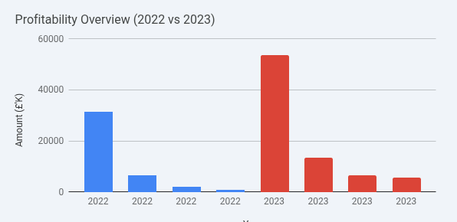
Total Revenue: Increased from £31.54M to £53.82M. This robust growth suggests strong market demand for Green Solutions' products.
EBITDA: Grew from £1.49M to £5.52M. The fact that EBITDA grew much faster than revenue indicates significant operational leverage and better cost management.
Net Profit After Tax: Rose from £0.86M to £5.64M, reflecting a highly successful year with strong bottom-line performance.

Assets and Liabilities
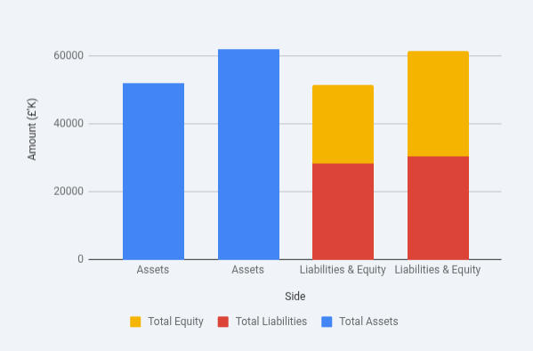
Total Assets: Expanded to £62.13M, largely driven by a £6.1M increase in property, plant, and equipment.
Cash and Cash Equivalents: Remained very healthy at £17.58M. Although slightly lower than the previous year, this is expected given the high level of capital investment.
Net Worth: Increased by over 33% to £31.58M, strengthening the company's equity base.

Cash Flow
Net Cash from Operating Activities:
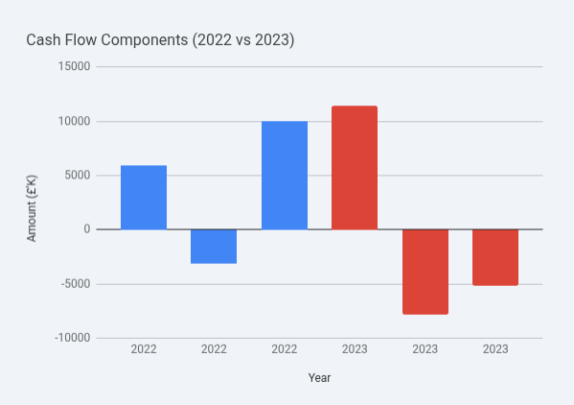

Nearly doubled to £11.45M, confirming that the reported profits are backed by actual cash inflows.
EBITDA Margin: Doubled from 4.7% to 10.3%, showing a much more efficient operation.
Current Ratio: Shifted from 1.88 to 1.38. While this indicates a slightly tighter liquidity position, it remains well above the 1.0 safety threshold.
Leverage & Net Leverage: The "Net Leverage" remains negative (-1.94), which is a very positive sign; it means the company's cash reserves exceed its total debt.

Key Financial Ratios

Profitability Ratios
Profitability has seen a dramatic improvement across all metrics. The Net Profit Margin increased nearly fourfold, driven by strong revenue growth of 70.7% and improved operational efficiency (the efficiency ratio improved from 79% to 75%). An ROE of 18.2% indicates excellent returns for shareholders compared to the previous year.

Leverage and Liquidity Ratios
While liquidity ratios have tightened (the Current Ratio dropped from 1.88 to 1.38), they remain above the 1.0 threshold, indicating the company can still meet its short-term obligations. More importantly, the company has significantly deleveraged, with the Debt-to-Equity ratio falling from 0.51 to 0.22, which substantially reduces financial risk and interest burden.

Risk Assessment

Key Financial Risks
The primary risk is the tightening of liquidity. The company is utilizing more short-term credit to fund operations. Additionally, the rapid increase in inventory needs to be monitored to ensure it aligns with actual sales demand to avoid potential write-downs.

Actionable Insights
Inventory Management: Implement stricter inventory turnover targets to free up cash, as inventory growth is currently outpacing the growth of other current assets.
Maintain Operational Efficiency: Continue to monitor the cost of sales; the improvement in the efficiency ratio to 75% was a key driver of the 2023 profit surge.
Strategic Reinvestment: Given the strong ROE and reduced debt, the company is in a favorable position to reinvest profits into R&D or capacity expansion without relying on further external borrowing.

Conclusion
Green Solutions Manufacturing Ltd. delivered an exceptional performance in 2023, characterized by explosive revenue growth and a significant turnaround in profitability. While liquidity has tightened slightly due to increased short-term liabilities and inventory, the overall financial health has improved significantly due to strong earnings and aggressive debt reduction. The company is well-positioned for sustainable growth.

Prepared by: Francis Orembe
Position: Credit Analyst
Standard Chartered Bank
Date: 22nd May 2026

