The best key value:
56ms is the minimum runtime when key is 34 in 10^6
579ms is the minimum runtime when key is 26 in 10^7
6014ms is the minimum runtime when key is 35 in 10^8
Running Table:
The result of 10^6's running time:
170ms 106ms 91ms 81ms 86ms 92ms 68ms 66ms 66ms 65ms
66ms 61ms 60ms 64ms 60ms 60ms 63ms 61ms 60ms 58ms
61ms 58ms 58ms 59ms 60ms 59ms 60ms 57ms 53ms 57ms
55ms 55ms 56ms 56ms 59ms 57ms 55ms 56ms 55ms 56ms

The result of 10^6's running time:
1823ms 904ms 943ms 802ms 775ms 964ms 781ms 670ms 666ms 675ms
661ms 655ms 649ms 659ms 644ms 597ms 612ms 647ms 639ms 602ms
601ms 575ms 604ms 592ms 575ms 579ms 584ms 579ms 614ms 589ms
546ms 537ms 566ms 557ms 601ms 566ms 574ms 582ms 610ms 560ms

The result of 10^6's running time:
18884ms 10171ms 9883ms 9154ms 8242ms 7961ms 7869ms 7961ms 7738ms 6884ms
6784ms 6956ms 6979ms 6611ms 6489ms 6726ms 6727ms 6857ms 6514ms 6201ms
6320ms 6399ms 6067ms 6175ms 6262ms 6403ms 6261ms 6350ms 6149ms 6354ms
6315ms 6348ms 6186ms 6123ms 6014ms 6107ms 6221ms 6623ms 5596ms 6347ms

56ms is the minimum runtime when key is 34 in 10^6
579ms is the minimum runtime when key is 26 in 10^7
6014ms is the minimum runtime when key is 35 in 10^8

Graph:
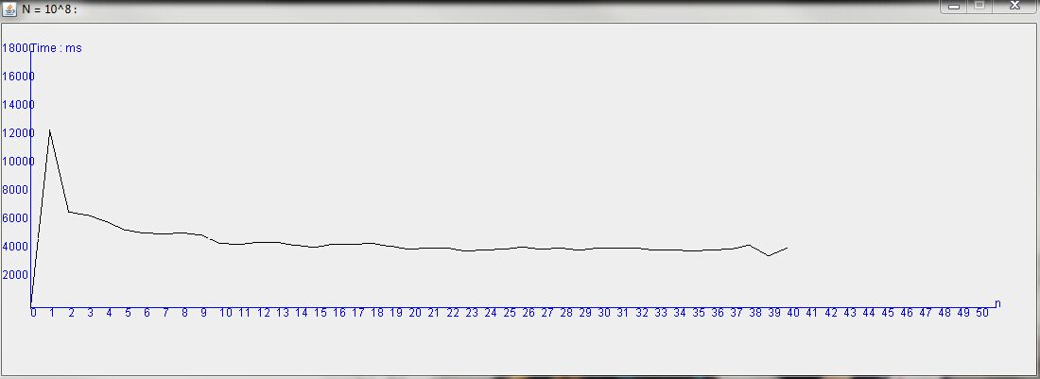

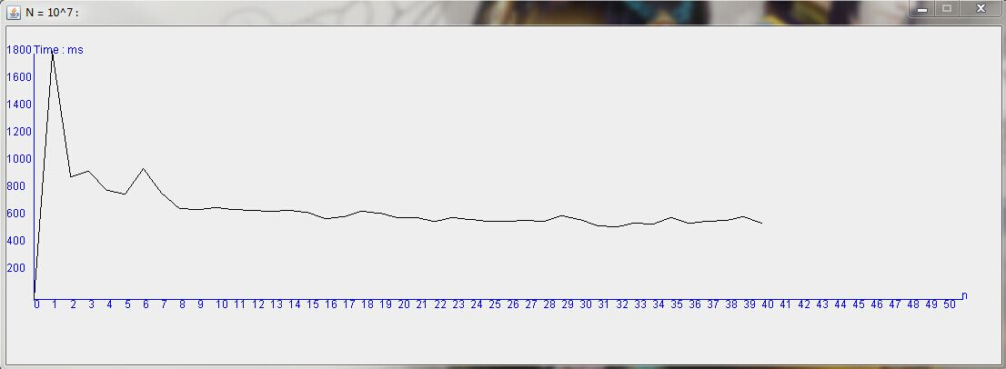

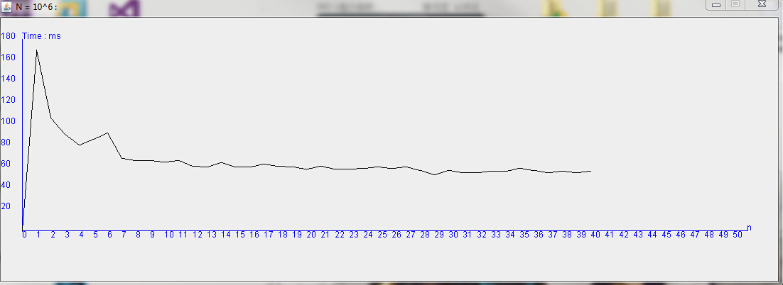
Code result:
Please wait 20s for the Random Array Initial .
The result will be appear by the form of Graph . And the final result will be calculate after about s
When the n = 10^6 ,k = 1 ,the run time to sort is for the sanme array(element from 1 to 100000) : 170ms
When the n = 10^7 ,k = 1 ,the run time to sort is for the sanme array(element from 1 to 100000) : 1823ms
When the n = 10^8 ,k = 1 ,the run time to sort is for the sanme array(element from 1 to 100000) : 18884ms

When the n = 10^6 ,k = 2 ,the run time to sort is for the sanme array(element from 1 to 100000) : 106ms
When the n = 10^7 ,k = 2 ,the run time to sort is for the sanme array(element from 1 to 100000) : 904ms
When the n = 10^8 ,k = 2 ,the run time to sort is for the sanme array(element from 1 to 100000) : 10171ms

When the n = 10^6 ,k = 3 ,the run time to sort is for the sanme array(element from 1 to 100000) : 91ms
When the n = 10^7 ,k = 3 ,the run time to sort is for the sanme array(element from 1 to 100000) : 943ms
When the n = 10^8 ,k = 3 ,the run time to sort is for the sanme array(element from 1 to 100000) : 9883ms

When the n = 10^6 ,k = 4 ,the run time to sort is for the sanme array(element from 1 to 100000) : 81ms
When the n = 10^7 ,k = 4 ,the run time to sort is for the sanme array(element from 1 to 100000) : 802ms
When the n = 10^8 ,k = 4 ,the run time to sort is for the sanme array(element from 1 to 100000) : 9154ms

When the n = 10^6 ,k = 5 ,the run time to sort is for the sanme array(element from 1 to 100000) : 86ms
When the n = 10^7 ,k = 5 ,the run time to sort is for the sanme array(element from 1 to 100000) : 775ms
When the n = 10^8 ,k = 5 ,the run time to sort is for the sanme array(element from 1 to 100000) : 8242ms

When the n = 10^6 ,k = 6 ,the run time to sort is for the sanme array(element from 1 to 100000) : 92ms
When the n = 10^7 ,k = 6 ,the run time to sort is for the sanme array(element from 1 to 100000) : 964ms
When the n = 10^8 ,k = 6 ,the run time to sort is for the sanme array(element from 1 to 100000) : 7961ms

When the n = 10^6 ,k = 7 ,the run time to sort is for the sanme array(element from 1 to 100000) : 68ms
When the n = 10^7 ,k = 7 ,the run time to sort is for the sanme array(element from 1 to 100000) : 781ms
When the n = 10^8 ,k = 7 ,the run time to sort is for the sanme array(element from 1 to 100000) : 7869ms

When the n = 10^6 ,k = 8 ,the run time to sort is for the sanme array(element from 1 to 100000) : 66ms
When the n = 10^7 ,k = 8 ,the run time to sort is for the sanme array(element from 1 to 100000) : 670ms
When the n = 10^8 ,k = 8 ,the run time to sort is for the sanme array(element from 1 to 100000) : 7961ms

When the n = 10^6 ,k = 9 ,the run time to sort is for the sanme array(element from 1 to 100000) : 66ms
When the n = 10^7 ,k = 9 ,the run time to sort is for the sanme array(element from 1 to 100000) : 666ms
When the n = 10^8 ,k = 9 ,the run time to sort is for the sanme array(element from 1 to 100000) : 7738ms

When the n = 10^6 ,k = 10 ,the run time to sort is for the sanme array(element from 1 to 100000) : 65ms
When the n = 10^7 ,k = 10 ,the run time to sort is for the sanme array(element from 1 to 100000) : 675ms
When the n = 10^8 ,k = 10 ,the run time to sort is for the sanme array(element from 1 to 100000) : 6884ms

When the n = 10^6 ,k = 11 ,the run time to sort is for the sanme array(element from 1 to 100000) : 66ms
When the n = 10^7 ,k = 11 ,the run time to sort is for the sanme array(element from 1 to 100000) : 661ms
When the n = 10^8 ,k = 11 ,the run time to sort is for the sanme array(element from 1 to 100000) : 6784ms

When the n = 10^6 ,k = 12 ,the run time to sort is for the sanme array(element from 1 to 100000) : 61ms
When the n = 10^7 ,k = 12 ,the run time to sort is for the sanme array(element from 1 to 100000) : 655ms
When the n = 10^8 ,k = 12 ,the run time to sort is for the sanme array(element from 1 to 100000) : 6956ms

When the n = 10^6 ,k = 13 ,the run time to sort is for the sanme array(element from 1 to 100000) : 60ms
When the n = 10^7 ,k = 13 ,the run time to sort is for the sanme array(element from 1 to 100000) : 649ms
When the n = 10^8 ,k = 13 ,the run time to sort is for the sanme array(element from 1 to 100000) : 6979ms

When the n = 10^6 ,k = 14 ,the run time to sort is for the sanme array(element from 1 to 100000) : 64ms
When the n = 10^7 ,k = 14 ,the run time to sort is for the sanme array(element from 1 to 100000) : 659ms
When the n = 10^8 ,k = 14 ,the run time to sort is for the sanme array(element from 1 to 100000) : 6611ms

When the n = 10^6 ,k = 15 ,the run time to sort is for the sanme array(element from 1 to 100000) : 60ms
When the n = 10^7 ,k = 15 ,the run time to sort is for the sanme array(element from 1 to 100000) : 644ms
When the n = 10^8 ,k = 15 ,the run time to sort is for the sanme array(element from 1 to 100000) : 6489ms

When the n = 10^6 ,k = 16 ,the run time to sort is for the sanme array(element from 1 to 100000) : 60ms
When the n = 10^7 ,k = 16 ,the run time to sort is for the sanme array(element from 1 to 100000) : 597ms
When the n = 10^8 ,k = 16 ,the run time to sort is for the sanme array(element from 1 to 100000) : 6726ms

When the n = 10^6 ,k = 17 ,the run time to sort is for the sanme array(element from 1 to 100000) : 63ms
When the n = 10^7 ,k = 17 ,the run time to sort is for the sanme array(element from 1 to 100000) : 612ms
When the n = 10^8 ,k = 17 ,the run time to sort is for the sanme array(element from 1 to 100000) : 6727ms

When the n = 10^6 ,k = 18 ,the run time to sort is for the sanme array(element from 1 to 100000) : 61ms
When the n = 10^7 ,k = 18 ,the run time to sort is for the sanme array(element from 1 to 100000) : 647ms
When the n = 10^8 ,k = 18 ,the run time to sort is for the sanme array(element from 1 to 100000) : 6857ms

When the n = 10^6 ,k = 19 ,the run time to sort is for the sanme array(element from 1 to 100000) : 60ms
When the n = 10^7 ,k = 19 ,the run time to sort is for the sanme array(element from 1 to 100000) : 639ms
When the n = 10^8 ,k = 19 ,the run time to sort is for the sanme array(element from 1 to 100000) : 6514ms

When the n = 10^6 ,k = 20 ,the run time to sort is for the sanme array(element from 1 to 100000) : 58ms
When the n = 10^7 ,k = 20 ,the run time to sort is for the sanme array(element from 1 to 100000) : 602ms
When the n = 10^8 ,k = 20 ,the run time to sort is for the sanme array(element from 1 to 100000) : 6201ms

When the n = 10^6 ,k = 21 ,the run time to sort is for the sanme array(element from 1 to 100000) : 61ms
When the n = 10^7 ,k = 21 ,the run time to sort is for the sanme array(element from 1 to 100000) : 601ms
When the n = 10^8 ,k = 21 ,the run time to sort is for the sanme array(element from 1 to 100000) : 6320ms

When the n = 10^6 ,k = 22 ,the run time to sort is for the sanme array(element from 1 to 100000) : 58ms
When the n = 10^7 ,k = 22 ,the run time to sort is for the sanme array(element from 1 to 100000) : 575ms
When the n = 10^8 ,k = 22 ,the run time to sort is for the sanme array(element from 1 to 100000) : 6399ms

When the n = 10^6 ,k = 23 ,the run time to sort is for the sanme array(element from 1 to 100000) : 58ms
When the n = 10^7 ,k = 23 ,the run time to sort is for the sanme array(element from 1 to 100000) : 604ms
When the n = 10^8 ,k = 23 ,the run time to sort is for the sanme array(element from 1 to 100000) : 6067ms

When the n = 10^6 ,k = 24 ,the run time to sort is for the sanme array(element from 1 to 100000) : 59ms
When the n = 10^7 ,k = 24 ,the run time to sort is for the sanme array(element from 1 to 100000) : 592ms
When the n = 10^8 ,k = 24 ,the run time to sort is for the sanme array(element from 1 to 100000) : 6175ms

When the n = 10^6 ,k = 25 ,the run time to sort is for the sanme array(element from 1 to 100000) : 60ms
When the n = 10^7 ,k = 25 ,the run time to sort is for the sanme array(element from 1 to 100000) : 575ms
When the n = 10^8 ,k = 25 ,the run time to sort is for the sanme array(element from 1 to 100000) : 6262ms

When the n = 10^6 ,k = 26 ,the run time to sort is for the sanme array(element from 1 to 100000) : 59ms
When the n = 10^7 ,k = 26 ,the run time to sort is for the sanme array(element from 1 to 100000) : 579ms
When the n = 10^8 ,k = 26 ,the run time to sort is for the sanme array(element from 1 to 100000) : 6403ms

When the n = 10^6 ,k = 27 ,the run time to sort is for the sanme array(element from 1 to 100000) : 60ms
When the n = 10^7 ,k = 27 ,the run time to sort is for the sanme array(element from 1 to 100000) : 584ms
When the n = 10^8 ,k = 27 ,the run time to sort is for the sanme array(element from 1 to 100000) : 6261ms

When the n = 10^6 ,k = 28 ,the run time to sort is for the sanme array(element from 1 to 100000) : 57ms
When the n = 10^7 ,k = 28 ,the run time to sort is for the sanme array(element from 1 to 100000) : 579ms
When the n = 10^8 ,k = 28 ,the run time to sort is for the sanme array(element from 1 to 100000) : 6350ms

When the n = 10^6 ,k = 29 ,the run time to sort is for the sanme array(element from 1 to 100000) : 53ms
When the n = 10^7 ,k = 29 ,the run time to sort is for the sanme array(element from 1 to 100000) : 614ms
When the n = 10^8 ,k = 29 ,the run time to sort is for the sanme array(element from 1 to 100000) : 6149ms

When the n = 10^6 ,k = 30 ,the run time to sort is for the sanme array(element from 1 to 100000) : 57ms
When the n = 10^7 ,k = 30 ,the run time to sort is for the sanme array(element from 1 to 100000) : 589ms
When the n = 10^8 ,k = 30 ,the run time to sort is for the sanme array(element from 1 to 100000) : 6354ms

When the n = 10^6 ,k = 31 ,the run time to sort is for the sanme array(element from 1 to 100000) : 55ms
When the n = 10^7 ,k = 31 ,the run time to sort is for the sanme array(element from 1 to 100000) : 546ms
When the n = 10^8 ,k = 31 ,the run time to sort is for the sanme array(element from 1 to 100000) : 6315ms

When the n = 10^6 ,k = 32 ,the run time to sort is for the sanme array(element from 1 to 100000) : 55ms
When the n = 10^7 ,k = 32 ,the run time to sort is for the sanme array(element from 1 to 100000) : 537ms
When the n = 10^8 ,k = 32 ,the run time to sort is for the sanme array(element from 1 to 100000) : 6348ms

When the n = 10^6 ,k = 33 ,the run time to sort is for the sanme array(element from 1 to 100000) : 56ms
When the n = 10^7 ,k = 33 ,the run time to sort is for the sanme array(element from 1 to 100000) : 566ms
When the n = 10^8 ,k = 33 ,the run time to sort is for the sanme array(element from 1 to 100000) : 6186ms

When the n = 10^6 ,k = 34 ,the run time to sort is for the sanme array(element from 1 to 100000) : 56ms
When the n = 10^7 ,k = 34 ,the run time to sort is for the sanme array(element from 1 to 100000) : 557ms
When the n = 10^8 ,k = 34 ,the run time to sort is for the sanme array(element from 1 to 100000) : 6123ms

When the n = 10^6 ,k = 35 ,the run time to sort is for the sanme array(element from 1 to 100000) : 59ms
When the n = 10^7 ,k = 35 ,the run time to sort is for the sanme array(element from 1 to 100000) : 601ms
When the n = 10^8 ,k = 35 ,the run time to sort is for the sanme array(element from 1 to 100000) : 6014ms

When the n = 10^6 ,k = 36 ,the run time to sort is for the sanme array(element from 1 to 100000) : 57ms
When the n = 10^7 ,k = 36 ,the run time to sort is for the sanme array(element from 1 to 100000) : 566ms
When the n = 10^8 ,k = 36 ,the run time to sort is for the sanme array(element from 1 to 100000) : 6107ms

When the n = 10^6 ,k = 37 ,the run time to sort is for the sanme array(element from 1 to 100000) : 55ms
When the n = 10^7 ,k = 37 ,the run time to sort is for the sanme array(element from 1 to 100000) : 574ms
When the n = 10^8 ,k = 37 ,the run time to sort is for the sanme array(element from 1 to 100000) : 6221ms

When the n = 10^6 ,k = 38 ,the run time to sort is for the sanme array(element from 1 to 100000) : 56ms
When the n = 10^7 ,k = 38 ,the run time to sort is for the sanme array(element from 1 to 100000) : 582ms
When the n = 10^8 ,k = 38 ,the run time to sort is for the sanme array(element from 1 to 100000) : 6623ms

When the n = 10^6 ,k = 39 ,the run time to sort is for the sanme array(element from 1 to 100000) : 55ms
When the n = 10^7 ,k = 39 ,the run time to sort is for the sanme array(element from 1 to 100000) : 610ms
When the n = 10^8 ,k = 39 ,the run time to sort is for the sanme array(element from 1 to 100000) : 5596ms

When the n = 10^6 ,k = 40 ,the run time to sort is for the sanme array(element from 1 to 100000) : 56ms
When the n = 10^7 ,k = 40 ,the run time to sort is for the sanme array(element from 1 to 100000) : 560ms
When the n = 10^8 ,k = 40 ,the run time to sort is for the sanme array(element from 1 to 100000) : 6347ms

The result of 10^6's running time:
170ms 106ms 91ms 81ms 86ms 92ms 68ms 66ms 66ms 65ms
66ms 61ms 60ms 64ms 60ms 60ms 63ms 61ms 60ms 58ms
61ms 58ms 58ms 59ms 60ms 59ms 60ms 57ms 53ms 57ms
55ms 55ms 56ms 56ms 59ms 57ms 55ms 56ms 55ms 56ms

The result of 10^6's running time:
1823ms 904ms 943ms 802ms 775ms 964ms 781ms 670ms 666ms 675ms
661ms 655ms 649ms 659ms 644ms 597ms 612ms 647ms 639ms 602ms
601ms 575ms 604ms 592ms 575ms 579ms 584ms 579ms 614ms 589ms
546ms 537ms 566ms 557ms 601ms 566ms 574ms 582ms 610ms 560ms

The result of 10^6's running time:
18884ms 10171ms 9883ms 9154ms 8242ms 7961ms 7869ms 7961ms 7738ms 6884ms
6784ms 6956ms 6979ms 6611ms 6489ms 6726ms 6727ms 6857ms 6514ms 6201ms
6320ms 6399ms 6067ms 6175ms 6262ms 6403ms 6261ms 6350ms 6149ms 6354ms
6315ms 6348ms 6186ms 6123ms 6014ms 6107ms 6221ms 6623ms 5596ms 6347ms

56ms is the minimum runtime when key is 34 in 10^6 579ms is the minimum runtime when key is 26 in 10^6 6014ms is the minimum runtime when key is 35 in 10^6

