Below is the running result form Console:
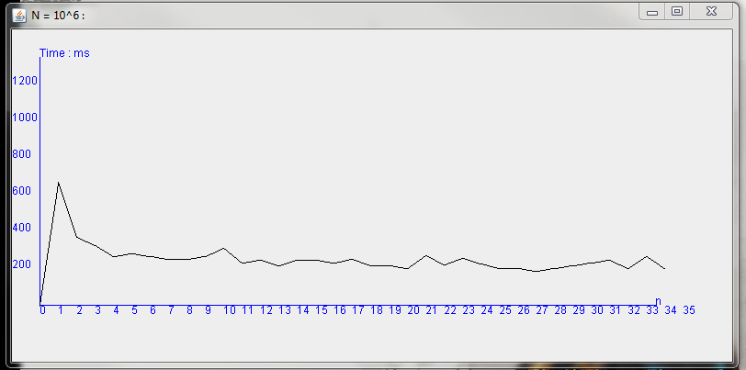
N=10^6

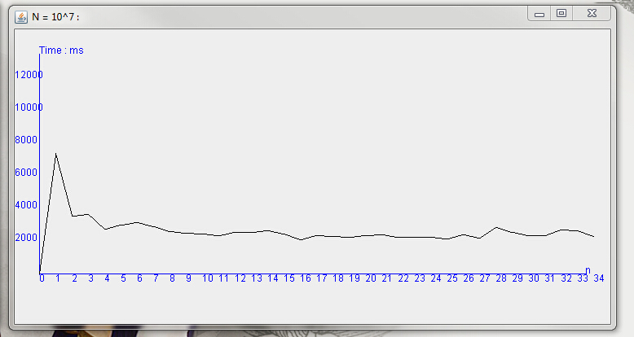
N=10^7

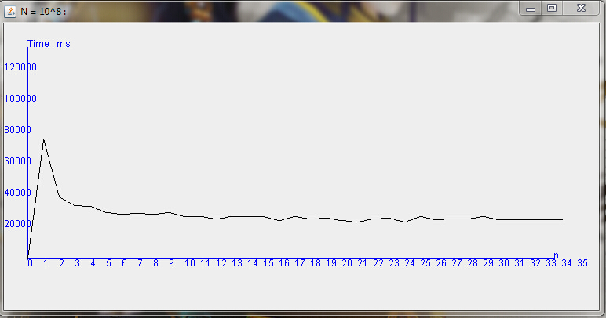
N=10^8

Please wait 20s for the Random Array Initial .
please enter the key's value you wan to test(you can input 0 to exit the test) :
1
When the n = 10^6 ,k = 1 ,the run time to sort is for the sanme array(element from 1 to 100000) : 671ms
When the n = 10^7 ,k = 1 ,the run time to sort is for the sanme array(element from 1 to 100000) : 7435ms
When the n = 10^8 ,k = 1 ,the run time to sort is for the sanme array(element from 1 to 100000) : 76590ms

please enter the key's value you wan to test(you can input 0 to exit the test) :
2
When the n = 10^6 ,k = 2 ,the run time to sort is for the sanme array(element from 1 to 100000) : 374ms
When the n = 10^7 ,k = 2 ,the run time to sort is for the sanme array(element from 1 to 100000) : 3593ms
When the n = 10^8 ,k = 2 ,the run time to sort is for the sanme array(element from 1 to 100000) : 39718ms

please enter the key's value you wan to test(you can input 0 to exit the test) :
3
When the n = 10^6 ,k = 3 ,the run time to sort is for the sanme array(element from 1 to 100000) : 328ms
When the n = 10^7 ,k = 3 ,the run time to sort is for the sanme array(element from 1 to 100000) : 3662ms
When the n = 10^8 ,k = 3 ,the run time to sort is for the sanme array(element from 1 to 100000) : 34438ms

please enter the key's value you wan to test(you can input 0 to exit the test) :
4
When the n = 10^6 ,k = 4 ,the run time to sort is for the sanme array(element from 1 to 100000) : 265ms
When the n = 10^7 ,k = 4 ,the run time to sort is for the sanme array(element from 1 to 100000) : 2794ms
When the n = 10^8 ,k = 4 ,the run time to sort is for the sanme array(element from 1 to 100000) : 33717ms

please enter the key's value you wan to test(you can input 0 to exit the test) :
5
When the n = 10^6 ,k = 5 ,the run time to sort is for the sanme array(element from 1 to 100000) : 281ms
When the n = 10^7 ,k = 5 ,the run time to sort is for the sanme array(element from 1 to 100000) : 3014ms
When the n = 10^8 ,k = 5 ,the run time to sort is for the sanme array(element from 1 to 100000) : 29787ms

please enter the key's value you wan to test(you can input 0 to exit the test) :
6
When the n = 10^6 ,k = 6 ,the run time to sort is for the sanme array(element from 1 to 100000) : 265ms
When the n = 10^7 ,k = 6 ,the run time to sort is for the sanme array(element from 1 to 100000) : 3185ms
When the n = 10^8 ,k = 6 ,the run time to sort is for the sanme array(element from 1 to 100000) : 28832ms

please enter the key's value you wan to test(you can input 0 to exit the test) :
7
When the n = 10^6 ,k = 7 ,the run time to sort is for the sanme array(element from 1 to 100000) : 250ms
When the n = 10^7 ,k = 7 ,the run time to sort is for the sanme array(element from 1 to 100000) : 2900ms
When the n = 10^8 ,k = 7 ,the run time to sort is for the sanme array(element from 1 to 100000) : 29067ms

please enter the key's value you wan to test(you can input 0 to exit the test) :
8
When the n = 10^6 ,k = 8 ,the run time to sort is for the sanme array(element from 1 to 100000) : 251ms
When the n = 10^7 ,k = 8 ,the run time to sort is for the sanme array(element from 1 to 100000) : 2624ms
When the n = 10^8 ,k = 8 ,the run time to sort is for the sanme array(element from 1 to 100000) : 28909ms

please enter the key's value you wan to test(you can input 0 to exit the test) :
9
When the n = 10^6 ,k = 9 ,the run time to sort is for the sanme array(element from 1 to 100000) : 266ms
When the n = 10^7 ,k = 9 ,the run time to sort is for the sanme array(element from 1 to 100000) : 2528ms
When the n = 10^8 ,k = 9 ,the run time to sort is for the sanme array(element from 1 to 100000) : 29602ms

please enter the key's value you wan to test(you can input 0 to exit the test) :
10
When the n = 10^6 ,k = 10 ,the run time to sort is for the sanme array(element from 1 to 100000) : 312ms
When the n = 10^7 ,k = 10 ,the run time to sort is for the sanme array(element from 1 to 100000) : 2482ms
When the n = 10^8 ,k = 10 ,the run time to sort is for the sanme array(element from 1 to 100000) : 27219ms

please enter the key's value you wan to test(you can input 0 to exit the test) :
11
When the n = 10^6 ,k = 11 ,the run time to sort is for the sanme array(element from 1 to 100000) : 234ms
When the n = 10^7 ,k = 11 ,the run time to sort is for the sanme array(element from 1 to 100000) : 2370ms
When the n = 10^8 ,k = 11 ,the run time to sort is for the sanme array(element from 1 to 100000) : 27482ms

please enter the key's value you wan to test(you can input 0 to exit the test) :
12
When the n = 10^6 ,k = 12 ,the run time to sort is for the sanme array(element from 1 to 100000) : 249ms
When the n = 10^7 ,k = 12 ,the run time to sort is for the sanme array(element from 1 to 100000) : 2594ms
When the n = 10^8 ,k = 12 ,the run time to sort is for the sanme array(element from 1 to 100000) : 25757ms

please enter the key's value you wan to test(you can input 0 to exit the test) :
13
When the n = 10^6 ,k = 13 ,the run time to sort is for the sanme array(element from 1 to 100000) : 218ms
When the n = 10^7 ,k = 13 ,the run time to sort is for the sanme array(element from 1 to 100000) : 2560ms
When the n = 10^8 ,k = 13 ,the run time to sort is for the sanme array(element from 1 to 100000) : 27109ms

please enter the key's value you wan to test(you can input 0 to exit the test) :
14
When the n = 10^6 ,k = 14 ,the run time to sort is for the sanme array(element from 1 to 100000) : 249ms
When the n = 10^7 ,k = 14 ,the run time to sort is for the sanme array(element from 1 to 100000) : 2669ms
When the n = 10^8 ,k = 14 ,the run time to sort is for the sanme array(element from 1 to 100000) : 27429ms

please enter the key's value you wan to test(you can input 0 to exit the test) :
15
When the n = 10^6 ,k = 15 ,the run time to sort is for the sanme array(element from 1 to 100000) : 249ms
When the n = 10^7 ,k = 15 ,the run time to sort is for the sanme array(element from 1 to 100000) : 2498ms
When the n = 10^8 ,k = 15 ,the run time to sort is for the sanme array(element from 1 to 100000) : 27365ms

please enter the key's value you wan to test(you can input 0 to exit the test) :
16
When the n = 10^6 ,k = 16 ,the run time to sort is for the sanme array(element from 1 to 100000) : 234ms
When the n = 10^7 ,k = 16 ,the run time to sort is for the sanme array(element from 1 to 100000) : 2123ms
When the n = 10^8 ,k = 16 ,the run time to sort is for the sanme array(element from 1 to 100000) : 24845ms

please enter the key's value you wan to test(you can input 0 to exit the test) :
17
When the n = 10^6 ,k = 17 ,the run time to sort is for the sanme array(element from 1 to 100000) : 250ms
When the n = 10^7 ,k = 17 ,the run time to sort is for the sanme array(element from 1 to 100000) : 2391ms
When the n = 10^8 ,k = 17 ,the run time to sort is for the sanme array(element from 1 to 100000) : 27117ms

please enter the key's value you wan to test(you can input 0 to exit the test) :
18
When the n = 10^6 ,k = 18 ,the run time to sort is for the sanme array(element from 1 to 100000) : 219ms
When the n = 10^7 ,k = 18 ,the run time to sort is for the sanme array(element from 1 to 100000) : 2341ms
When the n = 10^8 ,k = 18 ,the run time to sort is for the sanme array(element from 1 to 100000) : 25636ms

please enter the key's value you wan to test(you can input 0 to exit the test) :
19
When the n = 10^6 ,k = 19 ,the run time to sort is for the sanme array(element from 1 to 100000) : 218ms
When the n = 10^7 ,k = 19 ,the run time to sort is for the sanme array(element from 1 to 100000) : 2263ms
When the n = 10^8 ,k = 19 ,the run time to sort is for the sanme array(element from 1 to 100000) : 26131ms

please enter the key's value you wan to test(you can input 0 to exit the test) :
20
When the n = 10^6 ,k = 20 ,the run time to sort is for the sanme array(element from 1 to 100000) : 203ms
When the n = 10^7 ,k = 20 ,the run time to sort is for the sanme array(element from 1 to 100000) : 2375ms
When the n = 10^8 ,k = 20 ,the run time to sort is for the sanme array(element from 1 to 100000) : 24617ms

please enter the key's value you wan to test(you can input 0 to exit the test) :
21
When the n = 10^6 ,k = 21 ,the run time to sort is for the sanme array(element from 1 to 100000) : 271ms
When the n = 10^7 ,k = 21 ,the run time to sort is for the sanme array(element from 1 to 100000) : 2431ms
When the n = 10^8 ,k = 21 ,the run time to sort is for the sanme array(element from 1 to 100000) : 23938ms

please enter the key's value you wan to test(you can input 0 to exit the test) :
22
When the n = 10^6 ,k = 22 ,the run time to sort is for the sanme array(element from 1 to 100000) : 222ms
When the n = 10^7 ,k = 22 ,the run time to sort is for the sanme array(element from 1 to 100000) : 2261ms
When the n = 10^8 ,k = 22 ,the run time to sort is for the sanme array(element from 1 to 100000) : 25699ms

please enter the key's value you wan to test(you can input 0 to exit the test) :
23
When the n = 10^6 ,k = 23 ,the run time to sort is for the sanme array(element from 1 to 100000) : 259ms
When the n = 10^7 ,k = 23 ,the run time to sort is for the sanme array(element from 1 to 100000) : 2299ms
When the n = 10^8 ,k = 23 ,the run time to sort is for the sanme array(element from 1 to 100000) : 26299ms

please enter the key's value you wan to test(you can input 0 to exit the test) :
24
When the n = 10^6 ,k = 24 ,the run time to sort is for the sanme array(element from 1 to 100000) : 226ms
When the n = 10^7 ,k = 24 ,the run time to sort is for the sanme array(element from 1 to 100000) : 2285ms
When the n = 10^8 ,k = 24 ,the run time to sort is for the sanme array(element from 1 to 100000) : 23693ms

please enter the key's value you wan to test(you can input 0 to exit the test) :
25
When the n = 10^6 ,k = 25 ,the run time to sort is for the sanme array(element from 1 to 100000) : 203ms
When the n = 10^7 ,k = 25 ,the run time to sort is for the sanme array(element from 1 to 100000) : 2169ms
When the n = 10^8 ,k = 25 ,the run time to sort is for the sanme array(element from 1 to 100000) : 27186ms

please enter the key's value you wan to test(you can input 0 to exit the test) :
26
When the n = 10^6 ,k = 26 ,the run time to sort is for the sanme array(element from 1 to 100000) : 202ms
When the n = 10^7 ,k = 26 ,the run time to sort is for the sanme array(element from 1 to 100000) : 2437ms
When the n = 10^8 ,k = 26 ,the run time to sort is for the sanme array(element from 1 to 100000) : 25032ms

please enter the key's value you wan to test(you can input 0 to exit the test) :
27
When the n = 10^6 ,k = 27 ,the run time to sort is for the sanme array(element from 1 to 100000) : 187ms
When the n = 10^7 ,k = 27 ,the run time to sort is for the sanme array(element from 1 to 100000) : 2202ms
When the n = 10^8 ,k = 27 ,the run time to sort is for the sanme array(element from 1 to 100000) : 25620ms

please enter the key's value you wan to test(you can input 0 to exit the test) :
28
When the n = 10^6 ,k = 28 ,the run time to sort is for the sanme array(element from 1 to 100000) : 203ms
When the n = 10^7 ,k = 28 ,the run time to sort is for the sanme array(element from 1 to 100000) : 2853ms
When the n = 10^8 ,k = 28 ,the run time to sort is for the sanme array(element from 1 to 100000) : 25858ms

please enter the key's value you wan to test(you can input 0 to exit the test) :
29
When the n = 10^6 ,k = 29 ,the run time to sort is for the sanme array(element from 1 to 100000) : 219ms
When the n = 10^7 ,k = 29 ,the run time to sort is for the sanme array(element from 1 to 100000) : 2560ms
When the n = 10^8 ,k = 29 ,the run time to sort is for the sanme array(element from 1 to 100000) : 27061ms

please enter the key's value you wan to test(you can input 0 to exit the test) :
30
When the n = 10^6 ,k = 30 ,the run time to sort is for the sanme array(element from 1 to 100000) : 234ms
When the n = 10^7 ,k = 30 ,the run time to sort is for the sanme array(element from 1 to 100000) : 2393ms
When the n = 10^8 ,k = 30 ,the run time to sort is for the sanme array(element from 1 to 100000) : 25441ms

please enter the key's value you wan to test(you can input 0 to exit the test) :
31
When the n = 10^6 ,k = 31 ,the run time to sort is for the sanme array(element from 1 to 100000) : 249ms
When the n = 10^7 ,k = 31 ,the run time to sort is for the sanme array(element from 1 to 100000) : 2389ms
When the n = 10^8 ,k = 31 ,the run time to sort is for the sanme array(element from 1 to 100000) : 25430ms

please enter the key's value you wan to test(you can input 0 to exit the test) :
32
When the n = 10^6 ,k = 32 ,the run time to sort is for the sanme array(element from 1 to 100000) : 202ms
When the n = 10^7 ,k = 32 ,the run time to sort is for the sanme array(element from 1 to 100000) : 2747ms
When the n = 10^8 ,k = 32 ,the run time to sort is for the sanme array(element from 1 to 100000) : 25452ms

please enter the key's value you wan to test(you can input 0 to exit the test) :
33
When the n = 10^6 ,k = 33 ,the run time to sort is for the sanme array(element from 1 to 100000) : 266ms
When the n = 10^7 ,k = 33 ,the run time to sort is for the sanme array(element from 1 to 100000) : 2685ms
When the n = 10^8 ,k = 33 ,the run time to sort is for the sanme array(element from 1 to 100000) : 25252ms

please enter the key's value you wan to test(you can input 0 to exit the test) :
34
When the n = 10^6 ,k = 34 ,the run time to sort is for the sanme array(element from 1 to 100000) : 203ms
When the n = 10^7 ,k = 34 ,the run time to sort is for the sanme array(element from 1 to 100000) : 2345ms
When the n = 10^8 ,k = 34 ,the run time to sort is for the sanme array(element from 1 to 100000) : 25423ms

