**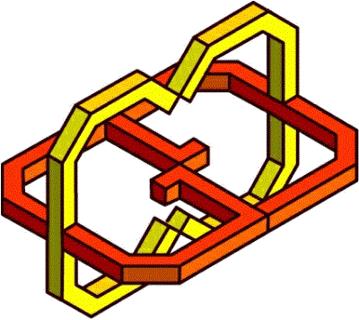Center for Graphics and   
Geometric Computing**