|  |
| --- |
| To seeed studis, From vikas |
| Seeed Studio LoRa E5 Custom Hardware Design |
| A proposal comprising a technical brief about my project |

|  |
| --- |
| Addepalli Dolendra Vikas (8112001vikas@gmail.com)  6/21/2022 |

Table of Contents

Title 2

Abstract 2

Plan for V1 2

Display 2

Notification 2

Location sharing 3

Lora chatting 3

Altitude 3

Attitude 3

Live navigation 3

Rechargeable 3

Battery percentage 3

QWERTY keyboard 3

PCB block diagram 4

Future plans 5

Conclusion 5

# Title

**dM (Direct Message):** A custom piece of hardware that communicates with the other same device over a secure 865MHz (EU868/US915/AU915/KR920/IN865) channel using the Lora E5 SOC from the Seeed Studios.

# Abstract

Everyone knows how interconnected 21st-century life is and the ubiquity of the internet. There's no privacy in this current century. You can’t even communicate privately with your friend by bypassing the network service provider or a 3rd person who is interested in you with the traditional way of communicating channels. So I planned to design and develop a device using the LoRa E5 SOC from the Seeed Studios which can establish a secure communication channel where the 3rd person can’t even predict the frequency of the channel that you are using to communicate. Yes, it’s retro time, This device is something like a two-way pager with advanced features like live navigating and sharing location, altitude, and attitude but has a limited range in the order of very few hundred meters.

# Plan for V1

The following are the features that I’m planning to include in the first version of the directMessage (hereinafter referred to as “dM”).

## Display

A 2.7” LCD display from sharp (LS027B7DH01) will be used as the user interface with the dM. This display communicates with the Lora E5 MCU over the SPI communication protocol.

## Notification

A Surface Mount Vibration Motor and Indication lights will be used to notify or invoke the dM user.

## Location sharing

A POT GPS module (Quectel L80) will be used to acquire the location of the dM. This module has very less power consumption (in the order of 20mA) during both acquisition and tracking. This also has a reacquisition time of less than 1sec which makes the dM acquire the user location very quickly (nearly 1 sec).

## Lora chatting

A peer-to-peer local communication channel will be created using the LoRa P2P feature to establish Lora chatting. A standard frequency will be used, by default it will be in the Indian frequency 865MHz, later the user can change the frequency based on their location using the user interface. One user can enter the other user's address and can send the connection request. When the other side user accepts the connection request the stream of messages can be sent/receive.

## Altitude

A pressure sensor (BME280) will be used as an altimeter. This sensor can be interfaced with the Lora E5 MCU over the I2C protocol. The user can select the altitude option using the interface and see the altitude. This sensor also provides the Humidity data, so humidity data can also be presented in the dM’s display.

## Attitude

A 9DOF IMU (MPU9250) is used to measure the attitude of the device. This IMU can be interfaced with the Lora E5 MCU over the I2C protocol. The user can see the roll, pitch, and yaw in the dM’s display. As this IMU has an accelerometer the device can also be used to show the acceleration of the user. All these options can be selected using the user interface.

## Live navigation

The dM navigates the user to the other dM users (let's say target). This feature fuses the target GPS location and the magneto meter data to navigate the first dM user to the target's location (yes you heard it right, this is something like an apple air tag).

The first user should send the “find you” request by entering the target’s address, when the target accepts the request the target's dM shares the GPS and magneto meter data with the first user. The dM of the first user will fuse the data and navigates the user to the target.

## Rechargeable

A LiPo cell will be used to power the whole dM. TP4056 will be used to charge and discharge the cell safely.

## Battery percentage

A fuel gauge (BQ27441) will be used to measure the charge left over the LiPo cell. The user can view the percentage of charge data all the time over the display of the dM.

## QWERTY keyboard

Blackberry Q10 keyboard will be used as a user input device. The user can control the whole device, text messages, and operate the whole device using these keys.

# PCB block diagram

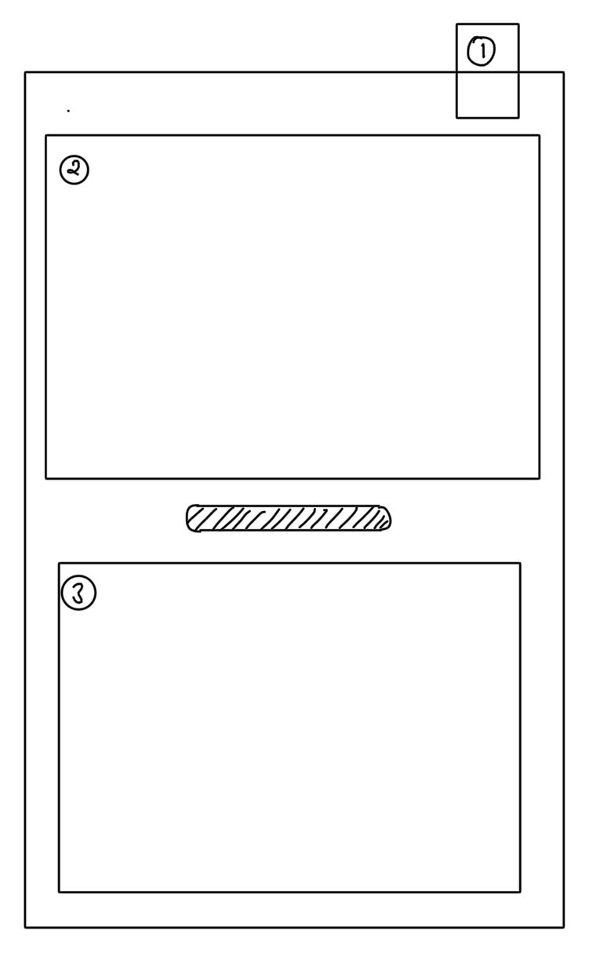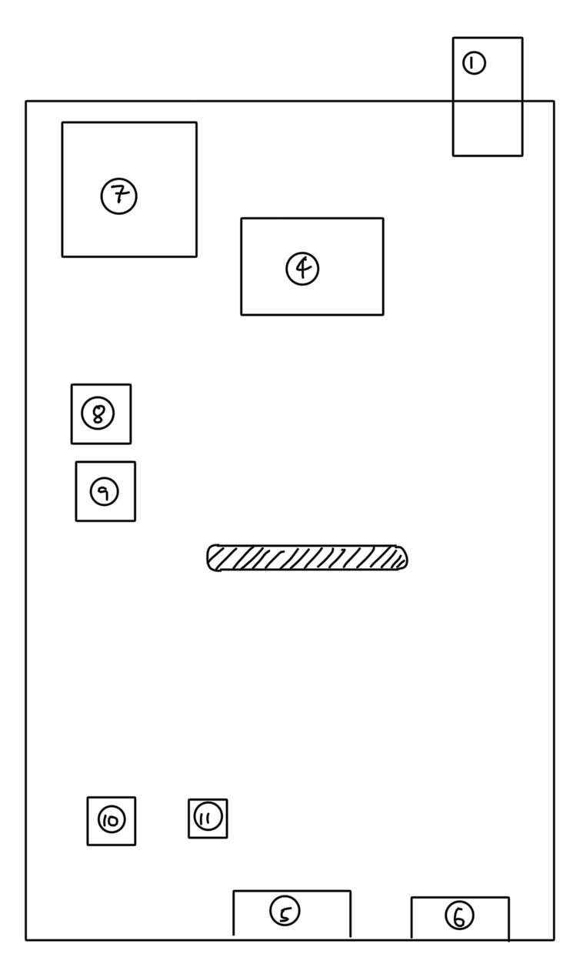

Figure Front & Back view of the hardware

The following is the major list of components used in the project, the components are indexed as shown in the above figure.

1. SMA edge launch connector.
2. LS027B7DH01 Sharp LCD 2.7” display
3. Blackberry Q10 Keyboard
4. Seeed Studio LoRa-E5
5. USB type C (16 pins)
6. Surface mount vibration motor
7. Quectel L80
8. BME280
9. MPU9250
10. TP4056
11. BQ27441

# Future plans

* Integrate the dM’s with the WiFi-powered controllers, so that the data from the mobile phones/ computers/cloud can be sent/received. This makes the device more ubiquitous and widens the applications.
* The network service providers and the 3rd persons who are interested in you can be bypassed by simply maintaining communications within the network.
* An SD card slot to provide the additional ROM. To store the messages, location data, etc...
* A mini solar panel that charges the battery.
* A buzzer for the notifications.
* Optimizing the power consumption.

# Conclusion

All the components were chosen for their minimal power consumption. Feel free to give feedback regarding this particular project. Thank you for sponsoring this hardware design project and making it real under the Lora E5 Campaign.