Installation Guide for

VAE DisCo BLACK BOX SYSTEM

|  |  |
| --- | --- |
| Document Version: | X2.02 |
| Last Updated On: | 22/05/2014 |

**Revision History**

|  |  |  |  |
| --- | --- | --- | --- |
| **Date** | **Version** | **Description** | **Author** |
| 07/05/2013 | X1.0 | First draft | Truong Xuan Huy |
| 08/05/2013 | X1.1 | Update Database section | Nguyen Trieu Vi |
| 08/05/2013 | X1.2 | Review, Update layout and correct some minor issues | Bui Nghia Thuat |
| 20/05/2013 | X1.3 | Update as requested from Urs | Bui Nghia Thuat |
| 31/05/2013 | X1.4 | Restructure document; Add information after Urs’ feedback | Truong Xuan Huy Bui Nghia Thuat |
| 04/06/2013 | X1.5 | Update database initialization with structure and step by step command execution | Bui Nghia Thuat |
| 20/06/2013 | X1.6 | Update postgres data base initialization | Le Xuan Binh |
| 24/06/2013 | X.1.7 | Update rpm package build | Nguyen Chi Toan |
| 25/06/2013 | X1.8 | Review and update some minor changes | Bui Nghia Thuat |
| 01/07/2013 | X1.9 | Update sql script from Binh | Truong Dang Trieu  Bui Nghia Thuat |
| 29/07/2013 | X2.0 | Update pst-vae_sql-01.05-1 | Nguyen Chi Toan |
| 30/07/2013 | X2.01 | Update pst-vae_sql-01.05-2 | Nguyen Chi Toan |
| 14/10/2013 | X2.02 | Update pst-vae_library-01.01-1 | Nguyen Chi Toan |
| 24/10/2013 | X2.03 | Update 3.2 Install and configure BlackBox | Truong Dang Trieu |
| 22/05/2014 | X2.03 | Update 3.2.5 install library module | Truong Dang Trieu |

**Table of Content**

1 Introduction 4

2 Reference 4

3 Deployment procedures 5

3.1 Initialize BlackBox database 5

3.1.1 Database account & permission 5

3.1.2 RPM package build for sql script 5

3.1.3 Install or update RPM package for sql script 7

3.1.4 Create accounts & grant permission 7

3.1.5 1st installation for vae database 10

3.1.6 Update structure (if any) for vae database 22

3.2 Install and configure BlackBox components dependencies 24

3.2.1 Add JBoss user 24

3.2.2 Install JDBC driver and set up Datasource 26

3.2.3 Configure Messaging System 30

3.2.4 Install library module 34

3.2.5 How the RPM package of libraries built 35

3.3 Install BlackBox system to JBoss 39

3.4 Configure BlackBox system 40

3.5 Start BlackBox system 41

3.6 Verification 42

# Introduction

The objective of this guide is to describe the deployment and configure of VAE 2 software on Black Box servers. This document is intended for IT technicians of Post IT and GHP Far East, who will deploy and maintain VAE 2 applications on Black Box servers.

Details of database installation and configuration are described in Ref-01, chapter 4.2.1.2. This guide contains only information regarding the account creating, permission granting and the initialization of BlackBox database (structure and default parameters for BlackBox application).

The main section of this document (section 3) gives descriptions and technical configuration of the deployment. There are 6 procedures:

1. Initialize BlackBox database
2. Install and configure BlackBox components dependencies
3. Install BlackBox system to JBoss
4. Configure BlackBox system
5. Start BlackBox system
6. Verification

# Reference

|  |  |  |
| --- | --- | --- |
| **Ref-ID** | **Document** | |
| Ref-01 | Specification_SystemSetup_BlackBox | GHP FE, Version X01-06, 10 May 2013 |
|  |  |  |

# Deployment procedures

## Initialize BlackBox database

This section will clarify how the structure and default parameters of BlackBox database initialized for the first installation and for each upgrade of BlackBox’s database.

### Database account & permission

Database name: vae

|  |  |  |
| --- | --- | --- |
| **Username** | **Description** | **Permission** |
| postgres | Super Admin account | All database(s) |
| vae_admin | This account is only use for:   * 1st setup * Update database structure * Backup/ Restore | Full access to database vae |
| vae_production | This account used by BlackBox application | Read/Write;  Execute store procedure |
| vae_monitor | This account used by Monitoring System | Limited read permission on schema information |

### RPM package build for sql script

This section will describe in detail how the rpm package of 2 sql script & 2 backup, restore bash script (refer VAE2_Postgres_Backup_Restore documentation) script is built and installed/updated on the server.

|  |  |  |  |
| --- | --- | --- | --- |
| **RPM package** | **Version** | **Release date** | **MD5** |
| pst-vae_sql-01.05-1.noarch.rpm | 1.5 | 26 July 2013 | 781bea683a802138dad934bec27be21e |
| pst-vae_sql-01.05-2.noarch.rpm | 1.5 | 30 July 2013 | b7b420ed448de188054899b1210a0a57 |

**Step 1:** Create a tarball and copy to folder SOURCES for rpm build

|  |
| --- |
| nctoan@nctoan:~> mkdir vae  nctoan@nctoan:~> cd vae && ll  -rw-r—r—1 nctoan nctoan Jul 1 13:02 vae_initialization.sql  -rw-r—r—1 nctoan nctoan Jul 1 13:02 vae_permission_grant.sql  -rw-r—r—1 nctoan nctoan Jul 26 18:02 vae_postgres_backup.sh  -rw-r—r—1 nctoan nctoan Jul 26 18:02 vae_postgres_restore.sh  nctoan@nctoan:~> tar –cvzpf ../vae_sql.tgz *  vae_initialization.sql  vae_permission_grant.sql  vae_postgres_restore.sh  vae_postgres_backup.sh  nctoan@nctoan:~> cp –v /home/nctoan/vae_sql.tgz /home/nctoan/rpmbuild/SOURCES |

**Step 2:** Create SPEC file

|  |
| --- |
| nctoan@nctoan:/home/nctoan/rpmbuid/SPECS> vi vae_sql-01.05.spec |

with content as below

|  |
| --- |
| # RPM spec file for vae_sql  # POST IT Specific  %define pname vae_sql    Name: pst-%{pname}  Version: 01.05  Release: 1  License: Die Schweizerische Post  URL: http://bullnix.post.ch  Vendor: Die Schweizerische Post  Source: %{pname}.tgz  Packager: Urs Frey <urs.frey@post.ch>  # we do not want Auto Dependencies ()  AutoReqProv: no    #BuildPrereq:  BuildRoot: %{_tmppath}/%{pname}-%{version}-root  BuildArch: noarch    Summary: VAE Database maintenance  Group: Applications/scripts    Prefix: /opt  %description  This package contains the sql scripts used for VAE  to initialze and maintain the databse    %prep  %setup -c -q -n %{pname}-%{version}    %build    %install  rm -rf %{buildroot}  mkdir -p %{buildroot}/data/vae/store2/script  install -p -m750 ./vae2_initialization.sql %{buildroot}/data/vae/store2/script  install -p -m750 ./vae2_permission_grant.sql %{buildroot}/data/vae/store2/script  install -p -m750 ./vae_postgres_backup.sh %{buildroot}/data/vae/store2/script  install -p -m750 ./vae_postgres_restore.sh %{buildroot}/data/vae/store2/script  if [ -r sh_file_list ]  then  rm sh_file_list  fi    find %{buildroot}/ -type f -print | \  sed -e 's,%{buildroot},,' > sh_file_list      %clean  test "$RPM_BUILD_ROOT" != "/" && rm -rf $RPM_BUILD_ROOT    %pre    %post  # inst upgr uninst  # %post $1==1 $1==2 (N/A)    %files -f sh_file_list  %defattr(-,postgres,postgres)    %changelog  * Tue Jul 30 2013 ToanNc <nctoan@ghp-fareast.vn>- update backup bash script  * Fri Jul 26 2013 ToanNc <nctoan@ghp-fareast.vn>  - update backup & restore bash script  * Fri Jul 12 2013 ToanNc <nctoan@ghp-fareast.vn>  - update backup & restore bash script minor fixes and updates  * Thu Jul 11 2013 ToanNc <nctoan@ghp-fareast.vn>  - update backup & restore bash script to version 1.4  * Mon Jul 01 2013 ToanNc <nctoan@ghp-fareast.vn>  - update sql script to version 1.3  * Wed Jun 05 2013 Urs Frey <urs.frey@post.ch>  - initial version |

**Step 3:** Build RPM package

|  |
| --- |
| nctoan@nctoan:/home/nctoan/rpmbuild/SPECS> rpmbuild –ba –clean vae_sql-01.05.spec  nctoan@nctoan:/home/nctoan/rpmbuild/RPMS/noarch> ls –l  -rw-r—r—1 nctoan nctoan Jul 26 18:19 pst-vae_sql-01.05-1.noarch.rpm |

### Install or update RPM package for sql script

For 1st time installation

*root@* *v05ujl:~> rpm –ivh pst-vae_sql-01.05-1.noarch.rpm*

For update new version of sql

*root@* *v05ujl:~> rpm –Uvh pst-vae_sql-01.05-1.noarch.rpm*

### Create accounts & grant permission

To grant permission for vae_production account, GHP provides a store procedure on a sql file which named “vae2_permission_grant_v1_3.sql”. You can find more detail as below:

|  |  |  |  |
| --- | --- | --- | --- |
| **File name** | **Version** | **Author** | **Release date** |
| vae2_permission_grant_v1_1.sql | 1.1 | Le Xuan Binh (DBA) | 04 June 2013 |
| vae2_permission_grant_v1_2.sql | 1.2 | Le Xuan Binh (DBA) | 20 June 2013 |
| vae2_permission_grant_v1_3.sql | 1.3 | Le Xuan Binh (DBA) | 26 June 2013 |
| vae2_permission_grant.sql | 1.3 | Le Xuan Binh (DBA) | 29 Jul 2013 |

The sql script **vae2_permission_grant_v1_3.sql** has been brought to the server by rpm package, which is described detail in section 3.1.2

File content:

*-- --------------------------------------------------------------------------------------------------------------------------------------------------*

*-- This script provides a store procedure to grant permission of all schema(s) to a specific account, database*

*-- Author : Le Xuan Binh - Database Administrator*

*-- Created : 31 May 2013*

*-- Last update : 26 June 2013*

*-- Version: 1.3*

*-- --------------------------------------------------------------------------------------------------------------------------------------------------*

*-- Change log:*

*-- ** 1.0 (31.05.2013): Le Xuan Binh*

*-- - Script with all functions*

*-- ** 1.1 (04.06.2013): Bui Nghia Thuat*

*-- - Review script and add header information for version control*

*-- ** 1.2 (20.06.2013): Le Xuan Binh*

*-- - Update sql file*

*-- ** 1.3 (26.06.2013): Le Xuan Binh*

*-- - Update sequences permission granting*

*-- --------------------------------------------------------------------------------------------------------------------------------------------------*

*CREATE OR REPLACE FUNCTION grant_all_schema_permission(v_login character varying, v_database character varying)*

*RETURNS integer AS*

*$BODY$DECLARE*

*-- Declare variables*

*v_sqlstr VARCHAR(500); -- string contain ‘schema_name To user’*

*v_sql VARCHAR(1000); -- string SQL to execute*

*-- Declare cursor select name of all nonsystem schemas*

*grant_schema_cursor CURSOR FOR*

*SELECT schema_name || ' TO ' || v_login || E';\n'*

*FROM information_schema.schemata WHERE catalog_name = v_database and schema_name not like 'pg_%' and schema_name not in ('information_schema','public') ;*

*BEGIN*

*OPEN grant_schema_cursor;*

*FETCH grant_schema_cursor INTO v_sqlstr;*

*WHILE FOUND LOOP*

*v_sql := '';*

*-- Grant select, insert and update permission on all table in schema to user*

*v_sql = 'GRANT SELECT,INSERT,UPDATE ON ALL TABLES IN SCHEMA ' || v_sqlstr;*

*-- Grant execute permission on all functions in schema to user*

*v_sql = v_sql || ' GRANT EXECUTE ON ALL FUNCTIONS IN SCHEMA ' || v_sqlstr;*

*-- Grant select permission on all sequences in schema to user*

*v_sql = 'GRANT SELECT ON ALL SEQUENCES IN SCHEMA ' || v_sqlstr;*

*-- Grant usage permission on schema to user*

*v_sql = v_sql || ' GRANT USAGE ON SCHEMA ' || v_sqlstr;*

*-- Raise notice to ouput*

*RAISE NOTICE 'running (%)',v_sql;*

*-- Execute query above*

*EXECUTE v_sql;*

*FETCH grant_schema_cursor INTO v_sqlstr;*

*END LOOP;*

*CLOSE grant_schema_cursor;*

*Return 1;*

*END;$BODY$*

*LANGUAGE plpgsql VOLATILE*

*COST 100;*

Under postgres linux account, administrator can execute/open pgsql session with highest privilege of postgres (superadmin).

*bnthuat@vae2-db-srv* *:~>* ***su - postgres***

From the command line, open the pgsql session with superadmin account (postgres) by using pgsql –U postgresl

*postgres@vae2-db-srv* *:~> p****sql*** *-****U*** *postgres*

The prompt for pgsql will appear. From here, administrator can create all accounts for first installation.

Create database vae and vae_admin

*postgres =#* ***CREATE USER*** *vae_admin* ***PASSWORD*** *‘pgdb4vae@CH’****;***

*postgres=#* ***CREATE DATABASE*** *vae* ***OWNER*** *vae_admin;*

Create vae_production

*postgres=#* ***CREATE USER*** *vae_production* ***PASSWORD*** *‘pgbb4vae@CH’****;***

Create vae_monitor

*postgres=#* ***CREATE USER*** *vae_monitor* ***PASSWORD*** *‘pgmon4vae@CH’****;***

Exit from Postgres

*postgres=#* ***\q***

Import the script of permission granting

*postgres@vae2-db-srv* *:~>* ***psql <*** vae2_permission_grant_v1_2.sql

### 1st installation for vae database

For database structure initialization, GHP provides a script named “vae2_initialization_v1_1.sql” which has detail information as below

|  |  |  |  |
| --- | --- | --- | --- |
| **File name** | **Version** | **Author** | **MD5 checksum** |
| vae2_initialization_v1_1.sql | 1.1 | Le Xuan Binh (DBA) | e20df3f690a2bc6cec506fac19f63827 |
| vae2_initialization.sql | 1.1 | Le Xuan Binh (DBA) | e20df3f690a2bc6cec506fac19f63827 |

From the command line of database server, run pgsql to initialize the structure of **vae** database under account **vae_admin**

*postgres@vae2-db-srv* *:~>* ***psql –U vae_admin –d vae < vae2_ initialization_v1_1.sql***

After create database and all accounts, administrator can connect to database vae and execute the stored procedure to grant permission for vae_production account from pgsql session

*postgres=#\c vae*

*vae=#* ***SELECT*** *grant_all_schema_permission(‘vae_production’,’vae’);*

To make sure the persistency of vae_production account, this query will always appear on the very last line of any sql script.

The sql script **vae2_initialization_v1_1.sql** has been brought to the server by rpm package which is described in detail in section 3.1.2

The content of sql file as below:

*-- --------------------------------------------------------------------------------------------------------------------------------------------------*

*-- This script provides a store procedure named "grant_all_schema_permission" to grant permission of all schema to a specific account, database*

*-- Author : Le Xuan Binh - Database Administrator*

*-- Created : 31 May 2013*

*-- Last update : 04 June 2013*

*-- Version: 1.1*

*-- --------------------------------------------------------------------------------------------------------------------------------------------------*

*-- Change log:*

*-- ** 1.0 (03.06.2013): Le Xuan Binh*

*-- - Modify and test first release from Software Developer*

*-- ** 1.1 (04.06.2013): Bui Nghia Thuat*

*-- - Review script and add header information for version control*

*-- --------------------------------------------------------------------------------------------------------------------------------------------------*

*-- Dumped from database version 9.1.5*

*-- Dumped by pg_dump version 9.1.5*

*-- Started on 2013-06-03 18:12:39*

*SET statement_timeout = 0;*

*SET client_encoding = 'UTF8';*

*SET standard_conforming_strings = on;*

*SET check_function_bodies = false;*

*SET client_min_messages = warning;*

*--*

*-- TOC entry 7 (class 2615 OID 16536)*

*-- Name: vae; Type: SCHEMA; Schema: -; Owner: vae_admin*

*--*

*CREATE SCHEMA vae;*

*ALTER SCHEMA vae OWNER TO vae_admin;*

*SET search_path = vae, pg_catalog;*

*--*

*-- TOC entry 551 (class 1247 OID 17083)*

*-- Dependencies: 7 173*

*-- Name: report_collection_remain; Type: TYPE; Schema: vae; Owner: vae_admin*

*--*

*CREATE TYPE report_collection_remain AS (*

*total_collection integer,*

*total_captured_collection integer*

*);*

*ALTER TYPE vae.report_collection_remain OWNER TO vae_admin;*

*--*

*-- TOC entry 554 (class 1247 OID 17086)*

*-- Dependencies: 7 174*

*-- Name: report_time_status; Type: TYPE; Schema: vae; Owner: vae_admin*

*--*

*CREATE TYPE report_time_status AS (*

*tar_filename character varying(50),*

*image_filename character varying(50),*

*xml_filename character varying(50),*

*status character varying,*

*totaltime integer*

*);*

*ALTER TYPE vae.report_time_status OWNER TO vae_admin;*

*--*

*-- TOC entry 557 (class 1247 OID 17089)*

*-- Dependencies: 7 175*

*-- Name: time_report; Type: TYPE; Schema: vae; Owner: vae_admin*

*--*

*CREATE TYPE time_report AS (*

*decwebservice integer,*

*uncompressedandvaliated integer,*

*inserteddatabase integer,*

*gotuserlevel integer,*

*sentcollectiontotypist integer,*

*captureduration integer,*

*exported integer,*

*updatedcapturedcollection integer,*

*returnedtovam integer,*

*totaltimeallstep integer*

*);*

*ALTER TYPE vae.time_report OWNER TO vae_admin;*

*--*

*-- TOC entry 195 (class 1255 OID 17090)*

*-- Dependencies: 562 7 551*

*-- Name: report_collection_remaining(); Type: FUNCTION; Schema: vae; Owner: vae_admin*

*--*

*CREATE FUNCTION report_collection_remaining() RETURNS SETOF report_collection_remain*

*LANGUAGE plpgsql*

*AS $$*

*DECLARE*

*BEGIN*

*RETURN QUERY*

*EXECUTE 'select*

*sum((select count(1) from vae.collection_status cs1 where cs1.id = cs.id))::int as total_collection,*

*sum((select count(1) from vae.collection_status cs2 where cs2.id = cs.id and step = 4 and record_status = 4))::int as total_captured_collection*

*from vae.collection_status cs';*

*END*

*$$;*

*ALTER FUNCTION vae.report_collection_remaining() OWNER TO vae_admin;*

*--*

*-- TOC entry 196 (class 1255 OID 17091)*

*-- Dependencies: 7 557 562*

*-- Name: report_time(); Type: FUNCTION; Schema: vae; Owner: vae_admin*

*--*

*CREATE FUNCTION report_time() RETURNS SETOF time_report*

*LANGUAGE plpgsql*

*AS $$*

*DECLARE*

*str_query varchar;*

*BEGIN*

*str_query := 'select distinct coalesce((select sum(duration)/count(0) from vae.log ll where ll.log_content like ''1.%'' ),0)::int as DECWebService,*

*coalesce((select sum(duration)/count(0) from vae.log l2 where l2.log_content like ''2.%'' ),0)::int as UncompressedAndValiated,*

*coalesce((select sum(duration)/count(0) from vae.log l3 where l3.log_content like ''3.%'' ),0)::int as InsertedDatabase,*

*coalesce((select sum(duration)/count(0) from vae.log l4 where l4.log_content like ''4.%'' ),0)::int as GotUserLevel,*

*coalesce((select sum(duration)/count(0) from vae.log l5 where l5.log_content like ''5.%'' ),0)::int as SentCollectionToTypist,*

*coalesce((select sum(duration)/count(0) from vae.log l6 where l6.log_content like ''6.%'' ),0)::int as CaptureDuration,*

*coalesce((select sum(duration)/count(0) from vae.log l7 where l7.log_content like ''7.%'' ),0)::int as Exported,*

*coalesce((select sum(duration)/count(0) from vae.log l8 where l8.log_content like ''8.%'' ),0)::int as UpdatedCapturedCollection,*

*coalesce((select sum(duration)/count(0) from vae.log l9 where l9.log_content like ''9.%'' ),0)::int as ReturnedToVAM,*

*(coalesce((select sum(duration)/count(0) from vae.log ll where ll.log_content like ''1.%'' ),0)+*

*coalesce((select sum(duration)/count(0) from vae.log l2 where l2.log_content like ''2.%'' ),0)+*

*coalesce((select sum(duration)/count(0) from vae.log l3 where l3.log_content like ''3.%'' ),0)+*

*coalesce((select sum(duration)/count(0) from vae.log l4 where l4.log_content like ''4.%'' ),0)+*

*coalesce((select sum(duration)/count(0) from vae.log l5 where l5.log_content like ''5.%'' ),0)+*

*coalesce((select sum(duration)/count(0) from vae.log l6 where l6.log_content like ''6.%'' ),0)+*

*coalesce((select sum(duration)/count(0) from vae.log l7 where l7.log_content like ''7.%'' ),0)+*

*coalesce((select sum(duration)/count(0) from vae.log l8 where l8.log_content like ''8.%'' ),0)+*

*coalesce((select sum(duration)/count(0) from vae.log l9 where l9.log_content like ''9.%'' ),0))::int*

*as TotalTimeAllStep*

*from vae.log l';*

*RETURN QUERY*

*EXECUTE str_query;*

*END*

*$$;*

*ALTER FUNCTION vae.report_time() OWNER TO vae_admin;*

*--*

*-- TOC entry 197 (class 1255 OID 17092)*

*-- Dependencies: 562 554 7*

*-- Name: report_time_status_collection(); Type: FUNCTION; Schema: vae; Owner: vae_admin*

*--*

*CREATE FUNCTION report_time_status_collection() RETURNS SETOF report_time_status*

*LANGUAGE plpgsql*

*AS $$*

*DECLARE*

*BEGIN*

*RETURN QUERY*

*EXECUTE 'select tar_filename, image_filename, xml_filename,*

*(case when (step = 4 and record_status = 4 ) then ''yes'' else ''no'' end)::character varying as status,*

*(select sum(duration) from vae.log l where cs.tar_filename = l.tar_filename)::int as totaltime*

*from vae.collection_status cs order by tar_filename';*

*END*

*$$;*

*ALTER FUNCTION vae.report_time_status_collection() OWNER TO vae_admin;*

*SET default_tablespace = '';*

*SET default_with_oids = false;*

*--*

*-- TOC entry 162 (class 1259 OID 16537)*

*-- Dependencies: 1922 7*

*-- Name: account; Type: TABLE; Schema: vae; Owner: vae_admin; Tablespace:*

*--*

*CREATE TABLE account (*

*id integer,*

*username character varying(20),*

*fullname character varying(250),*

*password character varying(50),*

*email character varying(100),*

*roleid integer,*

*shiftid integer,*

*leader_id integer,*

*is_in_active integer,*

*level integer,*

*group_name character varying(250),*

*password_backup character varying,*

*priority integer DEFAULT 1*

*);*

*ALTER TABLE vae.account OWNER TO vae_admin;*

*--*

*-- TOC entry 163 (class 1259 OID 16544)*

*-- Dependencies: 7*

*-- Name: collection; Type: TABLE; Schema: vae; Owner: vae_admin; Tablespace:*

*--*

*CREATE TABLE collection (*

*collection_id integer NOT NULL,*

*collection_status_id integer,*

*strasse character varying(100),*

*plz character varying(100),*

*ort character varying(100),*

*kdpid character varying(100),*

*person_expire_time character varying(100),*

*ortz_expire_time character varying(100),*

*ortz_type character varying(100),*

*anrede_id character varying(100),*

*isoland_code character varying(100),*

*zubo_adr_id character varying(100),*

*response_code integer,*

*anrede_typed character varying(50),*

*name_typed character varying(50),*

*vorname_typed character varying(50),*

*namenszusatz_typed character varying(200),*

*firmenname_typed character varying(200),*

*strasse_typed character varying(100),*

*hausnummer_typed character varying(50),*

*hausnummerzusatz_typed character varying(200),*

*stockwerk_typed character varying(100),*

*adresszusatz_typed character varying(100),*

*co_addresse_typed character varying(100),*

*plz_typed character varying(100),*

*ort_typed character varying(100),*

*land_typed character varying(100),*

*postfachnummer_typed character varying(100),*

*pickpostnummer_typed character varying(100),*

*anrede_value character varying(50),*

*name_value character varying(50),*

*vorname_value character varying(50),*

*namenszusatz_value character varying(200),*

*firmenname_value character varying(200),*

*strasse_value character varying(100),*

*hausnummer_value character varying(50),*

*hausnummerzusatz_value character varying(10),*

*stockwerk_value character varying(100),*

*adresszusatz_value character varying(100),*

*co_addresse_value character varying(100),*

*plz_value character varying(100),*

*ort_value character varying(100),*

*land_value character varying(100),*

*postfachnummer_value character varying(100),*

*pickpostnummer_value character varying(100),*

*bad_reason character varying(100),*

*hausnummer character varying(50),*

*hausnummerzusatz character varying(10),*

*address_type character varying(100),*

*postlagernd character varying(100)*

*);*

*ALTER TABLE vae.collection OWNER TO vae_admin;*

*--*

*-- TOC entry 164 (class 1259 OID 16550)*

*-- Dependencies: 163 7*

*-- Name: collection_collection_id_seq; Type: SEQUENCE; Schema: vae; Owner: vae_admin*

*--*

*CREATE SEQUENCE collection_collection_id_seq*

*START WITH 1*

*INCREMENT BY 1*

*NO MINVALUE*

*NO MAXVALUE*

*CACHE 1;*

*ALTER TABLE vae.collection_collection_id_seq OWNER TO vae_admin;*

*--*

*-- TOC entry 1957 (class 0 OID 0)*

*-- Dependencies: 164*

*-- Name: collection_collection_id_seq; Type: SEQUENCE OWNED BY; Schema: vae; Owner: vae_admin*

*--*

*ALTER SEQUENCE collection_collection_id_seq OWNED BY collection.collection_id;*

*--*

*-- TOC entry 165 (class 1259 OID 16552)*

*-- Dependencies: 1924 7*

*-- Name: collection_error_log; Type: TABLE; Schema: vae; Owner: vae_admin; Tablespace:*

*--*

*CREATE TABLE collection_error_log (*

*id integer NOT NULL,*

*tar_filename character varying(50),*

*tar_filepath character varying(300),*

*receive_time timestamp(0) without time zone DEFAULT (now())::timestamp(0) without time zone,*

*error_status integer,*

*log_content text*

*);*

*ALTER TABLE vae.collection_error_log OWNER TO vae_admin;*

*--*

*-- TOC entry 166 (class 1259 OID 16559)*

*-- Dependencies: 165 7*

*-- Name: collection_error_log_id_seq; Type: SEQUENCE; Schema: vae; Owner: vae_admin*

*--*

*CREATE SEQUENCE collection_error_log_id_seq*

*START WITH 1*

*INCREMENT BY 1*

*NO MINVALUE*

*NO MAXVALUE*

*CACHE 1;*

*ALTER TABLE vae.collection_error_log_id_seq OWNER TO vae_admin;*

*--*

*-- TOC entry 1958 (class 0 OID 0)*

*-- Dependencies: 166*

*-- Name: collection_error_log_id_seq; Type: SEQUENCE OWNED BY; Schema: vae; Owner: vae_admin*

*--*

*ALTER SEQUENCE collection_error_log_id_seq OWNED BY collection_error_log.id;*

*--*

*-- TOC entry 167 (class 1259 OID 16561)*

*-- Dependencies: 1926 1927 1928 1929 1930 7*

*-- Name: collection_status; Type: TABLE; Schema: vae; Owner: vae_admin; Tablespace:*

*--*

*CREATE TABLE collection_status (*

*id integer NOT NULL,*

*tar_filename character varying(50),*

*tar_filepath character varying(300),*

*image_filename character varying(50),*

*image_filepath character varying(300),*

*xml_filename character varying(50),*

*xml_filepath character varying(300),*

*error_status smallint,*

*present_user_id integer,*

*step integer,*

*record_status integer,*

*barcode_left_x double precision DEFAULT 0,*

*barcode_left_y double precision DEFAULT 0,*

*barcode_right_x double precision DEFAULT 0,*

*barcode_right_y double precision DEFAULT 0,*

*message_id character varying(50),*

*version character varying(12),*

*codingdate character varying(8),*

*codingsiteid character varying(8),*

*productid character varying(8),*

*sequencenumber character varying(50),*

*created_time timestamp(0) without time zone DEFAULT (now())::timestamp(0) without time zone,*

*start_time timestamp(0) without time zone,*

*end_time timestamp(0) without time zone,*

*export_time timestamp(0) without time zone,*

*export_filepath character varying(300),*

*export_filename character varying(50),*

*return_time timestamp(0) without time zone,*

*capture_user character varying(300)*

*);*

*ALTER TABLE vae.collection_status OWNER TO vae_admin;*

*--*

*-- TOC entry 168 (class 1259 OID 16572)*

*-- Dependencies: 167 7*

*-- Name: collection_status_id_seq; Type: SEQUENCE; Schema: vae; Owner: vae_admin*

*--*

*CREATE SEQUENCE collection_status_id_seq*

*START WITH 1*

*INCREMENT BY 1*

*NO MINVALUE*

*NO MAXVALUE*

*CACHE 1;*

*ALTER TABLE vae.collection_status_id_seq OWNER TO vae_admin;*

*--*

*-- TOC entry 1959 (class 0 OID 0)*

*-- Dependencies: 168*

*-- Name: collection_status_id_seq; Type: SEQUENCE OWNED BY; Schema: vae; Owner: vae_admin*

*--*

*ALTER SEQUENCE collection_status_id_seq OWNED BY collection_status.id;*

*--*

*-- TOC entry 181 (class 1259 OID 44484)*

*-- Dependencies: 7*

*-- Name: configuration; Type: TABLE; Schema: vae; Owner: vae_admin; Tablespace:*

*--*

*CREATE TABLE configuration (*

*property_name character varying,*

*value character varying,*

*id integer NOT NULL*

*);*

*ALTER TABLE vae.configuration OWNER TO vae_admin;*

*--*

*-- TOC entry 182 (class 1259 OID 44492)*

*-- Dependencies: 7 181*

*-- Name: configuration_id_seq; Type: SEQUENCE; Schema: vae; Owner: vae_admin*

*--*

*CREATE SEQUENCE configuration_id_seq*

*START WITH 1*

*INCREMENT BY 1*

*NO MINVALUE*

*NO MAXVALUE*

*CACHE 1;*

*ALTER TABLE vae.configuration_id_seq OWNER TO vae_admin;*

*--*

*-- TOC entry 1960 (class 0 OID 0)*

*-- Dependencies: 182*

*-- Name: configuration_id_seq; Type: SEQUENCE OWNED BY; Schema: vae; Owner: vae_admin*

*--*

*ALTER SEQUENCE configuration_id_seq OWNED BY configuration.id;*

*--*

*-- TOC entry 169 (class 1259 OID 16574)*

*-- Dependencies: 1932 7*

*-- Name: log; Type: TABLE; Schema: vae; Owner: vae_admin; Tablespace:*

*--*

*CREATE TABLE log (*

*log_id integer NOT NULL,*

*log_time timestamp(0) without time zone,*

*log_type character varying(20),*

*java_class character varying(100),*

*java_method character varying(100),*

*log_content text,*

*tar_filename character varying(50),*

*duration integer DEFAULT 0,*

*groups integer*

*);*

*ALTER TABLE vae.log OWNER TO vae_admin;*

*--*

*-- TOC entry 170 (class 1259 OID 16581)*

*-- Dependencies: 169 7*

*-- Name: log_log_id_seq; Type: SEQUENCE; Schema: vae; Owner: vae_admin*

*--*

*CREATE SEQUENCE log_log_id_seq*

*START WITH 1*

*INCREMENT BY 1*

*NO MINVALUE*

*NO MAXVALUE*

*CACHE 1;*

*ALTER TABLE vae.log_log_id_seq OWNER TO vae_admin;*

*--*

*-- TOC entry 1961 (class 0 OID 0)*

*-- Dependencies: 170*

*-- Name: log_log_id_seq; Type: SEQUENCE OWNED BY; Schema: vae; Owner: vae_admin*

*--*

*ALTER SEQUENCE log_log_id_seq OWNED BY log.log_id;*

*--*

*-- TOC entry 171 (class 1259 OID 16583)*

*-- Dependencies: 7*

*-- Name: roles; Type: TABLE; Schema: vae; Owner: vae_admin; Tablespace:*

*--*

*CREATE TABLE roles (*

*id integer NOT NULL,*

*rolename character varying(20) NOT NULL,*

*description text*

*);*

*ALTER TABLE vae.roles OWNER TO vae_admin;*

*--*

*-- TOC entry 172 (class 1259 OID 16589)*

*-- Dependencies: 171 7*

*-- Name: roles_id_seq; Type: SEQUENCE; Schema: vae; Owner: vae_admin*

*--*

*CREATE SEQUENCE roles_id_seq*

*START WITH 1*

*INCREMENT BY 1*

*NO MINVALUE*

*NO MAXVALUE*

*CACHE 1;*

*ALTER TABLE vae.roles_id_seq OWNER TO vae_admin;*

*--*

*-- TOC entry 1963 (class 0 OID 0)*

*-- Dependencies: 172*

*-- Name: roles_id_seq; Type: SEQUENCE OWNED BY; Schema: vae; Owner: vae_admin*

*--*

*ALTER SEQUENCE roles_id_seq OWNED BY roles.id;*

*--*

*-- TOC entry 1923 (class 2604 OID 16591)*

*-- Dependencies: 164 163*

*-- Name: collection_id; Type: DEFAULT; Schema: vae; Owner: vae_admin*

*--*

*ALTER TABLE ONLY collection ALTER COLUMN collection_id SET DEFAULT nextval('collection_collection_id_seq'::regclass);*

*--*

*-- TOC entry 1925 (class 2604 OID 16592)*

*-- Dependencies: 166 165*

*-- Name: id; Type: DEFAULT; Schema: vae; Owner: vae_admin*

*--*

*ALTER TABLE ONLY collection_error_log ALTER COLUMN id SET DEFAULT nextval('collection_error_log_id_seq'::regclass);*

*--*

*-- TOC entry 1931 (class 2604 OID 16593)*

*-- Dependencies: 168 167*

*-- Name: id; Type: DEFAULT; Schema: vae; Owner: vae_admin*

*--*

*ALTER TABLE ONLY collection_status ALTER COLUMN id SET DEFAULT nextval('collection_status_id_seq'::regclass);*

*--*

*-- TOC entry 1935 (class 2604 OID 44494)*

*-- Dependencies: 182 181*

*-- Name: id; Type: DEFAULT; Schema: vae; Owner: vae_admin*

*--*

*ALTER TABLE ONLY configuration ALTER COLUMN id SET DEFAULT nextval('configuration_id_seq'::regclass);*

*--*

*-- TOC entry 1933 (class 2604 OID 16594)*

*-- Dependencies: 170 169*

*-- Name: log_id; Type: DEFAULT; Schema: vae; Owner: vae_admin*

*--*

*ALTER TABLE ONLY log ALTER COLUMN log_id SET DEFAULT nextval('log_log_id_seq'::regclass);*

*--*

*-- TOC entry 1934 (class 2604 OID 16595)*

*-- Dependencies: 172 171*

*-- Name: id; Type: DEFAULT; Schema: vae; Owner: vae_admin*

*--*

*ALTER TABLE ONLY roles ALTER COLUMN id SET DEFAULT nextval('roles_id_seq'::regclass);*

*--*

*-- TOC entry 1937 (class 2606 OID 16597)*

*-- Dependencies: 163 163 1954*

*-- Name: collection_collection_status_id_key; Type: CONSTRAINT; Schema: vae; Owner: vae_admin; Tablespace:*

*--*

*ALTER TABLE ONLY collection*

*ADD CONSTRAINT collection_collection_status_id_key UNIQUE (collection_status_id);*

*--*

*-- TOC entry 1941 (class 2606 OID 16599)*

*-- Dependencies: 165 165 1954*

*-- Name: collection_error_log_pkey; Type: CONSTRAINT; Schema: vae; Owner: vae_admin; Tablespace:*

*--*

*ALTER TABLE ONLY collection_error_log*

*ADD CONSTRAINT collection_error_log_pkey PRIMARY KEY (id);*

*--*

*-- TOC entry 1939 (class 2606 OID 16601)*

*-- Dependencies: 163 163 1954*

*-- Name: collection_pkey; Type: CONSTRAINT; Schema: vae; Owner: vae_admin; Tablespace:*

*--*

*ALTER TABLE ONLY collection*

*ADD CONSTRAINT collection_pkey PRIMARY KEY (collection_id);*

*--*

*-- TOC entry 1943 (class 2606 OID 16603)*

*-- Dependencies: 167 167 1954*

*-- Name: collection_status_pkey; Type: CONSTRAINT; Schema: vae; Owner: vae_admin; Tablespace:*

*--*

*ALTER TABLE ONLY collection_status*

*ADD CONSTRAINT collection_status_pkey PRIMARY KEY (id);*

*--*

*-- TOC entry 1951 (class 2606 OID 44502)*

*-- Dependencies: 181 181 1954*

*-- Name: configuration_pkey; Type: CONSTRAINT; Schema: vae; Owner: vae_admin; Tablespace:*

*--*

*ALTER TABLE ONLY configuration*

*ADD CONSTRAINT configuration_pkey PRIMARY KEY (id);*

*--*

*-- TOC entry 1945 (class 2606 OID 16605)*

*-- Dependencies: 169 169 1954*

*-- Name: log_pkey; Type: CONSTRAINT; Schema: vae; Owner: vae_admin; Tablespace:*

*--*

*ALTER TABLE ONLY log*

*ADD CONSTRAINT log_pkey PRIMARY KEY (log_id);*

*--*

*-- TOC entry 1947 (class 2606 OID 16607)*

*-- Dependencies: 171 171 1954*

*-- Name: pk_roles_primary_id; Type: CONSTRAINT; Schema: vae; Owner: vae_admin; Tablespace:*

*--*

*ALTER TABLE ONLY roles*

*ADD CONSTRAINT pk_roles_primary_id PRIMARY KEY (id);*

*--*

*-- TOC entry 1949 (class 2606 OID 16609)*

*-- Dependencies: 171 171 1954*

*-- Name: u_rolename; Type: CONSTRAINT; Schema: vae; Owner: vae_admin; Tablespace:*

*--*

*ALTER TABLE ONLY roles*

*ADD CONSTRAINT u_rolename UNIQUE (rolename);*

*--*

*-- TOC entry 1952 (class 2606 OID 16610)*

*-- Dependencies: 1942 167 163 1954*

*-- Name: fk_collection_collection_status_id; Type: FK CONSTRAINT; Schema: vae; Owner: vae_admin*

*--*

*ALTER TABLE ONLY collection*

*ADD CONSTRAINT fk_collection_collection_status_id FOREIGN KEY (collection_status_id) REFERENCES collection_status(id);*

*--*

*-- TOC entry 1962 (class 0 OID 0)*

*-- Dependencies: 171*

*-- Name: roles; Type: ACL; Schema: vae; Owner: vae_admin*

*--*

*REVOKE ALL ON TABLE roles FROM PUBLIC;*

*REVOKE ALL ON TABLE roles FROM vae_admin;*

*GRANT ALL ON TABLE roles TO vae_admin;*

*-- Completed on 2013-06-03 18:12:40*

*--*

*-- vae_adminQL database dump complete*

*--*

*-- grant permission all schema of vae database to account vae_production*

*SELECT grant_all_schema_permission(‘vae_production’,’vae’);*

### Update structure (if any) for vae database

This section will describe how to apply a patch or an update of database structure or store procedure of BlackBox.

To update database structure/store procedure, GHP will provide a sql script. This script will follow the same convention of the initialization sql script with following information:

|  |  |  |  |
| --- | --- | --- | --- |
| **File name** | **Version** | **Author** | **MD5 checksum** |
| vae2_update_v**x**_**y**.sql | **x.y** | <<author name>> | <<md5 checksum here>> |

From the command line of database server, run pgsql to execute the sql queries on the script file under account **vae_admin**

*postgres@vae2-db-srv* *:~>* ***psql –U vae_admin –d vae <*** vae2_update_v**x**_**y**.sql

## Install and configure BlackBox components dependencies

BlackBox application depends on many server components such as Messaging System, library modules etc... This part will guide you how to install & configure dependency component of BlackBox on JBoss server.

The installation guide for dependency components contains six parts:

* Add JBoss user
* Configure JBoss Server
* Install JDBC driver and set up Datasource
* Configure Messaging System
* Install library modules
* Build RPM package of library

### Add JBoss user

JBoss use two type of user authentication, Management User use for JBoss Admin console, Application User use for application run on Jboss (Blackbox in this case). This section shows how to add JBoss users.

1. Add Management User: follow these steps
2. Run command $JBOSS_HOME/bin> ./add-user.sh , terminal will show

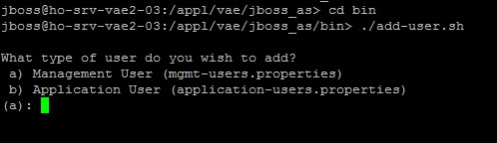

1. Choose type of user -> input ‘a’ -> Enter

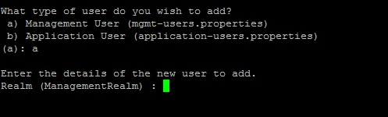

1. Input ‘ManagementRealm’ -> Enter , terminal will show

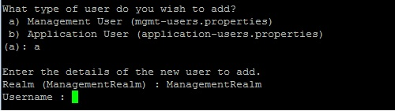

1. Input your admin username and set password -> Enter

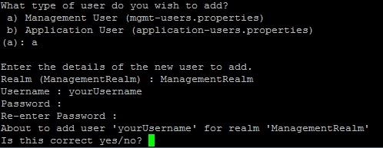

1. Input ‘y’ to confirm. New management user was stored in $JBOSS_HOME/standalone/configuration/mgmt-users.properties. This user is used to login in JBoss Admin console on browser.
   1. Add Application User: the steps are similar to Add Management User
2. Run command $JBOSS_HOME/bin> ./add-user.sh
3. Choose type of user -> input ‘b’ -> Enter
4. Input ‘ApplicationRealm’ -> Enter
5. Input your application username and set password -> Enter, terminal show

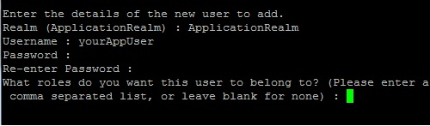

1. Input your user role or leave blank for none -> Enter. This role is used in application security settings. It’s stored in $JBOSS_HOME/standalone/configuration/application-roles.properties.
2. Input ‘y’ to confirm. New application user was stored in $JBOSS_HOME/standalone/configuration/application-users.properties. This user is used in application authentication settings.
3. In this version, BlackBox use username: testuser, role: guest

### Configure JBoss Server

To configure Jboss Server, edit configuration files in Jboss software installation folder. New or updated codes are shown in the highlight text.

1. Configure $JBOSS_HOME/standalone/configuration/standalone-full.xml
2. Configure <hornet-server>: add <connector name=“remote-jms”> into <connectors> tag as figure below, set <persistence-enable> to **false**

{Server IP}= 194.41.196.191

<subsystem xmlns="urn:jboss:domain:messaging:1.1">

<hornetq-server>

<persistence-enabled>***false***</persistence-enabled>

<journal-file-size>102400</journal-file-size>

<journal-min-files>2</journal-min-files>

<connectors>

***<connector name="remote-jms">***

***<factory-class>org.hornetq.core.remoting.impl.netty.NettyConnectorFactory</factory-class>***

***<param key="host" value="*{Server IP}*"/>***

***<param key="port" value="5445"/>***

***<param key="use-nio" value="true"/>***

***</connector>***

<netty-connector name="netty" socket-binding="messaging"/>

<netty-connector name="netty-throughput" socket-binding="messaging-throughput">

<param key="batch-delay" value="50"/>

</netty-connector>

<in-vm-connector name="in-vm" server-id="0"/>

</connectors>

1. Configure jms connection factory:

Replace <connector-ref connector-name="netty"/> with <connector-ref connector-name="remote-jms"/> as figure below.

<jms-connection-factories>

….

<connection-factory name="RemoteConnectionFactory">

<connectors>

<connector-ref connector-name="***remote-jms***"/>

</connectors>

<entries>

<entry name="RemoteConnectionFactory"/>

<entry name="java:jboss/exported/jms/RemoteConnectionFactory"/>

</entries>

***<retry-interval-multiplier>1.0</retry-interval-multiplier>***

***<reconnect-attempts>-1</reconnect-attempts>***

</connection-factory>

1. Configure tag <address-settings>, set <max-size-bytes> to -1, as figure below

<address-settings>

<address-setting match="#">

<dead-letter-address>jms.queue.DLQ</dead-letter-address>

<expiry-address>jms.queue.ExpiryQueue</expiry-address>

<redelivery-delay>0</redelivery-delay>

<max-size-bytes>***-1***</max-size-bytes>

<address-full-policy>BLOCK</address-full-policy>

<message-counter-history-day-limit>10</message-counter-history-day-limit>

</address-setting>

</address-settings>

1. Configure domain webservice

Edit tag <wsdl-host>, use value 0.0.0.0

<subsystem xmlns="urn:jboss:domain:webservices:1.1">

<modify-wsdl-address>true</modify-wsdl-address>

<wsdl-host>${jboss.bind.address:***0.0.0.0***}</wsdl-host>

<endpoint-config name="Standard-Endpoint-Config"/>

<endpoint-config name="Recording-Endpoint-Config">

….

</subsystem>

1. Configure tag <interfaces>

Edit jboss.bind.address, use value 0.0.0.0

<interfaces>

<interface name="management">

<inet-address value="${jboss.bind.address.management:***0.0.0.0***}"/>

</interface>

<interface name="public">

<inet-address value="${jboss.bind.address:***0.0.0.0***}"/>

</interface>

<interface name="unsecure">

<inet-address value="${jboss.bind.address.unsecure:***0.0.0.0***}"/>

</interface>

</interfaces>

1. Configure sub-system jmx

Add property *use-management-endpoint="false"*

<subsystem xmlns="urn:jboss:domain:jmx:1.1">

<show-model value="true"/>

<remoting-connector ***use-management-endpoint="false"***/>

</subsystem>

1. Increase heap size for Jboss server

Edit file $JBOSS_HOME\bin\standalone.conf, set new value for JAVA_OPTS:

JAVA_OPTS="-Xms2048m -Xmx8096m -XX:MaxPermSize= …

1. Restart Jboss to apply new configurations

After Jboss restart successfully, we continue to deploy and configure applications on Jboss server. On web browser, run jboss-admin-console at link: http://{Jboss Server IP}:9990/ -> login into page by Jboss admin user created before.

### Install JDBC driver and set up Datasource

In JBoss, all connections to database are setup and manage by Datasource. Applications in turn will request connections from Datasource to perform operations on database.

Datasource use Postgres JDBC driver to create connection to Postgres database. This section will show you how to install Postgres JDBC driver & configure Datasource on JBoss.

1. 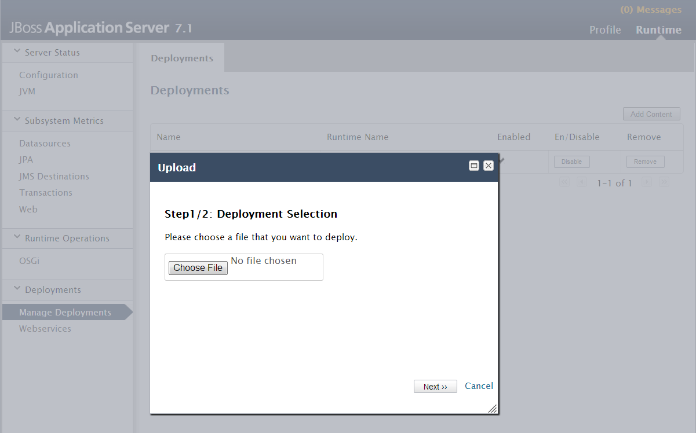In JBoss Admin console, click “Runtime” -> click “Manage Deployments” -> choose “Add Content”.
2. Click “Choose File” and browse to file postgresql-9.2-1002.jdbc4.jar -> Click “Next”.

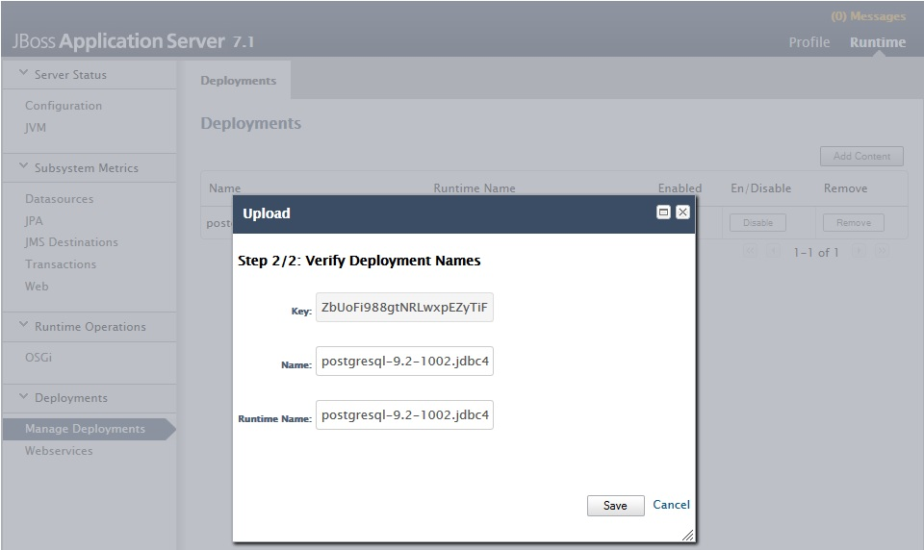

1. Click “Save” to deploy the package. Afterward, you can see the deployment as below:

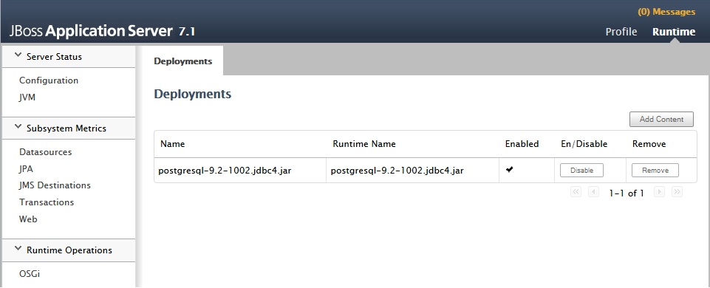

1. In JBoss Admin console, click “Profile” -> click “Datasources” -> click “Add”.

Input the following content:

* Name: VAE2-DS
* JNDI Name: java:jboss/datasources/PostgresDS

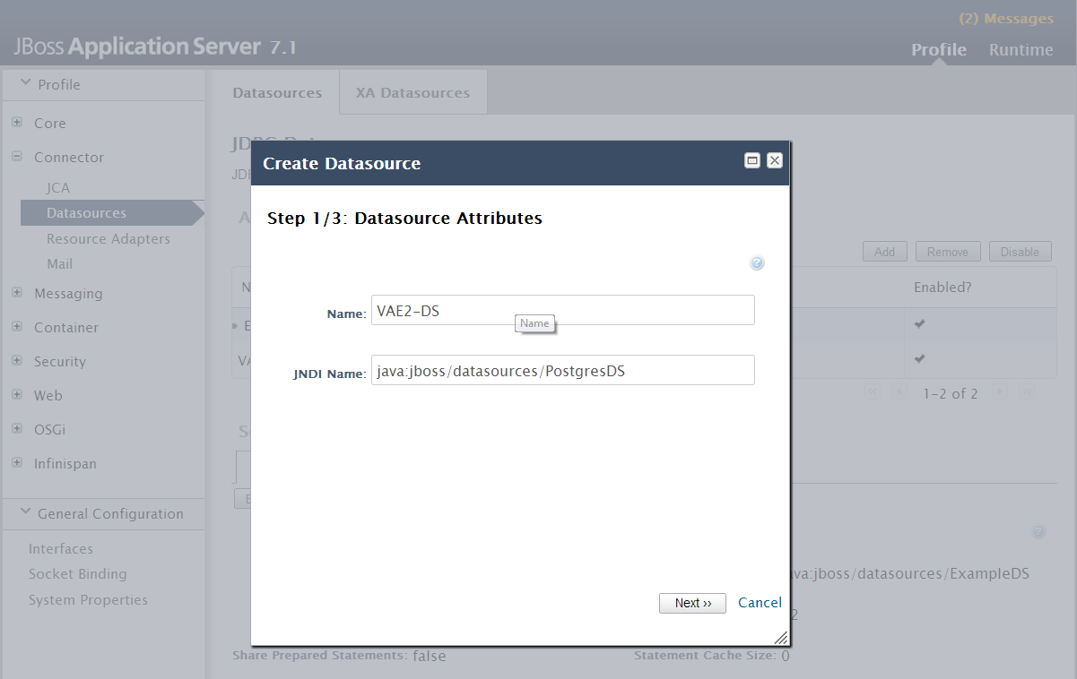

1. Click “Next” -> Choose Driver as “postgresql-9.2-1002.jdbc4.jar” -> Click “Next”. Input the following content:

* Connection URL: jdbc:postgresql://{DB_HOST}:5432/vae2
* Username: vae_production
* Password: <<will be specified>>

Note: DB_HOST is the IP address or domain name of database. The database vae2 and username vae_production must be created before and password will be provided by database admin team.

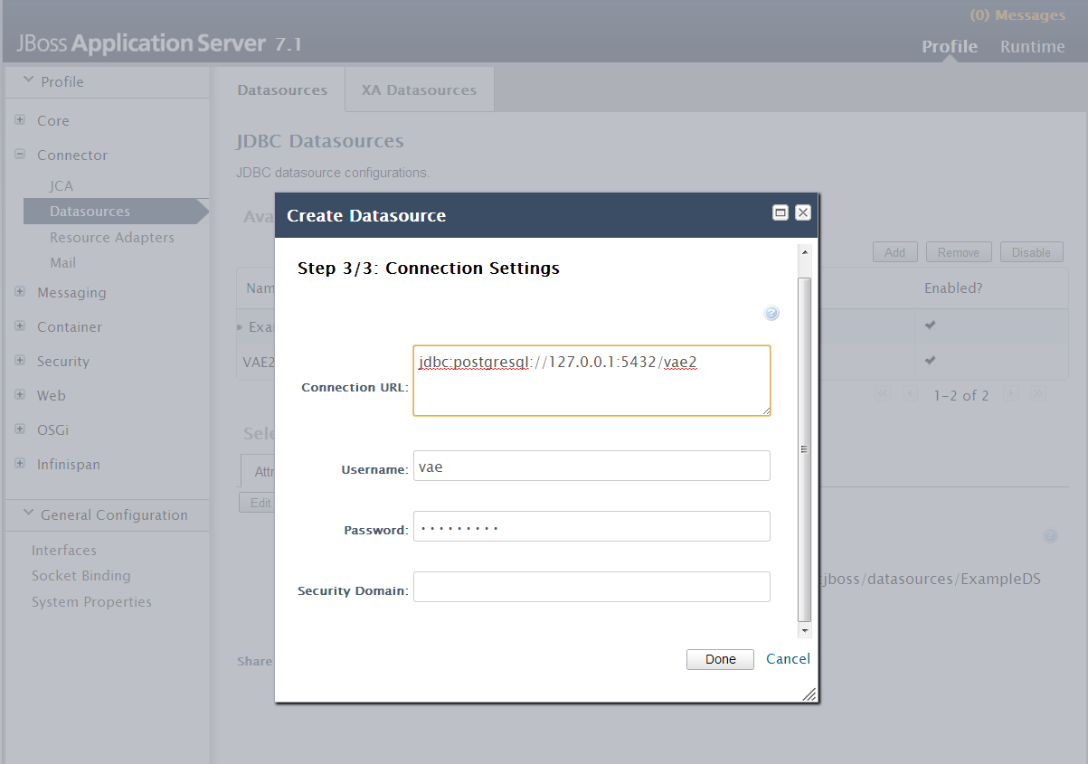

1. Click “Done”. If you configure Datasource successfully, a new Datasource naming VAE2-

DS is displayed as follow:

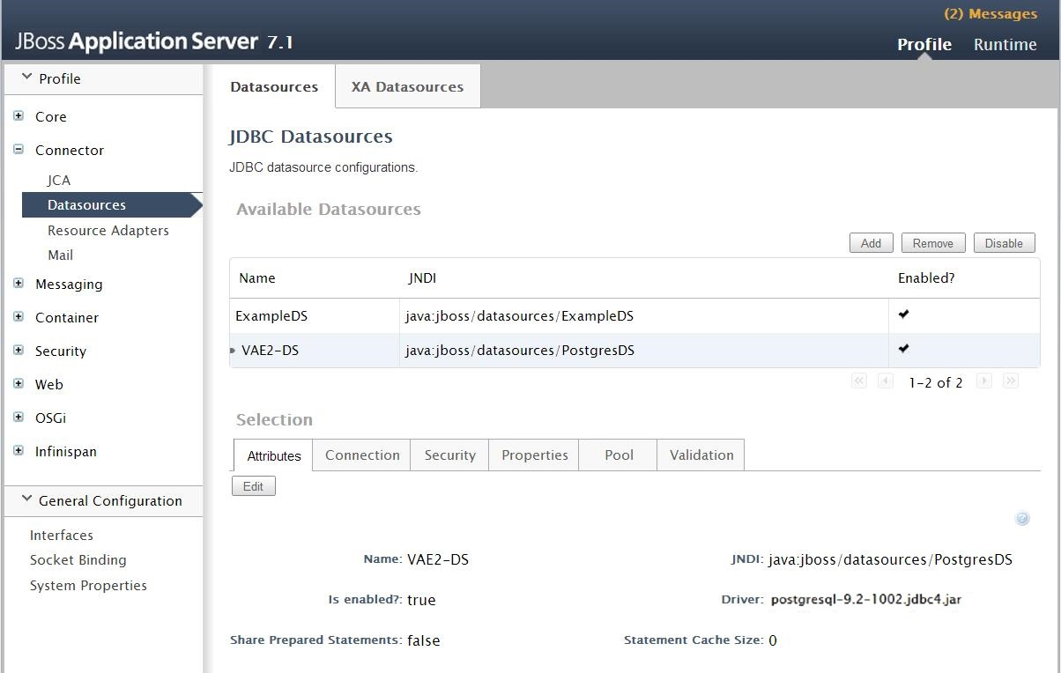

1. Configure data source pool size

In JBoss Admin console, click “Profile” -> click “Datasources” -> choose VAE2-DS-Proxy -> click tab Pool -> click Edit and input min pool size = 20, max pool size = 80 -> click Save.

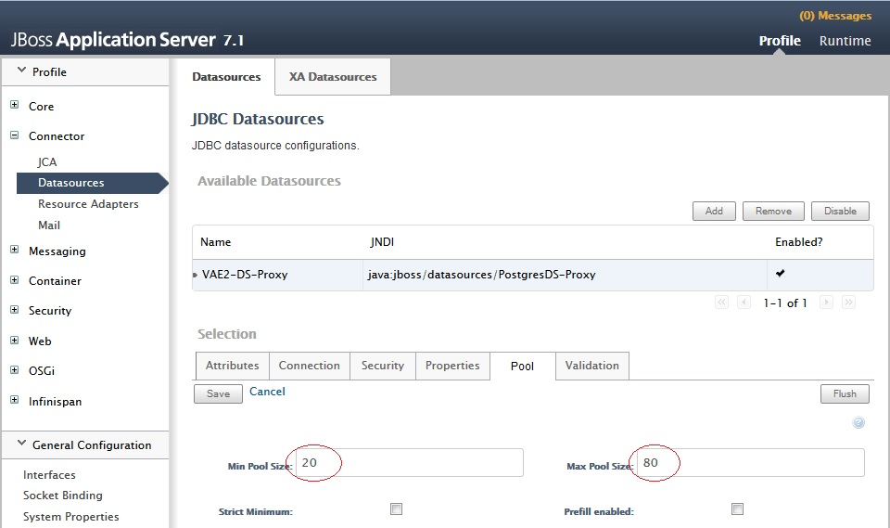

### Configure Messaging System

Java Message Service (JMS) is used to exchange data between Black Box and GHP Proxy. BlackBox embeds data (collection) in message and send to Proxy or vice versa. When messages arrives GHP Proxy, they are stored in queue to wait for processing.

1. In JBoss Admin Console, click “Messaging” -> click “Messaging Provider” -> Click “View”

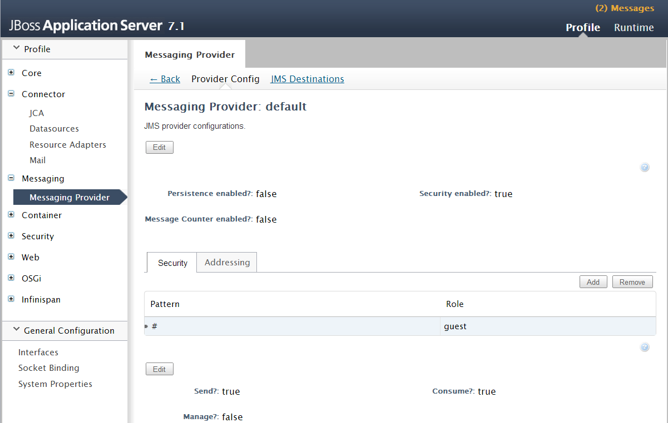

1. Choose “JMS Destinations”. To add a new Queue, click “Add”

* Input the following content:
* Name: responseQueue
* JNDI Name: java:jboss/exported/responseQueue

Click “Save”.

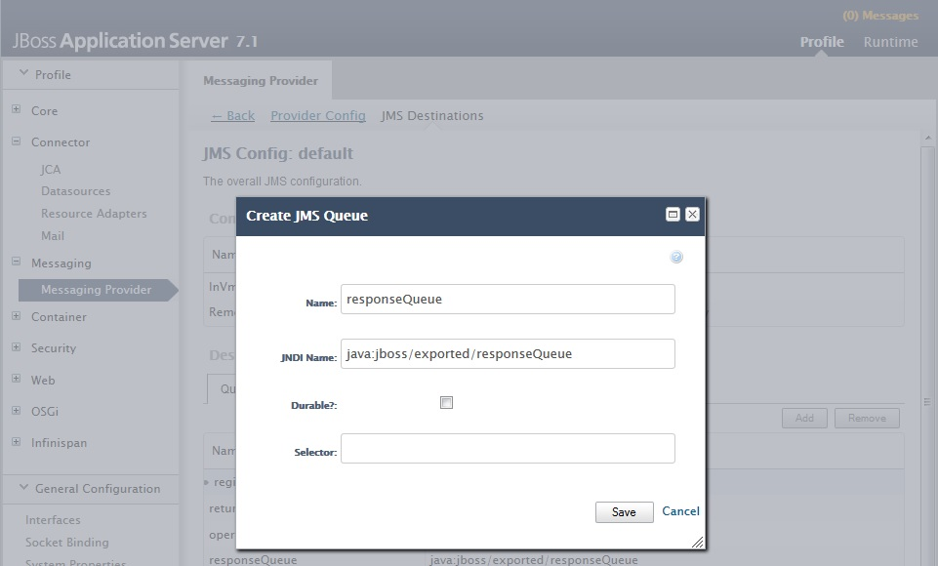

1. Repeat the above step add all of the queues in following table

|  |  |
| --- | --- |
| **Name** | **JNDI** |
| **requestQueue** | java:jboss/exported/requestQueue |

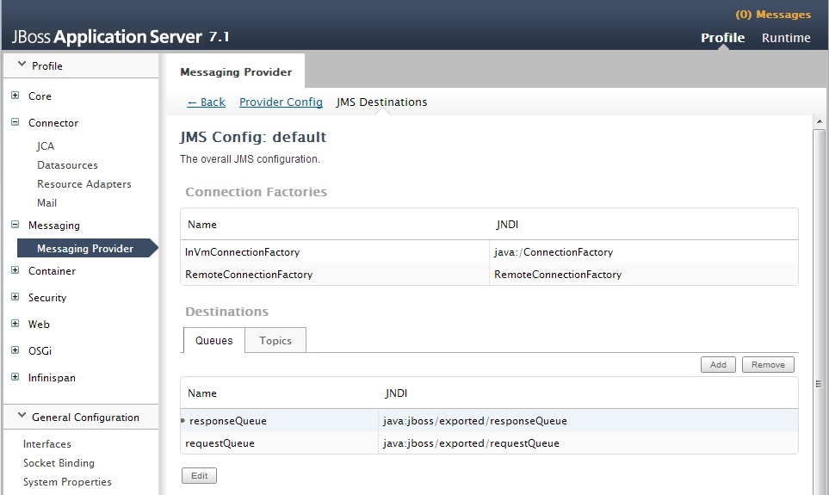

### Install library module

In order to reduce the size of BlackBox, thus making deployment and update process for BlackBox more quickly, all dependency libraries are divided into modules and install on BlackBox firstly.

There are five main library modules:

* Spring module
* Quartz module
* Hibernate module
* Resteasy module
* Httpcomponents module

The detail of each module is described in following table:

|  |  |  |  |  |  |
| --- | --- | --- | --- | --- | --- |
| **Name** | **Module name** | **Source** | **License** | **Version** | **Checksum** |
| Spring module | * springframework * grails |  |  |  |  |
| Quartz module | * quartz |  |  |  |  |
| Hibernate module | * hibernate * google * googlecode * 3-6-10 |  |  |  |  |
| Resteasy module | * resteasy |  |  |  |  |
| Httpcomponents module | * httpcomponents |  |  |  |  |

GHP provides RPM package to deploy all required libraries of BlackBox application as below

|  |  |  |  |
| --- | --- | --- | --- |
| **RPM package** | **Version** | **Release date** | **MD5** |
| pst-vae_library-01.00-1.noarch.rpm | 1.0 | 25 June 2013 |  |
| Pst-vae_library-01.01-1.norach.rpm | 1.1 | 14 Oct 2013 |  |

1st library installation

*root@v05ujh:~> rpm –ivh pst-vae_library-01.01-1.noarch.rpm*

For update version

*root@v05ujh:~> rpm –ivh pst-vae_library -01.01-1.noarch.rpm*

The library will be update as below:

* Copy “**springframework”** folder to /appl/vae/jboss_as/modules/org
* Copy “**hibernate”** folder to /appl/vae/jboss_as/modules/org
* Copy “**googlecode”** folder to /appl/vae/jboss_as/modules/com
* Copy “**google”** folder to /appl/vae/jboss_as/modules/com
* Copy “**quartz**” folder to /appl/vae/jboss_as/modules/org
* Copy “**resteasy**” folder to /appl/vae/jboss_as/modules/org/jboss, replace if it exist
* Copy “**httpcomponents**” folder to /appl/vae/jboss_as/modules/org/apache, replace if it exist

### How the RPM package of libraries built

**Step 1:** Create a tarball from library

|  |
| --- |
| *#unzip library.zip*  google googlecode hibernate springframework  *#ls -l /home/nctoan/library*  drwxrwxr-x 3 nctoan nctoan 4096 Jun 20 11:26 google/ drwxrwxr-x 3 nctoan nctoan 4096 Jun 20 11:26 googlecode/ drwxrwxr-x 6 nctoan nctoan 4096 Jun 20 11:27 hibernate/ drwxrwxr-x 3 nctoan nctoan 4096 Jun 20 11:25 springframework/  *#tar -cvzpf ../vae_library.tgz \** |

**Step 2:** Copy to folder SOURCES for rpm build

|  |
| --- |
| cp /home/nctoan/library.tgz /home/nctoan/rpmbuild/SOURCES |

**Step 3:** Create SPEC file

|  |
| --- |
| nctoan@nctoan:/home/nctoan/rpmbuid/SOURCES> vi vae_sql-01.01.spec |

with content as below

|  |
| --- |
| # RPM spec file for vae_library  # GHPFE Specific  %define pname   vae_library  Name:           pst-%{pname}  Version:        01.01  Release:        1  License:        GHP Far East  URL:            [*http://www.ghp-fareast.vn*](http://www.ghp-fareast.vn/)  Vendor:         GHP-FarEast  Source:         %{pname}.tgz  Packager:       NcToan <nctoan@ghp-fareast.vn>  # we do not want Auto Dependencies ()  AutoReqProv: no    #BuildPrereq:  BuildRoot:      %{_tmppath}/%{pname}-%{version}-root  BuildArch:      noarch  Summary:        VAE Application maintenance  Group:          Applications/scripts  Prefix:         /opt  %description  This package contains the library files which are used by VAE Black Box  %prep  %setup -c -q -n %{pname}-%{version}  %build  %install  rm -rf %{buildroot}  mkdir -p %{buildroot}/appl/vae/jboss_as/modules/org  mkdir -p %{buildroot}/appl/vae/jboss_as/modules/com  cp -R google %{buildroot}/appl/vae/jboss_as/modules/com  cp -R  googlecode %{buildroot}/appl/vae/jboss_as/modules/com  cp -R  hibernate %{buildroot}/appl/vae/jboss_as/modules/org  cp -R  springframework %{buildroot}/appl/vae/jboss_as/modules/org  if [ -r sh_file_list ]  then     rm sh_file_list  fi  find %{buildroot}/  -type f -print | \       sed -e 's,%{buildroot},,'  > sh_file_list  %clean  test "$RPM_BUILD_ROOT" != "/" && rm -rf $RPM_BUILD_ROOT  %pre  %post  %postun  if [ "$1" = "0" ]; then  rm -rf /appl/vae/jboss_as/modules/com/google  rm -rf /appl/vae/jboss_as/modules/com/googlecode  rm -rf /appl/vae/jboss_as/modules/org/springframework  rm -rf /appl/vae/jboss_as/modules/org/hibernate  fi  #         inst  upgr   uninst  # %post   $1==1 $1==2  (N/A)  %files -f  sh_file_list  %defattr(-,jboss,jboss)  /appl/vae/jboss_as/modules/com/google  /appl/vae/jboss_as/modules/com/googlecode  /appl/vae/jboss_as/modules/org/springframework  /appl/vae/jboss_as/modules/org/hibernate    %changelog  * Mon Oct 14 2013 NcToan <nctoan@ghp-fareast.vn>  - update rails library  * Thu Jun 20 2013 NcToan <nctoan@ghp-fareast.vn>  - initial version |

**Step 4:** Build RPM from SPEC file

|  |
| --- |
| nctoan@nctoan:/home/nctoan/rpmbuild> rpmbuild –ba –clean vae_library-01.01.spec  nctoan@nctoan:/home/nctoan/rpmbuild/RPMS/noarch> ls –l  -rw-r—r—1 nctoan nctoan Jun 20 13:22 pst-vae_library-01.01-1.noarch.rpm |

## Install BlackBox system to JBoss

1. In JBoss Admin console, click “Runtime” -> click “Manage Deployments” -> choose “Add Content”. Click “Choose File” and browse to file “blackbox-0.0.0.1.war”

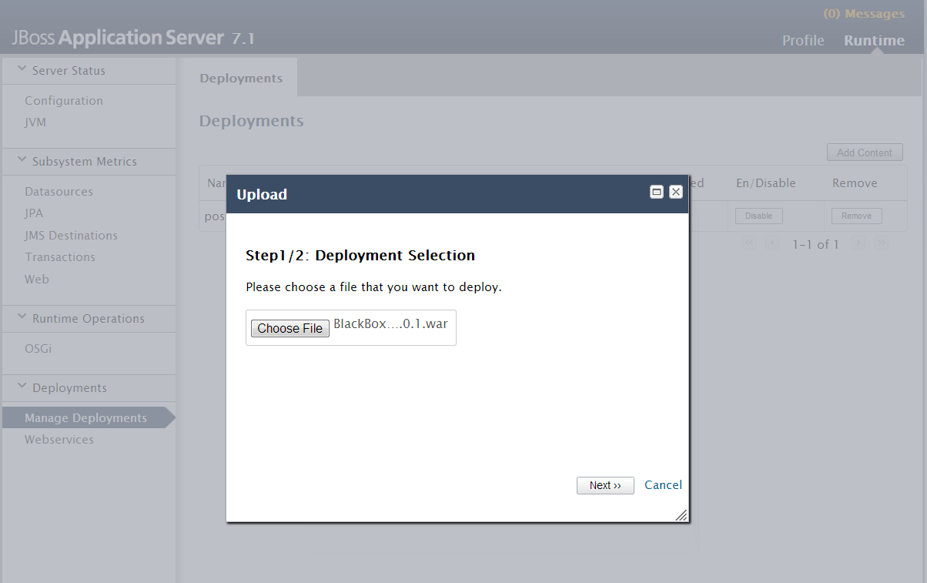

1. Click “Next” to upload the war file. After the upload process completed, you will see the verification of deployment.

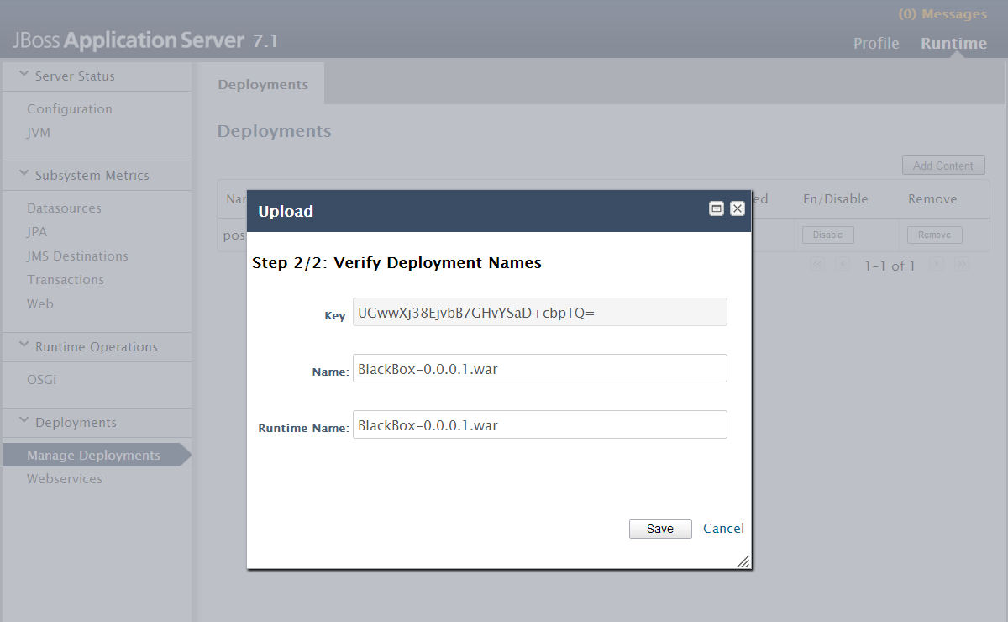

1. Click “Save”. You will see BlackBox application appears in the Deployments list.

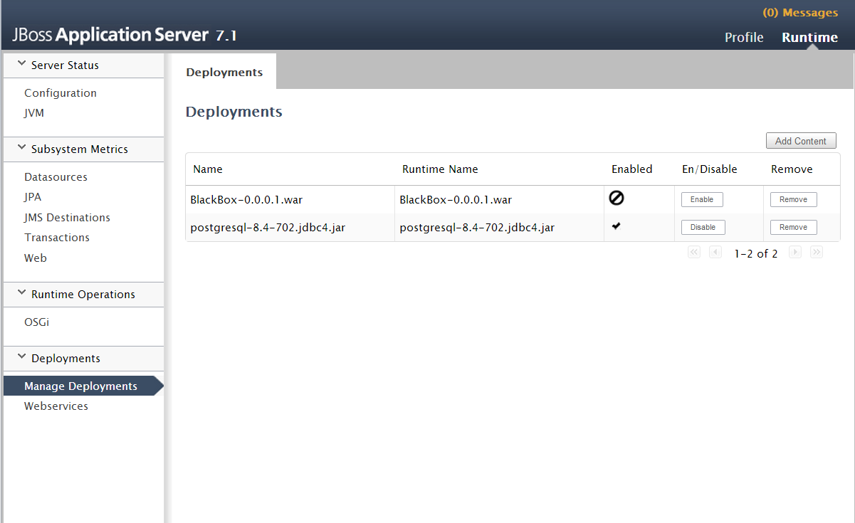

## Start BlackBox system

1. In Deployments list, move mouse over “blackbox-0.0.0.1.war” and click “Enable”. A confirmation box will appear. Click “Confirm”.

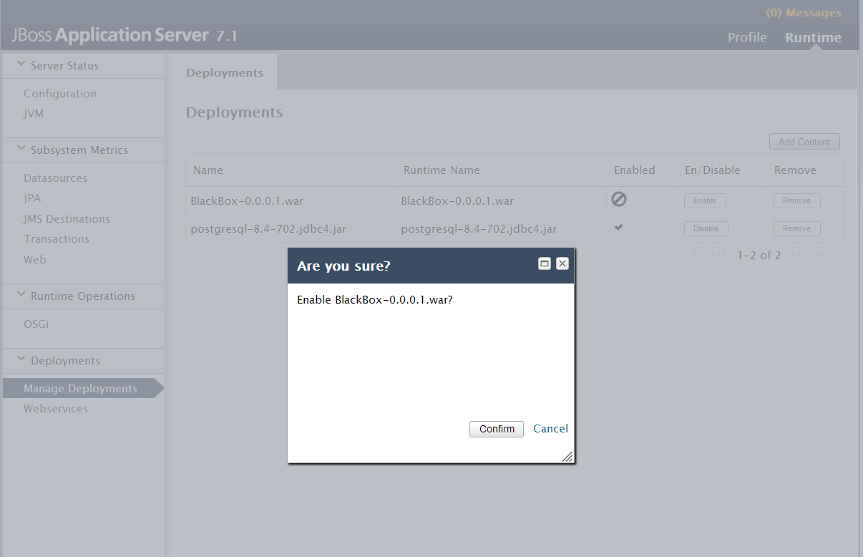

1. After BlackBox is started, the “Enabled” status will change as following:

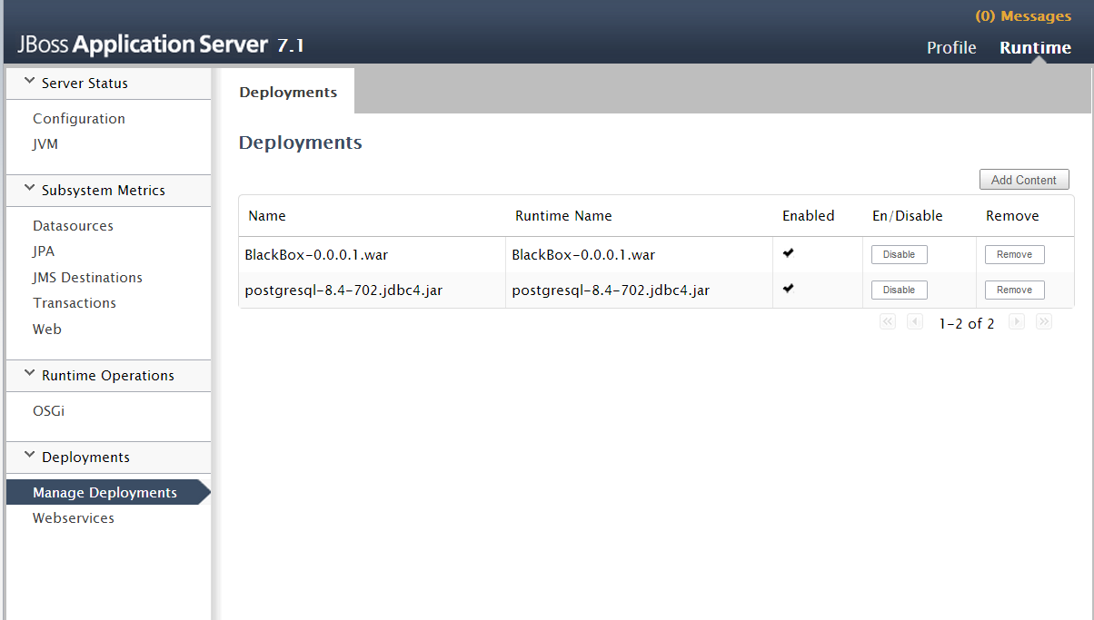

## Verification

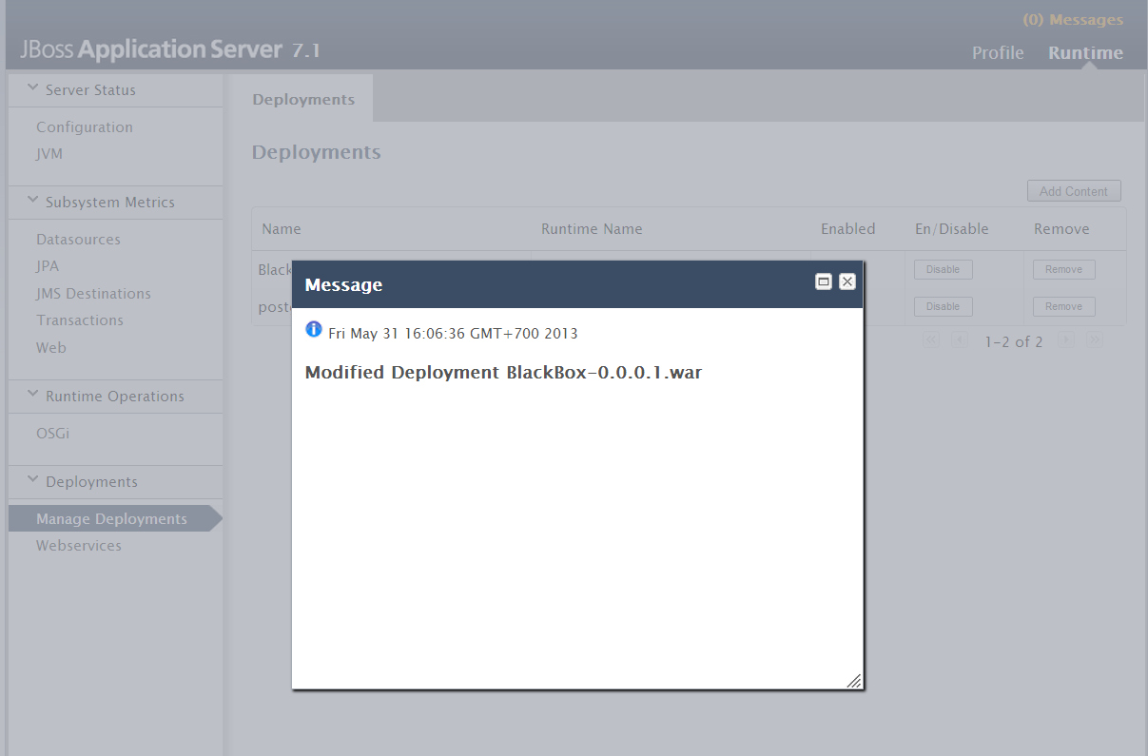If BlackBox is started successfully, you will see the following message: