Homework – 6

1. Which model has the best predictive ability for the biological predictors and what is the optimal performance?

Answer:

**MDA:**

Overall Statistics

Accuracy : 0.5072

95% CI : (0.3841, 0.6298)

No Information Rate : 0.5217

P-Value [Acc > NIR] : 0.6416

Kappa : 0.1582

Mcnemar's Test P-Value : 0.6055

Statistics by Class:

Class: Mild Class: None Class: Severe

Sensitivity 0.6111 0.3846 0.42857

Specificity 0.5455 0.7209 0.88710

Pos Pred Value 0.5946 0.4545 0.30000

Neg Pred Value 0.5625 0.6596 0.93220

Prevalence 0.5217 0.3768 0.10145

Detection Rate 0.3188 0.1449 0.04348

Detection Prevalence 0.5362 0.3188 0.14493

Balanced Accuracy 0.5783 0.5528 0.65783

**Plot of MDA:**

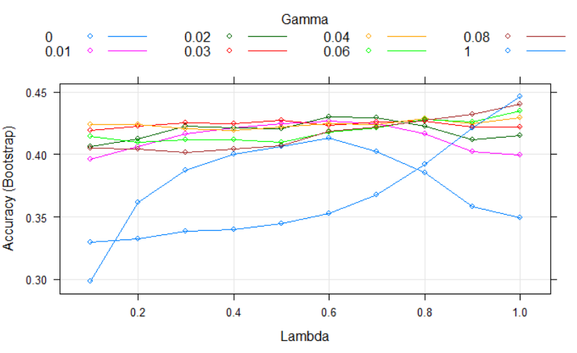

**Neural Network:**

Overall Statistics

Accuracy : 0.5312

95% CI : (0.4023, 0.6572)

No Information Rate : 0.5312

P-Value [Acc > NIR] : 0.5508

Kappa : 0

Mcnemar's Test P-Value : NA

Statistics by Class:

Class: Mild Class: None Class: Severe

Sensitivity 1.0000 0.0000 0.0000

Specificity 0.0000 1.0000 1.0000

Pos Pred Value 0.5312 NaN NaN

Neg Pred Value NaN 0.6406 0.8906

Prevalence 0.5312 0.3594 0.1094

Detection Rate 0.5312 0.0000 0.0000

Detection Prevalence 1.0000 0.0000 0.0000

Balanced Accuracy 0.5000 0.5000 0.5000

**Plot of Neural Network:**

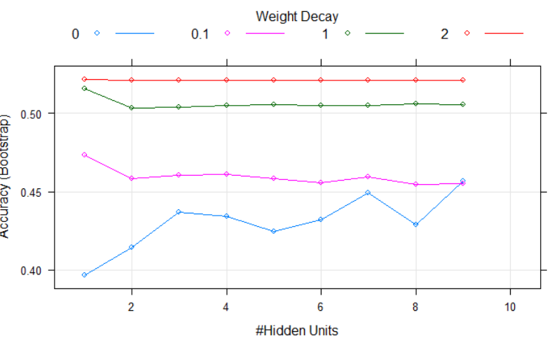

**FDA:**

Overall Statistics

Accuracy : 0.5217

95% CI : (0.398, 0.6435)

No Information Rate : 0.5217

P-Value [Acc > NIR] : 0.5486

Kappa : 0.0807

Mcnemar's Test P-Value : NA

Statistics by Class:

Class: Mild Class: None Class: Severe

Sensitivity 0.7222 0.3846 0.0000

Specificity 0.3030 0.7674 1.0000

Pos Pred Value 0.5306 0.5000 NaN

Neg Pred Value 0.5000 0.6735 0.8986

Prevalence 0.5217 0.3768 0.1014

Detection Rate 0.3768 0.1449 0.0000

Detection Prevalence 0.7101 0.2899 0.0000

Balanced Accuracy 0.5126 0.5760 0.5000

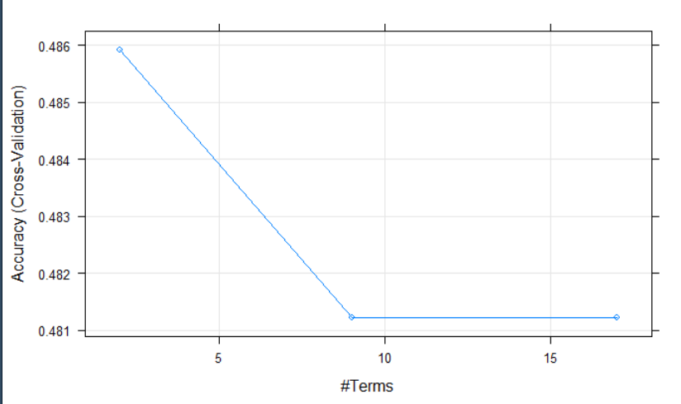

**RDA:**

> rda_cm

Confusion Matrix and Statistics

Reference

Prediction Mild None Severe

Mild 22 12 3

None 11 10 1

Severe 3 4 3

Overall Statistics

Accuracy : 0.5072

95% CI : (0.3841, 0.6298)

No Information Rate : 0.5217

P-Value [Acc > NIR] : 0.6416

Kappa : 0.1582

Mcnemar's Test P-Value : 0.6055

Statistics by Class:

Class: Mild Class: None Class: Severe

Sensitivity 0.6111 0.3846 0.42857

Specificity 0.5455 0.7209 0.88710

Pos Pred Value 0.5946 0.4545 0.30000

Neg Pred Value 0.5625 0.6596 0.93220

Prevalence 0.5217 0.3768 0.10145

Detection Rate 0.3188 0.1449 0.04348

Detection Prevalence 0.5362 0.3188 0.14493

Balanced Accuracy 0.5783 0.5528 0.65783

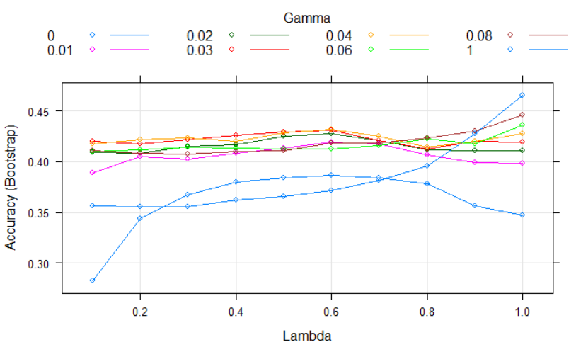

**SVM:**

Overall Statistics

Accuracy : 0.4573

95% CI : (0.398, 0.6435)

No Information Rate : 0.5217

P-Value [Acc > NIR] : 0.5486

Kappa : 0.0603

Mcnemar's Test P-Value : NA

Statistics by Class:

Class: Mild Class: None Class: Severe

Sensitivity 0.7222 0.3846 0.0000

Specificity 0.3030 0.7674 1.0000

Pos Pred Value 0.5306 0.5000 NaN

Neg Pred Value 0.5000 0.6735 0.8986

Prevalence 0.5217 0.3768 0.1014

Detection Rate 0.3768 0.1449 0.0000

Detection Prevalence 0.7101 0.2899 0.0000

Balanced Accuracy 0.5126 0.5760 0.5000

|  |  |
| --- | --- |
| **Model** | **Accuracy** |
| MDA | 0.5072 |
| FDA | 0.5217 |
| Neural Network | 0.5312 |
| SVM | 0.4573 |
| RDA | 0.5072 |
|  |  |

From the above given models, the best model with the highest accuracy is Neural Network with the highest accuracy of 0.5312.

1. Does the nonlinear structure of these models help to improve the classification performance?

Previously, linear models had the below accuracy:

|  |  |
| --- | --- |
| **Model** | **Accuracy** |
| Logistic Regression | 0.5072 |
| Linear Discriminant Analysis | 0.5072 |
| Partial Least Square Discriminant Analysis | 0.5362 |
| Penalized Model | 0.5652 |
| Nearest Shrunken Centroids | 0.5217 |

The best accuracy is of Penalized Model of 0.5652. However, in Non Linear Models, we observe that the best accuracy if of Neural Network, 0.5312. Hence, we can say that Linear Model performs better and Non linear Model does not improve the classification performance.

1. For the optimal models for the biological predictors, what are the top five important predictors?

The Best model that we see is Neural Network.

Top 5 important predictors are:

Overall Mild None Severe

Z93 100.00 100.00 100.00 100.00

Z116 85.94 85.94 85.94 85.94

Z100 74.44 74.44 74.44 74.44

Z159 73.02 73.02 73.02 73.02

Z82 66.04 66.04 66.04 66.04

**R CODE:**

**install.packages(c("glmnet", "pamr", "rms", "sparseLDA", "subselect", "kernlab"))**

**#12.1**

**library(caret)**

**library(AppliedPredictiveModeling)**

**data(hepatic)**

**library(MASS)**

**set.seed(1)**

**#barplot(table(injury), main="Imbalanced Class Distribution")**

**#PreProcess the data**

**#---------------------------**

**set.seed(1)**

**trainingRows = createDataPartition(injury, p = .75, list= FALSE)**

**trainBio <- bio[ trainingRows, ]**

**testBio <- bio[-trainingRows, ]**

**trainInjury <- injury[trainingRows]**

**testInjury <- injury[-trainingRows]**

**pp <- preProcess(trainBio, method = c("BoxCox","center","scale"))**

**trainBio <- predict(pp, trainBio)**

**testBio <- predict(pp, testBio)**

**nz <- nearZeroVar(trainBio)**

**trainBio <- trainBio[-nz]**

**testBio <- testBio[-nz]**

**hc <- cor(trainBio)**

**hc_p <- findCorrelation(hc)**

**trainBio <- trainBio[,-hc_p]**

**testBio <- testBio[,-hc_p]**

**#-------------------------**

**#Model building**

**###MDA####**

**set.seed(1)**

**ctrl <- trainControl(summaryFunction = defaultSummary)**

**mdaFit <- train(x = trainBio,**

**y = trainInjury,**

**method = "mda",**

**metric = "Accuracy",**

**tuneGrid = expand.grid(.subclasses = 1:4),**

**trControl = ctrl)**

**mdaFit**

**summary(mdaFit)**

**plot(mdaFit)**

**predictionmda<-predict(mdaFit,testBio)**

**confusionMatrix(data = predictionmda, reference = testInjury)**

**##RDA**

**set.seed(1)**

**library(klaR)**

**rdaGrid<-expand.grid(.gamma=c(0,.01,.02,.03,.04,.06,.08,1),**

**.lambda=seq(.1,1,length=10))**

**rda_clf<-train(x = trainBio,y = trainInjury,method="rda",**

**tuneGrid=rdaGrid,preProcess=c("center","scale"),**

**metric="Accuracy",**

**trControl = ctrl)**

**rda_clf**

**rda_pred<-predict(rda_clf,testBio)**

**rda_cm<-confusionMatrix(data=rda_pred,reference=testInjury)**

**rda_cm**

**summary(rda_clf)**

**plot(rda_clf)**

**## QDA**

**qda_fit<-train(trainBio,trainInjury,method="qda",**

**preProcess=c("center","scale"),metric="Accuracy",**

**trControl = ctrl)**

**qda_pred<-predict(qda_fit,testBio)**

**qda_cm<-confusionMatrix(data=qda_pred,reference=testInjury)**

**qda_cm**

**############### Neural Networks #############**

**library(nnet)**

**set.seed(1)**

**nnetGrid <- expand.grid(.size = 1:10, .decay = c(0, .1, 1, 2))**

**maxSize <- max(nnetGrid$.size)**

**numWts <- (maxSize * (98 + 1) + (maxSize+1)*2)**

**nnetFit <- train(x = trainBio,**

**y = trainInjury,**

**method = "nnet",**

**metric = "Accuracy",**

**preProc = c("center", "scale", "spatialSign"),**

**tuneGrid = nnetGrid,**

**trace = FALSE,**

**maxit = 2000,**

**MaxNWts = numWts,**

**trControl = ctrl)**

**nnetFit**

**nn_pred<-predict(nnetFit,testBio)**

**nn_cm<-confusionMatrix(data=nn_pred,reference=testInjury)**

**nn_cm**

**plot(nnetFit)**

**important=varImp(nnetFit)**

**plot(important, top = 5, scales = list(y = list(cex = .95)))**

**########## Flexible Discriminant Analysis ############**

**library(earth)**

**fda_grid<-expand.grid(.degree=1:4,.nprune=2:38)**

**fda_clf<-train(trainBio,trainInjury,**

**method="fda",preProc=c("BoxCox","center","scale"),**

**metric="Accuracy",**

**trControl = trainControl(method = "cv", number = 3))**

**fda_clf**

**plot(fda_clf)**

**fda_pred<-predict(fda_clf,testBio)**

**fda_cm<-confusionMatrix(data=fda_pred,reference=testInjury)**

**fda_cm**

**############## Support Vector Machines ##########**

**set.seed(1)**

**library(kernlab)**

**sigmaRangeReduced <- sigest(as.matrix(trainBio))**

**## Given a range of values for the "sigma" inverse width parameter**

**## in the Gaussian Radial Basis kernel for use with SVM.**

**## The estimation is based on the data to be used.**

**svmRGridReduced <- expand.grid(.sigma = sigmaRangeReduced[1],**

**.C = 2^(seq(-4, 6)))**

**svm_clf<-train(x=trainBio,y=trainInjury,**

**method="svmRadial",tuneGrid=svmRGridReduced,**

**preProc=c("center","scale"),**

**fit=FALSE,**

**metric="Accuracy",**

**trControl = trainControl(method = "cv", number = 3))**

**svm_clf**

**svm_clf$finalModel**

**plot(svm_clf)**

**svm_pred<-predict(svm_clf,testBio,type = "raw")**

**svm_cm<-confusionMatrix(data=svm_pred,reference=testInjury)**

**svm_cm**

**plot(svm_clf)**