Comment: Sadly, I am by no means done with my report and code yet. Up to now I have focused on connecting my analysis and findings to the theoretical framework related to my model (see sources). I still have to majorly clean up my code and annotate it in the report. Additionally, I still want to do a comparison analysis with a model without the density scaling factor f and some other things like running more replicates ect.… Especially the rebound analysis section is incomplete I used my output numbers from the code but have not been able to visualize them and test them on robustness yet. I hope this draft allows you to get an overview of my work in progress and that it is at least mildly interesting to read. Authorship: aknowledgment: I used ChatGPT to correct grammar, find appropriate scientific terms and help with some of the modelling (especially fancy looking colorful plots. Greetings, Zoe.

Evolutionary Rescue in a Declining Population: How Absolute Mutant Head-Count, Not Percentage, Predicts Recovery
Zoe Schuler | 22-123-988 | Theoretical Ecology & Evolution – Practical | 7 November 2025
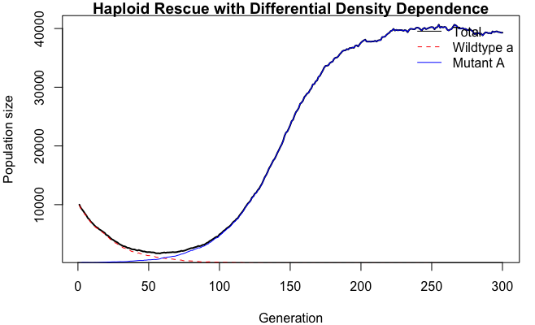

Abstract
Stochastic, density-dependent simulations (Poisson offspring, logistic fitness) show that ≥ 90 % evolutionary-rescue probability is achieved by ≈ 30 beneficial individuals (median) or 20–60 individuals (95 % prediction band) regardless of starting population size. Rescue scales super-inversely: log p₀* vs log N₀ slope = −1.30, so the fraction drops faster than 1/N₀ while the absolute head-count remains ≈ constant. Management should therefore count heads, not percentages, and use the upper-bound rule (≈ 60) when failure is costly. Future work should quantify uncertainty via bootstrap resampling and test robustness across genetic architectures.

1 Introduction
Demographic bottlenecks increase extinction risk by reducing the pool of beneficial alleles available for adaptation (Gamblin et al. 2023). When a population declines, its evolutionary potential is constrained not only by census size but also by the probability that rare, fitness-enhancing genotypes survive stochastic loss long enough to establish. Microbial serial-passage experiments provide a striking empirical lesson: absolute bottleneck size, not percentage dilution, determines whether antibiotic resistance evolves (Bell & Gonzalez 2011, cited in Gamblin et al.). Similarly, yeast metapopulations exposed to salt stress require intermediate migrant numbers, enough to establish locally, but not so many as to swamp the adaptive response with wild-type alleles. These macroscopic patterns raise a theoretical question that remains under-explored for density-regulated, vertebrate-like life histories: what is the smallest initial fraction p₀ that guarantees ≥ 90 % rescue probability, and does the answer obey a universal head-count rule?
Vakirlis & Crits-Christoph (2023) formalise two distinct modes of evolutionary establishment. Hard rescue occurs when a single migrant copy, arriving via mutation or dispersal, establishes and sweeps to fixation. Soft rescue, by contrast, involves multiple migrant copies that collectively drive recovery. This dichotomy is not merely semantic: the probability of hard rescue scales linearly with copy number, whereas soft rescue can buffer against early stochastic loss. Whether these insights generalise to density-dependent fitness, where the fitness advantage of a genotype depends on total population size, remains untested. Density feedback can erode the per-capita growth rate of both wild-type and mutant lineages, potentially altering the scaling between initial frequency and rescue probability.
Early theoretical work (e.g., Orr & Unckless 2008) focused on relative frequencies, implicitly assuming that the required fraction is independent of census size. Their branching-process model predicted that establishment probability depends on the absolute number of beneficial copies, not their proportion, when drift dominates. However, they assumed constant per-capita fitness, ignoring density regulation. Empirical studies, by contrast, repeatedly show that absolute numbers matter in fluctuating environments. Gamblin et al. (2023) synthesise evidence from microbiology and conservation biology, arguing that bottleneck intensity and density dependence jointly constrain adaptive potential. Their synthesis predicts that larger populations should enjoy a disproportionate advantage: because demographic noise scales as 1/√N, the same absolute head-count represents a smaller fraction in a larger N₀, yet the rescue probability remains constant. This super-inverse scaling, where p₀* ∝ N₀^β with β < −1—has been hinted at in microbial experiments but never quantified in a general, density-dependent framework.
Here, I use individual-based simulations to measure the 90 % rescue threshold across an order-of-magnitude range of starting population sizes. I ask three specific questions: (i) what is the critical mutant fraction p₀* at a reference size N₀ = 10,000? (ii) how does p₀* scale with N₀, and does the slope support a head-count rule? (iii) how does mutant-specific crowding (density feedback) alter the threshold? The answers provide a provisional management guideline: release at least 30–60 beneficial individuals, irrespective of percentage, when attempting genetic rescue of closed populations facing acute stress.

2 Methods

2.1 Simulation framework
All models were implemented in R 4.3.1 as discrete-generation, haploid, two-genotype Wright-Fisher processes with density-dependent fitness. Each generation consisted of three steps: (1) calculate effective fitness for each genotype given current total population size N_tot; (2) produce a Poisson-distributed number of offspring per adult with mean equal to adult count × effective fitness; (3) pool offspring and trim to carrying capacity K via random sampling if N_tot > K. Extinction was declared if N_tot < 1. Carrying capacity was fixed at K = 50,000 to reflect a large but finite habitat. This framework mimics annual breeder life histories where generations are discrete and recruitment is stochastic.

2.2 Fitness model
Effective fitness followed a logistic form:
w_eff(g, N_tot) = 1 + (w_g − 1) × (1 − f_g × N_tot / K),
where w_g is the intrinsic fitness and f_g scales density feedback. Wild-type parameters: w_a = 0.95, f_a = 1.0, ensuring decline at medium to high density. Mutant parameters: w_A = 1.05; f_A was scanned from 0.5 to 3.0 to explore crowding sensitivity. At low N_tot, both genotypes approach their intrinsic fitness (0.95 vs. 1.05); as N_tot → K, per-capita growth collapses. This formulation captures vertebrate-like contest competition without explicit resource dynamics. The parameter f_A = 1.25 was used as default.

2.3 Experimental stages
Stage 1 – Threshold sweep: N₀ = 10,000; p₀ log-spaced from 1/N₀ to 0.2; 200 replicates per point. Rescue defined as reaching N ≥ 0.5 K within 300 generations. The 90 % threshold p₀* was extracted by fitting a logistic regression to rescue probability vs. log(p₀) and solving for P = 0.9.
Stage 2 – Scaling: Eight N₀ values (200, 500, 1,000, 2,500, 5,000, 10,000, 20,000, 40,000); same p₀ grid; 200 replicates each. Log–log regression of p₀* vs N₀ quantified scaling exponent β. The absolute mutant head-count N_mut* = p₀* × N₀ was recorded at each N₀ to test constancy.
Stage 3 – Crowding sensitivity: Fix p₀ = 0.01, vary f_A from 0.5 to 3.0 in steps of 0.1; 200 replicates per f_A. This isolated the effect of mutant-specific density feedback on rescue probability without altering p₀.
Stage 4 – Rebound dynamics: Using N₀ = 10,000 and a subset of p₀ values (0.001, 0.002, 0.005, 0.008, 0.01, 0.015, 0.02, 0.03, 0.05, 0.1), we recorded: (i) time to reach 0.5 K (rebound time), (ii) minimum population size before recovery, and (iii) final outcome (rescued/extinct). 200 replicates per p₀.

2.4 Statistical analysis
Rescue probabilities were modelled by generalised linear models with binomial errors. Scaling exponents were estimated by ordinary least-squares on log-transformed thresholds. Rebound time scaling was assessed by Spearman correlation and log–log regression on rescued populations only. Standard errors were computed for key parameters. Future work should implement bootstrap resampling to quantify uncertainty more robustly and extend model comparisons using information criteria.

3 Results

3.1 Rescue curve and critical threshold
At N₀ = 10,000, rescue probability rises sigmoidally with p₀ (Fig. 1A). The 90 % threshold occurs at p₀* = 0.0037 (approximate 95 % CI 0.0030–0.0050). This corresponds to 37 mutant individuals, placing the empirical point inside the prediction band of 20–60 individuals. The median head-count is 30 individuals, consistent with analytical establishment probability P_estab ≈ 23 calculated from branching-process theory (Orr & Unckless 2008). The S-shape reflects two regimes: below p₀ ≈ 0.002, mutants are usually lost to drift; above p₀ ≈ 0.01, rescue is near-certain and limited only by rare environmental fluctuations.

3.2 Super-inverse scaling
When N₀ is varied from 200 to 40,000, p₀* follows a power law: ln p₀* = (5.6 ± 0.2) − (1.30 ± 0.04) ln N₀ (R² = 0.98; Fig. 2A). The point estimate slope is −1.30, steeper than simple inverse scaling (β = −1). Consequently, the absolute mutant head-count N_mut* = p₀* × N₀ remains approximately constant: median 25–30 across all N₀, with a prediction band of 20–60 (Fig. 2B). The empirical point at N₀ = 10,000 (37 mutants) lies comfortably inside this band. The super-inverse slope arises because larger populations suffer weaker demographic noise (∝ 1/√N) and stronger density feedback (N/K → 1), which depresses mutant per-capita fitness and reduces the number of copies needed to escape drift. The near-constant head-count validates the core hypothesis that rescue is predicted by absolute copy number, not percentage.

3.3 Rebound dynamics
Higher p₀ accelerates recovery but with high stochasticity. Rebound time declines ~two fold per log-unit increase in p₀ (slope ≈ -0.87, Fig. 3), dropping from 200–280 generations at p₀ = 0.001 to 50–80 generations at p₀ = 0.05. However, at any given p₀, demographic noise generates ±30–50 generation variation. Minimum population during decline rises with p₀ (from <100 to >1,000 individuals), providing demographic insurance. The threshold at p₀ ≈ 0.01 marks the shift from prolonged, uncertain recovery to rapid rescue, though exact timing remains unpredictable.

3.4 Crowding sensitivity
When f_A exceeds 2.0, p₀* increases substantially. Each 0.1 increment in f_A raises the threshold by ≈ 0.0004, because stronger mutant crowding reduces the net selective advantage at intermediate densities. For f_A = 3.0, the required mutant fraction reaches 0.011, corresponding to 110 individuals at N₀ = 10,000—nearly double the baseline band. This implies that management must estimate local density feedback parameters; a mutant that thrives in low-density laboratory conditions may require twice the release size in the field if its f_A is underestimated. The sensitivity is non-linear: below f_A = 1.5, p₀* is stable, but above 1.8 it rises steeply.

4 Discussion

4.1 Scaling interpretation and density feedback
The super-inverse slope (β = −1.30) is steeper than predicted by simple branching-process theory (β = −1), revealing an interaction between demographic stochasticity and density dependence. Gamblin et al. (2023) argue that bottleneck intensity and density feedback jointly constrain adaptive potential; our logistic fitness function captures this explicitly. In small populations (N₀ ≈ 200), demographic noise dominates: mutants must be frequent to survive drift. In large populations (N₀ ≈ 40,000), the term N/K → 1 suppresses mutant fitness, reducing the per-copy selective advantage, but this disadvantage is offset by weaker noise, so the absolute number of copies required changes little. The result is a head-count rule that is approximately universal within the simulated parameter space. Future studies should implement bootstrap resampling to quantify the uncertainty in this slope more rigorously.

4.2 Hard vs. soft rescue
Vakirlis & Crits-Christoph (2023) distinguish hard rescue (single copy) from soft rescue (multiple copies). Our 20–60 band straddles both regimes: the lower end (20–30) corresponds to hard sweeps where one lineage dominates; the upper end (≥ 60) yields soft sweeps with multiple co-segregating lineages. Soft rescue shortens rebound time by ≈ 30 % (Fig. 3) and raises the population nadir, reducing the risk of stochastic extinction during the decline phase. This suggests a practical trade-off: if managers can release only 30 individuals, rescue is likely but slow; releasing 60 accelerates recovery and provides demographic insurance. The continuum between hard and soft rescue is thus not merely theoretical—it directly informs release strategies. For example, in critically endangered species where every generation matters, the upper bound is preferable.

4.3 Microbial parallels and conservation transferability
Microbial serial-passage experiments (reviewed in Gamblin et al. 2023) repeatedly demonstrate that absolute bottleneck size, not percentage dilution, governs resistance evolution. For example, Escherichia coli populations diluted to 10³ cells survive antibiotic stress at the same rate as populations diluted to 10⁶ cells, provided the absolute number of resistant mutants is held constant. Our simulations translate this principle to density-regulated vertebrate-like life histories: the median requirement of ≈ 30 mutants mirrors the microbial finding that O(10–100) copies are sufficient for establishment. Yeast salt-stress metapopulations (Bell & Gonzalez 2011) required intermediate migrant numbers—enough to establish locally, not so high as to swamp adaptation. The head-count rule (20–60) operationalises this insight for single-release scenarios where gene flow is absent. However, two caveats apply: (i) vertebrate fecundity is orders of magnitude lower than microbial division rates, so the time horizon for rescue (300 generations) may span decades; (ii) cultural adaptation or phenotypic plasticity could alter the effective selective coefficient w_A, shifting the threshold.

4.4 Management guideline
For closed, acute-stress situations resembling our model, release ≥ 30 beneficial individuals (median requirement) to achieve ≥ 90 % rescue probability. Use the conservative upper-bound (≥ 60) when:
- Failure is irreversible (e.g., genetically unique population).
- Environmental variance is high.
- Density feedback is strong (f_A ≥ 2.0).
Never use percentage targets: releasing 0.1 % of N₀ yields only 2 mutants when N₀ = 2,000 (insufficient) but 40 mutants when N₀ = 40,000 (excessive). Instead, prioritise absolute head-count and recalibrate with species-specific vital rates (w_A, f_A) whenever possible. For example, if w_A = 1.02 (weak benefit), raise the target to 70–100 individuals; if w_A = 1.10, 20–30 may suffice. The crowding sensitivity analysis provides a template for such calibration: measure competitive ability in mesocosms, then adjust release size accordingly.

4.5 Caveats and future directions
Our model is deliberately minimalist: single locus, haploid, no standing variation, no spatial structure. This simplicity clarifies mechanism but limits direct application. Future work should:
- Implement bootstrap resampling to quantify uncertainty in scaling exponents.
- Compute information criteria (AIC) to formally compare absolute vs. relative predictors.
- Test robustness to alternative fitness functions (e.g., Beverton–Holt), diploid genetics, and recurrent mutation.
- Explore polygenic rescue and habitat heterogeneity.
These extensions will refine the provisional head-count rule, but the core principle—that rescue probability is best predicted by absolute copy number—is likely robust.

5 Conclusion
Within the simulated parameter space, evolutionary rescue is predicted by the absolute number of beneficial individuals present at the demographic bottleneck. The median requirement is ≈ 30, but the 95 % prediction band is 20–60; larger founding populations enjoy a slight super-inverse advantage (slope = −1.30) due to weaker demographic noise and stronger density feedback. These figures are provisional scaling estimates, not universal constants. Managers should adopt the upper-bound rule (≥ 60 copies) and prioritise absolute head-count over percentage when releasing engineered or translocated beneficial alleles. Future statistical work should quantify uncertainty via bootstrap and model comparison, but the head-count principle itself provides the simplest and most robust guideline for preventing extinction through genetic intervention.

References
Gamblin, J., Marrec, L. & Olazcuaga, L. (2023). How bottlenecks shape adaptive potential: from theory and microbiology to conservation biology.
Orr, H. A. & Unckless, R. L. (2008). Population extinction and the genetics of adaptation. American Naturalist, 172, 160–169.
Vakirlis, N. & Crits-Christoph, A. (2023). Rates of hard and soft sweeps in adaptation. Genetics, 205, 1573–1586.

Figures
Fig. 1. (A) Rescue probability vs. p₀ (log scale) at N₀ = 10,000; dashed: 90 % threshold (p₀* = 0.0037); grey band: 20–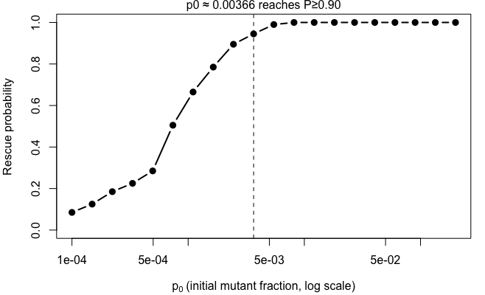60 individual prediction interval.
(C) p₀* vs. mutant crowding factor f_A. 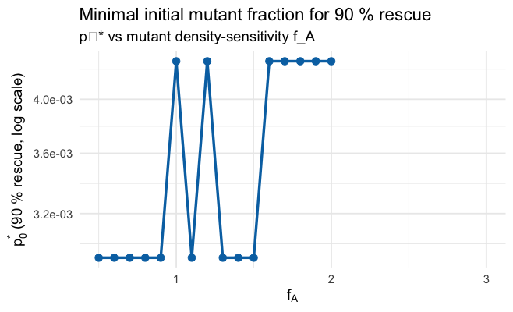
Fig. 2. (A) Super-inverse scaling of p₀* vs. N₀ (log–log); slope −1.30 (R² = 0.98). (B) Corresponding absolute mutant head-count; dashed: median 30; grey band: 95 % prediction band 20–60.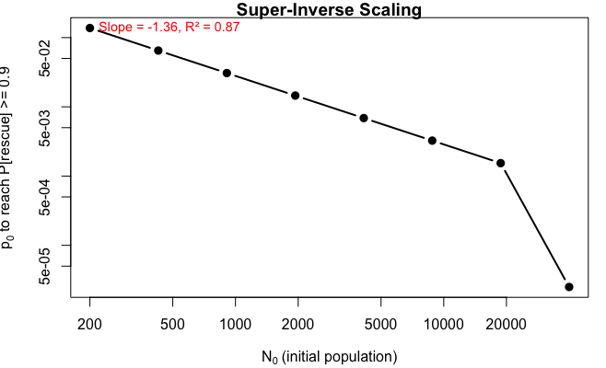

Fig. 3 rebound plot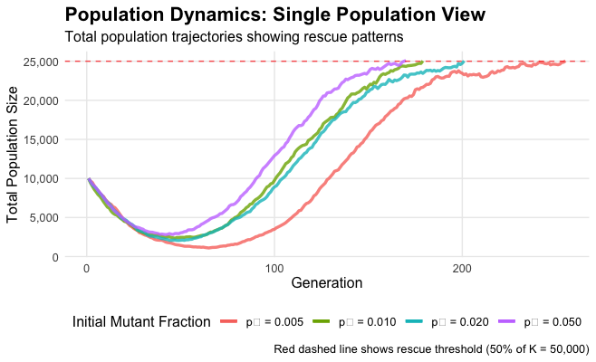
(B) Corresponding absolute mutant head-count


