


Collaborative University: London School of Business and Finance, Singapore

Course Title: Master of Business Administration – Global
Module Name: International Data Analytics
Module Code: COMP-1913-M04-2026-27

Assignment Title: Individual Report
Submission Due Date: 4 December 2026
Word Count: 1,980 words

Student
LSBF Student ID: [LSBF Student ID]
UOG Banner ID: [UOG Banner ID]

Name of Lecturer: Mr. Zhou Zhihao

Table of Contents
Executive Summary 3
1. Background 3
2. Evaluation of Visualisations 4
2.1 Overview 4
2.2 R&D Spending (page 5) 4
2.3 AI Use by Innovation Stage (page 9) 5
2.4 Actual vs. Expected Results (page 10) 6
2.5 Other Charts (pages 6 and 11) 7
3. Analytical Tools 7
4. Data Integrity and Cognitive Bias 8
4.1 Data Integrity 8
4.2 Survivorship Bias 8
4.3 Confirmation Bias and Conflict of Interest 8
4.4 Self-Reporting and Correlation 9
5. Recommendations 9
List of References 10
Declaration of AI Use 11

Executive Summary
This report evaluates Bain & Company's Innovation Report 2025. Based on a survey of 20 of the "most innovative companies", Bain's report offers valuable ideas on innovation and AI investment, but its evidence is weak. All 24 charts are donut charts, and none shows the sample size; some chart titles do not match the data, and expectations are mixed with actual results. Some questions were answered by only about 16 companies, so the margin of error is large. Bain's report may also reflect survivorship bias, confirmation bias and self-reporting, and it treats correlation as causation. This report recommends that executives use Bain's report as a starting point for discussion and test its claims with their own data first, and that Bain disclose its methods and improve its charts.

1. Background
Bain & Company is one of the world's leading management consulting firms. Its Innovation Report 2025, subtitled "How top companies scale bold ideas", is signed by Marissa Dent, Global Leader of Bain Innovation and Business Building (Bain & Company, 2025). It is based on a survey and interviews with 20 of Fast Company's 50 Most Innovative Companies in 2025, and contains four articles on innovation strategy, AI and innovation, customer insights, and running two innovation systems.
The business question the report aims to answer is: how do the most innovative companies invest, organise and use AI for innovation, and what can other companies learn from them? Its target audience is corporate executives, especially decision-makers who are considering investing more in innovation and AI. However, the report begins with a letter addressed "Dear colleague" and ends by promoting Bain's own "Engine 2" framework, which makes it marketing material for Bain's consulting services.
Bain's report can directly influence management decisions on R&D budgets, AI investment and how to organise innovation teams. If the evidence is weak, executives may spend money in the wrong places and make the wrong decisions: ignoring their own company's situation, following the trend in AI investment, and missing what they really should do.
This report argues that Bain's report raises valuable questions and ideas, but its evidence is weak: the sample is small and its size is not disclosed, and some charts may mislead readers. Therefore, executives should not use it directly as a basis for decisions. Sections 2 to 4 evaluate Bain's visualisations, the analytical tools it may have used, and its data integrity and cognitive biases; Section 5 provides recommendations.

2. Evaluation of Visualisations

2.1 Overview
Bain's report contains 24 charts, all of which are donut charts, and 21 of them show only a single percentage (Bain & Company, 2025). The advantage of this design is that it is eye-catching and consistent in style, so executives can see the key numbers quickly. However, when one number is drawn as a ring, there is no comparison and no distribution, so the chart gives very little information. Course literature suggests that bar charts are clearer than pie charts for comparing categories, and that several pie charts should not be compared side by side (Barrios Becerra et al., 2021). More importantly, none of the 24 charts shows the sample size or the original question wording.

2.2 R&D Spending (page 5)
The title of this chart is "Innovators don't outspend; they out-allocate", and the text says that about half of the companies spend the same as or less than their peers (Bain & Company, 2025, p. 5). However, the largest segment of the chart shows that 54% of the companies spend more on R&D than their peers, so the title does not match the data. The use of colour makes this worse: the minority groups, "lower" and "about the same", are shown in striking red, while the majority group, "higher", is shown in a light colour, so readers notice the minority first. This is an example of the framing effect: when the same data is emphasised in a different way, readers reach a different conclusion. The strength of this chart is that it has a legend and percentage labels. Figure 2 redraws it as a horizontal bar chart sorted by size, with the largest group in the darkest colour and a title that states what the data shows.
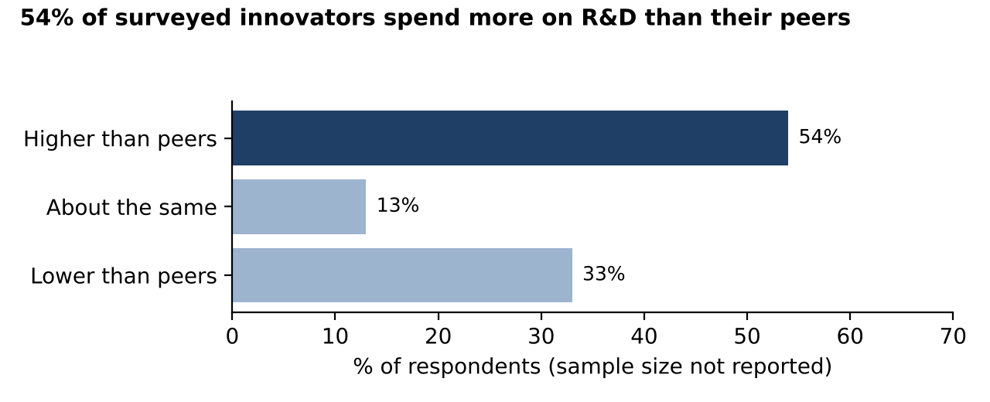
Figure 2: R&D spending compared with peers. Source: created by the author using data from Bain & Company (2025, p. 5).

2.3 AI Use by Innovation Stage (page 9)
Page 9 uses 12 small donut charts to show AI use in six innovation stages: the top group shows "today" and the bottom group shows "in 5 years" (Bain & Company, 2025, p. 9). The stage names and numbers are clear, but readers have to look up and down to see the changes, which is exactly what course literature advises against (Barrios Becerra et al., 2021). A bigger problem is that "today" is the situation reported by respondents, while "in 5 years" is only an expectation, yet both are drawn in exactly the same style, so readers may mistake expectations for facts. Figure 1 combines the 12 donut charts into one dumbbell chart: each row is a stage, filled dots show today and hollow dots show the expectation. The grey bars show 95% confidence intervals based on about 16 responses; for example, the true value of "63%" could be anywhere between about 39% and 82%. Therefore, "100% in five years" is only the expectation of about 16 companies, not a fact that will certainly happen: even the proportion itself has a 95% confidence interval of about 81% to 100%, and the expectation may not come true. Executives should not take it as a signal that they must follow the trend and invest in AI.
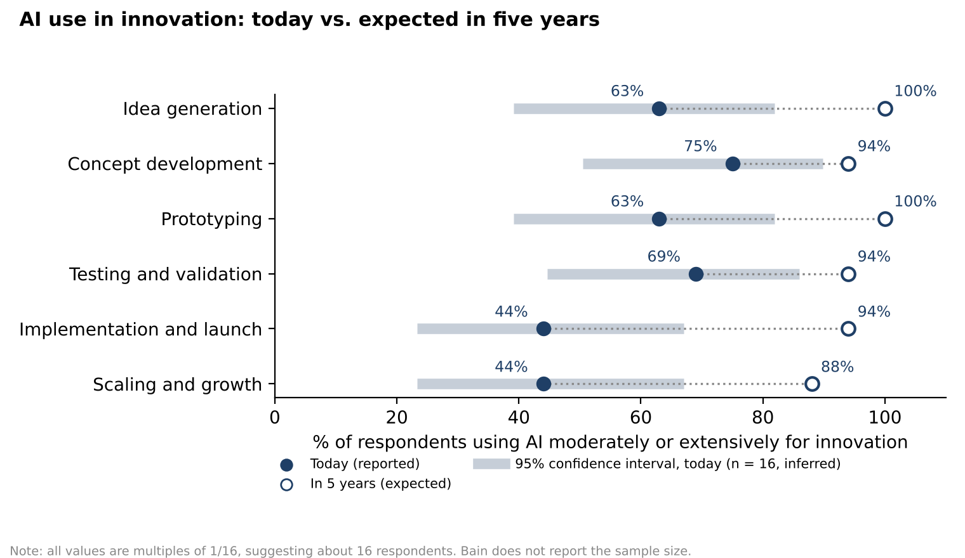
Figure 1: AI use today vs. expected in five years. Source: created by the author using data from Bain & Company (2025, p. 9).

2.4 Actual vs. Expected Results (page 10)
Page 10 places two donut charts side by side: 31% of the companies have cut their design-to-launch time by more than 20% in the past three years, and 82% expect to do so in the next five years (Bain & Company, 2025, p. 10). The two numbers look directly comparable, but one is a fact that has already happened and the other is only an expectation, and the time periods are different (three years and five years). In addition, 31% is approximately 5/16, while 82% is not a multiple of 1/16, which suggests that the two questions had different numbers of respondents, but the report does not say so. Figure 3 uses a solid bar for the actual result and a hatched bar for the expectation, and notes the different time periods.
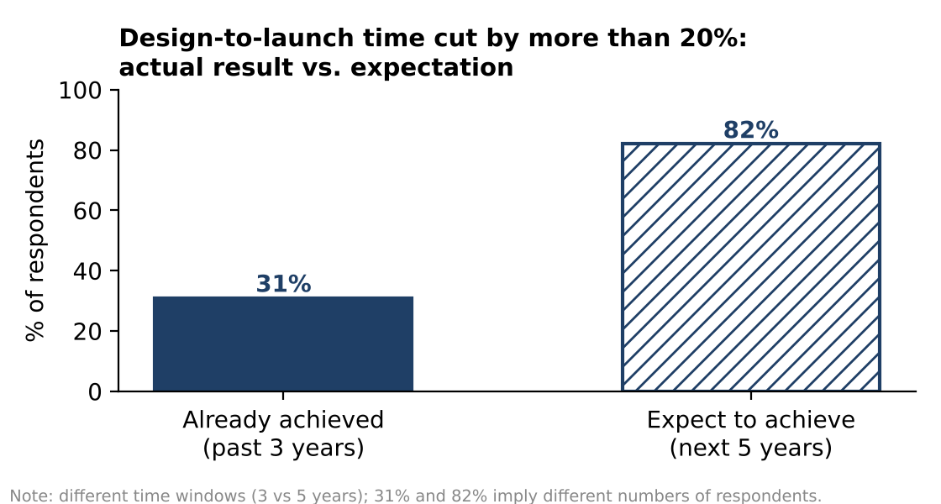
Figure 3: Actual vs. expected reduction in design-to-launch time. Source: created by the author using data from Bain & Company (2025, p. 10).

2.5 Other Charts (pages 6 and 11)
Page 6 shows the average resource allocation by type of innovation (39%, 37% and 24%), while the text claims that "the vast majority" of leading innovators devote more than 60% of their R&D to transformative or disruptive innovation (Bain & Company, 2025, p. 6). An average does not show the situation of each company, so it cannot support the claim about "the vast majority"; a dot plot showing each company's share would be more convincing. On page 11, a large number states that 88% "of leading innovators say AI has improved their innovation success rate" (Bain & Company, 2025, p. 11), but this is self-reported, and "success rate" is not defined (see Section 4). Of these five charts, the one on page 9 is the most likely to mislead executives: it suggests that following the trend and investing in AI is the right choice and will bring growth, but it only shows how many companies use AI, not whether AI has brought growth.

3. Analytical Tools
Bain's report does not say which tools were used to create the charts. However, the file properties of the PDF show that it was produced with Adobe InDesign, a desktop publishing program, and the 12 donut charts on page 9 are embedded as a single image rather than as data-linked charts. The charts were therefore probably made in Excel or design software and placed in the layout as static images, rather than built as interactive charts in analytical tools such as Tableau or Power BI.
This makes the report consistent in style and easy to read, which suits marketing, but it is less suitable for supporting decisions: readers cannot see the raw data, the sample size or the original question wording, cannot filter the results by industry or company size, and cannot verify the issues identified in Section 2. Executives can only follow Bain's claims rather than judge them against their own industry and company size, which makes investment decisions risky.
To improve this, Bain could attach data tables and a methodology note, and provide an interactive Tableau or Power BI version that lets readers filter the results by industry and see the number of respondents to each question.

4. Data Integrity and Cognitive Bias

4.1 Data Integrity
Bain states that the report is based on a survey and interviews with 20 companies (Bain & Company, 2025, p. 4), but it does not say how many companies answered each question, what the original question wording was, or who the respondents were. Section 2 showed that only about 16 companies answered the questions on page 9. With such a small sample, the margin of error is large: when 16 companies answer, a result of about 50% has a 95% confidence interval of approximately plus or minus 22 percentage points. Seemingly precise figures such as "94%" and "88%" may therefore reflect a difference of only one or two companies.

4.2 Survivorship Bias
The companies surveyed are all successful firms. Companies that invested just as boldly in innovation and AI but failed are not in the sample, so these practices may appear to lead to success only because the failures are not seen.

4.3 Confirmation Bias and Conflict of Interest
Bain itself sells innovation consulting, and the report says that what it heard was "consistent with Bain & Company research", while promoting Bain's "Engine 2" framework (Bain & Company, 2025, p. 4). This suggests confirmation bias: highlighting only the evidence that supports one's own view (Hammond, Keeney and Raiffa, 1998). It reduces the credibility of the whole report and may make readers question whether its main purpose is to sell.

4.4 Self-Reporting and Correlation
The claim that 88% "of leading innovators say AI has improved their innovation success rate" (Bain & Company, 2025, p. 11) is self-reported, with no definition of "success rate" and no control group. Similarly, eight of the ten public companies on the list had higher three-year total shareholder returns than their sectors (Bain & Company, 2025, p. 4), but ten companies can only show a correlation: firms that were already profitable may simply have been able to afford bold innovation. If executives mistake correlation for causation, they may assume that investing more in innovation will raise shareholder returns, and make unrealistic investment decisions.

5. Recommendations
For executives considering investing more in innovation and AI, this report makes three recommendations. First, they should treat the conclusions of Bain's report as a starting point for discussion rather than as evidence for decisions, because the sample is small and includes only successful companies. Second, before using any figure, they should find out how many companies answered, what the original question wording was and who the respondents were. Third, they should distinguish between actual results and expectations: "100% use of AI in five years" is only the expectation of a small number of companies, not a signal that they must follow the trend. Executives should first run small pilots using their own company and industry data, and invest at scale only after the results have been proven.
For Bain, this report suggests two improvements. First, it should publish a methodology note, including the sample size, the number of respondents to each question, the original question wording and the respondents' job roles. Second, it should choose more suitable charts: replacing single-number donut charts with bar charts and dumbbell charts, separating actual data from expectations, showing confidence intervals, and providing interactive data that can be filtered by industry.
Overall, this report concludes that Bain's report is useful for starting a discussion, but should not be used directly as a basis for investment decisions.

List of References
Bain & Company (2025) Innovation Report 2025: How top companies scale bold ideas. Boston, MA: Bain & Company. Available at: https://www.bain.com/globalassets/noindex/2025/bain_report_innovation_report_2025.pdf (Accessed: 5 November 2026).
Barrios Becerra, B., Vázquez Reyes, S., García Hernández, A., Velasco Elizondo, P. and González, A.M. (2021) 'Good practice guide for data visualization in the area of descriptive statistics', 2021 Mexican International Conference on Computer Science (ENC). IEEE. doi:10.1109/ENC53357.2021.9534814.
Hammond, J.S., Keeney, R.L. and Raiffa, H. (1998) 'The hidden traps in decision making', Harvard Business Review, 76(5), pp. 47–58.

Declaration of AI Use
Please append this page to the end of your assignment when you have used AI during the process of undertaking the assignment to acknowledge the ways in which you have used it.
I have used AI while undertaking my assignment in the following ways:
• To develop research questions on the topic – NO
• To create an outline of the topic – YES
• To explain concepts – YES
• To support my use of language – YES
• To summarise the following articles/resources: – YES
1. Bain & Company (2025), Innovation Report 2025
2. Barrios Becerra et al. (2021), Good practice guide for data visualization in the area of descriptive statistics
• In other ways, as described below:
– AI was used to help draft model paragraphs in Chinese for each section, based on the course materials and my own points and judgements. I revised these ideas and translated them into English myself.
– AI was used to create Figures 1–3 from the data in Bain's report, following my choice of charts; I reviewed and approved each figure.
– AI was used to check my English grammar and wording, and to check quotations, page numbers and calculations (sample sizes and confidence intervals).
– The final text and references were reviewed by me before submission.

