Preamble
A need has arisen in a Discord server I’m in to make a bot which can replace user messages with a garbled variant.
First steps, we should be familiar at a base level with what Node.js is. This is the language I’ll be writing the application with, and it’s heavily based on ECMAScript (Javascript). We should also be familiar with Discord and API usage in general. This writeup assumes basic knowledge of these things, but further reading for each of these can be found here:
- Node.js: https://nodejs.org/docs/latest/api/
- Discord: https://discord.com/developers/docs/reference
Goals
For the application, we should define the goals it should accomplish.
- It should be able to view the following information
- Server
- Channel ID
- Message ID
- Message Contents
- Sender ID
- It should be able to perform the following actions
- Delete the message if it matches our conditions
- Post an interaction message pretending to be the user, with modified text according to specific functions.
- Read and action on server slash commands for configuration (see below)

- It should be able to configure the following things on a per user basis
- Gag type
- Is the user gagged

Note that if we were designing this for a server outside of one specific channel in one server, we would want to create user configurable roles, channels and a better process for adding the application to a new server.
Phase One – Creating the Scaffolding
I generally like to get some workable skeleton on an application before diving into the actual features. For this example, I’m going to start a new project by creating a new folder and then navigating to it. Once I’m there, I’ll run npm init to create a package file with which we can build everything else off of. The defaults are fine, but if you want, you can add better information for the file.
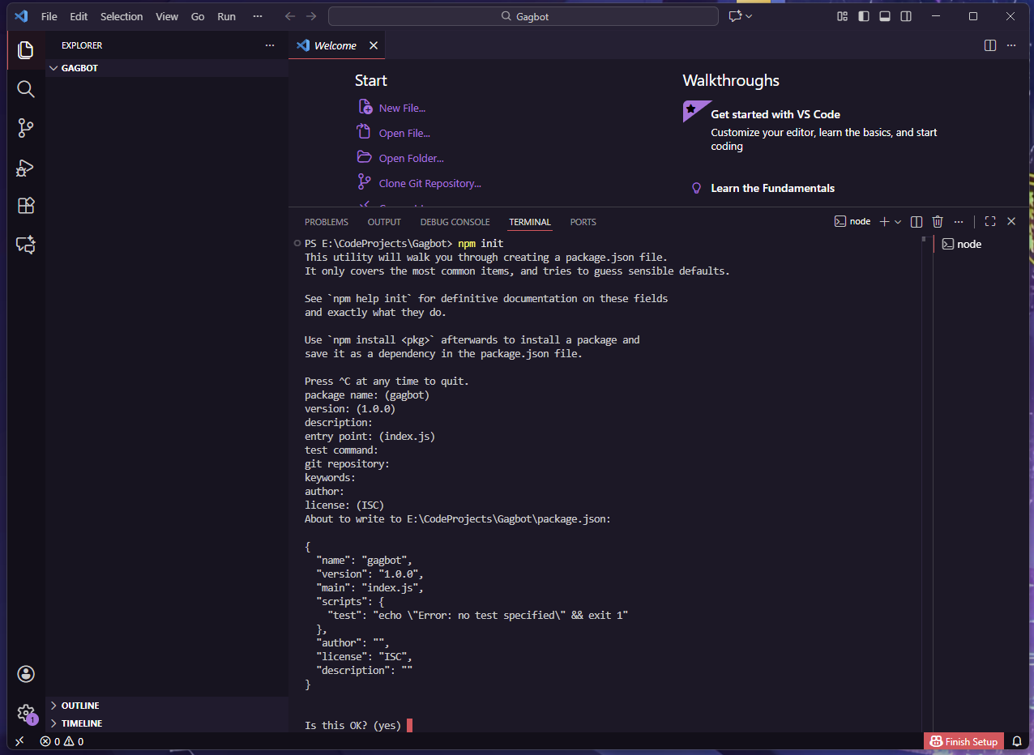
Once the project has been started, we should create a .env file. With this, I generally run it with a package called dotenv. You can install an extra package to your directory with npm install dotenv in your working directory. In this .env file, we’ll put stuff that we would not normally include in a github upload. For our purposes, this is going to be a DISCORDBOTTOKEN. We’ll get to that later.
Next, we want to create a project on Github. I’m going to use Github Desktop for this, much to the chagrin of a lot of people, but it’s fine. The process steps for this part can be done via CLI if preferred, but I’ll outline them using the GUI instead. On the window, click New Repository and then set the Local Path to the project folder. Give it a good name and description, then also checkmark Initialize this repository with a README and select Node in the Git ignore dropdown.
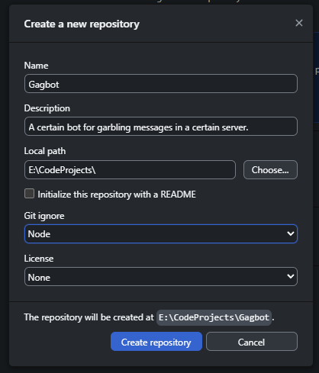
Note that you should set the local path to the parent folder and then the name to match the project folder you created, such that the repository is created at the folder you created at the beginning.
Once it’s created, you should see one changed file, which is your README.md that should have a title and description in there. This is what is displayed when viewing the code on Github and if it is something you want to show to others, you should strongly consider adding one of these just to present a tutorial if nothing else. Anyways, this starts a repository, but it won’t be published on Github until you Publish Repository using the button at the top.
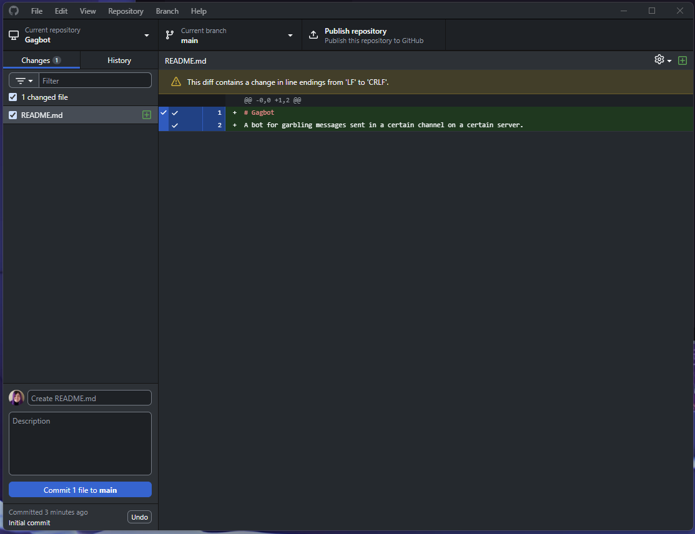
When you click to publish, you should probably keep the checkbox for Keep this code private checked, even if the project is not NSFW, until you’re ready for the internet to see it. Once you create it, you can view the repository on Github! A shortcut in the window is Control+Shift+G. Any time you implement changes, you should consider writing a description and committing the modified files and pushing them. We’ll cover the first push, but it’s a habit worth doing regularly when developing.
If you go onto Github and look at the project’s files, you should notice something strange. The node_modules folder and the .env files are missing! This is due to the .gitignore file, which specifies file strings and names which should not be published to Github. This means that while we’re developing, we can “safely” store our API keys and whatnot in the .env file and trust they won’t get leaked. We should, however, write in our documentation for others to use, exactly how to generate the .env file so that our program can properly function.
Finally for this step, we should go get a Discord API token, which allows our application to have a presence in Discord. You should go to https://discord.com/developers/applications and login there. Once you’re inside, click New Application at the top of the page and type in your app’s name. You can configure stuff here, but nothing’s really needed yet except for the Bot tab. Here, you want to scroll down until you find the Token section and then click Reset Token. Confirm and it’ll display a token which you should copy down.
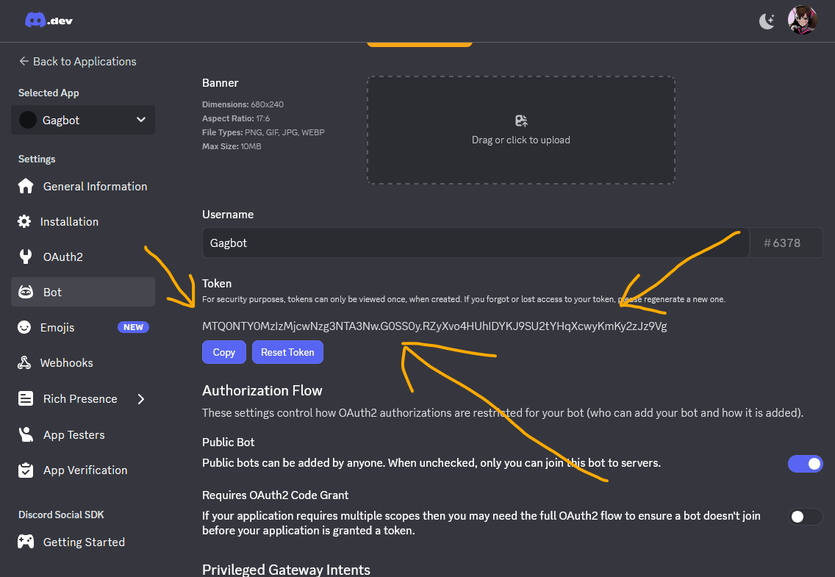
You should then go to your .env file in your project folder and add a new line starting with DISCORDBOTTOKEN= and then in parenthesis, put your token. It should look like this:
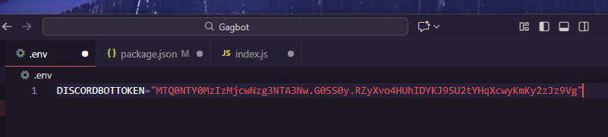
For obvious reasons, I’ve reset the token again after taking these screenshots – these should not be shared under any circumstances
Before leaving, make sure you check out the Privileged Gateway Intents and check off Server Members Intent and Message Content intent. They’ll both be important for this particular application. Save changes at the bottom once you’re finished.
Phase Two – Building the supports
Now that the project has been initialized, we can finally start doing the actual writing code stuff!
First up, this project is going to primarily use the Discord.js library. While we could make our own by sending REST api calls and whatnot, using this library makes things significantly easier. Download it with npm install discord.js.
Once it’s installed, create an index.js file, which is where the package.json file expects our entry point to be, unless you changed it. In that index.js file, we want to add a few things. First, we need to import a few libraries we’re going to be using. We can import them by declaring a variable and then assigning them to a required library.
To bring our dotenv and discord.js into scope:
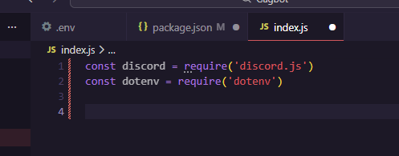
Once they’re in scope, we can call on functions within those libraries by calling their namespace. We will likely be using the Client namespace of the Discord library, so create a const Client as well. Given the modern library usage, you will also need to specify GatewayIntentBits under the intents as an array. For this application, you want Guilds, GuildMessages, MessageContent and GuildMembers. Explaining them in depth is a bit beyond the scope of this writeup. We should also run the config() function of the dotenv library, which will put it’s contents as properties of the window and become accessible under process.env.
Next, just to get something working, you want to put this line always at the bottom of your code, with DISCORDBOTTOKEN being whatever variable you choose in your .env file. Your code should look something like this:
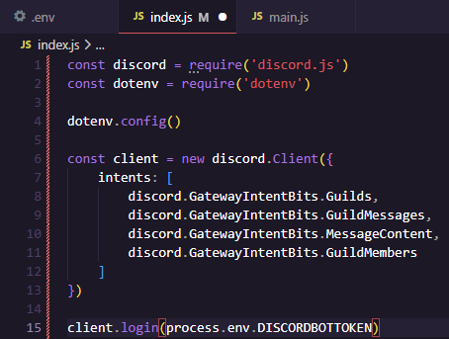
Next, you probably want to create some kind of status or message for when the bot has successfully logged in. This is useful if you want to delay a function until resources are available. The Discord client object uses events as callbacks, whereby certain things will “emit” a callback which we can register to. This is done by using the .on function, which takes a string name for the event and a callback function. We can write one for the “clientReady” function which is called once successfully logged in.
client.on(“clientReady”, async () => {
// This is run once we’re logged in!
console.log(`Logged in as ${client.user.tag}!`)
})
You’ll notice that we put “async” in there. This tells the application not to block other calls and to process this concurrently with other things in the application. This is generally preferred design in javascript, where it’s most common to see used in a browser. Synchronous calls freeze up everything else including a User Interface while it’s “thinking” and leads to a poor experience. This leads to await and promises, but that’s further down in this writeup. Stick it between the const client and the client.login lines.
Finally, test it out! Run your application by typing node index.
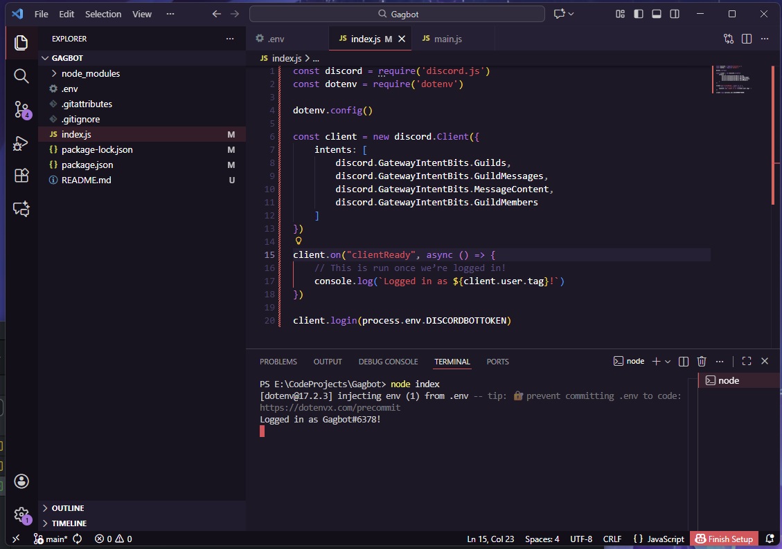
Step 3 – It’s Alive! Now save it and build some more!
Obviously, it doesn’t do much yet, but it is technically alive and you could add it to your server at this point! You can do so on the Installation tab on the Discord Developer portal. On this page, uncheck User install under Installation Contexts, and then scroll to the bottom and add “bot” to the scopes. You should also give it the Manage Messages permission. Copy the Install link and then open it up.
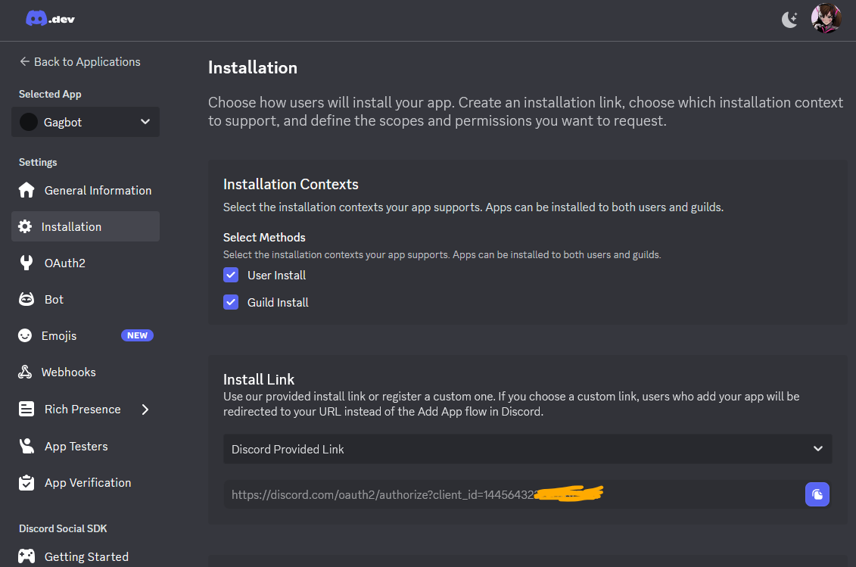
Once you add it to your test server, you should see it join the server, as if it were a user, because for all intents and purposes, it *is* a user and you need to give it Discord role permissions as you’d expect. The automatic role Discord gives the bot should already have global Manage Messages on it.
Now you’ve done a reasonable amount of coding, you should commit all of the changed files in Github along with a comment. The Summary is a “title” of sorts, while a more verbose description is offered if someone were to click into a particular commit you do. Once you’re satisfied with what to write there, click Commit to main. And then Push origin at the top afterwards.
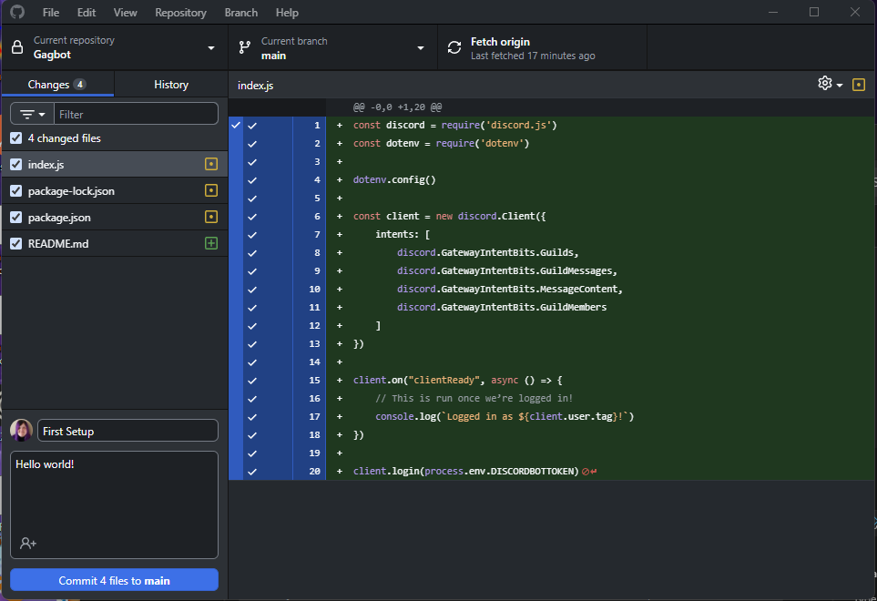
If you then look on github, you’ll see your newly created files and the current version of whatever other files you’ve modified. Once again, this should be regularly done when developing a project.
Next up, we want to start looking at reading some messages that are sent in our test server so we can understand what to do with them. Create a new channel that your bot can see in the server and copy it’s ID. In my case, my channel’s ID is 1445653355476291646, but yours will be different. Add it to your .env file, using quotes, even though it is a number.
In the code after the clientReady event, add another one for the messageCreate function. This event is given an object which we should call msg like below:
client.on(“messageCreate”, async (msg) => {
// This is called when a message is received.
})
You may be thinking, “but this will happen with every message!” and that’s entirely correct. Any message the bot sees will trigger this event. So we should carefully filter down what we even care about to begin with. Discord message objects have many properties, but the one we currently care about is the channel property, which is itself a reference to an object that has an ID. We can then check every single message and see if it’s channel id matches our id. If it does, console log it. If not, discard.
client.on(“messageCreate”, async (msg) => {
// This is called when a message is received.
if (msg.channel.id != process.env.CHANNELID) { return }
console.log(msg)
})
The return statement will immediately escape out of a function, so it does not get to the console log bit which is what we want. Save and run your code again to get something like below:
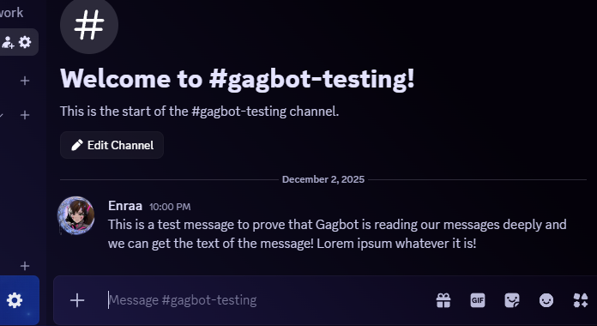
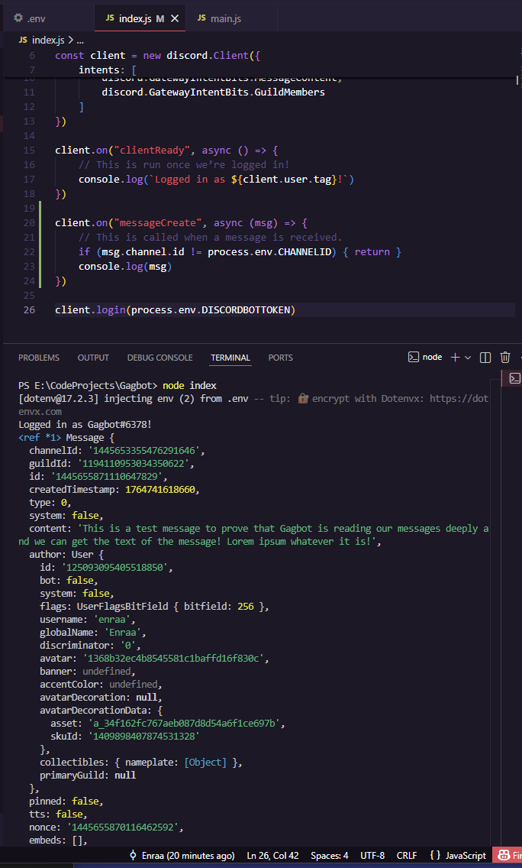
We could then access the message contents by checking the msg.content property. Lets work on having our bot reply with the same message contents whenever we see something. To do this, we’ll use webhooks, which have to be created in a server under the Integrations tab. Click on the button to create a webhook and then give it a name and point it to your channel.
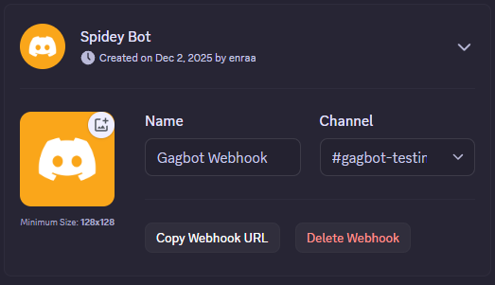
Because we’re using webhooks, you should also add a condition which checks if the message is a webhook, so we don’t action on ourselves. You can do this by checking if msg.webhookId is not undefined. Change your messageCreate code to below:
client.on(“messageCreate”, async (msg) => {
// This is called when a message is received.
if ((msg.channel.id != process.env.CHANNELID) || (msg.webhook)) { return }
console.log(msg)
})
This will check if the channel id is NOT your channel id, or if msg.webhook exists at all. By default, every property is undefined until it’s assigned a value, and when it is undefined or null, it will return false in a conditional. Likewise, if you check a value and it returns anything at all, it will return as true, except in certain edgecases which javascript is notorious for.
On your webhook, say the Webhook URL is like below.
https://discord.com/api/webhooks/1445681922285240400/zbv-wpYGWHJ19w6Wj-U-UykmIfc2I2de1eqpwvCAeryzuCd1xt19hl1tZOos8W846stQ
On this url, the 1445681922285240400 part is the id, while the zbv-wpYGWHJ19w6Wj-U-UykmIfc2I2de1eqpwvCAeryzuCd1xt19hl1tZOos8W846stQ is the token. You should add these as part of your .env file to access later. Don’t forget the quotes!
As a side note, it IS possible to generate these webhooks via the API and would be preferred in a client that we’re allowing better customization for. This setup is sufficient for a singular server. Read more on this particular process at https://discordjs.guide/legacy/popular-topics/webhooks
Next, let’s create a new folder in the project directory called functions. This allows us to segment our code so that we can do our changes in bite size files rather than massive ones. Both ways technically work. In the functions folder, add a new file called messagefunctions.js and access it. In there, we want to create exports which we will eventually bring into our main function. Start by creating a messageSend function like below.
const messageSend = async (str, avatarURL, username) => {
// When called, we want to do something with str and then return it.
}
This function takes in an avatarURL and username, which we’ll pass to this function, so that we can send to the webhook as if we’re the user. For this, we need to generate a new webhook client. Our messagefunctions.js can import parts of the Discord library directly, instead of assigning it to it’s own namespace, by declaring an object with the exports we wish to import. For this, lets import WebhookClient from discord.js. The process will already have the env variables set at this point so we do not need to import those again.
Next, we can declare a variable called webhook and assign it to a new instance inside our messageSend function of the WebhookClient with the id and token properties matching up to our process env variables. Next, we can evoke the .send function with a content, username and avatarURL.
Finally, we need to assign the messageSend property with our function. The final code should look something like this:
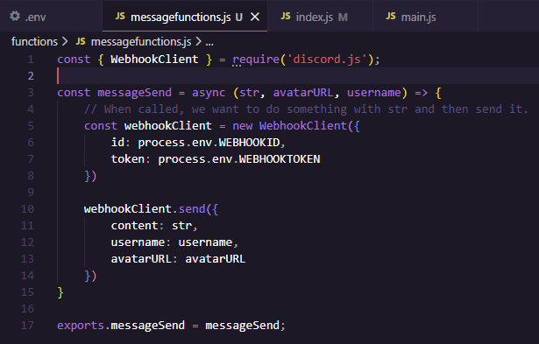
Now to bring it into our main function’s scope! Import your function by pointing to it in the local path. Keep in mind when an application runs, it’s working directory is going to be wherever index.js is by default. Therefore, your new function’s relative path should be `./functions/messagefunctions.js`. You can import this in a similar fashion as you did within the module at the top of your index.js file.
const { messageSend } = require(`./functions/messagefunctions.js`)
Now, you need to find the avatar URL and the username of the person who sent a message. These can be found in the message’s member property. We can check these using a simple console log. Check for the displayAvatarURL() function and the displayName property of an incoming message by console logging each of them.
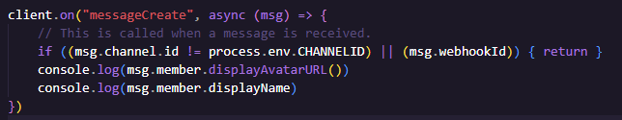
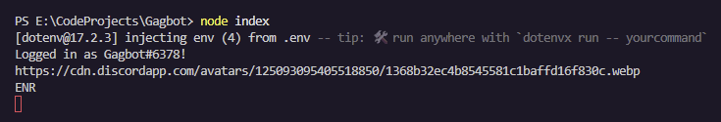
Now, we can pipe this data into our messageSend function we just created! Comment out your console log lines and add a new one for that function we made earlier.
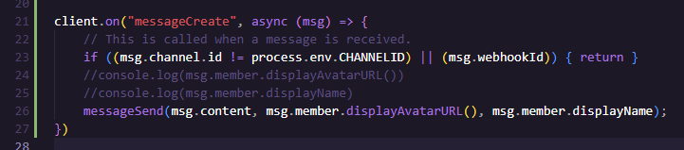
Now, when we send a message, it will immediately echo it.
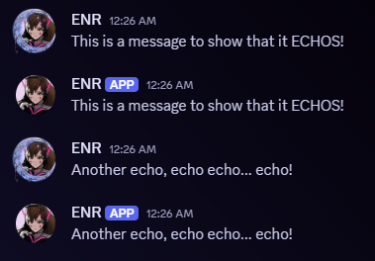
Step 4 – Configuration and Interactions
Okay, so we have something that can send messages to our channel. Now we should build out a system by which users can gag each other. We’ll do this using interactions, such that a user can type something like /gag user:Enraa and it will gag them. We also need to maintain who we’re currently gagging, so we should store this somewhere.
Create a new file in your functions folder called gagfunctions.js. In it, we want to create a couple of functions for getting and setting a gag order. We should assign them to the process variable with it’s own space, and using the property of the user’s ID since that’ll never change and for the key, it should be the user’s gag type. Something like this will do the trick:
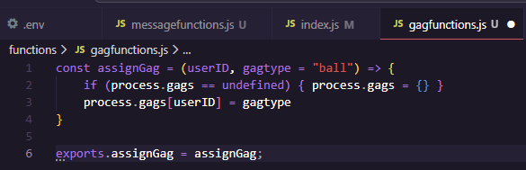
So what is this doing? In function parameters (the data we’re passing into the function), if you declare a variable and assign it to something, then that will be it’s default value unless you pass it something else. For this example, if I specify something on the second parameter, it’ll use it, else it’ll use “ball” as the gagtype. Additionally, we are safely checking if process.gags has been assigned yet, which for our first pass, it probably hasn’t. If it doesn’t exist, we’ll create it to hold our gags. Finally, by putting a variable name in brackets, we can use it as a property name.
We should make another one which retrieves a gagtype. While we CAN access this stuff directly in the other function and since it’s a oneliner, it wouldn’t be hard to do so, it’s better to use getters and setters to keep things organized. This limits the amount of places we touch our variables too, which should come out to more reliable and less erroneous code.
Make a similar one which simply returns the user’s gag type. And then make one that deletes the userID if called. The final code for this bit should look something like this.
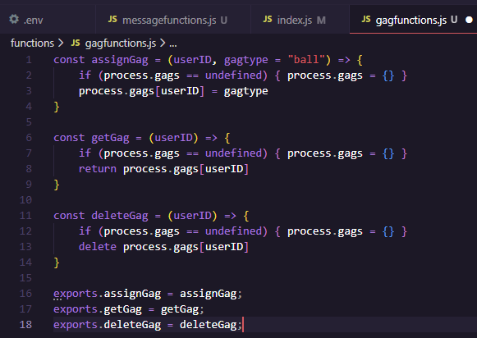
Now that we have some kind of assignment going, let’s start creating some interaction code. Create a new js file called deploy-commands.js. This file is simply going to be run whenever we need to update our commands, so it won’t always be going. In it, we need to bring in the path and fs libraries, which are native to Node, in addition to the usual Discord.js and dotenv. Your imports should be something like this:
// Import the Discord library and fs and path and dotenv.
const { REST, Routes } = require('discord.js');
const fs = require('fs');
const path = require('path');
require('dotenv').config();
After we have it, we should create a new folder called commands. These commands will be .js files which correspond to the interactions we want to allow with the bot. Next, we should make a shorthand for finding the path to all of our commands using the path library we brought in. A sample to read all of the commands, require them, and then make them available as an array can be found here:
// Grab all the command files from the commands directory
const commands = [];
const commandsPath = path.join(__dirname, 'commands');
const commandFiles = fs.readdirSync(commandsPath).filter(file => file.endsWith('.js'));

// Grab the SlashCommandBuilder#toJSON() output of each command's data for deployment
for (const file of commandFiles) {
const command = require(`./commands/${file}`);
commands.push(command.data.toJSON());
}
The idea with this is each .js file is being read, required and then we’re pushing the data export which we’ll create later. Now that we have all of the commands in memory, lets create a new handler for the interaction commands. Discord’s API functions on REST calls, so we can use REST version 10 by declaring it below:
// Construct and prepare an instance of the REST module
const rest = new REST({ version: '10' }).setToken(process.env.DISCORDTOKEN);
Then, we need to attempt to publish each command. This version of it will publish the commands globally using Routes.applicationCommands, however if you want to make it individual to a guild, use Routes.applicationGuildCommands instead. Put each command using something like below:
// Post these commands globally.
(async () => {
const data = await rest.put(
Routes.applicationCommands(process.env.CLIENTID),
{ body: commands },
);
console.log(`Successfully reloaded ${data.length} application (/) commands.`);
})();
Note, we use an async function and call it immediately so that we can await the rest.put function. This will make the code wait until it gets a response from Discord’s API before proceeding to the console.log line.
The final code for this interactions handler should look something like this:
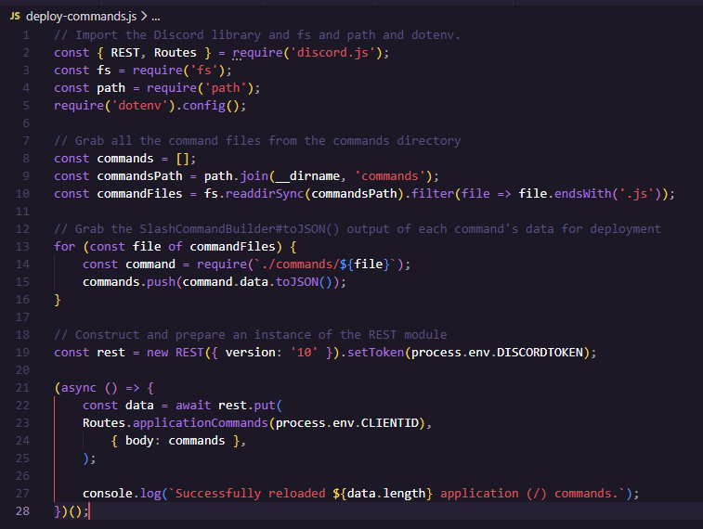
Now lets create a simple command to add someone to the list of gagged people. Create a new file in the commands folder named gag.js. In this one, we’re going to use the SlashCommandBuilder module of the Discord library.
const { SlashCommandBuilder } = require('discord.js');
Then, like with how we did functions, we’re going to export modules. This time, instead of declaring the functions and assigning them, we’re going to set the module.exports to an object with properties. The properties this time are data and execute, where data is constructed using the SlashCommandBuilder and the execute property is an asynchronous function that takes in an interaction. The data part is used during the deploy-commands.js part, while our main function will use the execute part. Review https://discordjs.guide/legacy/app-creation/creating-commands for way more detail about this part.
Our module’s data function needs to call the SlashCommandBuilder() and then setName, setDescription, addUserOption, and then addChoices. These functions can be chained on each other even across different lines, which means they’ll be called in succession, as long as you don’t put a semicolon between them. We will also be assigning those choices to the gagtypes variables, which we’ll set up in a second. This way, whenever we add a new function to our gags folder, it can automatically retrieve and add it to the function without any code editing here.
Finally, we’re going to start by console logging the interaction, but we’ll do something meaningful with it in a bit! A sample that can be used for the gag interaction function is below:
module.exports = {
data: new SlashCommandBuilder()
.setName('gag')
.setDescription('Apply a gag to the user')
.addUserOption(opt =>
opt.setName('user')
.setDescription('The user to gag')
.setRequired(true)
)
.addStringOption(opt =>
opt.setName('gag')
.setDescription('Type of gag to use')
.addChoices(...gagtypes)
),
async execute(interaction) {
console.log(interaction)
console.log(interaction.options)
}
}
Now, it’s pretty important that we set up the gag folder and add something in there. Create another folder named gags and then create a file in it called ball.js for now. For testing, we’ll do a simple replacement for all ‘th’ to ‘f’ on the return string. Declare this as the function named garbleText and then assign it to the exports similar to how we did with gagfunctions.js. We should also export a property named choicename. A sample is below:
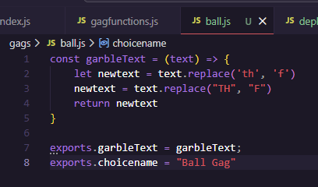
Back to our slash gag function, we should require the fs and path modules and find every file in the gags folder similar to how we found them for the deploy-commands.js file. A notable difference however, we need to construct the array we build with objects based on the export’s choicename. Value can simply be the file name. When we put … before an array, js will spread these as additional arguments, which is precisely what addChoices is expecting. A sample of my gag.js interaction command below:
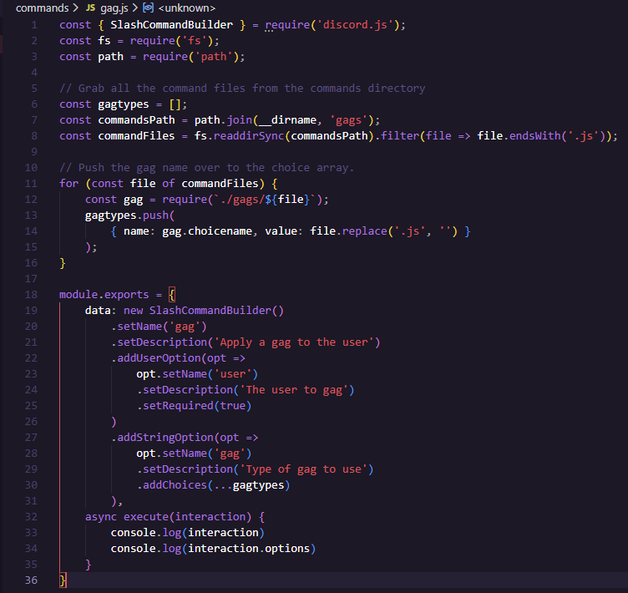
Now let’s run deploy-commands.js and test it!
You’ll notice while we were copy-pasting that though the right concept seems to be there, it crashed. Why? Drilling down into it, we should look at the gag.js command. It’s __dirname path starts in /commands, so we should add a ‘..’ before gags in the commandsPath.
const commandsPath = path.join(__dirname, '..', 'gags');
We should also take a look at the require bit and change it to ./../ instead.
const gag = require(`./../gags/${file}`);
We still get an error. This is due to not having our client ID in the Routes. We should go copy that from the Developer portal and put it in the .env file under CLIENTID. Once you do, it should all work as expected:
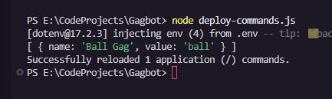
Wait a few minutes and it’ll show up when typing / on your test channel.

Part 5 – The gags keep on coming!
Now we just gotta tell the user how to work with interactions, create a list, and actually implement the gag function in /gags, and then we’re done!

