DSA 4060: Recommender Systems
Semester Project Proposal
TasteMatch: A Restaurant Recommender System Using Cuisine Preferences, Ratings, and Budget
Assignment 1: Semester Project Selection and Proposal
Student:
Claire Mwarari - 669470
GitHub Repository:
Repository Link
Date:
18/09/2026

A. Project Title and Problem Statement
Title: TasteMatch: a restaurant recommender that helps users discover restaurants matching their cuisine preferences, budget, and rating history, while introducing relevant restaurants they have not yet rated.
Choosing where to eat is harder than it looks. A city has thousands of restaurants with different cuisines, prices, and ratings, while search and delivery apps rank results mainly by popularity, advertising, or distance instead of personal taste. Because of this, people go back to the same familiar restaurants and good but less visible ones stay hidden. This affects everyday diners, students, and travellers who want suggestions matched to their taste but cannot express that taste as a search query. My system will learn from a user's past ratings and the features of restaurants they liked, then rank unrated restaurants by predicted relevance. This saves decision time, matches results to cuisine and budget, and brings up restaurants the user would not have found in a popularity-ranked list.

B. Intended Users and Recommendation Task
Aspect | Description
Users | Diners seeking personalised restaurant suggestions: students, residents, and visitors in the city covered by the dataset.
Items | Restaurants (7,076 businesses after filtering the Yelp Open Dataset to the Restaurants category in Philadelphia).
Inputs | User-restaurant star-rating history, plus optional explicit inputs such as preferred cuisines, price range, and city; item attributes (cuisine categories, price level, ambience, location).
Output | A ranked top-10 list of restaurants, each with predicted rating, cuisine tags, price level, and a short explanation (e.g., "because you rated Italian restaurants highly").
Recommendation moment | When a user requests suggestions, and again after they rate new restaurants as their profile grows.
Constraints | Recommended restaurants must be open (is_open = 1), located in the chosen city, and within the selected price range if specified.

User Scenario
A student who has previously rated several affordable Mexican and Thai restaurants opens the system, selects Philadelphia, sets a maximum price level of 2, and requests recommendations. The system returns ten restaurants ranked by predicted rating, mostly unrated Mexican and Thai spots plus a few similar Vietnamese restaurants, each with cuisine, price level, average rating, and a one-line explanation.

C. Dataset Selection and Feasibility
Primary dataset: Yelp Open Dataset (Yelp Inc.), https://business.yelp.com/data/resources/open-dataset/. Full scale: 6.99 million reviews, 150,346 businesses, roughly 2 million users, and 908,915 tips across 11 metropolitan areas. Filtering to the Restaurants/Food category retains 64,616 restaurants; focusing on Philadelphia (the largest restaurant city in the dataset) gives a dense, Colab-manageable subset of 7,076 restaurants and 738,688 reviews. After keeping restaurants with 20+ reviews and users with 5+ ratings, the working dataset contains 27,771 users, 4,495 restaurants, and 436,931 ratings (matrix density 0.35%). See Figures 1-4 for the dataset inspection output.

Important Columns
File | Key columns | What they represent
business.json | business_id, name, city, state, latitude, longitude, stars, review_count, is_open, attributes, categories, hours | Item metadata: identity, location, aggregate rating, cuisine categories, and an attributes object (price range, parking, ambience, WiFi) expanding into 30+ columns.
review.json | review_id, user_id, business_id, stars, date, useful, funny, cool | User-item interactions: the 1-5 star rating is the core signal for collaborative filtering and rating prediction; date enables time-based splits.
user.json | user_id, review_count, average_stars, yelping_since, fans | User metadata: activity level and rating behaviour.
tip.json / checkin.json | user_id, business_id, text, date | Supplementary implicit interaction signals.

Interactions and Item Attributes
The dataset gives me explicit user-item interactions at scale: each review links a user_id and business_id with a 1-5 star rating and a timestamp, which supports user/item-based collaborative filtering, matrix factorization, and RMSE/MAE evaluation. For content-based filtering and hybrid designs, each restaurant has cuisine categories, an attributes object with 30+ fields (price range, ambience, parking, dietary options), coordinates, and an aggregate rating.

Known Limitations and Access Conditions
- Sparsity: most users rate few restaurants; I reduce this by keeping active users/restaurants and one dense city (density 0.35%).
- Popularity bias: a few restaurants receive most reviews; I will measure it with coverage and diversity metrics.
- Geographic skew and missing attributes: data covers 11 metropolitan areas; some business attributes are absent for some restaurants.
- License: free for educational use under the Yelp Dataset License; redistribution is prohibited, so my repository will contain download instructions and preprocessing scripts, not raw data.

D. Proposed Recommendation Approaches
Baseline (popularity-based): recommend the highest-rated, most-reviewed restaurants in the chosen city (a weighted rating combining stars and review_count). It needs only business.json and gives my later models a benchmark to beat.
- Content-based filtering: suits the problem because restaurants have rich structured features (cuisines, price range, ambience). Uses business.json categories/attributes plus the user's rating history to build a preference profile; recommends by cosine similarity and produces natural explanations. Limitation: recommends "more of the same", with limited novelty, and ignores taste patterns shared across users.
- Collaborative filtering (user-based and item-based kNN): suits the problem because 436,931 real ratings let taste be learned from interaction patterns without item metadata. Uses the user-restaurant rating matrix; item-based kNN is typically more stable since restaurant similarity is less volatile than user similarity. Limitation: suffers from sparsity and cold start for new users/restaurants.
- Matrix factorization and hybrid (Weeks 8-10): SVD-style factorization learns latent taste factors, handles sparsity better than neighbourhood methods, and usually achieves the best RMSE; a justified hybrid combines factorization with content-based scores so cold-start restaurants remain recommendable. Limitation: less interpretable; the hybrid adds tuning complexity.

E. Evaluation Plan
- RMSE and MAE: held-out (user, restaurant, stars) triples from review.json measure how accurately each approach predicts known ratings.
- Precision@K and Recall@K: treating restaurants a user rated 4+ as relevant, these measure how many top-K recommendations are relevant; the rating history provides the ground truth.
- NDCG@K: because Yelp ratings are graded (1-5 stars), NDCG assesses whether the best restaurants appear at the top of the list, not merely somewhere in it.
- Supporting metrics: catalogue coverage and intra-list cuisine diversity, used to detect popularity bias and repetitive recommendations.
Data separation: I will use a time-based split per user (earlier ratings for training, the most recent for testing), which mirrors real usage. I will tune models on a validation slice and report results once on the test set. I will compare every approach against the popularity baseline on identical splits and adopt an approach only if it beats the baseline.

F. Challenges and Responsible Design
Challenge | Initial response
New users with no history | I ask the user for 2-3 quick inputs (cuisines, city, budget) and fall back to content-based and popularity recommendations until ratings build up.
New restaurants with few ratings | The content-based component can recommend them from attributes immediately; the hybrid design prevents invisibility.
Sparse interactions | I filter to active users/restaurants, focus on one dense city, and use matrix factorization, which handles sparse data well.
Popularity bias | I report coverage and diversity alongside accuracy, and re-rank top-N lists to include less-known restaurants where relevance is similar.
Privacy and appropriate data use | Yelp data is anonymised; I will not attempt re-identification, I will respect the license, and I will not redistribute raw data.
User understanding and control: every recommendation carries a short explanation (e.g., "Recommended because you rated three Thai restaurants 4+ stars"), and users can adjust cuisine and price constraints and re-request recommendations, giving them direct influence over the output.

G. Implementation Plan
I will work in Python with Pandas/NumPy, Scikit-learn, and Surprise, using Google Colab for compute, Streamlit for the final interface, and GitHub for version control. This is an individual project; the plan below shows my main tasks and expected outputs per milestone period.
Weeks | Main tasks | Expected outputs
1-2 | Problem selection, dataset inspection, proposal, GitHub setup | Proposal, repository with README
3-4 | Data cleaning, restaurant/city subset, baseline model, content-based prototype | Clean dataset, baseline + content-based notebook
5-6 | Collaborative filtering (user/item kNN), preliminary evaluation | kNN models, evaluation tables
7 | Mid-semester examination | -
8-10 | Matrix factorization, hybrid design, hyperparameter tuning | SVD + hybrid models, improved metrics
11-13 | Interface, evaluation, documentation, presentation | App, report, demo

Appendix: Dataset Sample (Section C Evidence)
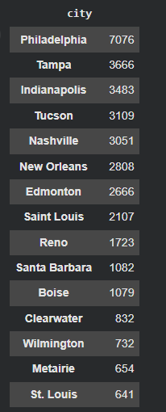
Figure 1. Restaurant counts by city (top 15); Philadelphia leads with 7,076.
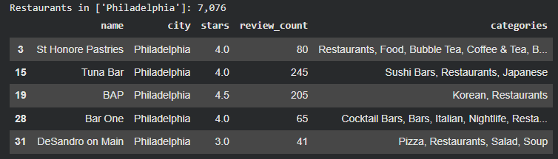
Figure 2. Sample of filtered Philadelphia restaurants (business.json).
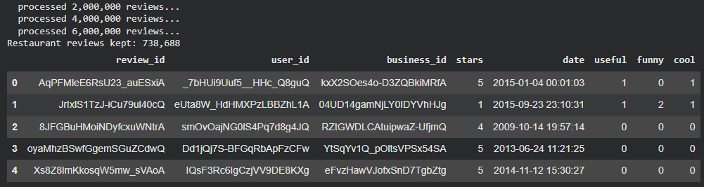
Figure 3. Restaurant review records: 738,688 kept (review.json).
Figure 4. Working dataset after activity filtering: 27,771 users, 4,495 restaurants, 436,931 ratings.
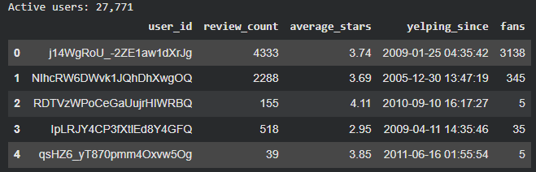
Figure 5. Active user metadata sample (user.json).

Sample Business Records (business.json)
name | city | state | stars | review_count | categories (truncated)
St Honore Pastries | Philadelphia | PA | 4.0 | 80 | Restaurants, Food, Bubble Tea, Coffee & Tea, B…
Perkiomen Valley Brewery | Green Lane | PA | 4.5 | 13 | Brewpubs, Breweries, Food
Sonic Drive-In | Ashland City | TN | 2.0 | 6 | Burgers, Fast Food, Sandwiches, Food, Ice Crea…
Tsevi's Pub And Grill | Affton | MO | 3.0 | 19 | Pubs, Restaurants, Italian, Bars, American (Tr…
Sonic Drive-In | Nashville | TN | 1.5 | 10 | Ice Cream & Frozen Yogurt, Fast Food, Burgers,…

References
- Yelp Inc. Yelp Open Dataset. https://business.yelp.com/data/resources/open-dataset/
- Ricci, F., Rokach, L., & Shapira, B. Recommender Systems Handbook (2nd ed.). Springer.

