**[Kick-Start: Bower – A Simple Tutorial of Setting-Up and Using Bower.JS](https://bardevblog.wordpress.com/2013/10/26/a-simple-tutorial-of-setting-up-and-using-bower-on-windows/)**

The goal of this post is to provide a simple description of how to install Bower JS and how to use Bower JS to manage client side dependencies. Assumptions:

1. Download and install Node.js

To run Bower you will need to download and install Node.js. Go to <http://nodejs.org/> website and select the “install” button (see image below). This should download the version of Node.js you need Once Node.js is download, execute the file.

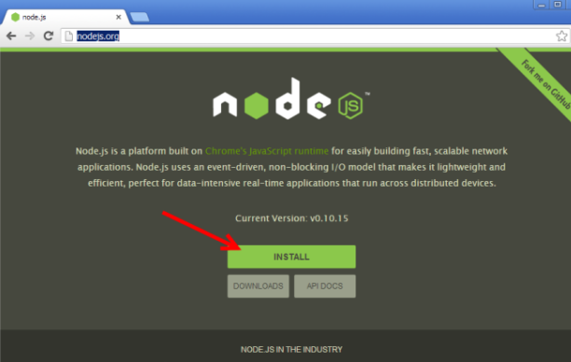

Use all default options while installing and click next.

2. Confirm Node.js is installed

When Node.js installation has completed we need to confirm it was installed successfully. Open a Windows Command Prompt and type “Node” and [enter]. You should get prompted with a “>”.

(If you previously had Windows Command Prompt open, you will need to close it and reopen it. The reason is that Node will be added to Environment Variable Path. If the Command Prompt is open when you install Node, it will not have the new Node Path.)

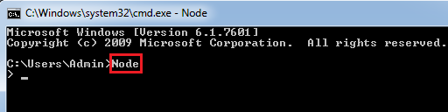

Now at the prompt type something like “2 + 2″ and [enter]. You should get a result. I got back 4. Now we have confirmed that Node.js is installed correctly. You can quit Node.js by using the keyboard and typing [ctrl]+C twice.

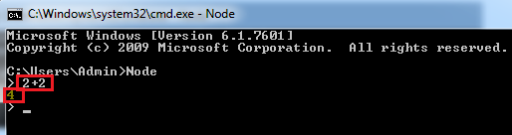

Install GIT

You can download GIT from http://git-scm.com/

From GIT’s ([git-scm.com](http://git-scm.com/)) download GIT

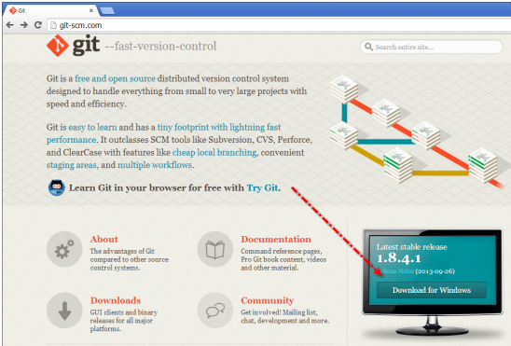

Use all the defaults (keep default path). But a key option that needs to be select is to “Run Git from the Windows Command Prompt”. This will add the PATH variable for Git. Click Next and Install.

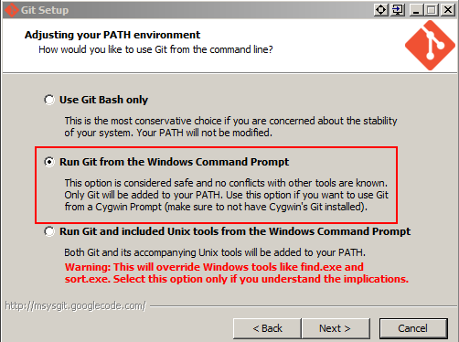

3. Create Folder Structure

Create the following folder structure. Install bower in your application.(For example, D:\Projects\WebApplication1\WebApplication1)

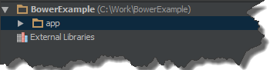

(In the image above, ignore “External Libraries”. This is part of the WebStorm IDE)

4. Install Bower

The primary reason to use Bower is so that you do not have to manage client side dependencies (css, JavaScript, and etc). Here we will install Bower so that we can use it latter to manage dependencies.

Use Node Package Manger (npm) to install Bower. Since we are using the “-g” (global) switch we can install Bower from any directory.

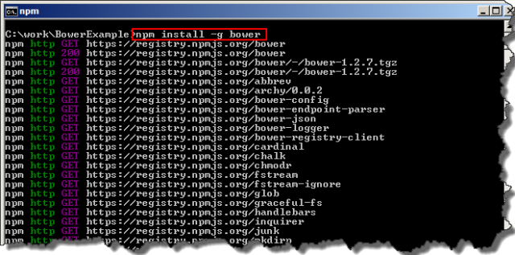

(The npm statement is case sensitive.)

5. Test Bower is Installed

Since we will want to install the dependencies in the “app” direction, go ahead and navigate to the “app” directory”

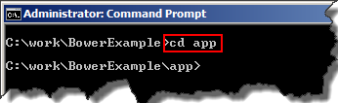

Lets do a Bower search for jQuery. Remember, it is case sensitive

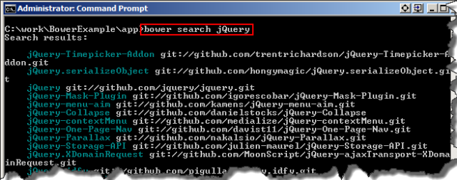

There is a ton of jQuery libraries. But that’s okay.

6. Install Dependencies (jQuery & Underscore)

In the command window enter “bower install jQuery” and press [Enter]. Again remember case sentitivity.

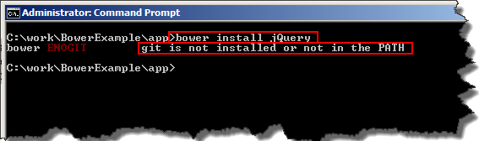

You may receive an error if you do not have GIT installed.

8.Install Dependencies (jQuery & Underscore) – Again

Important – Close the current Command Prompt. If you attempt to install jQUery again with the current command prompt you will get the same error.

Open a new Command Prompt and navigate to the “app” directory that we created previously.

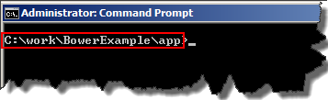

Install jQuery using Bower. Remember, it’s case sensitive.

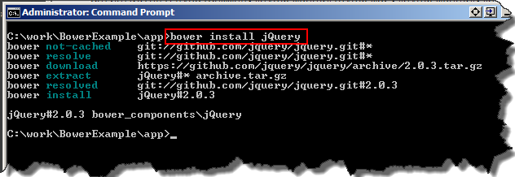

Now install Underscore

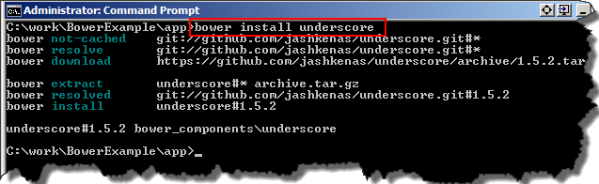

9. Confirm Dependencies

There should be a new directory create by Bower call “bower_components” this is where jQuery and Underscore should have been installed at.

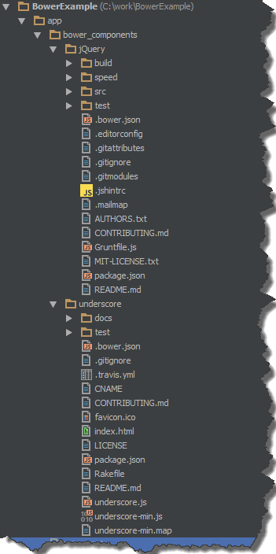

10. Finished

No you can go out and create your application without having to worry maintaining client side dependencies.