**Set Up a Project on GitHub**

## Getting Started

1. Goto<https://github.com/>
2. Sign in with you username and password.
3. If you don’t have an account on GitHub, create one and then sign in.

## Create A Repo

1. To put your project up on GitHub, you'll need a repository for it to live in.
2. On GitHub, you can store all kinds of projects in [*repositories*](https://help.github.com/articles/github-glossary#repository). Personal repositories belong to user accounts, so after you've [signed up for GitHub](https://help.github.com/articles/signing-up-for-a-new-github-account), you can create your first repository!

## Create a new repository on GitHub

In the upper-right corner of any page, click + , and then click **New repository**.

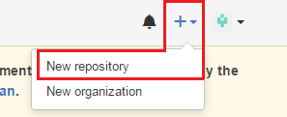

1. Create a short, memorable name for your repository.
2. Optionally, add a description of your repository. For example, "My first repository on GitHub."
3. Choose between creating a *public* or *private* repository.

* **Public** repositories are a great choice for getting started! They're visible to any user on GitHub, so you can benefit from a collaborative community.

1. **Private** repositories require a little more setup. They're only available to you, the repository owner, as well as any collaborators you choose to share with. Private repositories are only available for paid accounts.
2. Select **initialize this repository with a README**.
3. Click **Create repository**.

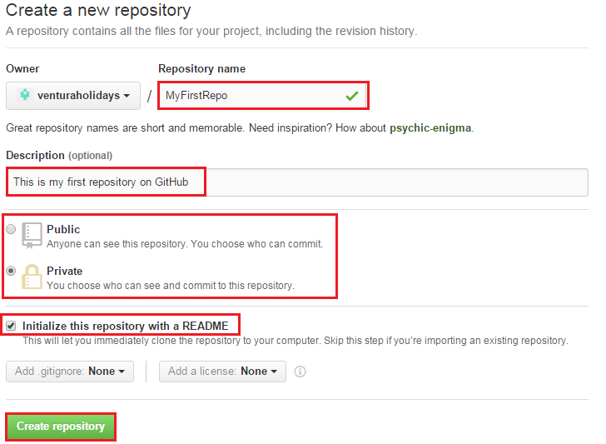

## Cloning a repository

## You can clone a repository either through GitHub Desktop or through command line

## Cloning a repository to GitHub Desktop

* When [GitHub Desktop is installed](https://help.github.com/desktop/guides/getting-started/installing-github-desktop), you can clone any repository, or fork of a repository, from GitHub.

1. On GitHub, navigate to the main page of the repository.



1. Under your repository name, click  to copy the clone URL for the repository.

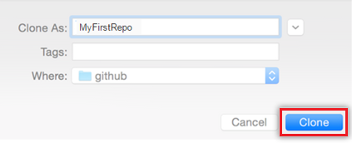

1. In GitHub Desktop, after verifying the name and location on your hard drive where you'd like to clone the repository, click **Clone**.

## Cloning a repository through cmd

## To execute Git commands on cmd, you need to installgit-scm.

## You can download it from <http://git-scm.com/download>. Select your OS and download will start automatically.

## While installing Git keep all the default values except one, select “Use Git from the Windows command prompt”

## 

1. On GitHub, navigate to the main page of the repository.



1. Under your repository name, click  to copy the clone URL for the repository.
2. Open Terminal (for Mac and Linux users) or the command prompt (for Windows users).
3. Change the current working directory to the location where you want the cloned directory to be made.
4. For example, Here the working directory is D:\Dolly\Projects\TestGitProject

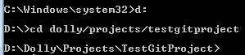

1. Type git clone, and then paste the URL you copied in Step 2.



For example,



1. Press Enter. Your local clone will be created.

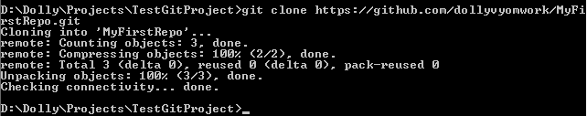

## Adding a file to a repository from the command line

1. On your computer, move the file you'd like to upload to GitHub into the local directory that was created when you cloned the repository.
2. Open Terminal (for Mac and Linux users) or the command prompt (for Windows users).
3. Change the current working directory to your local repository.



1. Stage the file for the first commit to your repository.

## 



1. Commit the files that you've staged in your local repository.

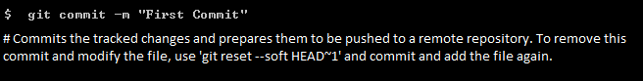



1. [Push the changes](https://help.github.com/articles/pushing-to-a-remote) in your local repository to GitHub.





1. Pull project from GitHub



