Naya Aayam Multi Indisciplinary Institute

Name: Dolma Sherpa

Faculty: BSc.(Hons) Computing

U.N. ID:15444347

Year: First year

Assignment: Web Development CSY1018

Submission Date: 04/09/2017

Contents:

Getting started 1

Designs 1

Wire frames : 2

This is my wireframe for Home page 2

This is my wireframe for CV page 2

This is my wireframe for Bio page 2

This is my wireframe for Contact page 3

The wireframe for useful links 3

Sketches: 4

Sketches of Home page

Sketches of CV page

Sketches of Bio page

Sketches of Contact page

Prototypes

Images I have created

Evidence of Good Practices

Page load speed

W3C Validator

Progress on websites over 12 weeks:

Week 1-4

Week 4-8

Week 8-12

Getting Started:

Before I started creating my portfolio, I went through many websites and got ideas about how to style my website. Most of the web sites I had viewed were very simple and used HTML5 and CSS. Then, I decided on styling my website and wanted to make changes over the time period of 12 weeks by using HTML5 and CSS.I wanted to create a simple website. It provided me the idea and helped me in creating my own web site. Some of the websites I have taken as an idea were:

<https://www.awwwards.com/>

<http://joel.sh/>

[www.w3schools.com](http://www.w3schools.com)

[www.littlewebhut.com](http://www.littlewebhut.com)

Designs

Wireframes:

This is the wireframe for my home page.

This is the wireframe for CV page.

This is my wireframe for Bio page.

This is the wireframe for my Contact page:

Sketches

Sketches of Home page:

I want my Home page to be simple so that users can navigate from one page to another page of websites. I will add a picture of myself on the left side. I will also put my information next to my picture. I will put header on top and footer in the bottom of each page. The navigation bar is of light blue color and the linked pages text color is blue and turns into black on hover. On hover,

Sketches of CV:

In CV page, I used div tag each and every topic to differentiate it. I will use h3 tag for the topic and the information has the same font-size.

Sketches of Bio:

The bio page also consists of the same header, footer and navigation bar. I have used regular fonts .I will write my bio in the center.

Sketch of Contact:

For Contact Page, I will make a contact form on the right side. On the left side, there is information about me.

Images I have put on my webpage:



I made this image using photo shop. The DS Images I have put on my webpage symbolizes the abbreviation of my name. I have used this image as a logo which is displayed on the left corner of every page in the website. The logo is used on the left side of the header when the logo is clicked it directly returns to home page.

Evidences of Good Practices:

Page load speed:

In this age of technology, everyone uses internet. So, everyone knows speed is important. The loading speed of web page should be faster. Since, the web page is faster it uses moral of good practices .I have tested my website on tools.pingdom.com.

W3C Validator:

I have checked all my Html codes on the website <https://validator.w3.org/>.

The screenshots of html codes :

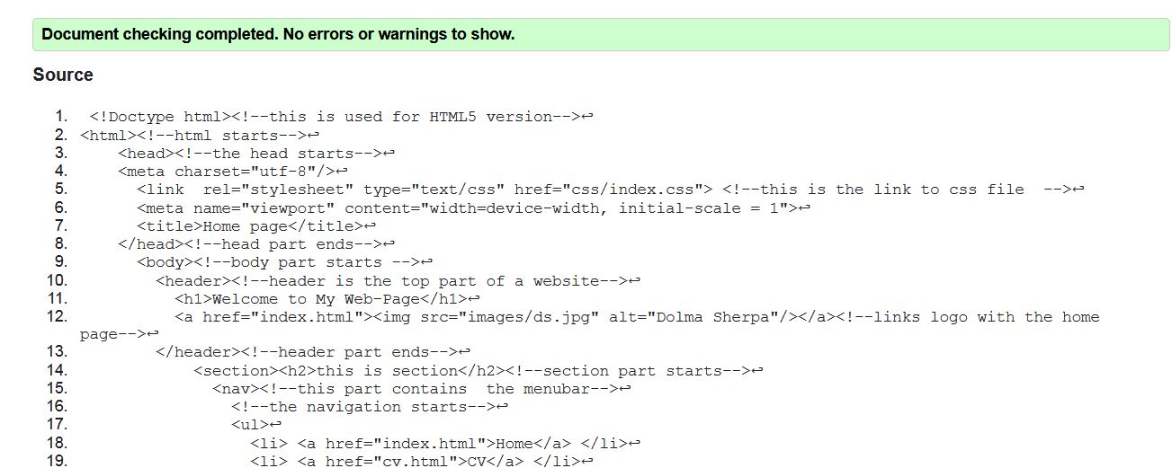

Screenshot of index.html

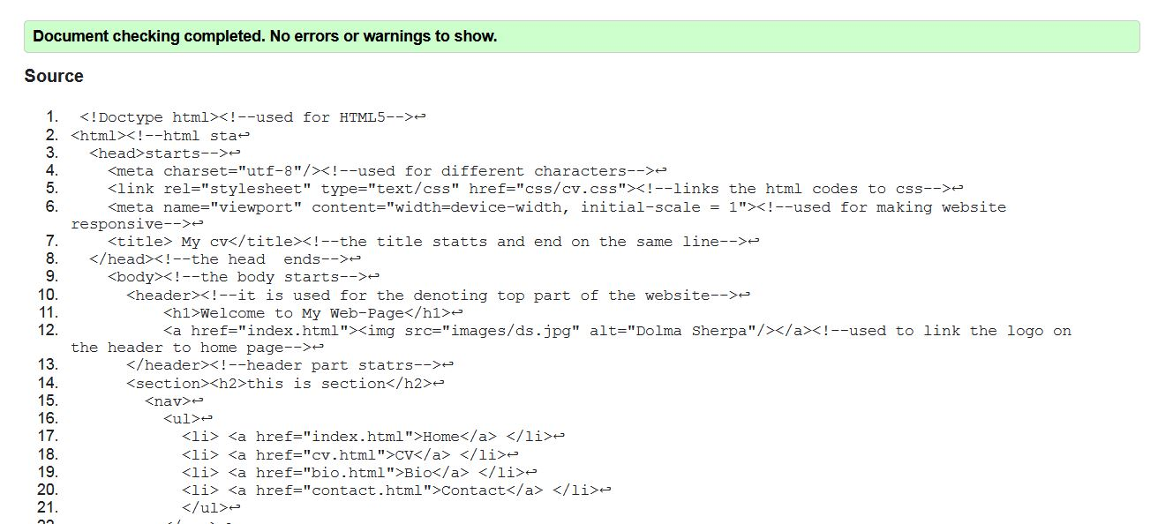

Screenshot of Cv.html

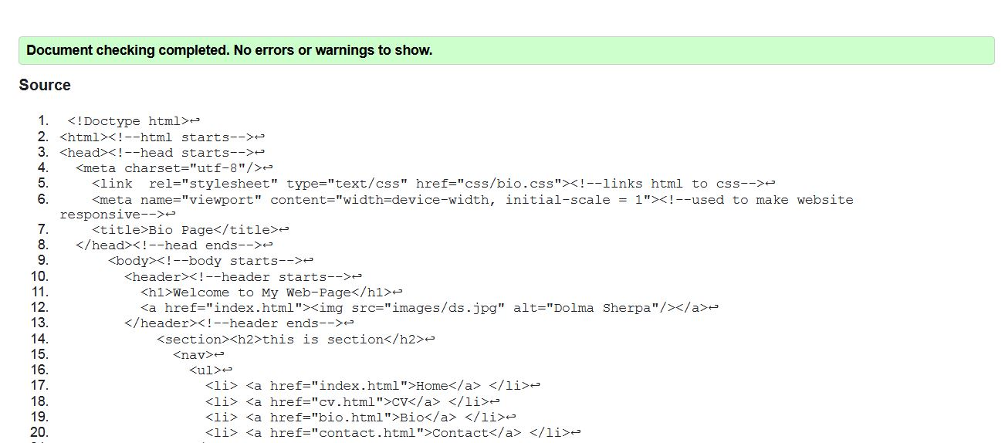

Screenshot of bio.html

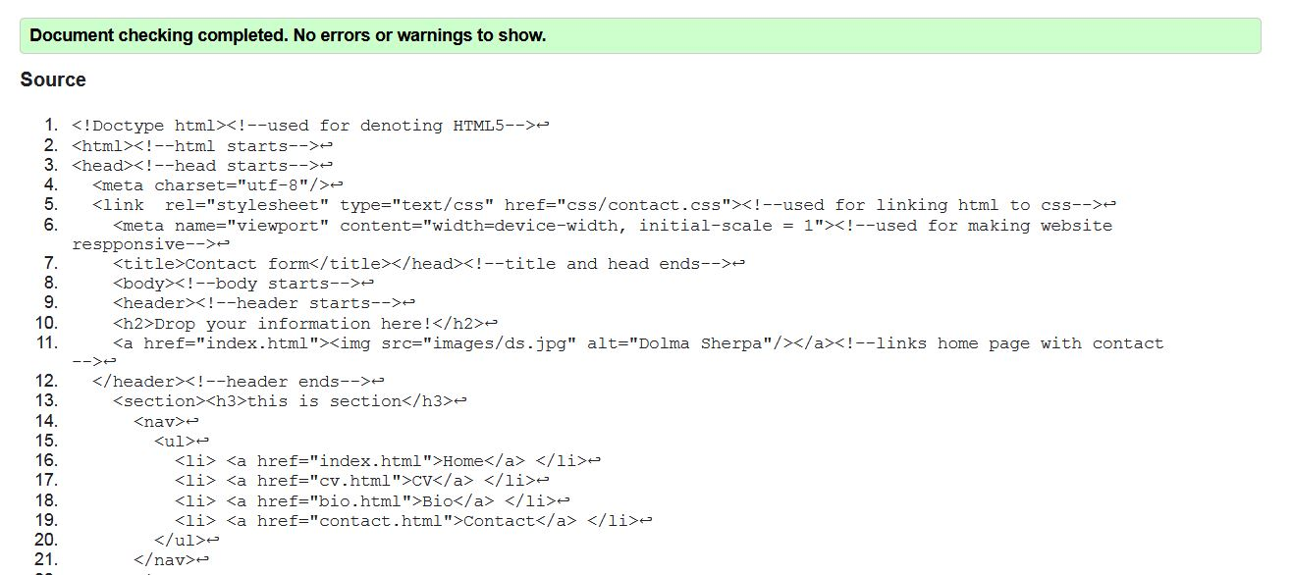

Screenshot of contact.html

The website I have used to check my CSS code is <https://jigsaw.w3.org/css-validator/>.

The screenshot of the CSS validator:

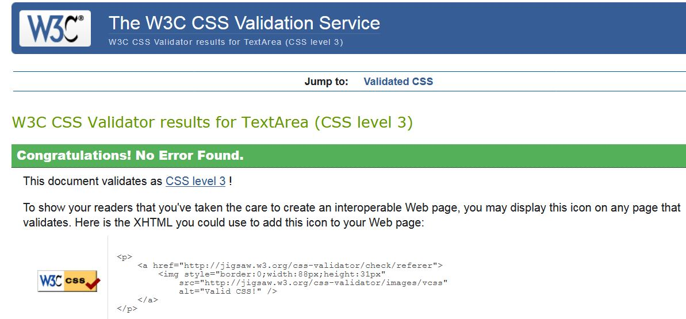

Screenshot of index.css

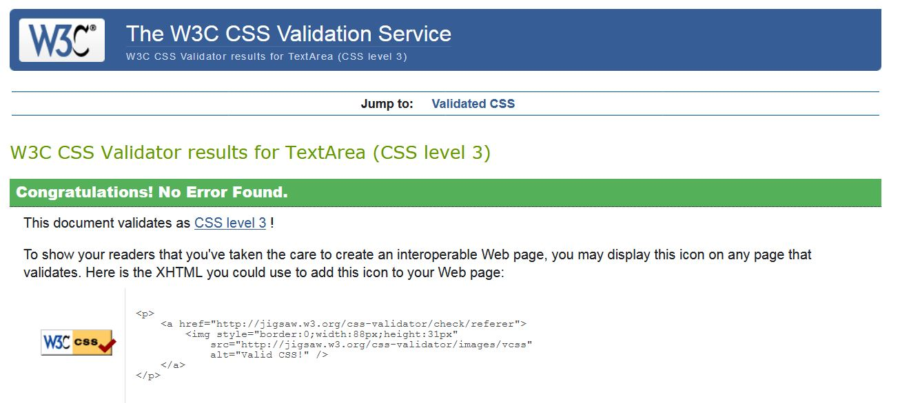

Screenshot of cv.css

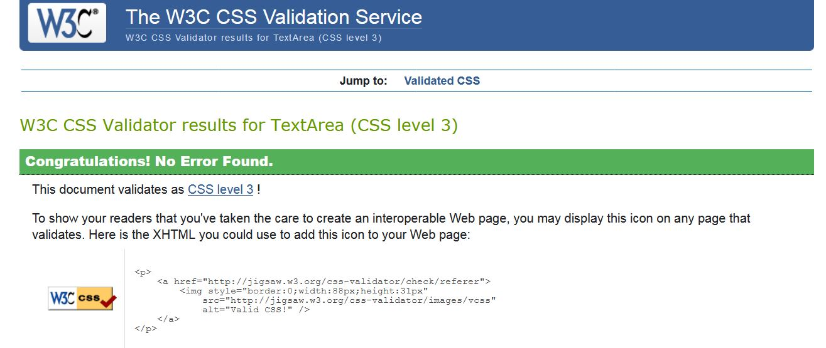

Screenshot of bio.css

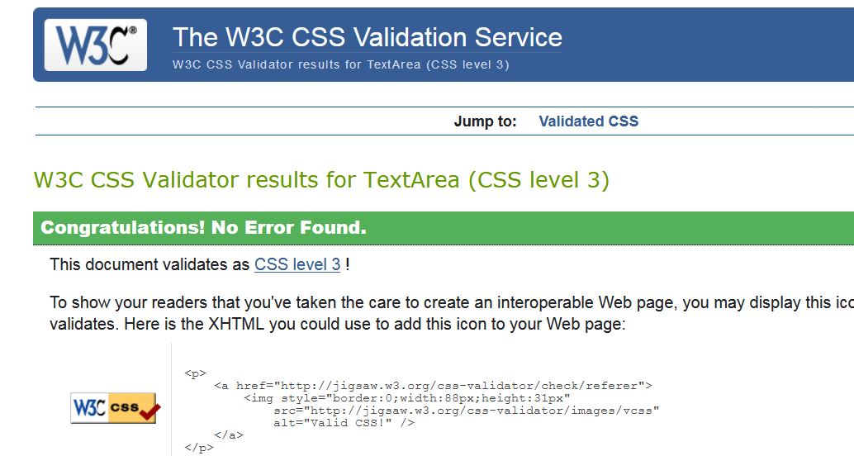

Screenshot of contact.css

 Progress on Website over 12 weeks:

Week 1-4:

.