Assignment Instructions: Assignment 3

# Purpose

The purpose of this assignment is to conduct post-optimality and sensitivity analysis for an LP problem.

# Directions

Consider the problem from a previous assignment.

The Weigelt Corporation has three branch plants with excess production capacity. Fortunately, the corporation has a new product ready to begin production, and all three plants have this capability, so some of the excess capacity can be used in this way. This product can be made in three sizes--large, medium, and small--that yield a net unit profit of $420, $360, and $300, respectively. Plants 1, 2, and 3 have the excess capacity to produce 750, 900, and 450 units per day of this product, respectively, regardless of the size or combination of sizes involved.

The amount of available in-process storage space also imposes a limitation on the production rates of the new product. Plants 1, 2, and 3 have 13,000, 12,000, and 5,000 square feet, respectively, of in-process storage space available for a day's production of this product. Each unit of the large, medium, and small sizes produced per day requires 20, 15, and 12 square feet, respectively.

Sales forecasts indicate that if available, 900, 1,200, and 750 units of the large, medium, and small sizes, respectively, would be sold per day.

At each plant, some employees will need to be laid off unless most of the plant’s excess production capacity can be used to produce the new product. To avoid layoffs if possible, management has decided that the plants should use the same percentage of their excess capacity to produce the new product.

Management wishes to know how much of each of the sizes should be produced by each of the plants to maximize profit.

1. Solve the problem using lpsolve, or any other equivalent library in R.

See R file for HW3.

1. Identify the shadow prices, dual solution, and reduced costs

Recall the objective function:

Max: Z = 420 L1 + 420 L2 + 420 L3 + 360 M1 + 360M2 + 360M3 + 300S1 + 300S2 + 300S3

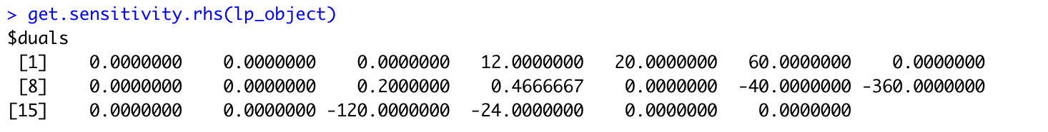

**Shadow Prices:**

As shown in the output above, the shadow prices for the storage constraints of Plant 1, 2 and 3 are 12, 20, and 60, respectively. The shadow price of the excess production percentage constraint between Plant 1 and 2 is 0.2. The shadow price of the excess production percentage constraint between Plant 2 and 3 is 0.47. All other constraints have a shadow price of 0.

**Reduced Costs:**

As shown in the output above, the reduced costs of all variables are:

L1 = 0

L2 = -40

L3 = -360

L4 = 0

L5 = 0

L6 = -120

L7 = -24

L8 = 0

L9 = 0

**Dual solution:**

The dual solution of this problem is a LP problem with 11 variables and 9 constraints.

Objective function:

Min: W = 750P1 + 900P2 + 450P3 + 13000T1 + 12000T2 + 5000T3 + 900D1 + 1200D2 + 750D3

ST: P1 + 20T1 + D1 + 900E1 $≥$ 420

P2 + 20T2 + D1 – 700E1 + 450E2 $≥$ 420

P3 + 20T3 + D1 – 900E2 $≥$ 420

P1 + 15T1 + D2 + 900E1 $≥$ 360

P2 + 15T2 + D2 -700E1 + 450E2 $≥$ 360

P3 + 15T3 + D2 – 900E2 $≥$ 360

P1 + 12T1 + D3 + 900E1 $≥$ 300

P2 + 12T2 + D3 -700E1 + 450E2 $≥$ 300

P3 + 12T3 + D3 – 900E2 $≥$ 300

P1, P2, P3, T1, T2, T3, D1, D2, D3 $≥$ 0

E1, E2 unrestricted

1. Further, identify the sensitivity of the above prices and costs. That is, specify the range of shadow prices and reduced cost within which the optimal solution will not change.

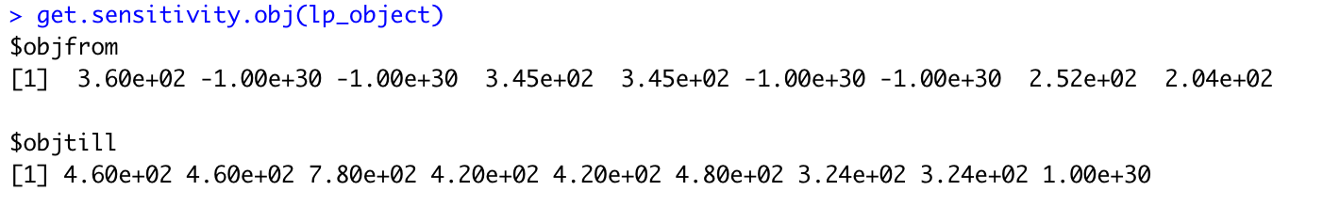

As shown in the output above, the ranges for each variable of shadow prices and reduced cost within which the optimal solution will not change are:

360 $≤$ L1 $≤$ 460

- $∞≤$ L2 $≤$ 460

- $∞≤$ L3 $≤$ 780

345 $≤$ M1 $≤$ 420

345 $≤$ M2 $≤$ 420

- $∞≤$ M3 $≤$ 480

- $∞≤$ S1 $≤$ 324

252 $≤$ S2 $≤$ 324

204 $≤$ S3 $≤$ $∞$

1. Formulate the dual of the above problem and solve it. Does the solution agree with what you observed for the primal problem?

See R file for HW3.

# Learning Outcomes

The assignment will help you with the following course outcomes:

1. To formulate and solve an LP model, and conduct post-optimality analysis
2. To formulate and solve the dual problem

# Requirements

All assignments are due before the next class.

# General Submission Instructions

*All work must be your own. Copying other people’s work or from the Internet is a form of plagiarism and will be prosecuted as such.*

* Upload an R markdown file, along with any required .lp files to your git repository. Name your file Username_#.ext, where Username is your Kent State User ID (the part before @), and # is the Assignment number.
* Note that the R markdown file allows you to add text, comments, and output as part of the file. So, all documentation should be part of the file. You can read about the R markdown file syntax [here](https://rmarkdown.rstudio.com/lesson-1.html), or download the cheat sheet [directly](https://github.com/rstudio/cheatsheets/raw/master/rmarkdown-2.0.pdf).

Provide the link to your git repository in Blackboard Learn for the assignment.