Assignment Instructions: Assignment 4

# Purpose

The purpose of this assignment is to formulate and solve a transportation / transshipment problem.

# Directions

1. Heart Start produces automated external defibrillators (AEDs) in each of two different plants (A and B). The unit production costs and monthly production capacity of the two plants are indicated in the table below. The AEDs are sold through three wholesalers. The shipping cost from each plant to the warehouse of each wholesaler along with the monthly demand from each wholesaler are also indicated in the table. How many AEDs should be produced in each plant, and how should they be distributed to each of the three wholesaler warehouses so as to minimize the combined cost of production and shipping?

|  |  |  |  |  |  |  |
| --- | --- | --- | --- | --- | --- | --- |
|  | *Unit Shipping Cost* | | |  | *Unit* | *Monthly* |
|  | *Warehouse 1* | *Warehouse 2* | *Warehouse 3* | *D* | *Production*  *Cost* | *Production*  *Capacity* |
| *Plant A* | *$22* | *$14* | *$30* | *0* | *$600* | *100* |
| *Plant B* | *$16* | *$20* | *$24* | *0* | *$625* | *120* |
| *Monthly Demand* | *80* | *60* | *70* | *10* |  |  |

# Formulate and solve this transportation problem using *lpsolve*, or any other equivalent library in R.

Let Xai be the amount of units produced at Plant A and distributed to Warehouse i, i = 1, 2, 3

Let Xbi be the amount of units produced at Plant B and distributed to Warehouse i, i = 1, 2, 3

Do I need a dummy variable here?

Since this is a transportation problem, yes? But I feel like in this case since the monthly production capacity is larger than the monthly demand, if the production capacity is not reached the solve of the problem will still make sense?

Create dummy variable Xa4, Xb4

Min: 600 (Xa1 + Xa2 + Xa3) + 625 (Xb1 + Xb2 + Xb3) + 22Xa1 + 14Xa2 + 30Xa3 + 16Xb1 + 20 Xb2 + 24Xb3

= 622Xa1 + 614Xa2 + 630Xa3 + 641Xb1 + 645Xb2 + 649Xb3

ST:

[Production]

Xa1 + Xa2 + Xa3 + Xa4=100

Xb1 + Xb2 + Xb3 + Xb4=120

[Demand]

Xa1 + Xb1 = 80

Xa2 + Xb2 = 60

Xa3 + Xb3 = 70

Xa4 + Xb4 = 10

1. **Oil Distribution** Texxon Oil Distributors, Inc., has three active oil wells in a west Texas oil field. Well 1 has a capacity of 93 thousand barrels per day (TBD), Well 2 can produce 88 TBD, and Well 3 can produce 95 TBD. The company has five refineries along the Gulf Coast, all of which have been operating at stable demand levels. In addition, three pump stations have been built to move the oil along the pipelines from the wells to the refineries. Oil can flow from any one of the wells to any of the pump stations, and from any one of the pump stations to any of the refineries, and Texxon is looking for a minimum cost schedule. The refineries’ requirements are as follows.

|  |  |  |  |  |  |
| --- | --- | --- | --- | --- | --- |
| Refinery | R1 | R2 | R3 | R4 | R5 |
| Requirement (TBD) | 30 | 57 | 48 | 91 | 48 |

The company’s cost accounting system recognizes charges by the segment of pipeline that is used. These daily costs are given in the tables below, in dollars per thou- sand barrels.



1. What is the minimum cost of providing oil to the refineries? Which wells are used to capacity in the optimal schedule? Formulation of the problem is enough.

Let Xia be the flow scheduled from Well i to Pump Station A, i = 1, 2, 3

Let Xib be the flow scheduled from Well i to Pump Station B, i = 1, 2, 3

Let Xic be the flow scheduled from Well i to Pump Station C, i = 1, 2, 3

Let Xai be the flow scheduled from Pump Station A to Refinery i, i = 1, 2, 3, 4, 5, 6

Let Xbi be the flow scheduled from Pump Station B to Refinery i, i = 1, 2, 3, 4, 5, 6

Let Xci be the flow scheduled from Pump Station C to Refinery i, i = 1, 2, 3, 4, 5, 6

[Objective function]

Min: 1.52X1a + 1.60X1b + 1.40X1c + 1.70X2a + 1.63X2b + 1.55X2c + 1.45X3c + 1.57X3b + 1.30X3c + 5.15Xa1 + 5.69Xa2 + 6.13Xa3 + 5.63Xa4 + 5.80Xa5 + 5.12Xb1 + 5.47Xb2 + 6.05Xb3 + 6.12Xb4 + 5.71Xb5 + 5.32Xc1 + 6.16Xc2 + 6.25Xc3 + 6.17Xc4 + 5.87Xc5

ST:

X1a + X1b + X1c = 93

X2a + X2b + X2c = 88

X3a + X3b + X3c = 95

Xa1 + Xb1 + Xc1 = 30

Xa2 + Xb2 + Xc2 = 57

Xa3 + Xb3 + Xc3 = 48

Xa4 + Xb4 + Xc4 = 91

Xa5 + Xb5 + Xc5 = 48

Xa6 + Xb6 + Xc6 = 2

From the solution (see R file), Well 1 and Well 2 used to capacity in the optimal model.

1. Show the network diagram corresponding to the solution in (a). That is, label each of the arcs in the solution and verify that the flows are consistent with the given information.

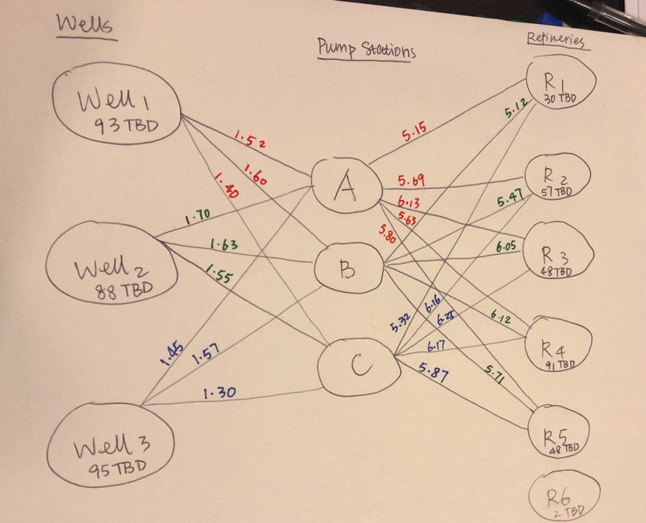

# Learning Outcomes

The assignment will help you formulate and solve a transportation and transshipment problem.

# Requirements

All assignments are due before the next class.

# General Submission Instructions

*All work must be your own. Copying other people’s work or from the Internet is a form of plagiarism and will be prosecuted as such.*

1. Upload an R markdown file, along with any required .lp files to your git repository. Name your file Username_#.ext, where Username is your Kent State User ID (the part before @), and # is the Assignment number.
2. Note that the R markdown file allows you to add text, comments, and output as part of the file. So, all documentation should be part of the file. You can read about the R markdown file syntax [here](https://rmarkdown.rstudio.com/lesson-1.html), or download the cheat sheet [directly](https://github.com/rstudio/cheatsheets/raw/master/rmarkdown-2.0.pdf).

Provide the link to your git repository in Blackboard Learn for the assignment.