Assignment Instructions: Assignment 6

# Purpose

The purpose of this assignment is to

* Explore the use of DEA, formulate and solve DEA problems under different assumptions.
* Compare and contrast these results
* Explore goal programming formulations and solutions

# Directions

## Hope Valley Health Care Association

1. The Hope Valley Health Care Association owns and operates six nursing homes in adjoining states. An evaluation of their efficiency has been undertaken **using two inputs and two outputs.** The inputs are staffing labor (measured in average hours per day) and the cost of supplies (in thousands of dollars per day). The outputs are the number of patient-days reimbursed by third-party sources and the number of patient-days reimbursed privately. A summary of performance data is shown in the table below.

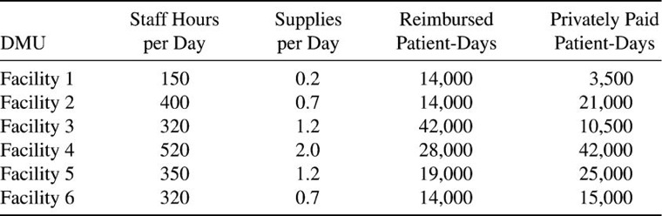

# Questions

1. Formulate and perform DEA analysis under all DEA assumptions of FDH, CRS, VRS, IRS, DRS, and FRH.
2. Determine the Peers and Lambdas under each of the above assumptions
3. Summarize your results in a tabular format

Please see answers to the above questions in zchu_6.html.

1. Compare and contrast the above results

FDH and FRH do not give peers, but the other models do, some more than 2.

CRS and DRS give the same lambdas;

VRS and IRS give the same lambdas;

FRH and FDH give the same lambdas.

1. The Research and Development Division of the Emax Corporation has developed three new products. A decision now needs to be made on which mix of these products should be produced. Management wants primary consideration given to three factors: total profit, stability in the workforce, and achieving an increase in the company’s earnings next year from the $75 million achieved this year. In particular, using the units given in the following table, they want to

Maximize Z = P - 6C - 3D, where

P = total (discounted) profit over the life of the new products,

C = change (in either direction) in the current level of employment,

D = decrease (if any) in next year’s earnings from the current year’s level.

The amount of any increase in earnings does not enter into Z, because management is concerned primarily with just achieving some increase to keep the stockholders happy. (It has mixed feelings about a large increase that then would be difficult to surpass in subsequent years.)

The impact of each of the new products (per unit rate of production) on each of these factors is shown in the following table:

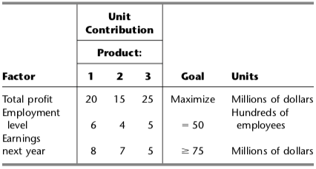

# Questions

1. Define y1+ and y1-, respectively, as the amount over (if any) and the amount under (if any) the employment level goal. Define y2+ and y2- in the same way for the goal regarding earnings next year. Define x1, x2, and x3 as the production rates of Products 1, 2, and 3, respectively. With these definitions, use the goal programming technique to express y1+, y1- , y2+ and y2- algebraically in terms of x1, x2, and x3. Also express P in terms of x1, x2, and x3.

6x1 + 4x2 + 5x3 - y1p + y1m = 50;

8x1 + 7x2 + 5x3 - y2p + y2m >= 75;

P = 20x1 + 15x2 +25x3

1. Express management’s objective function in terms of x1, x2, x3, y1+, y1- , y2+ and y2-.

/* Objective function*/

max: 20x1 + 15x2 +25x3 - 6y1p - 6y1m - 3y2m

1. Formulate and solve the linear programming model. What are your findings?

The solution for the objective function is $225 million. The company should produce product 3 at 15 percent rate. It should not produce product 1 and 2. The company will have an increase in employment for 25 employees.

# Learning Outcomes

The assignment will help you with the following course outcomes: CL2: DEA and Goal Programming

# Requirements

All assignments are due before the next class.

# General Submission Instructions

*All work must be your own. Copying other people’s work or from the Internet is a form of plagiarism and will be prosecuted as such.*

Upload an R markdown file, along with any required .lp files to your git repository. Name your file Username_#.ext, where Username is your Kent State User ID (the part before @), and # is the Assignment number.

Provide the link to your git repository in Blackboard Learn for the assignment.