What to write about
- What the game is about. What game influenced the idea.
- Dedicated time to learn agile/scrum methodology before starting the project.
- Finding out whether a single developer can successfully follow scrum technique.
- Main tasks.
- Iterations with brief explanation!!!
- How and why I changed the player controls from only allowing half automatic turning in specific points to giving full freedom of turning.
- Segments not spawning properly. Spawners have incorrect rotations.
  - Fixed left corner by removing unnecessary segments and rotating it by 90 degrees as soon as its instantiated. Original code assigned spawner’s rotation and since left corner only rotated version
  - Properly modified prefab so its natural Y rotation is 0, just like all other segments.
- Optimisation of voxel models by dissolving faces.
- Optimization by removing mesh colliders. http://forum.unity3d.com/threads/36860-Performance-issue-with-instantiating
- Deciding on method of throwing the paper. Towards mouse pointer location or physics based.
- Not planning size of roads and houses
- Ensuring the player not exploiting the game by limiting how many times a single target can be hit with a newspaper.
  - Fixed houses rewarding multiple times
- What I learnt about component based programming.
- Gaining motivation when 3D models added a unified look to the game.
- Learnt about composition and component based systems.
- Destroying segments. Checkpoints and falling off the map.
- Prefab nesting. Shouldve instantiaded the buildings. Any changes need to be repeated in all sections.
- Fixed timer still counting down when game is paused by saving time when tha game was paused and adding the difference between the time of resume and time of pause to time when the counting down is supposed to end. (BRILLIANT)
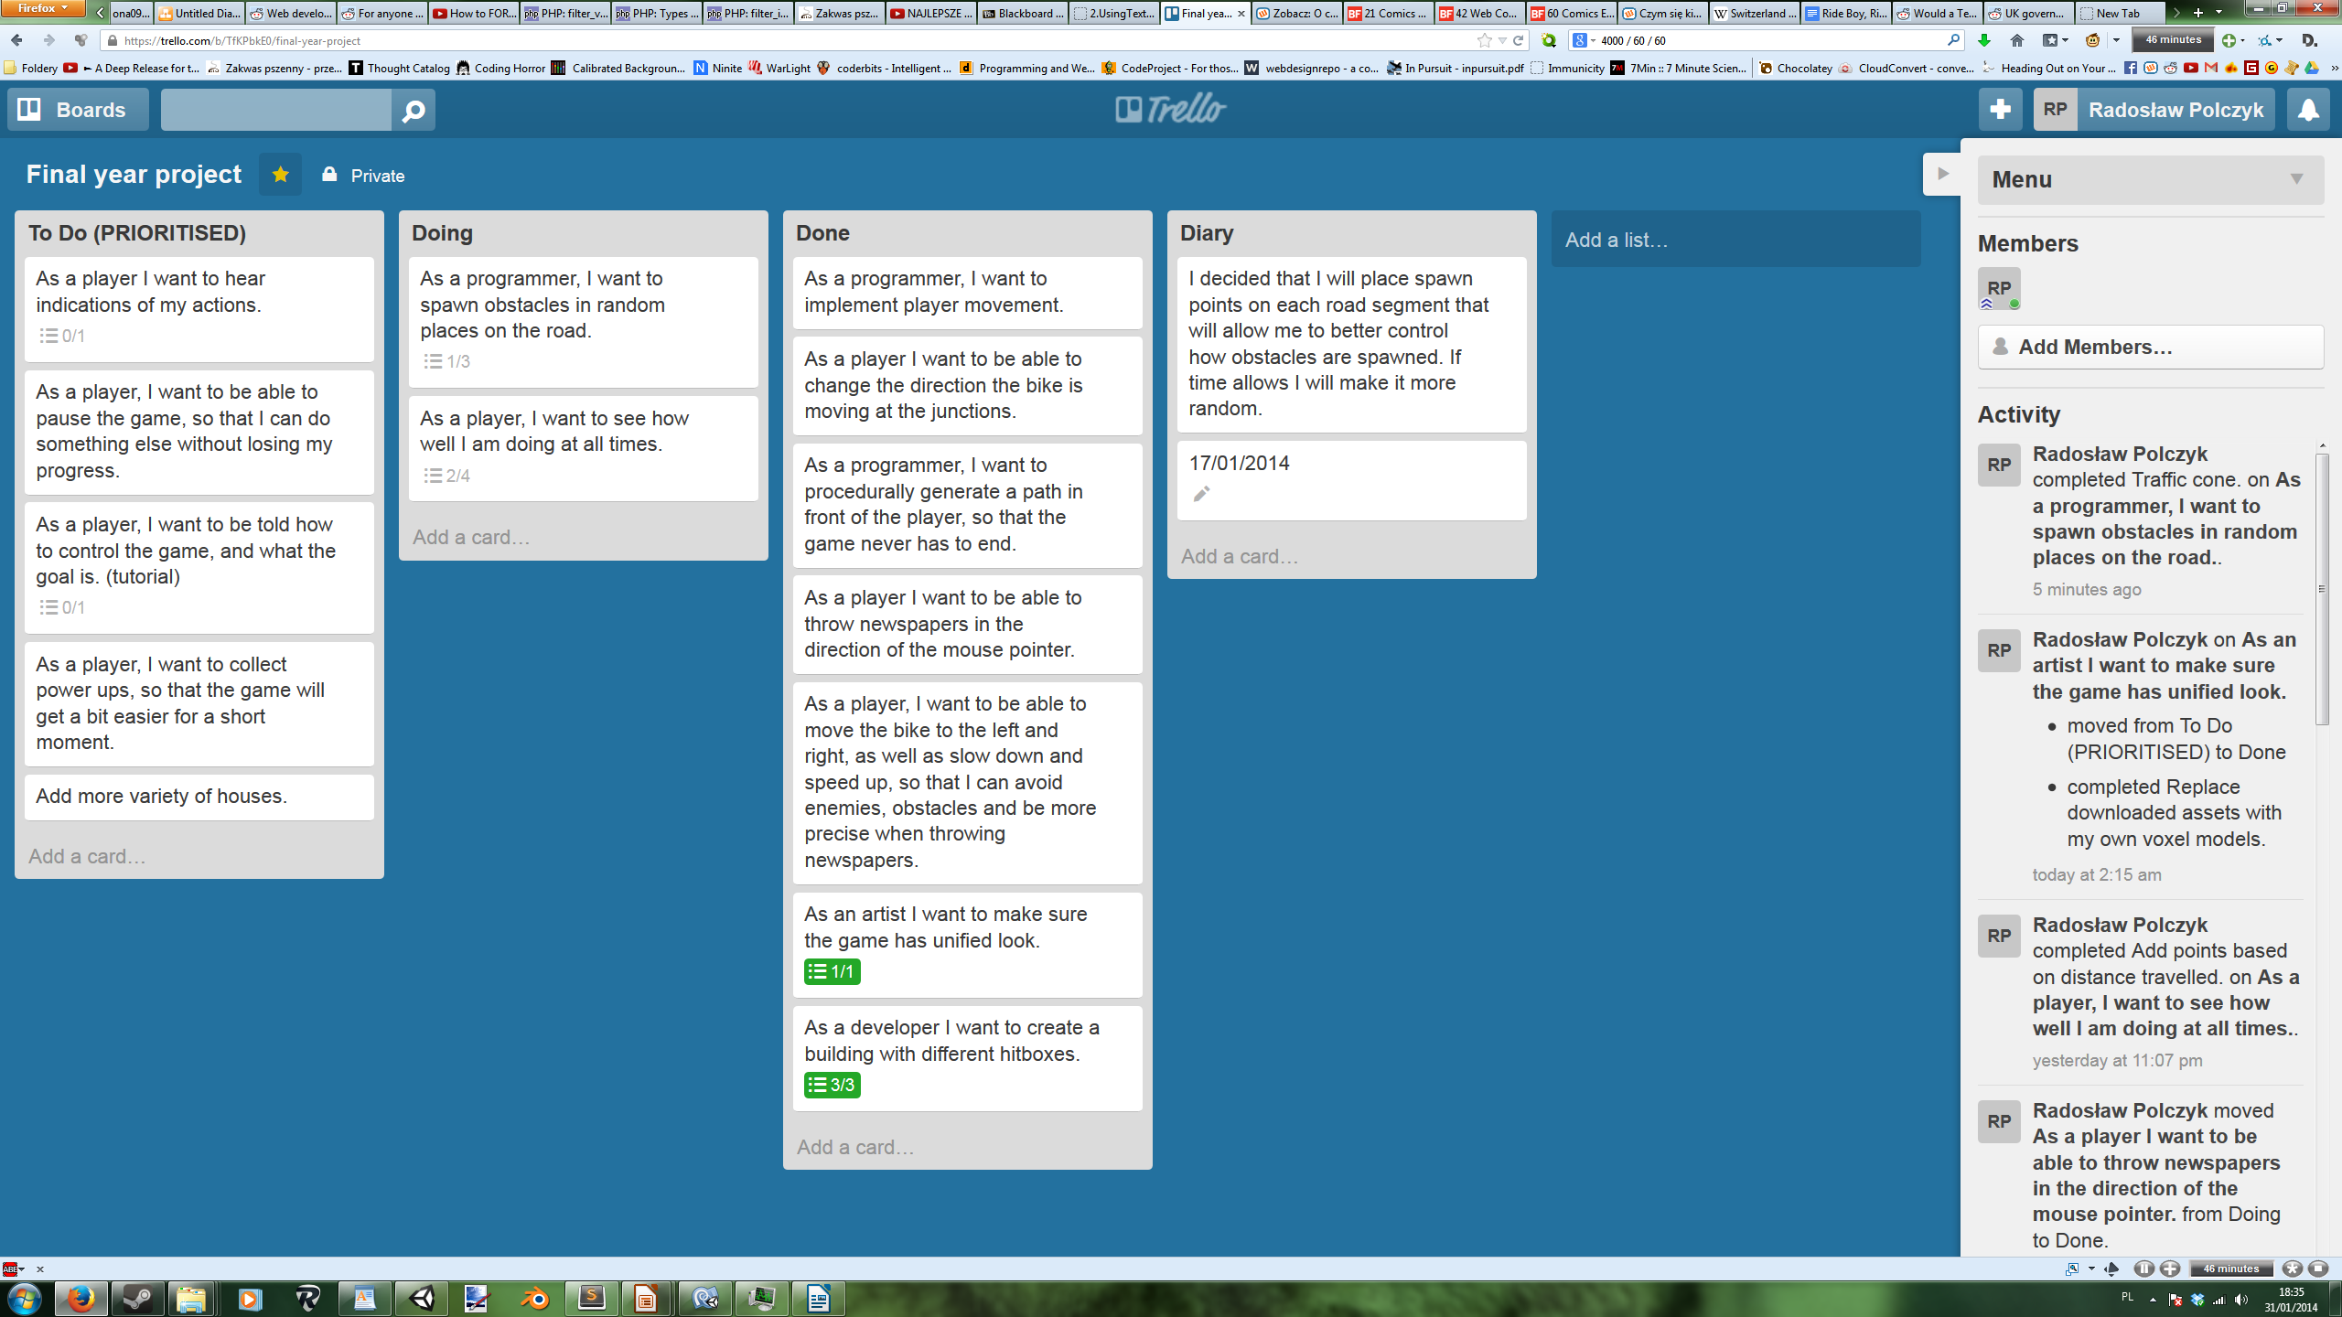
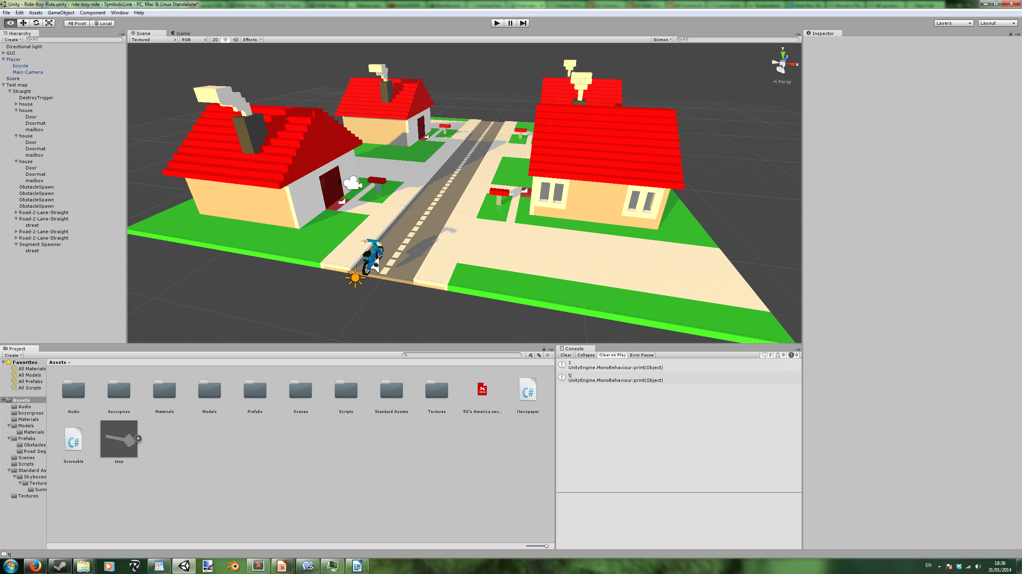

Table of Contents
What to write about 1
1. Introduction 5
2. Aims 6
3. Objectives 7
4. Literature Review 8
5. Analysis 9
6. Design 10
7. Implementation 11
8. Testing 12
9. Critical Review 13
10. Reference 14
11. Appendix 15
11.1 Resources used 15

1. Introduction

2. Aims

3. Objectives

4. Literature Review

5. Analysis

6. Design

7. Implementation

8. Testing

9. Critical Review

10. Reference

11. Appendix

11.1 Resources used
Background music - http://incompetech.com/music/royalty-free/index.html?isrc=USUAN1300022
Dog barking - http://www.freesound.org/people/felix.blume/sounds/199261/
Old man - http://www.freesound.org/people/scuzzpuck/sounds/40841/
Doormat - http://www.freesound.org/people/simon.rue/sounds/49949
Door - http://www.freesound.org/people/juskiddink/sounds/108617/
bicycle - http://www.freesound.org/people/metamorphmuses/sounds/90649/
Mailbox - http://www.freesound.org/people/eliasheuninck/sounds/3543/
newspaper whoosh - http://www.freesound.org/people/petenice/sounds/9509/
birds - http://www.freesound.org/people/keweldog/sounds/184870/
hedge texture - http://www.cgtextures.com/texview.php?id=42279&PHPSESSID=58hg171dp92h3rhfnjne90b3j2
fence - http://www.blendswap.com/blends/view/68645

