

**The Experiment Report of**

***Machine Learning***

**College Software College**

**Subject Software Engineering**

**Members**

**Student ID 201530661741**

**E-mail yimingzhao0@qq.com**

**Tutor**   **Mingkui Tan**

**Date submitted** **2017. .**

**1. Topic: Logistic regression, logistic classification and gradient decent method**

**2. Time: 2017.12.2 PM 2:00-5:00**

**3. Reporter: Yiming Zhao**

**4. Purposes:**

* **Understand the differences between the gradient decent and stochastic gradient decent method.**
* **Understand the connection between the logistic regression and linear regression.**
* **Practicing the SVM on the bigger data set.**

**5. Data sets and data analysis:**

**Using a9a data set from LIBSVM Data, including** **32561 / 16281(testing) samples and 123 features in each sample.**

**6. Experimental steps:**

* **Read the data set using sklearn’s function**
* **Randomly initializing the parameters.**
* **Selecting a proper loss function and using NAG, Adam, Adadelta, RMSProp to optimize the loss function.**

**7. Code:**

from sklearn import datasets as ds  
import numpy as np  
from numpy import random  
import matplotlib.pyplot as plt  
  
  
def sigmoid(input_):  
 return 1 / (1 + np.exp(-input_))  
  
  
def train(x_train, y_train, x_test, y_test, method, iters, test_errors):  
 max_iterations = 100  
 theta = random.rand(num_features + 1)  
 num_test_samples, num_test_features = x_test.shape  
  
 if method == 'sgd':  
 lr = 0.01  
  
 for i in range(max_iterations):  
 output = sigmoid(np.dot(x_train[i], theta))  
 error = output - y_train[i]  
 theta = theta - lr * np.dot(x_train[i], error)  
  
 predict_error = 0  
 for j in range(num_test_samples):  
 predict_output = sigmoid(np.dot(x_test[j], theta))  
 predict_error -= y_test[j] * np.log(predict_output) + (1 - y_test[j]) * np.log(1 - predict_output)  
 print(str(i) + '\t' + str(predict_error / num_test_samples))  
  
 iters.append(i)  
 test_errors.append(predict_error / num_test_samples)  
  
 if method == 'nag':  
 lr = 0.01  
 miu = 0.9  
 momentum = np.zeros(num_features + 1)  
  
 for i in range(max_iterations):  
 output = sigmoid(np.dot(x_train[i], theta - lr * miu * momentum))  
 error = output - y_train[i]  
 grad = np.dot(x_train[i], error)  
 momentum = momentum * lr + grad  
 theta = theta - lr * momentum  
  
 predict_error = 0  
 for j in range(num_test_samples):  
 predict_output = sigmoid(np.dot(x_test[j], theta))  
 predict_error -= y_test[j] * np.log(predict_output) + (1 - y_test[j]) * np.log(1 - predict_output)  
 print(str(i) + '\t' + str(predict_error / num_test_samples))  
  
 iters.append(i)  
 test_errors.append(predict_error / num_test_samples)  
  
 if method == 'rmsprop':  
 lr = 0.1  
 expectation = 1  
 rho = 0.95  
 delta = 10e-7  
  
 for i in range(max_iterations):  
 output = sigmoid(np.dot(x_train[i], theta))  
 error = output - y_train[i]  
 grad = np.dot(x_train[i], error)  
 norm = np.dot(grad, grad)  
 expectation = rho * expectation + (1 - rho) * norm  
 theta = theta - lr * grad / (np.sqrt(expectation) + delta)  
  
 predict_error = 0  
 for j in range(num_test_samples):  
 predict_output = sigmoid(np.dot(x_test[j], theta))  
 predict_error -= y_test[j] * np.log(predict_output) + (1 - y_test[j]) * np.log(1 - predict_output)  
 print(str(i) + '\t' + str(predict_error / num_test_samples))  
 iters.append(i)  
 test_errors.append(predict_error / num_test_samples)  
  
 if method == 'adam':  
 delta = 10e-8  
 rho1 = 0.9  
 rho2 = 0.999  
 lr = 0.1  
 s = 0  
 r = 0  
  
 for i in range(max_iterations):  
 output = sigmoid(np.dot(x_train[i], theta))  
 error = output - y_train[i]  
 grad = np.dot(x_train[i], error)  
  
 s = rho1 * s + (1 - rho1) * grad  
 r = rho2 * r + (1 - rho2) * grad * grad  
 s_hat = s / (1 - rho1)  
 r_hat = r / (1 - rho2)  
 delta_theta = (-lr * s_hat) / (np.sqrt(r_hat) + delta)  
 theta = theta + delta_theta  
  
 predict_error = 0  
 for j in range(num_test_samples):  
 predict_output = sigmoid(np.dot(x_test[j], theta))  
 predict_error -= y_test[j] * np.log(predict_output) + (1 - y_test[j]) * np.log(1 - predict_output)  
 print(str(i) + '\t' + str(predict_error / num_test_samples))  
 iters.append(i)  
 test_errors.append(predict_error / num_test_samples)  
  
 if method == 'adadelta':  
 r = 0  
 e = 0  
 miu = 0.9  
 delta = 10e-7  
 lr = 10  
  
 for i in range(max_iterations):  
 output = sigmoid(np.dot(x_train[i], theta))  
 error = output - y_train[i]  
 grad = np.dot(x_train[i], error)  
  
 r = miu * r + (1 - miu) * grad * grad  
 delta_theta = (-lr * grad * np.sqrt(e + delta)) / (np.sqrt(r + delta))  
 theta = theta + delta_theta  
 e = miu * e + (1 - miu) * e * e  
  
  
 predict_error = 0  
 for j in range(num_test_samples):  
 predict_output = sigmoid(np.dot(x_test[j], theta))  
 predict_error -= y_test[j] * np.log(predict_output) + (1 - y_test[j]) * np.log(1 - predict_output)  
 print(str(i) + '\t' + str(predict_error / num_test_samples))  
 iters.append(i)  
 test_errors.append(predict_error / num_test_samples)  
  
if __name__ == '__main__':  
 x_train, y_train = ds.load_svmlight_file('./data/a9a')  
 x_test, y_test = ds.load_svmlight_file('./data/a9a.t')  
  
 num_samples, num_features = x_train.shape  
 num_test_samples, num_test_features = x_test.shape  
  
 x_train = x_train.toarray()  
 temp = np.ones(shape=[32561, 1], dtype=np.float32)  
 x_train = np.concatenate([x_train, temp], axis=1)  
 x_test = x_test.toarray()  
 temp = np.zeros(shape=[16281, 1], dtype=np.float32)  
 temp1 = np.ones(shape=[16281, 1], dtype=np.float32)  
 x_test = np.concatenate([x_test, temp, temp1], axis=1)  
  
 for i in range(0, len(y_train)):  
 if y_train[i] == -1:  
 y_train[i] = 0  
 for i in range(0, len(y_test)):  
 if y_test[i] == -1:  
 y_test[i] = 0  
  
  
 methods = ['sgd', 'nag', 'rmsprop', 'adadelta', 'adam']  
 for method in methods:  
 iters = []  
 test_errors = []  
 train(x_train, y_train, x_test, y_test, method, iters, test_errors)  
 plt.plot(iters, test_errors, label=method)  
  
plt.xlabel('Iteration')  
plt.ylabel('Loss')  
plt.legend()  
plt.show()

from sklearn import datasets as ds  
import numpy as np  
from numpy import random  
import matplotlib.pyplot as plt  
  
  
def train(x_train, y_train, x_test, y_test, method, iters, test_errors):  
 max_iterations = 200  
 theta = random.rand(num_features + 1)  
 gamma = 1  
 num_test_samples, num_test_features = x_test.shape  
  
 if method == 'sgd':  
 lr = 0.01  
  
 for i in range(max_iterations):  
 output = np.dot(x_train[i], theta)  
 grad = max(0, 1 - y_train[i] * output) * (-y_train[i] * x_train[i]) + gamma * theta  
 theta = theta - lr * grad  
  
 predict_error = 0  
 for j in range(num_test_samples):  
 predict_output = np.dot(x_test[j], theta)  
 predict_error += max(0, predict_output * y_test[j]) + 0.5 * gamma * np.dot(theta, theta)  
 print(str(i) + '\t' + str(predict_error / num_test_samples))  
  
 iters.append(i)  
 test_errors.append(predict_error / num_test_samples)  
  
 if method == 'nag':  
 lr = 0.01  
 miu = 0.9  
 momentum = np.zeros(num_features + 1)  
  
 for i in range(max_iterations):  
 output = np.dot(x_train[i], theta - lr * miu * momentum)  
 grad = grad = max(0, 1 - y_train[i] * output) * (-y_train[i] * x_train[i]) + gamma * theta  
 momentum = momentum * lr + grad  
 theta = theta - lr * momentum  
  
 predict_error = 0  
 for j in range(num_test_samples):  
 predict_output = np.dot(x_test[j], theta)  
 predict_error += max(0, predict_output * y_test[j]) + 0.5 * gamma * np.dot(theta, theta)  
 print(str(i) + '\t' + str(predict_error / num_test_samples))  
  
 iters.append(i)  
 test_errors.append(predict_error / num_test_samples)  
  
 if method == 'rmsprop':  
 lr = 0.1  
 expectation = 1  
 rho = 0.95  
 delta = 10e-7  
  
 for i in range(max_iterations):  
 output = np.dot(x_train[i], theta)  
 grad = max(0, 1 - y_train[i] * output) * (-y_train[i] * x_train[i]) + gamma * theta  
 norm = np.dot(grad, grad)  
 expectation = rho * expectation + (1 - rho) * norm  
 theta = theta - lr * grad / (np.sqrt(expectation) + delta)  
  
 predict_error = 0  
 for j in range(num_test_samples):  
 predict_output = np.dot(x_test[j], theta)  
 predict_error += max(0, predict_output * y_test[j]) + 0.5 * gamma * np.dot(theta, theta)  
 print(str(i) + '\t' + str(predict_error / num_test_samples))  
 iters.append(i)  
 test_errors.append(predict_error / num_test_samples)  
  
 if method == 'adam':  
 delta = 10e-8  
 rho1 = 0.9  
 rho2 = 0.999  
 lr = 0.1  
 s = 0  
 r = 0  
  
 for i in range(max_iterations):  
 output = np.dot(x_train[i], theta)  
 grad = grad = max(0, 1 - y_train[i] * output) * (-y_train[i] * x_train[i]) + gamma * theta  
  
 s = rho1 * s + (1 - rho1) * grad  
 r = rho2 * r + (1 - rho2) * grad * grad  
 s_hat = s / (1 - rho1)  
 r_hat = r / (1 - rho2)  
 delta_theta = (-lr * s_hat) / (np.sqrt(r_hat) + delta)  
 theta = theta + delta_theta  
  
 predict_error = 0  
 for j in range(num_test_samples):  
 predict_output = np.dot(x_test[j], theta)  
 predict_error += max(0, predict_output * y_test[j]) + 0.5 * gamma * np.dot(theta, theta)  
 print(str(i) + '\t' + str(predict_error / num_test_samples))  
 iters.append(i)  
 test_errors.append(predict_error / num_test_samples)  
  
 if method == 'adadelta':  
 r = 0  
 e = 0  
 miu = 0.9  
 delta = 10e-7  
 lr = 10  
  
 for i in range(max_iterations):  
 output = np.dot(x_train[i], theta)  
 grad = max(0, 1 - y_train[i] * output) * (-y_train[i] * x_train[i]) + gamma * theta  
  
 r = miu * r + (1 - miu) * grad * grad  
 delta_theta = (-lr * grad * np.sqrt(e + delta)) / (np.sqrt(r + delta))  
 theta = theta + delta_theta  
 e = miu * e + (1 - miu) * e * e  
  
  
 predict_error = 0  
 for j in range(num_test_samples):  
 predict_output = np.dot(x_test[j], theta)  
 predict_error += max(0, predict_output * y_test[j]) + 0.5 * gamma * np.dot(theta, theta)  
 print(str(i) + '\t' + str(predict_error / num_test_samples))  
 iters.append(i)  
 test_errors.append(predict_error / num_test_samples)  
  
if __name__ == '__main__':  
 x_train, y_train = ds.load_svmlight_file('./data/a9a')  
 x_test, y_test = ds.load_svmlight_file('./data/a9a.t')  
  
 num_samples, num_features = x_train.shape  
 num_test_samples, num_test_features = x_test.shape  
  
 x_train = x_train.toarray()  
 temp = np.ones(shape=[32561, 1], dtype=np.float32)  
 x_train = np.concatenate([x_train, temp], axis=1)  
 x_test = x_test.toarray()  
 temp = np.zeros(shape=[16281, 1], dtype=np.float32)  
 temp1 = np.ones(shape=[16281, 1], dtype=np.float32)  
 x_test = np.concatenate([x_test, temp, temp1], axis=1)  
  
  
 methods = ['sgd', 'nag', 'rmsprop', 'adadelta', 'adam']  
 for method in methods:  
 iters = []  
 test_errors = []  
 train(x_train, y_train, x_test, y_test, method, iters, test_errors)  
 plt.plot(iters, test_errors, label=method)  
  
plt.xlabel('Iteration')  
plt.ylabel('Loss')  
plt.legend()  
plt.show()

(Fill in the contents of 8-11 respectively for logistic regression and linear classification)

**8. The initialization method of model parameters:**

Randomly initializing.

**9. The selected loss function and its derivatives:**

$$w=(w;1)$$

$$p_{i}=sigmoid(w^{T}x_{i})$$

$$Loss= -\frac{1}{N}\sum_{i=1}^{N}{y_{i}log\left(p_{i}\right)+(1-y_{i})log(1-p_{i})}$$

$$\frac{∂Loss}{∂w}=-\frac{1}{N}\sum_{i=1}^{N}{x_{i}(p_{i}-y_{i})}$$

**10. Experimental results and curve:**(Fill in this content for various methods of gradient descent respectively)

## Hyper-parameter selection:

SGD:

Learning rate = 0.01

NAG:

Learning rate = 0.01

Miu = 0.9

Momentum_ini = ${\left[0, 0…,0\right]}^{T}$

RMSProp:

Learning rate = 0.1

Expectation = 1

$ρ=0.95$

delta= $10e-7$

Adam:  
delta = 10e-8

rho1 = 0.9

rho2 = 0.999

lr = 0.1

s = 0

r = 0

Adadelta

r = 0

        e = 0

        miu = 0.9

        delta = 10e-7

        lr = 10

## Predicted Results (Best Results):

## Loss curve:

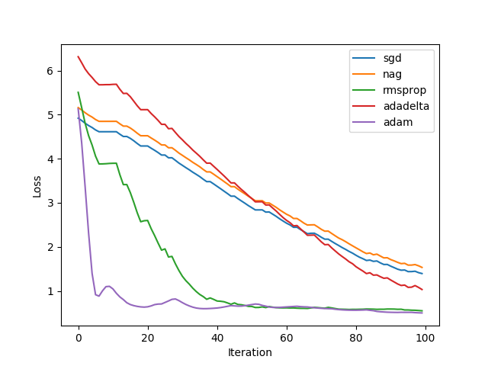

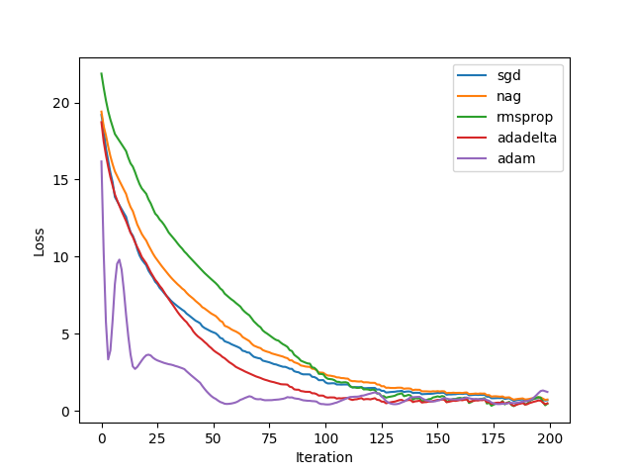

**11. Results analysis:**

**12. Similarities and differences between logistic regression and linear classification：**

**13. Summary:**