**Sentinel-3 Tool Box**

This algorithm was developed to automate the process of generating Sentinel-3 altimetry time series plot directly from the raw netCDF file.

******************************************************************************To run this program, you need the following matlab file scripts and functions in your directory

Required matlab files:

* altimetryoutlier.m
* decyear2matdate.m
* iqrange.m
* hgt_comp.m
* SingleProcess_TimeSeries.m
* Sentinel-3_WaterLevelExtracter.prj
* mjd2gre.m
* uncertainty.m
* sentinel_3.m
* sentinel_3.fig
* s3_reader.m
* geoidegm2008grid.mat
* variable_extract.m

.

**Disclaimer:**

The software developer is not responsible for any liability or damages arising from the use of this algorithm. The use of all or any part of this algorithm is prohibited without the express reference to the developer/paper below:

Okeowo, M. A., Lee, H., Hossain, F., & Getirana, A. (2017). Automated Generation of Lakes and Reservoirs Water Elevation Changes From Satellite Radar Altimetry. IEEE Journal of Selected Topics in Applied Earth Observations and Remote Sensing.

M.A. Okeowo1, 2, Hyongki Lee1, 2, Faisal Hossain3, Augusto Getirana4

1. Department of Civil and Environmental Engineering, University of Houston, Houston, TX, USA
2. National Center for Airborne Laser Mapping, University of Houston, Houston, TX, USA
3. Department of Civil and Environmental Engineering, University of Washington, Seattle, WA, USA
4. Hydrological Sciences Laboratory, NASA Goddard Space Flight Center, Greenbelt, MD, USA

**Sentinel-3 Time Series**

**Step 1: Extract Information from the netCDF files using main function - s3_reader.m. This function will further call variable_extract.m and hgt_comp.m function to extract data from the netCDF files and determine water level height, respectively.**

* To use the function: **s3_reader (Data_Folder, In_Pass, lat_range, File_Suffix_name)**. Where the input arguments are:
* Data_Folder: The directory where user stored netCDF data.
* In_Pass: The orbit number
* lat_range: [MINlatitude, MAXlatitude]
* File_Suffix_name: you may use any name to output the txt result.

e.g. **s3_reader (‘D:\Research\Data\s3\’,338, [12.4877, 12.7756], ‘TonleSapLake’)**

**NB**: Two dialogue boxes will appear. The first one asks user to enter the directory where user stored netCDF files. The second one requires user to enter the information into the dialogue box for toolbox being able to extract water level data from netCDF files. After finishing two dialogues, a wait bar will pop up showing the processing progress then wait till it is done.

|  |  |
| --- | --- |
| **First dialogue:** | **Second dialogue:** |
|  |  |
|  |  |

|  |
| --- |
| **Wait bar:** |
|  |

The **output file name** will be:

**s3_NTC_o338_TonleSapLake_12.487700_12.775600_ocog_info.txt.**

**Step 2: Generate the Time Series plot**

* Run the file, **SingleProcess_TimeSeries.m** to generate the time series plot of the study area.

**NB**: Two dialogue boxes will appear, the first requires user to enter the information as shown below while the second requires the user to select the txt file generated from **Step 1.** Note that the input “Minimum Latitude” and “Maximum Latitude” should be less or equal to the latitude boundary input in Step 1.

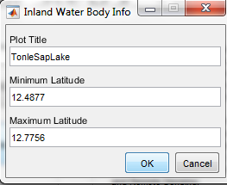

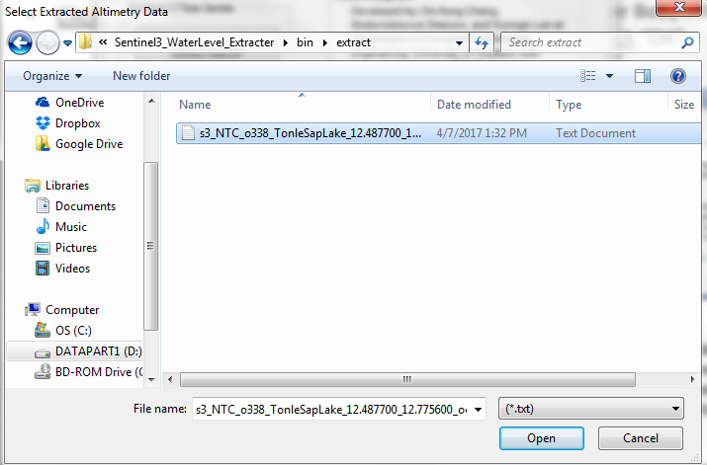

The final output of Step 2 is a Time Series plot window as well as the output files as shown in the figure below.



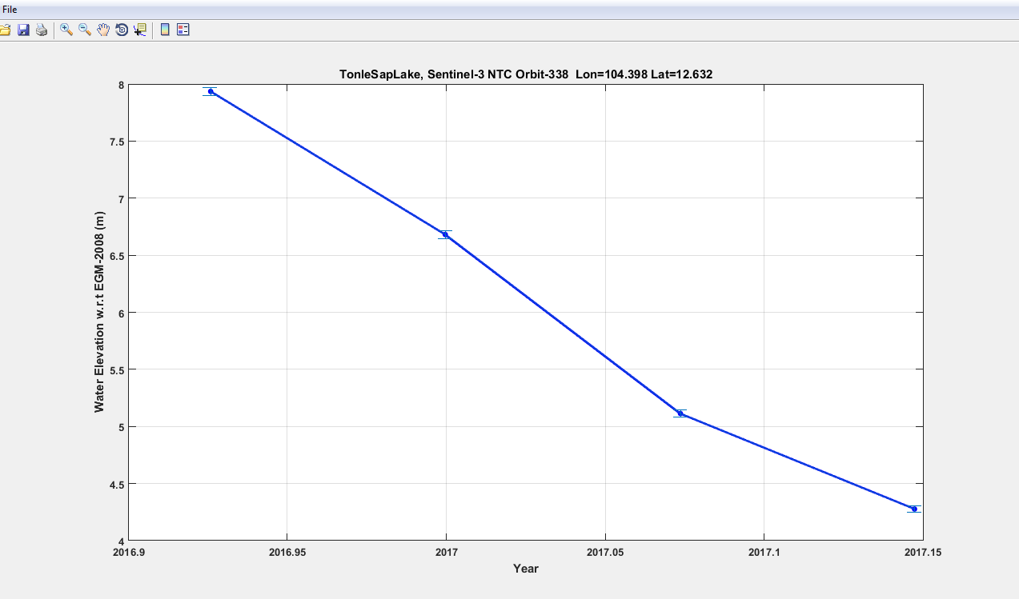

As an example, the output file

**“s3_NTC_o338_TonleSapLake_12.487700_12.775600_ocog_info.txt”**

contains the information below:

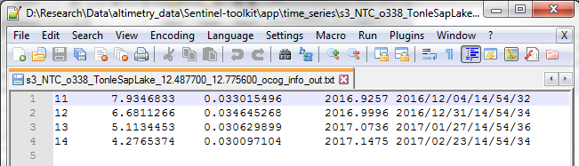

5

4

3

2

1

**The description of the columns is given below:**

(1) Sentinel-3 Cycle Numbers

(2) Height (meter w.r.t. EGM08 Geoid)

(3) Uncertainty (meter)

(4) Decimal year

(5) YYYY/MM/DD/HH/MM/SS