Link youtube: https://www.youtube.com/watch?v=O6PCkrpsTu8

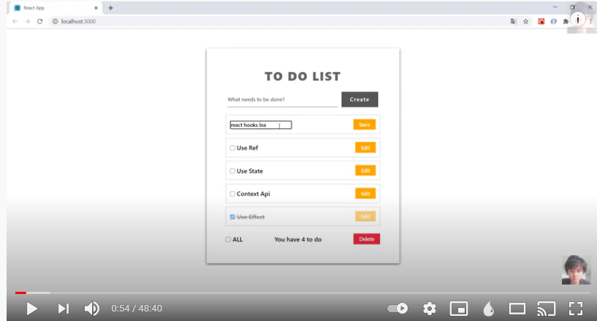

Tìm hiểu CSS:
- autoComplete: https://v1study.com/html5-autocomplete-a81.html
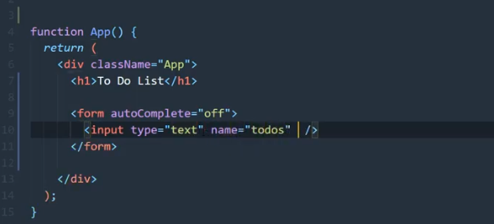
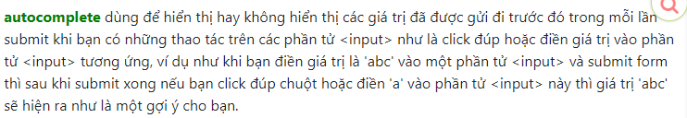
- htmlFor: https://vi.reactjs.org/docs/dom-elements.html
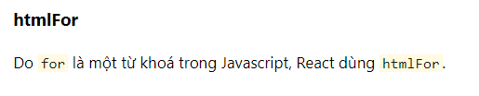
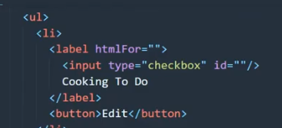

- thuộc tính flex:
