# Mandelbrot Origins

The mandelbrot fractal is recognisable to most people who’ve a passing interest in mathematics, and it’s named after a chap called Benoir Mandelbrot who spent his life discussing fractal theories. However the mandelbrot fractal itself wasn’t discovered by Benoir.

The mandelbrot was first studied by the mathematicians Robert W Brooks and Peter Matelski in 1978. The very first image you’ll find of the set is this one, first published by the pair.

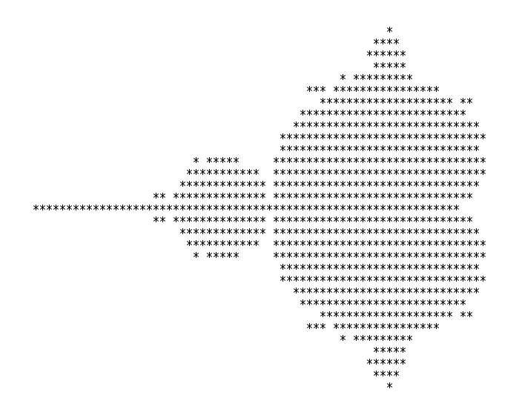The first image of the Mandelbrot set

Further study was then carried out by Benoir Mandelbrot, and the fractal eventually become synonymous with his work and became known as “the Mandelbrot set” from the mid 1980s.

Renderings of the fractal became commonplace in the 80s, and it’s easy for you to personally build your own Mandelbrot images using freely available software.

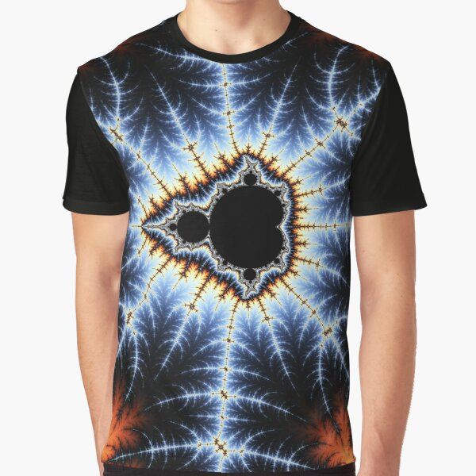A mandelbrot T Shirt

This helped the Mandelbrot to become embedded in popular culture, and it also formed the foundation for a set of mathematics that was popularly coined as Chaos Theory.

If you’ve seen Jurassic Park you may remember the droplet scene, where “mathematician” Malcolm, played by Jeff Goldblum talks about how a droplet that starts on the same place of Ellie’s hand will take different routes dependent on variables such as the hairs on the back of her hand, etc. etc. The point of the example is that in certain systems, small variations in initial conditions can lead to significantly different outcomes.

Chaos Theory explained in Jurassic Park

Another common example is the Butterfly Effect. The origins go back to early weather simulations where researchers discovered that very small changes in initial conditions could lead to vastly different forecasts within a day or two’s time. The butterfly effect refers to the idea that a butterfly flapping it’s wings could change the condition of the atmosphere in a subtle way, which could then lead to a significant weather event like a Tornado in a different country, weeks later.

The Mandelbrot is similarly related to chaos theory as it’s a great example of how very small changes in initial conditions (in this case the x,y coordinate) can have a massive effect on the output of an iterated formula. If you zoom in to the fractal you’ll find that moving a very small amount in the x or y coordinate can be the difference between the formula terminating almost immediately (blue in this case), or continuing forever (black).

Small variation in x,y coordinates in a deepzoom of the Mandelbrot set

The other aspect of the Mandelbrot is it’s fractal nature. There are two aspects to this. Firstly the Mandelbrot is self-similar, i.e. the pattern of the original Mandelbrot appears again and again within the fractal itself.

The second aspect of fractals are that they’re infinitely detailed. You can continue zooming into a fractal until you reach the limits of the accuracy of the numbers you’re using in the calculations that generate the image. And with a proper arbitrary precision implementation you can zoom in for as long as you like, constantly finding more and more detail.

The really amazing aspect of the Mandelbrot is the simplicity of the formula which generates these images, but I’ll talk about that in another post!

# Mandelbrot Locations

The Mandelbrot is worth just zooming around to find fun places that can make nice images. To help you out I thought I’d take you through a few of the popular areas that are often cropping up in images.

Firstly lets start with the most obvious features. The very large black area is known as the main cardioid. The word cardioid comes from the Greek for “heart” which makes a certain amount of sense when you look at it.

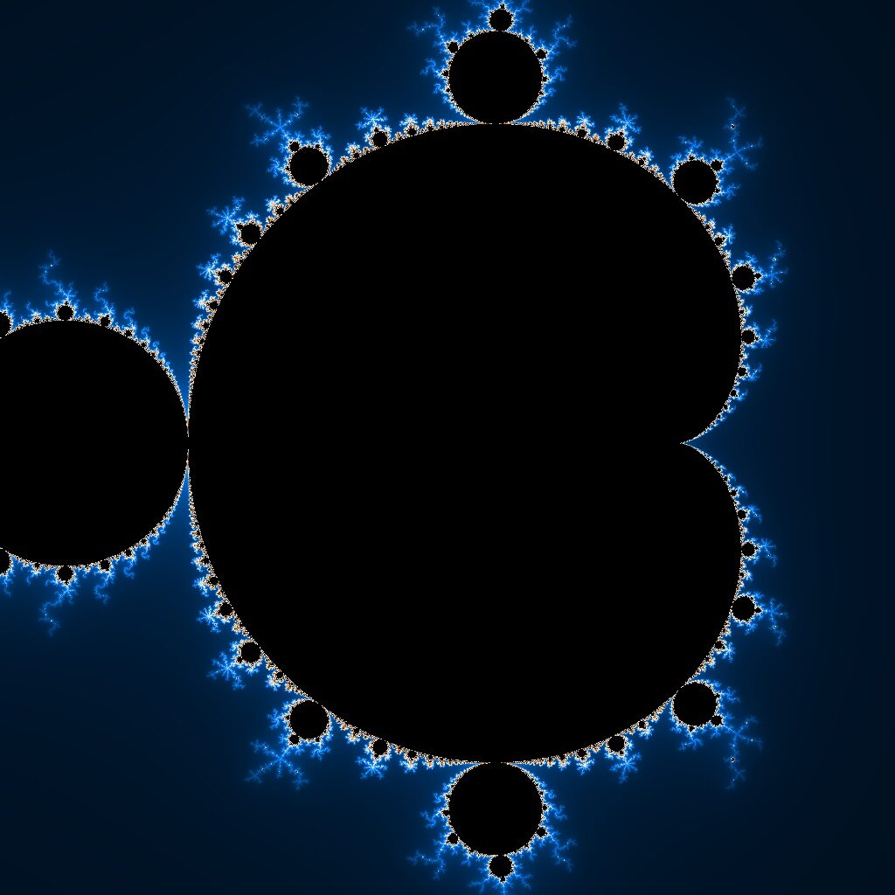The Main Cardioid

To the left of the main cardioid you have a perfect circle known as “the main bulb”. There are many of these circles around the main cardioid, and then again around the main bulb, and then again and again as you zoom into the edges of each of the circles.

The Main Bulb

The next obvious feature that people talk about is “the valley of the seahorses”. This sits between the main cardioid and the main bulb, where the two coloured areas of the manelbrot start fo move towards each other. The name comes from the resemblance of the swirly areas to a seahorse.

Seahorse Valley

These valleys occur whenever a bulb grows out of the edges of the cardoid or a sub-bulb, and they each have that characterstic swirlyness.

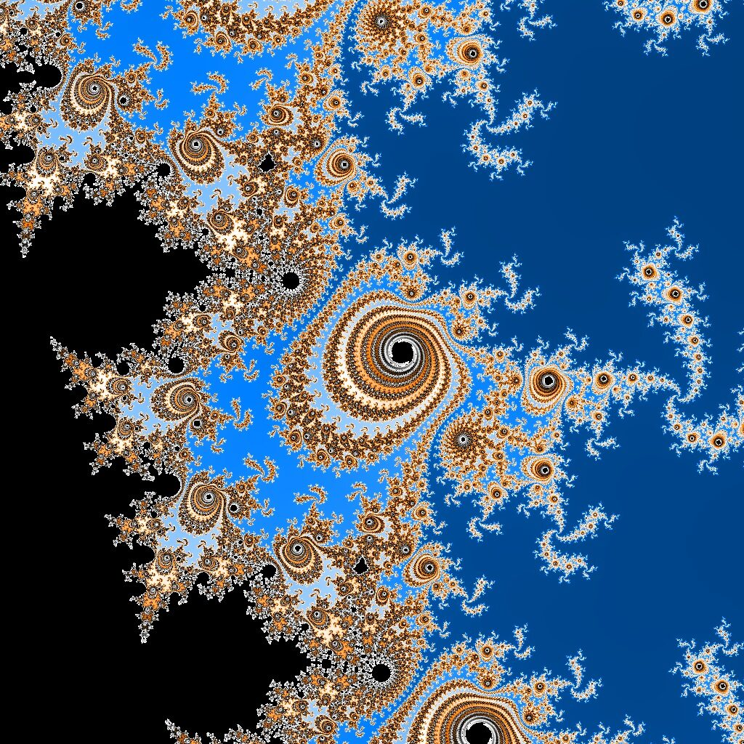Another seahorse valley deeper into the mandelbrot

Moving back to a sidebulb, you’ll notice that there are “antennae” that move away from each bulb. These antenna have interesting properties. For example, if you look at the sub-bulb at the top of the main cardoid you’ll notice that it has 3 antennae (including the one pointing back at the bulb). We’ll come back to these another time, but you’ll notice that different sidebulbs have different numbers of antennae.

The 3 antennae above the top sidebulb of the Mandelbrot

Another named area of the mandelbulb is Elephant Valley. This is on the right handside of the mandelbulb, where the main cardoid turns in towards the origin. The name comes from the resemblance of the antennae to the trunks of elephants.

An Elephant of Elephant Valley

One area that has a unique feel on the mandelbulb is to the left of the main bulb as you track along the antennae going horizontally left towards the -2 boundary. At this point the antennae are very long and closely resemble lightning.

Lightning on the left of the fractal

The mandelbulb itself occurs within the edges of the mandelbulb wherever you look in the fractal. Sometimes it’s slightly warped or squished, but it’s always recognisable. Here’s an example from zooming in deeper into the fractal.

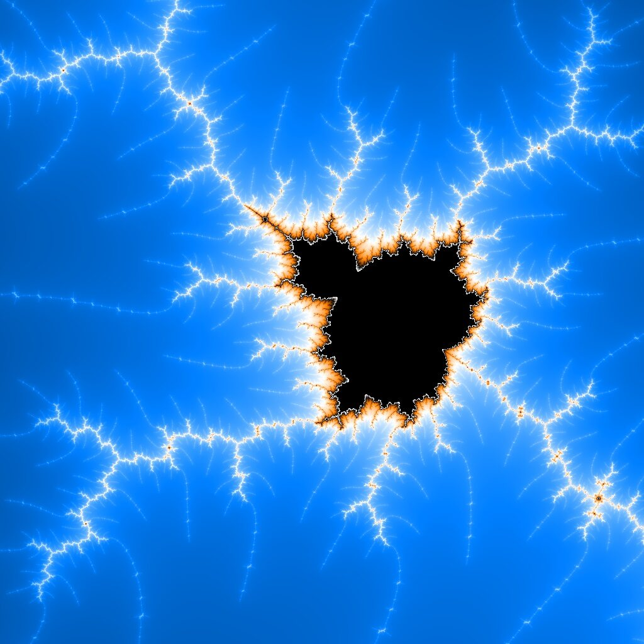A mini Mandelbrot

The Julia fractals are a set of fractals closely related to the mandelbrot, which I may come back to some other time. What’s somewhat surprising is that there are areas within the main mandelbrot which look just like julia fractals. Here’s an example found from zooming around the map.

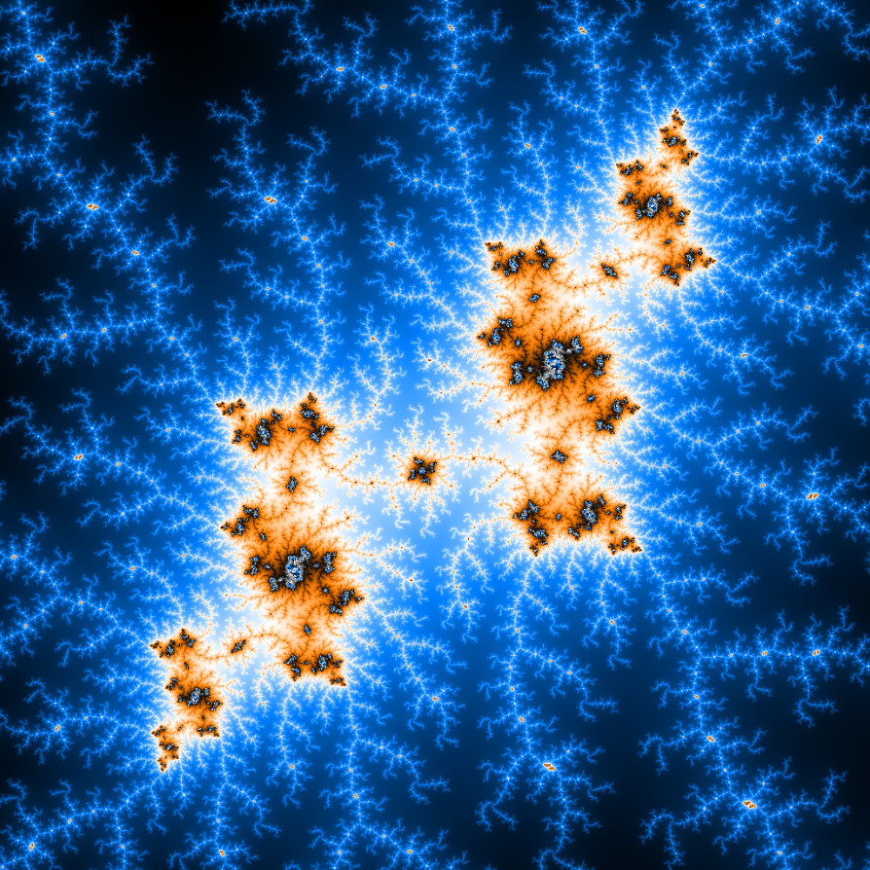

If you’d like to explore the mandelbrot in more detail, feel free to use the [mandelbrot viewer](http://woofractal.com/mandelbrot-viewer)available on this site. Happy exploring!

# Mandelbrot orbits

In this article I’ll dive into the Mandelbrot formula itself, and take a look at how the formula behaves at different points within the fractal.

As I mentioned in an earlier article, the Mandelbrot fractal is based around a single simple formula, which is often represented using complex numbers. I won’t bore you with complex number theory, because it’s irrelevant to the fractal. For now just think about each iteration of the formula as a function which acts on a 2 dimensional point in space.

For each iteration of the Mandelbrot formula a simple formula is used.

pn+1 = f(pn) + c, where c is the (x,y) coordinate on the fractal.

P0 is the starting location for the formula, and we put that at (0,0).

The function f() uses the following formulae to calculate the next x,y coordinate.

newx = x*x – y*y + cx

newy = 2*x*y + cy

Now we simply carry on doing this series of calculations and see what happens to the x and y coordinates. Specifically we’re watching to see whether or not this formula exceeds the circle of radius 2. If it does, then the x and y coordinates will rapidly accelerate away from the centre with each following iteration, the formula is unstable with the cx and cy values that we entered, and subsequent iterations will rapidly result in very large x and y coordinates. If the iteration continues to stay within that circle, then we assume the formula is stable.

To colour the fractal we then colour the stable points a fixed colour (normally black). And for all points with an unstable formula, we colour the point based on how many iterations of the formula it took before it exceeded the radius 2 circle.

We can look at this visually to observe how the x and y coordinates behave on each iteration. First up lets take a look at a stable point inside the main bulb of the Mandelbrot.

As you can see, not much to see frankly… The box on the top left shows each iteration point up to a total of 32 iterations. The first black dot in the middle is 0,0. This goes immediately left to about -0.3, 0.05, and then rapidly hones into a stable coordinate in the white dot.

If I move the cursor close to the edge with the main cardioid something interesting starts to happen.

This time around the iteration points rapidly move out to the coordinates at the edge of the main bulb, but instead of settling down to a single point, they start oscillating around in a circle. This formula may still remain stable under large numbers of iterations, but it may also start to escape the boundary. We don’t know until we continue to iterate the formula.

Now for something really strange I’ll move the cursor into the main bulb of the fractal (the large circle to the left of the main cardioid).

This time around the formula rapidly becomes stable once again, but now it has two stable locations which it continues to oscillate between.

And if we move into the bulb to the left of this one…

…we suddenly have 4 stable locations within the formula.

I’d strongly advise you to try this yourself by following this link to try it in realtime on your browser.

<http://woofractal.com/mandelbrot-viewer?x=-0.6557241586538461&y=-0.07106370192307691&z=0.65&m=0&jx=-0.38228665865384615&jy=-0.16421274038461536>

The next thing to mention is that the really interesting orbits within the formula happen close to the edges of stability. If we move the cursor within a sidebulb, and close to the edge, the orbits can start to make very elaborate patterns.

But what remains really difficult to predict, is whether or not a sequence of positions will remain stable within the radius of 2, or whether it will become unstable. And the only real way to find out is to carry on iterating that formula, and the more you iterate, the more likely you are to find that an orbit is unstable in the longer term.

For example, here’s a fractal with an iteration count of 256.

All of the points in black here have an orbit which is stable up to 256 iterations. Now lets change the fractal to use 512 iterations and see what happens.

The colour palette has changed a bit, but if you look at the black areas of the fractal you can see that there is now a much more clearly defined circular boundary to the dark areas, and previously black pixels now have a colour. Any pixels that are now coloured represent a Mandelbrot orbit which became unstable between 256 and 512 iterations.

You can continue upping the iteration count which will continue to uncover more points on the fractal with unstable iterations, but there are some points within this fractal that will never become unstable. That’s the fundamental beauty of the Mandelbrot fractal.

A final thing that you may find interesting is a correlation between the Mandelbrot fractal and bifurcation diagrams.

Julia fractals

The Fibonacci sequence