CNN LANGUAGE CLASSIFIER
Assignment 1

On this assignment I used Convolution Neural Network model in which has shown promised results in many research papers when applied to Natural Language Processing tasks such as text classification.

The model has been implemented in python using Keras and TensorFlow libraries. It’s compose of an embedding layer with 128 of dimension and 3 convolution branches where each branch applies convolution over 2, 3 and 4 words, then merged in fully connected network fashion.

CNN model architecture:

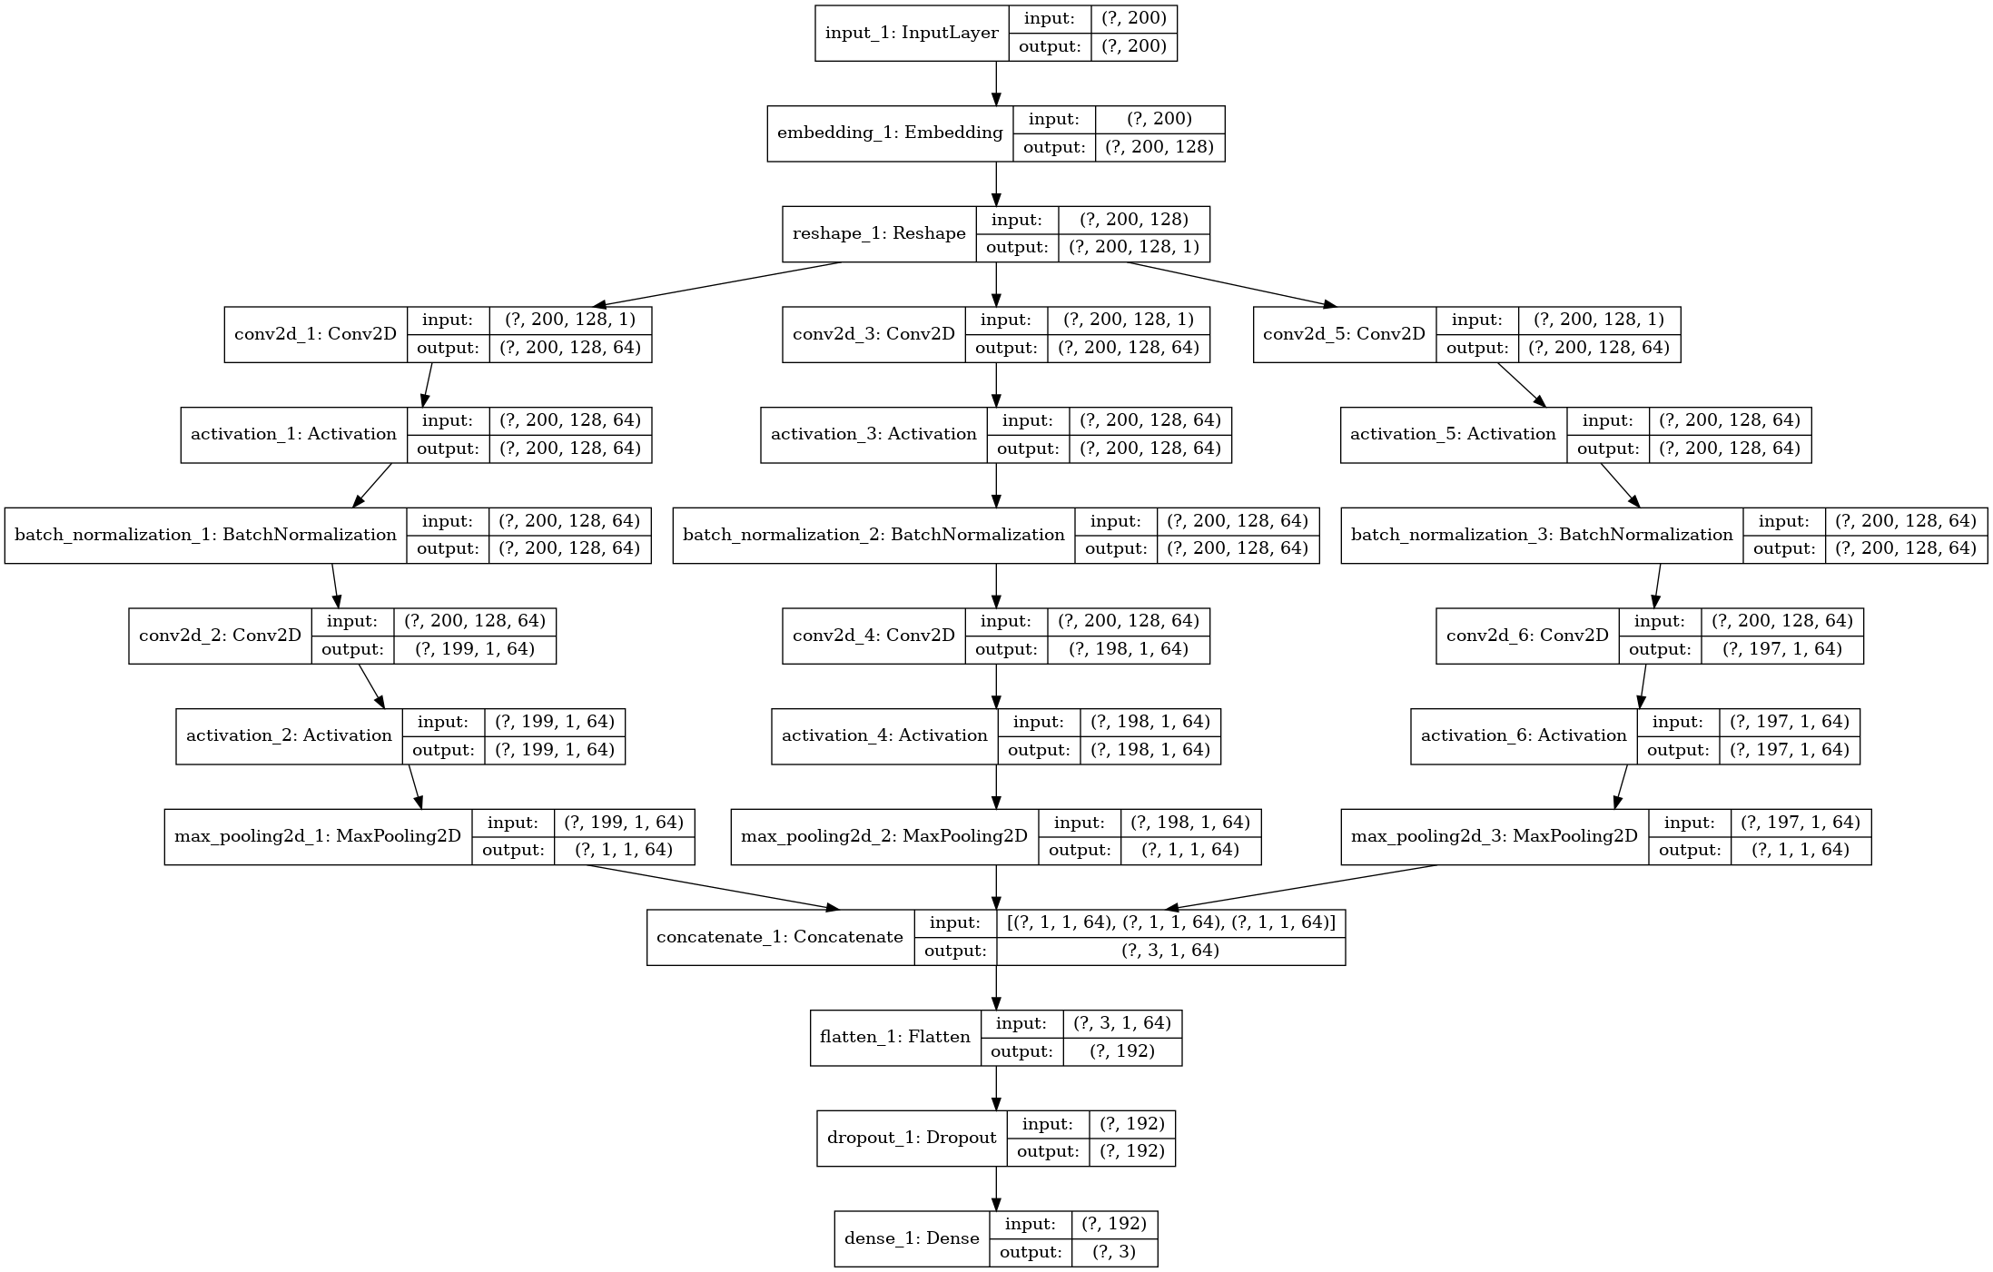

Data Analysis:

The dataset consist of 2761 rows (after remove null values) and 3 labels – Afrikaans, English and Nederlands where the dominant samples are labeled as English and few samples as Nederlands. Classification problems tends to work poorly on imbalanced dataset. For this purpose, sampling strategy has been applied, where sentences for each other classes are randomly duplicated to aligned with English samples. A better approach would be collecting more distinct samples for two classes with few samples.

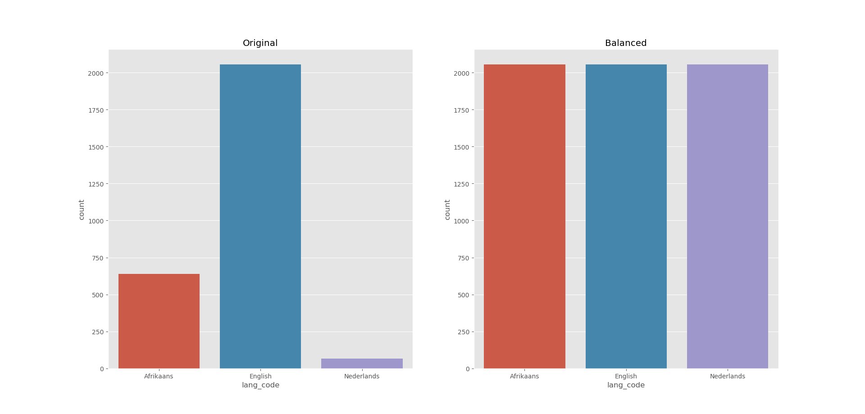

Data Cleaning:

I removed from data-frame the entire row where column value is nan and/or sentence has duplicated labels.

 | text | label count
34 | A dog is a man's best friend | 2
76 | A rolling stone gathers no moss | 2
204 | s different as chalk and cheese | 2
209 | As fit as a butcher's dog | 2
960 | For all intents and purposes | 2
1399 | It's not rocket science | 2
2179 | So maklik soos brood en botter. | 2
2291 | Take potluck | 2
2372 | The law is an ass | 2

Data Pre-Processing:

Using Keras Tokenizer the entire sentence list are converted into 2D array of codes where each code represents a word, then padded to same length using pad_sequences function. Similar conversion technique is applied for labels where each label is represent as an integer index (0 – Afrikaans, 1 – English, 2 – Nederlands) and then converted into categorical representation ([1,0,0] - Afrikaans, [0,1,0] – English, [0,0,1] – Nederlands).

 | text | label
 | Ship shape and Bristol fashion | English
Encoded | [33 1 33 2 19 0 0 0 0 0 0 0 0 0 0 0 0 0 0 0 0 0 0 0  0 0 0 0 0 0 0 0 0 0 0 0 0 0 0 0 0 0 0 0 0 0 0 0  0 0 0 0 0 0 0 0 0 0 0 0 0 0 0 0] | [0. 1. 0.]

Train Model

Using Tensorflow Dataset class, samples are shuffle and split into:
- 50 % train
- 35 % validation
- 25 % test

During training process I manually adjust hyper-parameters such as embedding dimension (embed_dim), filter_sizes, dropout, optimizer and it’s learning rate to improve validation and test accuracy. Semi automated algorithm can be used such as scikit-learn function GridSearchCv for fine-tuning hyper-parameters.

Model Train Accuracy:

The model has been trained for 40 epochs, with embedding dimension of 128 and 64 filters per convolution layer and validation accuracy reached 99%.

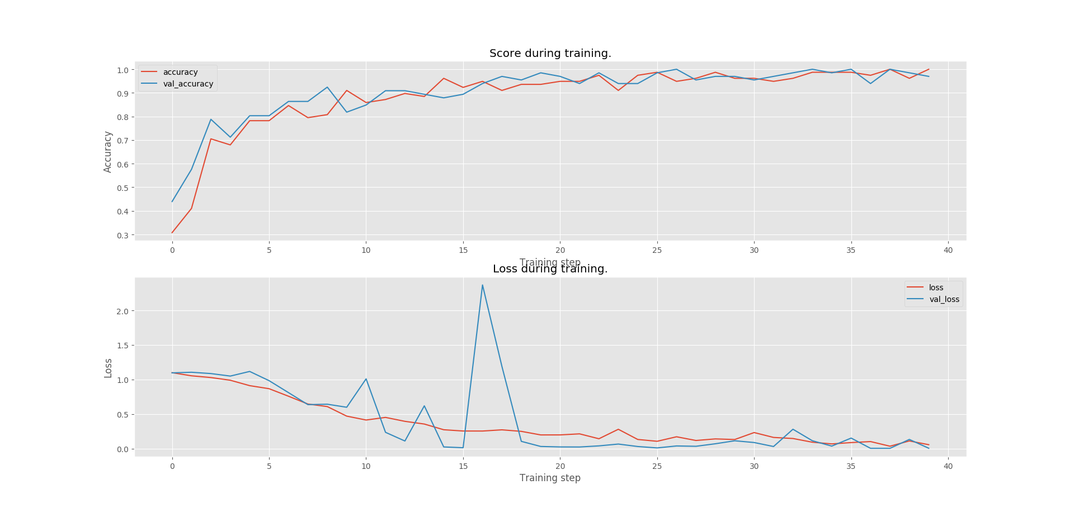

Model Test Accuracy:

Looking at subplots bellow where true labels of data samples are the legends above and predicted labels as bars. The bars represents how many text/sentences has been predicted correct (legend above and at bottom of bar matches) and incorrect (legend above and at bottom differs). For example, looking at subplot in blue, sentences with true label as Afrikaans has been incorrect classified as English approximately 25 times and 5 times as Nederlands.
