*HW#5: ServiceMix*

**ServiceMix QuickStart**

**Main steps**

- Create and deploy *inputOutput.xml* for moving files from one directory to another

- Create and deploy *activemq.xml* for moving files from one directory to another

-Create and deploy *messageLogging.xml* for creating a *log* when files from one directory to another are moved by *activemq.xml*

*\*ID: 226, 227, 228 Active Deployed bundles for the tasks above.*

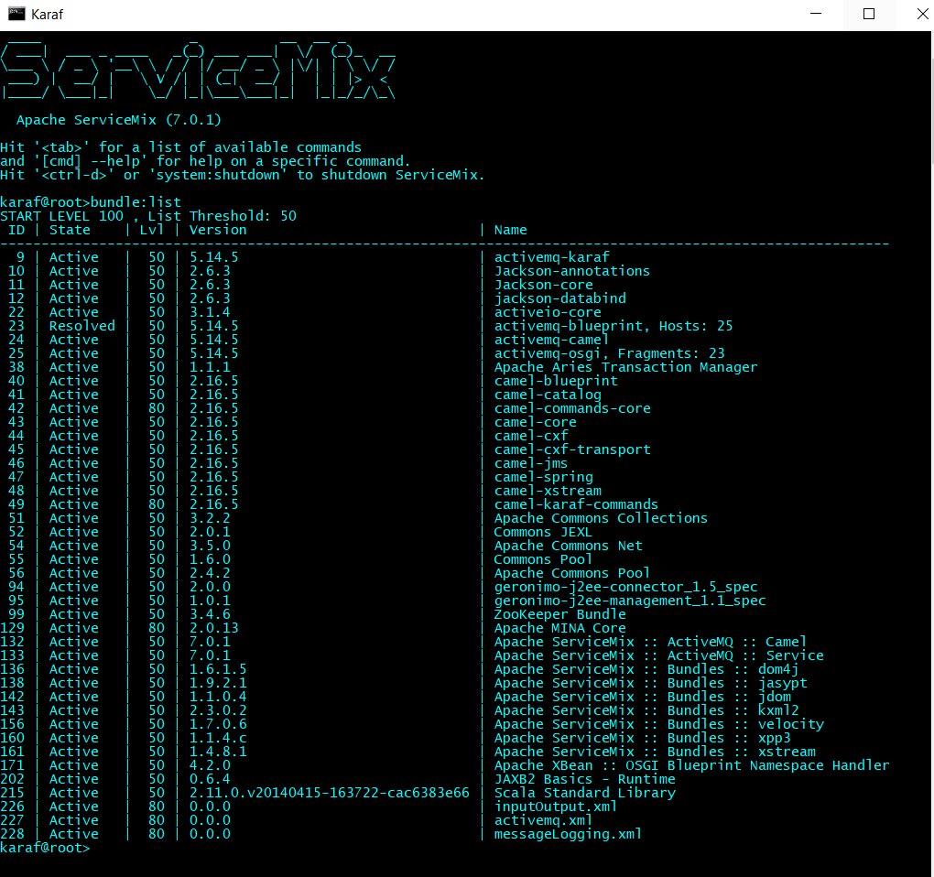

*Logged Events from *messageLogging.xml*

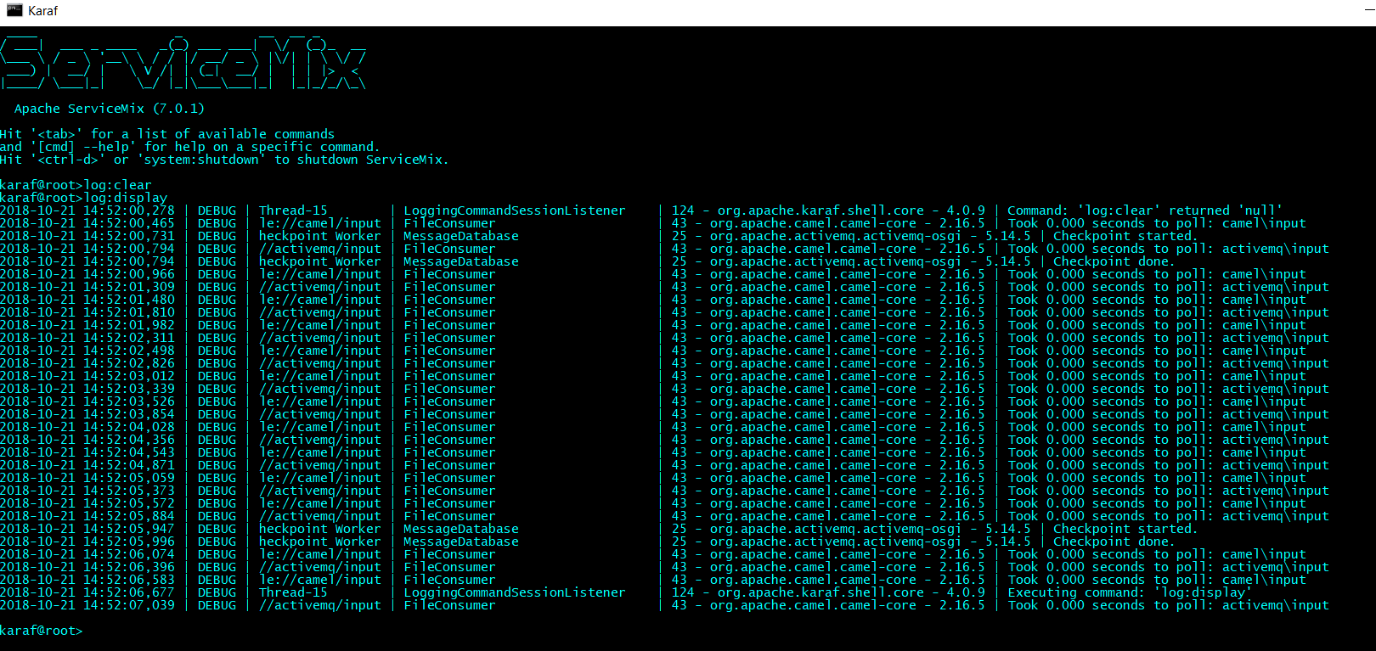

**Producer-- Consumer application using ActiveMQ and JMS as maven project**

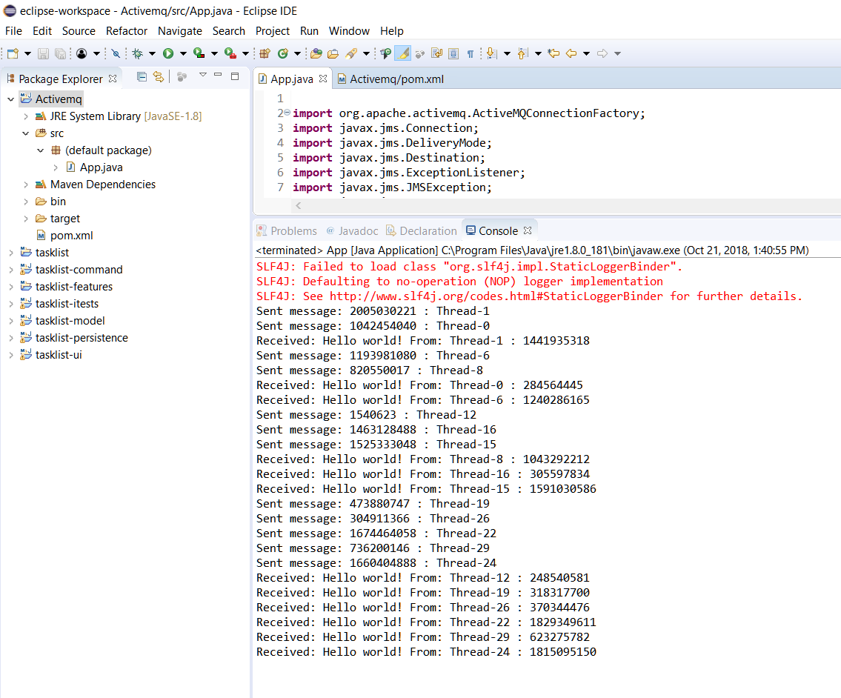

**ActiveMQ web console: Home**

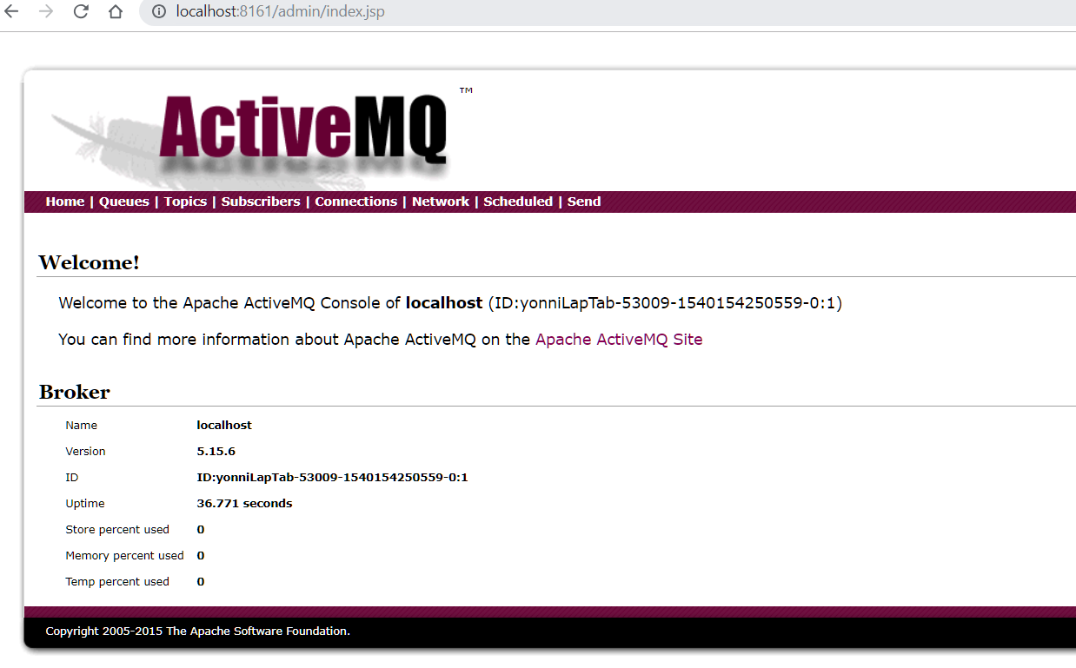

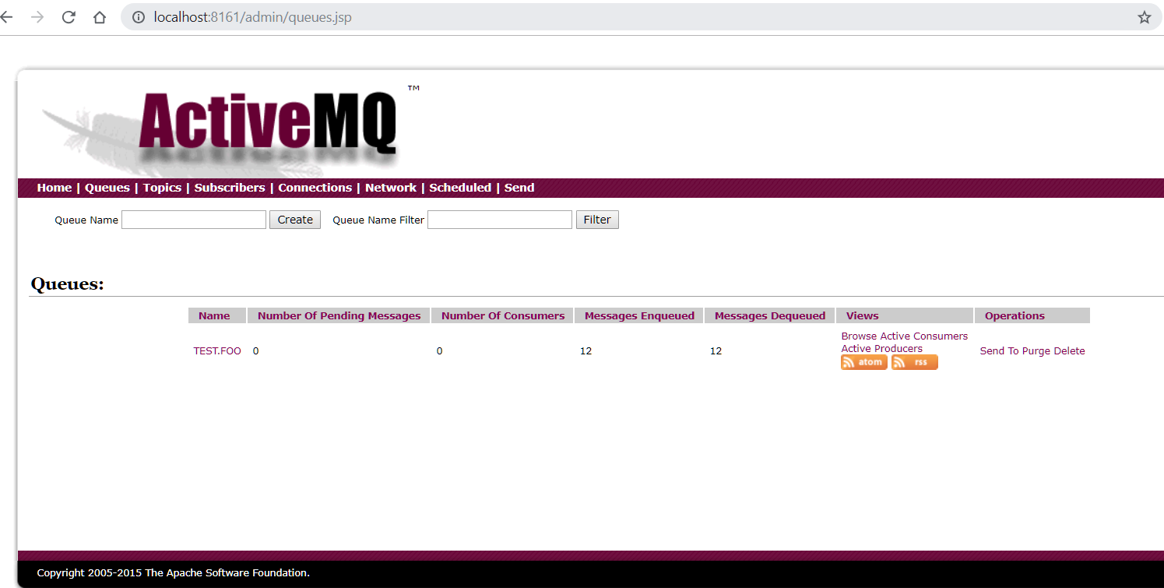**ActiveMQ web console: Queue**