Capstone Project — Banking System Data Pipeline
Samsung Innovation Campus

Banking System (Customer Churn)

1. Project Overview
This project aims to build an end-to-end Big Data and AI-driven Banking Customer Churn Prediction System that analyzes customer demographic, financial, product usage, marketing, and customer support data to identify customers who are likely to leave the bank.
The core of the system is the Customer Churn dataset, represented by the customer table, which contains the main customer information and the target variable exited. The customer data is integrated with multiple related banking datasets, including usage, offers, and customer support tickets.
The project will demonstrate a complete Data Engineering → Big Data Processing → Data Modeling → Machine Learning → Analytics pipeline.

2. Business Problem
Customer churn is a major challenge for banks because losing existing customers can result in significant revenue loss and increased customer acquisition costs.
The objective of this project is to answer questions such as:
- Which customers are most likely to churn?
- What customer characteristics are associated with churn?
- Does product usage affect customer retention?
- Can customer support interactions indicate dissatisfaction?
- Can the bank identify high-risk customers before they leave?
- What actions can the bank take to retain those customers?
The final goal is to build a system that can predict customer churn probability and provide actionable insights for customer retention.

3. Main Dataset and Target Variable
The customer table represents the central entity in the system.
It contains:
- Customer demographic information
- Credit information
- Geographic information
- Customer tenure
- Number of products
- Credit card ownership
- Active membership status
- Estimated salary
- Customer registration information
- Contact information
- Churn status
The main target variable is: exited
where:
- 0 → Customer stayed with the bank
- 1 → Customer exited the ban
Therefore, the Machine Learning problem is primarily a Binary Classification problem.

4. Data Model
The system follows a Customer-Centric Banking Data Model, where the customer table acts as the central entity.
Main Tables :
1. Customer
Contains the main customer profile and churn label.
customer → exited
This table is the foundation of the churn prediction model.
2. Customer Usage
Contains information about customer product usage and monthly balances.
Relationship:
Customer 1 ──── N Customer Usage
This table can be used to measure:
- Product engagement
- Number of products used
- Monthly balance
- Product diversity
3. Offers
Contains marketing and retention offers provided to customers.
Relationship:
Customer 1 ──── N Offers
This allows the system to analyze:
- Number of offers received
- Offer types
- Offer acceptance rate
- Relationship between offers and churn
4. Customer Support Tickets
Contains customer service interactions.
Relationship:
Customer 1 ──── N Customer Support Tickets
This can provide useful churn signals such as:
- Number of support tickets
- Issue severity
- Issue types
- Average resolution time
- Frequency of customer complaints
5. Data Engineering Layer
The raw banking data will initially be stored in CSV files.
The pipeline will perform:
- Data ingestion
- Schema validation
- Missing value handling
- Duplicate detection
- Data type correction
- Invalid value detection
- Referential integrity validation
- Date standardization
- Data normalization where required
- Data integration across multiple tables
The cleaned data will then be loaded into the Big Data ecosystem for scalable processing.

Dataset Size
The banking database currently contains the following number of records:
Table | Number of Records
Customer | 10,077
Customer Usage | 15,766
Offers | 8,446
Total Records: 34,289
The customer table represents the core entity of the system, while the other tables contain related financial, transactional, product usage, loan, marketing, and customer support information.

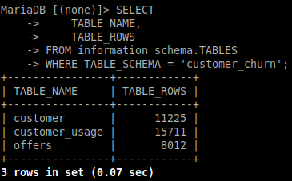

STEP  1 | Understand Requirements & Design the Database Schema  (Database Data Sourcing)
Description / Goal of this step :
Analyzed the project requirements and designed a relational banking database focused on Customer Churn Prediction.
The core customer entity is connected to related banking tables such as customer usage, offers, customer support tickets, and Customer data.
The data is sourced from 1 sources + AI Generated Tables:
Bank Customer Churn Dataset
Tools & Technologies used :
- MariaDB / MySQL
What was done (Commands & Scripts) :
- Designed the banking database schema with 3 related tables.
- Defined Primary Keys and Foreign Keys to maintain relationships and data integrity.
- Loaded the generated CSV datasets into MariaDB.
Steps :
1 – Move CSV Files to VM using Shared Folder :
2 - Open MySQL DB on VM and create DB:
mysql -u student -p and the password : student
CREATE DATABASE IF NOT EXISTS customer_churn;
USE customer_churn;
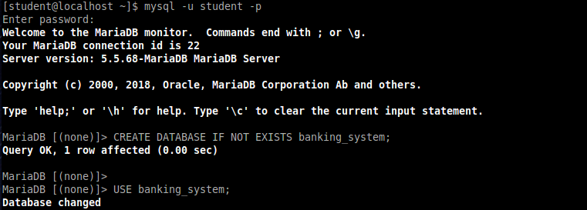
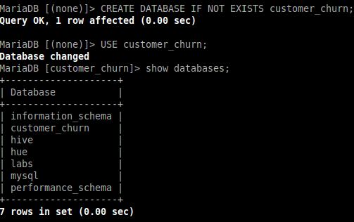
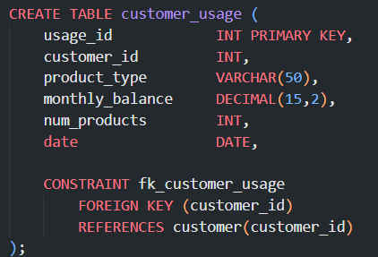
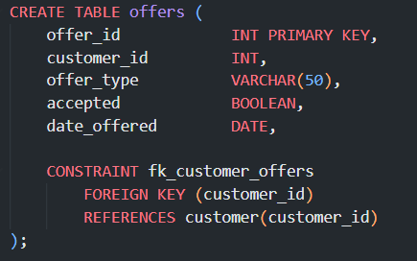
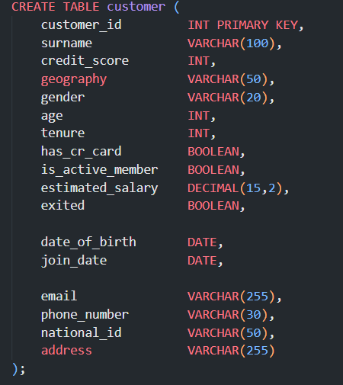
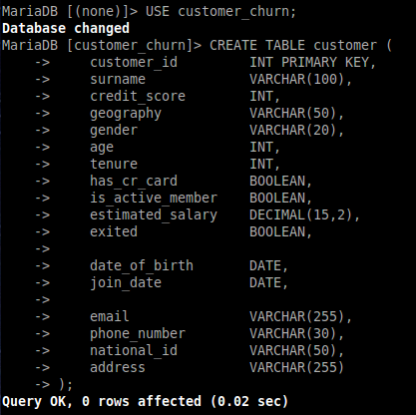
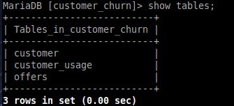
3 - Load CSVs data into MySQL Tables :
SHOW VARIABLES LIKE 'local_infile';
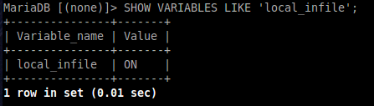
Now insert Data
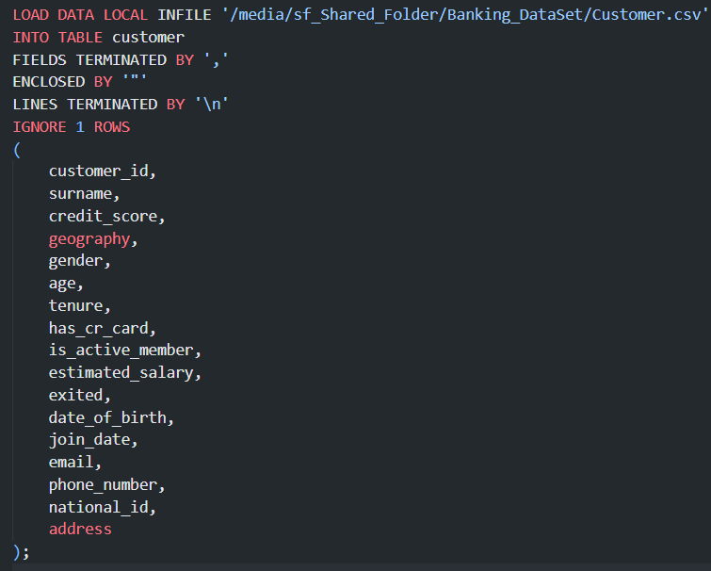
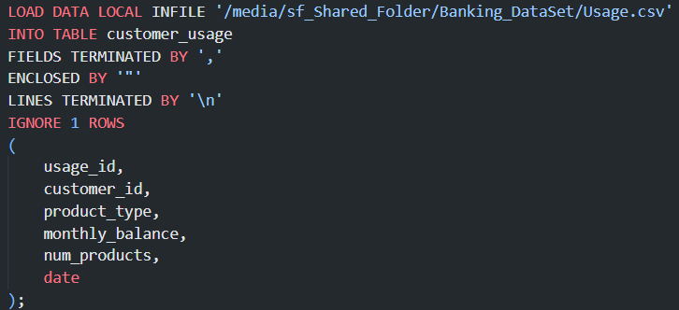
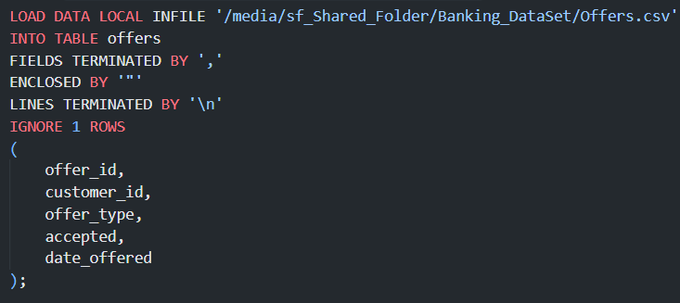

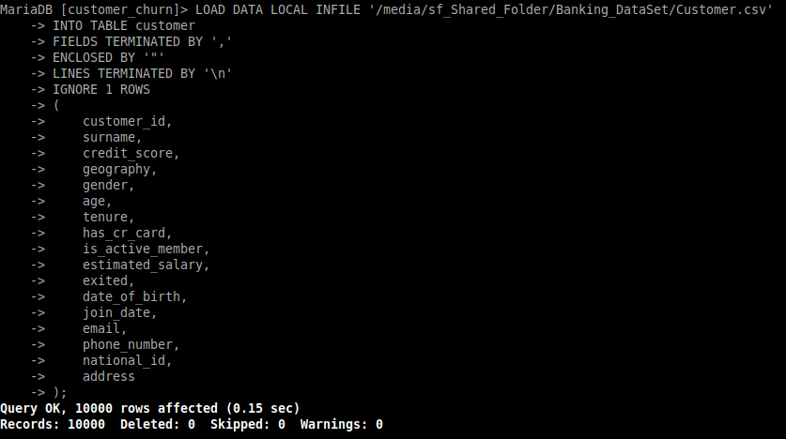
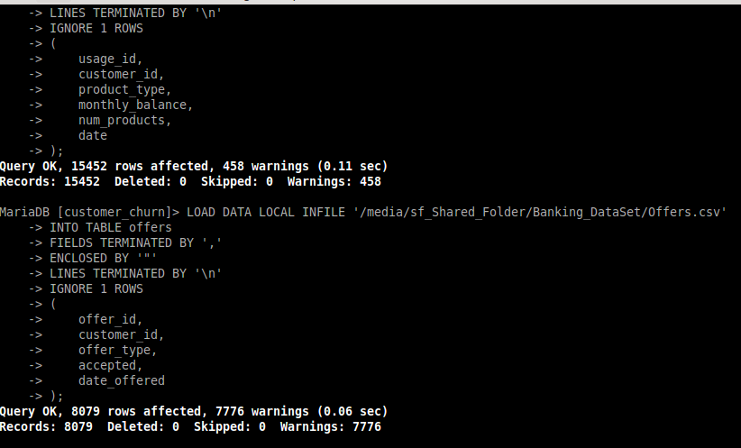
Created a database dump to share the complete banking_system database (schema + data) with the team using:
mysqldump -u root -p banking_system > banking_system.sql
For Easily transfer and restore the complete database on other team members' machines.
Challenges Faced :
- Handling Foreign Key constraint violations during data loading.
- Resolving CSV column order mismatches with the database schema.
- Fixing data type and data truncation warnings.
- Managing CSV headers correctly using IGNORE 1 ROWS

STEP  9 | Load data into HDFS  (Storage)
Description / Goal of this step
The goal of this step is to ingest data from the different data sources into HDFS, which acts as the centralized storage layer of the Big Data architecture.
The project contains data coming from two different data sources:
- MariaDB Database — contains the structured banking system data.
- CSV Files — contain additional data that is provided as file-based data.
The final goal is to have the data available in HDFS so that it can later be processed and analyzed using Apache Spark.

Tools / Technologies used :
Different ingestion tools were used according to the type of data source:
- Apache Sqoop was used to perform bulk data ingestion from MariaDB into HDFS.
- Apache NiFi was used to ingest CSV data, transform it from CSV to Parquet, and store the resulting file in HDFS.
- MariaDB — Source Database
- HDFS — Distributed storage layer

Steps :
Step 1 — Ingesting MariaDB Data into HDFS using Sqoop
The first data source is the MariaDB banking database.
The database used by the project is:
Database: customer_churn
Host: localhost
Port: 3306
User: student
Before performing the ingestion, the required banking tables were created and populated in MariaDB.

Checking the Database Port : SHOW VARIABLES LIKE 'port';
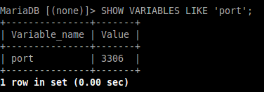
Step 2 — Creating the HDFS Project Directory :
A dedicated directory was created in HDFS to organize the project data:
hdfs dfs -mkdir -p /user/student/Capstone_Project
The HDFS directory structure is used to separate the different datasets and maintain an organized storage layer.
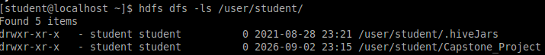
Step 3 — Importing MariaDB Tables using Sqoop
Apache Sqoop was used to perform the bulk data transfer from MariaDB to HDFS.
The general Sqoop connection was:
jdbc:mysql://localhost:3306/customer_churn
Examples Import: 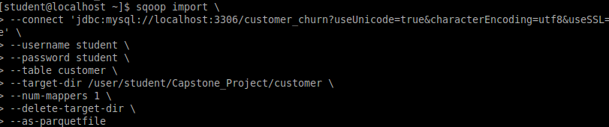
1) Customer : sqoop import \
--connect 'jdbc:mysql://localhost:3306/customer_churn?useUnicode=true&characterEncoding=utf8&useSSL=false' \
--username student \
--password student \
--table customer \
--target-dir /user/student/Capstone_Project/customer \
--num-mappers 1 \
--delete-target-dir \
--as-parquetfile
2) Customer_usage : sqoop import \
--connect 'jdbc:mysql://localhost:3306/customer_churn?useUnicode=true&characterEncoding=utf8&useSSL=false' \
--username student \
--password student \
--table customer_usage \
--target-dir /user/student/Capstone_Project/customer_usage \
--num-mappers 1 \
--delete-target-dir \
--as-parquetfile
3) offers : sqoop import \
--connect 'jdbc:mysql://localhost:3306/customer_churn?useUnicode=true&characterEncoding=utf8&useSSL=false' \
--username student \
--password student \
--table offers \
--target-dir /user/student/Capstone_Project/offers \
--num-mappers 1 \
--delete-target-dir \
--as-parquetfile
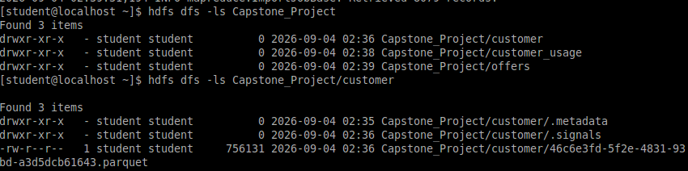
Why Parquet?
The data was imported directly as Parquet because it is a columnar storage format that provides:
- Efficient storage
- Compression
- Faster analytical queries
- Better performance with Apache Spark
- Schema preservation
Step 4 — Ingesting the Second Data Source using Apache NiFi
The project also contains data that does not from the MariaDB database.
The second data source is a CSV file: customer_support_tickets.csv
Its location is : /media/sf_Shared_Folder/Banking_DataSet/Customer_support_tickets.csv
Since this data source is file-based, Apache NiFi was used to create an ingestion pipeline.
The NiFi flow performs two main operations:
- Read the CSV file.
- Convert the CSV data into Parquet and upload it to HDFS.
Step 5 — Creating the NiFi Flow
GetFile -> ConvertRecord -> UpdateAttribute -> PutHDFS
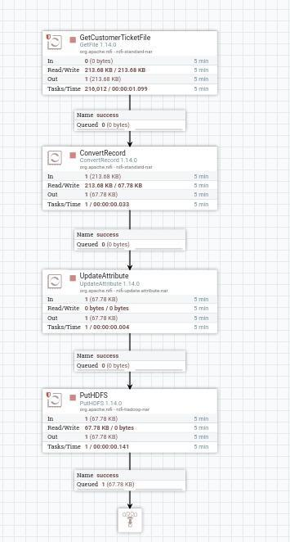

Nifi Processors :
1) GetFile : The GetFile processor was configured to read the CSV file from: /media/sf_Shared_Folder/Banking_DataSet
A file filter was used to select only:
^Customer_support_tickets\.csv$
This prevents other files in the directory from being processed.
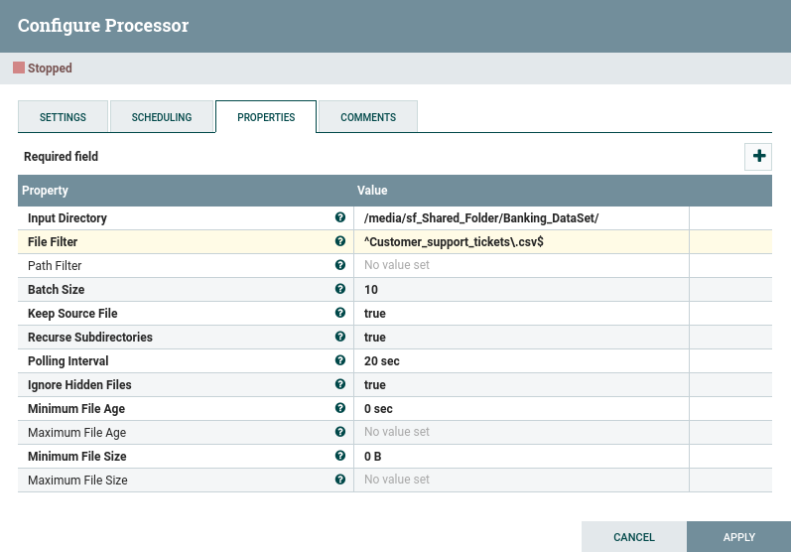
2) ConvertRecord : processor was used to convert the CSV records into Parquet format.
The processor was configured with:
Record Reader → CSVReader
Record Writer → ParquetRecordSetWriter
The CSVReader , ParquetRecordSetWriter use the registered Avro schema to correctly interpret the incoming records.
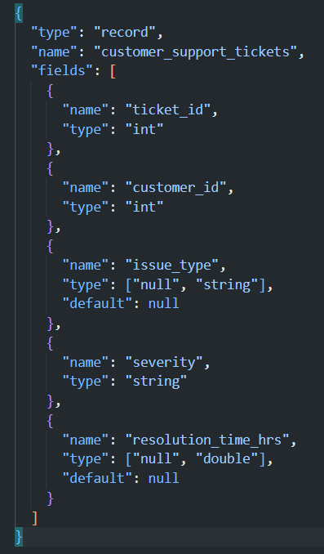
AvroSchemaRegistry : 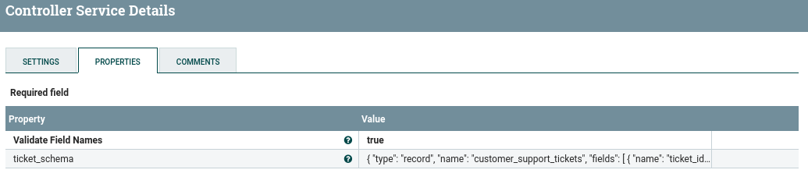

CSVReader Configuration 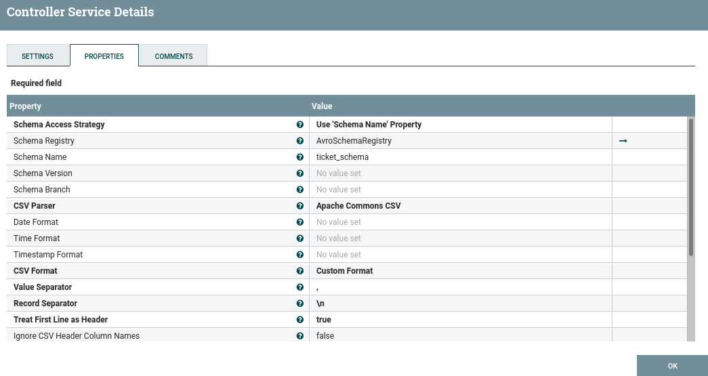ParquetRecordSetWriter Configuration 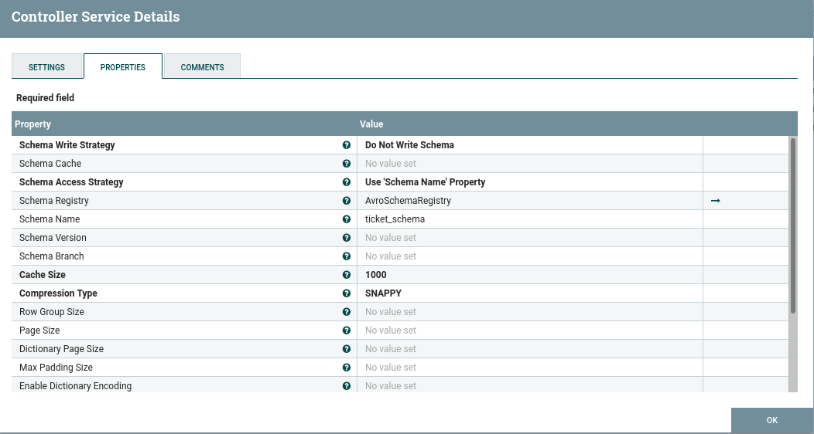

3) UpdateAttribute : processor was added to control the name of the generated Parquet file.
The following FlowFile attribute was configured:
filename = customer_support_tickets.parquet

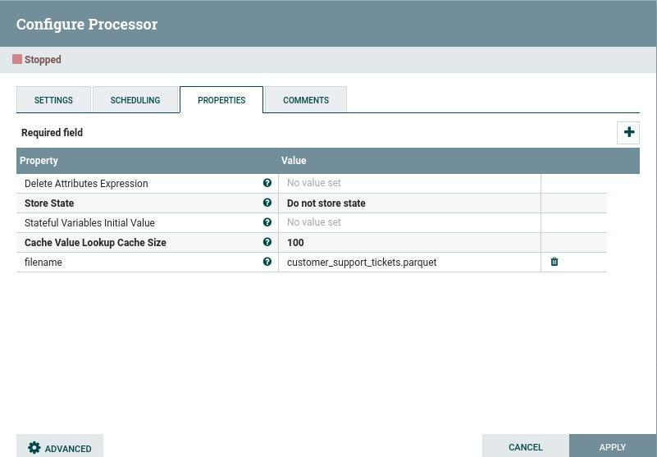
4) PutHDFS : processor was used to upload the generated Parquet file to HDFS.
The target directory was:
/user/student/Capstone_Project/tickets
The final expected path is:
/user/student/Capstone_Project/tickets/customer_support_tickets.parquet
The Hadoop configuration resources were configured using:
/home/hadoop/hadoop/etc/hadoop/core-site.xml
/home/hadoop/hadoop/etc/hadoop/hdfs-site.xml

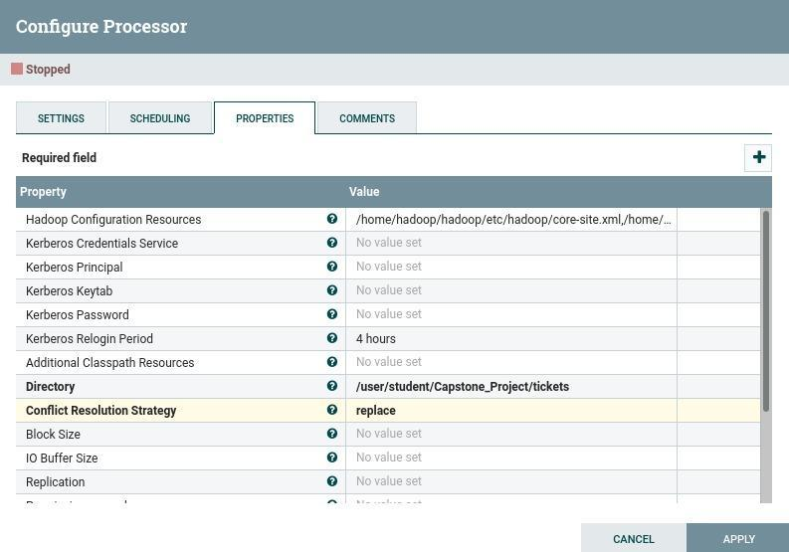
Found Hadoop configuration using : find / -name core-site.xml 2>/dev/null
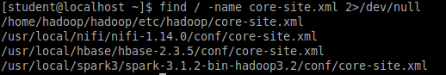

Step 6 : Verifying the NiFi Output in HDFS
After running the NiFi flow, the output was verified using:
hdfs dfs -ls /user/student/Capstone_Project/tickets
The expected output contains:
customer_support_tickets.parquet
The final structure is therefore:
/user/student/Capstone_Project/
├── customer/
├── customer_usage/
├── offers/
│
└── tickets/
└── customer_support_tickets.parquet
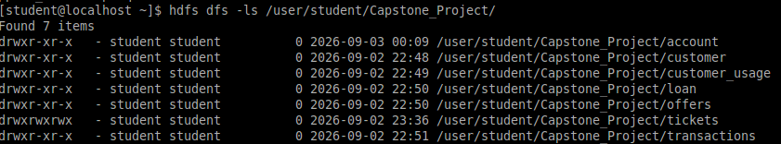
Final Data Ingestion Architecture :

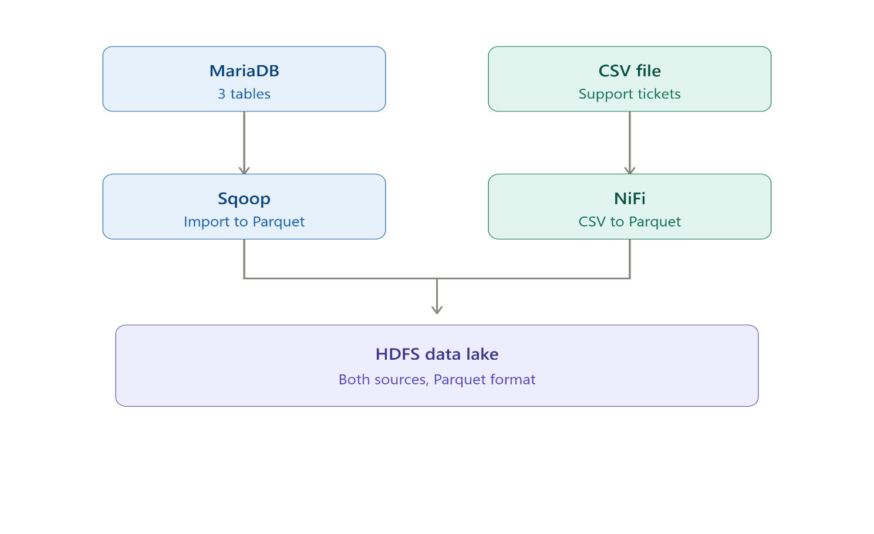

STEP  10 | Data Cleaning, Enrichment, Aggregation using PySpark  (Data Processing & Transformation)
Description / Goal of this step
Before performing any cleaning, an exploratory data analysis (EDA) and data quality assessment were conducted to identify existing data issues.
The following checks were performed:
- Duplicate IDs
- Missing and empty values
- Invalid numeric values
- Inconsistent categorical values
- Negative values
- Invalid business values
- Date format issues
The identified issues were then addressed during the cleaning stage.
Customer Data Cleaning & Validation :
- Duplicate customer_id
- Invalid age
- Invalid credit score
- Invalid tenure
- gender values
- geography values

After Cleaning :
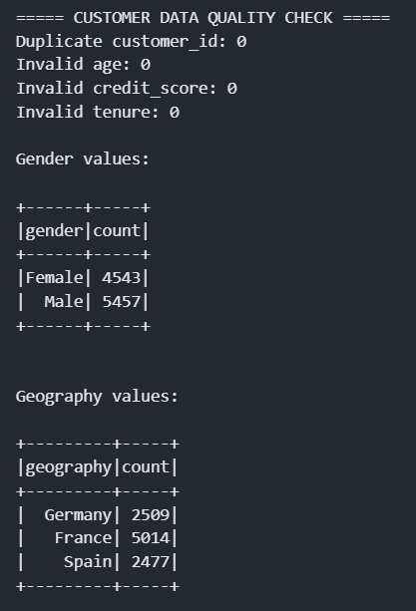
The categorical values of gender and geography were reviewed and standardized.
- Gender: Female, Male
- Geography: France, Spain, Germany
Customer Usage Data Cleaning & Validation :
The following fields were examined: usage_id, customer_id, product_type, monthly_balance, num_products, and date.

Issues Identified :

4.1 Inconsistent Product Types
Different formats of product_type were identified, such as Checking, CHECKING, checking, CreditCard, and Credit Card. The values were standardized by trimming spaces and normalizing the text format. CreditCard was standardized to Credit Card.

4.2 Empty Product Types
460 empty product_type values were identified. These values were replaced with Unknown.

4.3 Negative Monthly Balances
The EDA identified 228 records with negative monthly_balance values. Since negative balances were considered invalid for the project's business analysis, these records were removed.

4.4 Missing Monthly Balance
Missing monthly_balance values were handled using median imputation by product_type.

4.5 Date Conversion
The date column was stored as a Unix timestamp in the Parquet data. It was converted into a standard Spark Date format

Final Validation :
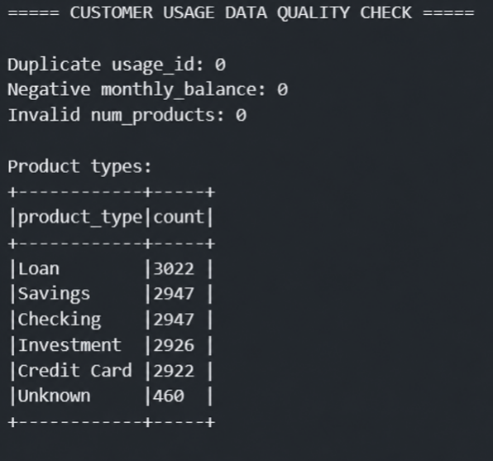
Customer Support Tickets Cleaning & Validation :
The following fields were examined: ticket_id, customer_id, issue_type, severity, resolution_time_hrs, is_resolved, and date.

Issues Identified

5.1 Missing Issue Types
Missing/empty issue_type values were identified and replaced with Unknown. The final dataset contains 175 Unknown issue types.

5.2 Inconsistent Issue Type
An inconsistent value such as loginn issue was standardized to Login Issue.

5.3 Negative Resolution Times
EDA identified 93 records with negative resolution_time_hrs values. These values were considered invalid and converted to 0.

5.4 Unresolved Tickets
A business rule was applied: resolution_time_hrs > 0 means is_resolved = 1, while resolution_time_hrs = 0 means is_resolved = 0. This ensured that unresolved tickets did not contain NULL resolution times.

5.5 Severity Standardization
Severity values were standardized into Low, Medium, High, and Critical.

Final Validation
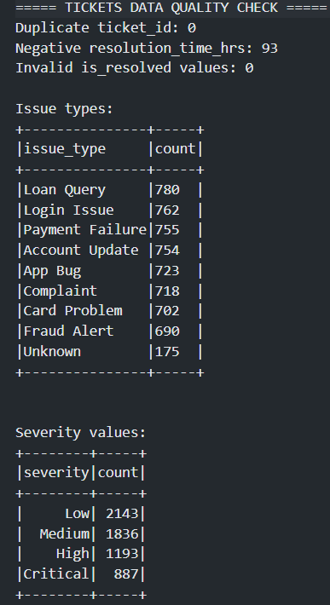
Offers Data Cleaning & Validation :
The following fields were examined: offer_id, customer_id, offer_type, accepted, and date_offered.

Issues Identified

6.1 Empty Offer Types
324 empty offer_type values were identified. These values were replaced with Unknown.

6.2 Accepted Value Standardization
The accepted field contained different representations of Boolean values, such as True/False, true/false, Yes/No, Y/N, and 1/0. These values were standardized into Boolean values: true and false.

Final Validation
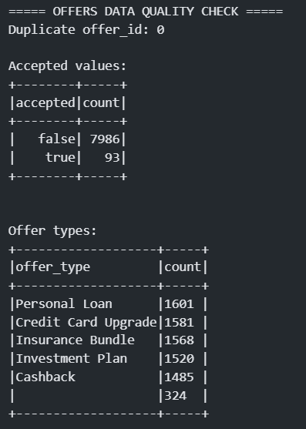

Overall Data Quality Results
After completing the cleaning and validation process, all four datasets passed the required data quality checks.
Dataset | Status
Customer | Passed
Customer Usage | Passed
Customer Support Tickets | Passed
Offers | Passed

Tools / Technologies used
- Pyspark

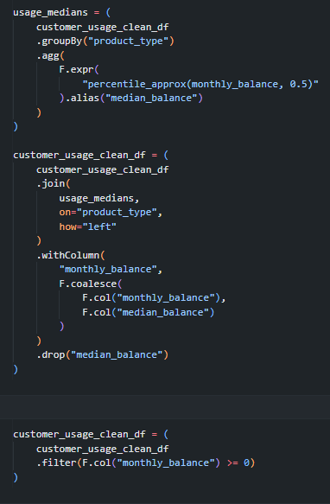
What was done (Commands / Scripts)
Example :
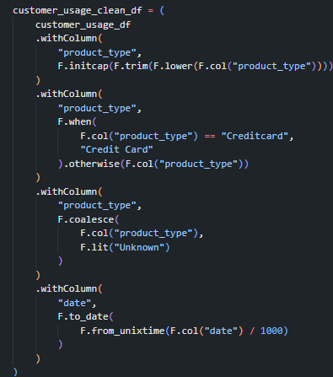

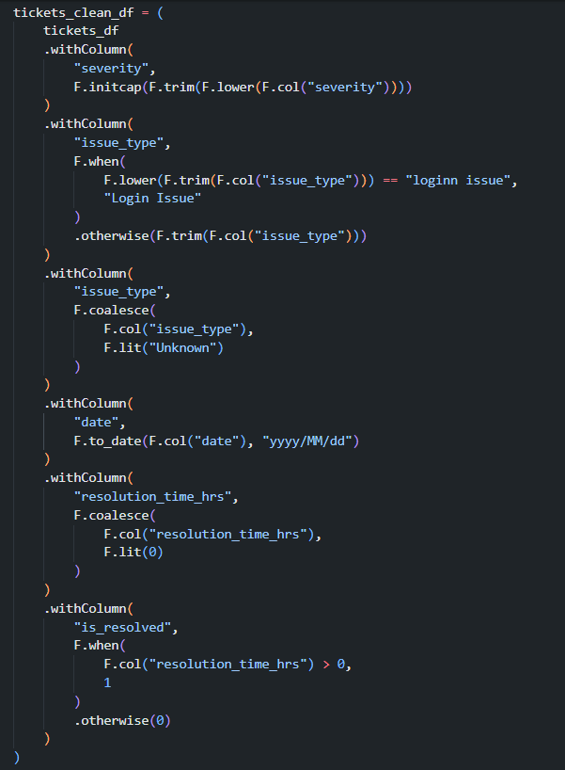
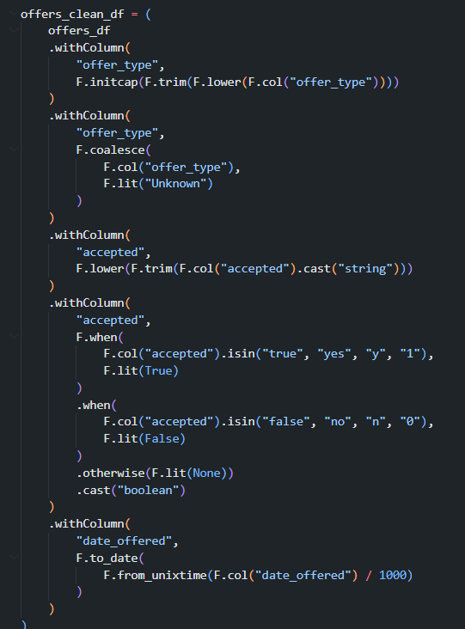

STEP  11 | Data Warehouse Design and Dimensional Modeling  (Data Warehouse Design & Dimensional Modeling
Description / Goal of this step
The goal of this step is to transform the cleaned banking data into a structured data warehouse that supports customer churn analysis, business reporting, and machine learning.
The warehouse is designed around the customer as the central business entity. It combines customer information with monthly product usage, marketing offers, and customer support activity.
The design follows a dimensional modeling approach, using:
- One central fact table
- Customer and date dimension tables
- Foreign keys to connect the tables
- Aggregated monthly measures for analytical queries
This design makes it easier to analyze customer behavior over time and compare different customer groups.
1. Data Warehouse Grain
The grain defines exactly what one row in a fact table represents.
The grain of the central fact table is:
One row represents the aggregated activity of one customer during one month.
For example, if customer 1001 has activity during January 2025, the fact table contains one row for that customer and month. That row may contain:
customer_id | activity_month | offers_received_count | tickets_opened_count | ending_monthly_balance
1001 | 2025-01-01 | 3 | 2 | 5000

If the same customer has activity during February 2025, another row is created:
customer_id | activity_month | offers_received_count | tickets_opened_count | ending_monthly_balance
1001 | 2025-02-01 | 1 | 4 | 4200

Therefore, the fact table does not contain one row for every individual offer or ticket. Instead, those records are aggregated at the customer-month level.
This grain was selected because the project focuses on understanding how customer behavior changes over time and how those changes may be associated with churn.
2. Data Warehouse Design
The warehouse contains the following main tables:
A. Fact_Customer_Monthly_Activity
This is the central fact table of the warehouse. It stores the measurable customer activity aggregated by month.
Main columns
Column | Description
activity_key | Surrogate primary key for the fact record
cust_key | Foreign key referencing Dim_Customer
date_key | Foreign key referencing Dim_Date
offers_received_count | Number of offers received during the month
offers_accepted_count | Number of offers accepted during the month
tickets_opened_count | Number of support tickets opened
critical_tickets_count | Number of critical support tickets
total_resolution_time_hrs | Total time required to resolve tickets
ending_monthly_balance | Customer balance at the end of the month
active_products_count | Number of distinct products used
load_timestamp | Time when the record was loaded into the warehouse

The fact table allows the system to answer questions such as:
- How many offers did a customer receive?
- How many offers did the customer accept?
- How many support tickets were opened?
- How did the customer's balance change over time?
- How many products did the customer use?
- Are customers with higher support activity more likely to churn?
B. Dim_Customer
The customer dimension contains descriptive information about each customer. It represents the customer profile and the churn-related attributes.
Main columns
Column | Description
cust_key | Surrogate primary key
customer_id | Original customer identifier
surname | Customer surname
gender | Customer gender
date_of_birth | Customer date of birth
age | Customer age
geography | Customer geographical location
credit_score | Customer credit score
tenure | Number of years with the bank
join_date | Customer registration date
estimated_salary | Estimated customer salary
has_cr_card | Whether the customer owns a credit card
is_active_member | Whether the customer is an active member
num_products | Number of products associated with the customer
is_churned | Churn label derived from exited
dw_start_date | Start date of the warehouse record
dw_end_date | End date of the warehouse record
is_current | Indicates whether the dimension record is current

The original exited column is transformed into is_churned:
is_churned = exited
Where:
- 0 means the customer stayed with the bank.
- 1 means the customer exited the bank.
The customer table is the main entity in the project because the original banking dataset contains the customer profile and the target variable used for churn prediction.
C. Dim_Date
The date dimension provides a standard way to analyze activity over time.
Main columns
Column | Description
date_key | Surrogate or generated date identifier
full_date | First day of the activity month
calendar_month | Numeric month
month_name | Month name
calendar_quarter | Quarter of the year
calendar_year | Year

This dimension allows the system to perform time-based analysis, such as:
- Comparing customer activity between months
- Comparing customer behavior between years
- Analyzing monthly churn-related patterns
- Grouping activity by quarter
3. Relationships Between the Tables
The warehouse follows a star-schema structure:
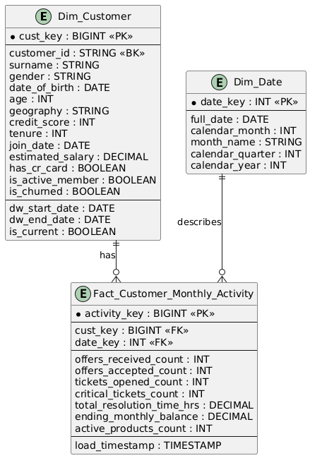
The relationships are:
Dim_Customer 1 ─────── N Fact_Customer_Monthly_Activity
Dim_Date 1 ─────── N Fact_Customer_Monthly_Activity
This means:
- One customer can have many monthly activity records.
- One date can be associated with many customers.
- Each fact record belongs to one customer and one month.
The fact table connects the customer dimension and date dimension through foreign keys.
4. Why This Warehouse Design Was Chosen
4.1 It supports the customer-centric nature of the project
The main objective of the project is to understand customer churn.
The customer table is therefore treated as the central entity, while usage, offers, and support tickets provide additional information about customer behavior.
This follows the original project data model, where customer usage, offers, and support tickets have a one-to-many relationship with the customer.
4.2 It avoids creating one large denormalized table
Instead of joining every source table into one large table containing repeated customer information, the warehouse separates:
- Customer descriptive information
- Date information
- Monthly activity measures
For example, customer information such as geography and credit score does not need to be repeated unnecessarily in every activity record.
This reduces data duplication and makes the warehouse easier to maintain.
4.3 It supports time-based analysis
The project needs to analyze how customer behavior changes over time.
By using a monthly grain, the warehouse can track:
- Monthly balance
- Monthly product usage
- Monthly offers
- Monthly support activity
This makes it possible to identify patterns such as:
- Customers whose balances decline over time
- Customers whose product usage decreases
- Customers who receive many offers but accept few
- Customers who experience frequent support problems
4.4 It supports business intelligence and reporting
The fact table contains numerical measures that can be aggregated efficiently.
For example, the bank can calculate:
- Total offers received by customer
- Total support tickets per month
- Average resolution time
- Average monthly balance
- Number of active products
These measures can be grouped by:
- Customer
- Geography
- Gender
- Age
- Year
- Month
- Churn status
This makes the warehouse suitable for dashboards and analytical reports.
4.5 It supports machine learning feature extraction
The warehouse is also designed to provide features for the churn prediction model.
Examples of possible features include:
- Total number of support tickets
- Number of critical tickets
- Average ticket resolution time
- Offer acceptance rate
- Number of active products
- Average monthly balance
- Balance decline over time
- Product usage decline over time
The warehouse does not replace the machine learning feature table. Instead, it provides a reliable and organized source from which machine learning features can be extracted.

STEP  12 | Build the Hive DDLs using Spark and Hue
Steps:
Step 1—Initialize the Hive configuration
- Create the Hive database and use it
HIVE_DB = "customer_churn_db"

spark.sql(f"""
CREATE DATABASE IF NOT EXISTS {HIVE_DB}
""")
spark.sql(f"USE {HIVE_DB}")
- Verify it using Hue
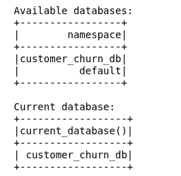
- Make the Hive external table point to my silver data ( the cleaned data)
spark.sql(f"""
CREATE TABLE IF NOT EXISTS {HIVE_DB}.customer_silver
USING PARQUET
LOCATION '{CUSTOMER_SILVER_PATH}'
""")

spark.sql(f"""
CREATE TABLE IF NOT EXISTS {HIVE_DB}.customer_usage_silver
USING PARQUET
LOCATION '{CUSTOMER_USAGE_SILVER_PATH}'
""")

spark.sql(f"""
CREATE TABLE IF NOT EXISTS {HIVE_DB}.tickets_silver
USING PARQUET
LOCATION '{TICKETS_SILVER_PATH}'
""")

spark.sql(f"""
CREATE TABLE IF NOT EXISTS {HIVE_DB}.offers_silver
USING PARQUET
LOCATION '{OFFERS_SILVER_PATH}'
""")

Why did I use external tables instead of managed tables?
As managed tables create Hive tables contains the data and the metadata, if I drop any table by coincidence, that will lead to data loss. External tables store only the metadata of the data files, so if I drop any table, only the metadata will be deleted, but the data will not be affected.

- Create the data frames of the silver layer
customer_silver_df = spark.table(f"{HIVE_DB}.customer_silver")
usage_silver_df = spark.table(f"{HIVE_DB}.customer_usage_silver")
tickets_silver_df = spark.table(f"{HIVE_DB}.tickets_silver")
offers_silver_df = spark.table(f"{HIVE_DB}.offers_silver")

- Calculate business requirements
In this step, the business requirements are translated into the aggregations and calculations needed to build the data warehouse.
These calculations ensure that the central fact table follows the selected grain:
One row represents the aggregated activity of one customer during one month.
The resulting aggregations are then used to populate Fact_Customer_Monthly_Activity, Dim_Customer, and Dim_Date, providing the foundation for the business insights and machine learning stages.
5.1 Prepare Activity Month
Get the activity months from each table ( tickets, usages, offers) to use it in my analysis
usage_monthly_base = (
usage_silver_df
.withColumn(
"activity_month",
F.trunc(F.col("date"), "month")
)
)

tickets_monthly_base = (
tickets_silver_df
.withColumn(
"activity_month",
F.trunc(F.col("date"), "month")
)
)

offers_monthly_base = (
offers_silver_df
.withColumn(
"activity_month",
F.trunc(F.col("date_offered"), "month")
)
)

5.2 Usage monthly aggregations
We calculate the aggregations by:

- Make a window function to partition by customer id and activity month ordered by data
- Calculate the latest usage record for each customer-month
- count the number of distinct products
- Join the latest balance to the product count

# A window for partitioning
usage_window = (
Window
.partitionBy("customer_id", "activity_month")
.orderBy(F.col("date").desc())
)
usage_latest_df = (
usage_monthly_base
.withColumn("row_num", F.row_number().over(usage_window))
.filter(F.col("row_num") == 1)
.drop("row_num")
)

usage_agg_df = (
usage_monthly_base
.groupBy("customer_id", "activity_month")
.agg(
F.countDistinct("product_type").alias("active_products_count")
)
)

usage_agg_df = (
usage_agg_df
.join(
usage_latest_df.select(
"customer_id",
"activity_month",
F.col("monthly_balance").alias("ending_monthly_balance")
),
on=["customer_id", "activity_month"],
how="left"
)
)
usage_agg_df.show()

Output:
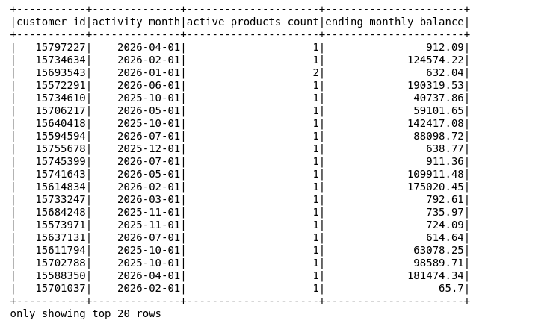
________________________________________________________________________________
5.3 Tickets monthly aggregation
We calculate the aggregations by:
Grouping by customer ID and activity month, calculate the:

Number of opened tickets using count(*)
Number of critical tickets
Total resolution time
tickets_agg_df = (
tickets_monthly_base
.groupBy("customer_id", "activity_month")
.agg(
F.count("*").alias("tickets_opened_count"),

F.sum(
F.when(
F.lower(F.col("severity")) == "critical",
1
).otherwise(0)
).alias("critical_tickets_count"),

F.sum("resolution_time_hrs")
.alias("total_resolution_time_hrs")
)
)
tickets_agg_df.show()
Output:
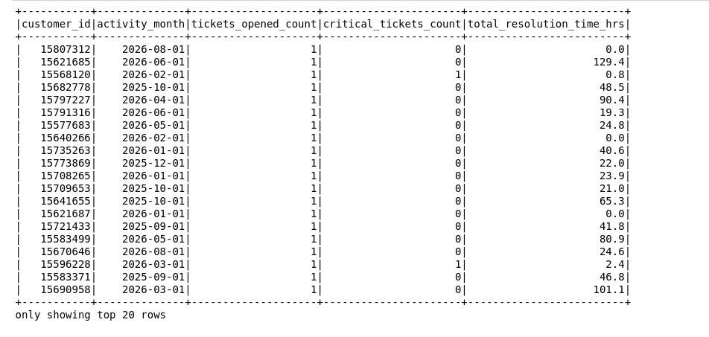

5.4 Offers monthly aggregation
By grouping by customer ID and activity month, I calculate the:
- offers received count
- offers accepted count
offers_agg_df = (
offers_monthly_base
.groupBy("customer_id", "activity_month")
.agg(
F.count("*").alias("offers_received_count"),

F.sum(
F.when(F.col("accepted") == True, 1)
.otherwise(0)
).alias("offers_accepted_count")
)
)

offers_agg_df.show()

Output: 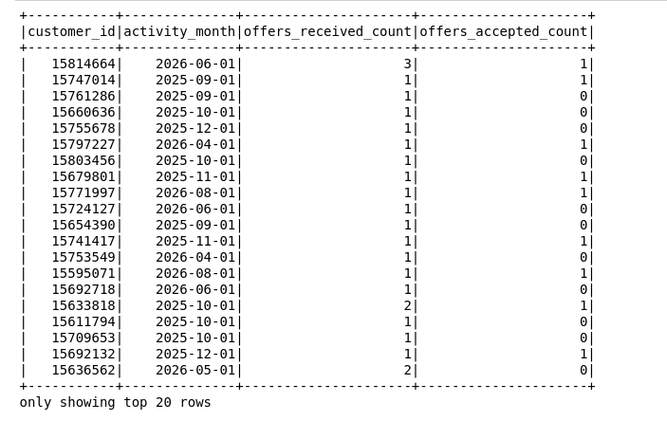
5.5 Calculate monthly activity

To build monthly activity, you should know that it's not proper to have the three events happening in the same month, so we need to get the active months first, then get the events that happened in this month

5.5.1 Get the active months

activity_spine_df = (
usage_agg_df
.select("customer_id", "activity_month")
.union(
tickets_agg_df.select("customer_id", "activity_month")
)
.union(
offers_agg_df.select("customer_id", "activity_month")
)
.distinct()
)

5.5.2 know the specific events that happened in the active months

monthly_activity_df = activity_spine_df \
.join(usage_agg_df, ["customer_id", "activity_month"], "left") \
.join(tickets_agg_df, ["customer_id", "activity_month"], "left") \
.join(offers_agg_df, ["customer_id", "activity_month"], "left")

5.5.3 Fix the nulls

As this join will lead us to have null values in the unhappened events, we need to replace them with a value indicating their non-existence.

This non-existence will be zero for each of the calculations except the ending_balance, because the balance can carry two meanings:
- Having a balance of $0
- Not having a balance record for this month.

So we need to keep it null as it is.

monthly_activity_df = (
monthly_activity_df
.fillna({
"offers_received_count": 0,
"offers_accepted_count": 0,
"tickets_opened_count": 0,
"critical_tickets_count": 0,
"total_resolution_time_hrs": 0,
"active_products_count": 0
})
)

monthly_activity_df.show(20, truncate=False)
monthly_activity_df.printSchema()

Output:
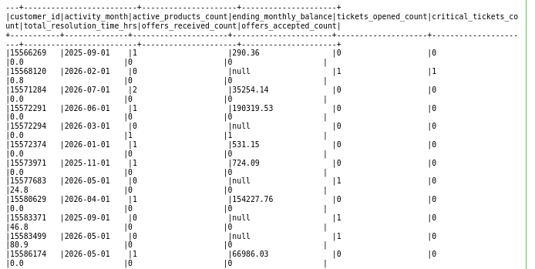
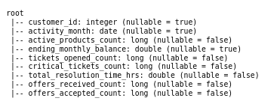
___________________________________________________________________________________

6. Build the dimension tables

6.1 Data Dimension

6.1.1 Get the active dates
I can get them from activity_spine_df, but this df is the latest one, and I will use this one for my fact table.

activity_dates_df = (
monthly_activity_df
.select("activity_month")
.distinct()
)

6.1.2 Create Date Dimension table

dim_date_df = (
activity_dates_df
.withColumnRenamed("activity_month", "full_date")

.withColumn(
"date_key",
F.date_format("full_date", "yyyyMMdd").cast("int")
)

.withColumn(
"calendar_month",
F.month("full_date")
)

.withColumn(
"month_name",
F.date_format("full_date", "MMMM")
)

.withColumn(
"calendar_quarter",
F.quarter("full_date")
)

.withColumn(
"calendar_year",
F.year("full_date")
)

.select(
"date_key",
"full_date",
"calendar_month",
"month_name",
"calendar_quarter",
"calendar_year"
)
)
Output:
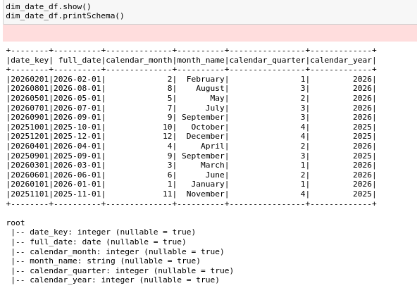

6.2 Create Customer_dim
- Select the target attributes from the customer silver table.

- Calculate the surrogate key using the window function row_number().

- Calculate is_churned by converting exited into boolean values.

- Use the Slowly Changing Dimension (SCD) Type 2:
- Calculate the start date as the current date.
- Calculate the end date using a big default value, 9999-12-31, to show that this record is still active.
- Use is_current to check if the record is the current active version.

- Drop exited because there is no need for it anymore after creating is_churned.

- Select the final attributes for the dim_customer table.

customer_key_window = Window.orderBy("customer_id")

dim_customer_df = (
customer_silver_df

.select(
"customer_id",
"surname",
"gender",
"date_of_birth",
"age",
"geography",
"credit_score",
"tenure",
"join_date",
"estimated_salary",
"has_cr_card",
"is_active_member",
"exited"
)

.withColumn(
"cust_key",
F.row_number().over(customer_key_window)
)

.withColumn(
"is_churned",
F.col("exited").cast("boolean")
)

.withColumn(
"dw_start_date",
F.current_date()
)

.withColumn(
"dw_end_date",
F.to_date(F.lit("9999-12-31"))
)

.withColumn(
"is_current",
F.lit(True)
)

.drop("exited")

.select(
"cust_key",
"customer_id",
"surname",
"gender",
"date_of_birth",
"age",
"geography",
"credit_score",
"tenure",
"join_date",
"estimated_salary",
"has_cr_card",
"is_active_member",
"is_churned",
"dw_start_date",
"dw_end_date",
"is_current"
)
)

Output:
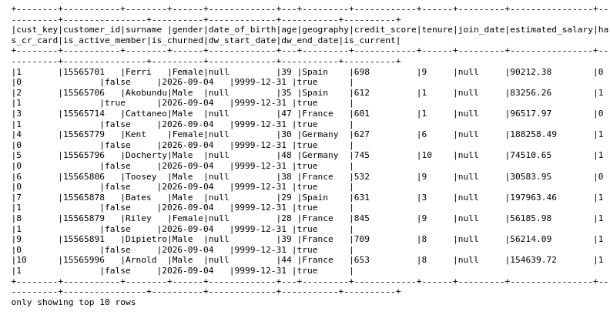

7. Create fact customer activity per month
7.1 Join the customer surrogate key to build the relation between the customer_dim and the fact

Why left join? Because I need to get each active month even if there is no customer associated with that month

fact_customer_monthly_activity_df = (
monthly_activity_df
.join(
dim_customer_df.select(
"cust_key",
"customer_id"
),
on="customer_id",
how="left"
)
)

7.2 Join the date key to build the relation between the date_dim and the fact

fact_customer_monthly_activity_df = (
fact_customer_monthly_activity_df
.join(
dim_date_df.select(
"date_key",
F.col("full_date").alias("activity_month")
),
on="activity_month",
how="left"
)
)

7.3 Build the fact table
- Calculate the activity_id as monotonically_increasing id
- Calculate the timestamp to be the current time
- Select the attributes for the fact

fact_customer_monthly_activity_df = (
fact_customer_monthly_activity_df
.withColumn(
"activity_key",
F.monotonically_increasing_id()
)

.withColumn(
"load_timestamp",
F.current_timestamp()
)

.select(
"activity_key",
"cust_key",
"date_key",
"offers_received_count",
"offers_accepted_count",
"tickets_opened_count",
"critical_tickets_count",
"total_resolution_time_hrs",
"ending_monthly_balance",
"active_products_count",
"load_timestamp"
)
)
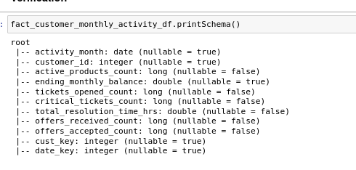

8. Write the Gold layer to HDFS as Parquet

dim_customer_df.write \
.format("parquet") \
.mode("overwrite") \
.save(DIM_CUSTOMER_PATH)

dim_date_df.write \
.format("parquet") \
.mode("overwrite") \
.save(DIM_DATE_PATH)

fact_customer_monthly_activity_df.write \
.format("parquet") \
.mode("overwrite") \
.save(FACT_ACTIVITY_PATH)

print("Gold Parquet data written successfully.")

9. Build Gold tables in Hive

spark.sql(f"""
CREATE TABLE IF NOT EXISTS {HIVE_DB}.dim_customer
USING PARQUET
LOCATION '{DIM_CUSTOMER_PATH}'
""")
spark.sql(f"""
CREATE TABLE IF NOT EXISTS {HIVE_DB}.dim_date
USING PARQUET
LOCATION '{DIM_DATE_PATH}'
""")
spark.sql(f"""
CREATE TABLE IF NOT EXISTS {HIVE_DB}.fact_customer_monthly_activity_df
USING PARQUET
LOCATION '{FACT_ACTIVITY_PATH}'
""")
9.1 Verify using hue

- Verify the tables using the command “show tables”
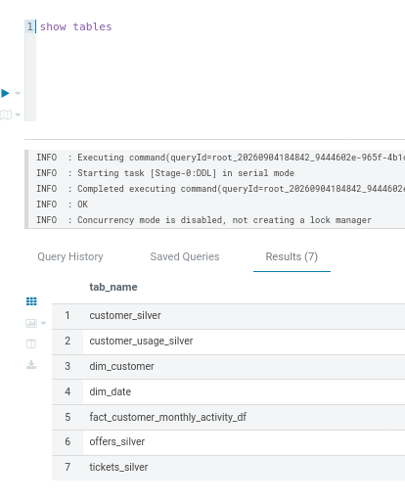
- Show records in customer_dim
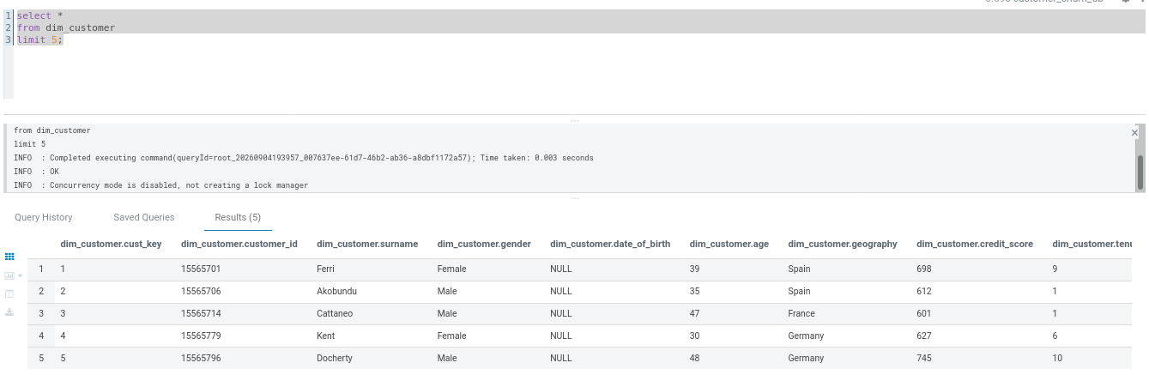
- Show records in dim_date
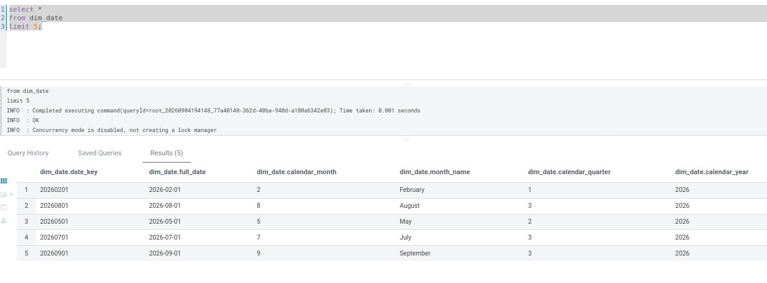
- Show records in activity_fact
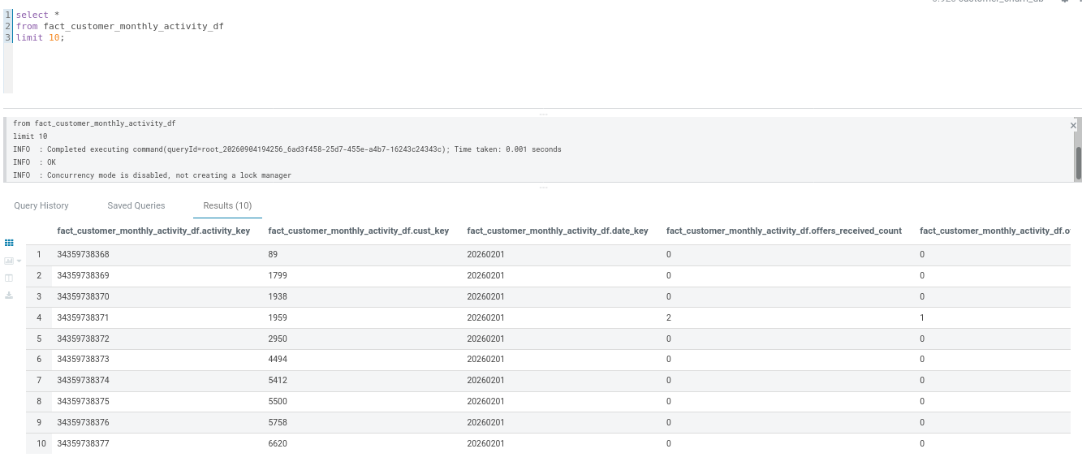
- Join between fact and dimension
select
c.customer_id,
c.geography,
c.age,
c.is_churned,
d.full_date,
f.offers_received_count,
f.offers_accepted_count,
f.tickets_opened_count,
f.critical_tickets_count,
f.total_resolution_time_hrs,
f.ending_monthly_balance,
f.active_products_count
from fact_customer_monthly_activity_df f
join dim_customer c
on f.cust_key = c.cust_key
join dim_date d
on f.date_key = d.date_key
order by c.customer_id, d.full_date
limit 10;
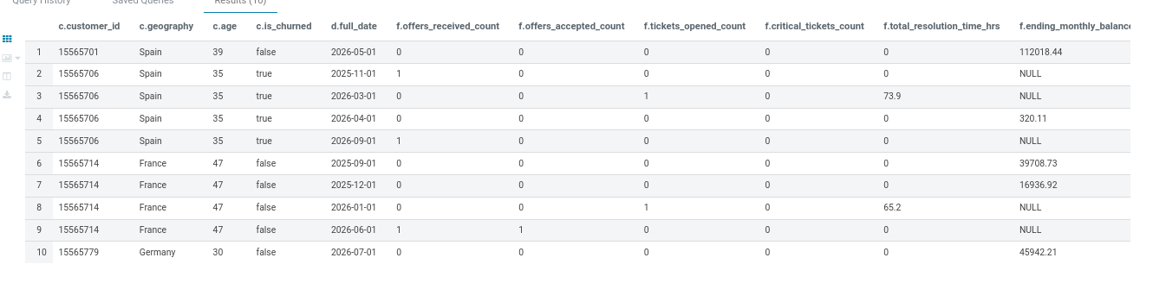

STEP  13 | Implement Some Business Analysis Using my warehouse tables
After completing the data engineering, data modeling, and data integration steps, the system will be used to generate business insights from the integrated banking data.
The purpose of this stage is to move beyond simply identifying whether a customer has churned and understand the factors and behavioral patterns associated with customer churn. The analysis combines customer information with monthly product usage, marketing offers, and customer support interactions.
The system will focus on the following four business insights:
1. Early Warning Churn Signals
This insight analyzes changes in customer behavior over time, such as declining monthly balances or a reduction in the number of active products. These changes can help identify behavioral patterns associated with customers who eventually churn.
2. Support Friction vs. Churn
This insight examines whether customer support interactions are associated with churn. It analyzes the number of support tickets, critical issues, and resolution time to determine whether customers experiencing higher support friction have higher churn rates.
3. Marketing Offer Effectiveness
This insight evaluates the relationship between marketing offers and customer churn. It analyzes the number of offers received, the number of accepted offers, and the offer acceptance rate to understand whether customer engagement with offers is associated with customer retention.
4. Customer Value Analysis / Simulated LTV
This insight estimates the relative value of customers using available information such as monthly balance, product usage, and customer tenure. Since the available datasets do not contain actual revenue or profit information, the analysis uses a simulated customer value score rather than calculating actual customer lifetime value.
These insights will be stored as separate analytical datasets in the Gold Layer and registered as external Hive tables. This allows the results to be queried using Hive and used later for reporting, visualization, and machine learning feature extraction.
The following sections explain the implementation of each business insight, including the required transformations, calculations, generated results, and storage process.

Insight 1 — Early Warning Churn Signals
In my data, we don't have a churn date, so we don't know the behavior of the customer in their last months, but we have is_churned, which indicates whether the customer has churned or not, so we will use this to study the behavior and the engagement of the customer and whether this behavior causes them to leave the bank or not.

That is, by identifying:

- Monthly balance changes
- Monthly product changes
- Whether the customer eventually churned

And that's by:
1.1 First join between the fact table and dimensions

monthly_behavior_df = spark.sql("""
SELECT
f.cust_key,
c.customer_id,
d.full_date AS activity_month,

c.is_churned,

f.ending_monthly_balance,
f.active_products_count

FROM fact_customer_monthly_activity_df f

JOIN dim_customer c
ON f.cust_key = c.cust_key

JOIN dim_date d
ON f.date_key = d.date_key
""")

1.2 Calculate the previous month's values (product counts and balance), and do that by using the window function last()

Here, I have two window functions:
- To partition by the customer_id, arranged by activity month
- To partition by customer_id, arranged by activity month, but only to fetch the previous months for the current
Then I calculate the balance as the previous_month_balance, so I am not affected by the current balance if it’s null values I have
Then I calculate the previous month's products

behavior_window = (Window.partitionBy("customer_id").orderBy("activity_month"))

last_known_balance_window = (
Window
.partitionBy("customer_id")
.orderBy("activity_month")
.rowsBetween(Window.unboundedPreceding, -1)
)

monthly_behavior_df = (
monthly_behavior_df
.withColumn(
"previous_month_balance",
F.last("ending_monthly_balance", ignorenulls=True).over(last_known_balance_window)
)
.withColumn(
"previous_month_products",
F.lag("active_products_count").over(behavior_window)
)
)

1.3 Calculate the changes

monthly_behavior_df = (
monthly_behavior_df
.withColumn(
"balance_change",
F.col("ending_monthly_balance")
- F.col("previous_month_balance")
)
.withColumn(
"product_change",
F.col("active_products_count")
- F.col("previous_month_products")
)
)

1.4 Summarize each customer's overall trend
In this step, I will turn month-by-month values into one row per customer that indicates whether balance and products are trending up or down and the percentage of their months that showed a decline.
This is achieved by:
- Grouping by customer id and is_churned
- Calculating average balance and average products
- Calculating the percentage by computing the declining_balance month-over-month change

customer_behavior_summary_df = (
monthly_behavior_df
.filter(F.col("balance_change").isNotNull())
.groupBy("customer_id", "is_churned")
.agg(
F.avg("balance_change").alias("avg_balance_change"),
F.avg("product_change").alias("avg_product_change"),
F.sum(
F.when(F.col("balance_change") < 0, 1).otherwise(0)
).alias("declining_balance_months"),
F.count("*").alias("months_with_change")
)
.withColumn(
"pct_months_balance_declined",
F.round(
F.col("declining_balance_months") / F.col("months_with_change") * 100,
2
)
)
)

1.5 Compare churned with non-churned

- group by is_churned
- calculate the aggregation avg_balance, avg_product, avg_percentage
churn_behavior_comparison_df = (
customer_behavior_summary_df
.groupBy("is_churned")
.agg(
F.round(F.avg("avg_balance_change"), 2).alias("avg_monthly_balance_change"),
F.round(F.avg("avg_product_change"), 2).alias("avg_monthly_product_change"),
F.round(F.avg("pct_months_balance_declined"), 2).alias("avg_pct_months_balance_declined"),
F.count("*").alias("num_customers")
)
)

churn_behavior_comparison_df.show(truncate=False)

1.6 Store in HDFS and Hive
1. Store in HDFS

monthly_behavior_df.write \
.mode("overwrite") \
.format("parquet") \
.option("compression", "snappy") \
.save(INSIGHT_1_PATH)

2. Build the Hive table
spark.sql(f"""
create table if not exists
{HIVE_DB}.insight_early_warning_churn
using parquet
location '{INSIGHT_1_PATH}'
""")

1.7 Validate with hue
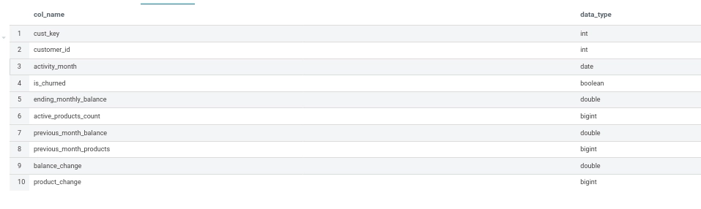
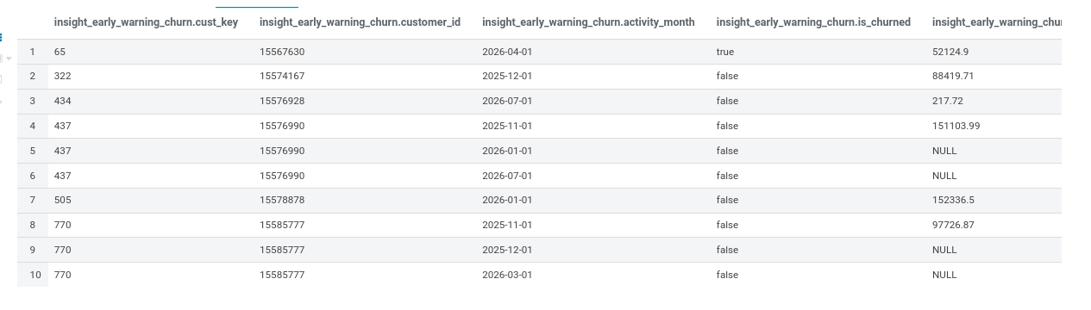
____________________________________________________________________________

Insight 2 — Support Friction vs. Churn
Analyze whether customers with higher support friction have higher churn rates.

Compare churn rates across customers with different levels of ticket volume, critical issues, and resolution time.

2.1 Aggregate support behavior by customer
Using the fact table joined with dim_customer, calculate:
a. Total number of tickets
b. Total critical tickets
c. Total resolution time
d. Average monthly resolution time
All grouped by customer key, customer ID, and is_churned—using the fact table joined with dim_customer.
support_customer_df = spark.sql("""
SELECT
c.cust_key,
c.customer_id,
c.is_churned,

SUM(f.tickets_opened_count)
AS total_tickets,

SUM(f.critical_tickets_count)
AS total_critical_tickets,

SUM(f.total_resolution_time_hrs)
AS total_resolution_time_hrs,

AVG(f.total_resolution_time_hrs)
AS avg_monthly_resolution_time_hrs

FROM fact_customer_monthly_activity_df f

JOIN dim_customer c
ON f.cust_key = c.cust_key

GROUP BY
c.cust_key,
c.customer_id,
c.is_churned
""")

2.2 Calculate average resolution time per ticket
This creates the average resolution time per customer by:
- Creating a column named avg_resolution_time_per_ticket
- Calculating its value as the total resolution hours divided by total tickets, if total tickets is not equal to zero
support_customer_df = (
support_customer_df
.withColumn(
"avg_resolution_time_per_ticket",
F.when(
F.col("total_tickets") > 0,
F.col("total_resolution_time_hrs")
/ F.col("total_tickets")
).otherwise(0)
)
)

2.3 Compare churned with non churned\

support_customer_df.groupBy("is_churned").agg(
F.count("*").alias("customer_count"),

F.avg("total_tickets")
.alias("avg_total_tickets"),

F.avg("total_critical_tickets")
.alias("avg_total_critical_tickets"),

F.avg("total_resolution_time_hrs")
.alias("avg_total_resolution_time_hrs"),

F.avg("avg_resolution_time_per_ticket")
.alias("avg_resolution_time_per_ticket")
).show()
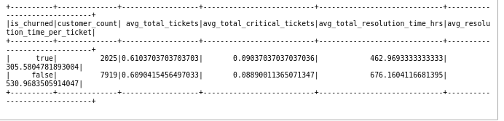

2.4 Create support-friction groups
Divides customers into groups:
- High Friction (at least 2 critical tickets OR average resolution time >= 24 hours)
- Medium Friction (at least 1 critical ticket OR average resolution time >= 12 hours)
- Low Friction (otherwise)
These numbers are assumptions.
support_customer_df = (
support_customer_df
.withColumn(
"support_friction_group",
F.when(
(F.col("total_critical_tickets") >= 2) |
(F.col("avg_resolution_time_per_ticket") >= 24),
"High Friction"
)
.when(
(F.col("total_critical_tickets") >= 1) |
(F.col("avg_resolution_time_per_ticket") >= 12),
"Medium Friction"
)
.otherwise("Low Friction")
)
)

2.5 Calculate churn rate based by support group

support_customer_df.groupBy(
"support_friction_group"
).agg(
F.count("*").alias("customer_count"),

F.sum(
F.when(F.col("is_churned") == True, 1).otherwise(0)
).alias("churned_customers"),

(
F.sum(
F.when(F.col("is_churned") == True, 1).otherwise(0)
) / F.count("*") * 100
).alias("churn_rate_percentage")
).orderBy(
F.desc("churn_rate_percentage")
).show()
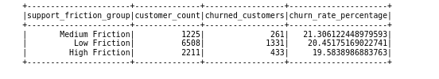

2.6 Store in HDFS and Hive
- Store in HDFS
support_customer_df.write \
.mode("overwrite") \
.format("parquet") \
.option("compression", "snappy") \
.save(INSIGHT_2_PATH)

- Store as Hive tables

spark.sql(f"""
create table if not exists
{HIVE_DB}.insight_support_friction_churn
using parquet
location '{INSIGHT_2_PATH}'
""")

2.7 verify with hue
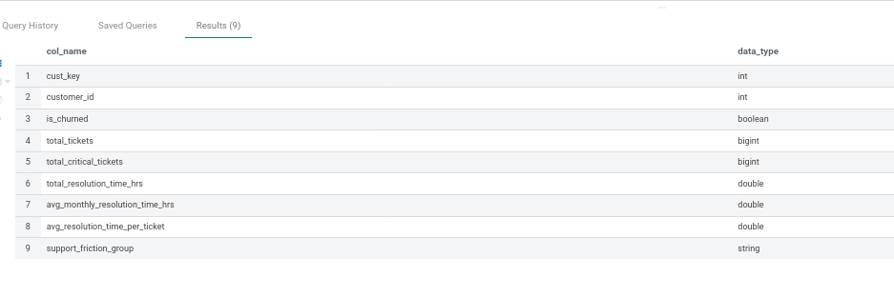
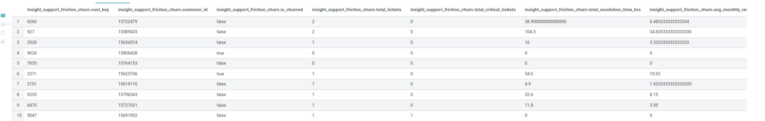
___________________________________________________________________________

Insight 3: Marketing Offer Effectiveness

Is offer engagement associated with more stable balances and lower customer churn?

3.1 Aggregate offers by customer

From the join of the fact table with customer_dim:

1. Calculate the total offers received
2. Calculate the total offers accepted
3. Calculate the average monthly balance

offer_customer_df = spark.sql("""
SELECT
c.cust_key,
c.customer_id,
c.is_churned,

SUM(f.offers_received_count)
AS total_offers_received,

SUM(f.offers_accepted_count)
AS total_offers_accepted,

AVG(f.ending_monthly_balance)
AS avg_monthly_balance

FROM fact_customer_monthly_activity_df f

JOIN dim_customer c
ON f.cust_key = c.cust_key

GROUP BY
c.cust_key,
c.customer_id,
c.is_churned
""")

3.2 Calculate offer acceptance rate

The acceptance rate = total accepted over total received, as long as total received is not equal to zero

offer_customer_df = (
offer_customer_df
.withColumn(
"offer_acceptance_rate",
F.when(
F.col("total_offers_received") > 0,
F.col("total_offers_accepted")
/ F.col("total_offers_received")
).otherwise(0)
)
)

3.3 Calculate balance stability

Calculate it by getting the standard deviation of monthly balances.

offer_customer_df = spark.sql("""
SELECT
c.cust_key,
c.customer_id,
c.is_churned,

SUM(f.offers_received_count)
AS total_offers_received,

SUM(f.offers_accepted_count)
AS total_offers_accepted,

AVG(f.ending_monthly_balance)
AS avg_monthly_balance,

STDDEV(f.ending_monthly_balance)
AS balance_standard_deviation

FROM fact_customer_monthly_activity_df f

JOIN dim_customer c
ON f.cust_key = c.cust_key

GROUP BY
c.cust_key,
c.customer_id,
c.is_churned
""")

3.4 Compare Churn cusomter with non churned

offer_customer_df.groupBy("is_churned").agg(
F.count("*").alias("customer_count"),

F.avg("total_offers_received")
.alias("avg_offers_received"),

F.avg("total_offers_accepted")
.alias("avg_offers_accepted"),

F.avg("offer_acceptance_rate")
.alias("avg_offer_acceptance_rate"),

F.avg("avg_monthly_balance")
.alias("avg_monthly_balance"),

F.avg("balance_standard_deviation")
.alias("avg_balance_standard_deviation")
).show()
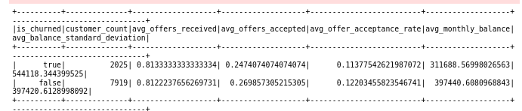

3.5 Create offer-engagement groups

Divide customers into groups:

1. No Offers
2. High Acceptance
3. Low Acceptance

offer_customer_df = (
offer_customer_df
.withColumn(
"offer_engagement_group",
F.when(
F.col("total_offers_received") == 0,
"No Offers"
)
.when(
F.col("offer_acceptance_rate") >= 0.50,
"High Acceptance"
)
.when(
F.col("offer_acceptance_rate") > 0,
"Low Acceptance"
)
.otherwise("No Accepted Offers")
)
)

3.6 Calculate churn rate by offer group

offer_customer_df.groupBy(
"offer_engagement_group"
).agg(
F.count("*").alias("customer_count"),

F.sum(
F.when(F.col("is_churned") == True, 1).otherwise(0)
).alias("churned_customers"),

(
F.sum(
F.when(F.col("is_churned") == True, 1).otherwise(0)
) / F.count("*") * 100
).alias("churn_rate_percentage"),

F.avg("avg_monthly_balance")
.alias("avg_monthly_balance"),

F.avg("balance_standard_deviation")
.alias("avg_balance_standard_deviation")
).orderBy(
F.desc("churn_rate_percentage")
).show()
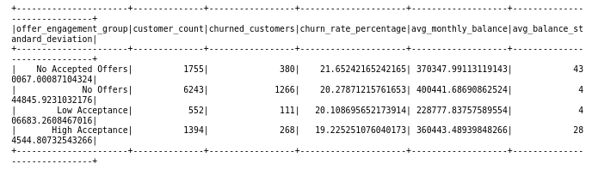

3.7 Store in Hdfs and hive
- Store in HDFS

offer_customer_df.write \
.mode("overwrite") \
.format("parquet") \
.option("compression", "snappy") \
.save(INSIGHT_3_PATH)

- Store as Hive tables

spark.sql(f"""
create table if not exists
{HIVE_DB}.insight_offer_effectiveness
using parquet
location '{INSIGHT_3_PATH}'
""")

3.8 Verify with hue
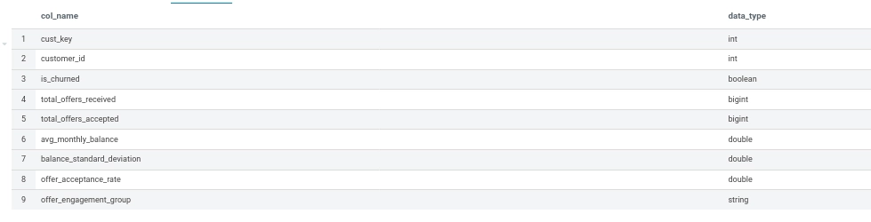
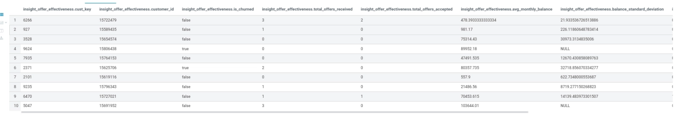
_____________________________________________________________________________

Insight 4: Customer Value Analysis / Simulated LTV

Because my datasets do not contain actual transactions, revenue, or profit, we will describe it as Simulated Customer Lifetime Value (LTV) rather than actual financial CLV.

4.1. Aggregate customer value information

Calculate:

- Average monthly balance
- Maximum monthly balance
- Average number of active products
- Maximum number of active products
- Customer tenure
- Churn status

customer_value_df = spark.sql("""
SELECT
c.cust_key,
c.customer_id,
c.is_churned,
c.tenure,

AVG(f.ending_monthly_balance)
AS avg_monthly_balance,

MAX(f.ending_monthly_balance)
AS max_monthly_balance,

AVG(f.active_products_count)
AS avg_active_products,

MAX(f.active_products_count)
AS max_active_products,

COUNT(DISTINCT f.date_key)
AS observed_active_months

FROM fact_customer_monthly_activity_df f

JOIN dim_customer c
ON f.cust_key = c.cust_key

GROUP BY
c.cust_key,
c.customer_id,
c.is_churned,
c.tenure
""")
4.2 Handle missing balance information

Identify whether the balance field is null or not and create a column with the boolean value

This is another way of handling the balance with a value equal to null.
customer_value_df = (
customer_value_df
.withColumn(
"balance_information_missing",
F.when(
F.col("avg_monthly_balance").isNull(),
True
).otherwise(False)
)
)

4.3 Calculate the balance score

As we have different scales, we should normalize their values before combining them.
The normalization will give me a value between 0 and 1: a value close to 0 means low average balance, and a value close to 1 means high.
Calculate the minimum and maximum balance:
balance_stats = customer_value_df.agg(
F.min("avg_monthly_balance").alias("min_balance"),
F.max("avg_monthly_balance").alias("max_balance")
).first()

min_balance = balance_stats["min_balance"]
max_balance = balance_stats["max_balance"]
Create the normalized balance score:

customer_value_df = (
customer_value_df
.withColumn(
"balance_score",
F.when(
F.col("avg_monthly_balance").isNull(),
0.0
)
.when(
F.lit(max_balance) == F.lit(min_balance),
0.0
)
.otherwise(
(
F.col("avg_monthly_balance") - F.lit(min_balance)
)
/
(
F.lit(max_balance) - F.lit(min_balance)
)
)
)
)

4.4 Calculate the product usage score
customer_value_df = (
customer_value_df
.withColumn(
"product_score",
F.when(
F.col("avg_active_products").isNull(),
0.0
)
.otherwise(
F.col("avg_active_products") / F.lit(4.0)
)
)
)

4.5 Calculate the tenure score
customer_value_df = (
customer_value_df
.withColumn(
"tenure_score",
F.when(
F.col("tenure").isNull(),
0.0
)
.otherwise(
F.col("tenure") / F.lit(10.0)
)
)
)

4.6. Calculate the simulated LTV score

After having the balance, product usage, and tenure, we can now calculate the LTV

The numbers in the code are estimated.

customer_value_df = (
customer_value_df
.withColumn(
"simulated_ltv_score",
(
F.col("balance_score") * F.lit(0.50)
+
F.col("product_score") * F.lit(0.30)
+
F.col("tenure_score") * F.lit(0.20)
)
)
)
4.7 Create customer value groups

Divide the customer into groups:

1. High value
2. Medium value
3. Low value

customer_value_df = (
customer_value_df
.withColumn(
"customer_value_group",
F.when(
F.col("simulated_ltv_score") >= 0.67,
"High Value"
)
.when(
F.col("simulated_ltv_score") >= 0.34,
"Medium Value"
)
.otherwise("Low Value")
)
)

4.8. Display the customer-level results

customer_value_df.select(
"cust_key",
"customer_id",
"is_churned",
"tenure",
"avg_monthly_balance",
"avg_active_products",
"simulated_ltv_score",
"customer_value_group"
).show(truncate=False)

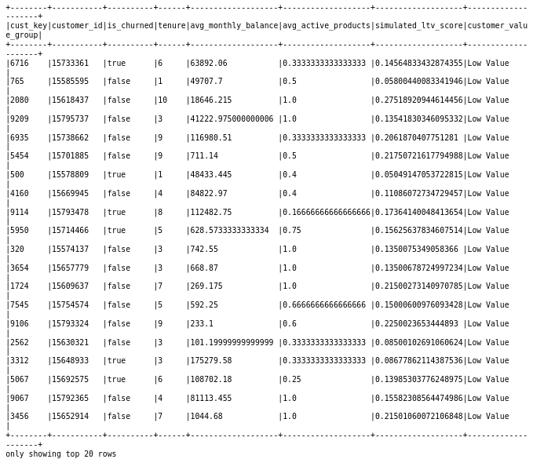
4.9 Calculate churn rate by value group

value_churn_df = (
customer_value_df
.groupBy("customer_value_group")
.agg(
F.count("*")
.alias("customer_count"),

F.sum(
F.when(F.col("is_churned") == True, 1)
.otherwise(0)
)
.alias("churned_customers"),

F.avg(
F.col("is_churned").cast("double")
)
.alias("churn_rate"),

F.avg("avg_monthly_balance")
.alias("average_balance"),

F.avg("avg_active_products")
.alias("average_active_products"),

F.avg("tenure")
.alias("average_tenure"),

F.avg("simulated_ltv_score")
.alias("average_simulated_ltv_score")
)
.orderBy("customer_value_group")
)

4.10 Store in HDFS and Hive
- Store in HDFS
customer_value_df.write \
.mode("overwrite") \
.format("parquet") \
.option("compression", "snappy") \
.save(INSIGHT_4_PATH)

- Create Hive tables
spark.sql(f"""
create table if not exists
{HIVE_DB}.insight_customer_value
using parquet
location '{INSIGHT_4_PATH}'
""")

4.11 Validate with Hue
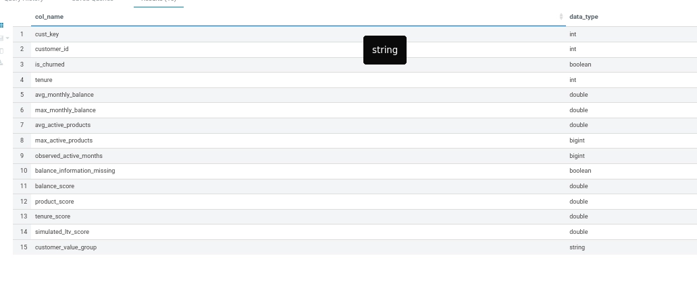
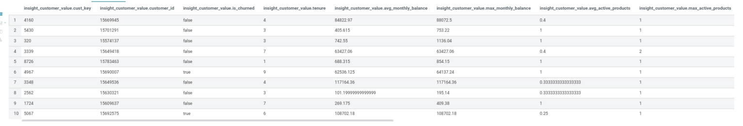

Conclusion

Customer churn remains a significant retention challenge, with 20.37% of customers having churned. The analysis shows that no single factor clearly explains churn. However, higher offer engagement is associated with lower churn, while support friction shows no simple direct relationship with churn. Higher-value customers also show lower churn rates, although this segment is very small. These findings can help the business improve retention by combining multiple customer signals, improving engagement, and prioritizing valuable customers.

