Home Page Banner

TechInvention I Vaccines

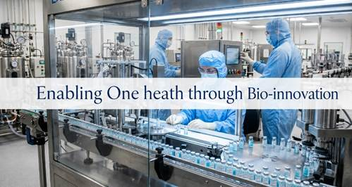

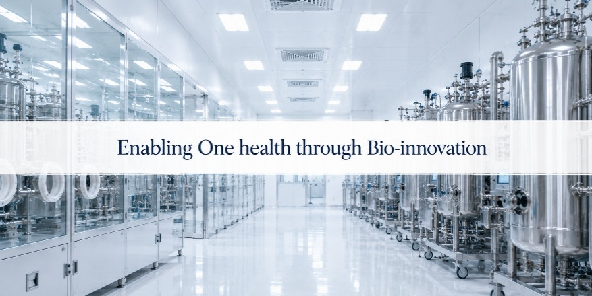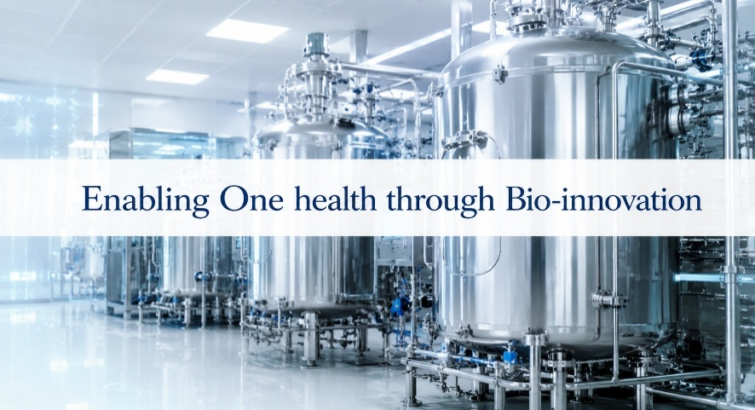

Four Verticals
Strategic Advisory & Tech Consulting

Our Strategic Advisory & Technical Consulting services help organizations build sustainable vaccine and biopharmaceutical manufacturing capabilities.

We provide end-to-end support across feasibility studies, portfolio planning, engineering design, project supervision, facility commissioning, and gap assessments.
Research and Development (R&D)
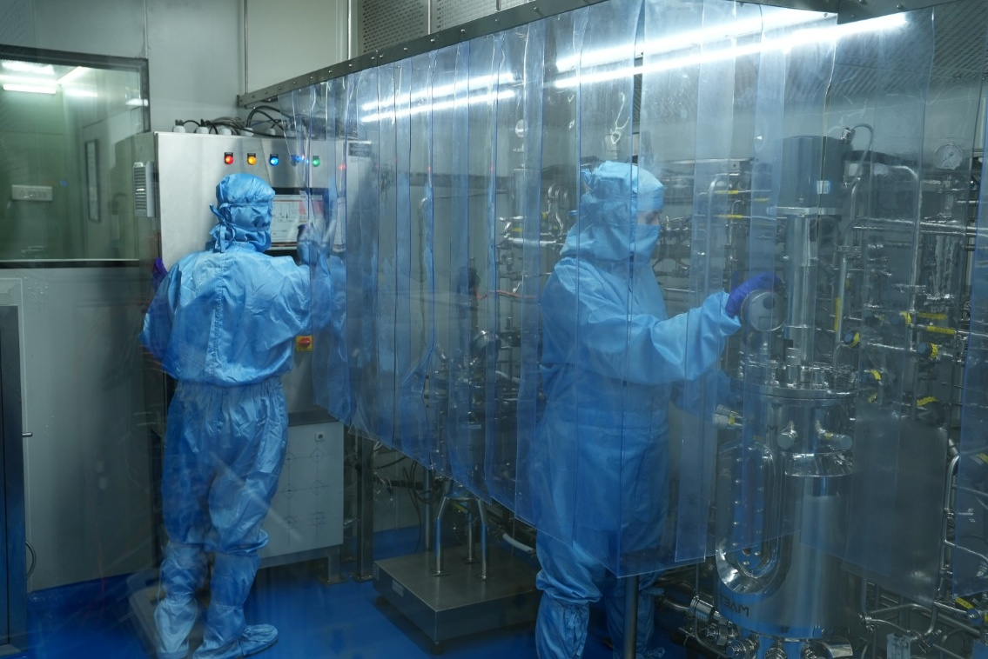
We focus on the research and development of next-generation vaccines against critical infectious diseases and AMR-associated pathogens.
Powered by our pilot GMP (HORIZON) and strategic collaborations with leading research institutions, our R&D portfolio spans recombinant and glycoconjugate vaccine platforms.
Licensing and Access

We enable strategic in-licensing and out-licensing of vaccines to accelerate access, innovation and commercialization.

By connecting promising technologies with the right development, manufacturing and market pathways, we help transform scientific assets into scalable global health solutions.
Commercial-Scale Manufacturing

TechInvention’s integrated GMP manufacturing facility (GCMC) provides Drug Substance and Fill-finish manufacturing for vaccines and biologics within a quality-driven, scalable framework.

It supports technology transfer, process scale-up, regulatory compliance, and commercial manufacturing.

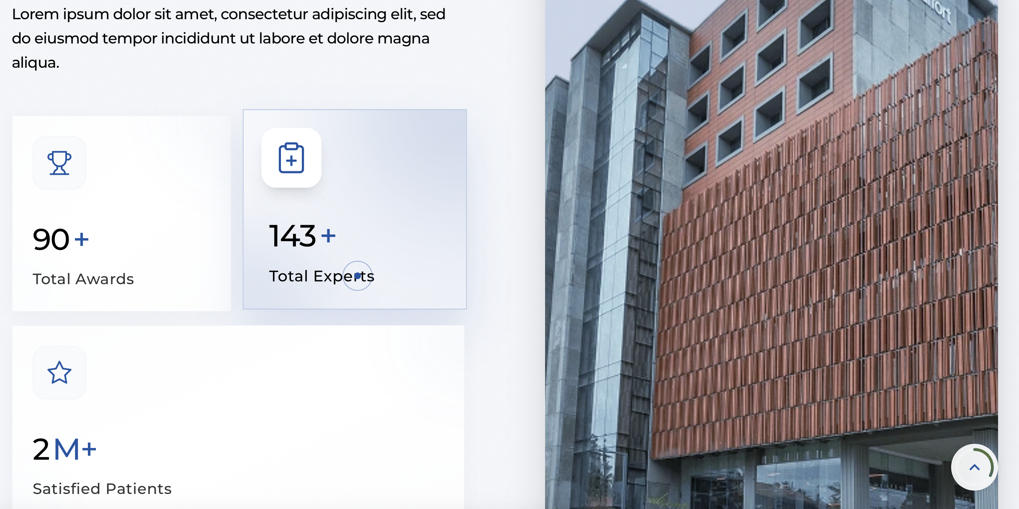
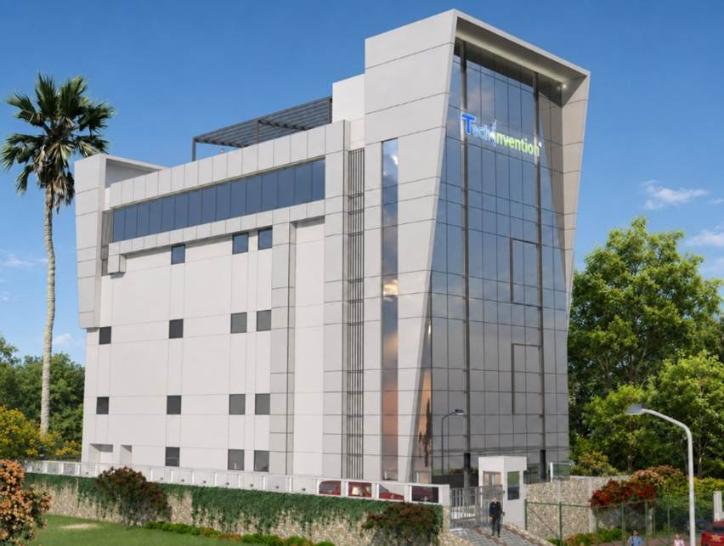Website Note: Add GCMC image.
Website Note: Add animated visual.
10+ years
15+ Countries
20+ projects

CEO Profile


Syed S. Ahmed
As Director , CEO and Founder of TechInvention ., Mr. Syed S. Ahmed represents a leadership vision shaped by scientific excellence, strategic foresight and an unwavering commitment to global health equity.
With more than two decades of experience across strategy, business development, technology transfer and capacity building, he has been instrumental in building TechInvention as an integrated vaccine innovation and manufacturing platform. His leadership reflects the rare ability to connect scientific ambition with execution, partnerships and long-term public health impact, guided by the conviction that life-saving vaccines should not remain limited to those who can afford them.



Nazneen Hamid

As Co-founder and Director – Corporate Affairs at TechInvention, Ms. Nazneen leads the organization's Corporate Governance, Human Resources, Finance, and Administration. She plays a key role in strengthening organizational excellence by driving strategic operations, people development, and effective governance.
A certified POSH (Prevention of Sexual Harassment) Trainer, she is committed to fostering a safe, inclusive, and professional workplace. Passionate about the organization's mission, Ms. Nazneen supports TechInvention's vision of making essential vaccines affordable, accessible, and available to populations across the developing world while nurturing a purpose-driven, high-performing team.

Vaccine & Biotherapeutics Pipeline
Vaccine / Biotherapeutics Candidate | R&D | POC | Pre-clinical | Phase 1/2
Pneumococcal Conjugate Vaccine (16-valent)
Hexavalent Meningococcal Vaccine (ABCYWX)
Pan-Salmonella Vaccine
Shigella Vaccine
Meningococcal B Vaccine
Malaria Vaccine
Tuberculosis Vaccine

6. Trusted by Global Partners
Website Note: Display all partner logos on the website.

7. Global Projects & Partners (already displayed on website)
Building trusted global partnerships to accelerate vaccine access, healthcare infrastructure and biomanufacturing excellence.
8. Latest Insights (blogs)
Explore expert perspectives, industry updates, and breakthrough developments in healthcare and biotechnology.
9. Client Testimonial
IAVI
“TechInvention demonstrated strong commitment and professionalism in successfully completing the assignment and delivering the final report.”
UNOPS – Biosafety & Biosecurity Training
“The training delivered by TechInvention significantly strengthened participants’ theoretical understanding and practical competencies in biosafety and biosecurity.”
UNOPS – Vaccine Analytics Training
“TechInvention successfully delivered a comprehensive vaccine analytics training programme, combining virtual learning with in-person practical and facility-based sessions.”
WHO Nepal
“TechInvention was commended for its professionalism, technical expertise and commitment throughout the successful delivery of the assignment.”

ABOUT TECHINVENTION
TechInvention is an innovation-led biotech company building integrated pathways from research and technology access to scale-up and GMP manufacturing - with a clear focus on global advancing vaccine access
VIDEO | Website update: Replace the HORIZON video with the latest TechInvention corporate video.

Built to Move Vaccine Innovation Further
Nelson Mandela said, “Health cannot be a question of income; it is a fundamental right.” In our world, access to good health is often a function of where we are born, our economic class, race, ethnicity, gender, and age. It is an unfortunate yet inescapable reality.
We are an innovative biotech company committed to bringing greater health equity to people and nations all over the world. We commenced our journey in 2016 with the focus of making essential vaccines and biopharmaceuticals acceptable, affordable, and accessible in the developing world.

LEADERSHIP
Leadership Shaping TechInvention
https://www.biontech.com/int/en/home/about/board-members.html?utm_source ( Ref)

Our Board of Directors


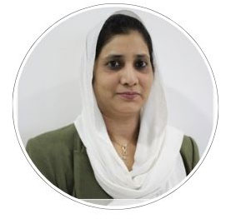


Mr. Syed Ahmed
Director & CEO
LinkedIn - https://www.linkedin.com/in/ssyedahmed
Mrs. Monika Thanvi Independent Director
LinkedIn -
Ms. Nazneen Hamid Director-Corporate Affairs
LinkedIn - www.linkedin.com/in/nazneen-hamid
Mr. Gopal Damisetti
Independent Director
LinkedIn - www.linkedin.com/in/gopal-damisetti-2bb8367

Scientific Advisory Board
Bringing together eminent scientific leaders whose expertise strengthens our vaccine research, development and innovation agenda.

Image  Name  Designation | Image  Name  Designation .

OUR VALUES
Three Principles. One Enduring Commitment.
These values are not just words, they shape our decisions, define our culture, and drive our mission toward global health equity.
Integrity  We act with honesty, transparency, and accountability in everything we do. | Inclusivity  We believe in creating equitable opportunities and fostering diverse collaborations across borders. | Ingenuity  We drive innovation through bold thinking and practical problem-solving, always focused on impactful outcomes..

MISSION & VISION
MISSION  Access to Essential Vaccines and Novel Biologics Should Not Only be the Privilege of Just the Affording Few. | VISION  Enabling One Health  through Bio-innovation  - Affordable  - Accessible  - Acceptable

Website Note: Add team photograph.
Website Note: Add certifications and awards.

Research & Development
TechInvention's state-of-the-art R&D facility, the High-impact One Health Research & Innovation ZONe (HORIZON), is designed to accelerate vaccine innovation by supporting end-to-end research from proof-of-concept development through preclinical advancement for priority infectious diseases and antimicrobial resistance (AMR)-associated pathogens.
Website Note: This visual can be developed as an animation.
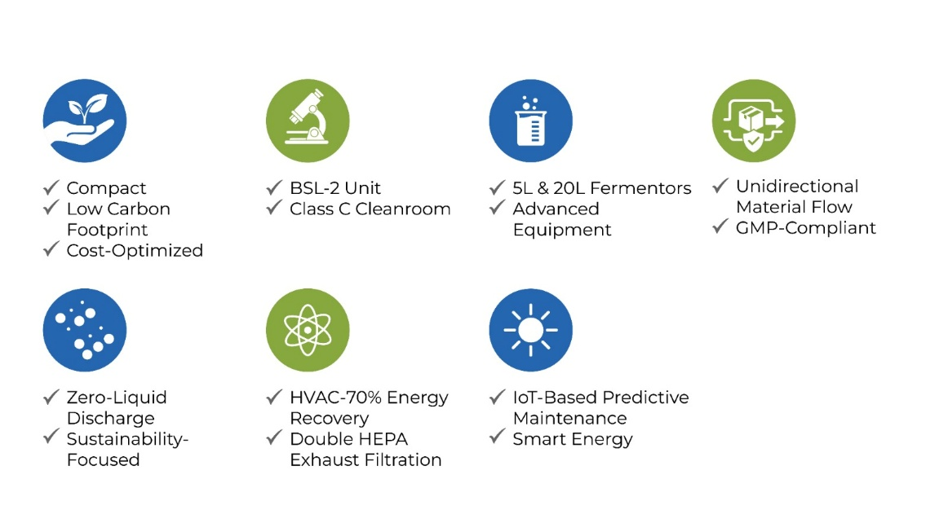

Website Note: Add the HORIZON video.



Can be in flow chart

Stage | Description
Ideate | Target identification, antigen discovery, AI/ML-enabled vaccine design, and platform selection.
Develop | Process and formulation development, analytical assay development, characterization, and proof-of-concept studies.
Evaluate | Preclinical efficacy, safety and toxicology studies, with regulatory documentation and compliance.
Scale | Process scale-up, technology transfer, GMP manufacturing readiness, and commercial translation.

Infectious Diseases and AMR-Associated Pathogen Focus

Vaccine / Biotherapeutics Candidate | R&D | POC | Pre-clinical | Phase 1/2
Pneumococcal Conjugate Vaccine (16-valent)
Hexavalent Meningococcal Vaccine (ABCYWX)
Pan-Salmonella Vaccine
Shigella Vaccine
Meningococcal B Vaccine
Malaria Vaccine
Tuberculosis Vaccine

Our Collaborations

Where Institutional Excellence Meets Next-Generation Vaccine Innovation
Together, our partnerships are focused on high-priority diseases of major public health significance, including Salmonella, Shigella, tuberculosis, malaria, and meningitis strengthening the pathway from scientific discovery to translational development and future vaccine impact.

Our current collaborations:
01 Institute of Life Sciences (ILS) | 02 Indian Institute of Technology  Bhubaneswar
03 ICMR- RMRC  Bhubaneswar | 04 ICMR-NIRBID  Kolkata

CDMO Page

Vaccine Manufacturing

Global Collaborative Centre for Medical Countermeasures

GCMC


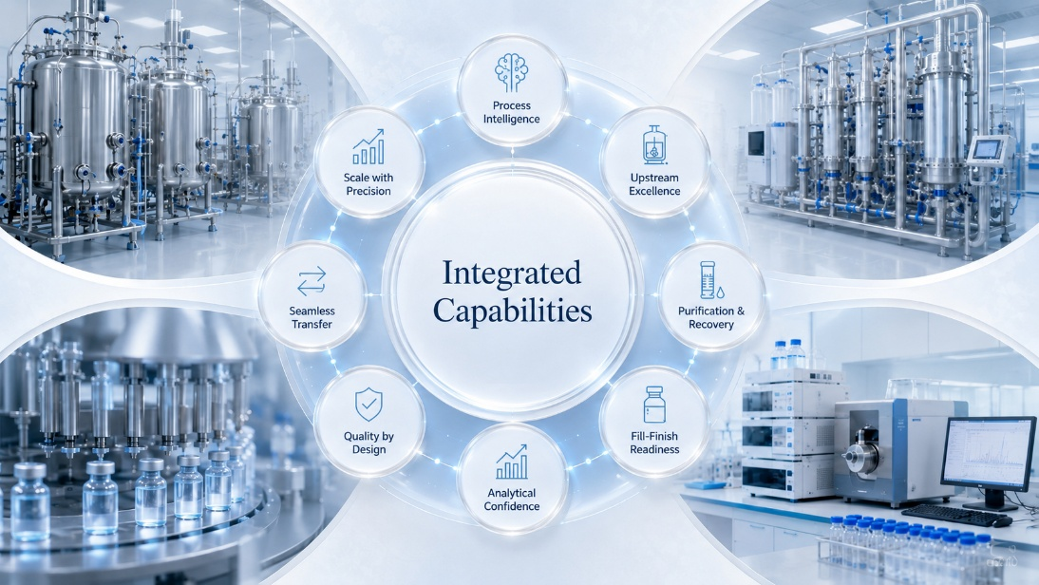

Vaccine Development & Manufacturing

Global Collaborative Centre for Medical Countermeasures (GCMC)

Integrated Full-Cycle Vaccine Development & Manufacturing Facility

From Innovation to Scalable Global Health Solutions
TechInvention's Global Collaborative Centre for Medical Countermeasures (GCMC) is an Integrated Full-Cycle Vaccine Development & Manufacturing Facility designed to accelerate the journey from scientific discovery to global health impact.
Developed in alignment with international GMP standards, GCMC brings together vaccine process development, manufacturing scale-up, technology transfer, analytical testing, quality systems, regulatory support, drug product manufacturing, digital innovation, and sustainable infrastructure within one integrated facility.
GCMC as a Bridge
Scientific innovation begins in research laboratories, universities, and biotechnology companies, but transforming promising discoveries into commercially viable vaccines requires specialized expertise, advanced manufacturing infrastructure, regulatory compliance, and scalable production capabilities.
GCMC bridges this critical gap by providing end-to-end support across vaccine development, process optimization, manufacturing scale-up, technology transfer, GMP manufacturing, quality assurance, and regulatory readiness.

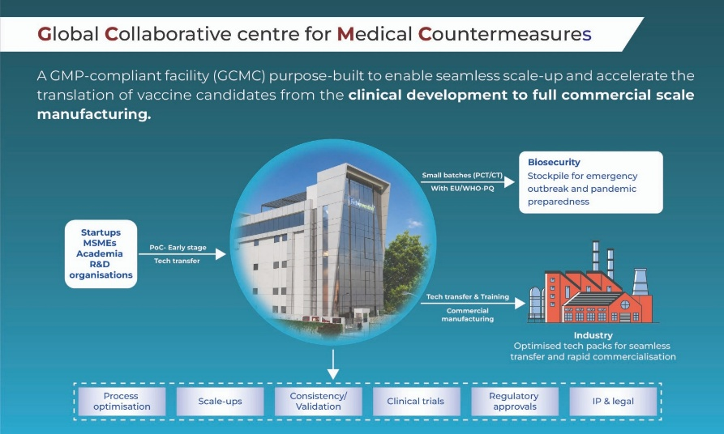

Why Partner with Us ?

End-to-End Capability
Integrated expertise supporting every stage of vaccine development—from process development and manufacturing scale-up to fill-finish, regulatory readiness, and technology transfer.

International Quality Standards
Manufacturing infrastructure designed in alignment with global GMP expectations, supported by robust quality systems, comprehensive documentation, and regulatory compliance.

Flexible Manufacturing
Advanced manufacturing technologies capable of supporting multiple vaccine and biologics platforms, enabling efficient development and scalable production.

Faster Development Pathways
Optimized scientific and manufacturing workflows designed to accelerate technology translation, reduce development risk, and shorten time to market.

Collaborative Innovation
A global ecosystem connecting biotechnology companies, pharmaceutical manufacturers, research institutions, governments, international organizations, and public health partners to advance vaccine innovation.

Sustainable Manufacturing
Energy-efficient infrastructure and intelligent facility management systems designed to reduce environmental impact while maintaining manufacturing excellence.

Integrated Manufacturing Capabilities

Upstream Manufacturing
Two flexible upstream manufacturing suites equipped with stainless-steel bioreactor systems (20 L and 100 L), enabling efficient process development, optimization, and manufacturing scale-up across diverse production platforms.

Downstream Processing
Integrated purification capabilities supporting recovery, concentration, purification, polishing, and process optimization to ensure consistent product quality and manufacturing robustness.

Drug Product Manufacturing
Flexible fill-finish capabilities through a multi-format manufacturing line supporting liquid vials and pre-filled syringes for clinical and commercial supply.

Quality, Regulatory & Technology Transfer
Comprehensive support for analytical development, quality management systems, regulatory documentation, validation, technology transfer, manufacturing readiness, and commercialization planning to enable successful product advancement.

Training & Workforce Development
Specialized hands-on training programs in vaccine manufacturing, GMP operations, quality assurance, biosafety, regulatory compliance, and advanced bioprocessing to strengthen global biomanufacturing capacity.



Digital Manufacturing Excellence
Digital technologies are integrated throughout GCMC to improve process efficiency, manufacturing visibility, operational performance, and product quality.
Key capabilities include: (graphics)
- AI-assisted process monitoring and optimization
- Machine learning-driven manufacturing analytics
- Computational biology workflows
- NGS-enabled research and development support
- Real-time manufacturing and utility monitoring
- Predictive maintenance through intelligent facility management
- Data-driven process optimization
- Digital quality and operational management
By embedding digital intelligence across research, development, manufacturing, and facility operations, GCMC enables faster decision-making, improved process consistency, enhanced product quality, and operational resilience.



Sustainability by Design
Sustainability is embedded into every aspect of GCMC's design and operations to support responsible and energy-efficient vaccine manufacturing.
The facility integrates renewable energy solutions, intelligent building management systems, water conservation strategies, and energy-efficient utilities to reduce environmental impact while maintaining world-class manufacturing performance.

Key Sustainability Features (graphics)
- Renewable energy integration to improve energy efficiency
- AI-enabled building management and predictive maintenance
- Energy-efficient HVAC and utility systems
- Smart chilled water and compressed air management
- Heat pump-based energy optimization
- Water conservation and zero liquid discharge planning
- Rainwater harvesting and resource optimization
- IoT-enabled monitoring for sustainable facility operations
These integrated sustainability measures reduce energy consumption, improve operational efficiency, and support environmentally responsible manufacturing.

Partner with GCMC
Together, we are advancing the future of vaccine development and manufacturing—accelerating innovation, strengthening global health security, and improving equitable access to life-saving vaccines worldwide.

Consultancy Page Content
Strategic Advisory & Tech Consulting

Strategic Advisory & Tech Consulting
Building resilient healthcare and biomanufacturing ecosystems through strategy, science and execution.
TechInvention supports governments, funding agencies, manufacturers, investors and research institutions in shaping vaccine and biopharmaceutical manufacturing infrastructure.

WHAT WE OFFER

Consulting Services Tailored for Healthcare Innovation
Focused advisory across the full journey from concept to commercialization:
Website Note: Create a visual graphic for the service areas below.
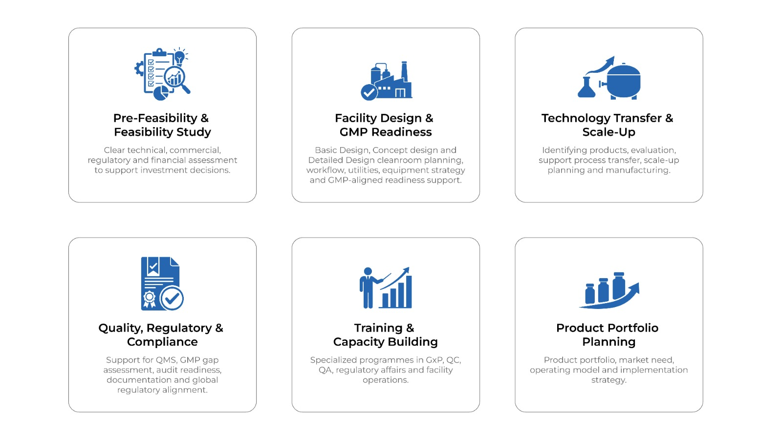

Clients
Website Note: Add consultancy client logos, e.g., ADB, IAVI and UNOPS.







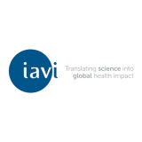




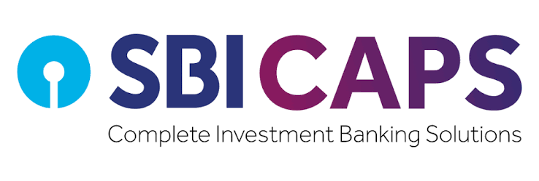

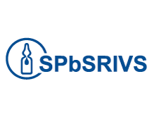


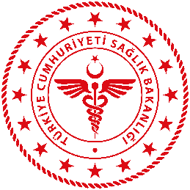

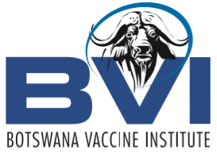

Case Studies
Website Note: Case studies to be shared

Feedback from Clients
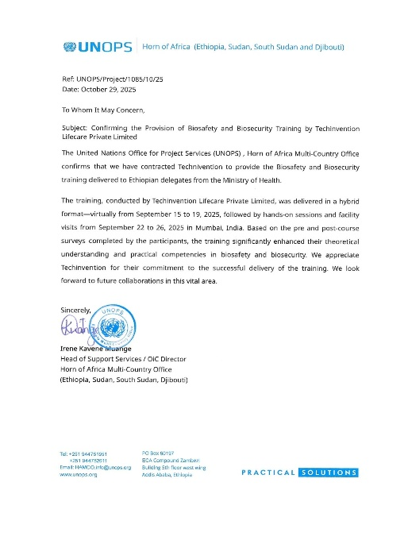
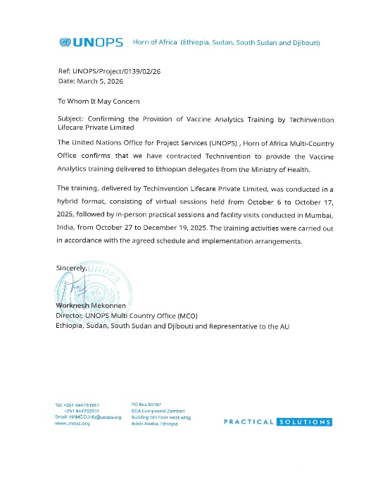
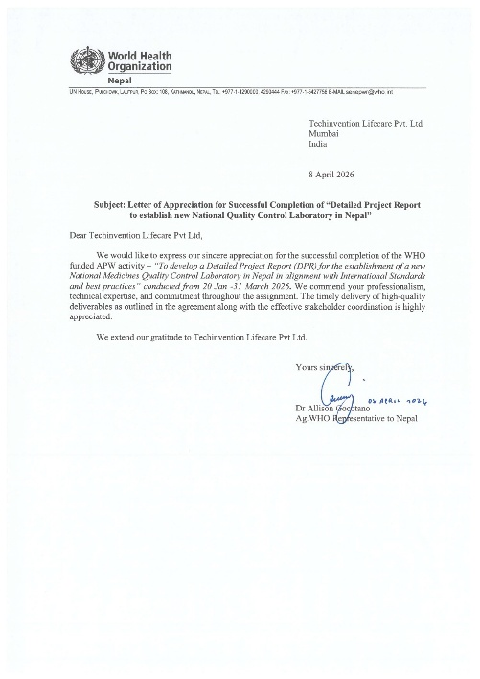

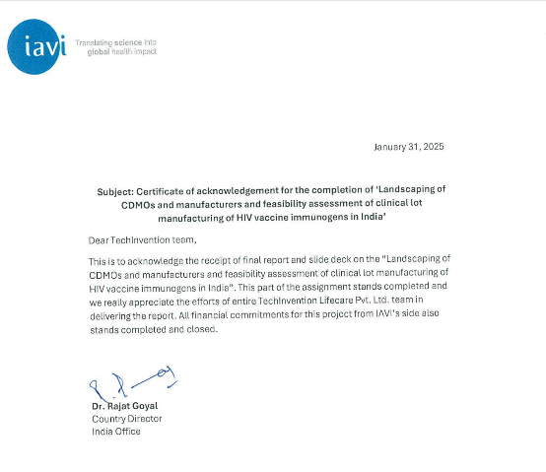

Call to Action

Advancing healthcare ambitions into scalable global impact.
Partner with TechInvention to design, build and strengthen future-ready vaccine, biologics and healthcare manufacturing ecosystems

PRODUCT PAGE CONTENT
Vaccines Built to Protect


A targeted portfolio of proven, globally approved and widely supplied essential vaccines, available for commercialization by partner companies, supporting prevention, immunization readiness, and equitable access partnerships across healthcare markets worldwide

PRODUCT DETAILS
Product Information Format
Use the below format for each product card or product-detail accordion on the website.
1 | Product Name: TdaPgen  Combined Tetanus Toxoid, Reduced Diphtheria Toxoid and Reduced Recombinant Pertussis Vaccine

Label Composition | Each single dose of 0.5 mL contains:  • Tetanus Toxoid — 7.5 Lf  • Diphtheria Toxoid — 2.0 Lf  • Bordetella pertussis antigens:  • Recombinant Pertussis Toxin (rPT) — 2 µg  • Filamentous Haemagglutinin (FHA) — 5 µg
Pack | 0.5 mL Prefilled Syringe
Therapeutic Use | Active booster immunization against diphtheria, tetanus and pertussis in individuals aged 4 to 65 years.

2 | Product Name: Varicella Vaccine, Live Attenuated

Label Composition | Each single dose of 0.5 mL contains:  • Live Attenuated Varicella-Herpes Zoster Virus (Oka strain) — 3.3 to 4.5 lg PFU/0.5 mL per dose  • Produced in human diploid (SV-1) cells  • International standard virus strain purchased from ATCC  • Virus titer tested using an in-house reference
Pack | Vial and WFI
Therapeutic Use | Active immunization against infection caused by varicella in individuals aged 1 year (12 months) to 12 years.

3 | Product Name: Inactivated Hepatitis A Vaccine (Adsorbed) I.P.

Label Composition | Each single dose of 0.5 mL contains:  • Inactivated HAV antigen (TZ84 strain)¹ — 250 U  • Aluminium, as Aluminium Hydroxide — 0.175 to 0.31 mg  • Disodium Hydrogen Phosphate — q.s.  • Sodium Chloride — 4.5 mg  • Sodium Dihydrogen Phosphate — q.s.  • Water for Injection — q.s. to 0.5 mL  • ¹ Produced in Human Diploid Cells
Pack | Vial / Prefilled Syringe
Therapeutic Use | Active immunization against infection caused by Hepatitis A virus.

4 | Product Name: Trivalent Influenza Vaccine

Label Composition | Each single dose of 0.5 mL contains:  • Each 0.5 mL dose contains 15 µg haemagglutinin (HA) of each influenza virus strain selected in accordance with the annual recommendations of the World Health Organization (WHO) for the applicable Northern or Southern Hemisphere influenza season.
Pack | Prefilled Syringe
Therapeutic Use | Active immunization of adults aged 18 years and older for prevention of influenza disease.

Access-Oriented  Built to support availability of essential vaccines across priority markets. | Market-Ready  Focused on regulated, market-authorized vaccine candidates. | Partnership-Led  Designed for institutional, commercial and public health collaborations.

Adverse Event Reporting
.
For any questions or to report an Adverse Event, please contact our AE Reporting team:
Phone: 18008902590
Email: feedback@techinvention.biz
Download Reporting Form: Please complete the AE Reporting form and send your response to the aforementioned email.
Your privacy is important to us.
All AE reports shall be handled with strict confidentiality.
Personal information is protected and used solely for safety monitoring purposes.

CTA SECTION
Partner With TechInvention for Vaccine Access
Connect with TechInvention to explore product availability, licensing partnerships and access opportunities for market-authorized vaccines.

Careers Page Content

Build With Purpose
Join a team where science, strategy and execution come together to create meaningful healthcare impact. At TechInvention, every role contributes to advancing vaccines, biologics and technologies that support access, affordability and resilience across global health ecosystems.

Website Note: Add Great Place to Work certificates from previous years.




Life at TechInvention
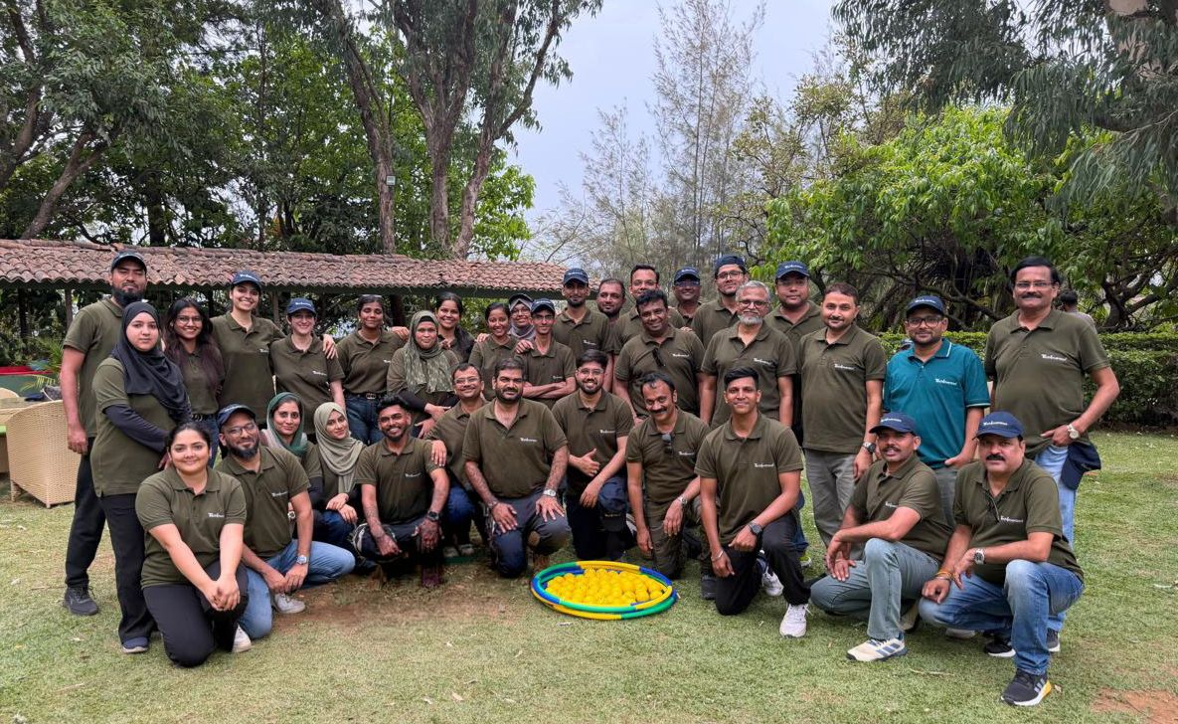

Why Join Us
Purpose-led work: Contribute to healthcare solutions that matter.
Global exposure: Work with partners, institutions and experts across diverse geographies.
Learning culture: Grow through hands-on projects, mentorship and cross-functional collaboration.
Ownership mindset: Take responsibility, lead ideas and make your contribution visible.
Innovation ecosystem: Be part of a growing biotech company working across vaccines, biologics and global health infrastructure.

Who We Look For

Talent with curiosity, discipline and drive
We welcome professionals who are ambitious, thoughtful and ready to take ownership. Whether you are a scientist, engineer, consultant, regulatory expert, finance professional or corporate leader, TechInvention offers the opportunity to grow with purpose.
Employee Voices




Stories from the people growing with TechInvention.
Name | Experience | Testimonial
Shahnawaz Shaikh  Designation - | 9+ Years | ““Having joined TechInvention in an Admin and HR role 10 years ago, I have had the privilege of growing alongside the organisation and taking on greater responsibility, ownership and purpose over the years. It has been an inspiring and deeply fulfilling journey, and I am proud to have witnessed and contributed to TechInvention’s remarkable growth and evolution.”
Aziz Mandsaurwala  Senior Manager - Global BD | 6+ Years | “Working at TechInvention means being part of projects that connect science, strategy and real-world healthcare impact. Every assignment brings learning and growth.”
Sarang Pathak  General Manager | 9+ Years | “Working at TechInvention has given me the opportunity to continuously learn, take on diverse responsibilities and contribute to meaningful work. The trust, exposure and support I have received here have played an important role in my professional growth and confidence.”
Bhakti Chavan  Deputy Manager Clinical Trials | 5+ Years | I joined TechInvention in 2019 at the start of my career, and over the past 6+ years, I have grown professionally in Preclinical and Clinical vaccine research. The opportunities, exposure, and learning I've received have been invaluable. It has been rewarding to grow alongside the company as it evolved from a startup to establishing its own manufacturing facility.
Priya Dhawale  Deputy Manager - GBD | 5+ Years | Completing over six years at TechInvention has been an incredibly rewarding journey. It has been inspiring to witness the company's transformation from a startup into a growing MSME with a strong global presence. Throughout this journey, I have been given the opportunity to work on diverse international business development and strategic consulting projects, collaborate with global stakeholders, and continuously expand my knowledge in the life sciences sector. The trust, support, and learning opportunities provided by the leadership and my colleagues have played a significant role in my professional growth. I look forward to being part of TechInvention's continued success and innovation.


Open Positions

Explore opportunities across functions
TechInvention offers roles across Business Consultancy, Licensing, Vaccine R&D, Production, Quality Control, Quality Assurance, Regulatory Affairs, Legal and IP, Finance, HR and corporate affairs.

Join Our Team

Begin your next chapter with impact
If you are looking for a career that challenges you, develops you and connects your work to a larger purpose, TechInvention is the place to grow.
Website Note: Add the application form in this section.
Training Page Content

Developing the Next Generation of Professionals in Vaccine Development and GMP Manufacturing
Through industry-aligned, experiential learning, we prepare professionals to meet the evolving demands of vaccine development and GMP manufacturing. Our comprehensive curriculum covers biosafety and biosecurity, GMP production, analytical testing, quality assurance, global regulatory requirements, clinical trial management and pharmacovigilance.

Training Purpose

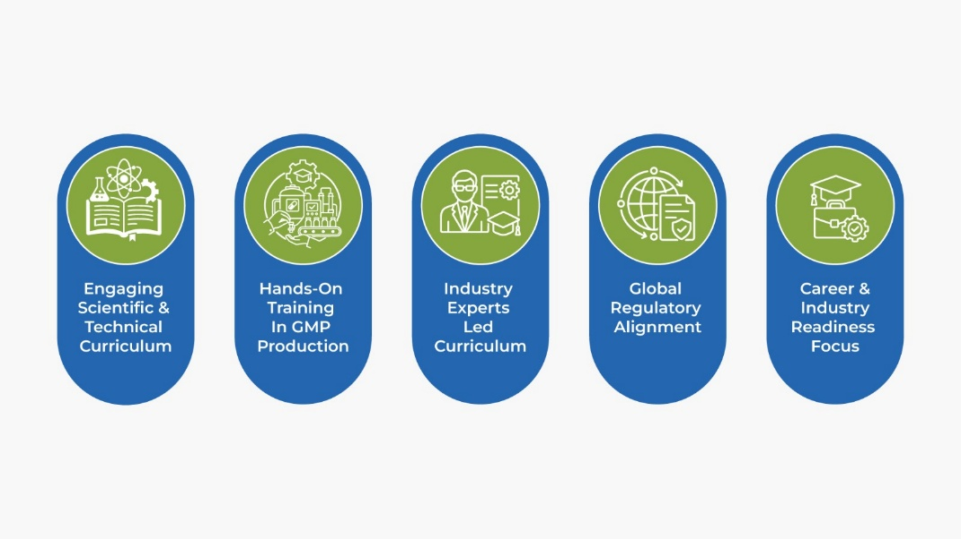

Website Note: Display each training module below as a drop-down.
GMP Compliance
Build a strong foundation in GMP principles, regulatory expectations, quality systems, and the culture of compliance required for manufacturing and testing operations.
Key Focus Areas
- WHO, US FDA & ICH Guidelines
- Good Documentation Practices (GDP)
- Personnel Hygiene & Safety
- Facility Design & Material/Personnel Flows
- Quality Culture & Compliance Mindset
Quality Management Systems (QMS)
Develop expertise in quality systems that ensure product consistency, regulatory compliance, and continuous improvement across the product lifecycle.
Key Focus Areas
- Deviation & Incident Management
- CAPA & Root Cause Investigations
- Change Control Systems
- Quality Risk Management (ICH Q9)
- OOS & OOT Investigations

Analytical & Quality Control Techniques
Gain exposure to analytical methodologies and quality control practices used in pharmaceutical, biotechnology, and vaccine testing laboratories.
Key Focus Areas
- HPLC & Chromatographic Techniques
- ELISA & Protein Quantification
- Endotoxin Testing (LAL)
- Molecular Characterization Methods
- Data Analysis & Result Interpretation
Molecular Biology & Advanced Testing
Understand modern molecular biology techniques used for product characterization, contamination monitoring, and quality assessment.
Key Focus Areas
- DNA Extraction & Purification
- PCR & Real-Time PCR
- Host Cell DNA Analysis
- Agarose Gel Electrophoresis
- Molecular Data Interpretation

Microbiology & Sterility Assurance
Learn critical microbiological practices that support contamination control and product safety in regulated manufacturing environments.
Key Focus Areas
- Sterility Testing
- Environmental Monitoring
- Bioburden Assessment
- Mycoplasma Detection
- Aseptic Techniques & Contamination Control

Aseptic Processing & Cleanroom Operations
Comprehensive understanding of cleanroom behavior, sterile manufacturing practices, and environmental control strategies.
Key Focus Areas
- Cleanroom Classifications
- Gowning Qualification & Validation
- Media Fill Simulations
- Environmental Monitoring Programs
- Microbial Control Strategies

Validation, Qualification & Lifecycle Management
Master the principles of qualification and validation required to demonstrate process consistency and regulatory compliance.
Key Focus Areas
- DQ, IQ, OQ & PQ Execution
- Process Validation Principles
- Cleaning Validation
- Computer System Validation (CSV)
- Equipment Lifecycle Management

Data Integrity & Digital Compliance
Ensure data reliability, traceability, and compliance through robust documentation and electronic record management practices.
Key Focus Areas
- ALCOA+ Principles
- Audit Trail Review
- Electronic Data Management
- BMR/BPR Documentation
- Data Governance & Compliance

Technology Transfer & Scale-Up Strategies
Understand the critical elements involved in successful transfer of processes from development to commercial manufacturing.
Key Focus Areas
- Technology Transfer Lifecycle
- Scale-Up Risk Assessment
- Process Capability Studies
- Analytical Method Transfer
- Cross-Functional Coordination

Regulatory Intelligence & Inspection Readiness
Prepare for audits and inspections through an understanding of global regulations and regulatory expectations.
Key Focus Areas
- WHO, EMA & US FDA Expectations
- Audit & Inspection Preparedness
- Regulatory Documentation
- Quality Metrics & Trending
- Regulatory Compliance Strategies

Industry Readiness & Professional Development
Bridge the gap between academic learning and industrial practice through real-world applications and quality-driven problem solving.
Key Focus Areas
- GMP Simulations & Case Studies
- Scientific Literature Review
- Technical Presentations
- Laboratory Investigation Exercises
- Career & Workforce Readiness

Laboratory Excellence & Scientific Problem Solving
Develop a systematic approach to laboratory operations, troubleshooting, and scientific decision-making to improve analytical reliability and operational efficiency.
Key Focus Areas
- Laboratory Best Practices
- Scientific Problem Solving
- Troubleshooting Analytical Methods
- Investigation of Laboratory Errors
- Critical Thinking & Decision Making.

Vaccine Manufacturing & Process Understanding
Gain insights into pharmaceutical and vaccine manufacturing processes, critical quality attributes, and process controls that ensure product safety, efficacy, and consistency.
Key Focus Areas
- Drug Product & Vaccine Manufacturing Overview
- Critical Process Parameters (CPPs)
- Critical Quality Attributes (CQAs)
- Process Monitoring & Control
- Manufacturing Deviations & Investigations

Scientific Communication & Documentation Excellence
Strengthen technical communication and documentation skills essential for regulated environments and cross-functional collaboration.
Key Focus Areas
- Technical Report Writing
- SOP Preparation & Review
- Scientific Presentation Skills
- Documentation Review Practices
- Regulatory Writing Fundamentals
Emerging Technologies in Biopharmaceutical Quality Control
Explore modern technologies and analytical advancements shaping the future of pharmaceutical and vaccine quality assessment.
Key Focus Areas
- Advanced Analytical Techniques
- Automation in QC Laboratories
- Digital Quality Systems
- Laboratory Informatics (LIMS)
- Trends in Biopharmaceutical Testing

UNOPS Biosafety & Biosecurity Training

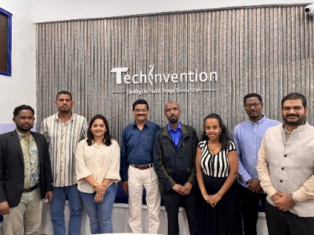
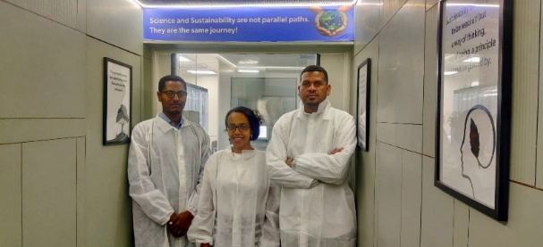
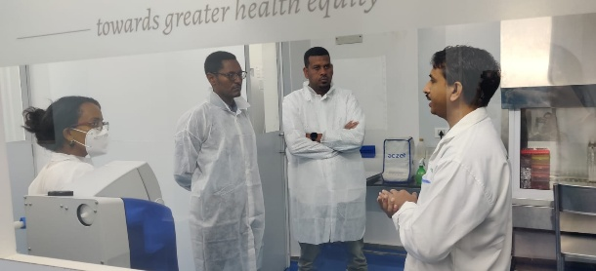

Advancing safer laboratory ecosystems through structured training in biosafety, biosecurity and containment practices.
The program blends technical understanding with practical risk-management approaches for modern biomedical laboratories.
It helps build institutional capability for safe, compliant and responsible scientific operations.

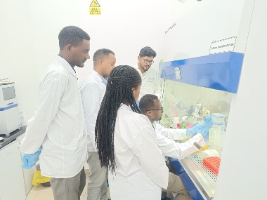
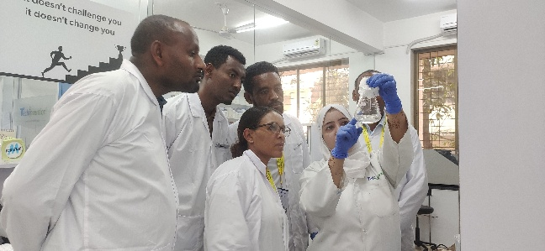
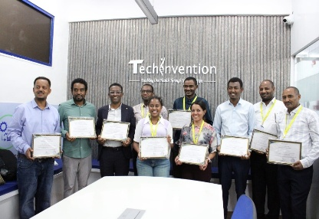
UNOPS Vaccine Analytics Training
Enhancing vaccine development capability through focused training in analytical science and product evaluation.
The program supports understanding of critical quality attributes, analytical methods, assay relevance and data interpretation.
It strengthens the technical foundation required for vaccine quality, regulatory readiness and development success.

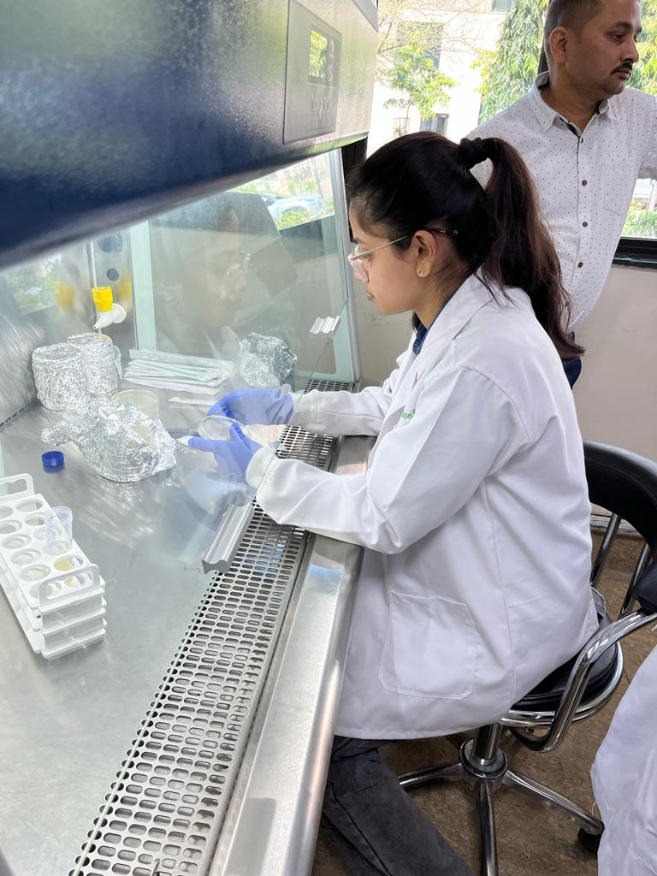

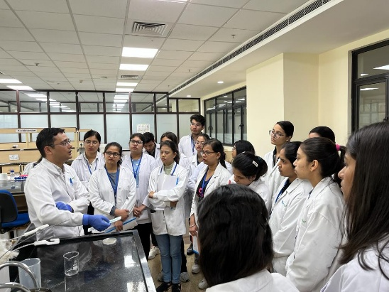
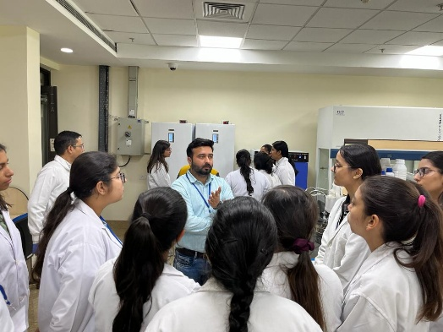

Bioprocessing Training at RCB
TechInvention conducted focused training programs at the Regional Centre for Biotechnology, Faridabad, covering the fundamentals of upstream and downstream processing, Quality Control, Quality Assurance and Good Manufacturing Practices. The sessions also included hands-on exposure to streaking and shake-flask techniques, fermentation operations, vaccine production workflows, QC laboratory practices and BSL-2 fermentation facilities, helping participants connect core bioprocessing concepts with real-world industry applications

Appreciation & Feedback
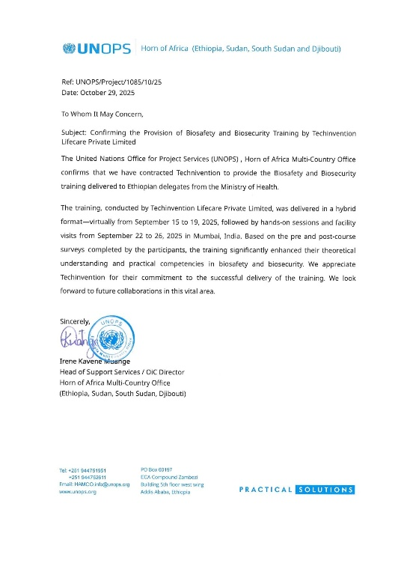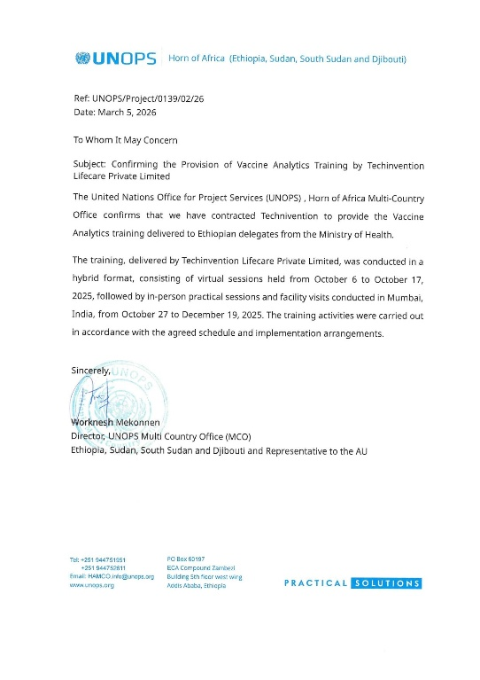

Testimonials
1. The training bridged my research background with practical applications, highlighting the importance of quality systems and regulatory compliance in real-world settings.
Dr. Meseret Habtamu
Researcher – Vaccine Analytics
Armauer Hansen Research Institute

2. I received end-to-end, hands-on exposure to vaccine quality control testing across upstream, downstream, and fill-finish processes aligned with global regulatory expectations.
Mr. Hailu Ashenafi
Senior Special Advisor for Quality Assurance
Ministry of Health/ShieldVax Project
3. I learned to apply data integrity (ALCOA+ principles) and Statistical Process Control to ensure the analytical pipeline remains a non-negotiable foundation for vaccine safety.
Mr. Kebede Fufa
QMS Lead – Executive Office Desk Head
Ethiopian Food and Drug Authority (EFDA)
4. The training provided an excellent combination of theoretical foundation and practical application that significantly enhanced my understanding of vaccine quality, safety, and effectiveness
Dr. Jaleta Shuka
Vaccine Quality Assurance Team Leader
National Veterinary Institute, Ethiopia

5. This program significantly improved my analytical competence in vaccine manufacturing, particularly regarding Quality Control and GMP-based testing.
Mr. Lami Bikila Kelbessa
Quality Control Chemist
Africure Pharmaceuticals Manufacturing Ethiopia PLC.

Explore Training Opportunities with TechInvention
Write to connect@techinvention.biz to learn more about our training programs and upcoming initiatives.
CONNECT WITH US
Contact Us



Website Copy  Whether you are exploring partnerships, product enquiries, R&D collaborations, scale-up and manufacturing opportunities or consultancy support for capacity building, our team would be pleased to hear from you.  TechInvention works with partners across global health systems to move science closer to meaningful public health impact. | Suggested CTA  Get in Touch  Start a Conversation

Contact Form Section
Let’s Start the Conversation  Send us your enquiry and the appropriate team will get back to you at the earliest. Whether your interest lies in products, partnerships, technology, manufacturing, advisory or training support, we look forward to connecting with you. | Recommended Form Fields  • Full Name *  • Email Address *  • Organisation  • Enquiry Type *  • Message *  Button: Send Message

Location & Address
Visit our corporate office or connect with us directly for partnership discussions, product enquiries, strategic collaborations and institutional communication.
Website Note: Add Google Maps location.
Corporate Office and Manufacturing Site  Plot No. EL-40, Mahape MIDC Electric Zone, MIDC Industrial Area, Mahape Village, Navi Mumbai, Thane, Maharashtra, 400710  Bio-Innovation Centre (HORIZON)  EL-125, Mahape MIDC Electric Zone, MIDC Industrial Area, Mahape Village, Navi Mumbai, Thane, Maharashtra, 400710 | Phone Enquiries  +91 22 4005 2123 | Email Address  connect@techinvention.biz

