1. 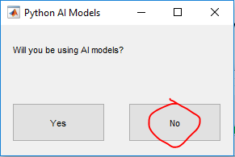Launch application
   1. You will be prompted with a question dialog:
      1. Select ‘**No**’.
2. In the ‘**Load** **DICOM**’ Section
   1. Click ‘**Load** **Directory**’
      1. Select the folder that you are assigned.

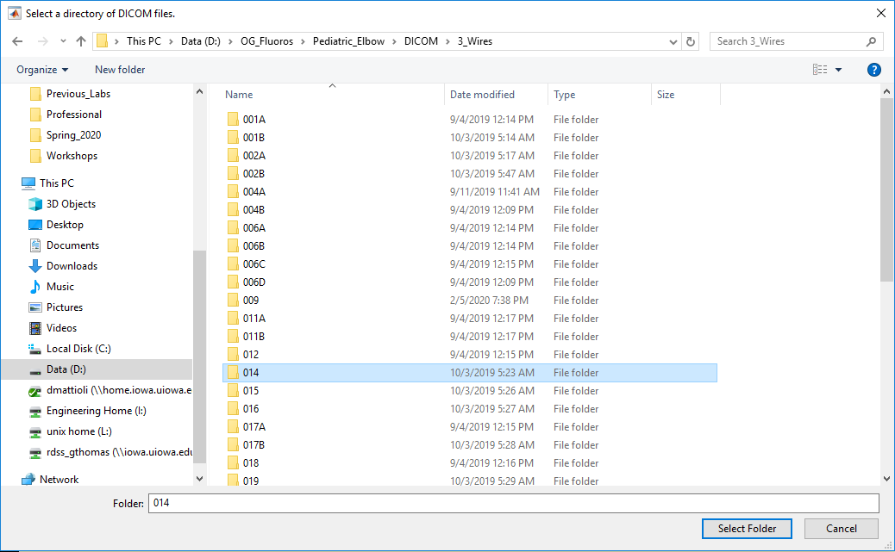

* + 1. A list of files will populate – select one that you are assigned (attached).
    2. Click ‘**Plot File**’.

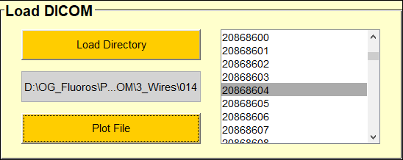

1. In the ‘**Procedure**’ section
   1. Select ‘**Mask Objects’.**

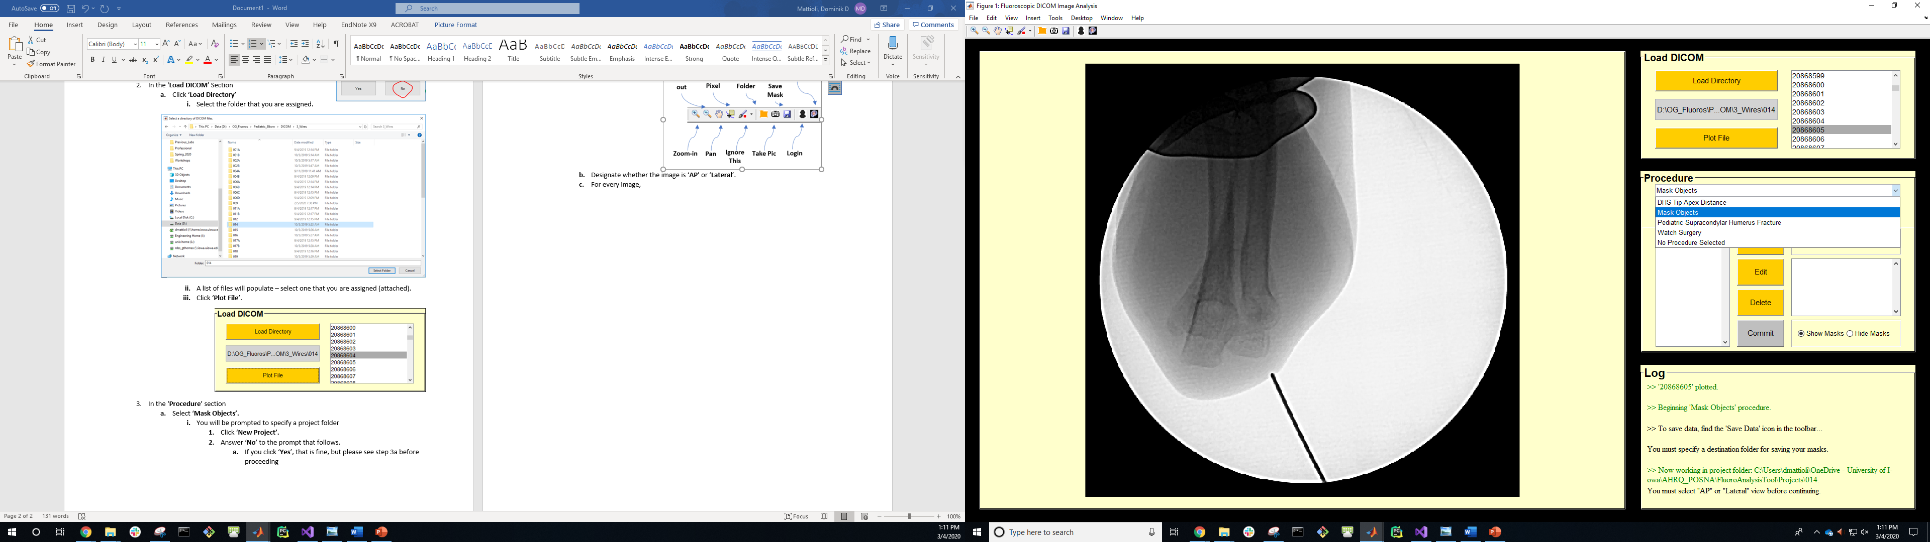

* + 1. You will be prompted to specify a project folder
       1. Click ‘**New Project’.**
       2. Answer ‘**No**’ to the prompt that follows.
          1. If you click ‘**Yes**’, that is fine, but please see step 3a before proceeding
       3. Make a folder somewhere titled ‘Name_Masks’.
          1. Your saved data will be placed here.
          2. Insert your last name instead of “Name”.
          3. You can change your ‘**Project Folder**’ at any time by using the Toolbar. A picture containing monitor, black, screen, light

             Description automatically generated
  1. Designate whether the image is ‘**AP**’ or ‘**Lateral**’.

1. For every image, you will ‘**Define**’ a mask for any/all wires and the Humerus.
   1. Refer to the attached document for the specific images that you are responsible for annotating these objects.
   2. For 46 specific images, everyone will be approximating the fracture Plane on the Humerus using a 2-point line segment.
      1. Select ‘**Fracture Plane**’, then click‘**Define**’.
   3. Once all objects in the image have been annotated, click ‘**Commit**’.
      1. Do not click ‘**Save Data**’ in the tool bar.
      2. Clicking ‘**Plot File**’ will delete your data.
   4. You can view the outlines of your drawn masks by toggling the ‘**Show Masks**’/’**Hide Masks**’ radio buttons.
   5. You can edit specific masks that you have made by selecting them in the ‘**Current Masks**’ list and then clicking ‘**Edit**’.
      1. An interpolation of your original mask will be plotted
      2. You can move the vertices around to improve the annotation.
         1. Double-Click to finish.
   6. You can delete specific masks that you have made by selecting them in the ‘**Current Masks**’ list and then clicking ‘**Delete**’.