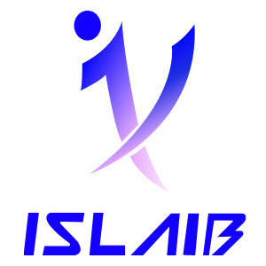 | Ministry of Higher Education and Scientific Research  University of Jendouba  Higher Institute of Applied Languages and Computer Science Béja (ISLAIB) | 

Ref: LA-GLSI……/2026
End-of-Year Internship Report (PFA)
In partial fulfillment of the requirements for the
BACHELOR’S DEGREE IN COMPUTER ENGINEERING (LICENCE GLSI)
Génie Logiciel et Systèmes d’Information
Title:
Design and Development of Synkro, a Collaborative
Project and Task Management Platform

Prepared by: | Adem Ouerhani
Professional Supervisor: | Mr. Mkaissi Khalil
Host Organization: | Kernel Solution & Innovation

Higher Institute of Applied Languages and Computer Science of Béja ISLAIB
Boulevard de l’environnement B.P. 340 Béja 9000 | Website: www.islaib.rnu.tn
Academic Year: 2025 - 2026
Dedication
To my parents, whose unconditional love, sacrifices, and unwavering belief in me have shaped every step of my education. Their patience through my doubts, their encouragement through my setbacks, and their quiet confidence in my abilities gave me the strength to pursue this path. None of this work, nor the person I have become, would exist without them.
To my extended family and friends, who stood by me through the long hours, the late nights, and the uncertainty that came with building something from scratch. Their constant encouragement, patience, and willingness to listen, even when the subject was far outside their own fields, were a genuine source of strength throughout this internship.
To every teacher, mentor, and colleague who believed in me and pushed me to give the best of myself, and to everyone, named or not, whose support, advice, or simple presence made this achievement possible. This work is dedicated to all of you, with gratitude and respect.
Acknowledgements
I would like to express my sincere and heartfelt gratitude to everyone who contributed, directly or indirectly, to the completion of this end-of-year internship (PFA) and to the design, development, and writing of this report. This project would not have reached its current form without the guidance, trust, and support of the people named below.
My thanks go first to Kernel Solution & Innovation for welcoming me as an intern and giving me the opportunity to work on a real, self-directed software project within a professional digital agency environment. Being trusted with genuine ownership over the direction of Synkro, rather than a purely observational or supporting role, gave me exposure to the full lifecycle of a software product, from initial requirements to a complete, working platform, and taught me lessons that a purely academic setting could not have provided.
I would particularly like to thank my professional supervisor, Mr. Mkaissi Khalil, for his guidance, his trust in letting me lead the technical direction of the project, and his availability throughout the internship. His willingness to answer questions, review progress, and give honest, constructive feedback at every stage of development was invaluable, and his confidence in my judgment pushed me to take real ownership of the technical decisions behind Synkro.
I also wish to thank the teaching staff of the Higher Institute of Applied Languages and Computer Science of Béja (ISLAIB) and, more broadly, the Licence Génie Logiciel et Systèmes d’Information (GLSI) program, for the knowledge and technical foundation that made this project possible. The theoretical grounding in software engineering, databases, and system design provided throughout the program gave me the tools to approach a project of this scale with confidence, and I am grateful to every instructor who took the time to explain concepts thoroughly and answer questions beyond the scope of the syllabus.
Finally, I would like to thank my family and friends for their unconditional support and encouragement during this internship. Their patience during long working sessions, their willingness to listen even without a technical background, and their constant reassurance during moments of doubt made this journey considerably lighter, and I am deeply grateful to have had them by my side throughout.
Table of Contents
General Introduction 1
Chapter 1. Project Context 2
1. Introduction 2
2. Host Organization 2
3. Preliminary Study 2
a) Presentation of Existing Solutions 2
b) Comparative Analysis 3
4. Problem Statement 3
5. Proposed Solution 3
6. Objectives 4
7. Actors Identification 4
8. Requirements Specification 5
a) Functional Requirements 5
b) Non-Functional Requirements 5
9. Methodology and Tools Justification 5
10. Conclusion 6
Chapter 2. Sprint 0 - Project Planning Phase 7
1. Introduction 7
2. Product Backlog 7
3. Sprint Planning 7
4. Sprint Durations 8
5. Global Use Case Diagram 8
6. Development Environment 9
a) Hardware Environment 9
b) Software Environment 9
7. Conclusion 10
Chapter 3. Sprint 1 - Authentication & User Management 10
1. Introduction 10
2. Sprint Backlog 11
3. Requirements Specification 11
4. Design 12
5. Realization 12
6. Conclusion 13
Chapter 4. Sprint 2 - Project & Task Management 14
1. Introduction 14
2. Sprint Backlog 14
3. Requirements Specification 14
4. Design 15
5. Realization 16
6. Conclusion 17
Chapter 5. Sprint 3 - Collaboration & Real-Time Features 18
1. Introduction 18
2. Sprint Backlog 18
3. Requirements Specification 19
4. Design 19
5. Realization 20
6. Conclusion 21
Chapter 6. Sprint 4 - Administration, Moderation & Analytics 21
1. Introduction 21
2. Sprint Backlog 21
3. Requirements Specification 22
4. Design 22
5. Realization 23
6. Conclusion 24
Chapter 7. General Discussion 24
1. Introduction 24
2. Skills Gained 24
3. Difficulties Encountered 25
4. Limits and Perspectives 25
5. Conclusion 25
General Conclusion and Recommendations 26
Bibliography and Webography 27
Annexes 28

List of Figures
Figure 1: Agile/Scrum-inspired iterative methodology 6
Figure 2: Gantt chart of the sprint schedule 8
Figure 3: General use case diagram of Synkro 9
Figure 4: Technical architecture of the Synkro platform 10
Figure 5: Use case diagram - Sprint 1 11
Figure 6: Sequence diagram - “Log in” 12
Figure 7: Class diagram - Sprint 1 12
Figure 8: Registration page 13
Figure 9: Login page 13
Figure 10: Use case diagram - Sprint 2 15
Figure 11: Sequence diagram - “Create & assign task” 15
Figure 12: Class diagram - Sprint 2 16
Figure 13: Task board (Kanban-style view) 16
Figure 14: Task detail view with checklist and deliverables 16
Figure 15: Task review workflow, awaiting review 16
Figure 16: Task review workflow, reviewer approve/reject decision 17
Figure 17: Use case diagram - Sprint 3 19
Figure 18: Sequence diagram - real-time notification broadcast 19
Figure 19: Class diagram - Sprint 3 20
Figure 20: Task comments / feedback thread 20
Figure 21: Live notification bell and notifications page 20
Figure 22: Use case diagram - Sprint 4 22
Figure 23: Sequence diagram - suspension & appeal 22
Figure 24: Class diagram - Sprint 4 23
Figure 25: Admin user management page 23
Figure 26: Admin project management (all projects) page 23
Figure 27: Admin analytics dashboard 24
Figure 28: Account settings panel 28
Figure 29: Appearance settings - theme selection 28
Figure 30: Active sessions (“logged in devices”) list 28
Figure 31: Feedback / support ticket panel 28
Figure 32: Project creation form 28
Figure 33: Task creation form 28
Figure 34: Trash, recoverable project and task deletion 28
Figure 35: Project deliverables page 28
Figure 36: Task checklist and personal notes 29
Figure 37: Project settings page 29
Figure 38: Project activity log 29
Figure 39: Suspension appeals list 29
Figure 40: Feedback / support ticket detail 29
Figure 41: Public landing page, light theme 30
Figure 42: Appeal History, in Account Settings 30
Figure 43: Personal dashboard 30
Figure 44: Login notification e-mail 30

List of Tables
Table 1: Comparison of existing project management solutions 3
Table 2: Identified actors of the Synkro platform 4
Table 3: Product backlog (condensed view) 7
Table 4: Sprint schedule 8
Table 5: Software environment and tools used 9
Table 6: Sprint 1 backlog 11
Table 7: Textual description of the “Log in” use case 12
Table 8: Sprint 2 backlog 14
Table 9: Textual description of the “Create task” use case 15
Table 10: Sprint 3 backlog 18
Table 11: Textual description of the real-time notification use case 19
Table 12: Sprint 4 backlog 21
Table 13: Textual description of the “Suspend account” use case 22

List of Abbreviations
Abbreviation | Meaning
PFA | Projet de Fin d’Année (End-of-Year Internship Project)
ISLAIB | Institut Supérieur des Langues Appliquées et de l’Informatique de Béja
GLSI | Génie Logiciel et Systèmes d’Information
UML | Unified Modeling Language
MVC | Model - View - Controller
ORM | Object-Relational Mapping
CRUD | Create, Read, Update, Delete
API | Application Programming Interface
REST | Representational State Transfer
UI / UX | User Interface / User Experience
RBAC | Role-Based Access Control
SPA | Single-Page Application
WS | WebSocket
KPI | Key Performance Indicator
MAMP | Macintosh (or Windows) - Apache - MySQL - PHP local server stack
SQL | Structured Query Language
CSS | Cascading Style Sheets
PC | Personal Computer
SEO | Search Engine Optimization

General Introduction
Software is how modern organizations plan, coordinate and get work done, and collaborative tools have become the default way teams break projects into tasks, assign responsibilities and track progress. Project and task management is now one of the most competitive corners of business software, with established products like Trello, Asana, Jira and ClickUp fighting for the same users.
This report covers the work I did during my end-of-year internship (Projet de Fin d’Année, PFA), completed at Kernel Solution & Innovation, a digital agency in Hammam-Lif, Tunisia, between June 15 and July 31, 2026, as part of the second year of my Licence in Génie Logiciel et Systèmes d’Information (GLSI) at the Higher Institute of Applied Languages and Computer Science of Béja (ISLAIB).
Unlike a typical internship built around a mission the host company hands you, this PFA was self-directed: I picked my own topic and designed, planned and built a complete product from scratch, under the host organization’s professional supervision. I chose to build Synkro, a collaborative project and task management platform for small and medium-sized teams, built with a modern full-stack architecture (Laravel, React, Inertia.js) and real-time technologies.
Two things drove this choice. First, project and task management is a concrete but genuinely rich problem: it touches authentication, access control, real-time communication, data modelling and team collaboration all at once, a good way to show a broad range of engineering skills in a short timeframe. Second, building a product this size alone meant living through the whole development lifecycle, instead of touching a narrow slice of someone else’s codebase.
The central problem this internship set out to answer comes down to three questions. How can a single developer, working to a tight seven-week schedule, design a project management platform that is both complete and pleasant to use? Which features genuinely matter for collaborative work between people with different responsibilities? And how do you add real-time feedback and activity tracking without making the app slower or harder to use?
To answer these questions, I followed an Agile, sprint-based approach inspired by Scrum, and this report mirrors that structure. Chapter 1 covers the project context and the proposed solution. Chapter 2 covers Sprint 0, the planning phase that set the backlog, the schedule and the environment. Chapters 3 to 6 go sprint by sprint through Synkro’s main functional areas: authentication, project and task management, real-time collaboration, and administration with analytics. Chapter 7 reflects on the skills gained and the difficulties along the way, before a general conclusion with recommendations.

Chapter 1. Project Context

1. Introduction
This first chapter introduces the host organization, looks at existing project management solutions to see where Synkro fits among them, states the problem this project addresses, and lays out the proposed solution with its functional and non-functional requirements. It ends with a short justification of the working methodology and modelling tools chosen for the project.

2. Host Organization
Kernel Solution & Innovation is a digital agency based on the RN1 road in Hammam-Lif, Tunisia. With more than seven years of experience behind it, the company works as a technology partner that turns client ideas into complete, reliable digital products, covering custom software and app development, mobile development, web design, brand identity, and digital marketing and SEO.
The agency structures its delivery around four stages that mirror an Agile way of working: project planning, development, testing and quality assurance, and launch with ongoing support. The team includes a CEO, an HR manager, full-stack developers, a mobile developer and an IT specialist, working on client projects from e-commerce platforms to educational and logistics applications.
It was inside this agile, product-oriented culture that I completed my internship, under the professional supervision of Mr. Mkaissi Khalil, founder and CEO of Kernel Solution & Innovation.

3. Preliminary Study

a) Presentation of Existing Solutions
Before designing Synkro, I looked at existing project and task management tools to understand common conventions and decide which features were worth keeping. Four widely used products came up repeatedly: Trello, known for its simple Kanban boards; Asana, which combines task lists, timelines and workload views; Jira, the go-to tool for Scrum teams with detailed backlogs and sprint boards; and ClickUp, an all-in-one workspace merging documents, goals and tasks.sprint boards; and ClickUp, an all-in-one workspace that tries to merge documents, goals and tasks into a single product.

b) Comparative Analysis
Table 1 compares these four tools against criteria that were considered important for Synkro: ease of use, real-time collaboration, granular role management, and cost for small teams.
Table 1: Comparison of existing project management solutions
Criterion | Trello | Asana | Jira | ClickUp
Ease of use | Very high | High | Moderate | Moderate
Real-time collaboration | Limited | Moderate | Moderate | Moderate
Granular team roles | Basic | Moderate | Advanced | Advanced
Learning curve | Low | Low-medium | High | High
Free tier for small teams | Yes | Yes (limited) | Yes (limited) | Yes (limited)
Source: author (Synkro project, 2026).
This comparison points to a recurring trade-off: the simplest tools, like Trello, give up fine-grained role management and real-time depth, while the most complete tools, Jira and ClickUp, become heavy and hard for a small team to adopt. That gap is what motivated the solution proposed below.

4. Problem Statement
Small and medium-sized teams, the kind you find in a digital agency like Kernel Solution & Innovation, need a tool that actually supports collaborative work: people with different responsibilities (an owner managing the project, managers planning and assigning work, members and testers doing and validating it) must all see the same up-to-date picture of a project, be notified the moment something relevant happens, and trust that sensitive actions are properly restricted by role. Few tools offer that combination of simplicity, live collaboration and fine-grained, role-aware permissions in one lightweight product.

5. Proposed Solution
To address this, this internship proposes Synkro, a web-based collaborative project and task management platform. Synkro lets any registered user create projects, invite collaborators, and assign them one of four project-level roles (owner, manager, member, tester); organize work into tasks that move through a clear status workflow; attach deliverables and checklists to tasks; and communicate through comments. Relevant events, such as task assignments, status changes, comments and membership changes, are pushed to connected users in real time through WebSockets, so every team member sees a live, consistent view of the project without refreshing the page. On top of this collaborative core sits an administration layer for moderating accounts, reviewing support tickets and suspension appeals, and following overall platform activity through an analytics dashboard.tasks that move through a clear status workflow; attach deliverables and checklists to tasks; and communicate through comments. Relevant events, task assignments, status changes, comments, membership changes, are pushed to connected users in real time through WebSockets, so every team member sees a live, consistent view of the project without ever refreshing the page. On top of this collaborative core sits an administration layer that lets platform administrators moderate accounts, review support tickets and suspension appeals, and keep an eye on overall platform activity through a dedicated analytics dashboard.

6. Objectives
- Design and implement a complete, usable collaborative project and task management web application within a seven-week internship.
- Provide fine-grained, role-based access control so that each project member only sees and does what their role allows.
- Deliver real-time collaboration (live notifications, live board updates) using WebSockets.
- Offer administration and moderation tools (user management, feedback tickets, suspension and appeal workflow, activity analytics).
- Apply an Agile, sprint-based methodology to plan and track the internship’s own progress.

7. Actors Identification
Synkro distinguishes two levels of roles: platform-level roles, which apply to the whole application, and project-level roles, which apply within a given project and are stored independently for each project a user belongs to. Table 2 summarizes the actors identified for the system.
Table 2: Identified actors of the Synkro platform
Actor | Description
Guest | An unauthenticated visitor who can access the public pages (registration, login, legal pages) and can also submit a feedback / support ticket directly from the welcome screen, without creating an account.
Registered User | Any authenticated platform user; can manage their own profile, create projects and join projects they are invited to.
Project Owner | The user who created a project; has full control over it, including deleting it and managing every member’s role.
Project Manager | A trusted collaborator who can create and assign tasks and manage other members, but cannot delete the project.
Project Member | A regular contributor who works on assigned tasks, updates their status, checks off checklist items, and adds deliverables.
Project Tester | A contributor with restricted permissions focused on validating submitted work.
Administrator | A platform-level role in charge of moderating users and content, handling support tickets, and reviewing suspension appeals.
Superadmin | The highest platform-level role, holding every administrator permission plus a few of its own: promoting or demoting a user between user, administrator and superadmin, deleting user accounts, and limited editing of a user’s core info.
Source: author (Synkro project, 2026).

8. Requirements Specification

a) Functional Requirements
- Account registration, e-mail verification, login, password reset and session (device) management.
- Profile and account settings management, including a choice of visual themes.
- Project creation, member invitation, project-level role assignment, and code-confirmed ownership transfer.
- Task creation, assignment, status tracking, checklist items and file or link deliverables, with due dates, automatic overdue alerts and a configurable per-task deadline reminder.
- Comments and feedback on tasks, with editing, threaded replies, and distinct handling of reviewer feedback.
- Real-time notifications, reminders, project notes and shared project resources.
- A personal dashboard with task and project statistics, an activity chart with a comparison-enabled legend, session and deadline calendars, and a My Notes widget for checklist items synced into personal notes.
- Activity logging and a recoverable trash (soft delete) for projects and tasks.
- A feedback / support ticket system, open to guests and registered users alike, with a trackable ticket identifier, image attachments, and inactivity-based auto-closing.
- Administration: user management, role promotion, account suspension, suspension appeals, and an analytics dashboard.

b) Non-Functional Requirements
- Usability: a clean, responsive interface usable on both desktop and mobile screens.
- Performance: real-time updates must reach connected clients with minimal latency.
- Security: every sensitive action must be protected by role-based authorization policies.
- Maintainability: a clear separation of concerns (MVC) and a normalized relational data model.
- Availability of a dark, light and additional custom colour theme for user comfort.

9. Methodology and Tools Justification
Given the short duration of the internship and the fact that I was both the sole developer and, in effect, my own product owner, an Agile methodology directly inspired by Scrum was chosen to structure the work. The project was broken down into a short planning phase (Sprint 0) followed by four development sprints, each delivering a coherent, demonstrable increment of the platform: authentication, project and task management, real-time collaboration, and administration with analytics. This iterative approach kept a working version of the application at the end of every sprint, allowed the backlog to be reprioritized if needed, and left the final sprint free for consolidation once the collaborative core was stable.
The Unified Modeling Language (UML) was used throughout the report to formalize the system’s design: use case diagrams to capture functional requirements per actor, sequence diagrams to describe the dynamic behaviour of key scenarios, and class diagrams to describe the underlying data model of each functional area.
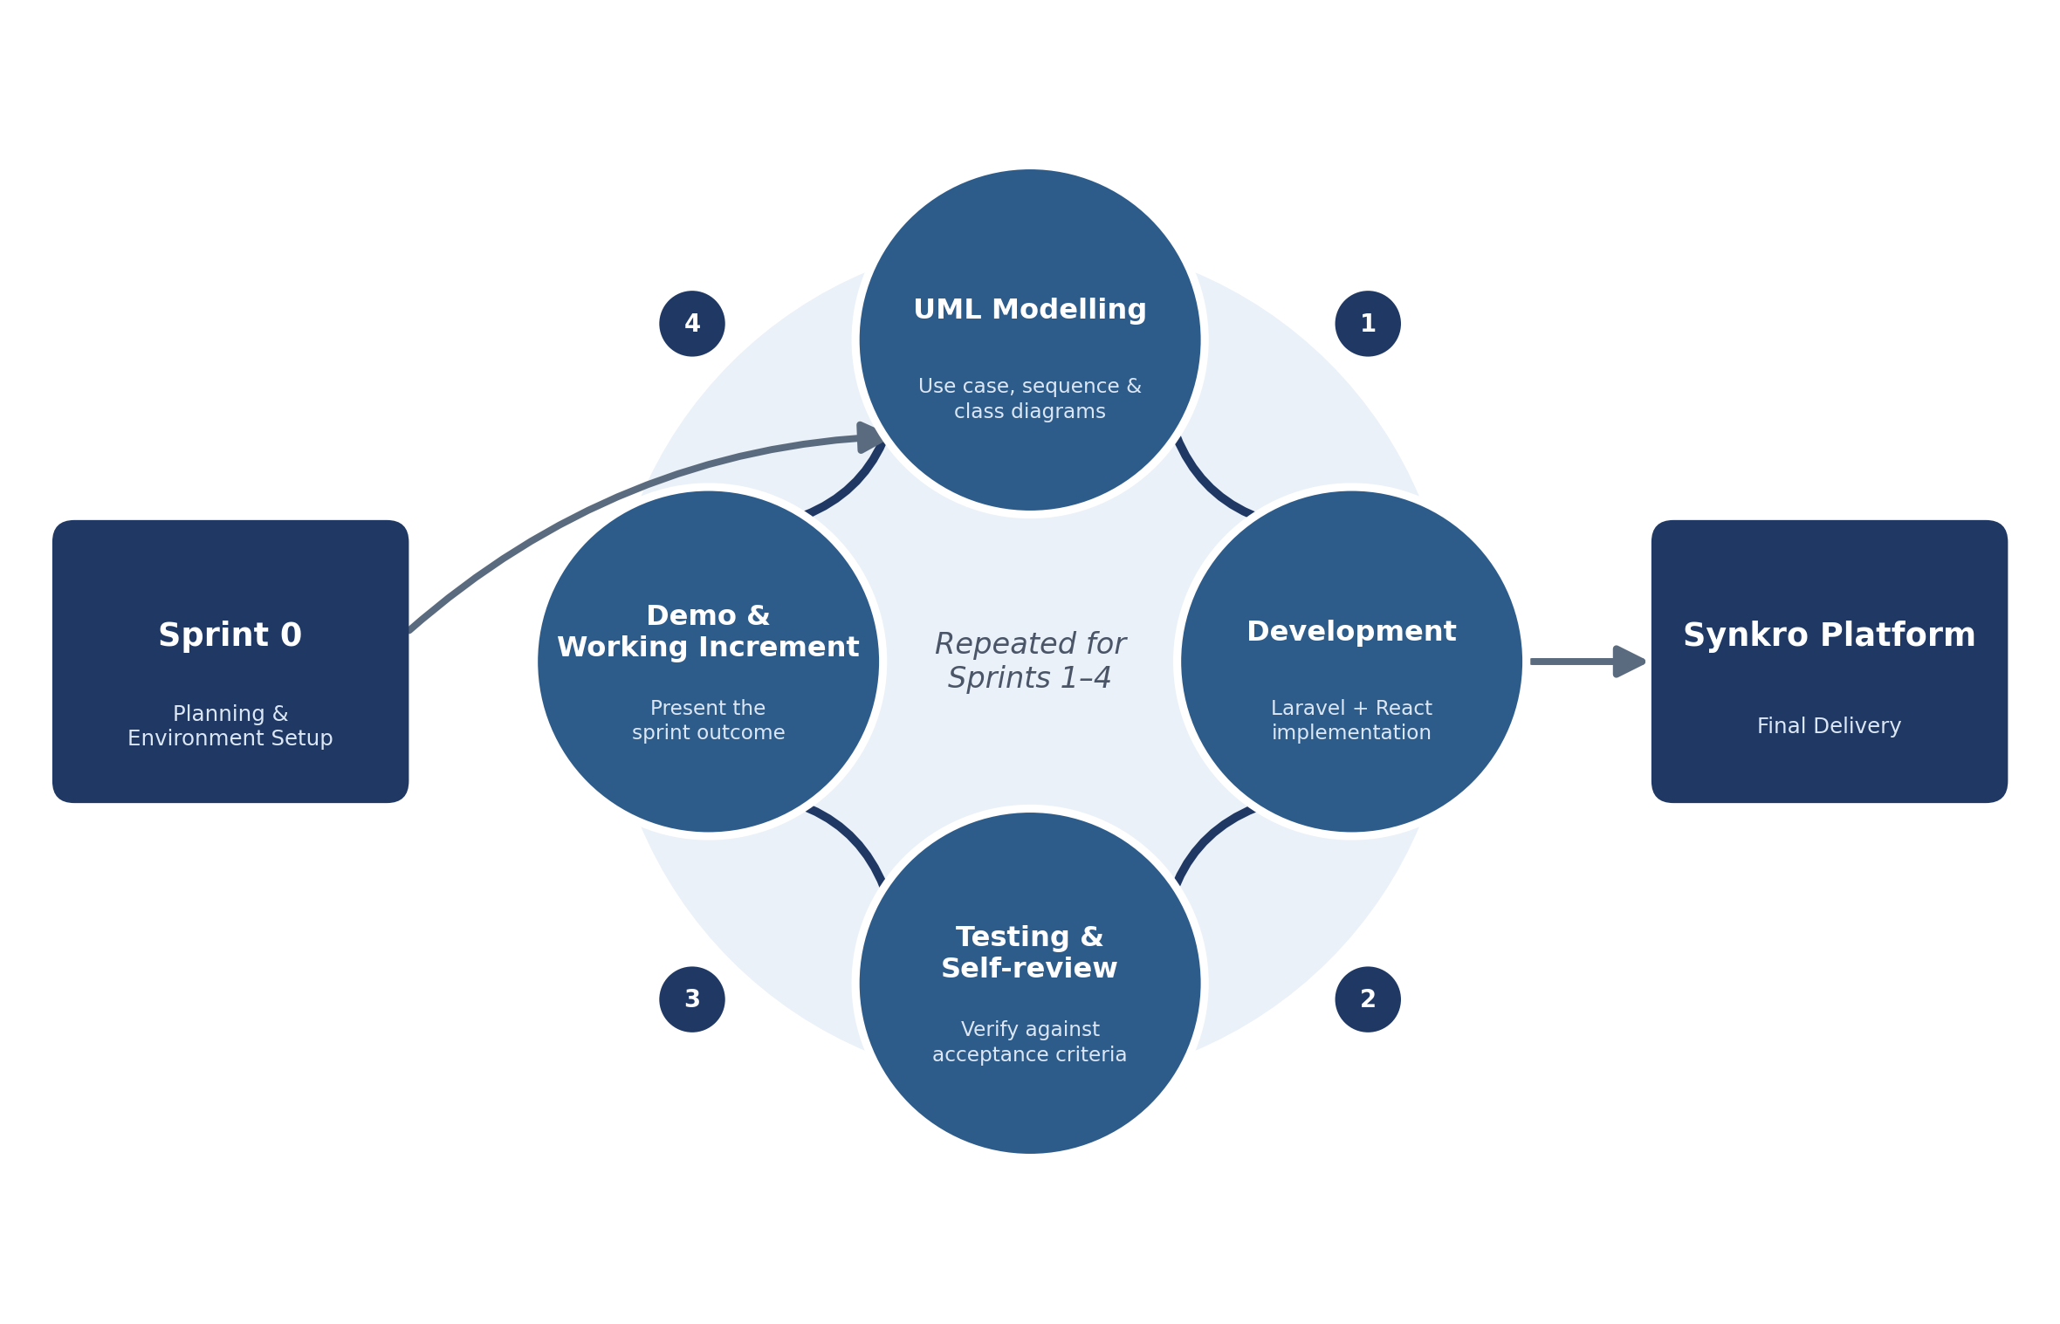
Figure 1: Agile/Scrum-inspired iterative methodology
Source: author (Synkro project, 2026).

10. Conclusion
This chapter set the context for the internship, positioned Synkro against existing project management tools, and defined the problem, objectives, actors and requirements that guide the rest of this report. The next chapter covers Sprint 0, where all of this was turned into a concrete product backlog and a development plan.

Chapter 2. Sprint 0 - Project Planning Phase

1. Introduction
Sprint 0 covers the first week of the internship (June 15 to June 19, 2026). Unlike the sprints that follow, it does not deliver a user-facing feature. Instead, it sets up everything needed to start development on solid footing: the product backlog, the sprint schedule, a first high-level view of the system through a global use case diagram, and the development environment.

2. Product Backlog
The product backlog lists the main features of Synkro, ordered by priority and grouped by the functional area they belong to. Table 3 presents a condensed view of this backlog, already organized by the sprint in which each group of items was implemented.
Table 3: Product backlog (condensed view)
Sprint | Backlog item | Priority | Estimate
Sprint 1 | User registration, e-mail verification, login, logout | High | 3 days
Sprint 1 | Password reset, profile & appearance settings, session list | High | 5 days
Sprint 2 | Project creation, member invitation, project roles | High | 4 days
Sprint 2 | Task CRUD, status workflow, checklist, deliverables | High | 6 days
Sprint 3 | Comments & feedback, real-time notifications | High | 3 days
Sprint 3 | Reminders, project notes, project resources, activity log, personal dashboard | Medium | 2 days
Sprint 4 | Admin: user management, suspension & appeals | High | 3 days
Sprint 4 | Feedback tickets, admin analytics dashboard, trash & restore | Medium | 2 days
Source: author (Synkro project, 2026).

3. Sprint Planning
The internship runs from Monday, June 15, 2026 to Friday, July 31, 2026, which corresponds exactly to seven full working weeks. This period was split into one planning sprint and four development sprints, summarized in Table 4 and illustrated by the Gantt chart in Figure 2.
Table 4: Sprint schedule
Sprint | Period | Duration | Goal
Sprint 0 | Jun 15 - Jun 19, 2026 | 1 week | Planning & environment setup
Sprint 1 | Jun 22 - Jul 3, 2026 | 2 weeks | Authentication & user management
Sprint 2 | Jul 6 - Jul 17, 2026 | 2 weeks | Project & task management
Sprint 3 | Jul 20 - Jul 24, 2026 | 1 week | Collaboration & real-time features
Sprint 4 | Jul 27 - Jul 31, 2026 | 1 week | Administration, moderation & analytics
Source: author (Synkro project, 2026).
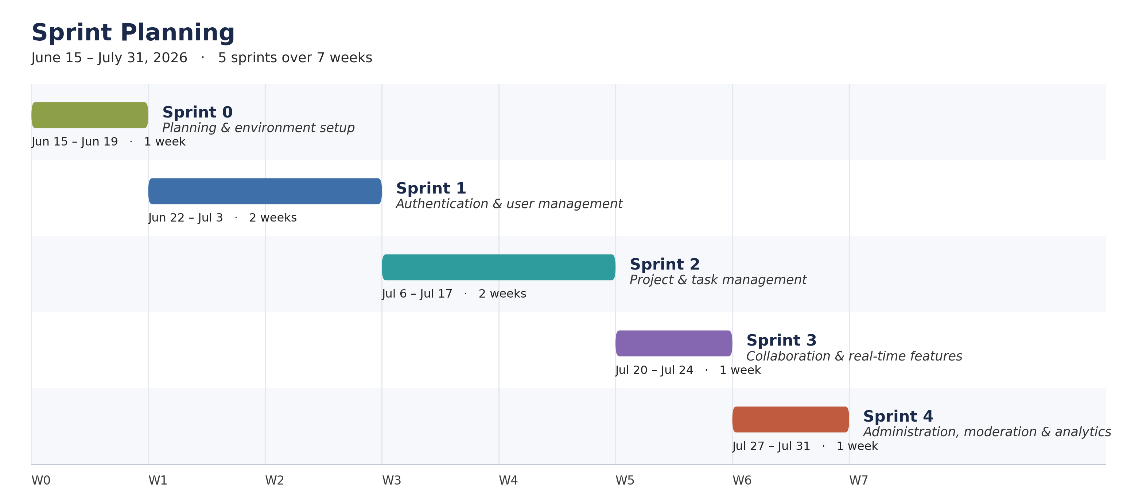
Figure 2: Gantt chart of the sprint schedule

4. Sprint Durations
Sprint durations were deliberately uneven: two weeks were allocated to Sprint 1 and Sprint 2 because authentication and, above all, project and task management form the functional core of the application and needed a solid, well-tested foundation. Sprint 3 and Sprint 4 were each given a single week, since they build incrementally on that core and involve comparatively smaller, more independent features (notifications, moderation tools, analytics).

5. Global Use Case Diagram
Before detailing each sprint individually, Figure 3 presents a global use case diagram summarizing the main interactions between the identified actors and the Synkro system as a whole. The following chapters refine this global view into one detailed use case diagram per sprint.
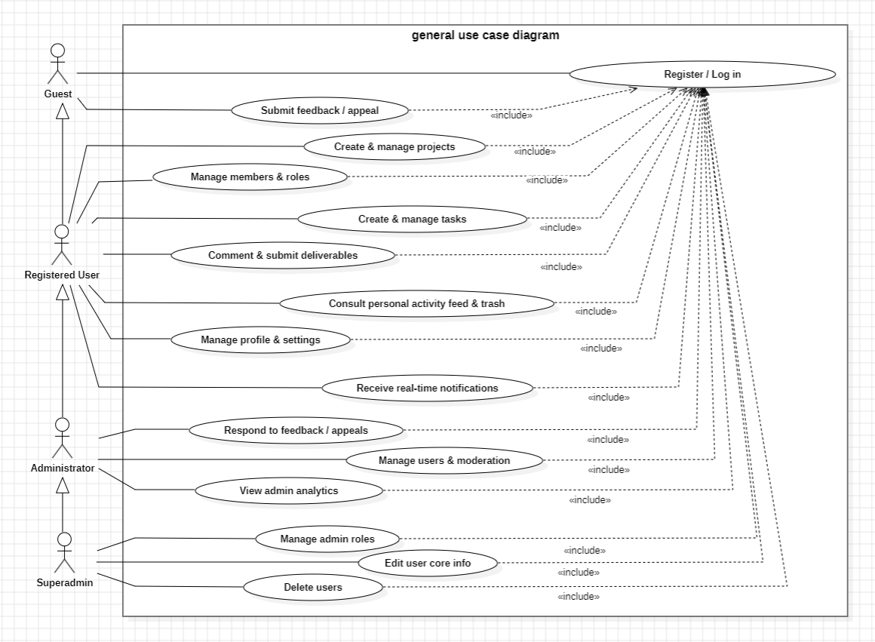
Figure 3: General use case diagram of Synkro

6. Development Environment

a) Hardware Environment
- Laptop: Dell Gaming G15 5530, Intel Core i5 (13th generation), 16 GB RAM, NVIDIA GeForce RTX 3050 (6 GB), Windows 11, 1920 × 1080 display.

b) Software Environment
Table 5: Software environment and tools used
Logo | Description
 | Laravel 13 (PHP). PHP web framework powering the whole back-end: routing, controllers, authorization policies and data access through the Eloquent ORM.
 | Inertia.js. Links the Laravel back-end directly to the React front-end as a single-page application, without a separate API layer.
 | React. JavaScript library rendering every page and interactive element of the front-end, from the kanban board to the notification bell.
 | Tailwind CSS. Utility-first CSS framework styling the whole interface, including its light, dark and custom black themes.
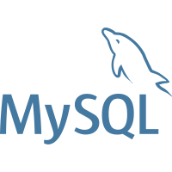 | MySQL. Relational database holding users, projects, tasks, notifications and activity logs.
 | Laravel Reverb. First-party WebSocket server broadcasting real-time events (notifications, live board and note updates, admin alerts) to connected clients.
 | Laravel Breeze. Authentication starter kit that scaffolded the initial registration, login and password-reset flows, later customized in Sprint 1.
 | MAMP. Local server environment used to run the MySQL database on port 3306 during development.
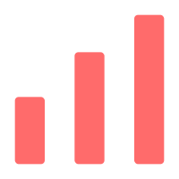 | Recharts. React charting library powering the analytics visualizations of the administration dashboard.
 | Git. Version control system used to track every change made to the source code during the internship.
 | GitHub Desktop. Graphical Git client used to manage and push commits to the public repository at github.com/domdomxy/synkro.
 | Command Prompt (cmd). Command line used to start the PHP server, WebSocket server, task scheduler and front-end build tooling.
Source: author (Synkro project, 2026).
Running the application locally requires several processes at once: the PHP application server (php artisan serve), the front-end bundler in watch mode (npm run dev), the WebSocket server (php artisan reverb:start) and the task scheduler (php artisan schedule:work), plus a queue worker (php artisan queue:work) whenever e-mail notifications need to be sent. These e-mails cover account security, collaboration events and administrative actions. Most categories can be turned off from the recipient’s own notification preferences, except security-critical ones such as password-reset and suspension e-mails. Figure 4 summarizes how these pieces communicate.
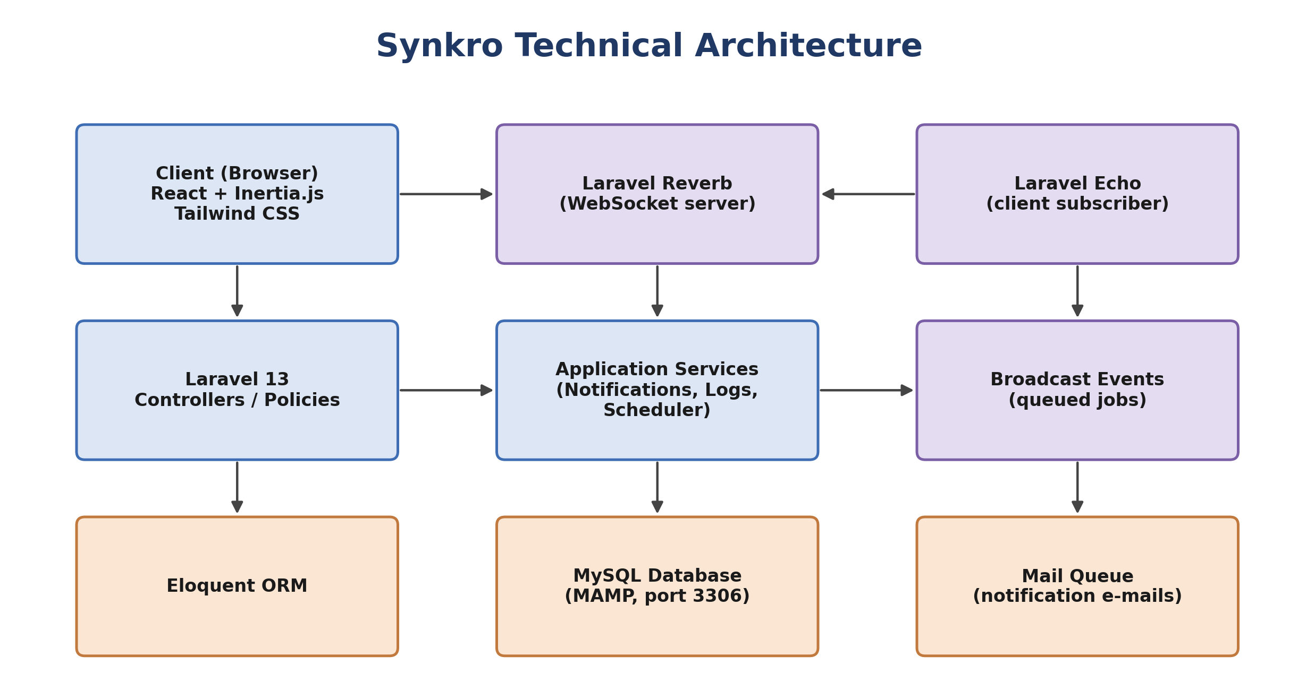
Figure 4: Technical architecture of the Synkro platform

7. Conclusion
Sprint 0 left me with a clear, prioritized understanding of what needed to be built and in what order, a schedule that actually fit the internship’s calendar, and a working local development environment. The next four chapters walk through, sprint by sprint, how that plan played out.

Chapter 3. Sprint 1 - Authentication & User Management

1. Introduction
Sprint 1 ran from June 22 to July 3, 2026 and focused on the piece everything else depends on: accounts. This sprint delivered registration with e-mail verification, login, password reset, profile and appearance settings, and a live list of active sessions.

2. Sprint Backlog
Table 6: Sprint 1 backlog
User story | Priority
As a guest, I want to register an account with my e-mail so that I can access the platform. | High
As a guest, I want to verify my e-mail address so that my account is confirmed. | High
As a guest, I want to log in and log out securely. | High
As a user, I want to reset my password if I forget it. | High
As a user, I want to edit my profile information. | Medium
As a user, I want to choose a visual theme (light, dark, black). | Medium
As a user, I want to see and close my active sessions on other devices. | Medium
As a user, I want to choose which notifications I receive. | Medium
As a user, I want to deactivate my account instead of deleting it, so I can step away without losing it. | Low
As a user who tried to log back into a deleted account, I want to restore it with a code instead of hitting a dead end. | Low
All stories were completed during the sprint. Source: author (Synkro project, 2026).

3. Requirements Specification
Figure 5 details the use cases available to a guest and to a registered user for this sprint.
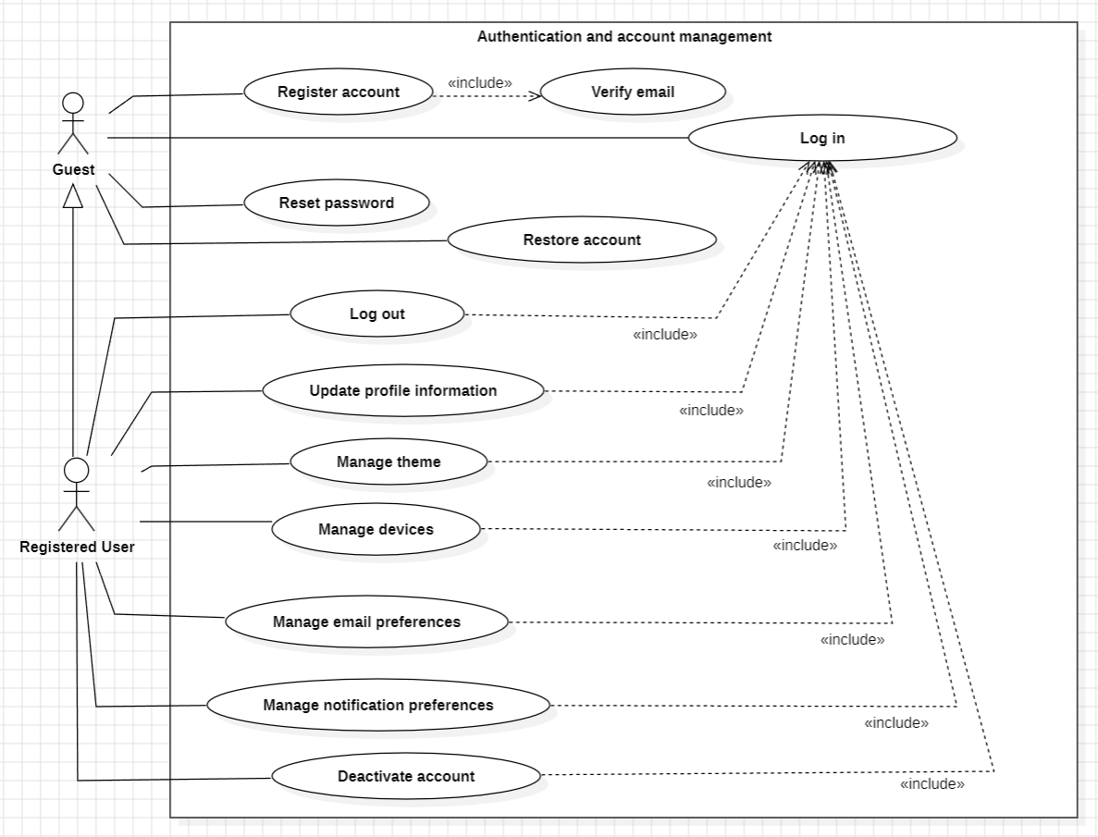
Figure 5: Use case diagram - Sprint 1
Table 7 gives the textual description of the central use case of this sprint, “Log in”.
Table 7: Textual description of the “Log in” use case
Field | Description
Actor | Guest
Precondition | The user already owns a verified account.
Main flow | 1. The guest opens the login page. 2. The guest enters their e-mail and password. 3. The system verifies the credentials. 4. The system creates a session and redirects to the dashboard.
Alternate flow | If the credentials are invalid, the system displays an error message and the guest can retry or request a password reset.
Postcondition | The user is authenticated and reaches their dashboard.
Source: author (Synkro project, 2026).

4. Design
Figure 6 shows the sequence diagram of the login flow, and Figure 7 shows the corresponding class diagram.
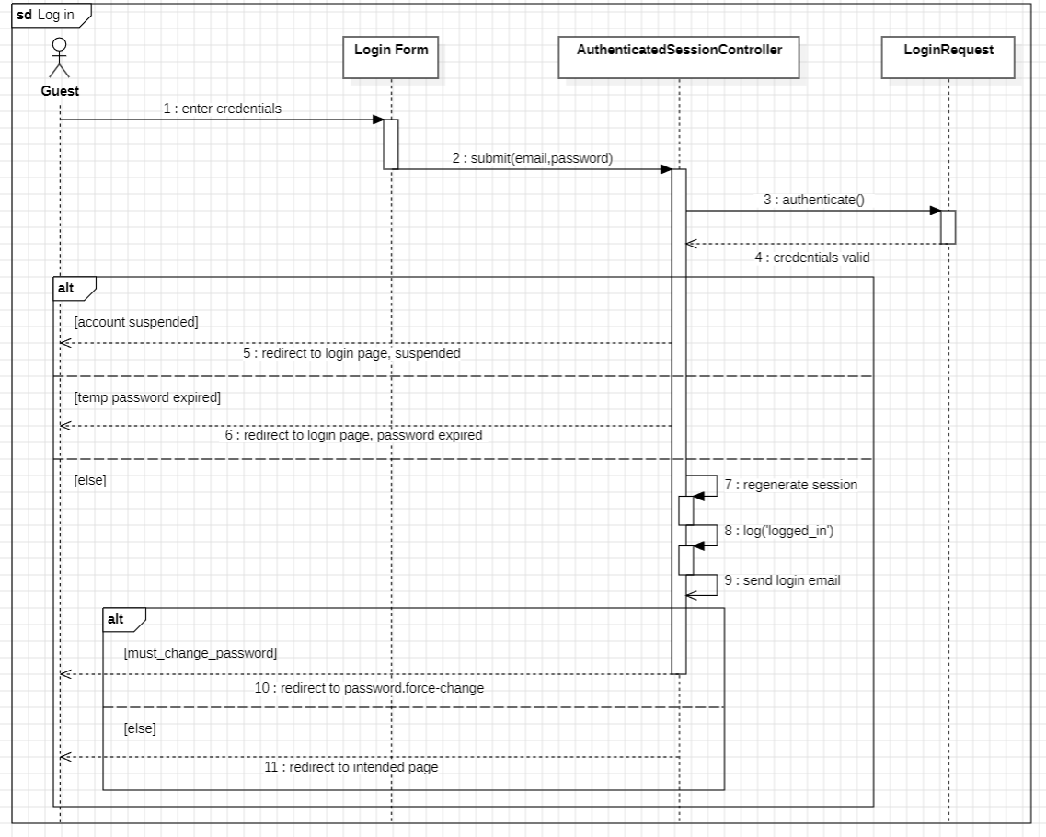
Figure 6: Sequence diagram - “Log in”
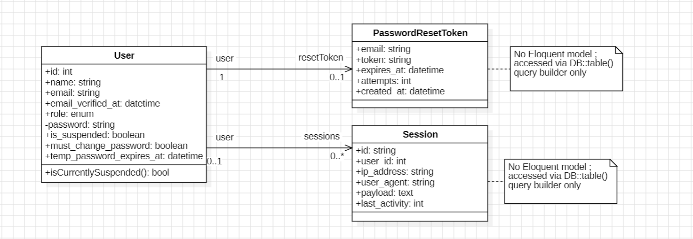
Figure 7: Class diagram - Sprint 1

5. Realization
This section illustrates the resulting interface with screenshots taken from the running application.
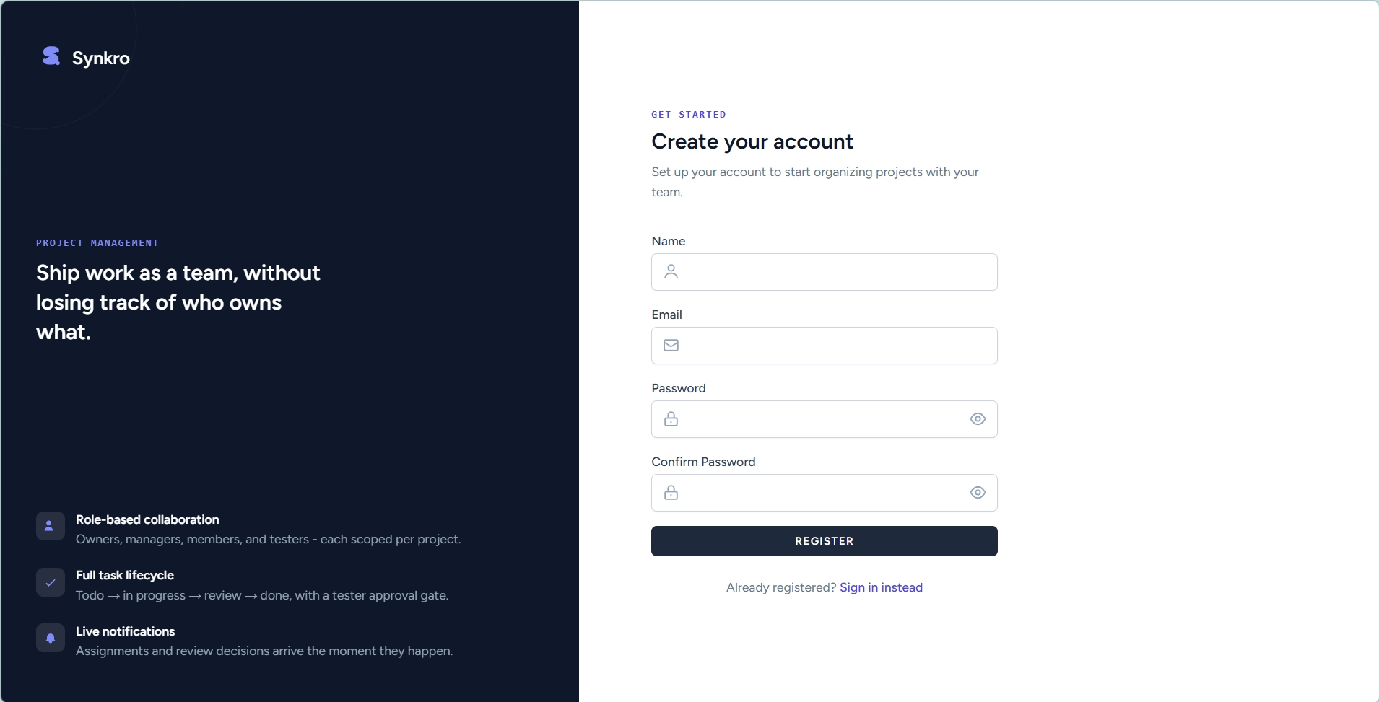
Figure 8: Registration page
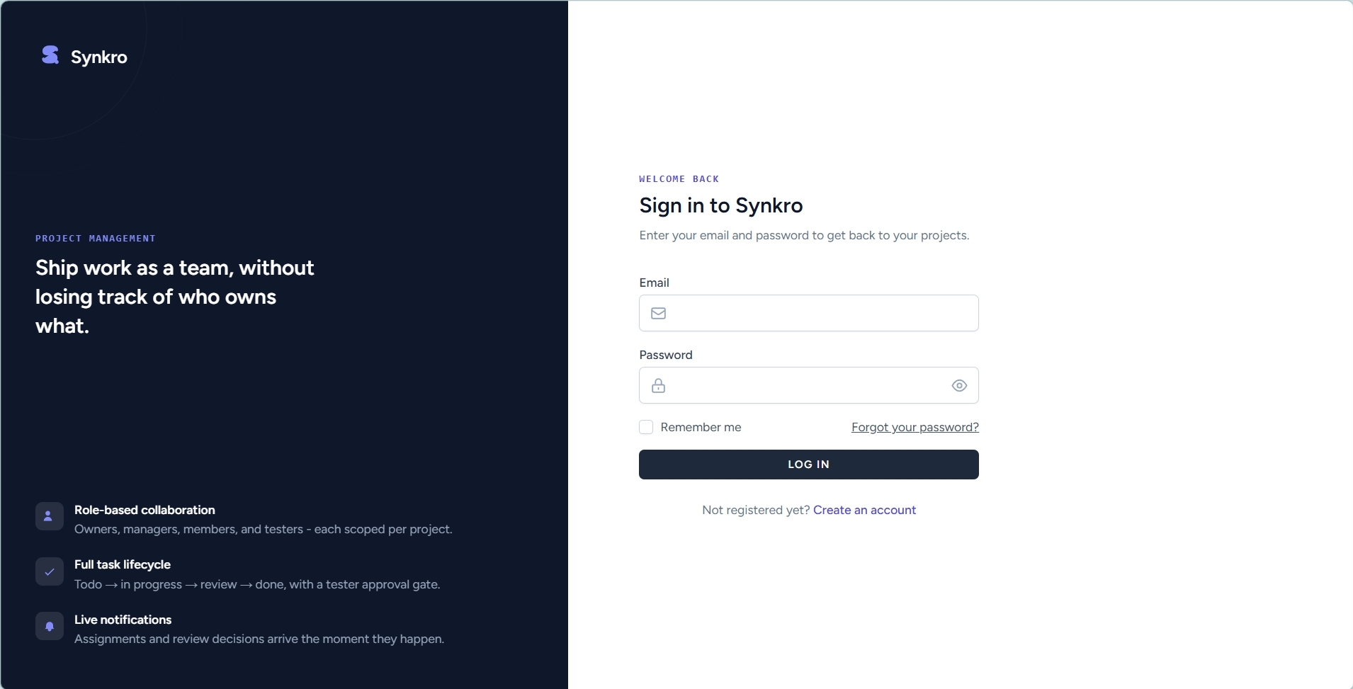
Figure 9: Login page
The account settings panel, appearance settings and active sessions list are shown in Figure 28, Figure 29 and Figure 30 in the Annex, respectively. The profile also gained avatar upload with cropping, e-mail-typo and password-match warnings, and a settings search box. Registration and every login are each backed by a security e-mail, sent through the same opt-out-able mailer used elsewhere on the platform.

6. Conclusion
By the end of Sprint 1, Synkro had a complete, secure account system that would go on to serve as the identity layer for every collaborative feature built afterward.

Chapter 4. Sprint 2 - Project & Task Management

1. Introduction
Sprint 2 ran from July 6 to July 17, 2026 and delivered Synkro’s functional core: projects, project membership and roles, and the full task lifecycle.

2. Sprint Backlog
Table 8: Sprint 2 backlog
User story | Priority
As a user, I want to create a project so that I can organize a piece of work. | High
As an owner, I want to invite members and assign them a role. | High
As a manager, I want to create tasks and assign them to a member. | High
As a member, I want to update the status of my tasks as I progress. | High
As a manager, I want to add checklist items to a task. | Medium
As a member, I want to attach a file or a link as a deliverable. | Medium
As a project member, I want to archive a project I no longer actively work in, so it's hidden from my project list. | Low
As a reviewer (owner, manager, or tester), I want a single queue of everything awaiting my review across all my projects. | Medium
As a manager, I want to act on several tasks at once (status, priority, assignee, due date, delete). | Low
As a manager, I want a departing member's finished or in-progress work frozen for my review instead of silently reset. | Medium
All stories were completed during the sprint. Source: author (Synkro project, 2026).

3. Requirements Specification
Figure 10 shows the use case diagram for this sprint, covering the four project-level roles.
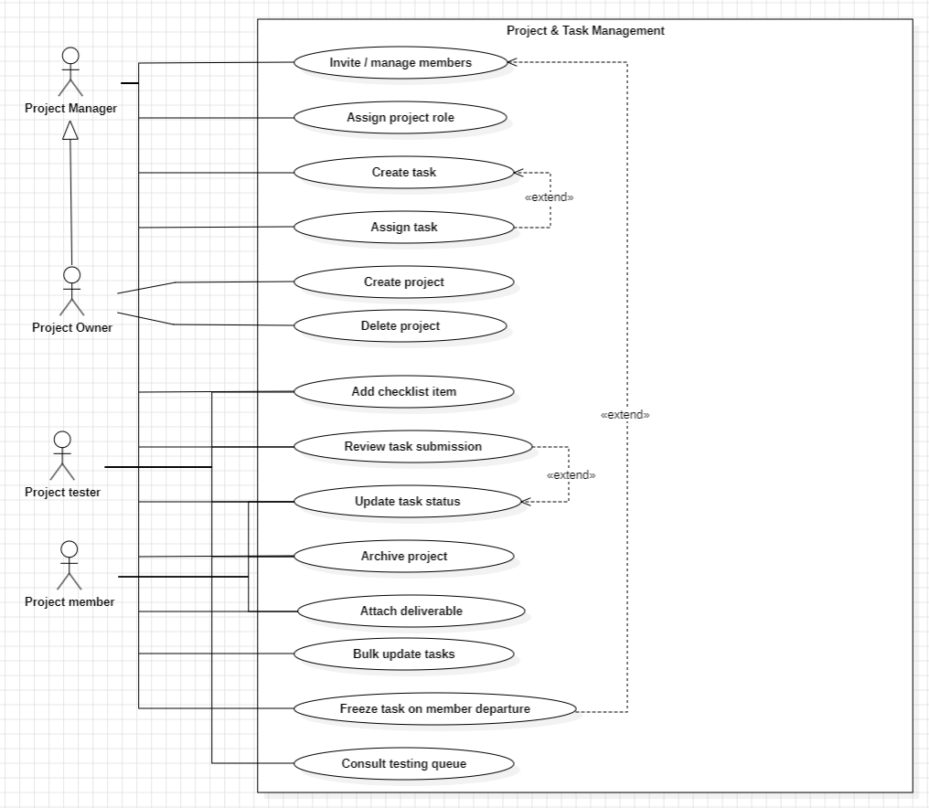
Figure 10: Use case diagram - Sprint 2
Table 9: Textual description of the “Create task” use case
Field | Description
Actor | Project Owner, Project Manager
Precondition | The actor holds the owner or manager role on the project.
Main flow | 1. The owner or manager opens the task board and selects “new task”. 2. They fill in the title, description, assignee and due date. 3. The system creates the task and adds it to the board. 4. The system broadcasts the change so the board updates live for every connected member.
Alternate flow | If a required field is missing, the form is rejected with a validation message.
Postcondition | The task exists, is visible to the whole project team, and the assignee is notified.
Source: author (Synkro project, 2026).

4. Design
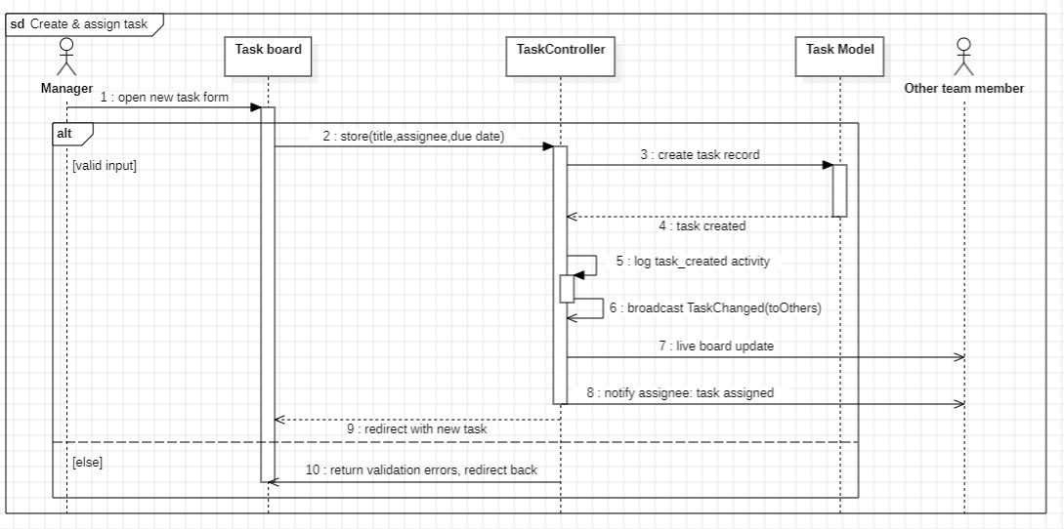
Figure 11: Sequence diagram - “Create & assign task”
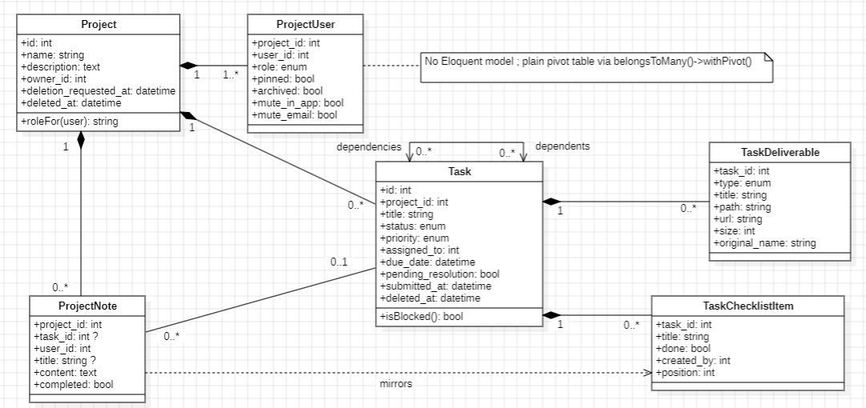
Figure 12: Class diagram - Sprint 2

5. Realization
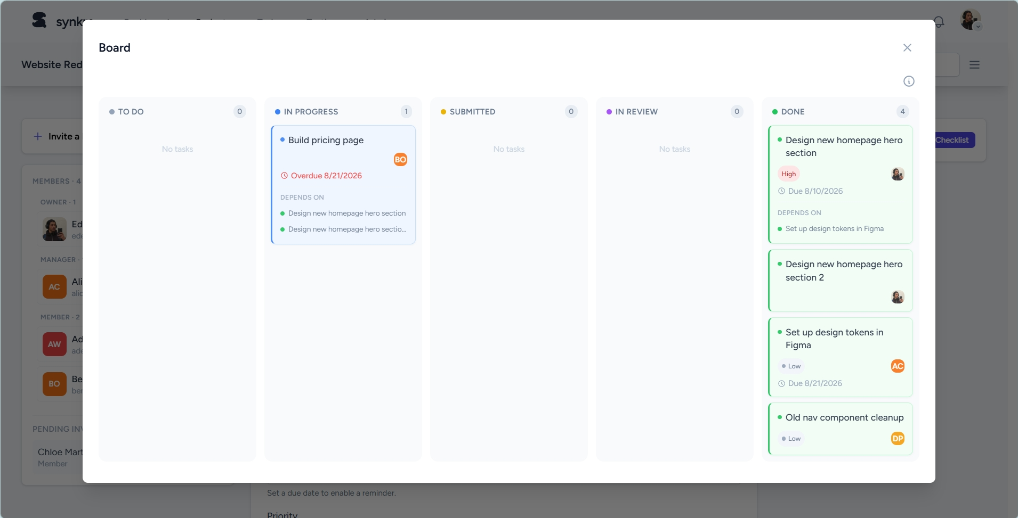
Figure 13: Task board (Kanban-style view)
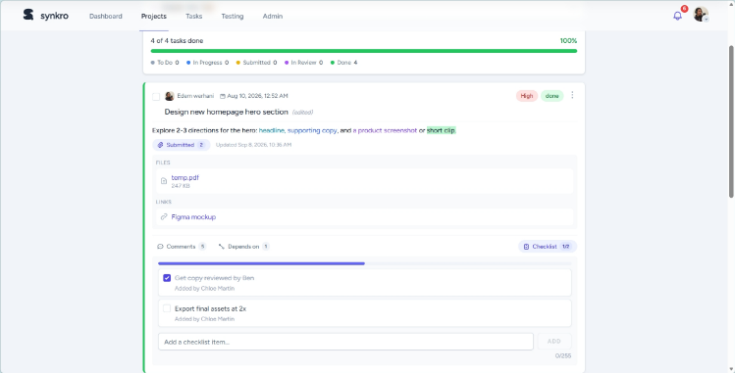
Figure 14: Task detail view with checklist and deliverables
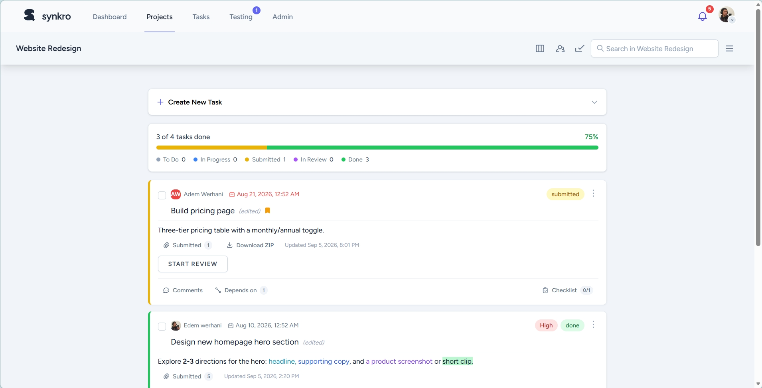
Figure 15: Task review workflow, awaiting review
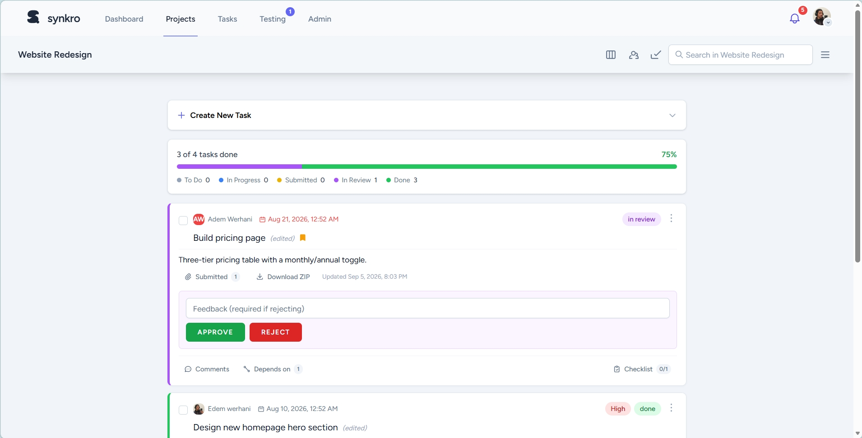
Figure 16: Task review workflow, reviewer approve/reject decision
A completed task can also be sent back for changes by its owner or manager, returning it to “in progress” with its history and feedback comment intact. The project creation, task creation, trash and deliverables views are shown in Figure 32, Figure 33, Figure 34 and Figure 35 in the Annex, respectively. Further refinements added per-task deadline reminders, an in-place file preview with syntax highlighting, and personal views for finding one’s own work: a Projects page, a My Tasks page with archive and pinning, and a tester-only Testing Queue. Pinning and archiving only affect the user’s own view.

6. Conclusion
Sprint 2 delivered the heart of Synkro: from this point on, a team could realistically plan and track its work from start to finish. The next sprint builds real-time collaboration on top of it.

Chapter 5. Sprint 3 - Collaboration & Real-Time Features

1. Introduction
Sprint 3 ran from July 20 to July 24, 2026. The goal was to turn Synkro from a shared workspace into a genuinely live one, where relevant events reach connected teammates instantly, and to add some lightweight collaboration tools around tasks and projects.

2. Sprint Backlog
Table 10: Sprint 3 backlog
User story | Priority
As a member, I want to comment on a task to discuss it with my team. | High
As a manager, I want to leave feedback on a submitted task. | High
As a user, I want to receive live notifications without refreshing the page. | High
As a user, I want to set a personal reminder for an upcoming deadline. | Medium
As a member, I want to write a personal note for my project. | Medium
As a manager, I want to upload a resource file for the whole project. | Medium
As a manager, I want to consult the project activity log. | Medium
As a user, I want to mute notifications for a specific project or task without changing my global preferences. | Low
As a user, I want a personal dashboard summarizing my task and project stats, recent activity, and upcoming deadlines. | Low
All stories were completed during the sprint. Source: author (Synkro project, 2026).

3. Requirements Specification
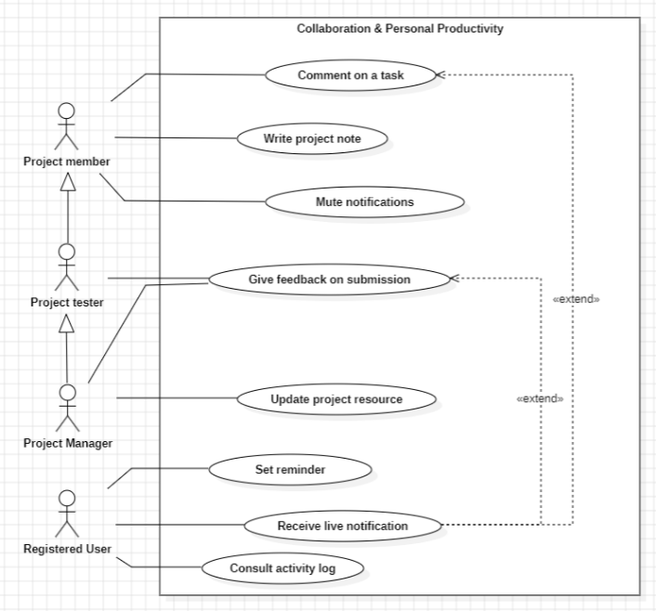
Figure 17: Use case diagram - Sprint 3
Table 11: Textual description of the real-time notification use case
Field | Description
Actor | Project Member
Precondition | The member is viewing a task they have access to.
Main flow | 1. The member posts a comment. 2. The system stores the comment and creates a notification for the relevant users. 3. The system broadcasts a “comment posted” event through the WebSocket server. 4. Connected clients receive the event and update the notification bell and the task view instantly.
Alternate flow | If the WebSocket connection is unavailable, the comment is still saved and will appear on the next page load.
Postcondition | All connected team members see the new comment without reloading the page.
Source: author (Synkro project, 2026).

4. Design
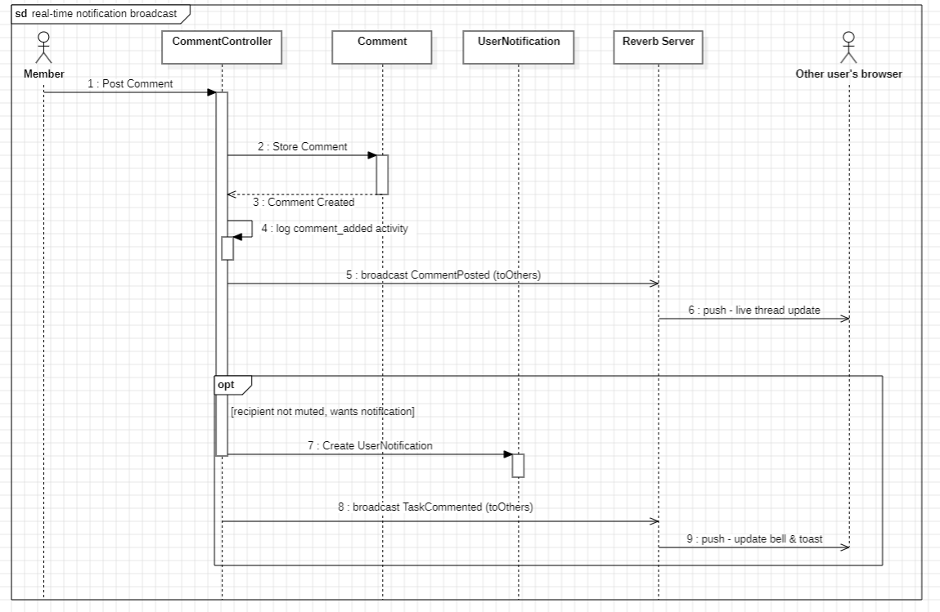
Figure 18: Sequence diagram - real-time notification broadcast
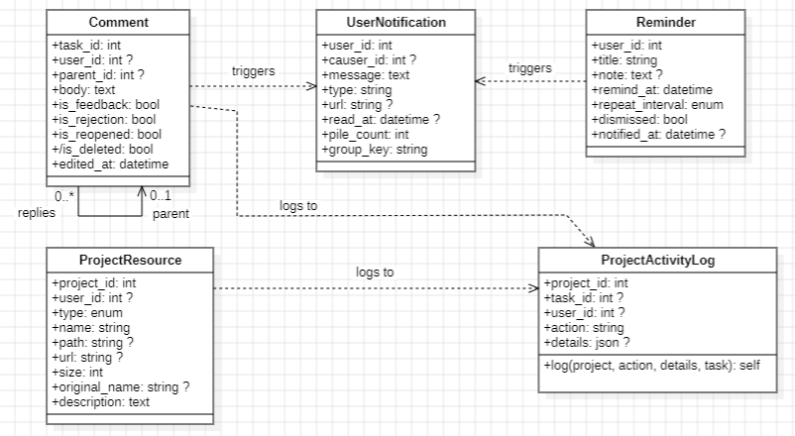
Figure 19: Class diagram - Sprint 3

5. Realization
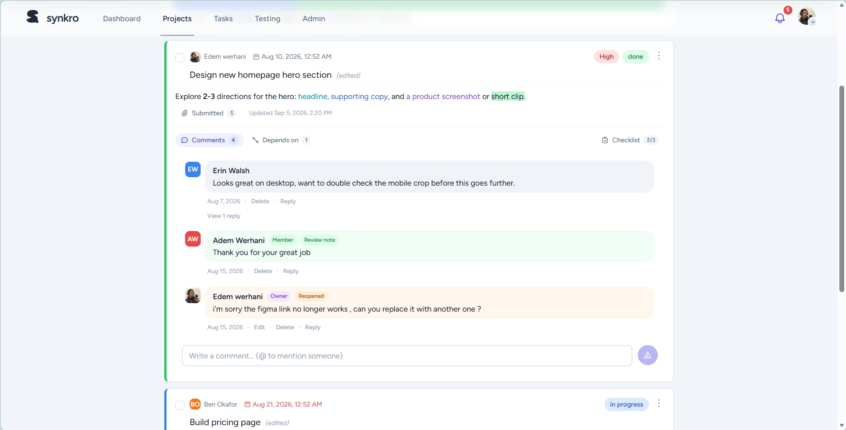
Figure 20: Task comments / feedback thread
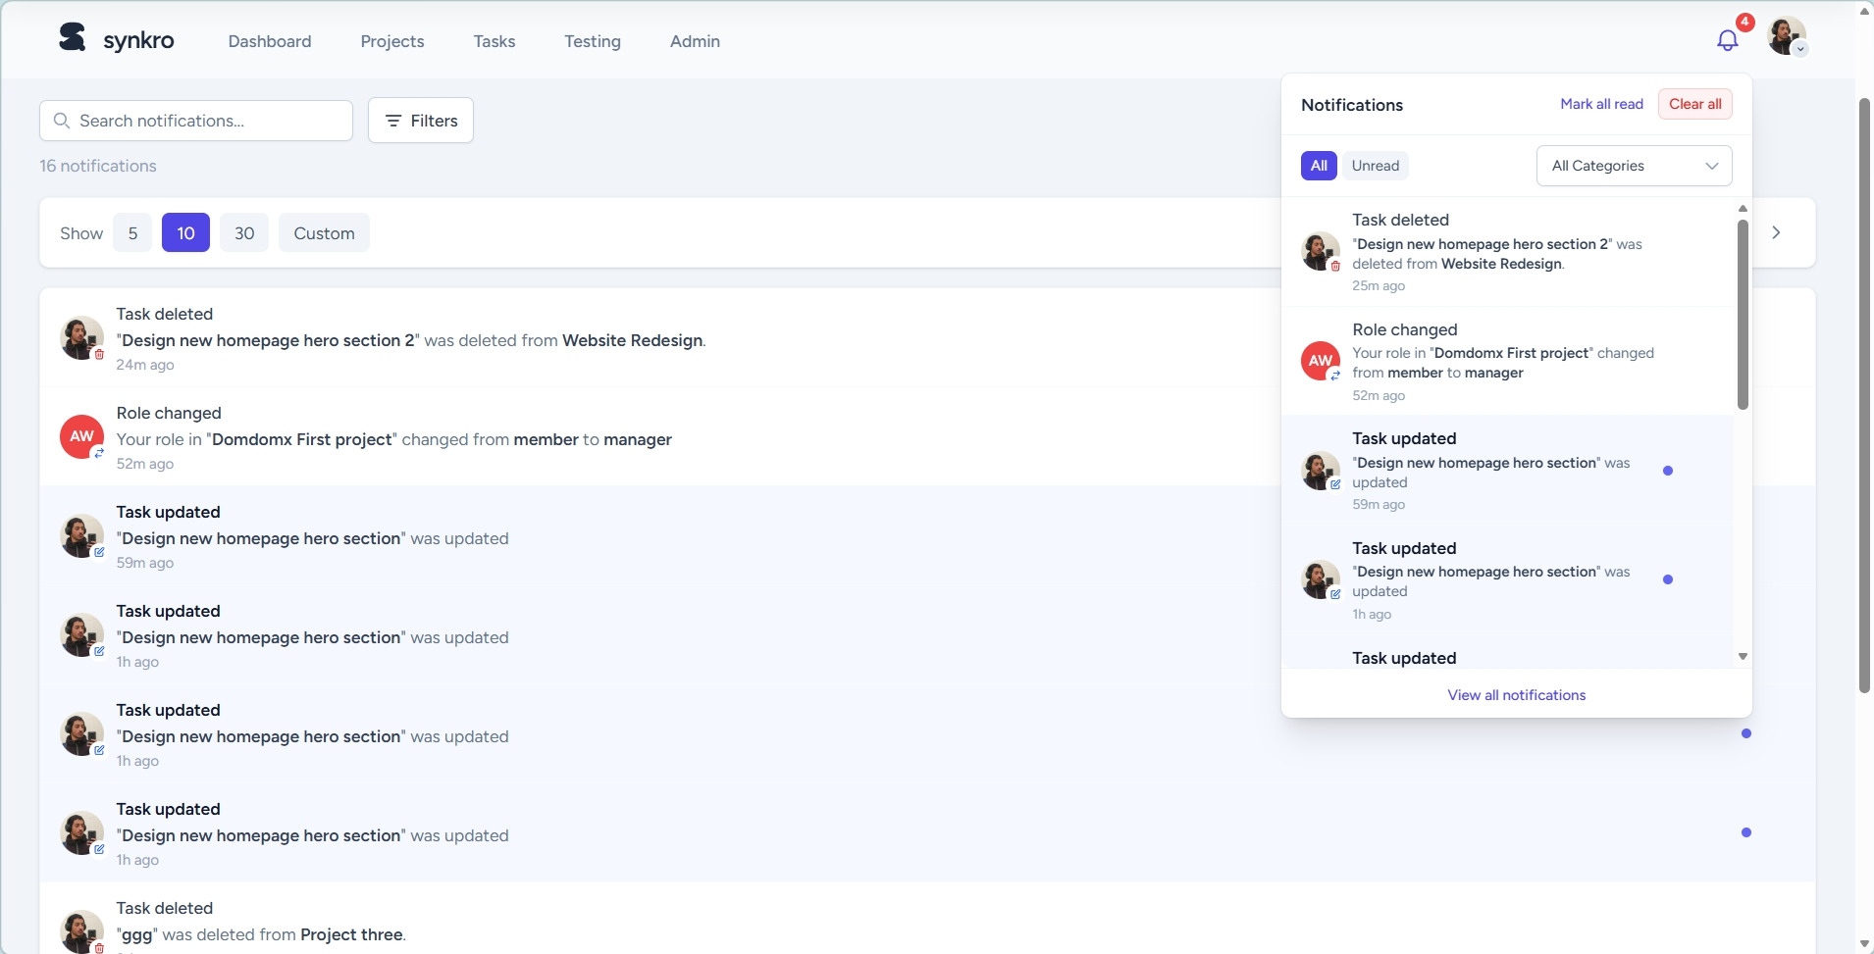
Figure 21: Live notification bell and notifications page
The personal notes panel, project settings page and activity log are shown in Figure 36, 37 and 38 in the Annex. This sprint also introduced the personal dashboard, summarizing a user’s tasks, projects, activity and notes in one place (Figure 43, Annex). Every real-time event, including account-security alerts, is also mirrored by an opt-out-able e-mail through the shared mailer that drives the notification bell, keeping users informed offline.

6. Conclusion
By the end of Sprint 3, Synkro genuinely behaved like a live collaborative tool. The final development sprint turns to the administration side of the platform.

Chapter 6. Sprint 4 - Administration, Moderation & Analytics

1. Introduction
Sprint 4, the last sprint of the internship, ran from July 27 to July 31, 2026. It gave Synkro the tools an administrator needs to keep the platform healthy: user moderation, a feedback ticket system, a suspension and appeal workflow, and an analytics dashboard.

2. Sprint Backlog
Table 12: Sprint 4 backlog
User story | Priority
As an admin, I want to view and manage the list of registered users. | High
As a superadmin, I want to promote or demote a user’s platform role. | High
As an admin, I want to suspend an account that violates the rules. | High
As a suspended user, I want to submit an appeal against my suspension. | Medium
As an admin, I want to review and decide on suspension appeals. | Medium
As an admin, I want to handle feedback / support tickets from users and guests. | Medium
As an admin, I want to view platform-wide analytics and KPIs. | Medium
As a project owner, I want to restore an accidentally deleted project or task. | Low
As an admin, I want to issue a temporary password for a user, forcing them to set a new one on next login. | Medium
As an admin, I want to manage the categories feedback tickets are filed under. | Low
All stories were completed during the sprint. Source: author (Synkro project, 2026).

3. Requirements Specification
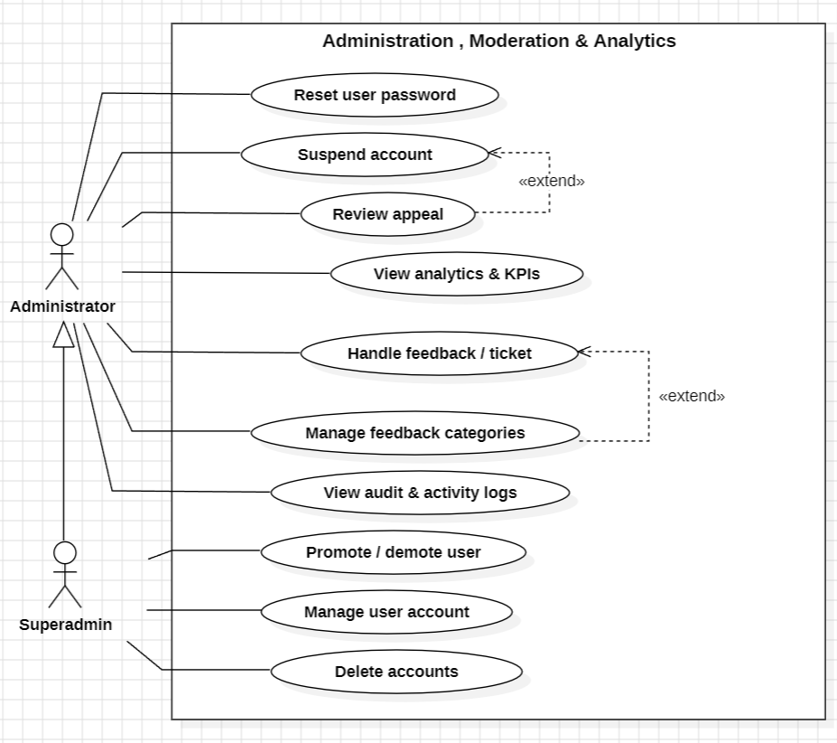
Figure 22: Use case diagram - Sprint 4
Table 13: Textual description of the “Suspend account” use case
Field | Description
Actor | Administrator, Superadmin
Precondition | The actor holds the administrator role, and a reported violation has been confirmed.
Main flow | 1. The admin opens the user’s profile in the admin panel and selects “suspend”. 2. The admin provides a reason. 3. The system updates the account status, records the action in the admin log, and notifies the user. 4. The user may submit an appeal, which an admin later reviews and approves or rejects.
Alternate flow | If the admin approves the appeal, the suspension is lifted and the decision is logged.
Postcondition | The account status and the full moderation history are consistent and auditable.
Source: author (Synkro project, 2026).

4. Design
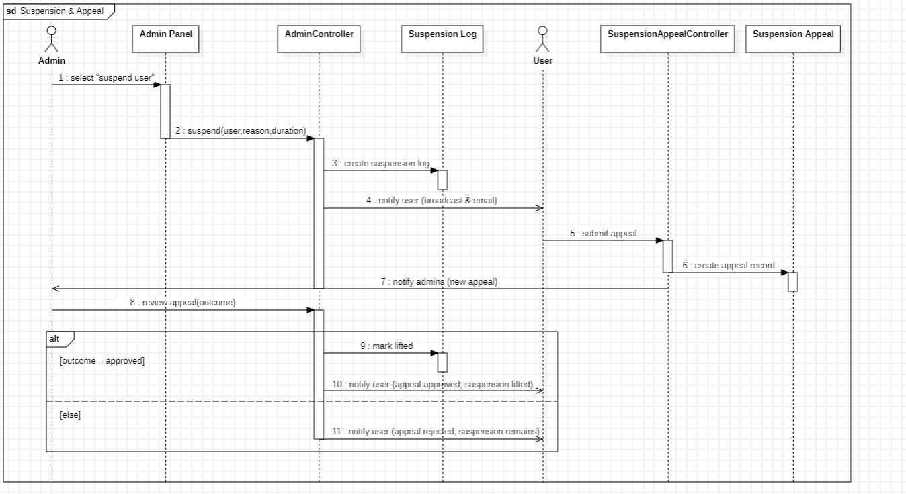
Figure 23: Sequence diagram - suspension & appeal
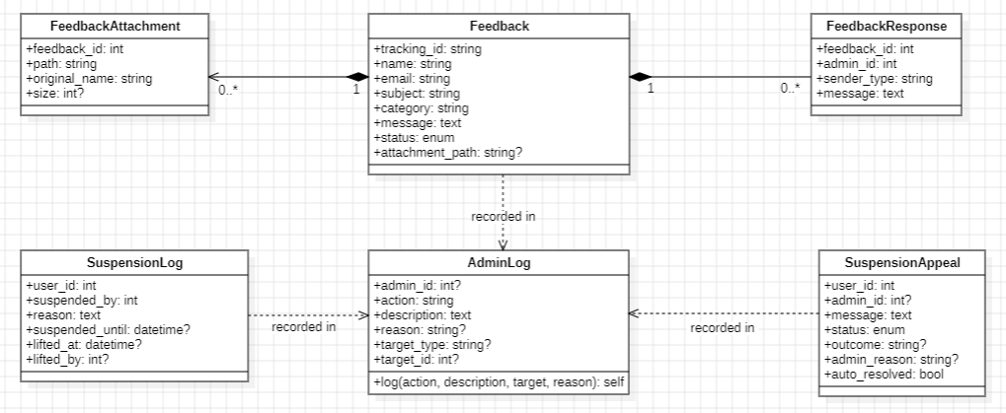
Figure 24: Class diagram - Sprint 4

5. Realization
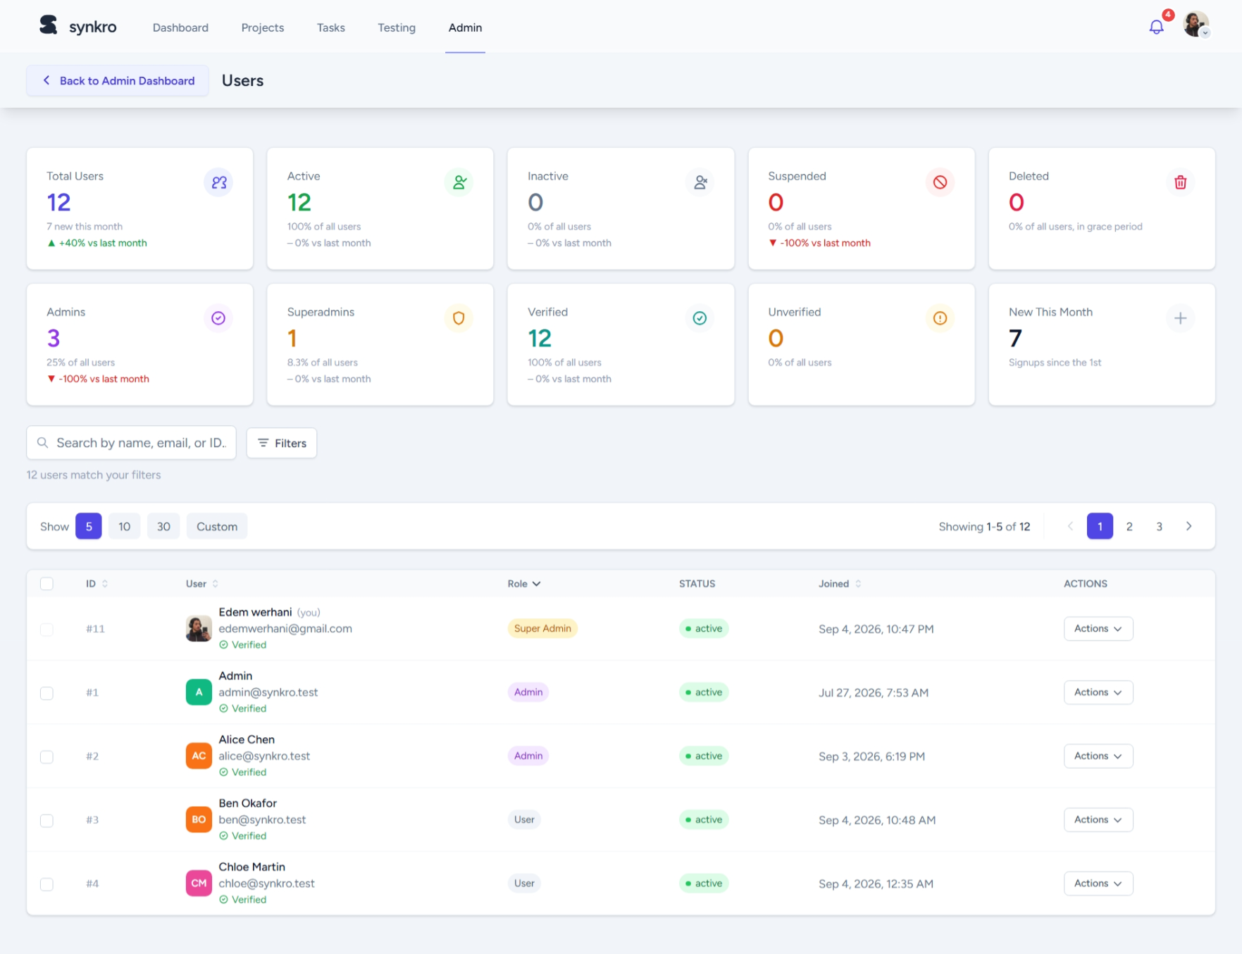
Figure 25: Admin user management page
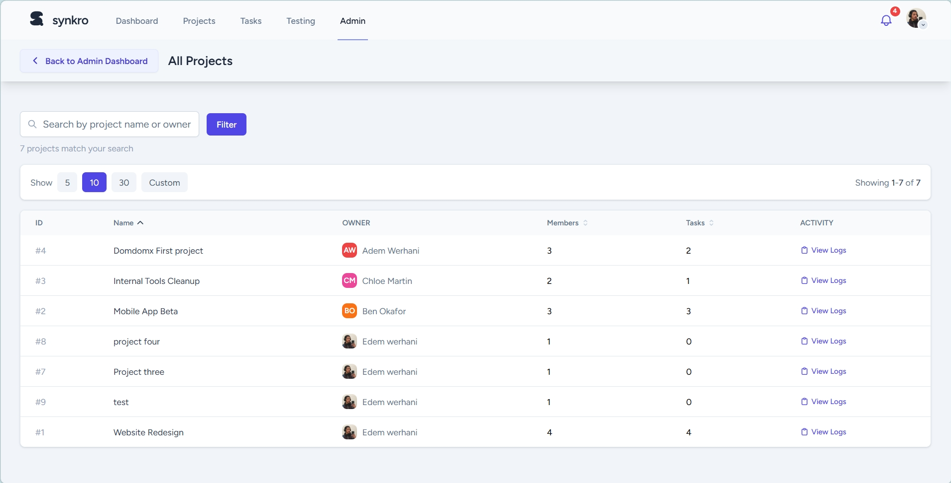
Figure 26: Admin project management (all projects) page
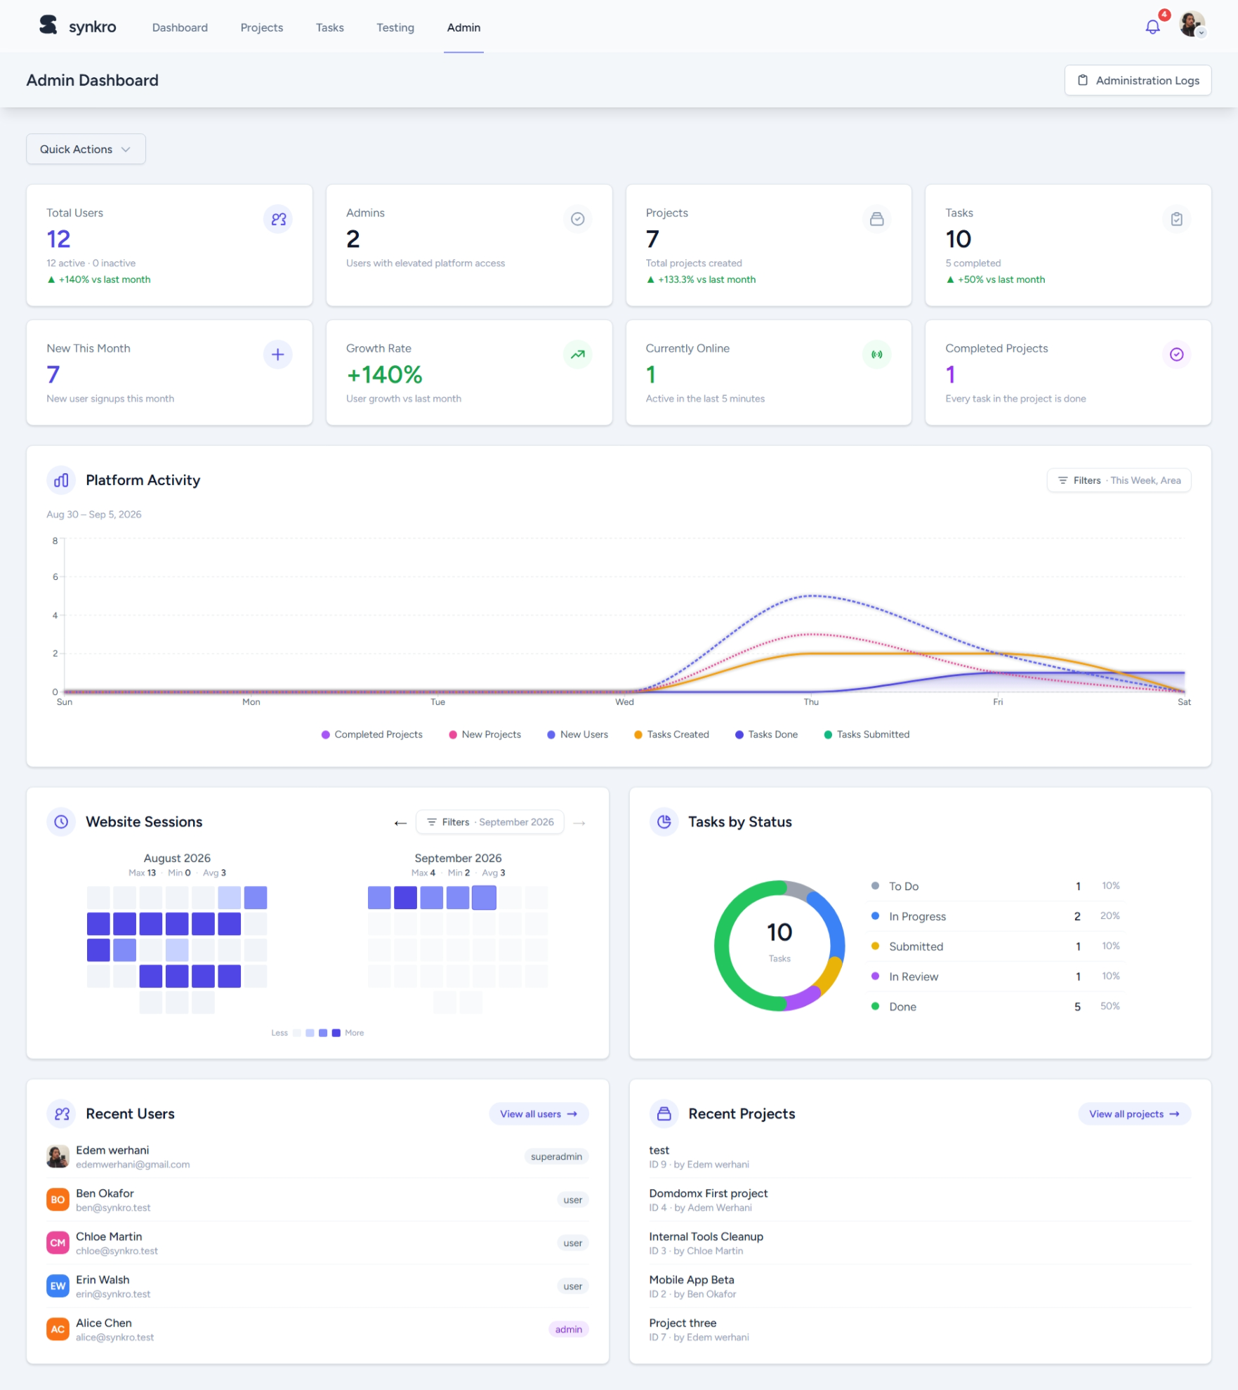
Figure 27: Admin analytics dashboard
The suspension appeals list and a feedback/support ticket detail view, which also opens a lightbox for reviewing image attachments, are shown in Figure 39 and Figure 40 in the Annex, respectively.

6. Conclusion
Sprint 4 closed out the development phase of the internship by giving Synkro a full moderation and oversight layer. Combined with the previous three sprints, the platform now covers the whole lifecycle of collaborative project work, from account creation to platform-wide administration. A public landing page, along with Terms of Use and Privacy Policy pages, rounds things out and gives the project a proper front door.

Chapter 7. General Discussion

1. Introduction
Beyond the features delivered sprint by sprint, this internship was also a personal and technical learning experience in its own right. This chapter steps back from the implementation details to talk about the skills gained, the difficulties I ran into and how I got past them, and the limits of the current version of Synkro.

2. Skills Gained
Working alone on a project of this scope, from the initial idea all the way to a deployment-ready product, meant covering skills that are usually split across several people on a professional team. On the technical side, this internship deepened my practical knowledge of Laravel and its ecosystem (Eloquent ORM, authorization policies, queued jobs, scheduled tasks), of building a single-page-like experience with React and Inertia.js without a separate REST API layer, and of real-time web technologies through Laravel Reverb and WebSockets. It also demanded solid relational database design, since the data model grew to cover users, projects, tasks, notifications, activity logs and moderation records.
On the organizational side, running my own Agile process sprint after sprint taught me how to break an ambitious idea down into a realistic, time-boxed backlog and how to make trade-off calls under a fixed deadline. Being both the developer and the de facto product owner of Synkro also sharpened my ability to think from the end user’s point of view, whether that user is a project member trying to get work done or an administrator keeping the platform healthy.

3. Difficulties Encountered
A few real difficulties came up along the way. Coordinating real-time updates across several connected clients meant handling WebSocket broadcasting carefully, so an action from one user wouldn’t get duplicated or missed on someone else’s screen. Designing a role-based permission system that stays flexible (four distinct project roles) while remaining simple to reason about took several passes. And a tight seven-week schedule meant constantly weighing scope against the time actually available.
Each of these was tackled methodically: real-time flows were isolated and tested in small, controlled scenarios before being wired into the full application, authorization checks were centralized in dedicated policy classes instead of being scattered across controllers, and a visible, sprint-based backlog kept scope decisions explicit rather than implicit.

4. Limits and Perspectives
The version of Synkro delivered at the end of this internship covers the core collaborative workflow end to end, but it is a first, functional iteration rather than a finished product. Directions for improvement are laid out as recommendations in the general conclusion below.

5. Conclusion
This chapter has tried to show that the value of this internship goes beyond the delivered application itself: it lies just as much in the engineering judgment built up while working under real constraints of time and scope.

General Conclusion and Recommendations
This report covers a seven-week, self-directed internship (PFA) at Kernel Solution & Innovation, during which I designed and built Synkro, a collaborative project and task management platform, from initial idea to a feature-complete product. An Agile, sprint-based methodology structured the work: a planning sprint produced the backlog, and four development sprints delivered account management, the core project and task workflow, real-time collaboration over WebSockets, and an administration layer with an analytics dashboard, all designed with UML and built on Laravel, React, Inertia.js, Laravel Reverb and MySQL.
The resulting platform meets the objectives set out in Chapter 1: it lets small teams organize collaborative work through role-aware projects and tasks, keeps everyone instantly up to date, and gives administrators what they need to keep the platform safe, while serving as a hands-on exercise in software engineering under a real deadline.
Naturally, a first version built in seven weeks by one developer leaves room for more work. The following are worthwhile next steps for Synkro:
- Add CAPTCHA or two-factor authentication for login, and allow account creation through Google sign-in.
- Introduce a user profile, distinct from the account settings, together with its own configurable settings.
- Add a messaging system covering direct and group chat, an administration broadcast channel, and a chatbot assistant to help users navigate the platform.
- Extend the moderation system with a graduated warning mechanism before suspension, and a fine-grained permission-revocation step.
- Add a global search bar to find users, and projects or tasks the user has joined or owns.
- Allow projects to be made open source and showcased on a member's profile and a dedicated page listing published projects.
- Let project owners define custom project roles with configurable, revocable permissions instead of the four fixed roles.
- Allow superadmins to broadcast system-wide announcement messages.
Taken together, these ideas would turn Synkro into a more production-ready platform, and the foundations already in place (data model, role-based access control, real-time infrastructure) give a solid base to build them on.

Bibliography and Webography
The following documentation resources were used throughout the design and development of Synkro and last time they were visited.
• Laravel 13 official documentation - https://laravel.com/docs (June 10, 2026)
• Laravel Reverb official documentation - https://laravel.com/docs/reverb (July 20, 2026)
• Inertia.js official documentation - https://inertiajs.com ( June 12, 2026)
• React official documentation - https://react.dev ( June 12, 2026)
• Tailwind CSS official documentation - https://tailwindcss.com/docs (June 14, 2026)
• MySQL 8.0 Reference Manual - https://dev.mysql.com/doc/refman/8.0/en/ (June 15, 2026)
• Recharts documentation - https://recharts.org (July 27, 2026)
• MAMP official website - https://www.mamp.info (June 10, 2026)
• Git official documentation - https://git-scm.com/doc (June 10, 2026)
• GitHub Desktop documentation - https://docs.github.com/en/desktop (June 10, 2026)
• Scrum Guide (Scrum.org) - https://scrumguides.org (June 8, 2026)
• Kernel Solution & Innovation - host company website - https://www.kernelsi.com (June 5, 2026)
• Synkro project repository - https://github.com/domdomxy/synkro (July 31, 2026)
• Laravel Breeze official documentation - https://laravel.com/docs/starter-kits#laravel-breeze (June 16, 2026)

Annexes
This section gathers supplementary screenshots referenced in the report that do not fit within the main body of the document.
Sprint 1: additional screenshots
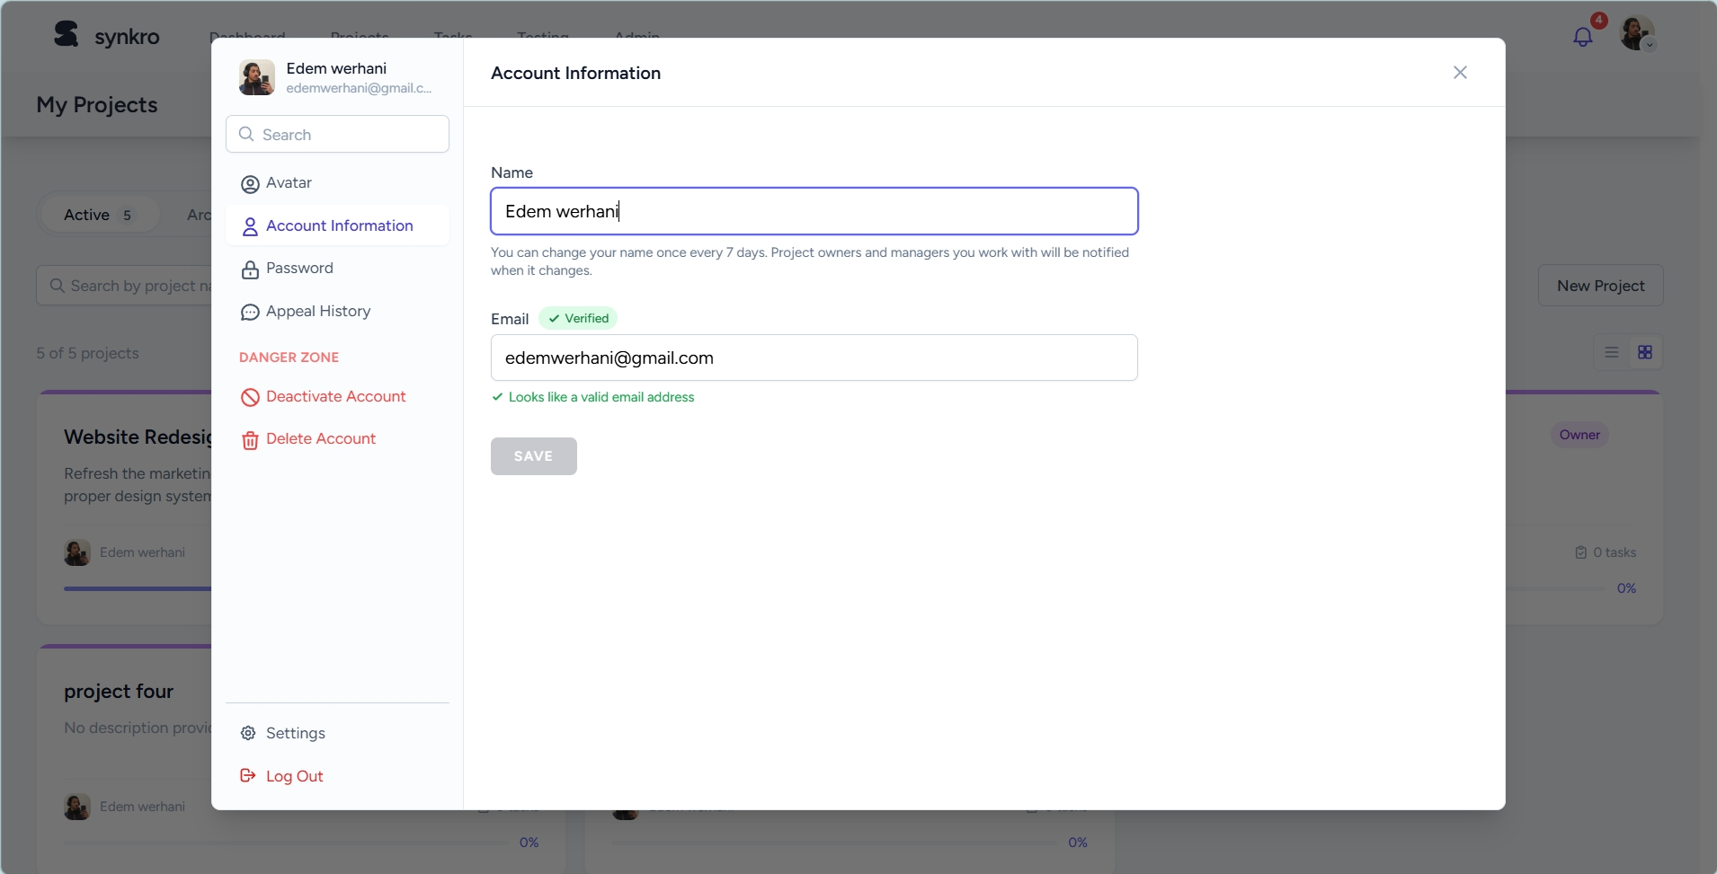  Figure 28: Account settings panel | 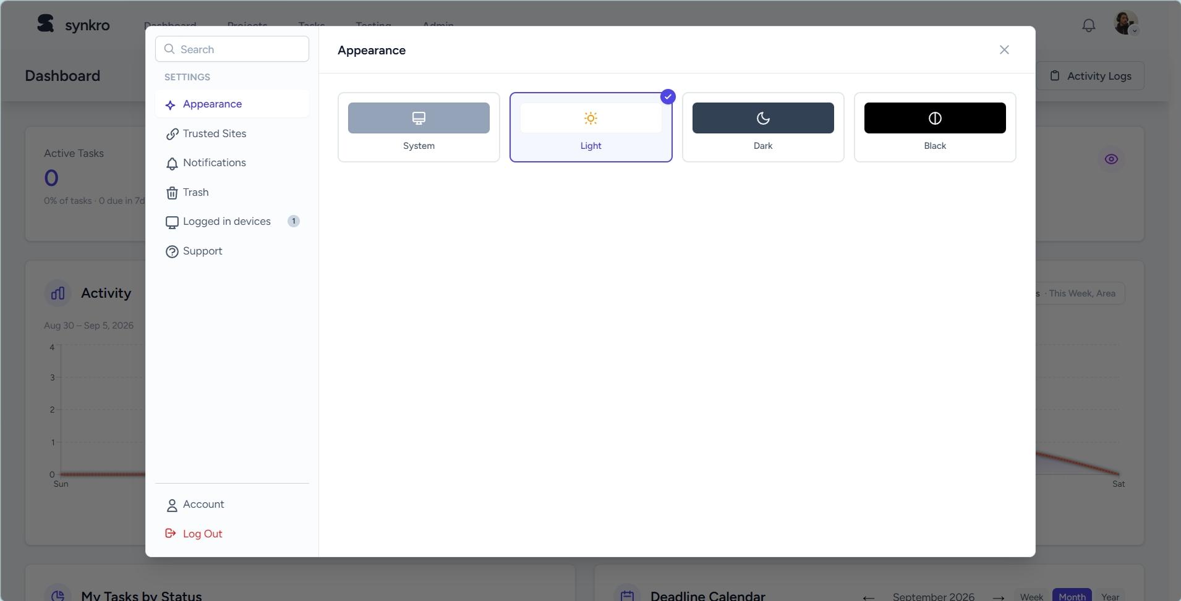  Figure 29: Appearance settings - theme selection
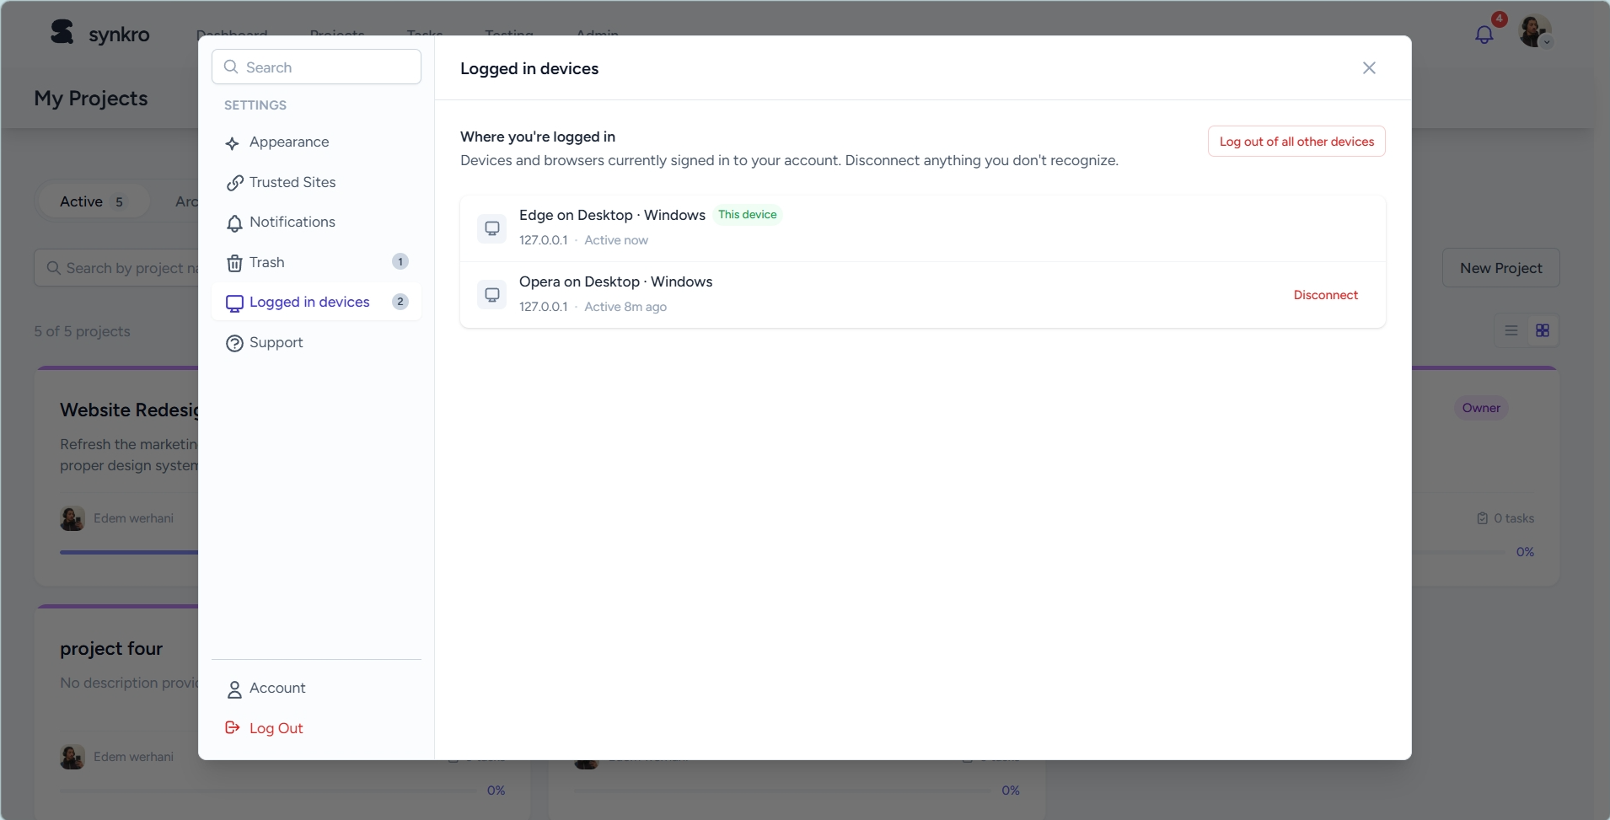  Figure 30: Active sessions (“logged in devices”) list | 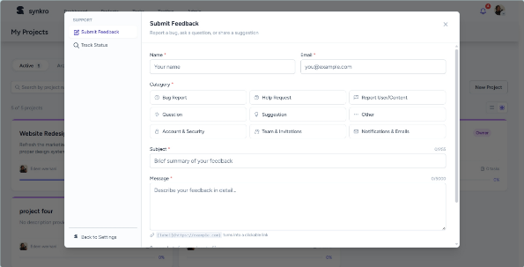  Figure 31: Feedback / support ticket panel
Sprint 2: additional screenshots
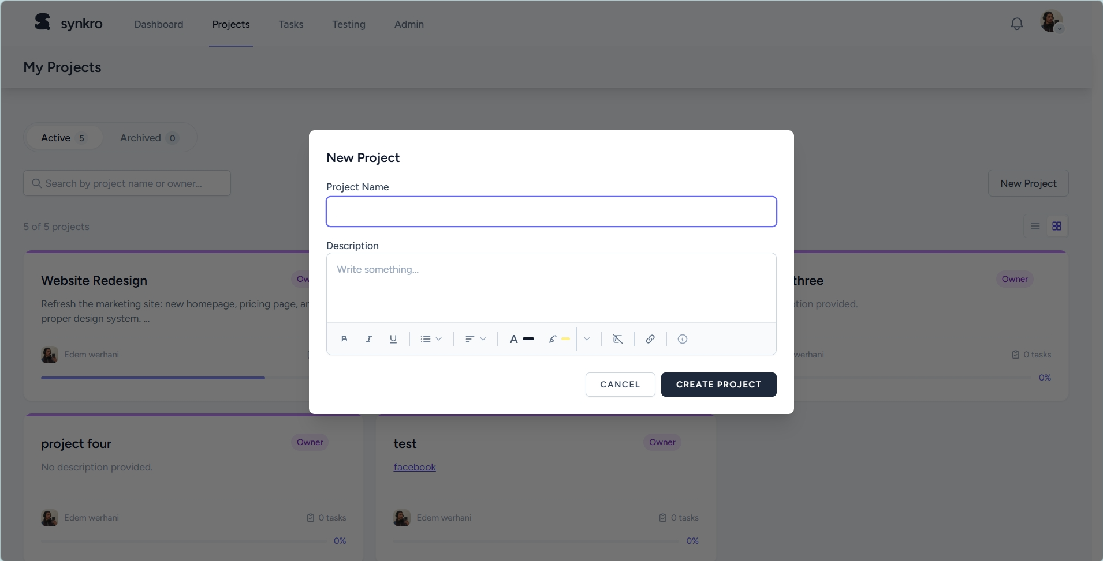  Figure 32: Project creation form | 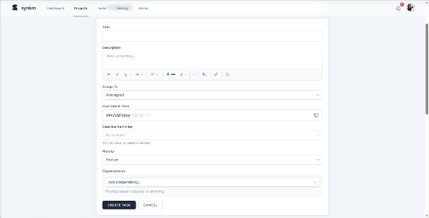  Figure 33: Task creation form
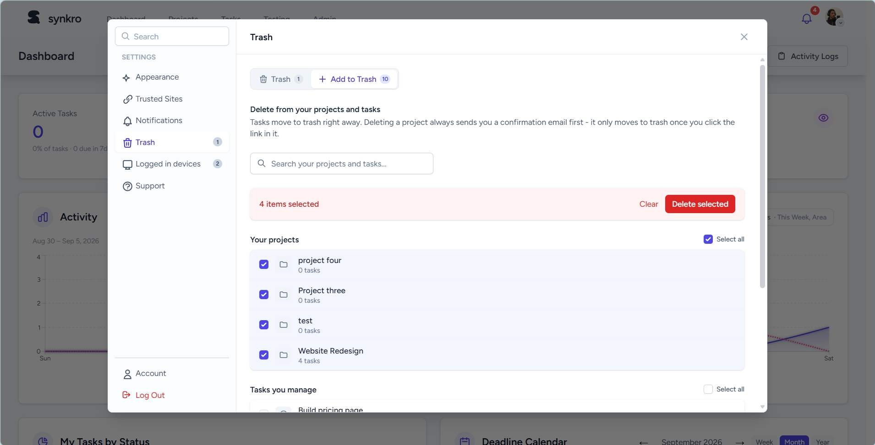  Figure 34: Trash, recoverable project and task deletion | 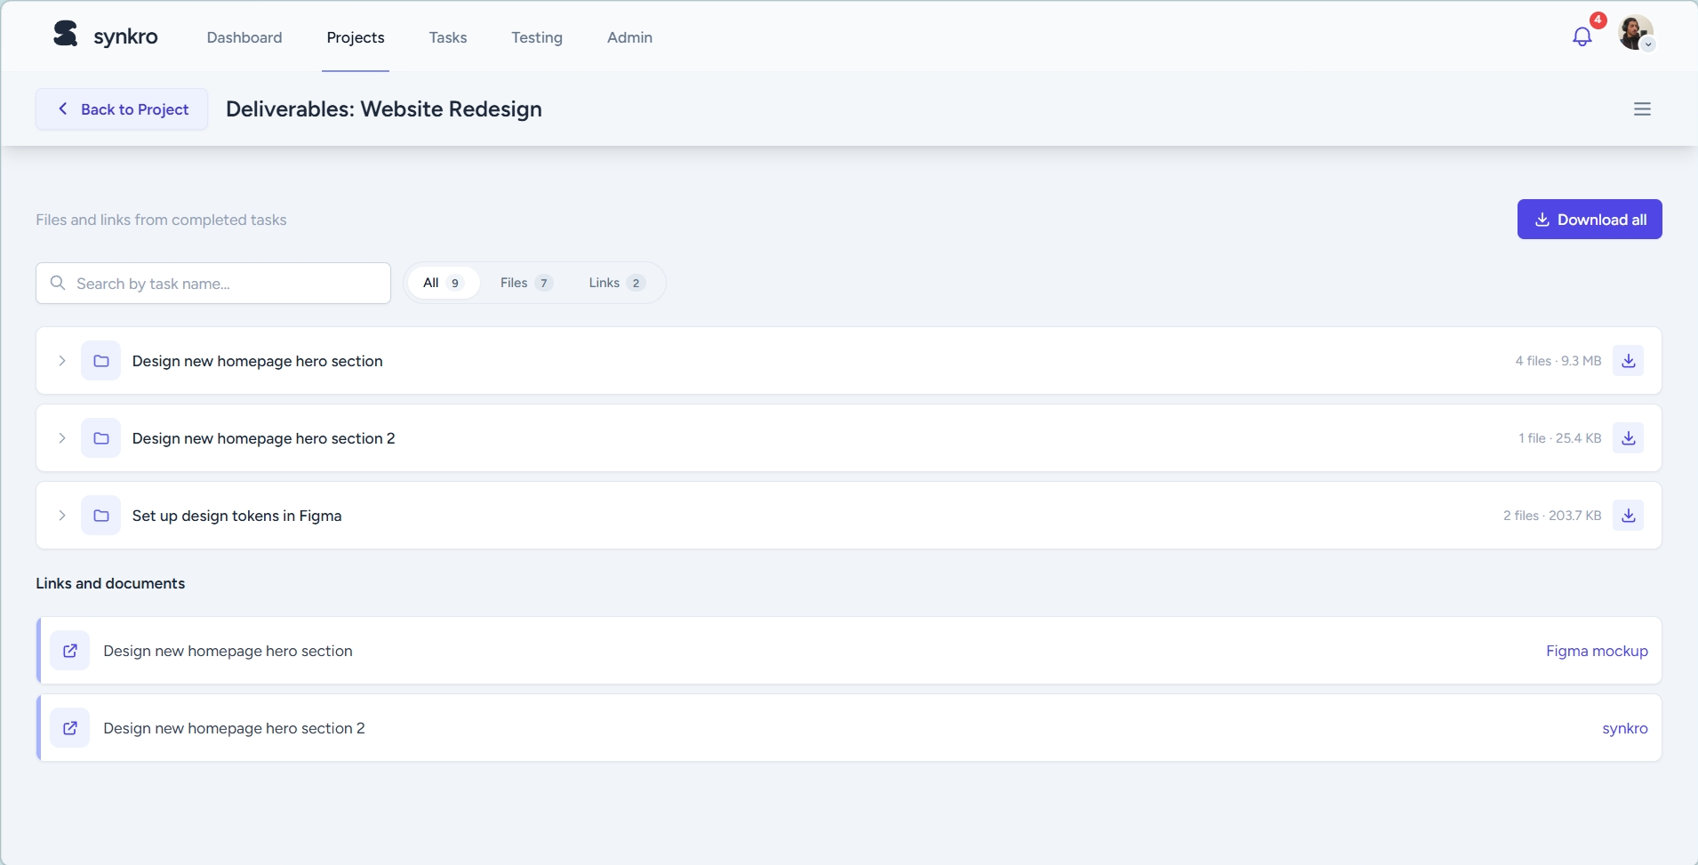  Figure 35: Project deliverables page
Sprint 3: additional screenshots
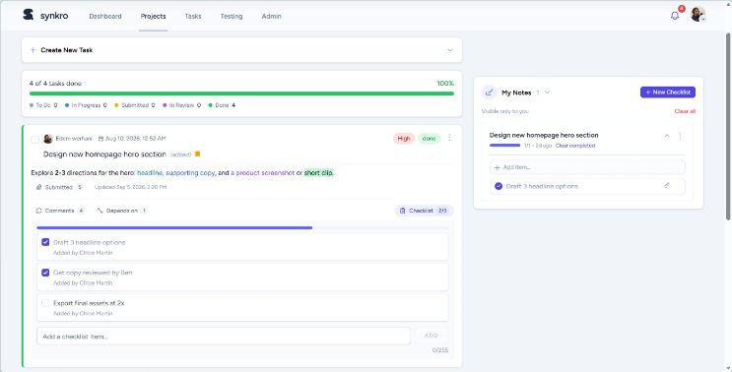  Figure 36: Task checklist and personal notes | 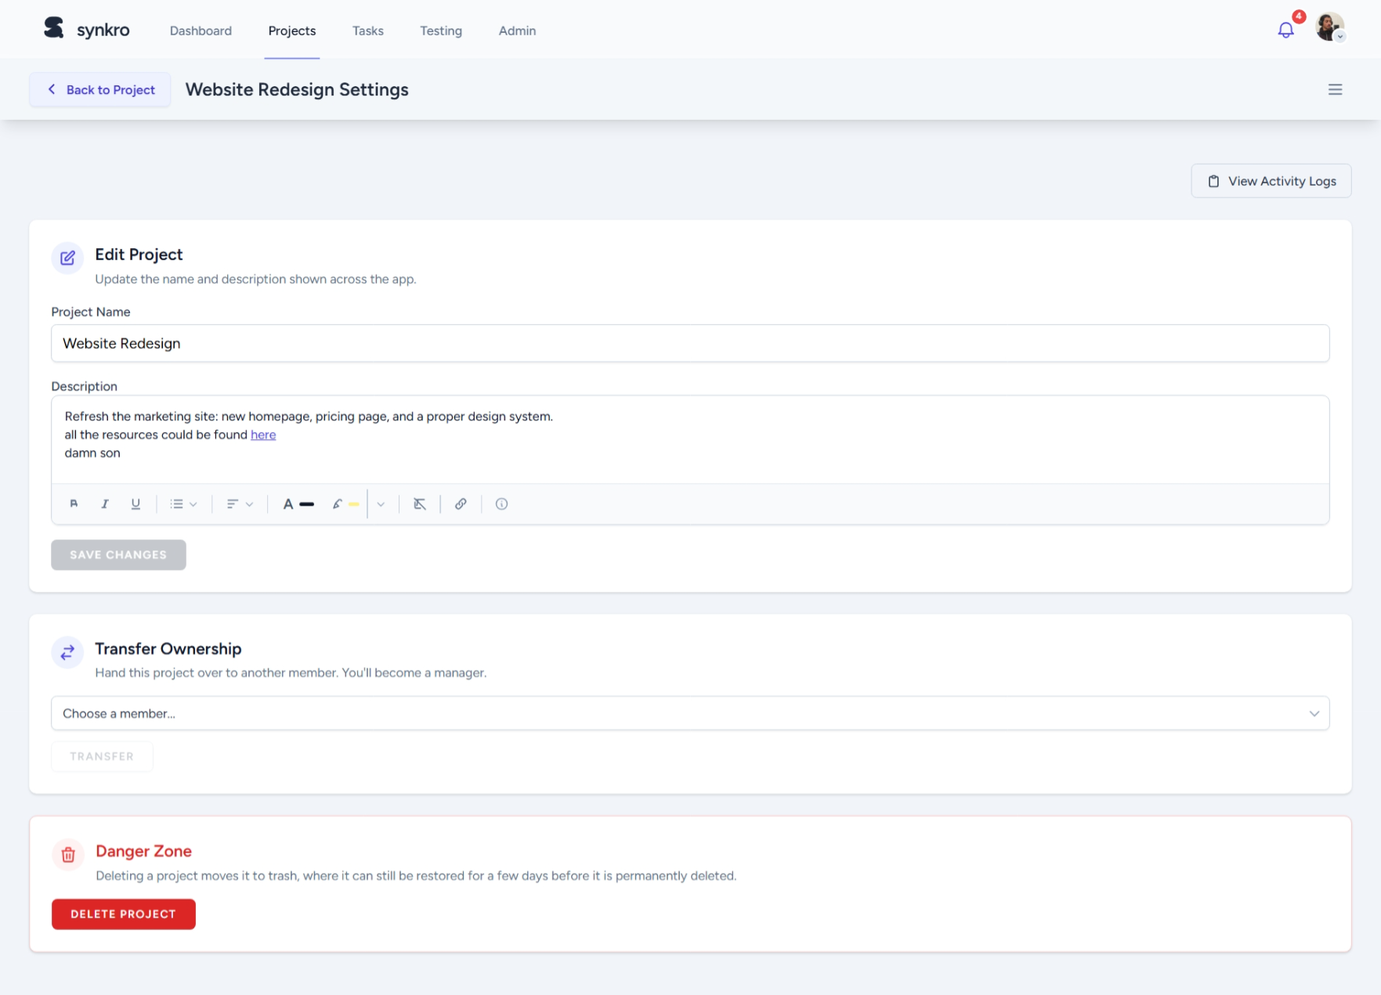  Figure 37: Project settings page
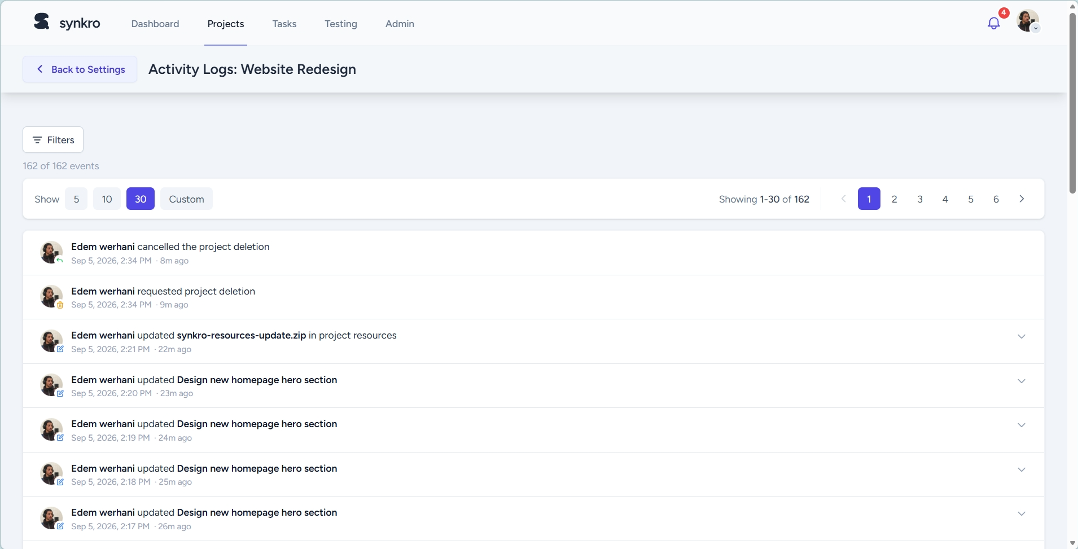
Figure 38: Project activity log
Sprint 4: additional screenshots
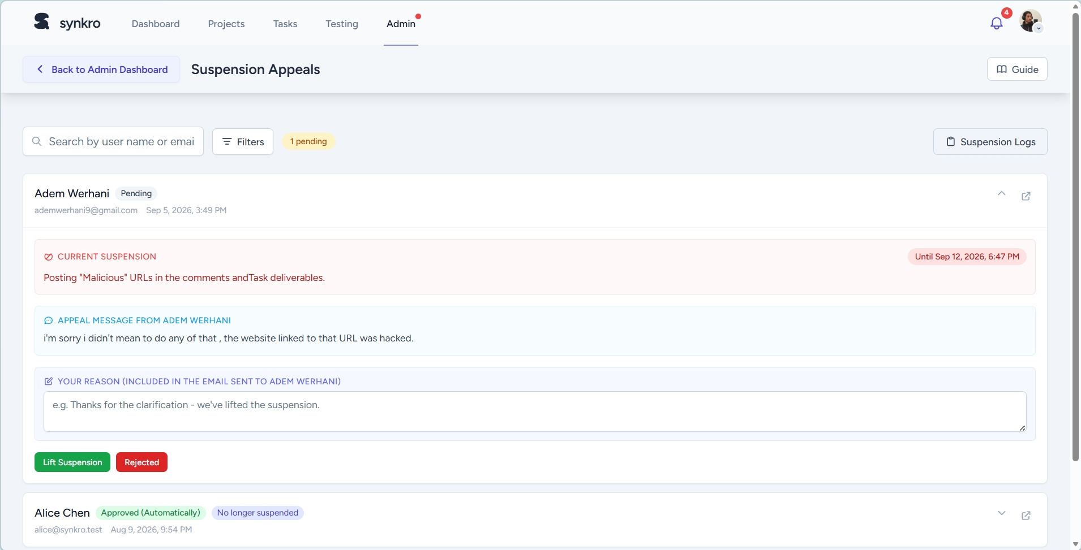  Figure 39: Suspension appeals list | 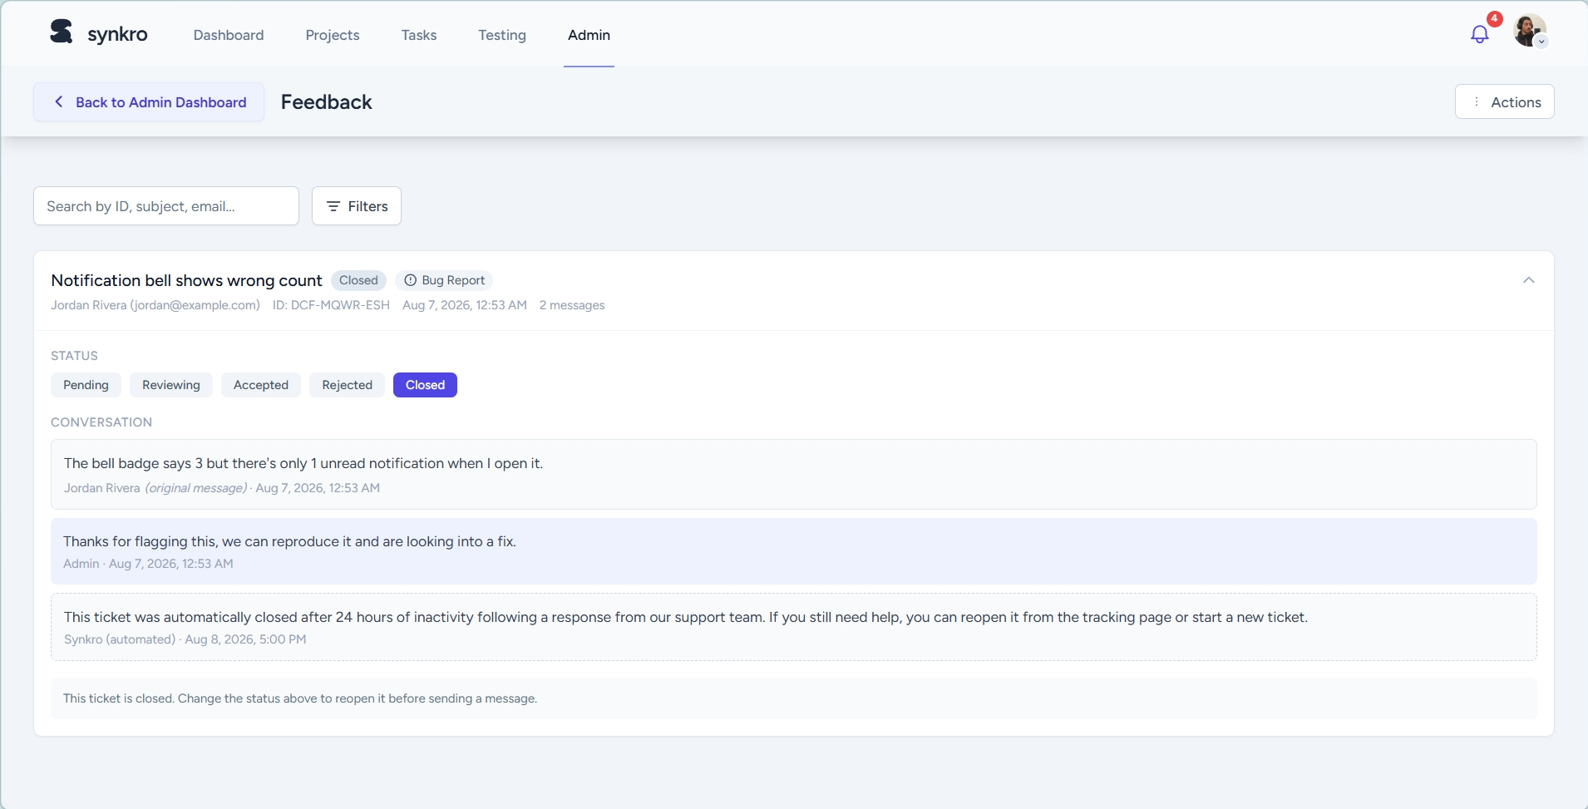  Figure 40: Feedback / support ticket detail

Additional platform screens
These screens were added or refined after the last screenshot pass.
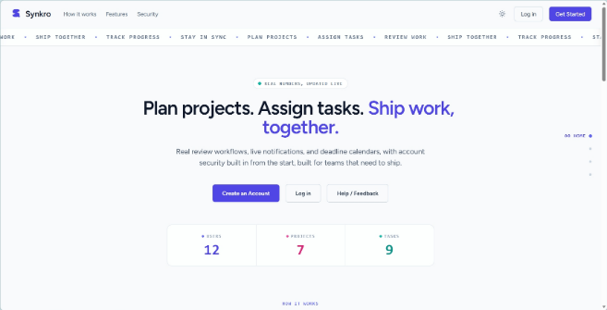  Figure 41: Public landing page, light theme | 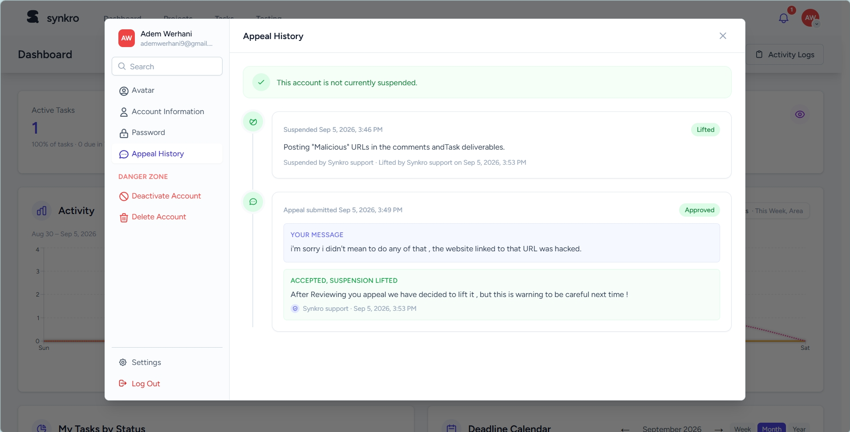  Figure 42: Appeal History, in Account Settings
Smaller late additions include a Trusted Sites list in the account settings, a per-task History panel recording status, assignee and checklist changes, and Synkro’s own branded 403, 404 and 503 error pages.
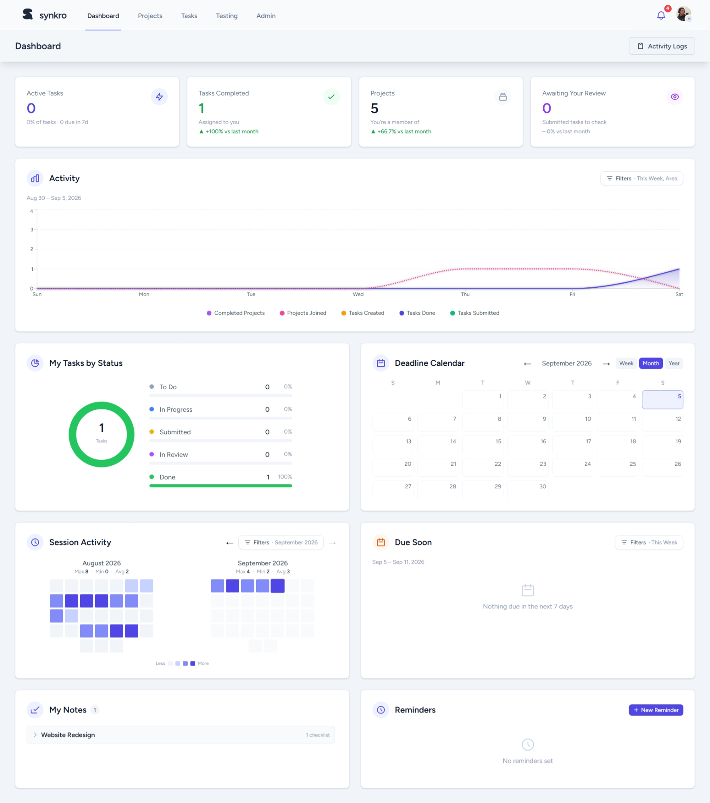  Figure 43: Personal dashboard | 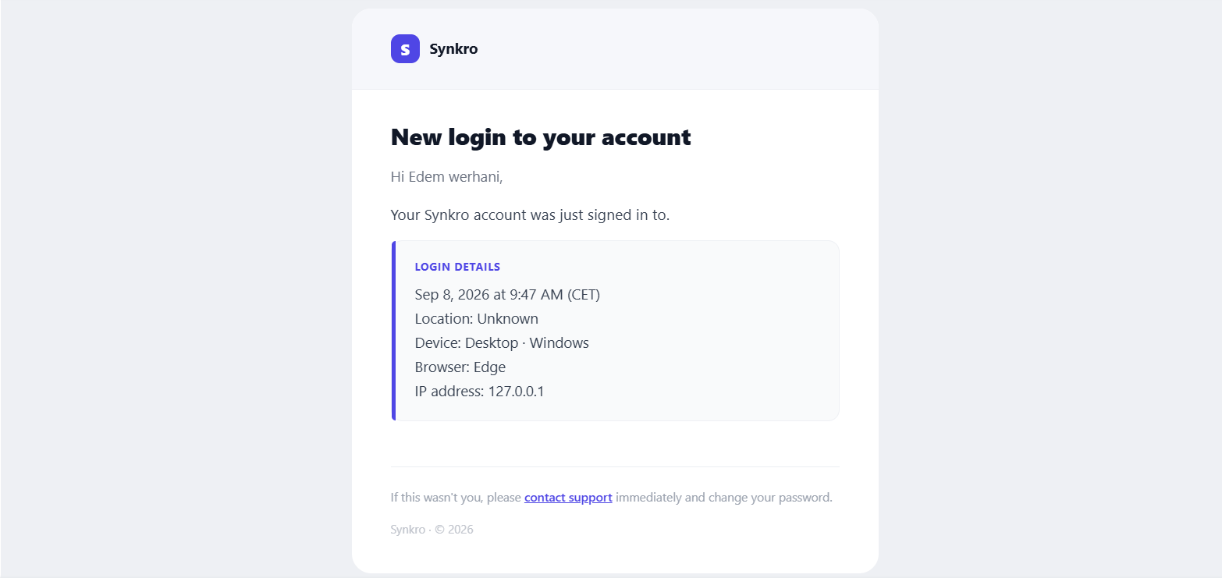  Figure 44: Login notification e-mail

Abstract - Résumé – ملخص
English
Small and medium-sized teams need collaborative tools that combine simplicity, live updates and fine-grained, role-aware access control, a combination that existing project management products rarely offer together. This report presents Synkro, a collaborative project and task management web platform designed and built single-handedly during a seven-week, self-directed end-of-year internship (PFA) at Kernel Solution & Innovation. Following an Agile, sprint-based methodology, the project was structured into a planning phase and four development sprints covering authentication and user management, project and task management, real-time collaboration through WebSockets, and administration with moderation and analytics. Each functional area was formalized with UML diagrams before being implemented in Laravel, React, Inertia.js, Laravel Reverb and MySQL. The resulting platform lets teams create projects, assign role-based responsibilities, track tasks through a clear status workflow, and stay instantly informed through real-time notifications, while giving administrators the tools they need to moderate the platform.
Keywords: collaborative platform, project management, task management, real-time, WebSocket, Laravel, React, role-based access control.
Français
Les petites et moyennes équipes ont besoin d’outils collaboratifs alliant simplicité, mise à jour en temps réel et gestion fine des droits selon le rôle de chacun, une combinaison rarement proposée par les solutions existantes de gestion de projets. Ce rapport présente Synkro, une plateforme web collaborative de gestion de projets et de tâches, conçue et développée seul au cours d’un stage de fin d’année (PFA) autogéré de sept semaines chez Kernel Solution & Innovation. Suivant une méthodologie Agile organisée en sprints, le projet a été structuré en une phase de planification suivie de quatre sprints de développement couvrant l’authentification et la gestion des utilisateurs, la gestion des projets et des tâches, la collaboration en temps réel via WebSockets, ainsi que l’administration, la modération et les statistiques. Chaque domaine fonctionnel a été formalisé à l’aide de diagrammes UML avant d’être implémenté avec Laravel, React, Inertia.js, Laravel Reverb et MySQL. La plateforme obtenue permet aux équipes de créer des projets, d’attribuer des rôles, de suivre l’avancement des tâches et d’être informées instantanément.
Mots-clés : plateforme collaborative, gestion de projets, gestion des tâches, temps réel, WebSocket, Laravel, React, contrôle d’accès basé sur les rôles.
العربية
تحتاج الفرق الصغيرة والمتوسطة إلى أدوات تعاونية تجمع بين البساطة والتحديث الفوري والتحكم الدقيق في الصلاحيات حسب الدور، وهو مزيج نادراً ما توفره أدوات إدارة المشاريع الحالية مجتمعة. يقدم هذا التقرير منصة Synkro، وهي منصة ويب تعاونية لإدارة المشاريع والمهام، صُمّمت وطُوّرت بشكل فردي خلال تدريب ذاتي التوجيه في نهاية السنة الدراسية (PFA) مدته سبعة أسابيع لدى شركة Kernel Solution & Innovation. باتباع منهجية Agile قائمة على السبرينتات، نُظّم المشروع في مرحلة تخطيط وأربع سبرينتات تطوير غطّت المصادقة وإدارة المستخدمين، وإدارة المشاريع والمهام، والتعاون الفوري عبر WebSockets، والإدارة مع الإشراف والتحليلات. وُثّق كل مجال وظيفي بمخططات UML قبل تنفيذه باستخدام Laravel وReact وInertia.js وLaravel Reverb وMySQL. تتيح المنصة الناتجة للفرق إنشاء المشاريع، وتوزيع المسؤوليات حسب الأدوار، ومتابعة المهام عبر مسار حالة واضح، والبقاء على اطلاع فوري بالإشعارات في الوقت الفعلي، مع تزويد المسؤولين بالأدوات اللازمة للإشراف على المنصة.
الكلمات المفتاحية: منصة تعاونية، إدارة المشاريع، إدارة المهام، الوقت الفعلي، WebSocket، Laravel، React، التحكم في الصلاحيات حسب الدور.
Higher Institute of Applied Languages and Computer Science of Béja ISLAIB
Boulevard de l’environnement B.P. 340 Béja 9000 | Website: www.islaib.rnu.tn

