
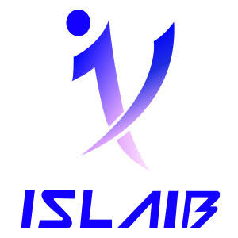 | Ministry of Higher Education and Scientific Research  University of Jendouba  Higher Institute of Applied Languages and Computer Science Béja (ISLAIB) | 

Ref: LA-GLSI……./2026
End-of-Year Internship Report (PFA)
In partial fulfillment of the requirements for the
BACHELOR’S DEGREE IN COMPUTER ENGINEERING (LICENCE GLSI)
Génie Logiciel et Systèmes d’Information
Title:
Design and Development of Synkro, a Collaborative
Project and Task Management Platform
Prepared by: | Adem Ouerhani
Supervised by:
Professional Supervisor: | Mr. Mkaissi Khalil
Host Organization: | Kernel Solution & Innovation
Academic Year: 2025 – 2026

Higher Institute of Applied Languages and Computer Science of Béja ISLAIB
Boulevard de l’environnement B.P. 340 Béja 9000 | Website: www.islaib.rnu.tn

Dedication
To my parents, whose unconditional love, sacrifices, and unwavering belief in me have shaped every step of my education. Their patience through my doubts, their encouragement through my setbacks, and their quiet confidence in my abilities gave me the strength to pursue this path. None of this work, nor the person I have become, would exist without them.
To my extended family and friends, who stood by me through the long hours, the late nights, and the uncertainty that came with building something from scratch. Their constant encouragement, patience, and willingness to listen, even when the subject was far outside their own fields, were a genuine source of strength throughout this internship.
To every teacher, mentor, and colleague who believed in me and pushed me to give the best of myself, and to everyone, named or not, whose support, advice, or simple presence made this achievement possible. This work is dedicated to all of you, with gratitude and respect.
Acknowledgements
I would like to express my sincere and heartfelt gratitude to everyone who contributed, directly or indirectly, to the completion of this end-of-year internship (PFA) and to the design, development, and writing of this report. This project would not have reached its current form without the guidance, trust, and support of the people named below.
My thanks go first to Kernel Solution & Innovation for welcoming me as an intern and giving me the opportunity to work on a real, self-directed software project within a professional digital agency environment. Being trusted with genuine ownership over the direction of Synkro, rather than a purely observational or supporting role, gave me exposure to the full lifecycle of a software product, from initial requirements to a deployed, working platform, and taught me lessons that a purely academic setting could not have provided.
I would particularly like to thank my professional supervisor, Mr. Mkaissi Khalil, for his guidance, his trust in letting me lead the technical direction of the project, and his availability throughout the internship. His willingness to answer questions, review progress, and give honest, constructive feedback at every stage of development was invaluable, and his confidence in my judgment pushed me to take real ownership of the technical decisions behind Synkro.
I also wish to thank the teaching staff of the Higher Institute of Applied Languages and Computer Science of Béja (ISLAIB) and, more broadly, the Licence Génie Logiciel et Systèmes d’Information (GLSI) program, for the knowledge and technical foundation that made this project possible. The theoretical grounding in software engineering, databases, and system design provided throughout the program gave me the tools to approach a project of this scale with confidence, and I am grateful to every instructor who took the time to explain concepts thoroughly and answer questions beyond the scope of the syllabus.
Finally, I would like to thank my family and friends for their unconditional support and encouragement during this internship. Their patience during long working sessions, their willingness to listen even without a technical background, and their constant reassurance during moments of doubt made this journey considerably lighter, and I am deeply grateful to have had them by my side throughout.
Table of Contents

List of Figures

List of Tables

List of Abbreviations
Abbreviation | Meaning
PFA | Projet de Fin d’Année (End-of-Year Internship Project)
ISLAIB | Institut Supérieur des Langues Appliquées et de l’Informatique de Béja
GLSI | Génie Logiciel et Systèmes d’Information
UML | Unified Modeling Language
MVC | Model – View – Controller
ORM | Object-Relational Mapping
CRUD | Create, Read, Update, Delete
API | Application Programming Interface
UI / UX | User Interface / User Experience
RBAC | Role-Based Access Control
SPA | Single-Page Application
WS | WebSocket
KPI | Key Performance Indicator
MAMP | Macintosh (or Windows) – Apache – MySQL – PHP local server stack
SQL | Structured Query Language
CSS | Cascading Style Sheets
PC | Personal Computer

General Introduction
Software has become the backbone of how modern organizations plan, coordinate and deliver work. Whether in a small digital agency or a large enterprise, teams increasingly rely on collaborative tools to break down projects into manageable tasks, assign responsibilities, track progress and keep every stakeholder informed in real time. This shift has turned project and task management platforms into one of the most active segments of business software, with well-established international products such as Trello, Asana, Jira or ClickUp competing to offer the most efficient, most pleasant experience.
This report presents the work carried out during my end-of-year internship (Projet de Fin d’Année, PFA), completed at Kernel Solution & Innovation, a digital agency based in Hammam-Lif, Tunisia, between June 15 and July 31, 2026, as part of the second year of the Licence in Génie Logiciel et Systèmes d’Information (GLSI) at the Higher Institute of Applied Languages and Computer Science of Béja (ISLAIB).
Unlike a classic internship built around a pre-defined mission handed down by the host company, this PFA was self-directed: I was given the autonomy to choose my own topic and to design, plan and build a complete software product from the ground up, while still operating under the professional supervision of the host organization. I chose to design and develop Synkro, a collaborative project and task management web platform aimed at small and medium-sized teams, similar in spirit to tools such as Trello or Asana, but built entirely by myself using a modern full-stack architecture (Laravel, React, Inertia.js) and real-time technologies.
This choice was motivated by several factors. First, project and task management is a problem domain that is both concrete and rich: it touches on authentication and access control, real-time communication, data modelling, user experience design and team collaboration, which made it an ideal vehicle to demonstrate a broad range of software engineering skills within a limited timeframe. Second, building a product of this scale from scratch, alone, made it possible to experience the entire software development lifecycle first-hand, from requirements gathering to deployment, rather than a narrow slice of an existing large codebase.
The central problem this internship addresses can be summarized by the following questions: how can a single developer, working within a constrained schedule of about seven weeks, design a project management platform that is both functionally complete and pleasant to use? Which features are essential to support real collaborative work between team members with different responsibilities (owners, managers, members, testers)? And how can real-time feedback (notifications, activity tracking) be integrated without compromising the performance or the simplicity of the application?
To answer these questions, the work was organized using an Agile, sprint-based approach, directly inspired by Scrum. The rest of this report follows that same organization. Chapter 1 presents the context of the project: the host organization, a study of existing project management solutions, the problem statement, the proposed solution and its requirements. Chapter 2 covers Sprint 0, the planning phase during which the product backlog, the sprint schedule and the development environment were defined. Chapters 3 to 6 detail, sprint by sprint, the design and implementation of Synkro’s main functional areas: authentication and user management, project and task management, real-time collaboration features, and administration with analytics. Chapter 7 opens a general discussion on the skills gained and the difficulties encountered. Finally, a general conclusion summarizes the work accomplished and outlines recommendations and perspectives for future development.

Chapter 1. Project Context

1. Introduction
This first chapter lays the groundwork for the rest of the report. It presents the host organization and the environment in which the internship took place, reviews existing project management solutions to position Synkro among them, states the problem this project addresses, and details the proposed solution together with its functional and non-functional requirements. The chapter closes with a justification of the working methodology and the modelling tools chosen for the project.

2. Host Organization
Kernel Solution & Innovation is a digital agency located on the RN1 road in Hammam-Lif, Tunisia. Founded on more than seven years of experience in the field, the company positions itself as a technology partner that turns client ideas into complete, reliable digital products. Its activity covers custom software and application development, mobile app development, web design, brand and identity design, and digital marketing and SEO services.
The agency organizes its delivery process around four stages that closely mirror an Agile way of working: project planning (understanding the client’s goals and defining a roadmap), development (building the solution with modern technologies), testing and quality assurance, and finally launch and ongoing support. The team is composed of a CEO, an HR manager, full-stack developers, a mobile developer and an IT specialist, working collaboratively on client projects ranging from e-commerce platforms to educational and logistics applications.
It was within this agile, product-oriented culture that I completed my internship, under the professional supervision of Mr. Mkaissi Khalil, founder and CEO of Kernel Solution & Innovation.

3. Preliminary Study

a) Presentation of Existing Solutions
Before designing Synkro, it was necessary to study existing project and task management tools in order to understand common conventions, identify strong features worth keeping, and find room for a coherent, focused alternative. Four widely used products were considered: Trello, known for its simple Kanban boards and drag-and-drop cards; Asana, which combines task lists, timelines and workload views for larger teams; Jira, the reference tool for software teams practising Scrum, with detailed backlogs and sprint boards; and ClickUp, an all-in-one workspace that tries to merge documents, goals and tasks into a single product.

b) Comparative Analysis
Table 1 compares these four tools against criteria that were considered important for Synkro: ease of use, real-time collaboration, granular role management, and cost for small teams.
Table : Comparison of existing project management solutions
Criterion | Trello | Asana | Jira | ClickUp
Ease of use | Very high | High | Moderate | Moderate
Real-time collaboration | Limited | Moderate | Moderate | Moderate
Granular team roles | Basic | Moderate | Advanced | Advanced
Learning curve | Low | Low-medium | High | High
Free tier for small teams | Yes | Yes (limited) | Yes (limited) | Yes (limited)
Source: author (Synkro project, 2026).
This comparison shows a recurring trade-off: the simplest tools (Trello) sacrifice fine-grained role management and real-time depth, while the most complete tools (Jira, ClickUp) become heavier and harder to adopt for a small team. This observation directly motivated the proposed solution described below.

4. Problem Statement
Small and medium-sized teams, such as those found in a digital agency like Kernel Solution & Innovation, need a tool that supports real collaborative work: several people with different responsibilities (an owner who manages the project, managers who plan and assign work, members and testers who execute and validate it) need to see the same up-to-date picture of a project at all times, be notified immediately when something relevant happens, and be able to trust that access to sensitive actions is properly restricted by role. Existing market tools rarely offer this combination of simplicity, live collaboration and fine-grained, role-aware permissions in a single lightweight product.

5. Proposed Solution
To address this problem, this internship proposes Synkro, a web-based collaborative project and task management platform. Synkro lets any registered user create projects, invite collaborators and assign them one of four project-level roles (owner, manager, member, tester), organize work into tasks that move through a clear status workflow, attach deliverables and checklists to tasks, and communicate through comments. All relevant events (task assignments, status changes, comments, membership changes) are pushed to connected users in real time through WebSockets, so that every team member always sees a live, consistent view of the project without needing to refresh the page. An administration layer on top of this collaborative core allows platform administrators to moderate accounts, review support tickets and suspension appeals, and monitor overall platform activity through a dedicated analytics dashboard.

6. Objectives
- Design and implement a complete, usable collaborative project and task management web application within a seven-week internship.
- Provide fine-grained, role-based access control so that each project member only sees and does what their role allows.
- Deliver real-time collaboration (live notifications, live board updates) using WebSockets.
- Offer administration and moderation tools (user management, feedback tickets, suspension and appeal workflow, activity analytics).
- Apply an Agile, sprint-based methodology to plan and track the internship’s own progress.

7. Actors Identification
Synkro distinguishes two levels of roles: platform-level roles, which apply to the whole application, and project-level roles, which apply within a given project and are stored independently for each project a user belongs to. Table 2 summarizes the actors identified for the system.
Table : Identified actors of the Synkro platform
Actor | Description
Guest | An unauthenticated visitor who can only access the public pages (registration, login, legal pages).
Registered User | Any authenticated platform user; can manage their own profile, create projects and join projects they are invited to.
Project Owner | The user who created a project; has full control over it, including deleting it and managing every member’s role.
Project Manager | A trusted collaborator who can create and assign tasks and manage other members, but cannot archive or delete the project.
Project Member | A regular contributor who works on assigned tasks, updates their status, checks off checklist items, and adds deliverables.
Project Tester | A contributor with restricted permissions focused on validating submitted work.
Administrator | A platform-level role in charge of moderating users and content, handling support tickets, and reviewing suspension appeals.
Superadmin | The highest platform-level role, holding every administrator permission plus a few of its own: promoting or demoting a user between user, administrator and superadmin, deleting user accounts, and limited editing of a user’s core info.
Source: author (Synkro project, 2026).

8. Requirements Specification

a) Functional Requirements
- Account registration, e-mail verification, login, password reset and session (device) management.
- Profile and account settings management, including a choice of visual themes.
- Project creation, member invitation and project-level role assignment.
- Task creation, assignment, status tracking, checklist items and file or link deliverables.
- Comments and feedback on tasks, with distinct handling of reviewer feedback.
- Real-time notifications, reminders, project notes and shared project resources.
- Activity logging and a recoverable trash (soft delete) for projects and tasks.
- A feedback / support ticket system with a trackable ticket identifier.
- Administration: user management, role promotion, account suspension, suspension appeals, and an analytics dashboard.

b) Non-Functional Requirements
- Usability: a clean, responsive interface usable on both desktop and mobile screens.
- Performance: real-time updates must reach connected clients with minimal latency.
- Security: every sensitive action must be protected by role-based authorization policies.
- Maintainability: a clear separation of concerns (MVC) and a normalized relational data model.
- Availability of a dark, light and additional custom colour theme for user comfort.

9. Methodology and Tools Justification
Given the short duration of the internship and the fact that I was both the sole developer and, in effect, my own product owner, an Agile methodology directly inspired by Scrum was chosen to structure the work. The project was broken down into a short planning phase (Sprint 0) followed by four development sprints, each delivering a coherent, demonstrable increment of the platform: authentication, project and task management, real-time collaboration, and administration with analytics. This iterative approach made it possible to keep a working version of the application at the end of every sprint, to reprioritize the backlog if needed, and to dedicate the final sprint to consolidation, moderation features and analytics once the collaborative core was stable.
The Unified Modeling Language (UML) was used throughout the report to formalize the system’s design: use case diagrams to capture functional requirements per actor, sequence diagrams to describe the dynamic behaviour of key scenarios, and class diagrams to describe the underlying data model of each functional area.
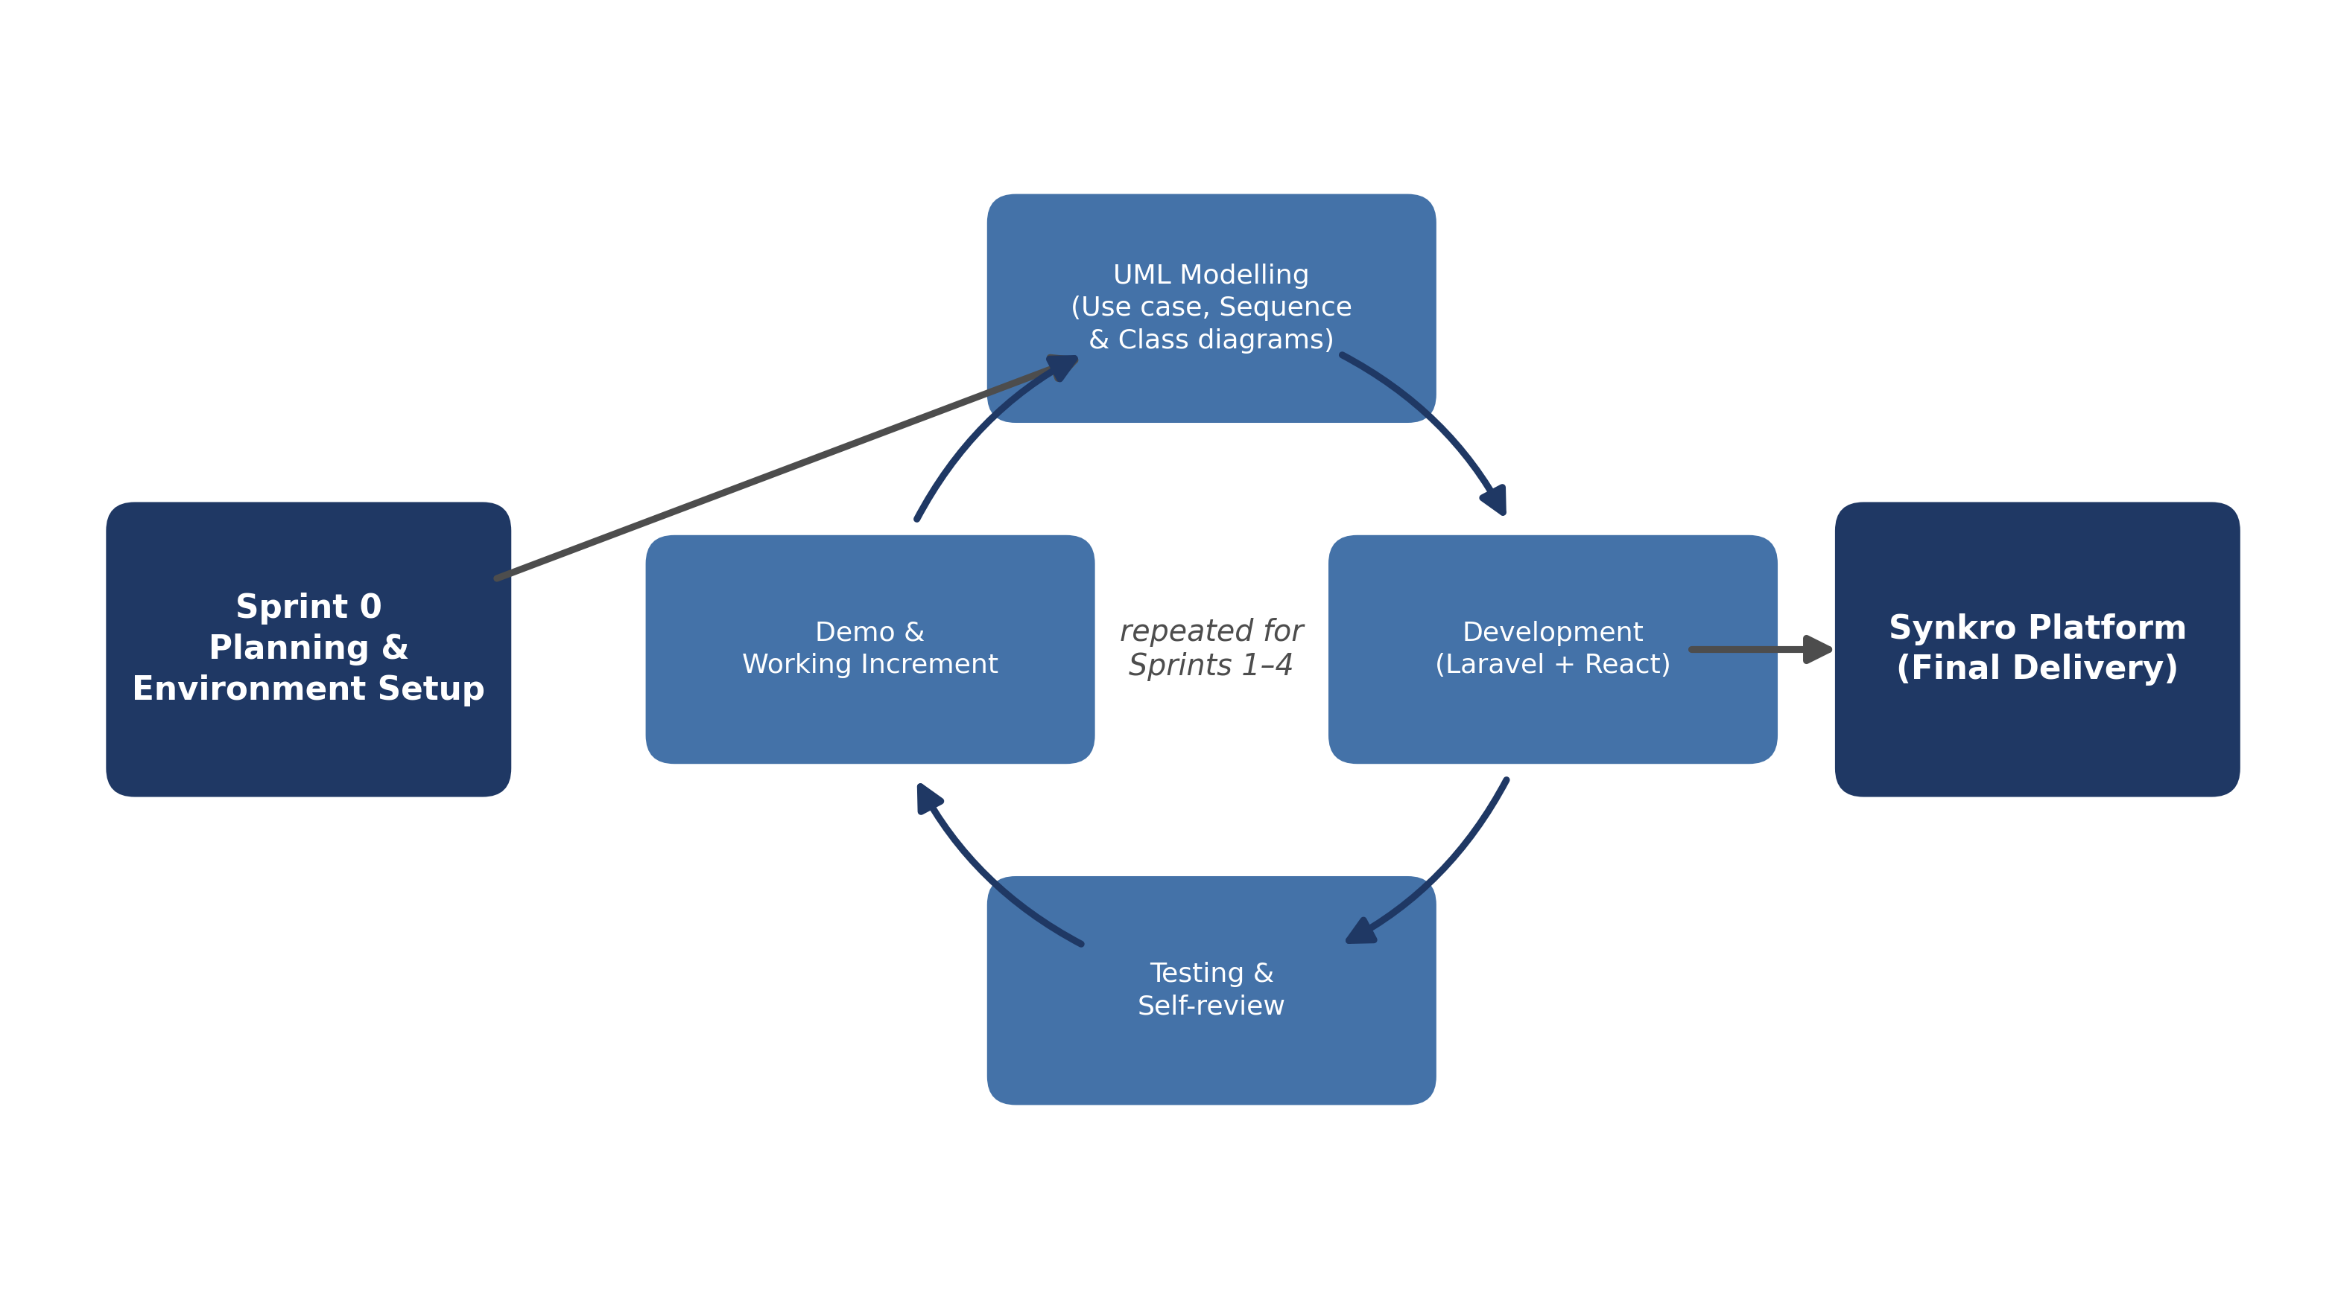
Figure : Agile/Scrum-inspired iterative methodology
Source: author (Synkro project, 2026).

10. Conclusion
This chapter introduced the context of the internship, positioned Synkro relative to existing project management tools, and defined the problem, objectives, actors and requirements that guide the rest of this report. The following chapter details Sprint 0, during which this context was translated into a concrete product backlog and a development plan.

Chapter 2. Sprint 0 – Project Planning Phase

1. Introduction
Sprint 0 corresponds to the first week of the internship (June 15 to June 19, 2026). Unlike the following sprints, it does not deliver a user-facing feature; instead, it sets up everything needed to start development under good conditions: the product backlog, the sprint schedule, a first high-level view of the system through a global use case diagram, and the development environment.

2. Product Backlog
The product backlog lists the main features of Synkro, ordered by priority and grouped by the functional area they belong to. Table 3 presents a condensed view of this backlog, already organized by the sprint in which each group of items was implemented.
Table : Product backlog (condensed view)
Sprint | Backlog item | Priority | Estimate
Sprint 1 | User registration, e-mail verification, login, logout | High | 3 days
Sprint 1 | Password reset, profile & appearance settings, session list | High | 5 days
Sprint 2 | Project creation, member invitation, project roles | High | 4 days
Sprint 2 | Task CRUD, status workflow, checklist, deliverables | High | 6 days
Sprint 3 | Comments & feedback, real-time notifications | High | 3 days
Sprint 3 | Reminders, project notes, project resources, activity log | Medium | 2 days
Sprint 4 | Admin: user management, suspension & appeals | High | 3 days
Sprint 4 | Feedback tickets, admin analytics dashboard, trash & restore | Medium | 2 days
Source: author (Synkro project, 2026).

3. Sprint Planning
The internship runs from Monday, June 15, 2026 to Friday, July 31, 2026, which corresponds exactly to seven full working weeks. This period was split into one planning sprint and four development sprints, summarized in Table 4 and illustrated by the Gantt chart in Figure 1.
Table : Sprint schedule
Sprint | Period | Duration | Goal
Sprint 0 | Jun 15 – Jun 19, 2026 | 1 week | Planning & environment setup
Sprint 1 | Jun 22 – Jul 3, 2026 | 2 weeks | Authentication & user management
Sprint 2 | Jul 6 – Jul 17, 2026 | 2 weeks | Project & task management
Sprint 3 | Jul 20 – Jul 24, 2026 | 1 week | Collaboration & real-time features
Sprint 4 | Jul 27 – Jul 31, 2026 | 1 week | Administration, moderation & analytics
Source: author (Synkro project, 2026).
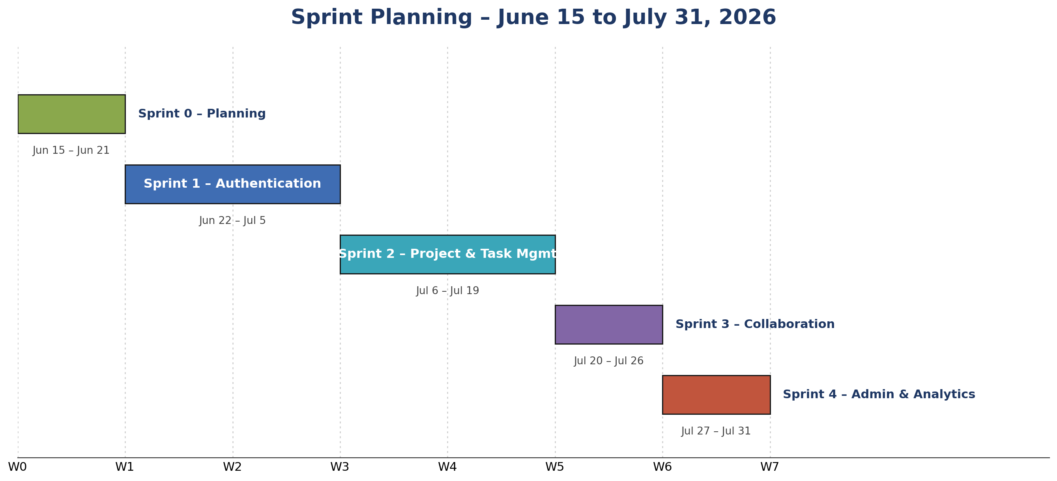
Figure : Gantt chart of the sprint schedule

4. Sprint Durations
Sprint durations were deliberately uneven: two weeks were allocated to Sprint 1 and Sprint 2 because authentication and, above all, project and task management form the functional core of the application and needed a solid, well-tested foundation. Sprint 3 and Sprint 4 were each given a single week, since they build incrementally on top of that core and involve comparatively smaller, more independent features (notifications, moderation tools, analytics).

5. Global Use Case Diagram
Before detailing each sprint individually, Figure 2 presents a global use case diagram summarizing the main interactions between the identified actors and the Synkro system as a whole. The following chapters refine this global view into one detailed use case diagram per sprint.
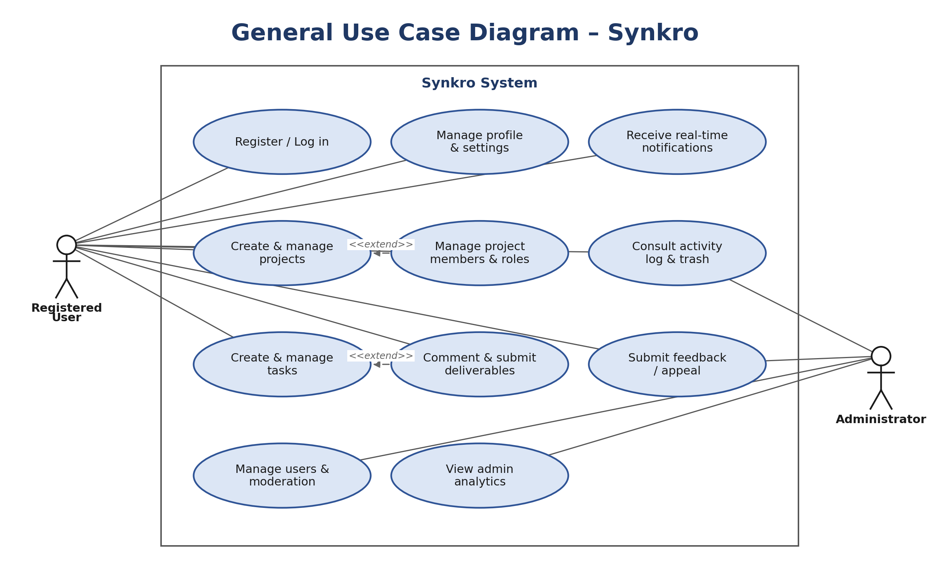
Figure : General use case diagram of Synkro

6. Development Environment

a) Hardware Environment
- Laptop: Dell Gaming G15 5530
- Processor: Intel Core i5, 13th generation
- Memory: 16 GB RAM
- Graphics: NVIDIA GeForce RTX 3050, 6 GB
- Operating system: Windows 11
- Display: 1920 × 1080 pixels

b) Software Environment
Table : Software environment and tools used
Logo | Description
 | Laravel 13 (PHP). Laravel is a PHP web application framework with expressive, elegant syntax. In Synkro, it powers the entire back-end: routing, controllers, authorization policies, and data access through the Eloquent ORM.
 | Inertia.js. Inertia.js lets developers build fully client-rendered single-page applications using classic server-side routing and controllers, without a separate API layer. It links Synkro's Laravel back-end directly to its React front-end.
 | React. React is a JavaScript library for building user interfaces out of reusable, composable components. It renders every page and interactive element of Synkro's front-end, from the kanban board to the notification bell.
 | Tailwind CSS. Tailwind CSS is a utility-first CSS framework that provides low-level classes for building custom designs directly in markup. It styles the entirety of Synkro's interface, including its light, dark, and custom black themes.
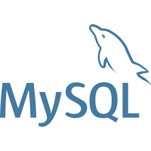 | MySQL. MySQL is an open-source relational database management system that uses SQL to store and query structured data. It is Synkro's primary data store, holding users, projects, tasks, notifications, and activity logs.
 | MAMP. MAMP is a free local server environment that bundles Apache, MySQL, and PHP for macOS and Windows. It was used throughout development to run Synkro's MySQL database locally on port 3306.
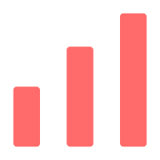 | Recharts. Recharts is a composable charting library built on React and D3, used to render responsive charts with minimal configuration. It powers the analytics visualizations on Synkro's administration dashboard.
 | Git. Git is a distributed version control system used to track and manage changes to source code over time. Every change made to Synkro throughout the internship was committed and versioned using Git.
 | GitHub Desktop. GitHub Desktop is a graphical client for Git and GitHub that simplifies committing, branching, and pushing changes without the command line. It was used to manage and push commits to the project's public repository at github.com/domdomxy/synkro.
 | Command Prompt (cmd). The Windows Command Prompt is a command-line interpreter used to run local development processes. It was used to start Synkro's PHP application server, WebSocket server, task scheduler, and front-end build tooling during development.
Source: author (Synkro project, 2026).
Running the application locally requires several processes at once: the PHP application server (php artisan serve), the front-end bundler in watch mode (npm run dev), the WebSocket server (php artisan reverb:start) and the task scheduler (php artisan schedule:work); an additional queue worker (php artisan queue:work) is started whenever e-mail notifications need to be processed. Figure 3 summarizes how these pieces communicate.
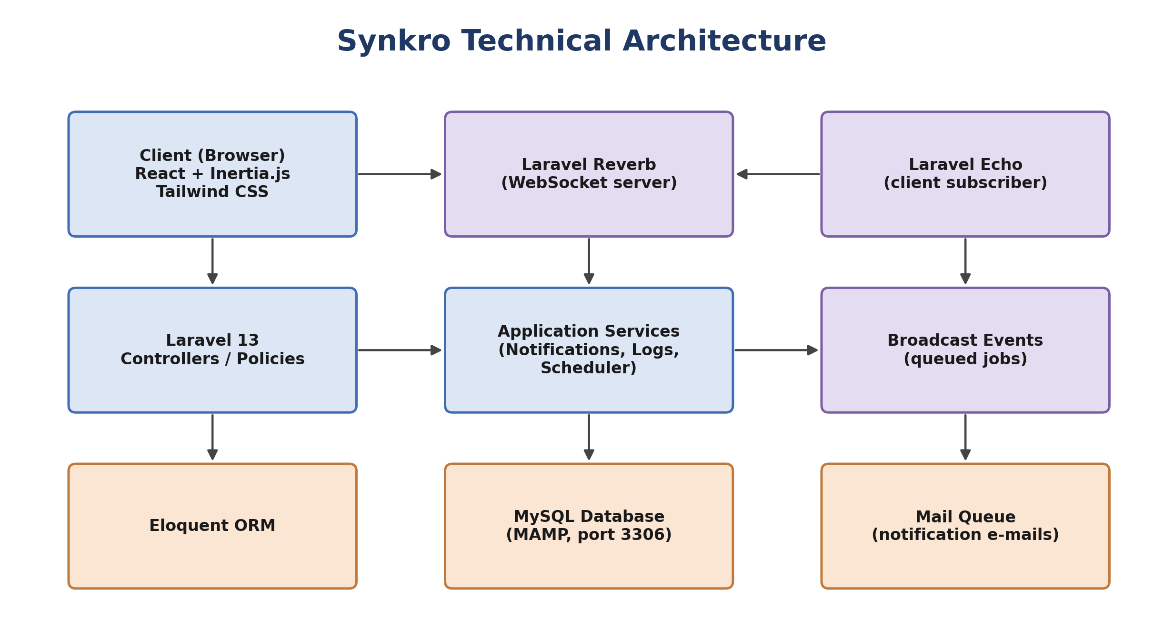
Figure : Technical architecture of the Synkro platform

7. Conclusion
Sprint 0 established a shared, prioritized understanding of what needed to be built and in what order, a realistic schedule anchored to the internship’s actual calendar, and a working local development environment. The next four chapters detail, sprint by sprint, how this plan was executed.

Chapter 3. Sprint 1 – Authentication & User Management

1. Introduction
Sprint 1 ran from June 22 to July 3, 2026 and focused on the foundation every other feature depends on: accounts. This sprint delivered registration with e-mail verification, login, password reset, profile and appearance settings, and a live list of active sessions.

2. Sprint Backlog
Table : Sprint 1 backlog
User story | Priority | Status
As a guest, I want to register an account with my e-mail so that I can access the platform. | High | Done
As a guest, I want to verify my e-mail address so that my account is confirmed. | High | Done
As a guest, I want to log in and log out securely. | High | Done
As a user, I want to reset my password if I forget it. | High | Done
As a user, I want to edit my profile information. | Medium | Done
As a user, I want to choose a visual theme (light, dark, black). | Medium | Done
As a user, I want to see and close my active sessions on other devices. | Medium | Done
Source: author (Synkro project, 2026).

3. Requirements Specification
Figure 4 details the use cases available to a guest and to a registered user for this sprint.
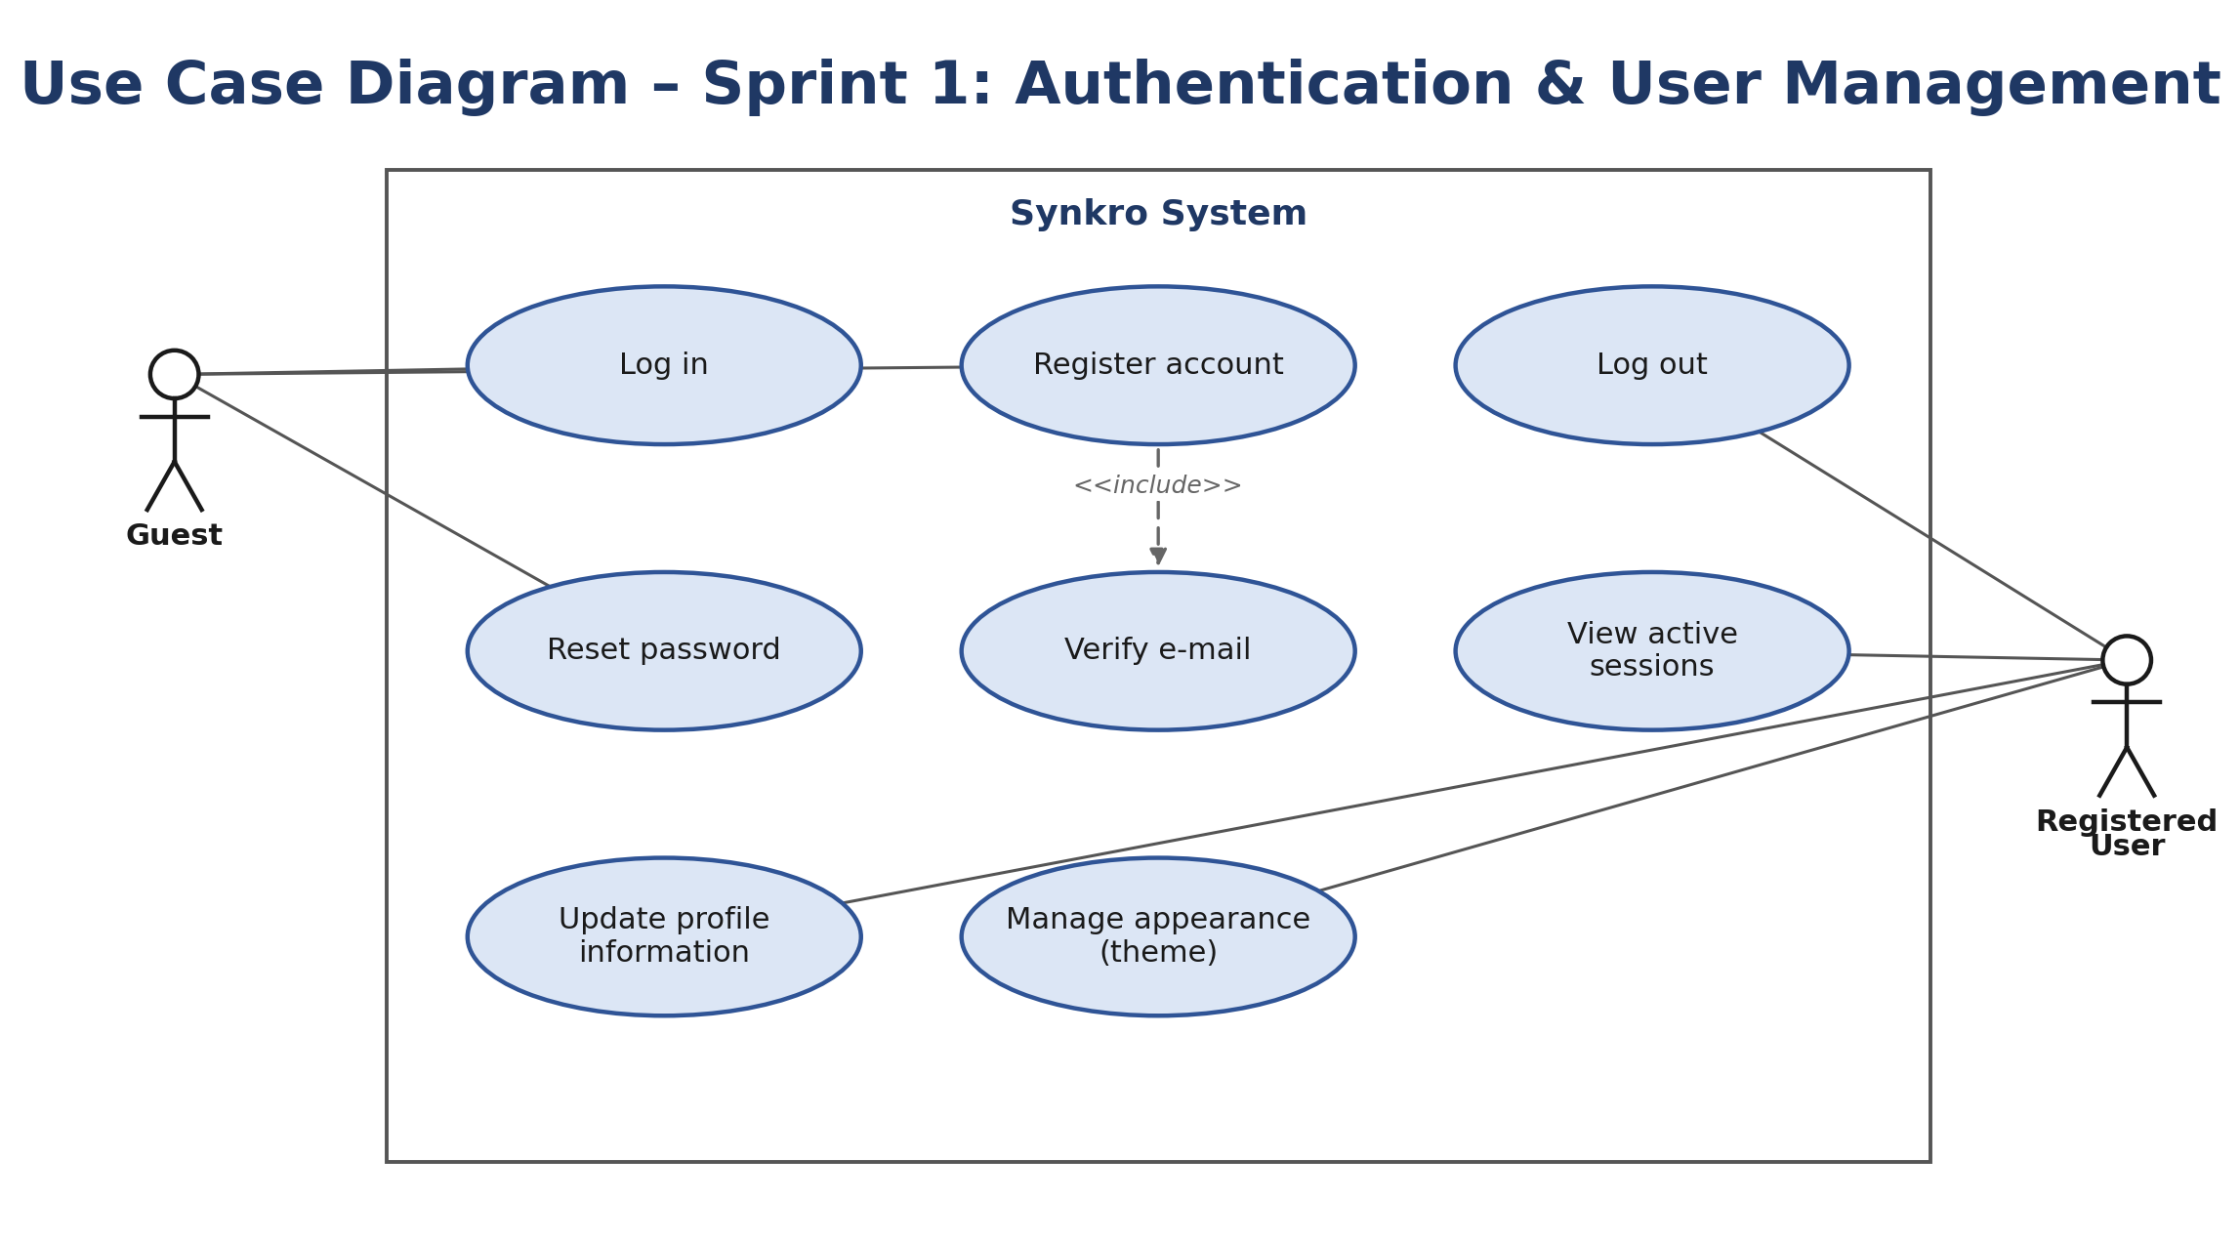
Figure : Use case diagram – Sprint 1
Table 5 gives the textual description of the central use case of this sprint, “Log in”.
Table : Textual description of the “Log in” use case
Field | Description
Actor | Guest
Precondition | The user already owns a verified account.
Main flow | 1. The guest opens the login page. 2. The guest enters their e-mail and password. 3. The system verifies the credentials. 4. The system creates a session and redirects to the dashboard.
Alternate flow | If the credentials are invalid, the system displays an error message and the guest can retry or request a password reset.
Postcondition | The user is authenticated and reaches their dashboard.
Source: author (Synkro project, 2026).

4. Design
Figure 5 shows the sequence diagram of the login flow, and Figure 6 shows the corresponding class diagram.
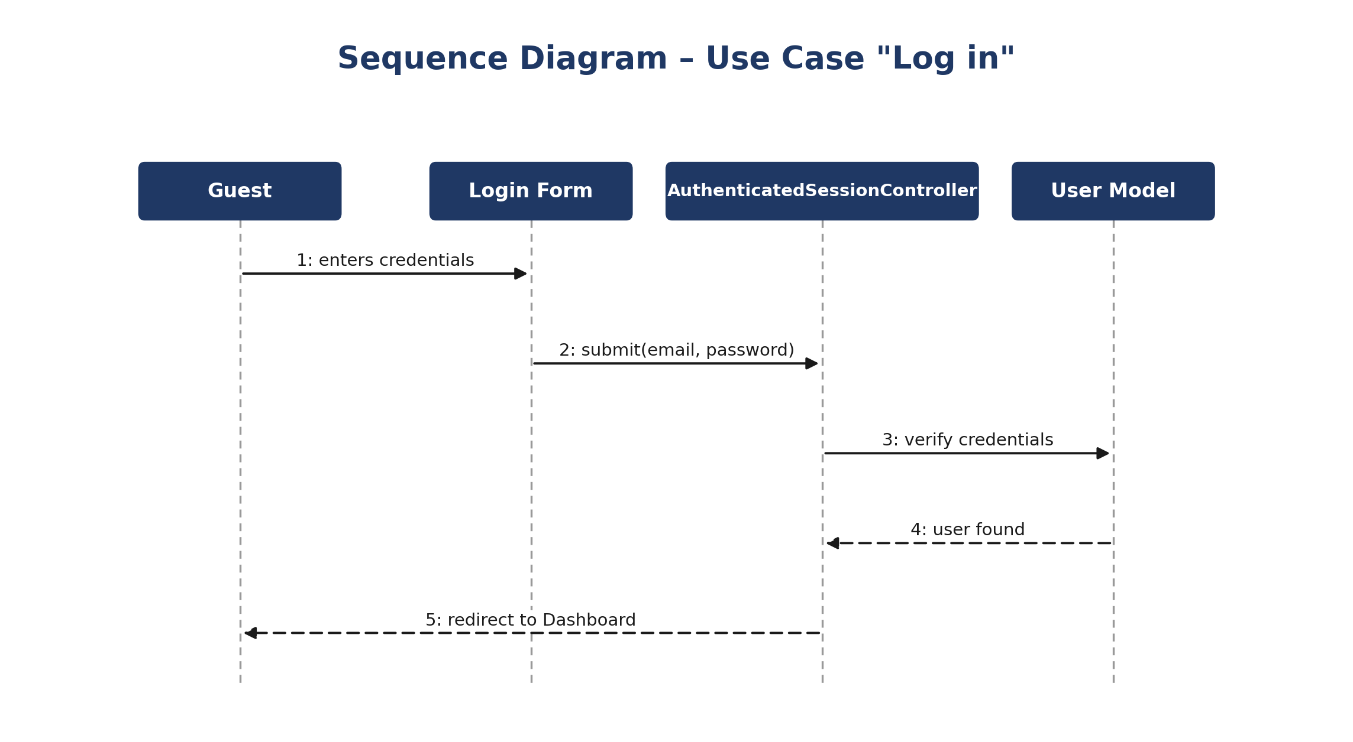
Figure : Sequence diagram – “Log in”
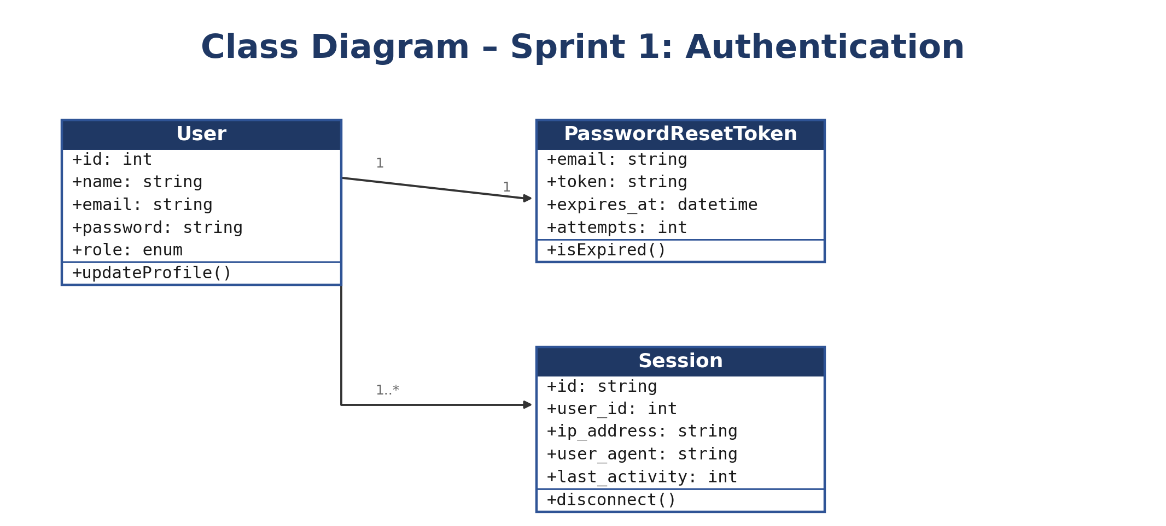
Figure : Class diagram – Sprint 1

5. Realization
This section illustrates the resulting interface with screenshots taken from the running application.
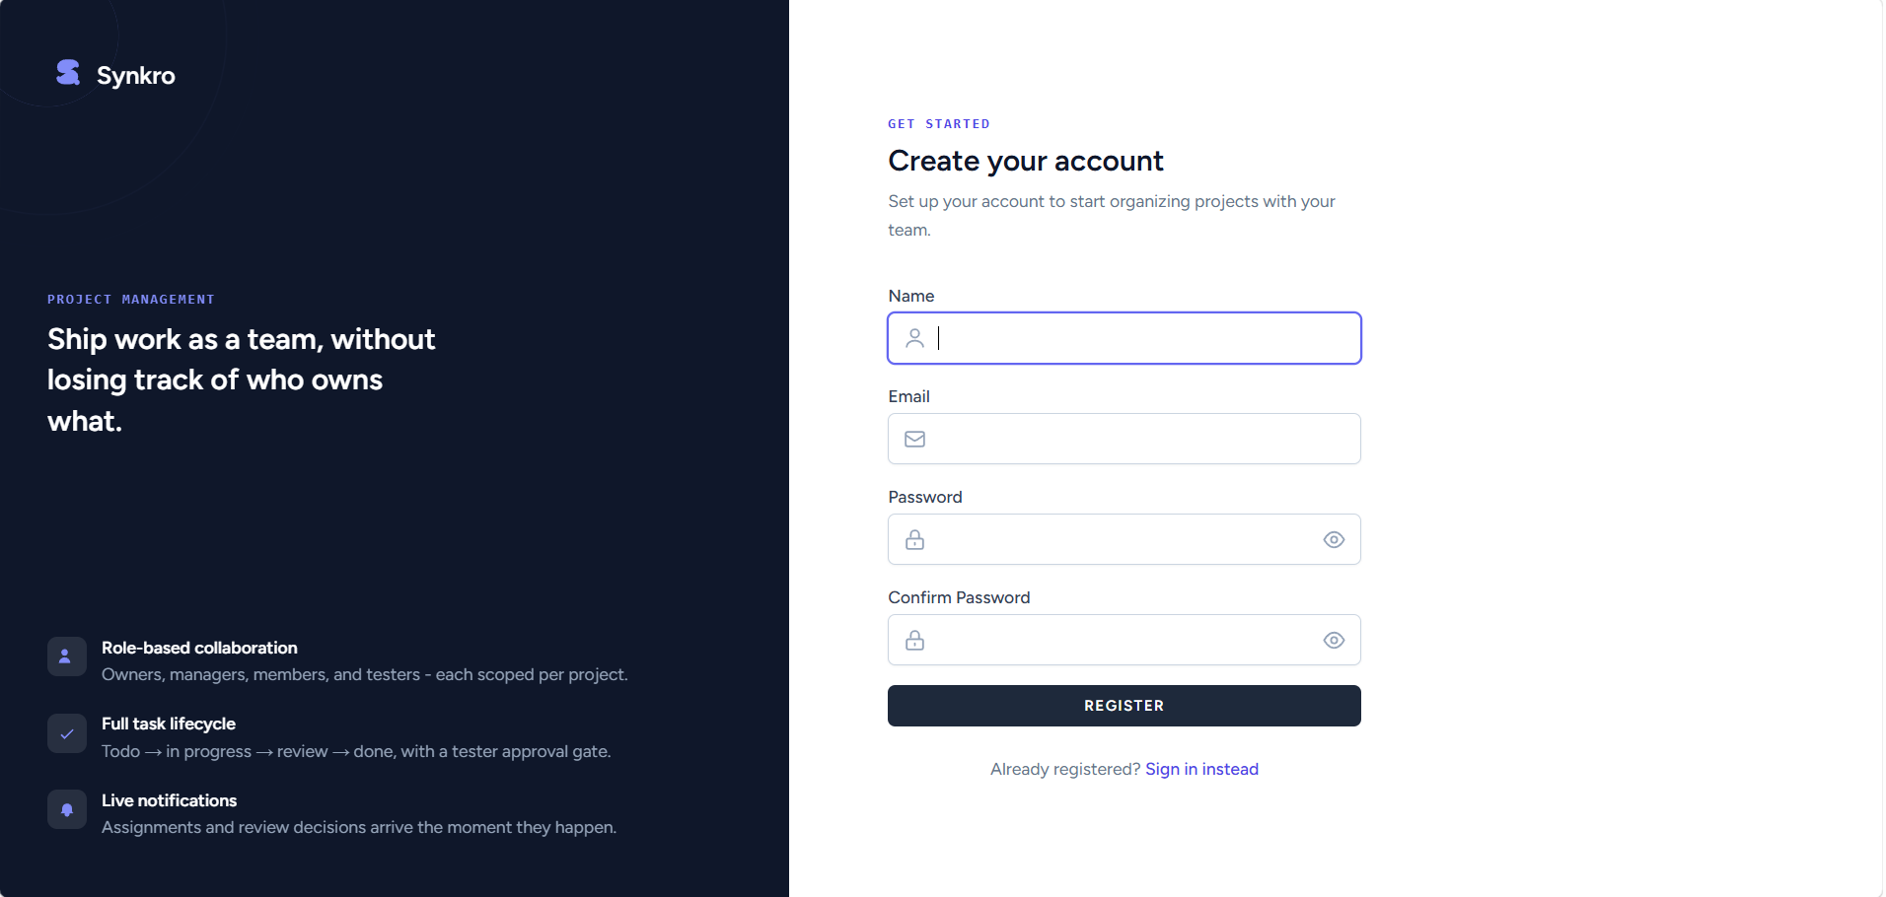
Figure : Registration page
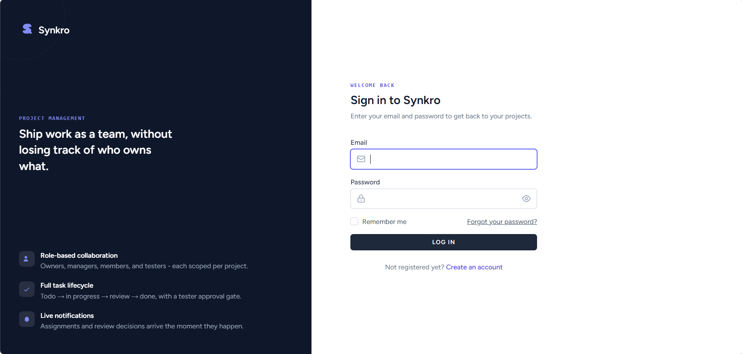
Figure : Login page
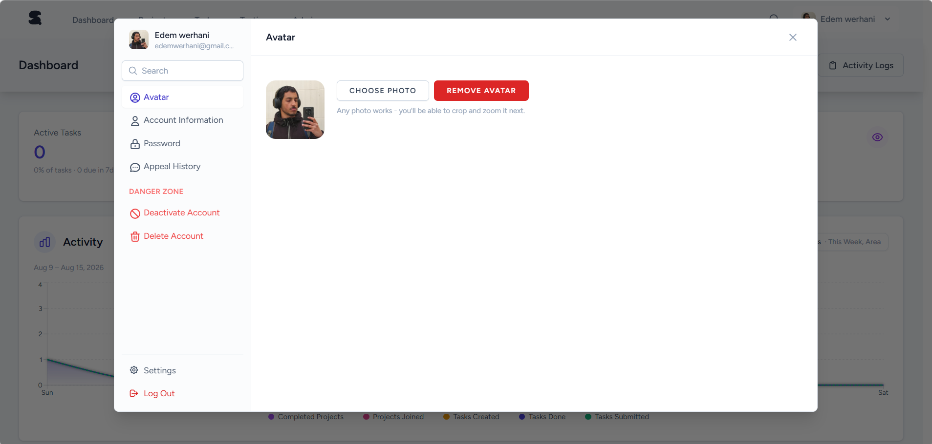
Figure : Account settings panel
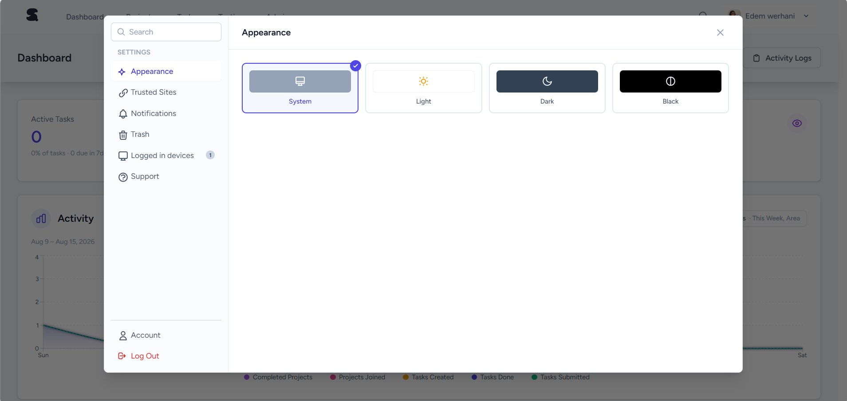
Figure : Appearance settings – theme selection
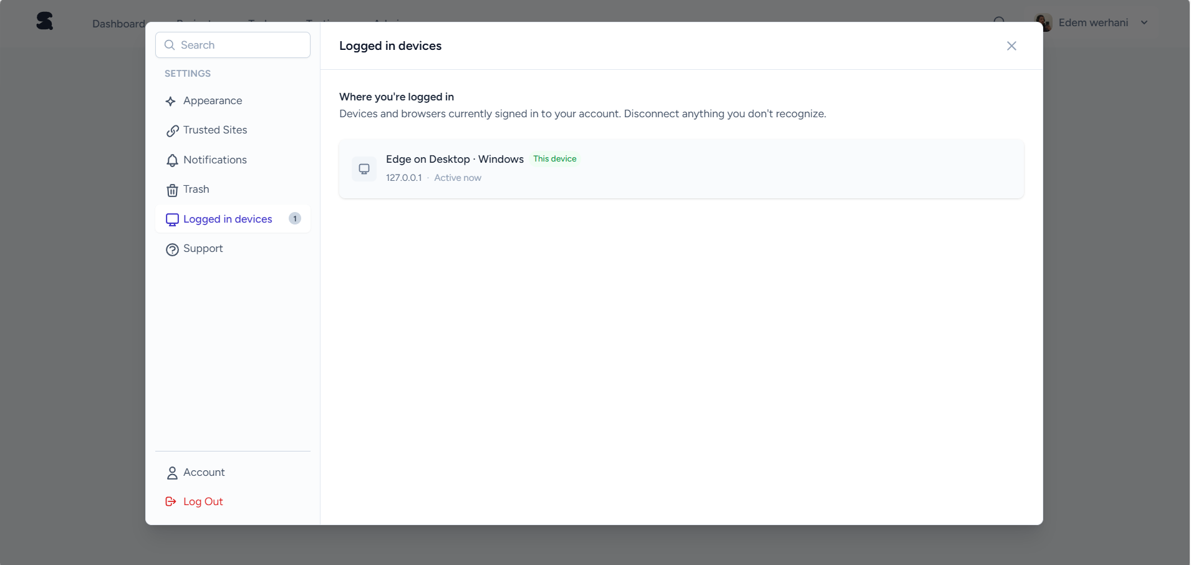
Figure : Active sessions (“logged in devices”) list

6. Conclusion
At the end of Sprint 1, Synkro had a complete, secure account system, providing the identity layer on which every collaborative feature of the next sprints was built.

Chapter 4. Sprint 2 – Project & Task Management

1. Introduction
Sprint 2 ran from July 6 to July 17, 2026 and delivered the functional core of Synkro: projects, project membership and roles, and the full task lifecycle.

2. Sprint Backlog
Table : Sprint 2 backlog
User story | Priority | Status
As a user, I want to create a project so that I can organize a piece of work. | High | Done
As an owner, I want to invite members and assign them a role. | High | Done
As a manager, I want to create tasks and assign them to a member. | High | Done
As a member, I want to update the status of my tasks as I progress. | High | Done
As a manager, I want to add checklist items to a task. | Medium | Done
As a member, I want to attach a file or a link as a deliverable. | Medium | Done
As a project member, I want to archive a project I no longer actively work in, so it's hidden from my project list. | Low | Done
Source: author (Synkro project, 2026).

3. Requirements Specification
Figure 7 shows the use case diagram for this sprint, covering the four project-level roles.
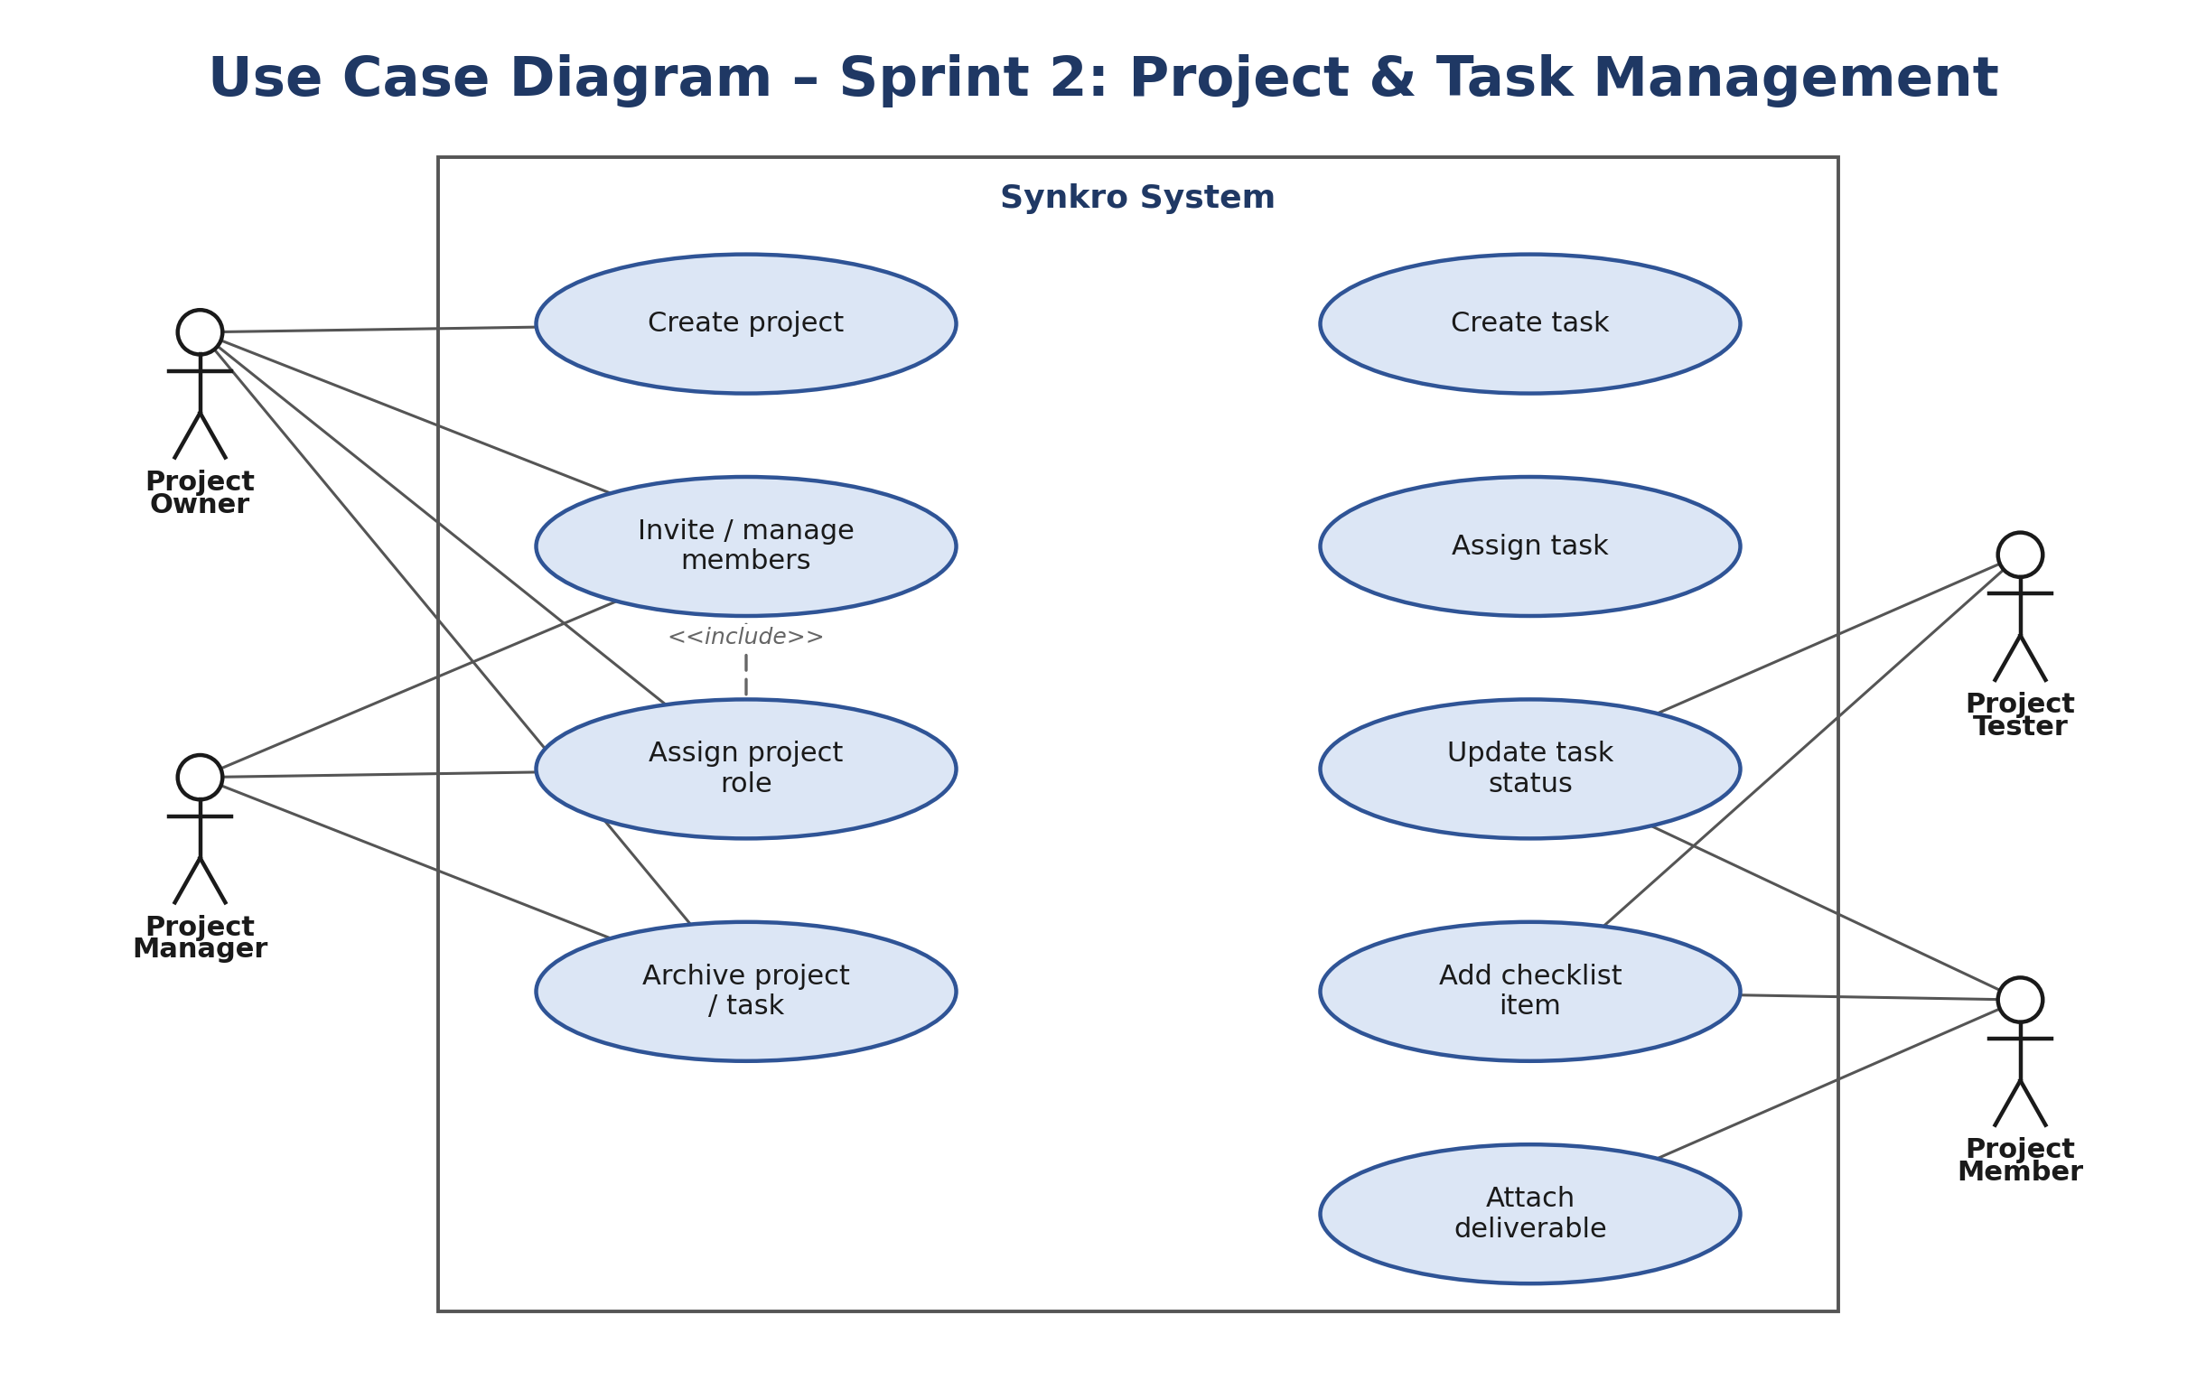
Figure : Use case diagram – Sprint 2
Table : Textual description of the “Create task” use case
Field | Description
Actor | Project Manager
Precondition | The actor holds the manager role on the project.
Main flow | 1. The manager opens the task board and selects “new task”. 2. The manager fills in the title, description, assignee and due date. 3. The system creates the task and adds it to the board. 4. The system broadcasts the change so the board updates live for every connected member.
Alternate flow | If a required field is missing, the form is rejected with a validation message.
Postcondition | The task exists, is visible to the whole project team, and the assignee is notified.
Source: author (Synkro project, 2026).

4. Design
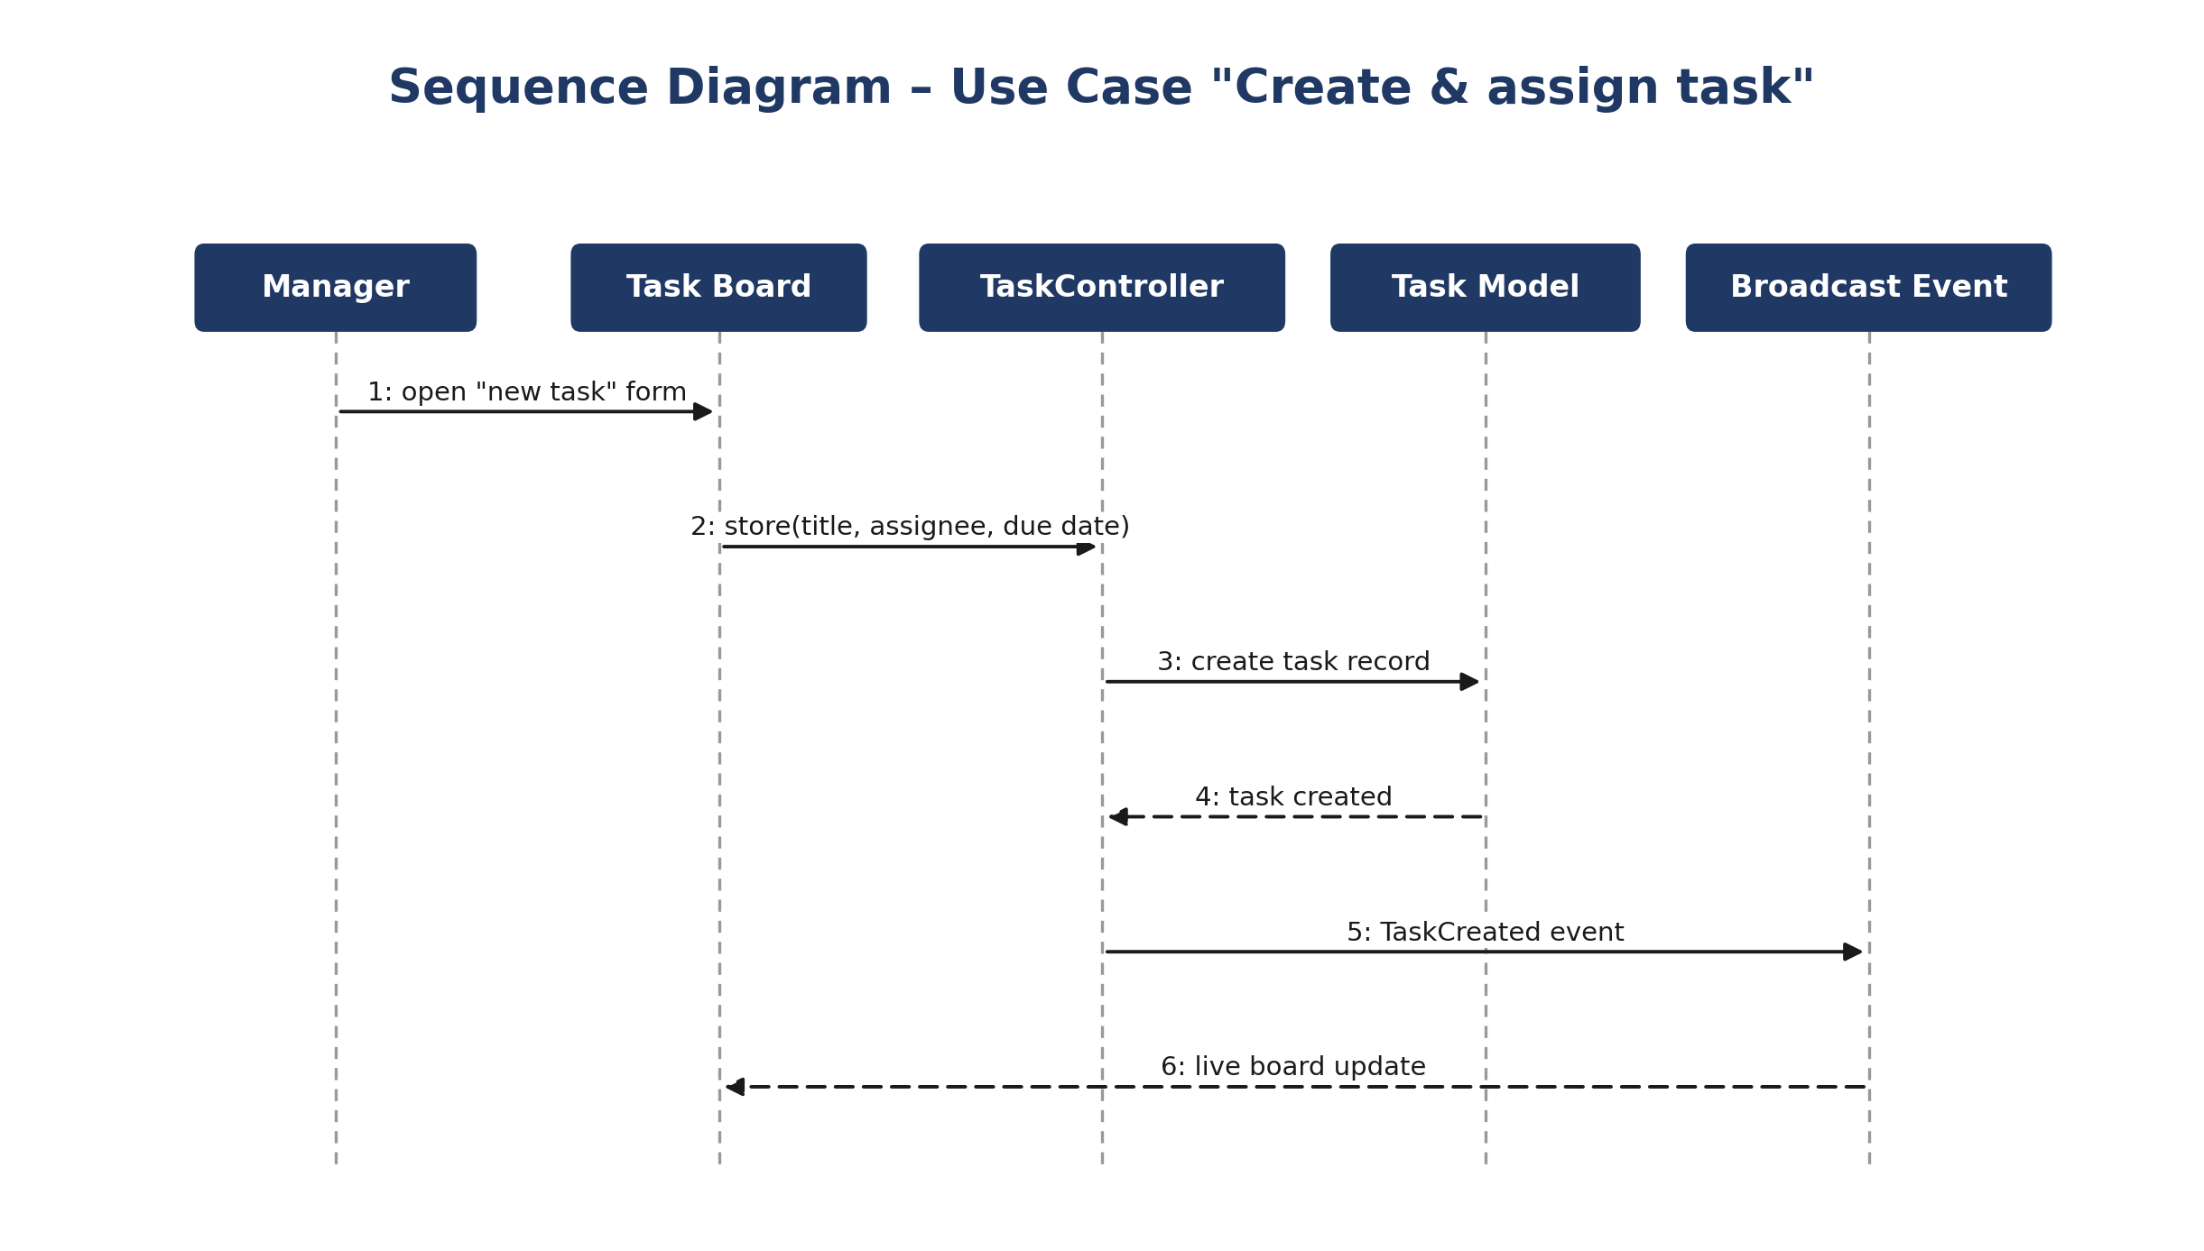
Figure : Sequence diagram – “Create & assign task”
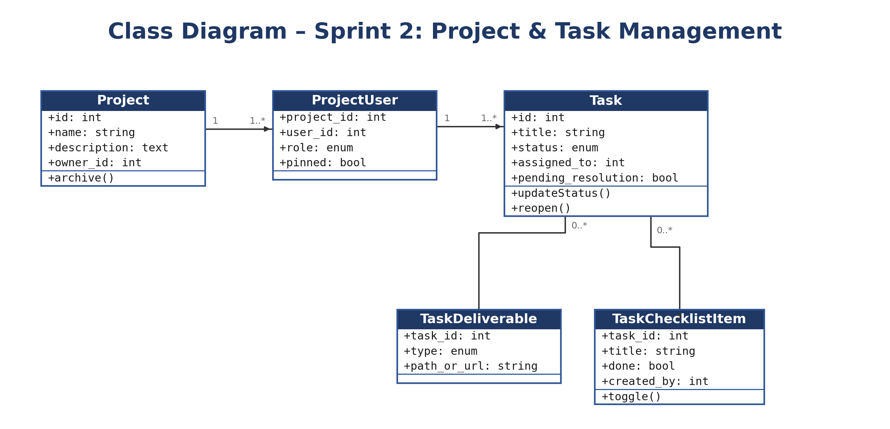
Figure : Class diagram – Sprint 2

5. Realization
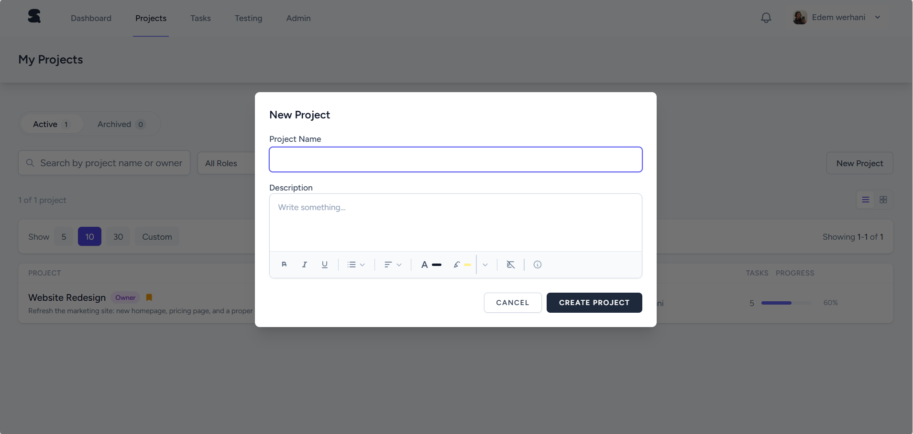
Figure : Project creation form
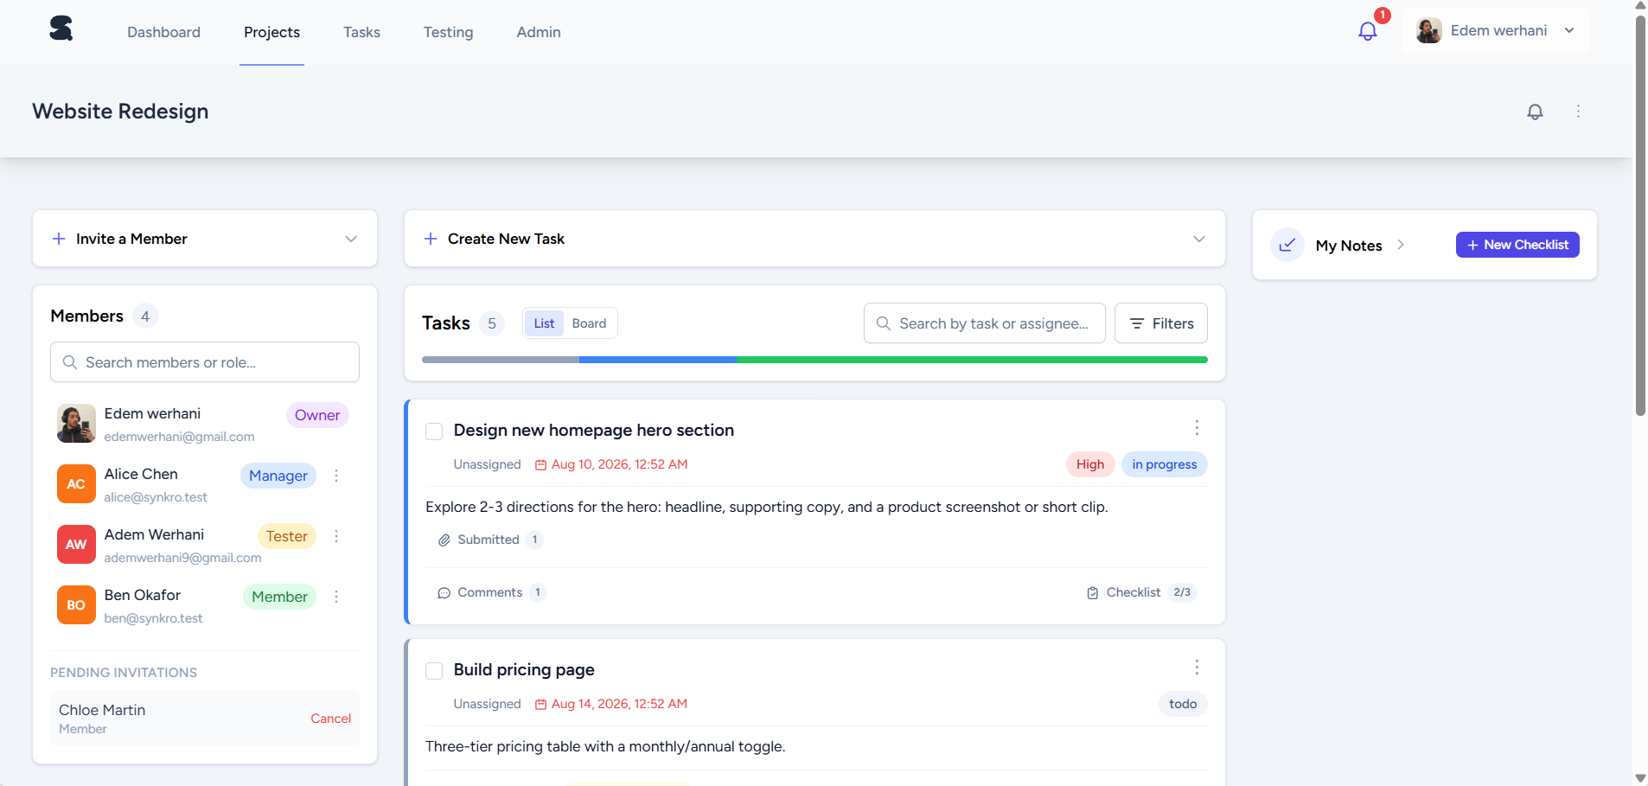
Figure : Project members panel with role assignment
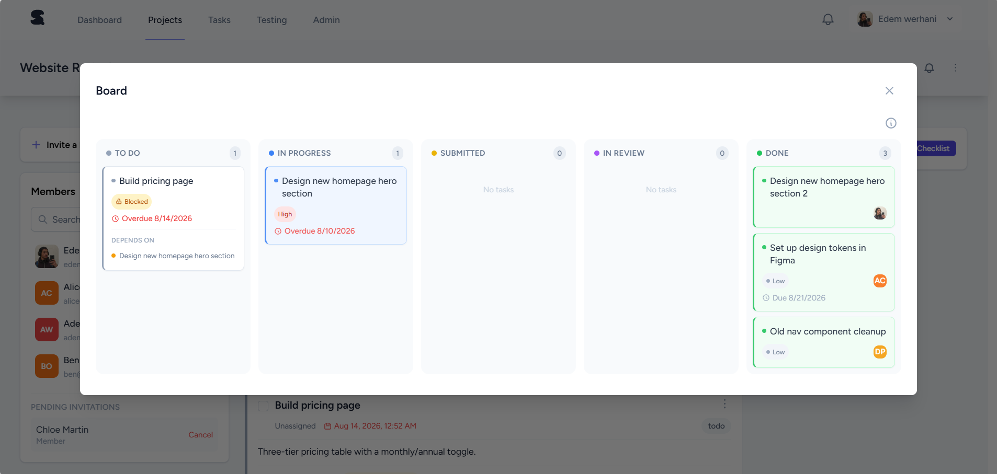
Figure : Task board (Kanban-style view)
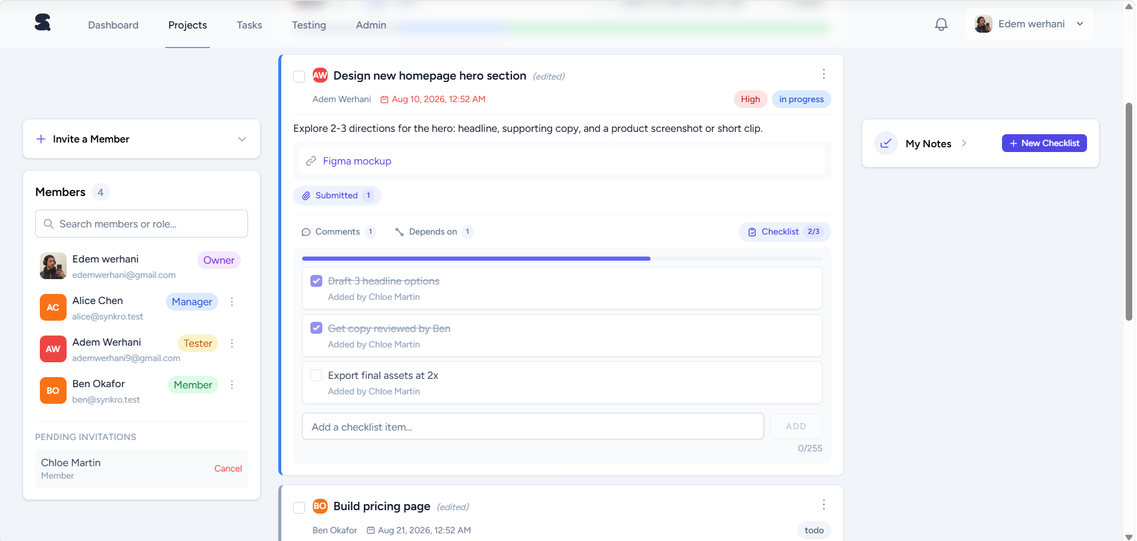
Figure : Task detail view with checklist and deliverables
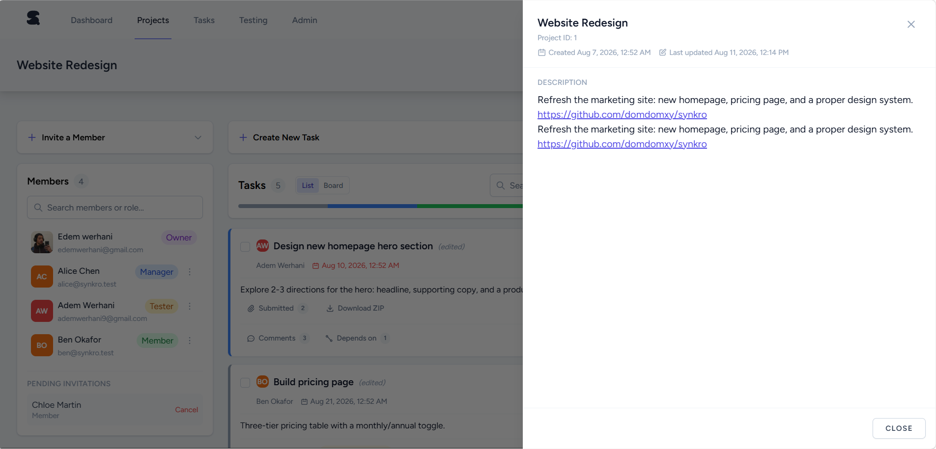
Figure : Project information overview
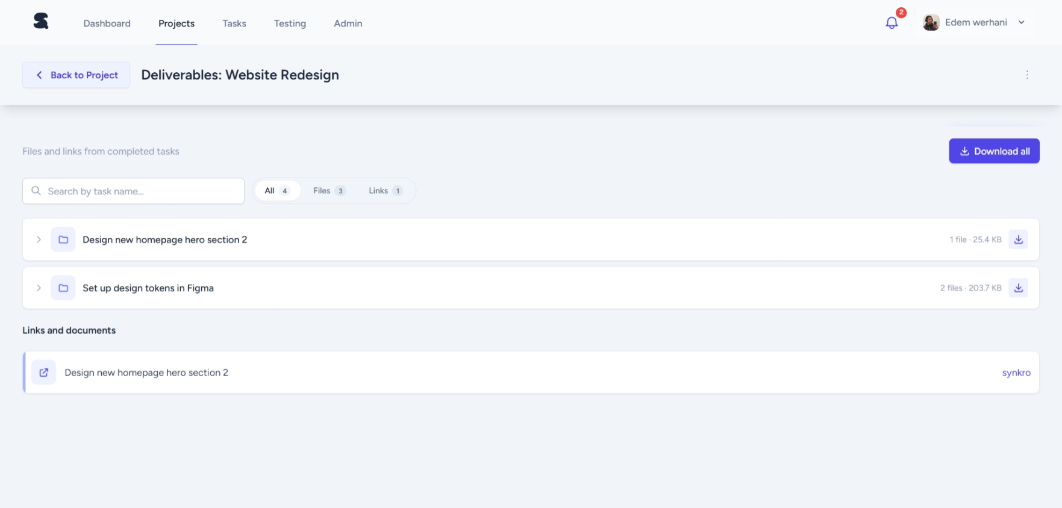
Figure : Project deliverables page

6. Conclusion
Sprint 2 delivered the heart of Synkro: from this point on, a team could realistically use the platform to plan and track its work from end to end. The next sprint builds real-time collaboration on top of this core.

Chapter 5. Sprint 3 – Collaboration & Real-Time Features

1. Introduction
Sprint 3 ran from July 20 to July 24, 2026. Its goal was to turn Synkro from a shared workspace into a truly live one, where every relevant event reaches connected teammates instantly, and to add lightweight collaboration tools around tasks and projects.

2. Sprint Backlog
Table : Sprint 3 backlog
User story | Priority | Status
As a member, I want to comment on a task to discuss it with my team. | High | Done
As a manager, I want to leave feedback on a submitted task. | High | Done
As a user, I want to receive live notifications without refreshing the page. | High | Done
As a user, I want to set a personal reminder for an upcoming deadline. | Medium | Done
As a member, I want to write a personal note for my project. | Medium | Done
As a manager, I want to upload a resource file for the whole project. | Medium | Done
As a manager, I want to consult the project activity log. | Medium | Done
Source: author (Synkro project, 2026).

3. Requirements Specification
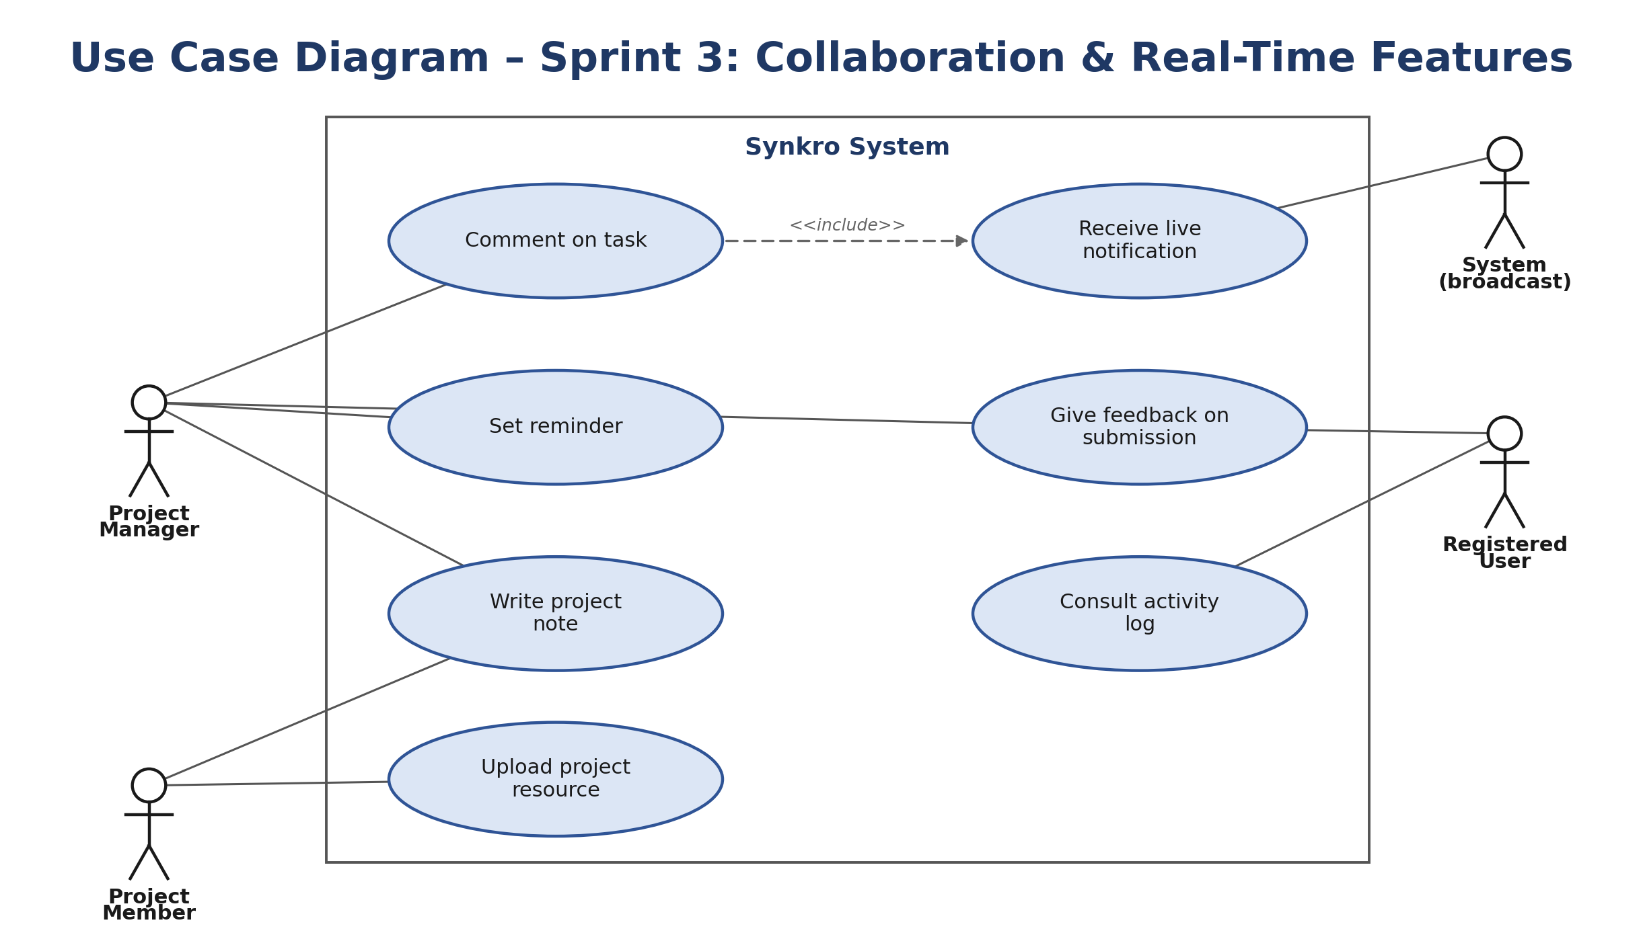
Figure : Use case diagram – Sprint 3
Table : Textual description of the real-time notification use case
Field | Description
Actor | Project Member, System (broadcast)
Precondition | The member is viewing a task they have access to.
Main flow | 1. The member posts a comment. 2. The system stores the comment and creates a notification for the relevant users. 3. The system broadcasts a “comment posted” event through the WebSocket server. 4. Connected clients receive the event and update the notification bell and the task view instantly.
Alternate flow | If the WebSocket connection is unavailable, the comment is still saved and will appear on the next page load.
Postcondition | All connected team members see the new comment without reloading the page.
Source: author (Synkro project, 2026).

4. Design
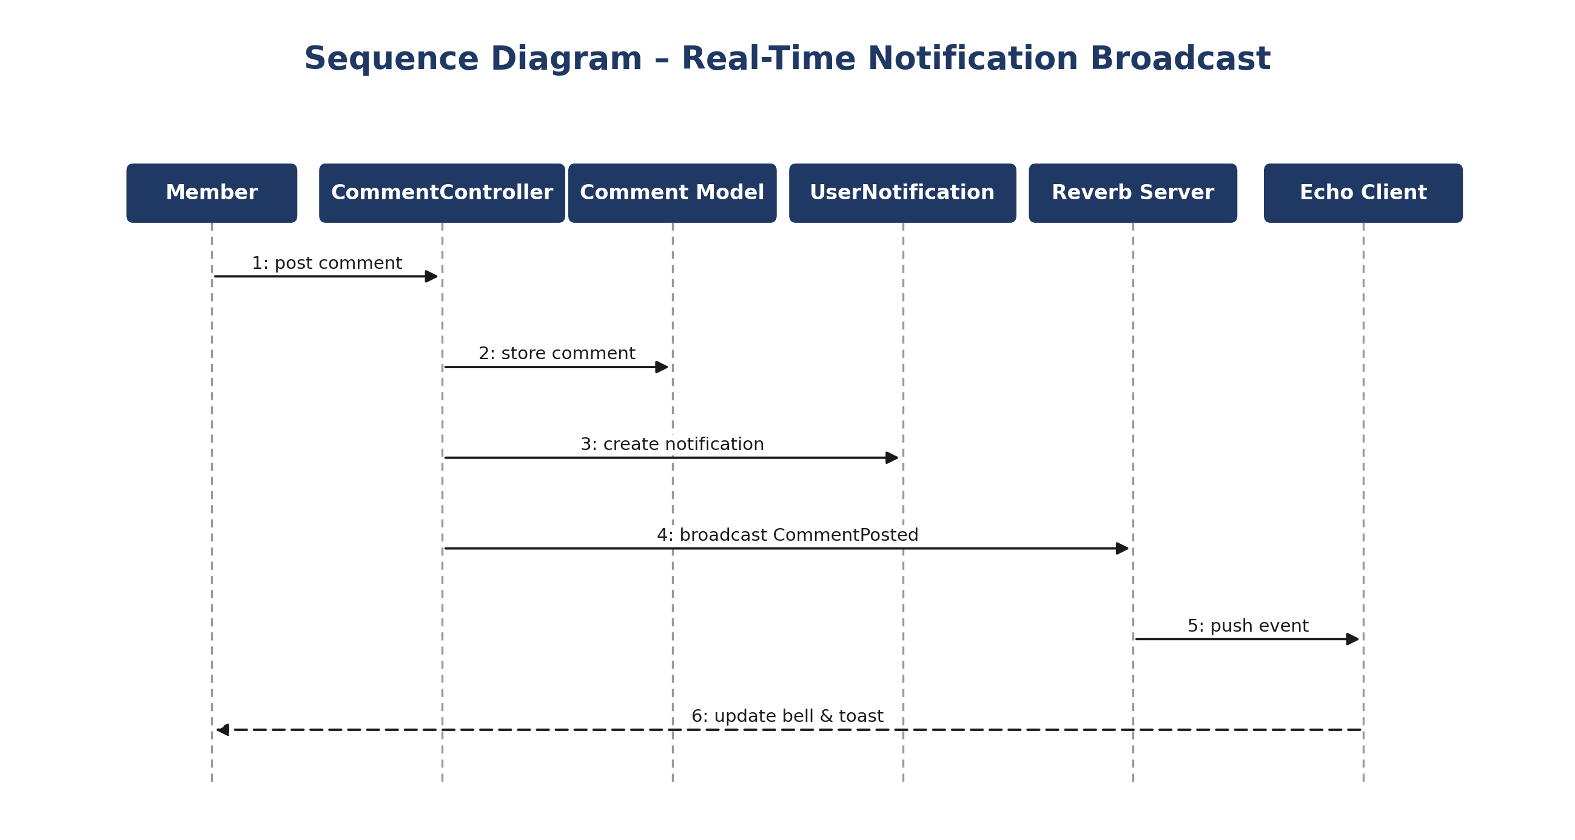
Figure : Sequence diagram – real-time notification broadcast
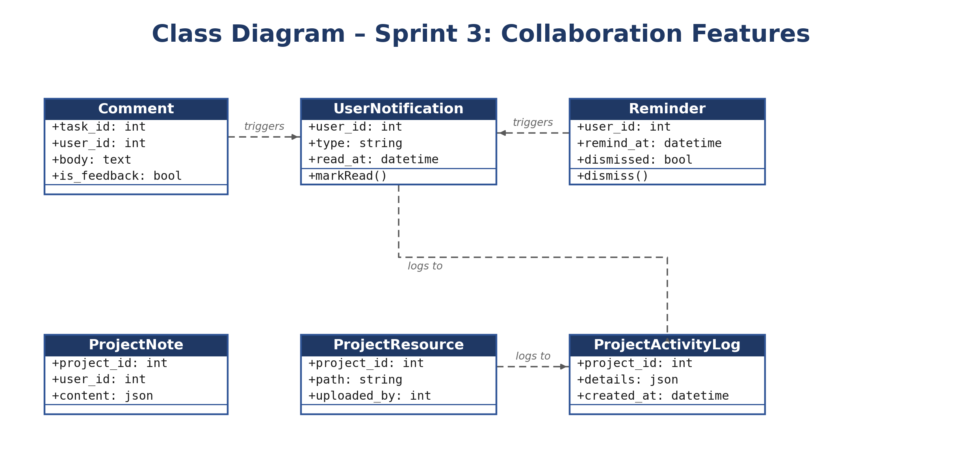
Figure : Class diagram – Sprint 3

5. Realization
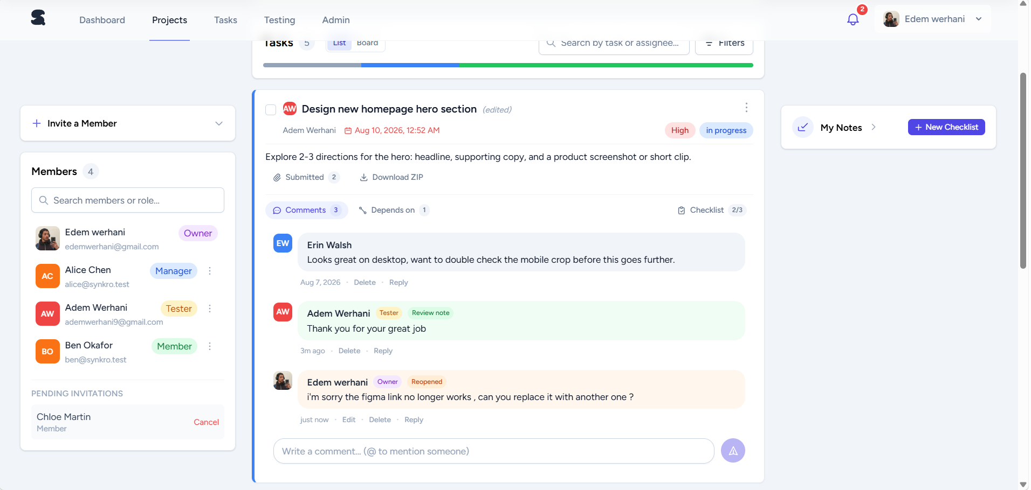
Figure : Task comments / feedback thread
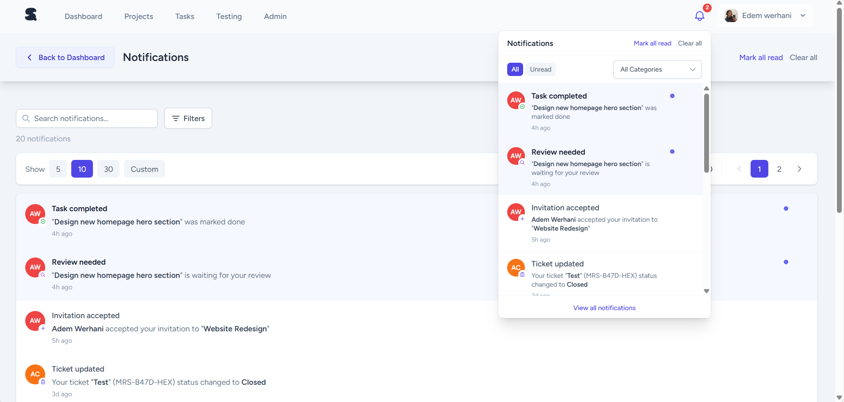
Figure : Live notification bell and toast notifications
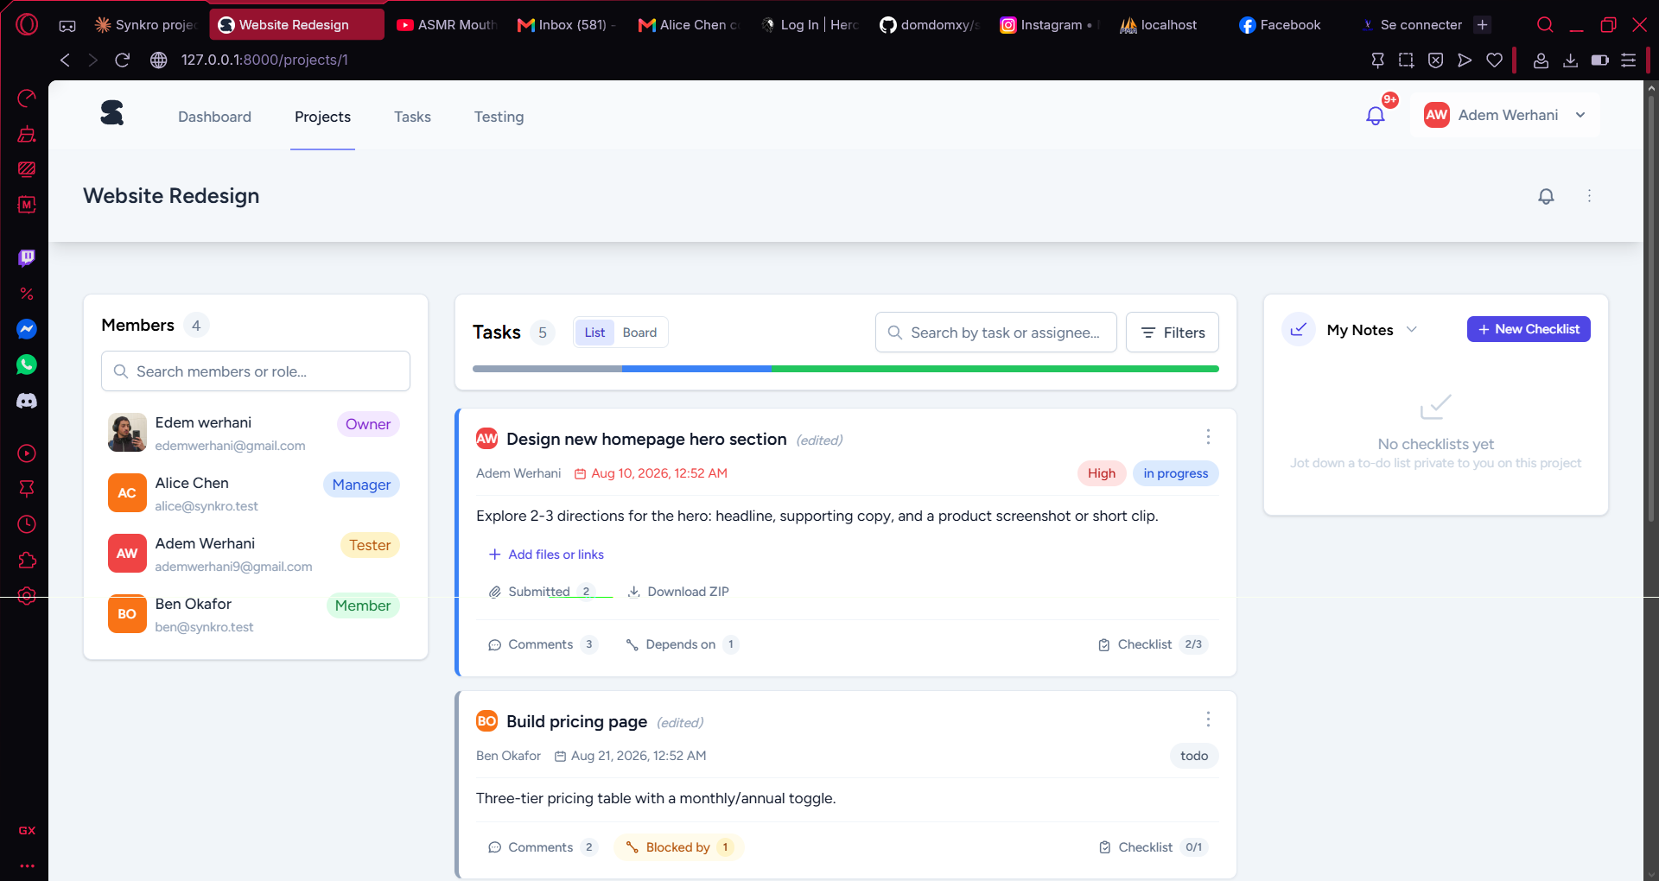
Figure : Personal project notes panel
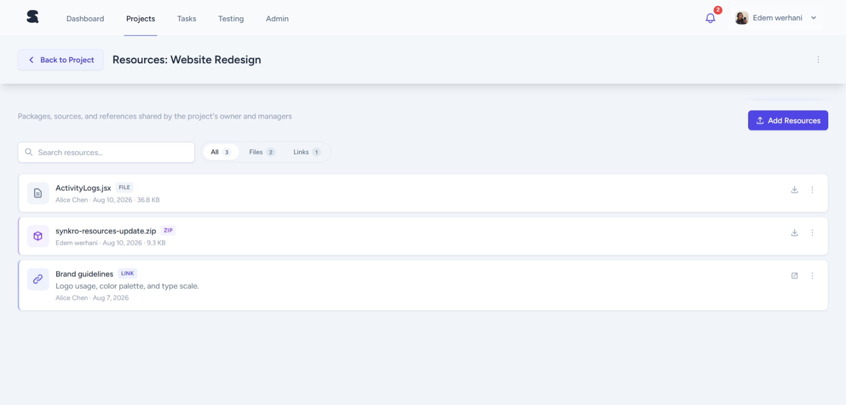
Figure : Project resources panel
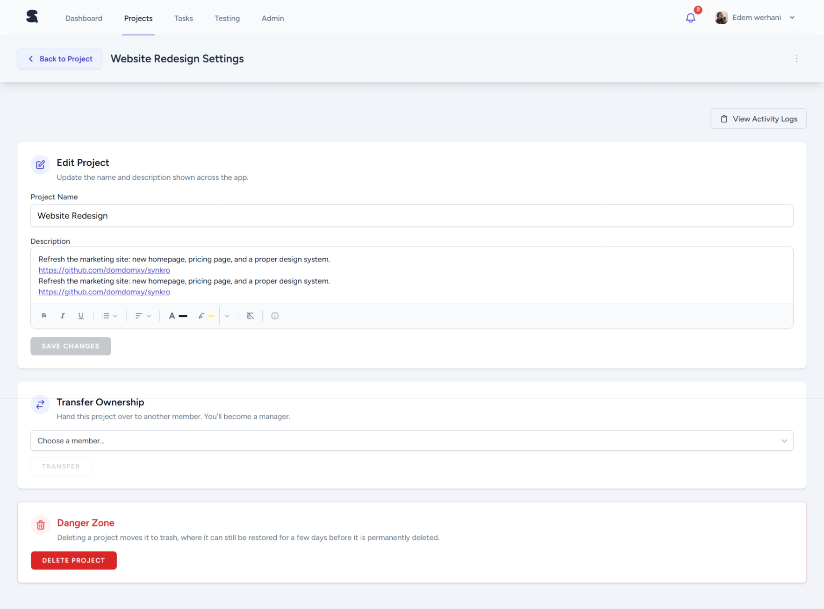
Figure : Project settings page
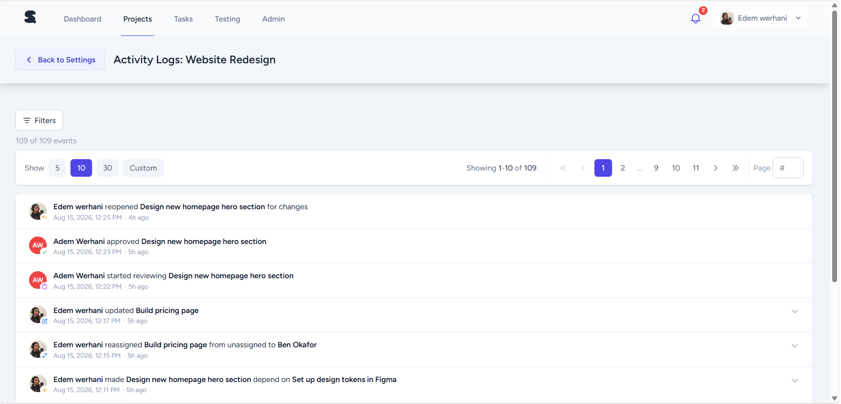
Figure : Project activity log

6. Conclusion
With Sprint 3 complete, Synkro behaved as a genuinely live collaborative tool. The final development sprint turns to the administration side of the platform.

Chapter 6. Sprint 4 – Administration, Moderation & Analytics

1. Introduction
Sprint 4, the last sprint of the internship, ran from July 27 to July 31, 2026. It equipped Synkro with the tools an administrator needs to keep the platform healthy: user moderation, a feedback ticket system, a suspension and appeal workflow, and an analytics dashboard.

2. Sprint Backlog
Table : Sprint 4 backlog
User story | Priority | Status
As an admin, I want to view and manage the list of registered users. | High | Done
As a superadmin, I want to promote or demote a user’s platform role. | High | Done
As an admin, I want to suspend an account that violates the rules. | High | Done
As a suspended user, I want to submit an appeal against my suspension. | Medium | Done
As an admin, I want to review and decide on suspension appeals. | Medium | Done
As an admin, I want to handle feedback / support tickets from users. | Medium | Done
As an admin, I want to view platform-wide analytics and KPIs. | Medium | Done
As a project owner, I want to restore an accidentally deleted project or task. | Low | Done
Source: author (Synkro project, 2026).

3. Requirements Specification
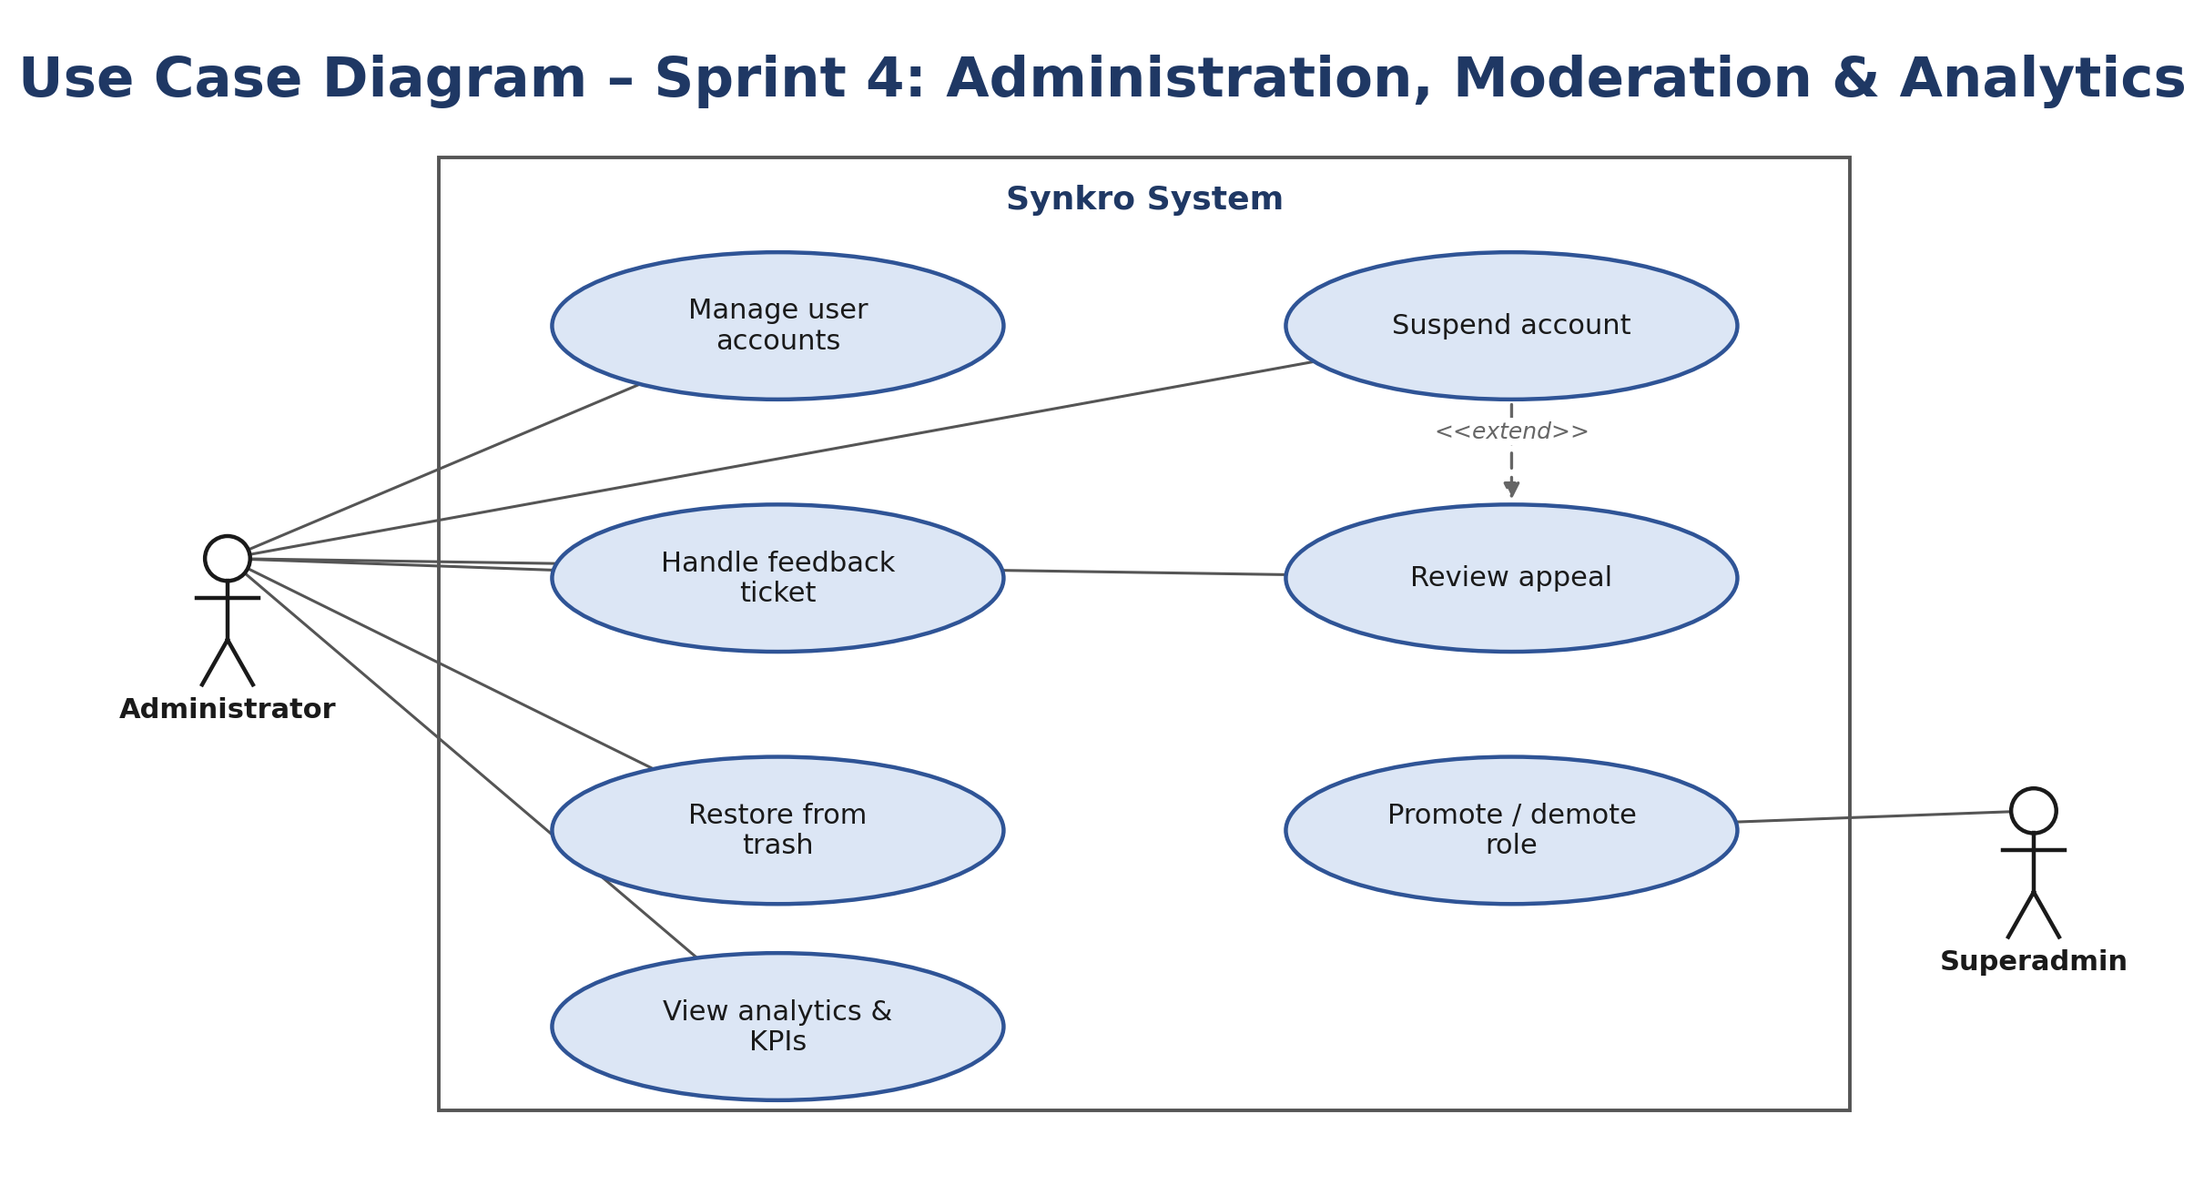
Figure : Use case diagram – Sprint 4
Table : Textual description of the “Suspend account” use case
Field | Description
Actor | Administrator, Superadmin
Precondition | The actor holds the administrator role, and a reported violation has been confirmed.
Main flow | 1. The admin opens the user’s profile in the admin panel and selects “suspend”. 2. The admin provides a reason. 3. The system updates the account status, records the action in the admin log, and notifies the user. 4. The user may submit an appeal, which an admin later reviews and approves or rejects.
Alternate flow | If the admin approves the appeal, the suspension is lifted and the decision is logged.
Postcondition | The account status and the full moderation history are consistent and auditable.
Source: author (Synkro project, 2026).

4. Design
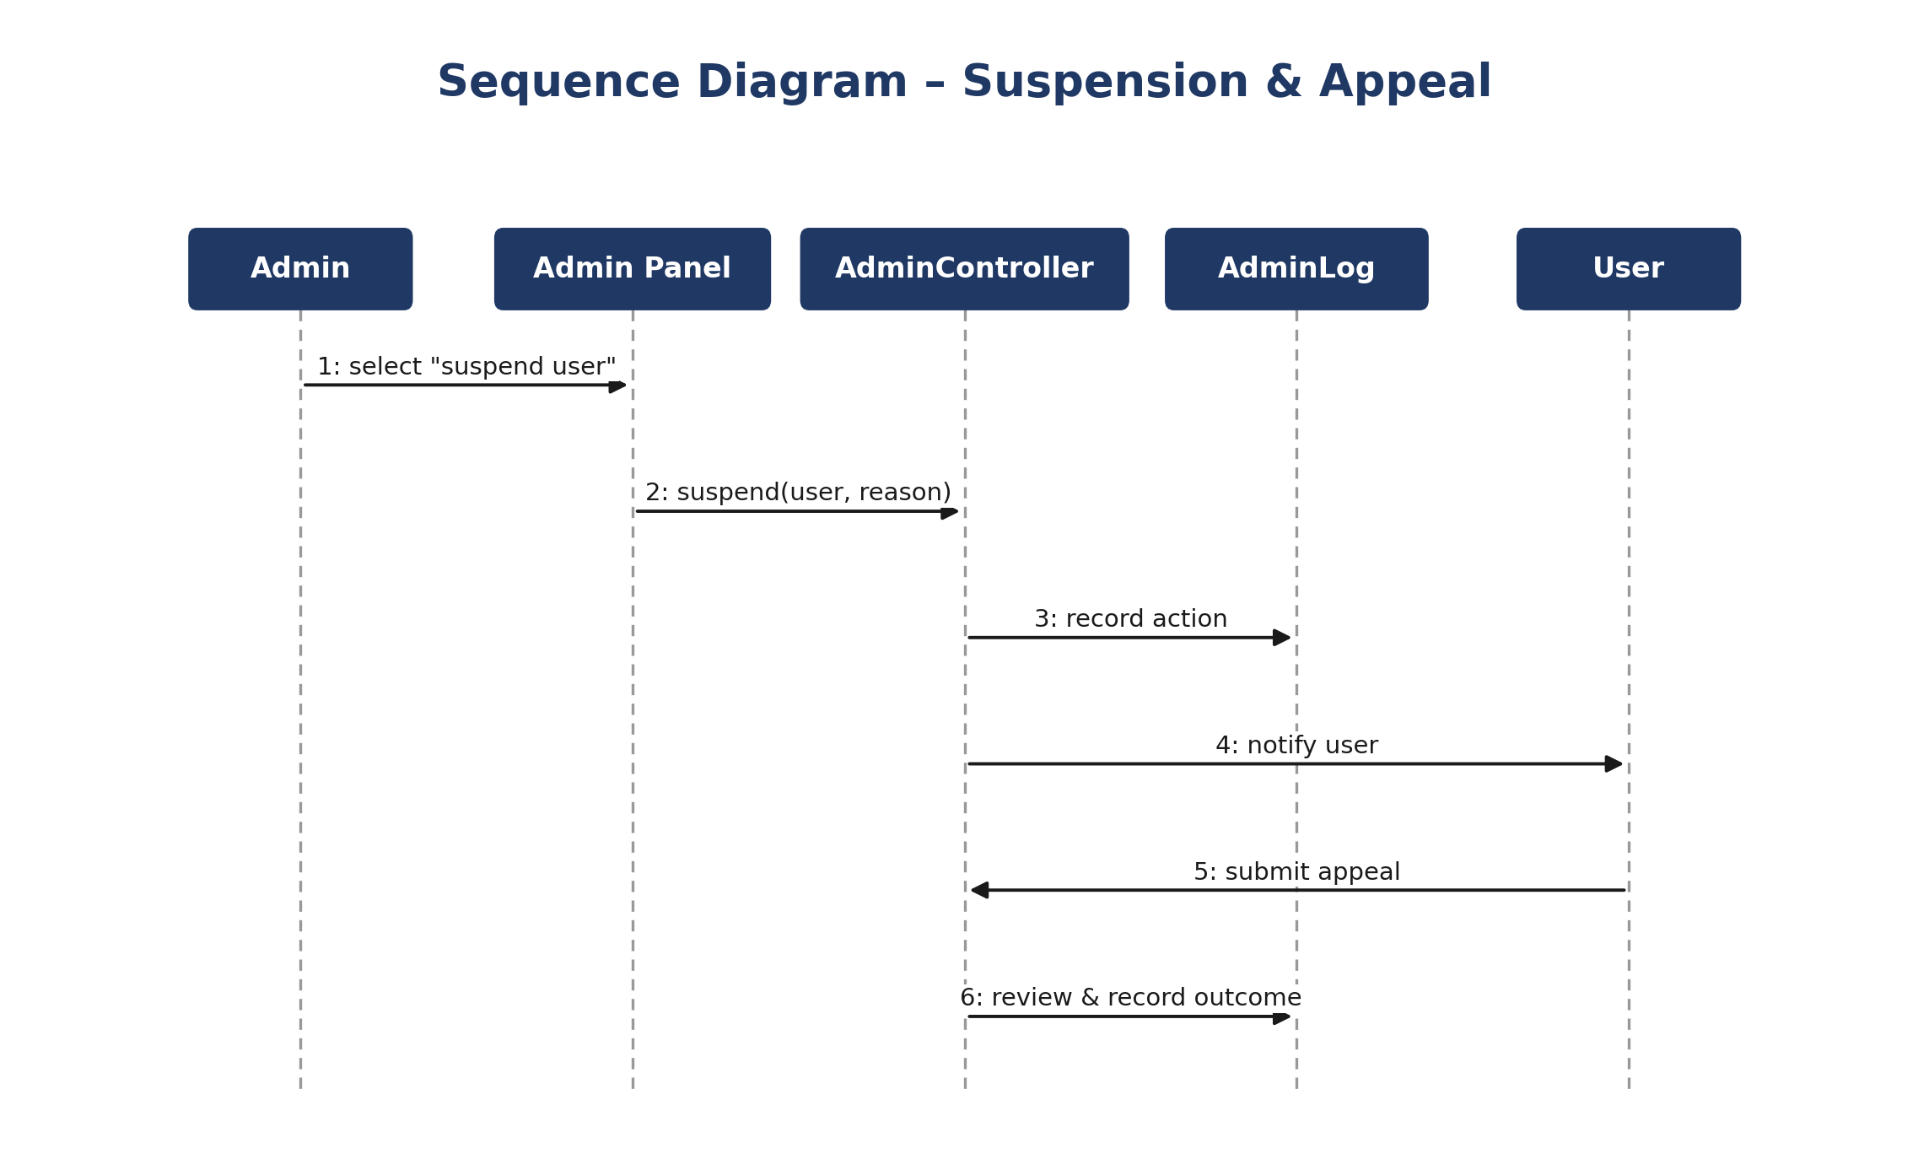
Figure : Sequence diagram – suspension & appeal
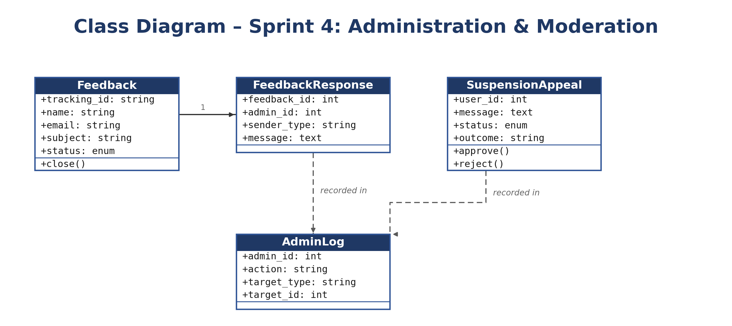
Figure : Class diagram – Sprint 4

5. Realization
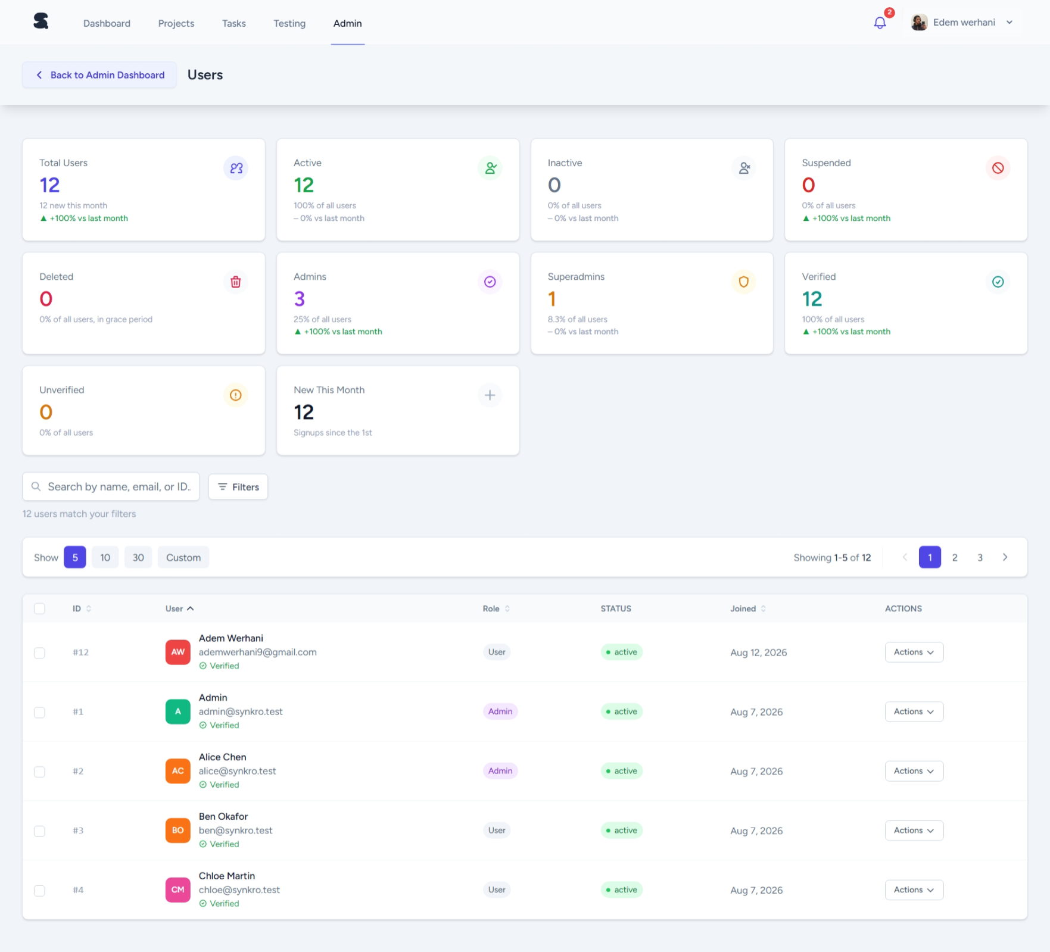
Figure : Admin user management page
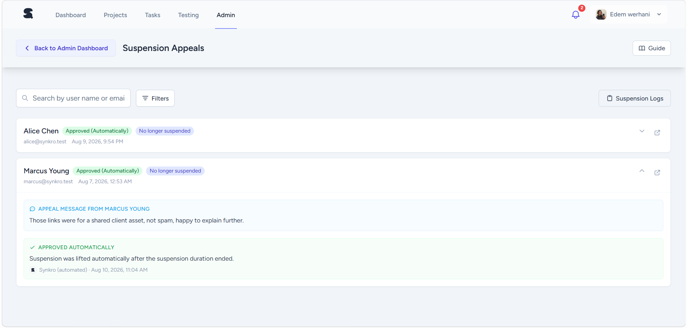
Figure : Suspension appeals list
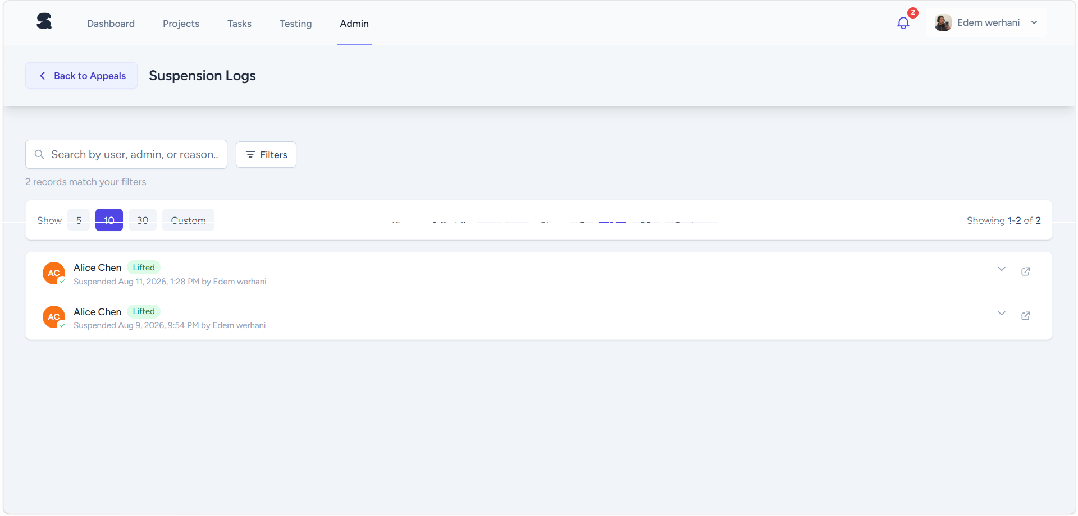
Figure : Suspension logs history
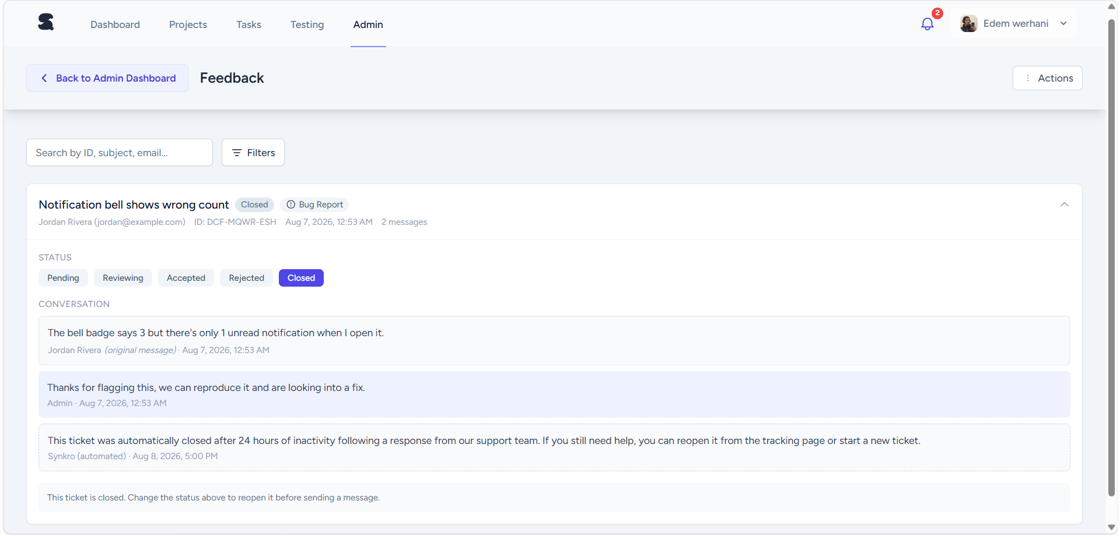
Figure : Feedback / support ticket detail
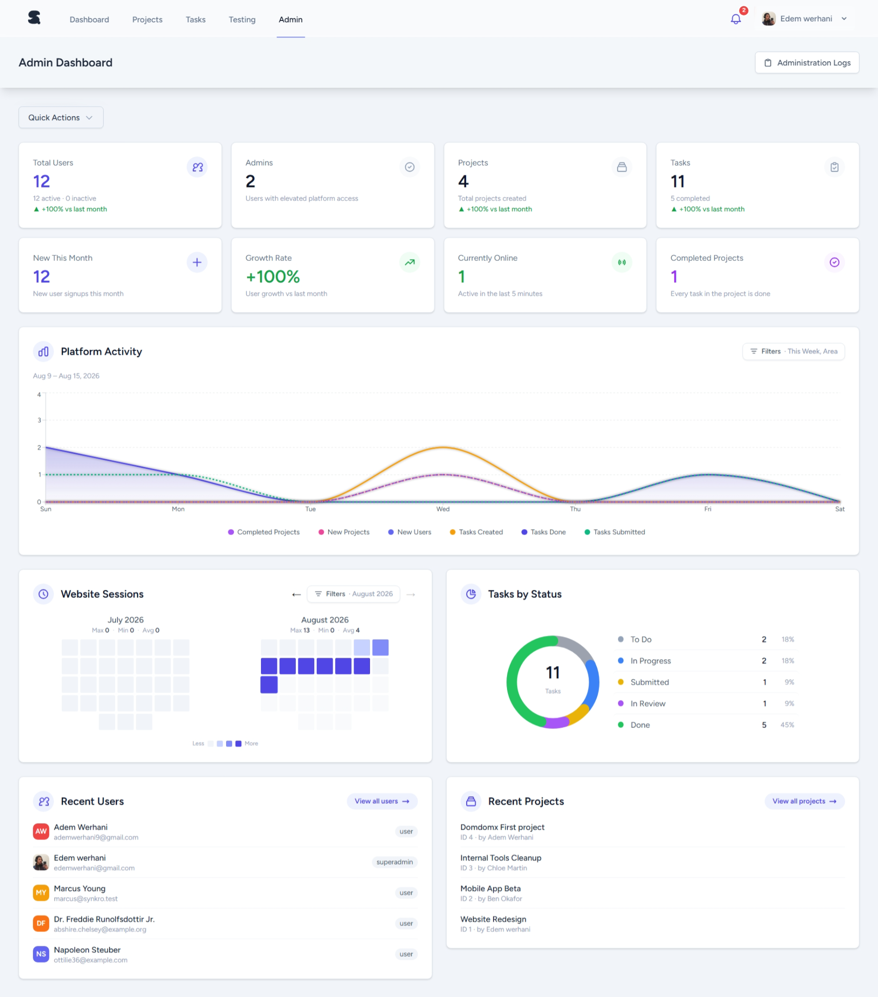
Figure : Admin analytics dashboard

6. Conclusion
Sprint 4 closed the development phase of the internship by giving Synkro a complete moderation and oversight layer. Combined with the previous three sprints, the platform now covers the full lifecycle of collaborative project work, from account creation to platform-wide administration.

Chapter 7. General Discussion

1. Introduction
Beyond the features delivered sprint by sprint, this internship was also a personal and technical learning experience. This chapter steps back from the implementation details to discuss the skills gained, the difficulties encountered and how they were overcome, and the limits of the current version of Synkro.

2. Skills Gained
Working alone on a project of this scope, from the initial idea to a working, deployed-ready product, required combining skills that are often split across several people in a professional team. On the technical side, the internship deepened my practical knowledge of the Laravel framework and its ecosystem (Eloquent ORM, authorization policies, queued jobs, scheduled tasks), of building a modern single-page-like experience with React and Inertia.js without a separate REST API layer, and of real-time web technologies through Laravel Reverb and WebSockets. It also required a solid understanding of relational database design, since the data model grew to cover users, projects, tasks, notifications, activity logs and moderation records while staying consistent and query-efficient.
On the organizational side, running my own Agile process, sprint after sprint, taught me how to break down an ambitious idea into a realistic, time-boxed backlog, and how to make trade-off decisions under a fixed deadline. Finally, being both the developer and the de facto product owner of Synkro strengthened my ability to think from the end user’s perspective, whether that user is a project member trying to get work done or an administrator trying to keep the platform healthy.

3. Difficulties Encountered
Several difficulties arose during the internship. Coordinating real-time updates across multiple connected clients required careful handling of WebSocket broadcasting so that an action performed by one user would not be duplicated or missed on another user’s screen. Designing a role-based permission system that stays both flexible (four distinct project roles) and simple to reason about also took several iterations before reaching a coherent authorization model. Finally, working under a tight seven-week schedule meant constantly prioritizing which features would bring the most value to the core collaborative experience, and consciously postponing secondary ideas rather than spreading effort too thin.
Each of these difficulties was addressed methodically: by isolating and testing real-time flows in small, controlled scenarios before integrating them into the full application, by centralizing authorization checks in dedicated policy classes rather than scattering permission logic across controllers, and by keeping a visible, sprint-based backlog that made scope decisions explicit rather than implicit.

4. Limits and Perspectives
The version of Synkro delivered at the end of this internship covers the core collaborative workflow end to end, but it is a first, functional iteration rather than a finished commercial product. Several directions for improvement were identified during the internship and are detailed as recommendations in the general conclusion below.

5. Conclusion
This chapter has shown that the value of this internship goes beyond the delivered application itself: it lies equally in the engineering judgment developed while building it under real constraints of time and scope.

General Conclusion and Recommendations
This report has presented the work carried out during a seven-week, self-directed end-of-year internship (PFA) at Kernel Solution & Innovation, during which I designed and built Synkro, a collaborative project and task management web platform, entirely on my own, from the initial idea to a functional, feature-complete product.
The work was structured around an Agile, sprint-based methodology: after a planning sprint that produced a prioritized backlog and a realistic schedule, four development sprints progressively delivered account and identity management, the core project and task management workflow, real-time collaboration features built on WebSockets, and finally an administration and moderation layer with an analytics dashboard. Each of these areas was designed using UML (use case, sequence and class diagrams) before being implemented with a modern stack combining Laravel, React, Inertia.js and Laravel Reverb, backed by a MySQL database.
The resulting platform meets the objectives set out in Chapter 1: it allows small teams to organize collaborative work through role-aware projects and tasks, keeps every connected member instantly up to date through real-time notifications, and gives administrators the tools needed to keep the platform safe and healthy. Beyond the product itself, this internship was a complete, hands-on exercise in software engineering, covering requirements analysis, system design, implementation, and iterative planning under real time constraints.
Naturally, a first version built in seven weeks by a single developer leaves room for further work. The following improvements were identified as valuable next steps for Synkro and are recommended for a future iteration of the project:
- Add CAPTCHA or two-factor authentication for login, and allow account creation through Google sign-in.
- Introduce a user profile, distinct from the account settings, together with its own configurable settings.
- Add a messaging system covering direct user-to-user chat, per-project group chat, and an administration broadcast channel.
- Integrate a chatbot assistant to help users navigate and use the platform.
- Extend the moderation system with a graduated warning mechanism before suspension, and a fine-grained permission-revocation step.
- Add a global search bar to find users, and projects or tasks the user has joined or owns.
- Allow projects to be made open source, with members able to showcase them on their public profile (“worked as … in …”).
- Introduce a home page where publicly published projects are showcased.
- Let project owners define custom project roles with configurable, revocable permissions instead of the four fixed roles.
- Allow superadmins to broadcast system-wide announcement messages.
- Make deliverables and project resources editable and savable in place, instead of view-only.
Taken together, these perspectives would turn Synkro from a functional internship project into a more complete, production-ready collaborative platform, while the foundations laid during this internship, the data model, the role-based access control system, and the real-time infrastructure, already provide a solid base on which to build them.

Bibliography and Webography
The following documentation resources were used throughout the design and development of Synkro.
• Laravel 13 official documentation – https://laravel.com/docs
• Laravel Reverb official documentation – https://laravel.com/docs/reverb
• Inertia.js official documentation – https://inertiajs.com
• React official documentation – https://react.dev
• Tailwind CSS official documentation – https://tailwindcss.com/docs
• MySQL 8.0 Reference Manual – https://dev.mysql.com/doc/refman/8.0/en/
• Recharts documentation – https://recharts.org
• Scrum Guide (Scrum.org) – https://scrumguides.org
• Kernel Solution & Innovation – host company website – https://www.kernelsi.com
• Synkro project repository – https://github.com/domdomxy/synkro

Annexes
This section is reserved for supplementary material referenced in the report (for example, extended entity-relationship diagrams or additional screenshots) that does not fit within the main body of the document.


Abstract – Résumé – ملخص
English
Small and medium-sized teams need collaborative tools that combine simplicity, live updates and fine-grained, role-aware access control, a combination rarely offered together by existing project management products. This report presents Synkro, a collaborative project and task management web platform designed and developed single-handedly during a seven-week, self-directed end-of-year internship (PFA) at Kernel Solution & Innovation. Following an Agile, sprint-based methodology, the project was structured into a planning phase and four development sprints covering authentication and user management, project and task management, real-time collaboration through WebSockets, and administration with moderation and analytics. Each functional area was formalized using UML diagrams before being implemented with Laravel, React, Inertia.js, Laravel Reverb and MySQL. The resulting platform allows teams to create projects, assign role-based responsibilities, track tasks through a clear status workflow, and stay instantly informed through real-time notifications, while giving administrators the tools to moderate the platform.
Keywords: collaborative platform, project management, task management, real-time, WebSocket, Laravel, React, role-based access control.
Français
Les petites et moyennes équipes ont besoin d’outils collaboratifs alliant simplicité, mise à jour en temps réel et gestion fine des droits selon le rôle de chacun, une combinaison rarement proposée par les solutions existantes de gestion de projets. Ce rapport présente Synkro, une plateforme web collaborative de gestion de projets et de tâches, conçue et développée seul au cours d’un stage de fin d’année (PFA) autogéré de sept semaines chez Kernel Solution & Innovation. Suivant une méthodologie Agile organisée en sprints, le projet a été structuré en une phase de planification suivie de quatre sprints de développement couvrant l’authentification et la gestion des utilisateurs, la gestion des projets et des tâches, la collaboration en temps réel via WebSockets, ainsi que l’administration, la modération et les statistiques. Chaque domaine fonctionnel a été formalisé à l’aide de diagrammes UML avant d’être implémenté avec Laravel, React, Inertia.js, Laravel Reverb et MySQL. La plateforme obtenue permet aux équipes de créer des projets, d’attribuer des rôles, de suivre l’avancement des tâches et d’être informées instantanément.
Mots-clés : plateforme collaborative, gestion de projets, gestion des tâches, temps réel, WebSocket, Laravel, React, contrôle d’accès basé sur les rôles.
العربية
تحتاج الفرق الصغيرة والمتوسطة إلى أدوات تعاونية تجمع بين البساطة والتحديث الفوري والتحكم الدقيق في الصلاحيات حسب الدور، وهو مزيج نادراً ما توفره أدوات إدارة المشاريع الحالية مجتمعة. يقدم هذا التقرير منصة Synkro، وهي منصة ويب تعاونية لإدارة المشاريع والمهام، تم تصميمها وتطويرها بشكل فردي خلال فترة تدريب ذاتي التوجيه مدتها سبعة أسابيع لدى شركة Kernel Solution & Innovation.
الكلمات المفتاحية: منصة تعاونية، إدارة المشاريع، إدارة المهام، الوقت الفعلي.
Higher Institute of Applied Languages and Computer Science of Béja ISLAIB
Boulevard de l’environnement B.P. 340 Béja 9000 | Website: www.islaib.rnu.tn

