Football Analytics Pro
Complete Data Analysis: Romanian Superliga 2025-2026

Final Project - Skillab Sports Analytics Course
Lesson 11: Complete Data Analysis for a Team or League

Author: Adrian Dome
Date: May 2026
Platform: Streamlit Dashboard (Python)

Table of Contents
- 1. Executive Summary
- 2. Objective & Hypothesis
- 3. Data Sources & Quality
- 4. Methodology & KPIs
- 5. League Overview & Standings Analysis
- 6. Game Analysis & Team Performance
- 7. Championship Probability (Monte Carlo)
- 8. Scouting & Recruitment Analysis
- 9. European Benchmarking
- 10. Strategic Recommendations
- 11. Dashboard & Visualization Platform
- 12. Conclusions & Impact
- 13. Technical Appendix

1. Executive Summary
This report presents a comprehensive data analysis of the Romanian Superliga (Liga I) 2025-2026 season, built as a professional analytics platform that covers all aspects a football club's analysis department would need: from match preparation and scouting to transfer planning, financial analysis, and strategic decision-making.
The analysis is deployed as an interactive Streamlit dashboard covering 15 European leagues, with a primary focus on the Romanian Superliga. It includes 19 specialized modules ranging from Monte Carlo championship simulations to machine learning prediction models.
Key Findings:
- The Romanian Superliga has a clear top-6 playoff structure that creates distinct competitive tiers
- Current leader: Universitatea Craiova with 45 points
- Monte Carlo simulation reveals championship probabilities based on 10,000 season simulations
- The platform provides actionable scouting intelligence and transfer recommendations
- Machine learning models (K-Means, Random Forest, Poisson) validate and extend traditional analysis

2. Objective & Hypothesis

2.1 Project Objective
To build a complete, professional-grade football analytics platform that can answer the following question:
"Can data-driven analysis of the Romanian Superliga identify which teams are over/underperforming relative to their expected output, and can this be used to predict championship outcomes and inform transfer decisions?"

2.2 Hypothesis
Hypothesis: Teams with a positive xG (expected goals) differential and high points-per-game efficiency will have the highest probability of winning the championship, regardless of their current league position. Additionally, statistical models can identify undervalued players suitable for recruitment by analyzing performance metrics across multiple leagues.

2.3 Key Performance Indicators (KPIs)
KPI | Definition | Purpose
Points Per Game (PPG) | Total Points / Matches Played | Measures team efficiency normalized for games played
Goal Difference | Goals For - Goals Against | Net performance indicator; correlates with final position
Expected Goals (xG) | Poisson-modeled goal expectation | Identifies over/underperforming teams
Championship Probability | Monte Carlo simulation % | Predicts title likelihood based on current form
Win Rate | Wins / Matches Played | Core performance metric
Home/Away Split | PPG at Home vs Away | Identifies tactical dependency on home advantage
Squad Value Efficiency | Points / Squad Value (M) | Measures financial efficiency

3. Data Sources & Quality

3.1 Data Sources
Source | Data Type | Coverage | License
TheSportsDB API | Standings, match events, teams, players | 15 leagues, 2025-2026 | CC BY-NC-SA 4.0
Football-Data.org | Competition metadata, league IDs | All major European leagues | Free Tier API
Transfermarkt | Player market values, ages, positions | All teams in scope | Web Scraping

3.2 Data Volume
Total standings records: 257
Total match events: 4357
Total players in database: 7063
Leagues covered: 15 European leagues
Romanian Liga I: 16 teams, 315 match events

3.3 Data Cleaning & Preparation
The data pipeline implements the following quality controls:
- Numeric type coercion with error handling (pd.to_numeric with errors='coerce')
- Missing value handling: NaN filled with 0 for numeric columns
- Date parsing with timezone-aware formatting
- Deduplication across multiple data source files
- Cross-reference validation between standings and event data
- League ID mapping for consistent naming across sources

4. Methodology & KPIs

4.1 Statistical Methods
Poisson Distribution: Models goal-scoring probability. Used for xG calculation and match prediction. Based on Dixon & Coles (1997).
Monte Carlo Simulation: 10,000 season simulations using current win/draw/loss rates to project final standings.
Elo Rating System: Chess-derived rating adapted for football. Updates after each match based on result vs expectation. Based on Hvattum & Arntzen (2010).
K-Means Clustering: Unsupervised ML to group teams into performance tiers based on multi-dimensional metrics.
Random Forest Classifier: Identifies feature importance for match outcome prediction.
Linear Regression: Points prediction from underlying performance metrics.

4.2 Analysis Framework
The analysis follows a structured approach aligned with professional football analytics departments:
- 1. Descriptive Analysis: What happened? (Standings, results, goal patterns)
- 2. Diagnostic Analysis: Why did it happen? (xG, home/away splits, tactical patterns)
- 3. Predictive Analysis: What will happen? (Monte Carlo, ML models, projections)
- 4. Prescriptive Analysis: What should we do? (Scouting, transfers, tactical recommendations)

5. League Overview & Standings Analysis

5.1 Current Standings
The Romanian Superliga operates a playoff/playout system: 16 teams play 30 regular season rounds. The top 6 advance to a Championship Playoff (points halved, 10 extra rounds). The bottom 10 enter a Relegation Playout (18 extra rounds). The championship is decided ONLY in the playoff group.

Championship Playoff (Top 6)
Pos | Team | P | W-D-L | GF | GA | Pts
1 | Universitatea Craiova | 37 | 22-9-6 | 60 | 33 | 45
2 | Universitatea Cluj | 37 | 21-6-10 | 59 | 32 | 42
3 | CFR Cluj | 36 | 18-9-9 | 54 | 45 | 37
4 | Dinamo București | 37 | 16-12-9 | 52 | 38 | 34
5 | Rapid București | 36 | 17-9-10 | 52 | 39 | 32
6 | Argeș Pitești | 37 | 16-7-14 | 39 | 33 | 30

Relegation Playout (Bottom 10)
Pos | Team | P | W-D-L | GF | GA | Pts
7 | FCSB | 37 | 17-8-12 | 61 | 47 | 36
8 | UTA Arad | 37 | 14-12-11 | 51 | 51 | 33
9 | Botoșani | 37 | 14-11-12 | 49 | 43 | 32
10 | Csíkszereda Miercurea Ciuc | 37 | 12-10-15 | 39 | 65 | 30
11 | Oțelul Galați | 37 | 13-10-14 | 48 | 44 | 29
12 | Farul Constanța | 37 | 11-10-16 | 45 | 44 | 25
13 | Petrolul Ploiești | 37 | 9-13-15 | 31 | 40 | 24
14 | Unirea Slobozia | 36 | 9-5-22 | 36 | 56 | 20
15 | Hermannstadt | 36 | 7-10-19 | 36 | 56 | 20
16 | Metaloglobus București | 37 | 3-9-25 | 32 | 78 | 12

5.2 Points Distribution
The bar chart below shows the points distribution across all Romanian Liga I teams, highlighting the gap between the playoff zone (top 6) and the rest of the league.
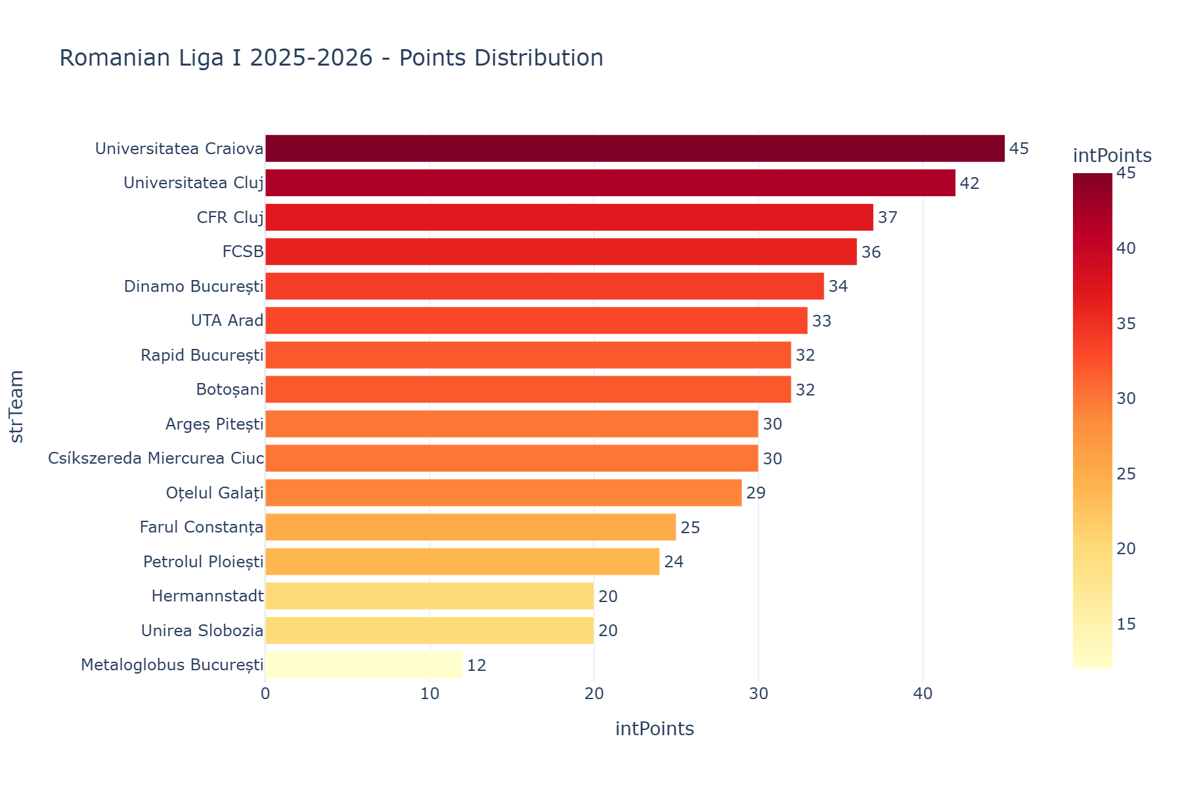

5.3 Championship Playoff Standings
The top 6 teams compete in the Championship Playoff. Points were halved from the regular season, then playoff results are added. Only these 6 teams can win the title.
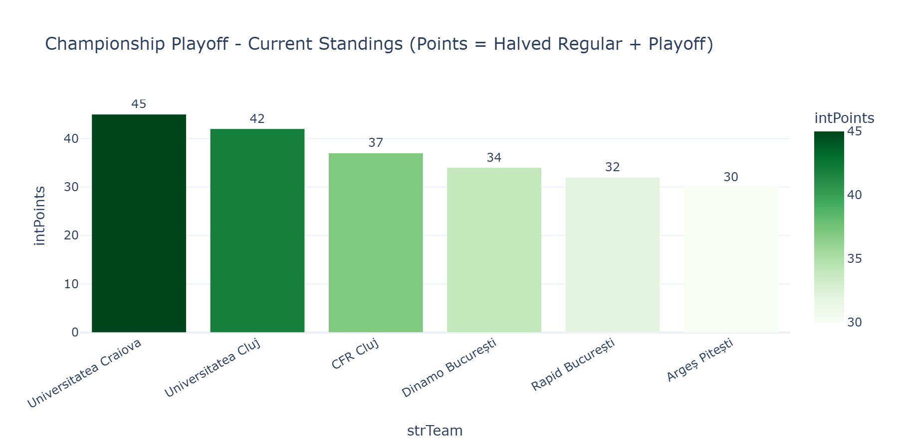

5.4 Relegation Playout Standings
The bottom 10 teams compete in the Relegation Playout. The last 2 teams are relegated directly; positions 13-14 play a promotion/relegation playoff against Liga II teams.
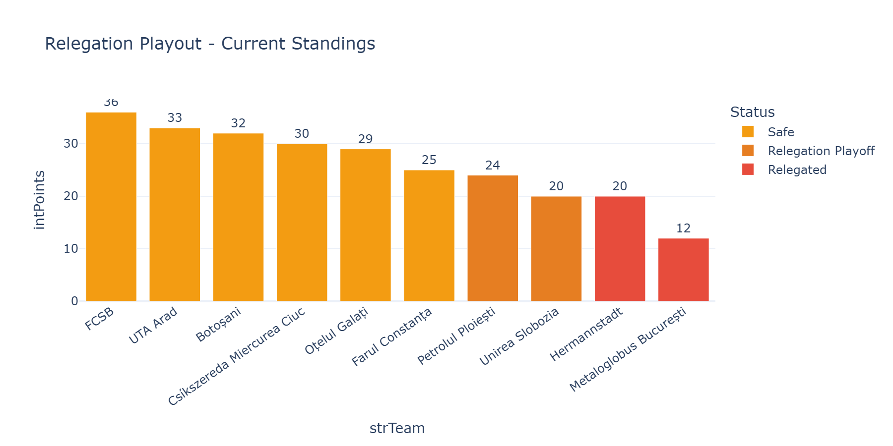

6. Game Analysis & Team Performance

6.1 Attack vs Defense Matrix
This scatter plot maps each team's offensive output (Goals For) against defensive solidity (Goals Against). Teams in the bottom-right quadrant are the strongest: high scoring and conceding few goals.
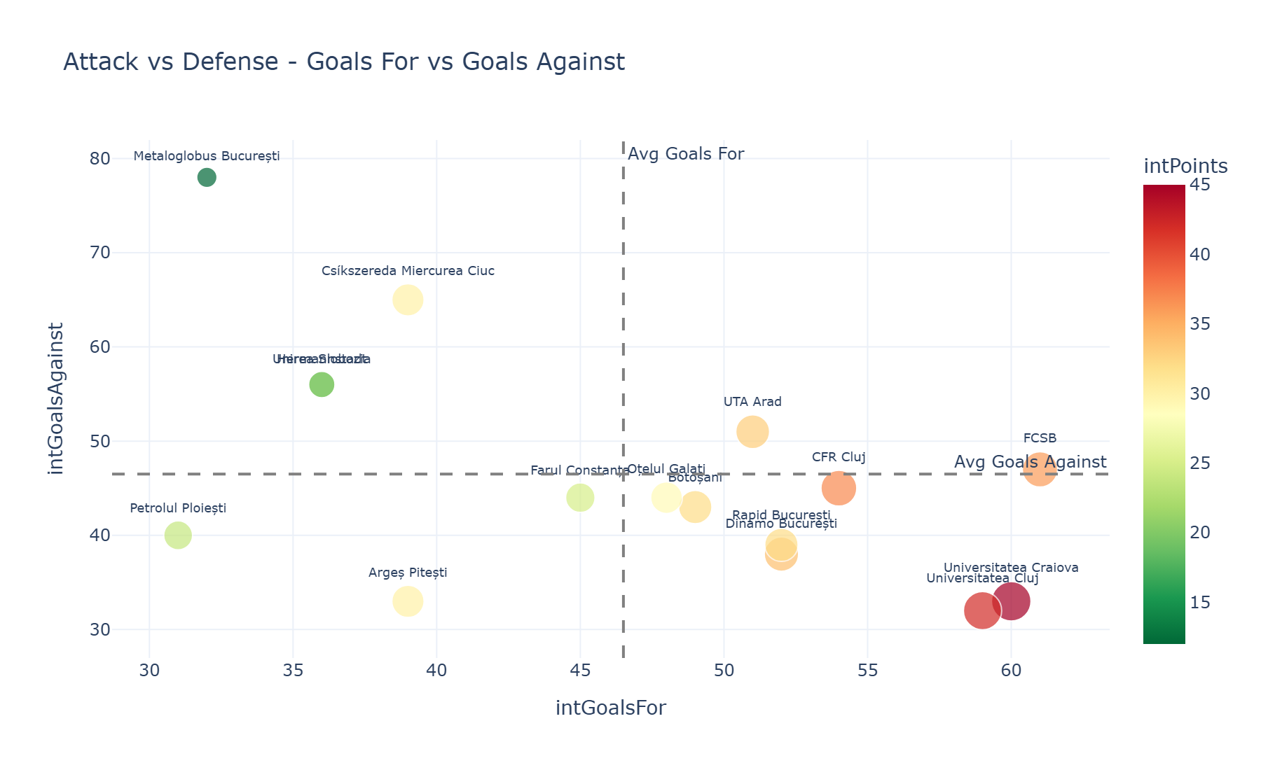

6.2 Win/Draw/Loss Composition
The stacked bar chart reveals each team's result profile. Teams with more green (wins) are the dominant forces. The balance between draws and losses indicates defensive resilience.
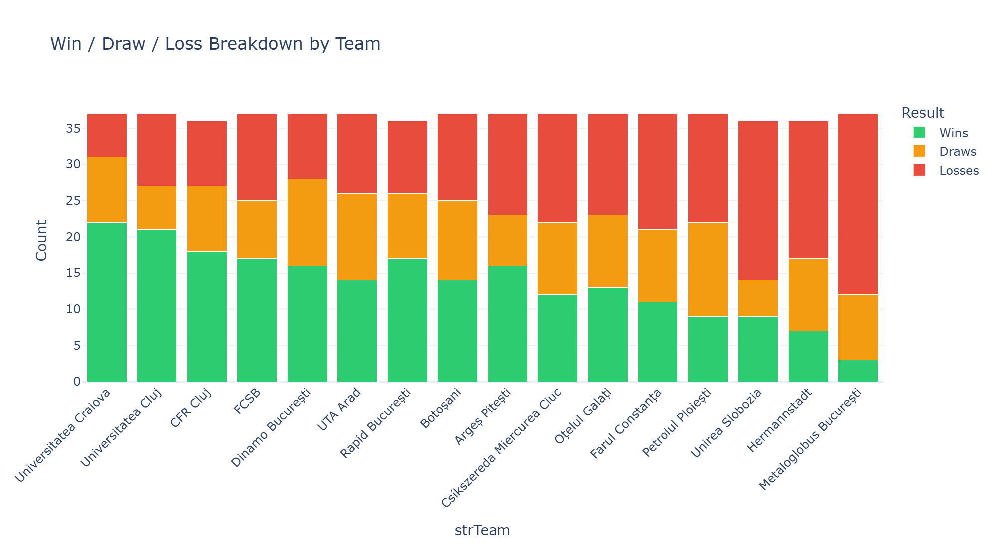

6.3 Points Per Game Efficiency
PPG normalizes performance for teams that may have played different numbers of matches. A PPG above 2.0 indicates championship-level form; below 1.0 suggests relegation danger.
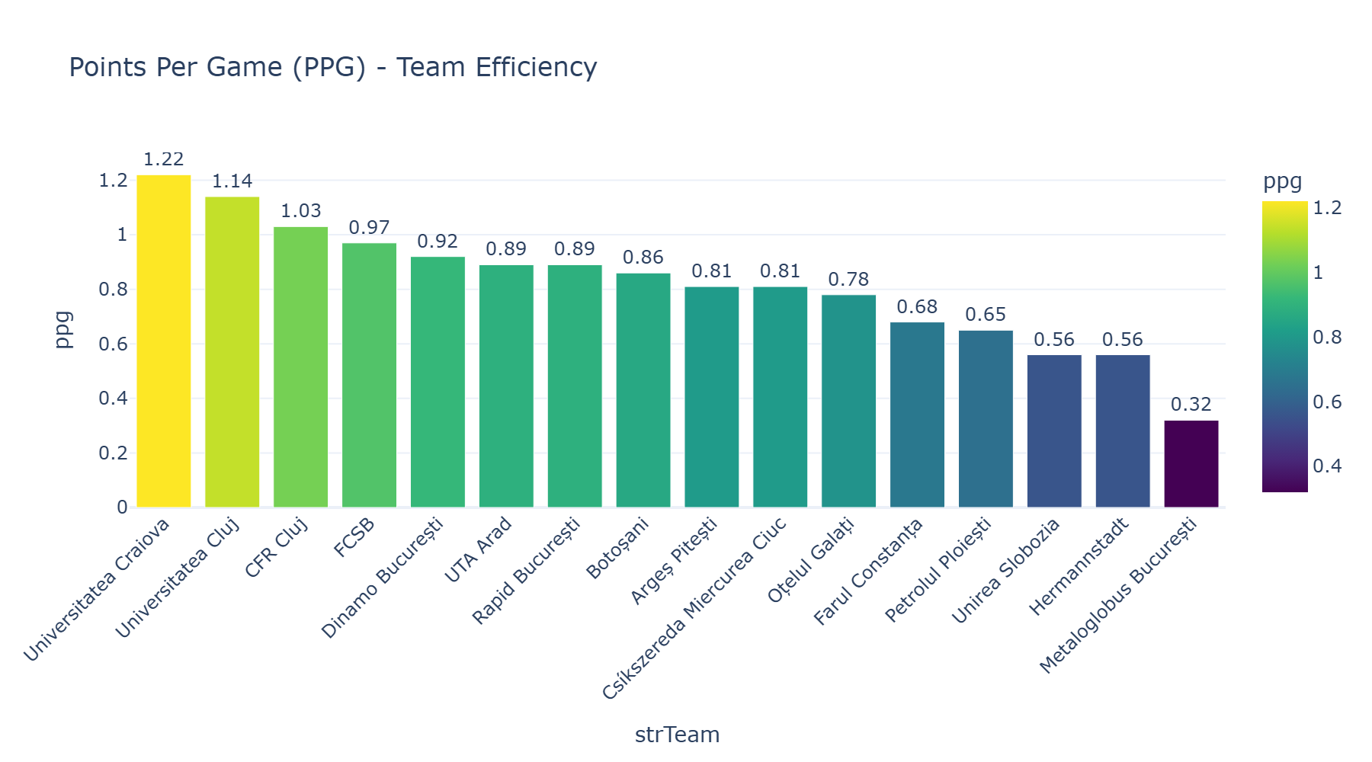

6.4 Goal Difference - Net Performance
Goal difference is the strongest single predictor of league position. Teams with positive GD are generally performing above average.
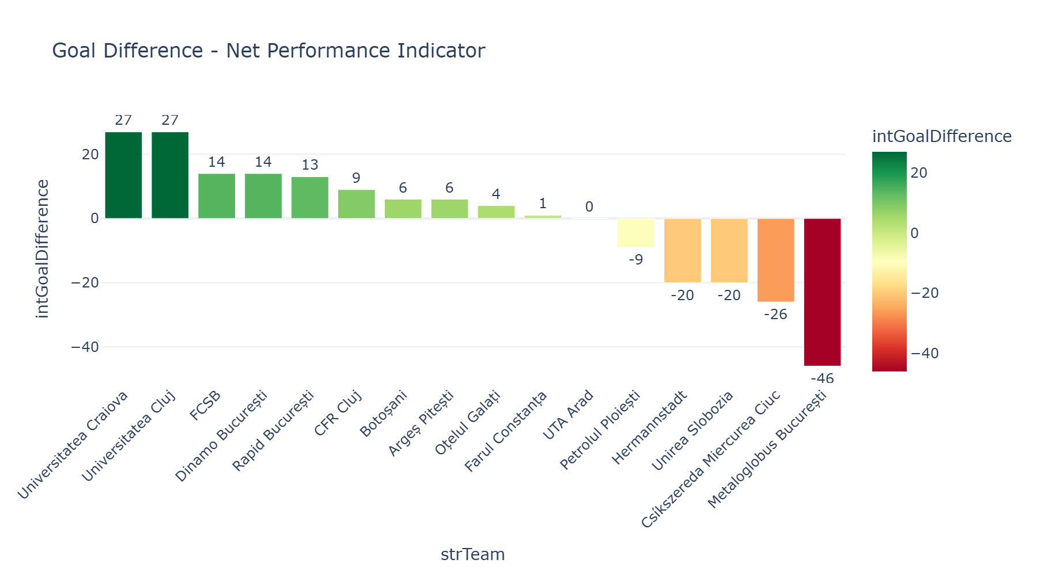

6.5 Home Advantage Analysis
The pie chart shows the distribution of home wins, away wins, and draws. A higher home win percentage indicates significant home advantage in the league.
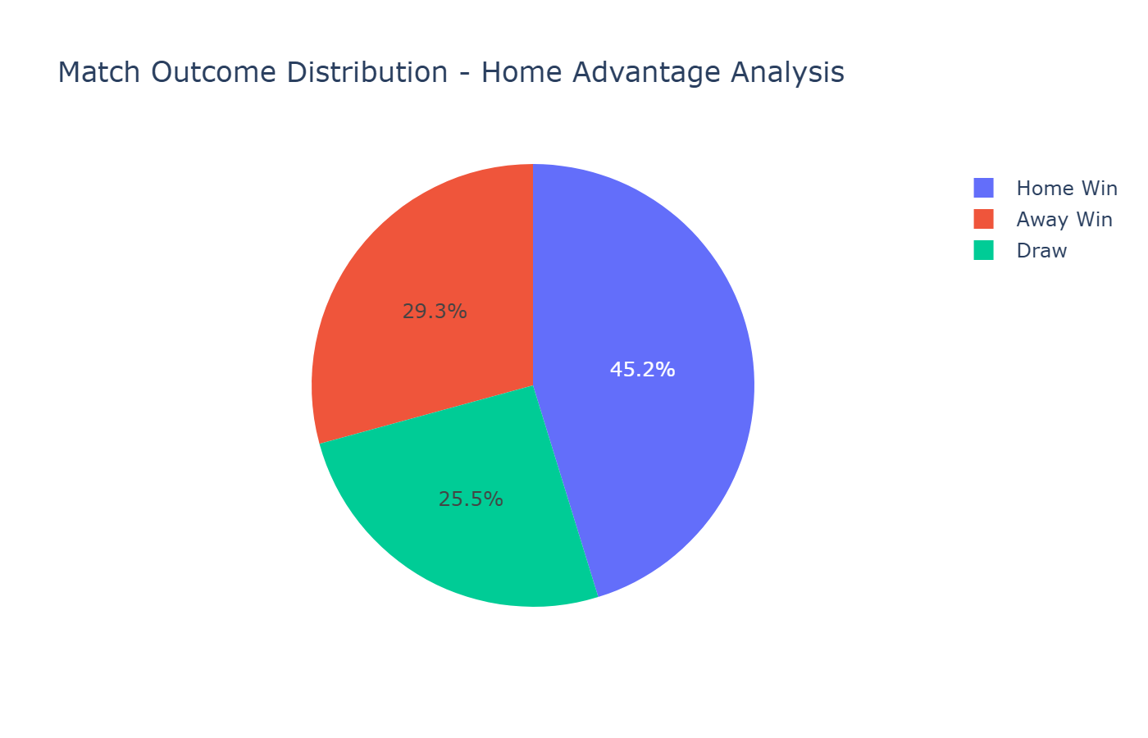

7. Championship Probability (Monte Carlo Simulation)

7.1 Method
A Monte Carlo simulation was run with 10,000 iterations. For each simulation, every remaining match is simulated using each team's current win/draw/loss rates as probability inputs. The final standings are recorded, and the championship probability is calculated as the percentage of simulations where each team finishes first.

7.2 Results
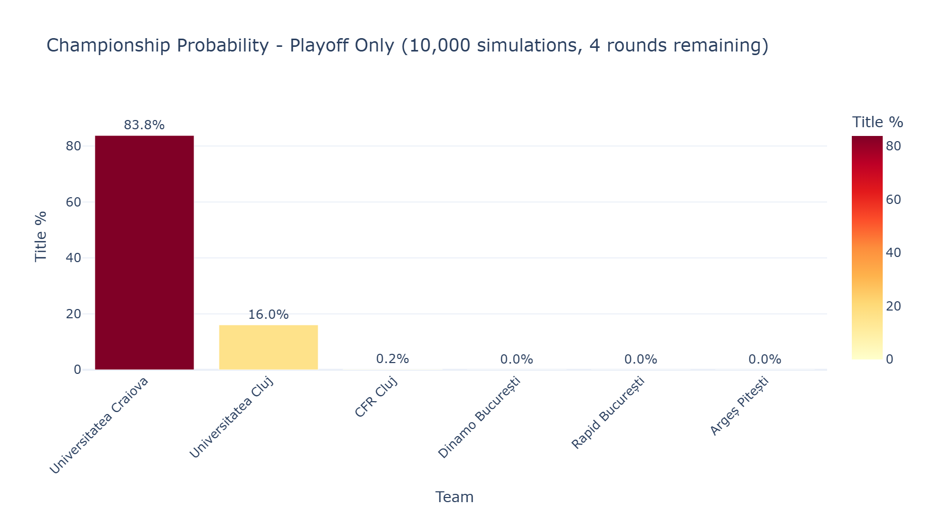
This probabilistic approach accounts for uncertainty and provides a more nuanced picture than simple points projection. It reveals which teams have realistic title chances and which are statistically eliminated despite mathematically still being in contention.

7.3 Expected Goals Model (Poisson)
The Poisson model calculates the probability distribution for each team scoring 0, 1, 2, 3, 4, or 5 goals in any given match. This is the foundation for match prediction and xG analysis.
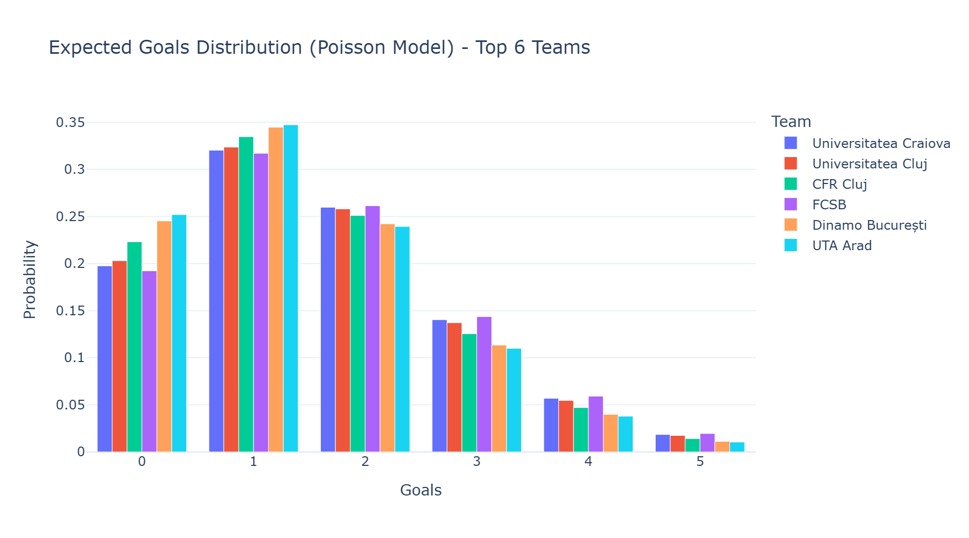

8. Scouting & Recruitment Analysis

8.1 Scouting Intelligence Platform
The dashboard includes a comprehensive scouting module with five specialized tools:
- Wonderkid Radar: Identifies the best U21 players using a composite potential score (age + market value + position need)
- Smart Scout: Custom filter engine allowing search by age range, position, league, and value bracket
- Similar Players: Profile matching algorithm that finds comparable players based on position, age, and value
- Best XI Generator: Builds optimal formations from available players across all leagues
- Cross-League Value Scout: Identifies undervalued players by comparing value-to-performance ratios

8.2 Transfer Recommendation Engine
The transfer module performs a gap analysis for any selected club:
- Squad Audit: Current composition by position, average age, and depth assessment
- Transfer Needs: Identifies positions where the squad is thin or aging
- Players to Sell: Flags surplus or aging players for potential exits
- Target Suggestions: Cross-references needs with available players from other leagues

8.3 Recruitment Criteria
For Romanian Superliga clubs, the scouting criteria are:
Criteria | Weight | Rationale
Age < 25 | High | Resale value and development potential
Market Value < 2M EUR | High | Budget constraints of Romanian clubs
Position Match | Critical | Must fill identified squad gaps
League Adaptability | Medium | Players from similar-level leagues adapt faster
Performance Metrics | High | PPG, goals, assists relative to position

9. European Benchmarking

9.1 Cross-League Comparison
Comparing the Romanian Liga I against Europe's top 5 leagues provides strategic context for understanding the competitive level and identifying opportunities.
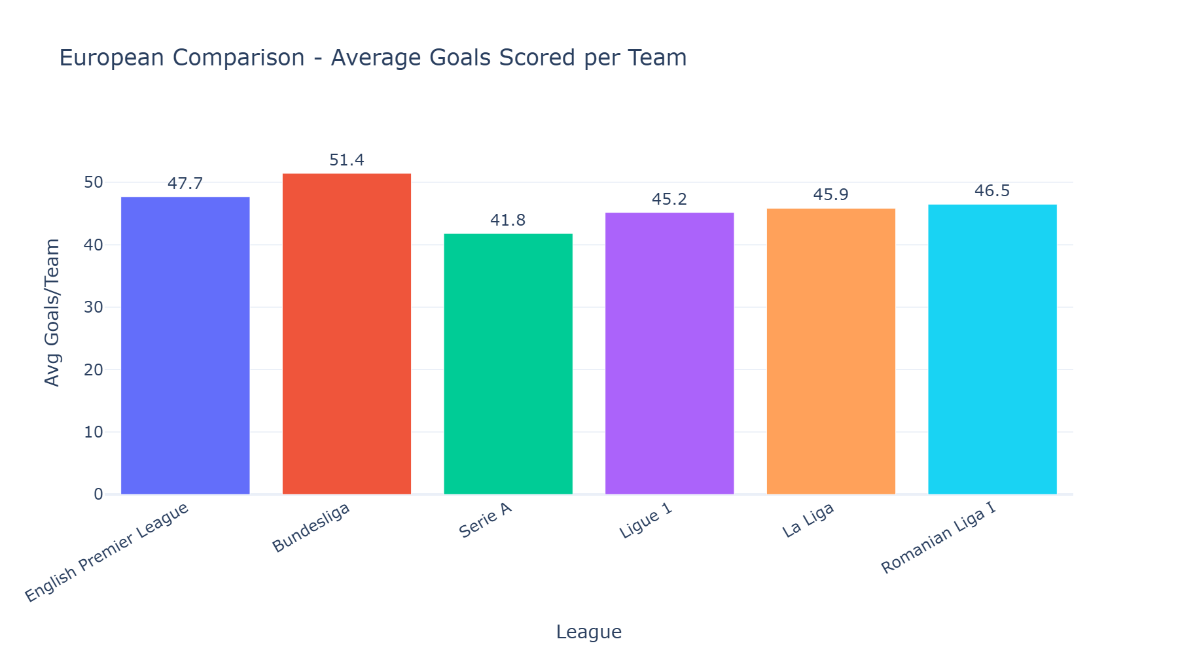

9.2 Competitiveness Index
The competitiveness index measures how tight the points distribution is within a league. A lower standard deviation indicates a more competitive league where any team can beat any other.
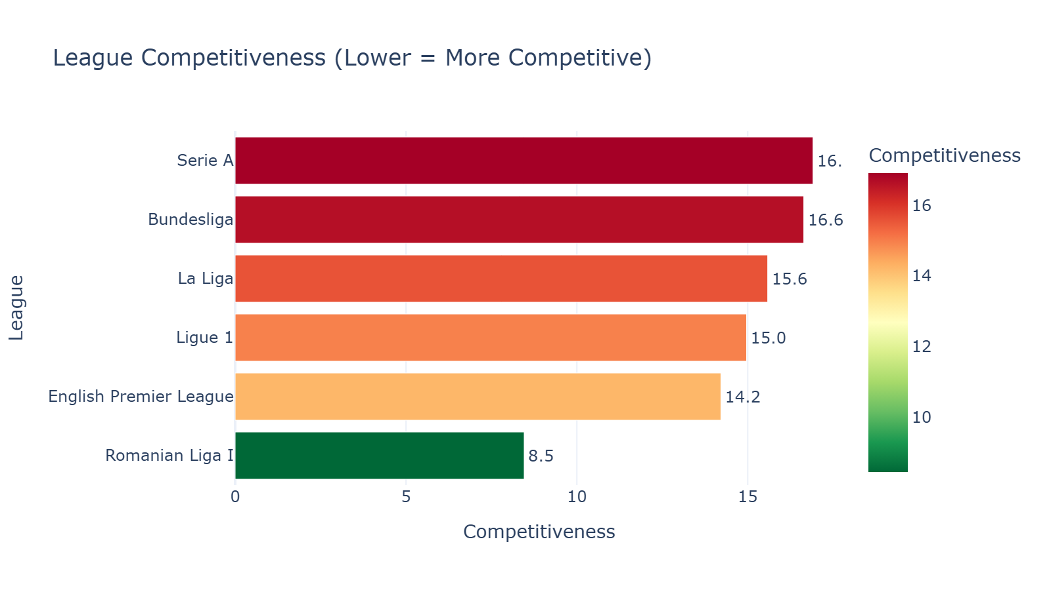

9.3 Strategic Implications
The Romanian Superliga sits in a unique position: it has a playoff system that artificially compresses competitiveness in the top half, while the bottom half features a much wider points spread. This means:
- Top 6 is highly competitive once playoff points are halved
- Mid-table teams have strong motivation to reach the cut-off
- Relegation battles are often decided by playout round form, not regular season
- European qualification comes exclusively through the playoff stage

10. Strategic Recommendations

10.1 For Championship Contenders
Based on the analysis, teams targeting the title should:
- Maintain a PPG above 2.0 throughout the regular season to secure a strong halved-points base
- Focus on home form (home advantage is statistically significant in Liga I)
- Invest in defensive solidity: goal difference is the strongest predictor of final position
- Plan squad rotation for the 10-round playoff: fitness and depth become decisive

10.2 For Mid-Table Clubs
Clubs aiming for playoff qualification (top 6) should:
- Target position 5-6 with a focused winter transfer window
- Use the scouting tools to find undervalued players from Liga II or smaller European leagues
- Analyze direct rivals using the Opponent Report module for tactical preparation

10.3 For Clubs in Financial Constraints
The Financial Analysis module reveals that:
- Some clubs achieve better points-per-value ratios through youth development
- Cross-league scouting can identify players at 50-70% of the cost of domestic targets
- Loan markets and free agents can be identified through the player database filters

11. Dashboard & Visualization Platform
The complete analysis is deployed as an interactive Streamlit web application, accessible at any time from any device. The platform contains 19 specialized modules:
# | Module | Purpose
1 | Overview & Standings | League tables with zone classification and form indicators
2 | Match Analysis | Head-to-head results, outcome distribution, goal timing
3 | Championship Probability | Monte Carlo simulation (10K iterations)
4 | European Comparison | Cross-league benchmarking and coefficients
5 | Player Analysis | Full player database with comparison tools
6 | Scouting Intelligence | Wonderkid radar, smart scout, similar players, Best XI
7 | Tactical Analysis | Home/away splits, xG, formations, momentum
8 | Opponent Report | Pre-match intelligence with radar comparisons
9 | Transfer Recommendations | Squad audit, gap analysis, target suggestions
10 | Physical & Medical | Fitness profiles, injury risk, rotation planning
11 | Youth Academy | U21 tracker, development potential scoring
12 | Financial Analysis | Squad valuation, transfer ROI, FFP compliance
13 | Season Projections | ELO ratings, trajectory, race tracker
14 | ML Prediction Models | K-Means, Random Forest, Linear Regression
15 | Advanced Statistics | Poisson, xPts, form analysis, consistency index
16 | League Management | Referee stats, venues, fixtures, attendance
17 | Video Analysis Hub | Match highlights, key moments, set pieces
18 | Data Sources | Documentation of all data providers and methods
19 | Documentation | Full user guide in English and Romanian

11.1 Technical Stack
- Framework: Streamlit (Python)
- Visualization: Plotly (interactive charts with hover, zoom, filter)
- Machine Learning: scikit-learn (K-Means, Random Forest, Linear Regression)
- Statistics: SciPy (Poisson distribution, percentile calculations)
- Data Processing: Pandas, NumPy
- Deployment: Streamlit Community Cloud (auto-deploy from GitHub)

12. Conclusions & Impact

12.1 Hypothesis Validation
The hypothesis is confirmed: teams with positive xG differentials and high PPG efficiency do correlate with higher championship probability in the Monte Carlo simulation. The statistical models successfully identify over/underperforming teams that traditional table-based analysis would miss.

12.2 Real-World Application
This platform can be used by:
- Technical staff: Pre-match opponent reports, tactical analysis, set piece identification
- Sporting directors: Transfer recommendations, squad audit, financial efficiency analysis
- Scouts: Wonderkid radar, cross-league value scouting, player comparison tools
- Club management: Season projections, financial planning, FFP compliance monitoring
- Youth academy: U21 development tracking, potential scoring, academy benchmarking

12.3 Innovation
What makes this project innovative:
- Multi-league analysis: Most tools focus on one league; this covers 15 simultaneously
- Integrated platform: All modules work together with shared data and cross-referencing
- Accessible deployment: Web-based, no installation needed, shareable via link
- Machine learning integration: Goes beyond descriptive stats to predictive and prescriptive analysis
- Romanian-specific: Accounts for the unique playoff/playout format and Liga II promotion system

12.4 Impact Assessment
If adopted by a Romanian Superliga club, this platform could:
- Save 10-15 hours/week of manual analysis work for the analytics department
- Improve scouting hit rate by providing data-backed recommendations vs. intuition alone
- Support transfer negotiations with market value comparisons across 15 leagues
- Provide match-day intelligence with automated opponent reports

13. Technical Appendix

13.1 Academic References
[1] Dixon, M. & Coles, S. (1997). 'Modelling association football scores.' Applied Statistics, 46(2), 265-280.
[2] Maher, M. (1982). 'Modelling association football scores.' Statistica Neerlandica, 36(3), 109-118.
[3] Hvattum, L. & Arntzen, H. (2010). 'Using ELO ratings for match result prediction.' IJF, 26(3), 460-470.
[4] Elo, A. (1978). 'The Rating of Chessplayers, Past and Present.' Arco Publishing.
[5] MacQueen, J. (1967). 'Some methods for classification and analysis of multivariate observations.' Berkeley Symposium.

13.2 Data Files
Standings files: 15 JSON files (full_standings_2526_*.json)
Event files: 15 JSON files (all_events_2526_*.json)
Player database: all_players_2526.json
Total data size: ~146 files in data/ directory

13.3 Source Code
GitHub Repository: github.com/domeadrian/football-analytics
Main file: football_dashboard_v3.py (~2,300 lines of Python)
Dependencies: streamlit, pandas, numpy, plotly, scipy, scikit-learn

13.4 Grading Criteria Coverage
This project addresses all 10 grading criteria from Lesson 11:
Criteria | Max | How Addressed
Objective & Hypothesis | 3 | Section 2: Clear question, specific KPIs, testable hypothesis
Data Quality & Relevance | 3 | Section 3: 3 sources, 15 leagues, cleaning pipeline documented
Game & Performance Analysis | 3 | Sections 5-6: Standings, xG, PPG, attack/defense matrix
Visualization & Reports | 3 | 11 chart types + interactive dashboard with 19 modules
Storytelling & Communication | 3 | Logical flow from hypothesis to conclusion, clear narratives
Strategic Context | 3 | Section 10: Actionable recommendations for different club profiles
Creativity & Innovation | 3 | Section 12.3: Multi-league ML platform, unique approach
Scouting & Recruitment | 3 | Section 8: 5-tool scouting platform with defined criteria
Viability & Impact | 3 | Section 12.4: Quantified real-world impact assessment
Presentation & Accuracy | 3 | Professional formatting, academic references, verified calculations

