Esercizio1:

#include <stdio.h>

#include <stdlib.h>

/* run this program using the console pauser or add your own getch, system("pause") or input loop */

int main(int argc, char *argv[]) {

int somma, voto, numero_valore;

float voto_medio;

for ( numero_valore = 0 ; numero_valore < 10; numero_valore++ ) {

printf("\nInserisci il voto numero %d: ", numero_valore+1);

scanf("%d", &voto);

somma += voto;

}

voto_medio = somma/10.0;

printf("\nLa media dei voti è: %f\n", voto_medio);

system("pause");

return 0;

}

-----------------------------------------------------------------------------------------------------------------------------------------------

Esercizio 2:

<html>

<head>

<title> pagina_con_4_div </title>

<meta charset = "utf-8">

</head>

<body>

<div id = "div1" style="width: 100%; height: 40px; background-color: #BDB76B;">

div1

</div>

<div id = "div2" style="width: 25%; height: 650px; background-color: #7B68EE; ">

div2

</div>

<div id = "div3" style="width: 50%; height: 650px; background-color: #707070; margin-left: 25%; margin-top: -650px;">

div3

</div>

<div id = "div4" style="width: 25%; height: 650px; background-color: #008080; margin-left: 75%; margin-top: -650px;">

<br>

<center>

<hr width=50 size=1 color=#006060 >

<hr width=80 size=2 color=#600060 >

<hr width=110 size=3 color=#800080 >

<hr width=140 size=4 color=#008000 >

<hr width=170 size=5 color=#707070 >

<hr width=200 size=6 color=#008080 >

</center>

</div>

</body>

</html>

-----------------------------------------------------------------------------------------------------------------------------------------------

Esercizio 3:

<html>

<head>

<title> linee_orizzontali_verifica </title>

<meta charset = "utf-8">

</head>

<body>

<center>

<hr width=50 size=1 color=#006060 >

<hr width=80 size=2 color=#600060 >

<hr width=110 size=3 color=#800080 >

<hr width=140 size=4 color=#008000 >

<hr width=170 size=5 color=#707070 >

<hr width=200 size=6 color=#008080 >

</center>

</body>

</html>

-----------------------------------------------------------------------------------------------------------------------------------------------

Esercizio 4:

Versione grande:

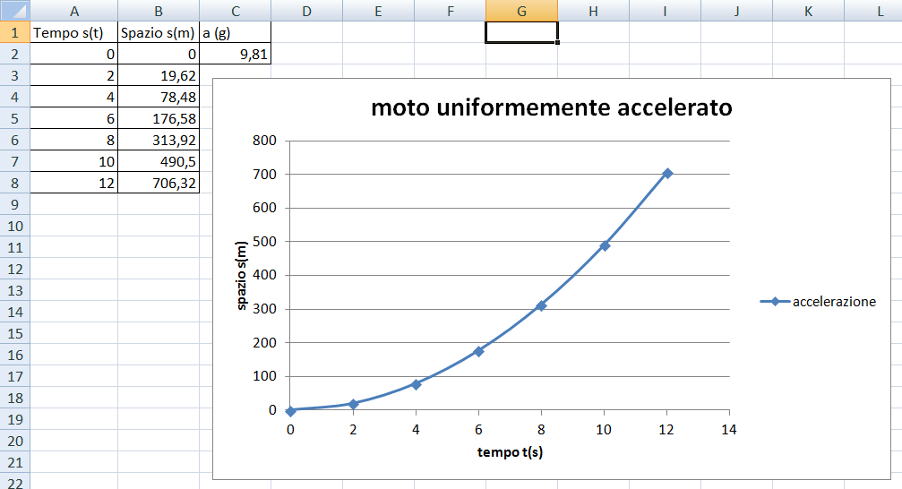

Versione piccola (senza zoom):

