dw Secret Notes
The user guide for people who have never used it before
Every screen, every button, every text field — explained simply.
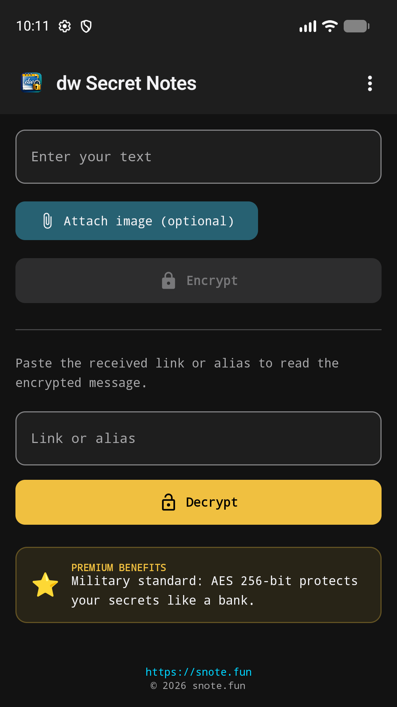
The main screen — the heart of the app
What does this app do?
dw Secret Notes lets you send a secret message (text or a picture) that destroys itself automatically after being read exactly once. You write a message, the app scrambles it beyond recognition, and gives you a link. You send that link to someone — WhatsApp, email, SMS, anything. The other person opens the link, reads the message one single time, and then it is permanently deleted from the server forever. Nobody — not even the app's developer — can ever read it again.

Think of it as a "this message will self-destruct" note from a spy movie — but for real, everyday use: sharing a password, a private thought, or a sensitive photo without leaving a trace anywhere.

Table of Contents
Click any line below (Ctrl+Click if Word asks) to jump straight to that page. If it still shows page 1 for every entry, right-click it and choose "Update Field" once.
Table of Contents 3
1. The First Time You Open the App 4
2. The Main Screen — Where Everything Happens 4
Sending a secret (top half) 5
Reading a secret (bottom half) 6
3. The Menu (⋮ icon, top-right corner) 8
4. Help Screen 10
5. Premium Screen 10
6. TinyURL Screen 12
7. Info Screen (About) 12
8. Support Screen ("Buy Me a Coffee") 14
9. Home Screen Widgets 15
10. Why Is This Safe? 16

1. The First Time You Open the App
The very first time you start dw Secret Notes, you see the Language screen shown below. It is a simple scrolling list of 15 languages.
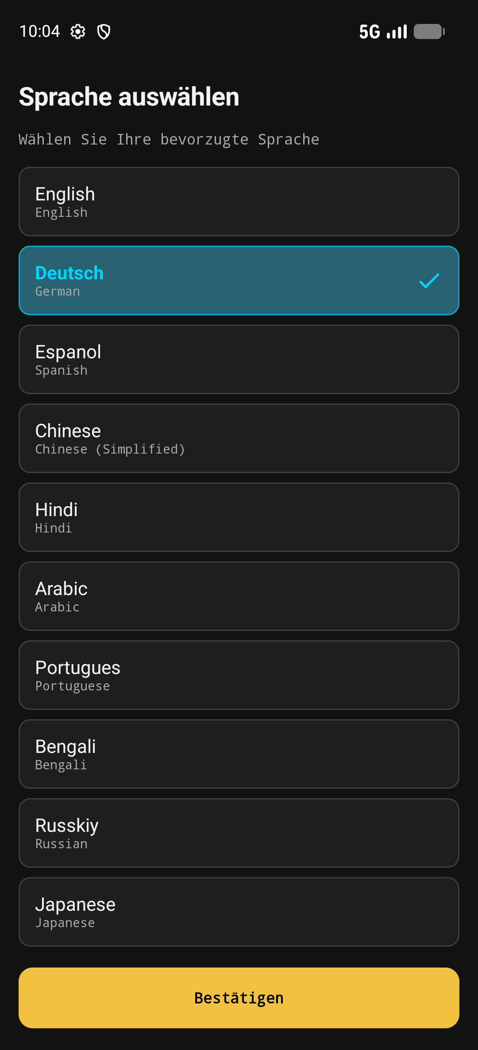
The language picker (shown here in its German labels — the list itself is the same in every language)
- Tap the language you want in the list — the selected one turns blue with a checkmark.
- Tap the yellow "Confirm" button at the very bottom to save your choice and enter the app.
- You can change the language again at any time later from the menu (see Section 3).

2. The Main Screen — Where Everything Happens
The main screen is split into two halves: the top half is for sending a secret, and the bottom half is for reading one.

The main screen before anything has been typed

Sending a secret (top half)
- "Enter your text" field — type the message you want to keep secret here.
- "Attach image (optional)" button — pick a picture from your phone's gallery. You can attach an image instead of text, or together with text. A small preview appears next to the button; tap the ✕ on it to remove the picture again.
- "Encrypt" button — once you have typed something (or attached an image), tap this. The app scrambles your message with bank-grade AES-256 encryption and uploads only the scrambled, unreadable version — your original text never leaves your phone in readable form.
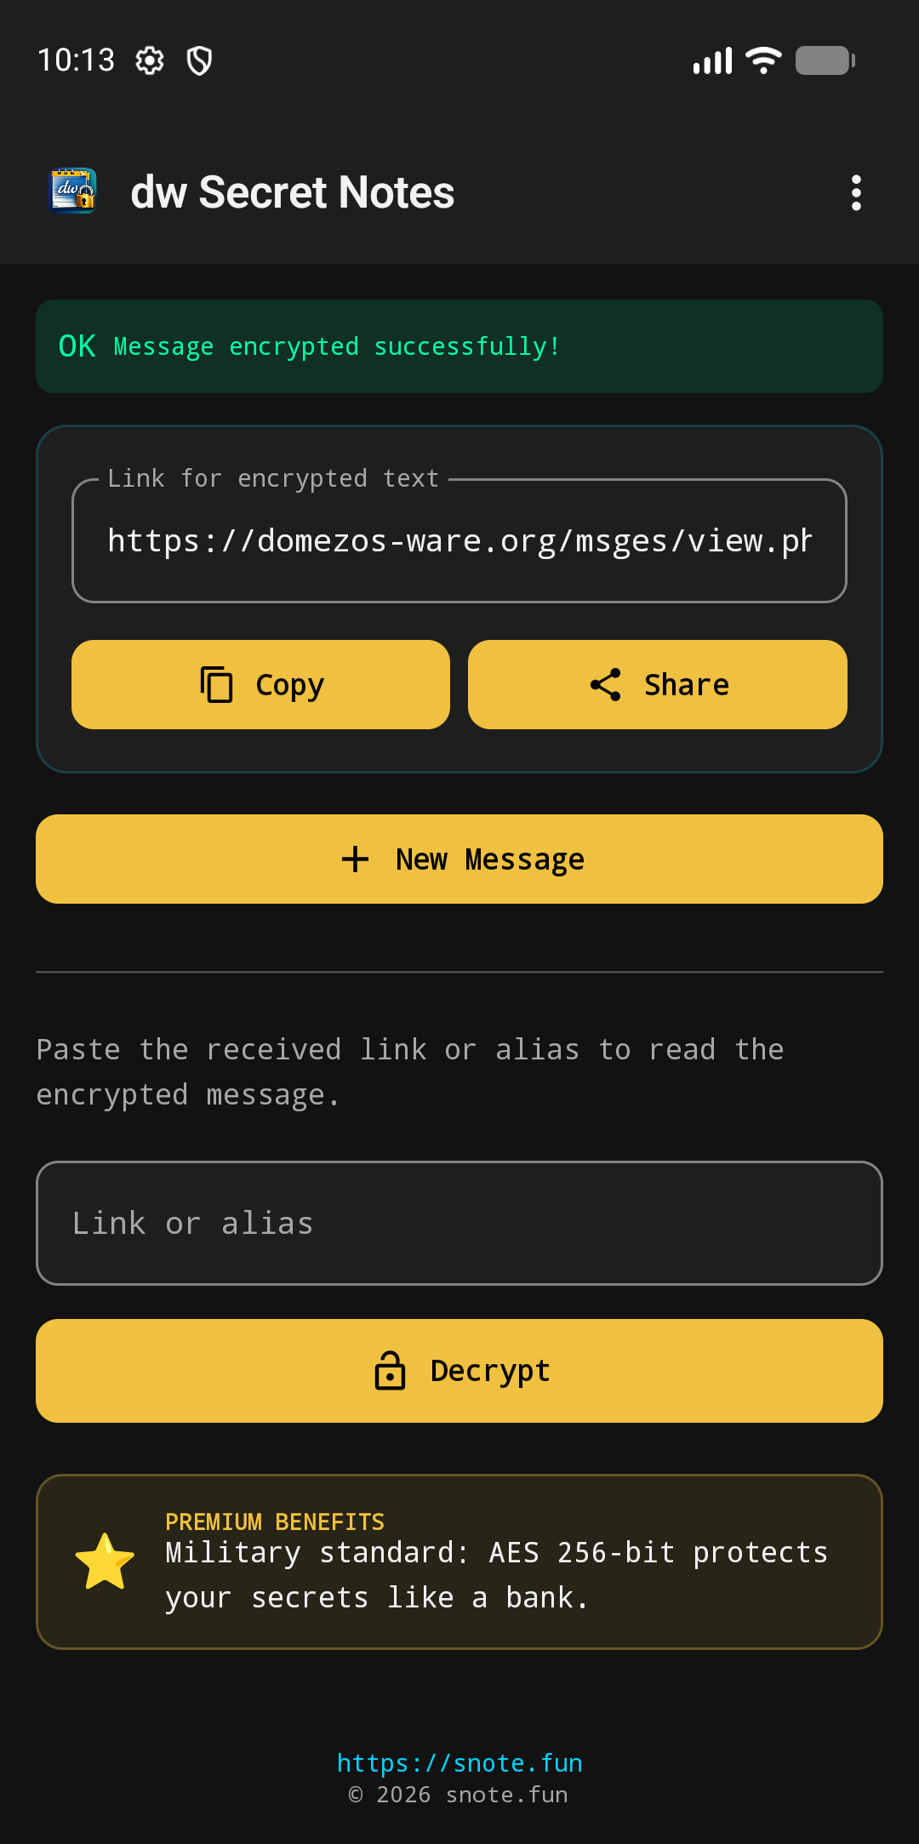
After tapping Encrypt: your secret link is ready
- Link field — the secret link you need to share (read-only, you cannot type into it).
- "Copy" button — copies the link to your clipboard so you can paste it anywhere.
- "Share" button — opens your phone's normal share menu (WhatsApp, email, SMS, etc.) with the link already filled in.
- "New Message" button — clears everything so you can encrypt another secret.

Reading a secret (bottom half)
- "Link or alias" field — paste the secret link (or just the short 5-character code) you received here.
- "Decrypt" button — fetches and unlocks the message. If it was already read before (or never existed), you will see a red "not found" warning instead.
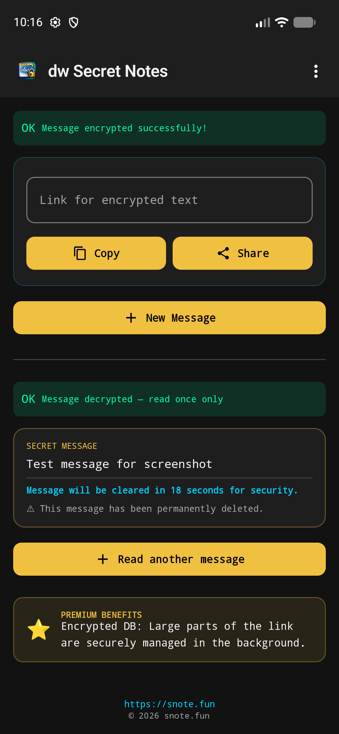
After tapping Decrypt: the secret is revealed — once
- The secret text and/or image — revealed just this once. Tap an image to view it fullscreen; tap anywhere to close it again.
- The countdown ("This message will be deleted in 60 seconds…") — a reminder that the content is temporary. It has already been permanently deleted from the server the moment you opened it — the on-screen countdown only clears your own view.
- "Read another message" button — clears the screen for the next link.
Below both sections there is a small highlighted box — an ad for Premium, or, if you already own Premium, a small thank-you message. Tapping it opens the Premium screen (Section 5).

3. The Menu (⋮ icon, top-right corner)
Tap the three dots in the top-right corner of any screen to open this dropdown menu:
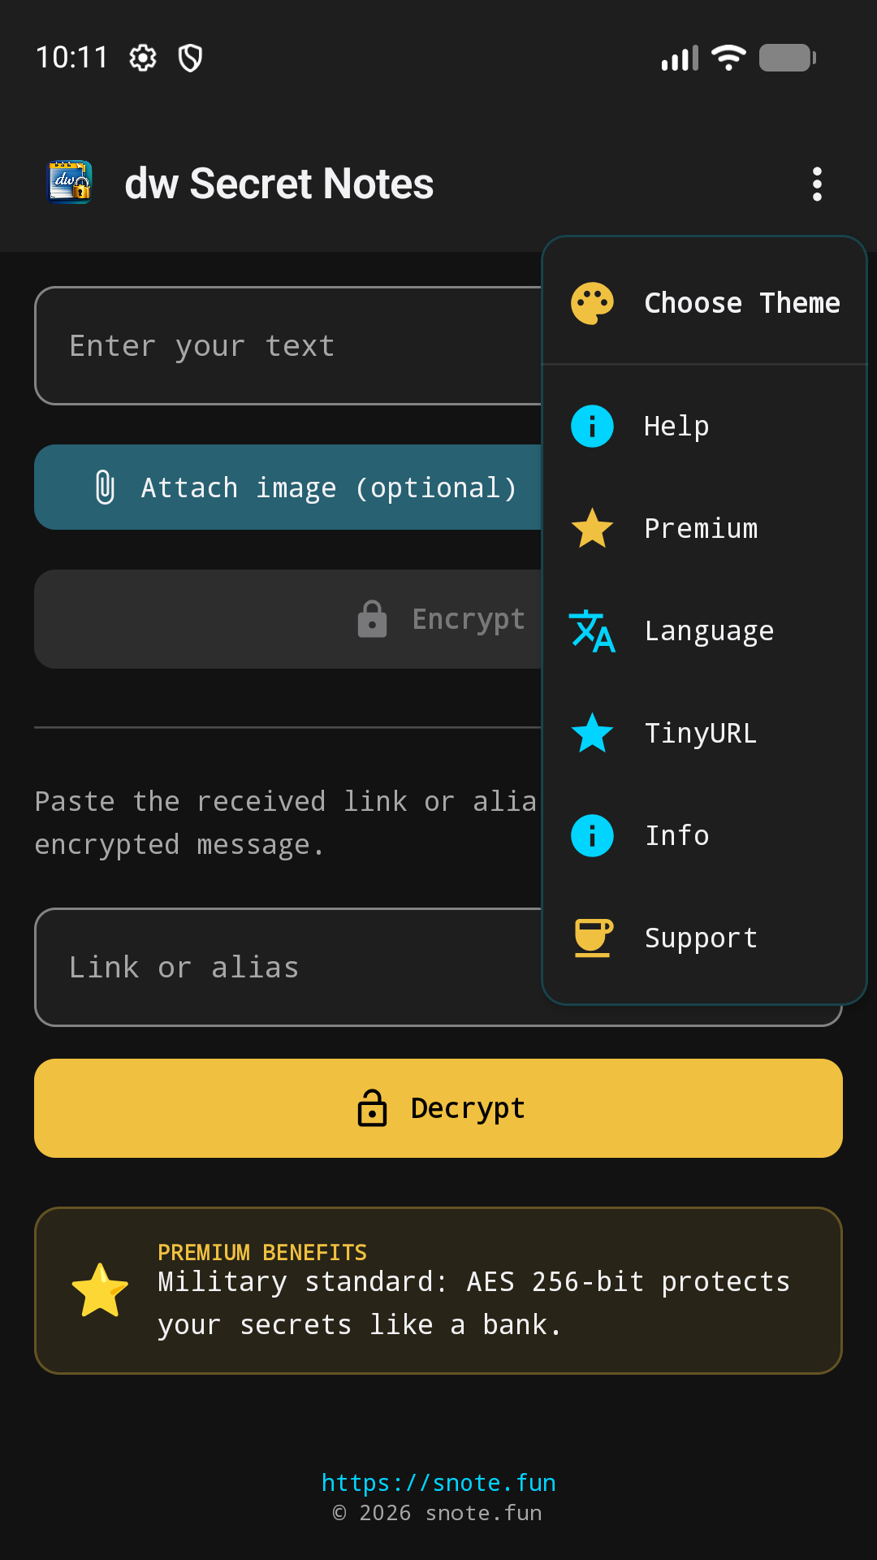
The overflow menu, opened from the main screen
Menu item | What it does
Choose Theme | Opens a second menu listing 16 color themes (Classic Blue, Midnight Purple, Forest Green, Cyberpunk Neon, Dracula Dark, Dark Mode, Light Mode, and more). Tap one to instantly re-color the whole app.
Help | Opens the Help & FAQ screen (Section 4).
Premium | Opens the Premium screen to unlock extra features (Section 5).
Language | Re-opens the language picker to switch the app's language at any time.
TinyURL | Opens a screen about shortening long web links (Section 6).
Info | Opens the About screen with version, developer, and legal info (Section 7).
Support | Opens the "Buy me a coffee" support/tip screen (Section 8).

4. Help Screen
A simple FAQ page explaining, in plain language, how the app works, why it is secure, and answering common questions such as whether a message can be read twice, whether a deleted message can be recovered, and how Premium links and Premium accounts work.
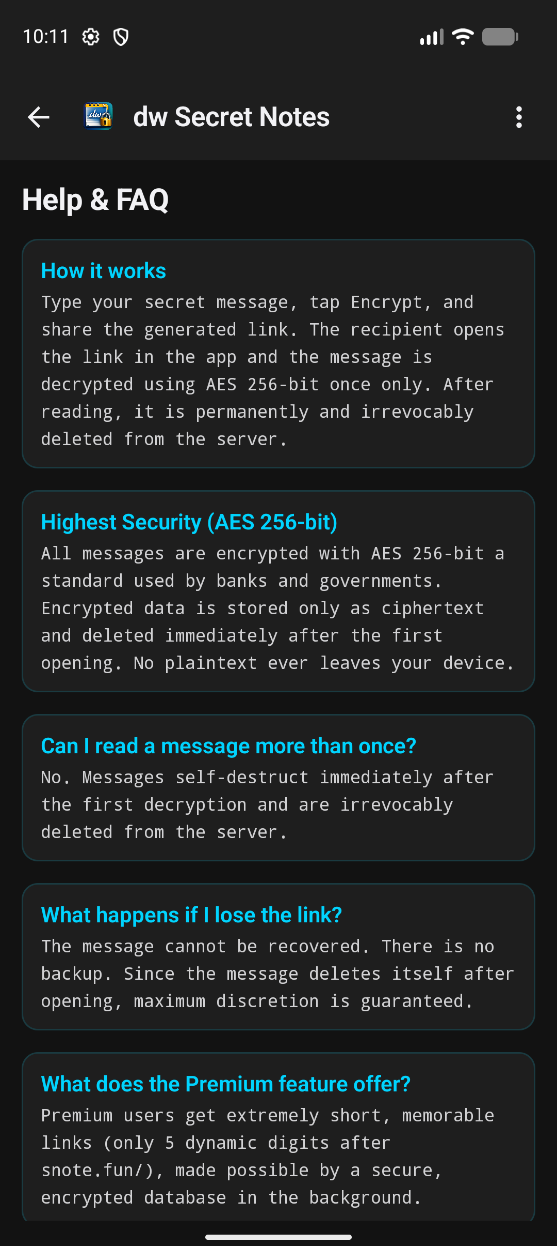
The Help & FAQ screen

5. Premium Screen
Premium is an optional upgrade you can buy. It shows a feature list, two plan cards to choose between, a details box explaining exactly what you get, and a buy button that opens Google Play's official payment screen.
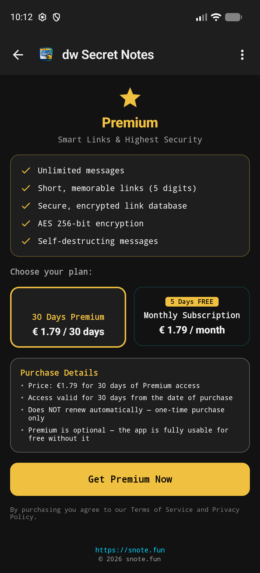
The Premium upgrade screen
- Feature list — unlimited messages, short 5-digit memorable links, a secure encrypted link database, AES 256-bit encryption, and self-destructing messages.
- "30 Days Premium" — a one-time purchase valid for 30 days, does not renew automatically.
- "Monthly Subscription" — a recurring subscription, usually with a few free trial days shown as a badge on the card.
- The buy button's text changes depending on which plan you selected. If you already own Premium, it is disabled and simply reads "Premium".
All prices shown are fetched live from Google Play in your own local currency — never hardcoded, so what you see is always accurate for your country.

6. TinyURL Screen
A separate, related feature: shortening any long web link down to just 5 characters, hosted on the developer's own website (snote.fun).
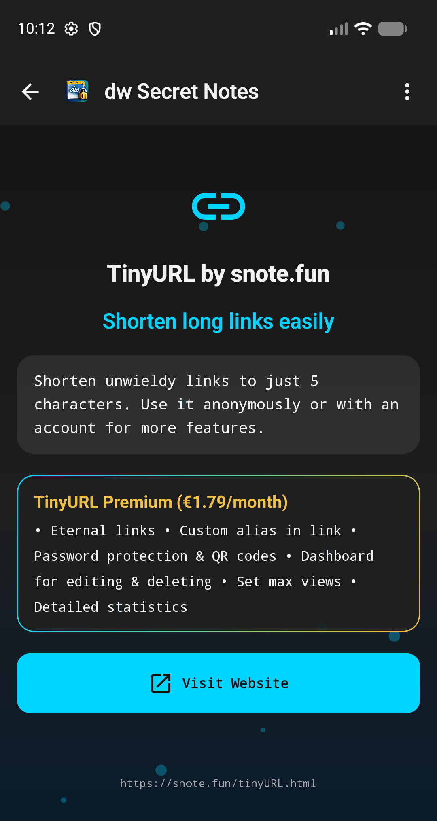
The TinyURL screen
- A short description of the feature.
- A box describing the Premium version of TinyURL (eternal links, custom alias, password protection, QR codes, a dashboard, and statistics), with its own separate monthly price.
- "Visit Website" button — opens the snote.fun website in your phone's browser, where you actually create the short link (this part happens outside the app).

7. Info Screen (About)
A simple reference screen listing the app's version, developer, website, and license, plus a short reminder of the AES-256 encryption guarantee.
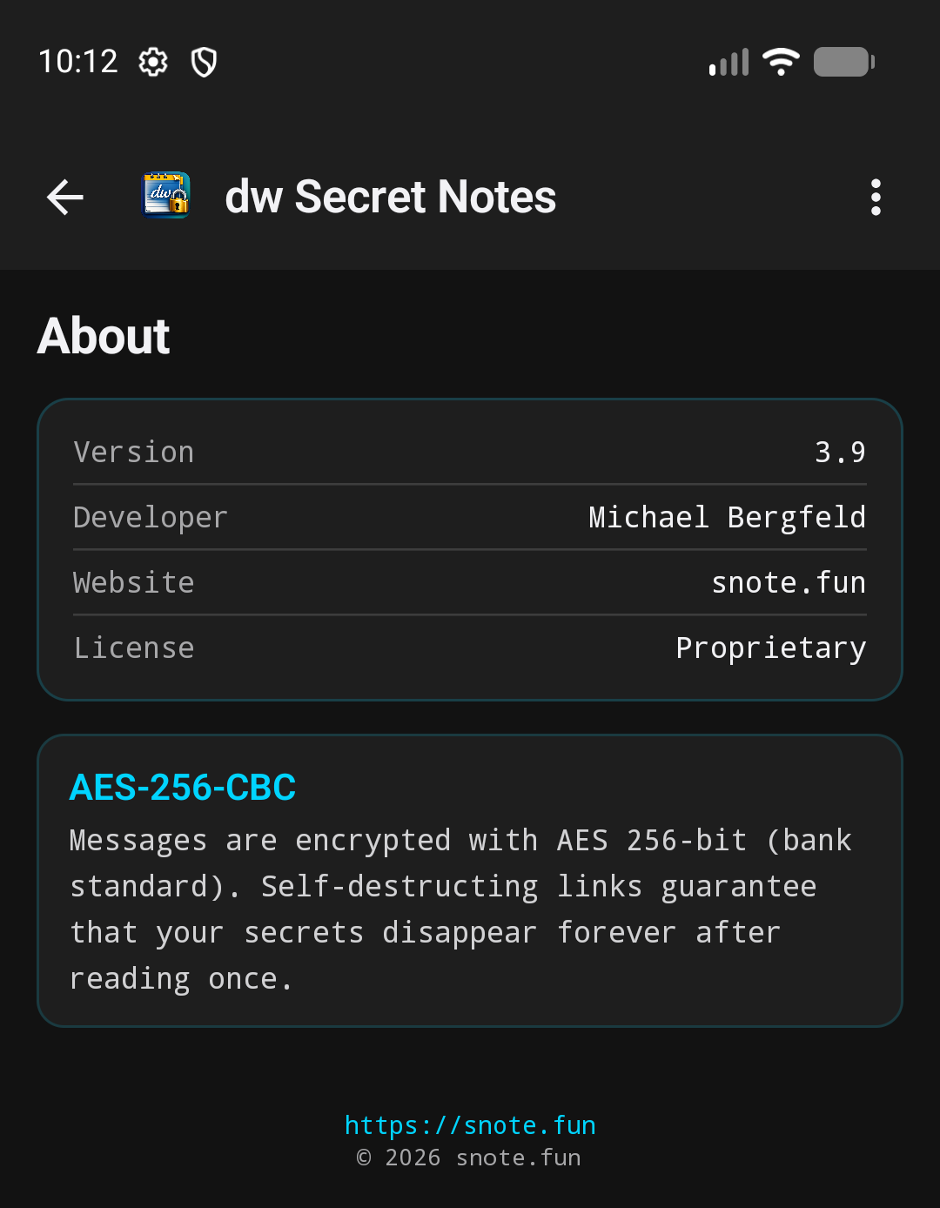
The About screen

8. Support Screen ("Buy Me a Coffee")
This is a pure, voluntary donation.
It unlocks nothing at all. It exists only so people who like the app can help keep it running.

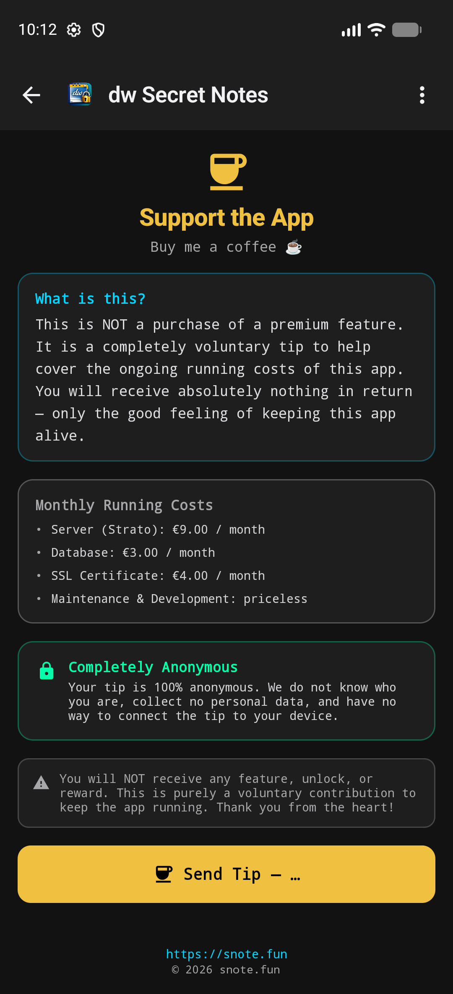
The Support screen
- "What is this?" — a plain explanation that this is not a purchase of any feature.
- "Monthly Running Costs" — a transparent breakdown of what actually costs money each month (the server, the database, the SSL certificate, and maintenance/development).
- "Completely Anonymous" — your tip is never tied to your identity in any way.
- "Send Tip" button — opens Google Play's payment screen for a small one-time tip. If you have tipped before, a badge shows how many times you have supported the app already.

9. Home Screen Widgets
Two small widgets can be added to your phone's home screen — outside the app itself — by long-pressing the home screen and choosing "Widgets":
- Quick Encrypt widget — lets you type a message and get a share link directly from your home screen, without opening the app fully.
- Launcher widget — a simple icon that just opens the app when tapped.

10. Why Is This Safe?
Your message is scrambled (encrypted) with AES-256 — the same encryption strength used by banks and governments — before it ever leaves your phone.
The server only ever stores the scrambled, unreadable version.
The instant someone opens and reads the message, it is permanently and irrevocably deleted — there is no way to read it a second time, and no backup exists anywhere.
Premium status is tied to an anonymous code generated on your device, not to your name, email, or any personal account — so the app cannot track who you are.

Website: snote.fun

